<Report 2018-26190 유성욱>

* Environment

Window 10 Education

Intel Core i3-4150 CPU 3.50GHz

RAM 8.00GM 64 bit

Ubuntu 16.04 (using vmware)

* Brief Description

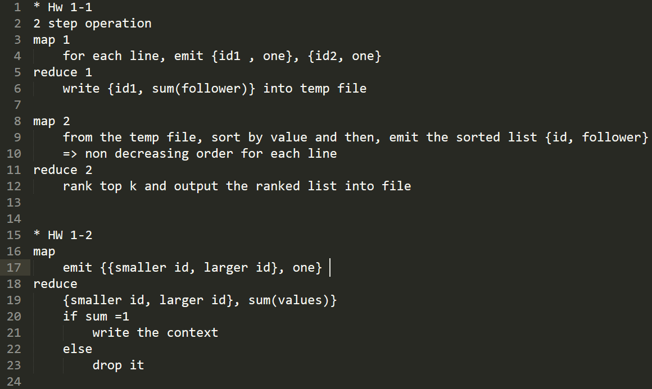

* Detailed Process

Hw1-1 …

Social Network dataset consists of {${id}_{1}$, ${id}_{2}$} pairs. It means ${id}_{1}$ follows ${id}_{2}$.

So, # of id1’s follower ++, if there exist id1 another’s id in a line.

In this situation, we have to find {${id}_{k}$, # of ${id}_{k}$’s follower}

I will show the whole process that finds outputs

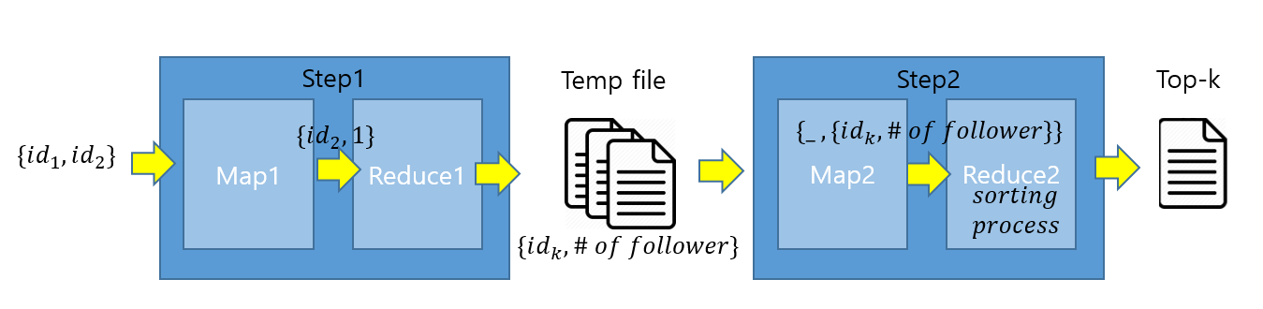

Hw1-2 …

Non symmetric friendship dataset consists of {${id}_{1}$, ${id}_{2}$} pairs. It means ${id}_{1}$ follows ${id}_{2}$.

If a relationship becomes a symmetric friendship,

there must be {${id}_{1}, {id}_{2}$} and ${\{id}_{1}$, ${id}_{2}$} in the dataset.

So, in the mapper, if it emits {(${Id}_{smaller}$, ${Id}_{larger}$], 1},

In the Reducer, if there is a symmetric friendship, values is [1, 1]

Therefore, if the sum(values) = 1, the relationship is non symmetric.

I will show the whole process that finds outputs

