Rohan – AI Companion Chatbot

Objective:
To create a personalized, emotionally intelligent chatbot that engages in meaningful, context-aware conversations with users.

Key Features:
- Personalized conversations using user profiles
- Message classification (suggestive, discussive, humorous, help)
- Contextual response generation
- Emotional support and safety handling
- Automatic profile enrichment through chat history analysis

System Overview:
Architecture Summary:
- Client (Frontend React app)
- Server (FastAPI backend)
- AI Layer (Google Gemini API)
- Database (JSON-based user storage for prototype)

Flow Diagram:

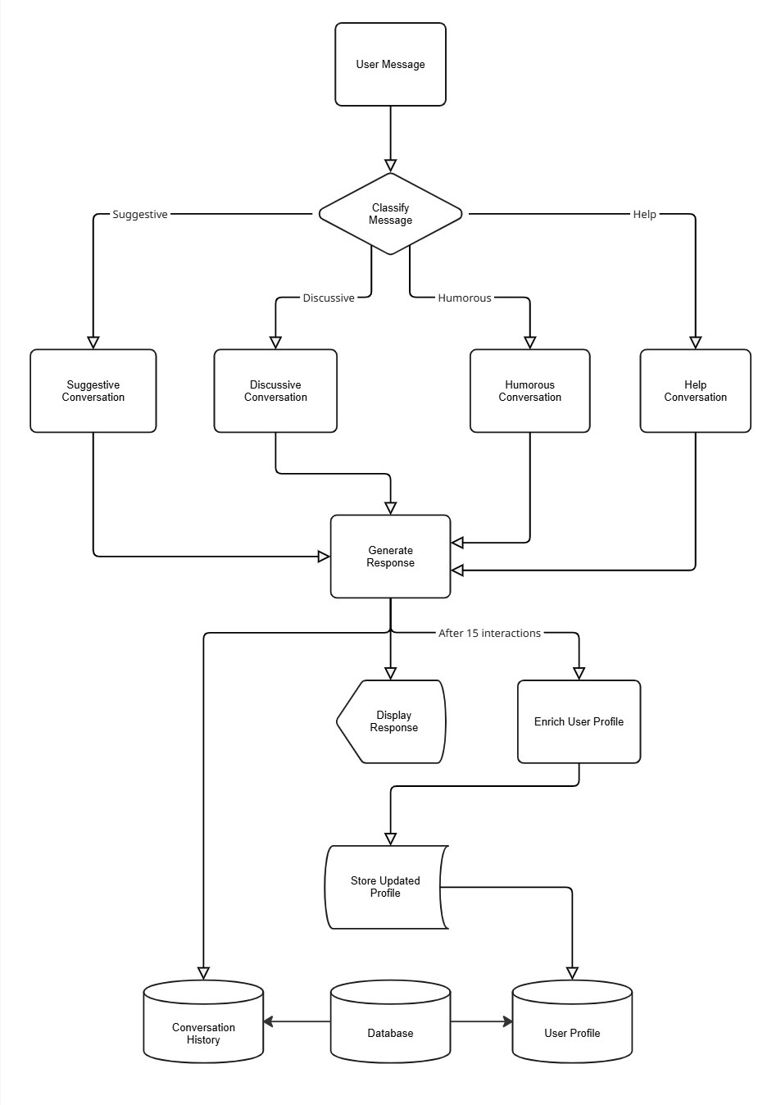

Technology Stack:
- Backend Framework - FastAPI
- AI Model - Google Gemini (google.genai api client)
- Data Storage – JSON local file
- Environment Config – dotenv (python)
- Server – Uvicorn
- Language – Python3.x

Core Modules & Logic:
User Management:
Handles signup, signin, and JSON-based storage in database folder.

Conversation Classification:
Uses Gemini to classify each user message as:
- Suggestive – seeking advice
- Discussive – meaningful talk
- Humorous – playful tone
- Help – signs of distress

Response Generation:
Each message type calls a specific handler:
- handle_suggestive()
- handle_discussive()
- handle_humorous()
- handle_help()
Each function creates a structured Gemini prompt with:
- User profile
- Bot profile
- Recent chat history

Profile Enrichment :
Every 15 user messages, the system extracts key personal info from the conversation:
- Favorites
- Events
- People
These details are stored in the user’s profile for personalization.

