Use Case Diagram
Blood Bank Management System
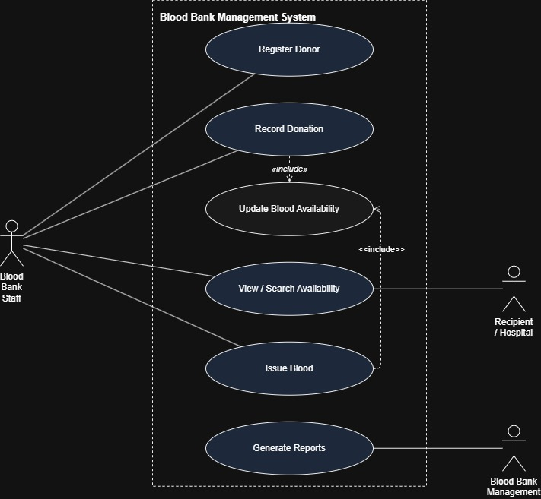

Actors and use cases
Actor | Use cases
Blood bank staff | Register donor, Record donation, View/search availability, Issue blood
Recipient / hospital | View/search availability
Blood bank management | Generate reports

“Update blood availability” is not directly triggered by any actor — it always executes as part of another use case. “Record donation” «includes» it to add stock on a donation (FR-04); “Issue blood” «includes» it to subtract stock on an issue (FR-07, together with FR-03).

