**ACADEMIC ADMINISTRATION APP**

1. **Class Diagram:**

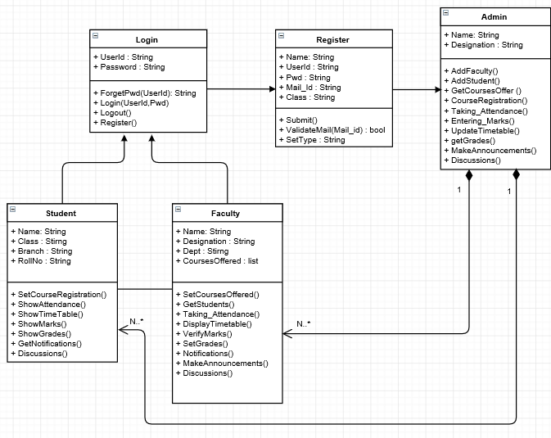

**2. Use Case Diagram:**

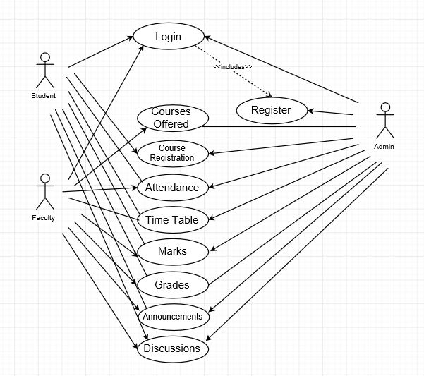

**3.Sequential diagram:C:\Users\Sunil\Downloads\Sequential  Diagram 1.png**