Software Requirements Specification (SRS) Document
<Academic Administration Application, R.Vamshi Krishna and Sunil Kumar>

Brief problem statement
Taking the student’s attendance using pen, paper and entered into the systems is a boring and routine activity for faculty and admin people. To resolve this problem, we are going to make an android app for faculty, admin, students and also a portal for faculty. In addition to above mentioned problem, we can add some more features like announcements, displaying grades, time-table to the students by the faculty and admin.

System requirements
- Java Programming, XML for Android Studio
- PHP
- Apache Server
- MySQL Database

Users profile
- Students who are registered under ‘Student Mode’ can be used.
- Faculty who are registered under ‘Faculty Mode’ can be used.
- Admin People who are registered under ‘Admin Mode’ can be used.

Feature requirements (described using use cases)

No. | User Case Name | Description | Release
 | User Registration | User must be registered as a student or faculty or admin with his/her true information. | R1
 | User Login | After Registration, User can login to portal or into app | R1
 | Courses Offered | Faculty can give the name of offered courses to admin | R1
 | Course Registration | Admin can offer course registration to students. Students can be registered courses. | R1
 | Attendance | Admin or Faculty can take attendance of students using android app. Students can see their attendance by registered courses wise. | R2
 | Time Table | Admin updates the time table and students, faculty can see it. | R2
 | Marks Entering | Admin can be entered students marks into server. | R2
 | Grades | Faculty can give grade to each student. Admin and students can see them | R3
 | Announcements | Faculty, Admin can make announcements like class postpone or prepone, Deadlines…… to students. Students can get such announcements as notifications. | R3
 | Discussions | Discussions can be made between faculty and student, faculty and admin. | R3

Use case diagram

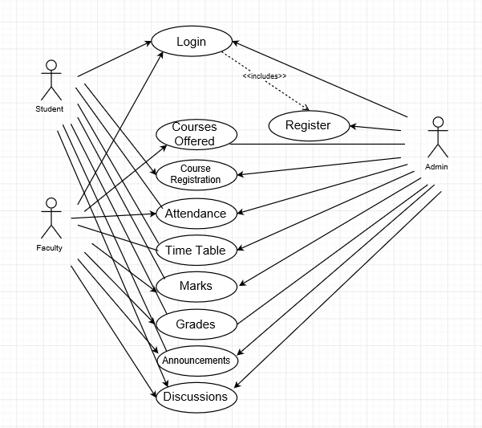

*Arrow indicates writable; Line indicates readable.

Use case description

Use Case Number: | UC-01
Use Case Name: | Registration
Overview: | User need to register to login into the app or portal
Actors: | Faculty, Student, Admin
Pre condition: | User must be have valid information like valid emailed etc.
Flow: | Main (success) Flow: User presses the Submit button  - User conformation through email authentication
Post Condition: | User get logged.

Use Case Number: | UC-02
Use Case Name: | Login
Overview: | After Registration, User can login to portal or into app
Actors: | Faculty, Student, Admin
Pre condition: | User must be registered before login
Flow: | Main (success) Flow: Entered into App or Portal
Post Condition: | User get logged.

Use Case Number: | UC-03
Use Case Name: | Courses Offered
Overview: | Faculty offers the list of courses which are going to teach.
Actors: | Faculty, Admin
Pre condition: | Faculty needed to be registered
Flow: | Main (success) Flow: Faculty presses the “SEND” button after giving the courses.  - Admin got the list of courses which are offered by faculty
Post Condition: | Faculty getting offered courses.

Use Case Number: | UC-04
Use Case Name: | Course Registration
Overview: | Admin can offer course registration to students. Students can be registered courses.
Actors: | Student, Admin
Pre condition: | Student must be registered and Admin must be got the list of offered courses by faculty.
Flow: | Main (success) Flow: Student need to tick the courses in which he/she desires.  - Press Submit button after chosen the courses  - Admin got the list of courses registered by student wise.
Post Condition: | Student get registered into courses.

Use Case Number: | UC-05
Use Case Name: | Attendance
Overview: | Admin or Faculty can take attendance of students using android app. Students can see their attendance by registered courses wise.
Actors: | Student, Admin, Faculty
Pre condition: | Faculty can take only the students who are registered his/her offered courses.  Admin can take all courses students.
Flow: | Main (success) Flow: Admin/Faculty needs to tick the students who are attended the class.  - Press Submit button after taken the attendance.  - Admin can send the attendance of each student by month wise.
Post Condition: | Attendance got counted by month wise.

Use Case Number: | UC-06
Use Case Name: | Time Table
Overview: | Admin can notify the time table to students and faculty.
Actors: | Student, Admin, Faculty
Pre condition: | Admin only can update the time table.
Flow: | Main (success) Flow: After browsing the pdf of time table admin can be uploaded.  - Students and faculty get notification on time table modification.  - Students and Faculty can see the time table
Post Condition: | Admin notified the time table modification

Use Case Number: | UC-07
Use Case Name: | Marks Entering
Overview: | Admin can be entered students marks into server and students, faculty can see the marks.
Actors: | Student, Admin, Faculty
Pre condition: | Admin, faculty only can update the marks
Flow: | Main (success) Flow: Admin can enter the marks of students course wise.  - Student and Faculty can see the students marks.  - Faculty and Admin can update the marks.
Post Condition: | Student marks can be entered course wise.

