Color Formulations
This color scheme accounts for normal color vision as well as Protanopia, Deuteranopia and Tritanopia color perception deficiencies.*
(Color values shown are derived from the Adobe® Color Model.)

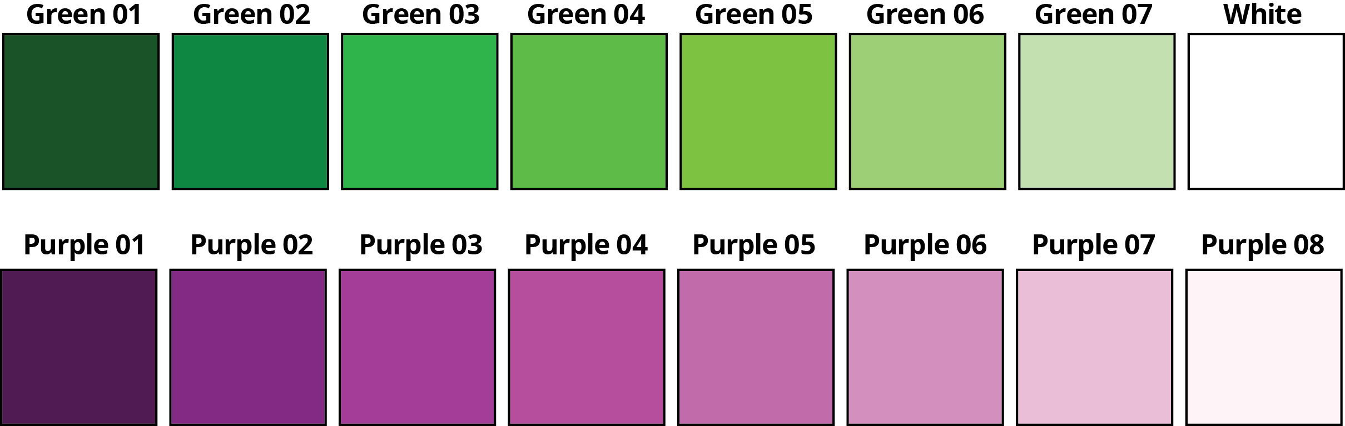

No. Name #Hex values R G B
01. Green 01 1C5229 28 82 41
02. Green 02 0A8641 10 164 66
03. Green 03 2CB14A 44 177 74
04. Green 04 5FBB46 5 187 70
05. Green 06 7FC242 127 94 66
06. Green 07 9BCD75 155 205 117
07. Green 08 C2E0B1 194 274 77
08. White FFFFFF 255 255 255
09. Purple 01 4F1A51 79 26 81
10. Purple 02 812983 129 41 131
11. Purple 03 A33D96 163 61 150
12. Purple 04 B64E9D 182 78 157
13. Purple 05 C16BAA 193 107 170
14. Purple 06 D28FBC 210 143 188
15. Purple 07 E8BDD6 232 189 214
16. Purple 08 FDF2F7 193 107 170

* Source: University of Oregon, Department of Geology, http://geog.uoregon.edu/datagraphics/color_scales.htm#Other Schemes

