F-65 Megawing
Product Story
Origin framing for Main Concept v1.6 · August 2026

The Situation
The Coalition of American States projects power the old-fashioned way: carriers, long-range interceptors, and control of the sea. The Pacific Directorate has other ideas. Using the same playbook that turns reefs into air bases, the Directorate is steadily surrounding the independent island city-state of Aurelia. Reefs become outposts. Outposts become runways. Runways become faits accomplis. Aurelia is next.
The CAS response is classic great-power projection. Carrier groups move into the approaches. The F-65A flies cover. The player is one of those pilots.

How the Aircraft Exists
President Richard Rump is unapologetically nostalgic. He likes big carriers that look like carriers, and he likes big fleet interceptors that look like the ones that once owned the sky. While the rest of the world moved on to fixed-wing stealth and networked everything, Rump leaned hard on Aero Dynamics West and told them to build a modern 4.5-generation aircraft that still had variable-sweep wings, twin engines, a two-seat cockpit, and the long-range interceptor character of the old Tomcat.
The result is the F-65A Megawing. It is not a museum piece and it is not a pure nostalgia act. It is a contemporary fighter with swing wings, modern sensors, and enough 1980s DNA that it still feels like the aircraft you always wanted to fly. The procurement was half serious strategy and half presidential vanity project. The airplane that came out of it is real enough to fight.

The Aircraft
Role: Large two-seat, twin-engine, variable-geometry fleet interceptor.
Standard load: Six long-range radar missiles, two medium-range radar missiles, two infrared heaters, 675 cannon rounds.
Performance targets: Empty ~40,000 lb · Fuel ~20,000 lb · MTOW ~72,000 lb · Mach 2.5 · Ceiling ~65,000 ft.
Flight controls: AUGMENTED (default) gives scheduled G and roll-rate command with protection. AUG_OFF is true direct flight — natural stability, pilot trim, no artificial limiting.
Carrier: Full catapult and arrested recovery. ADLC approach overlay when systems allow.
Cockpit identity: Bubble canopy primary. Green monochrome HUD. Left-side aircraft status. Right-side fused radar/navigation display. RIO in the back seat. Deliberately early-90s / late-80s character with synthwave audio and presentation.

Engineering Views
Orthographic studies matched to the carrier launch concept. Variable-sweep geometry is the defining feature.
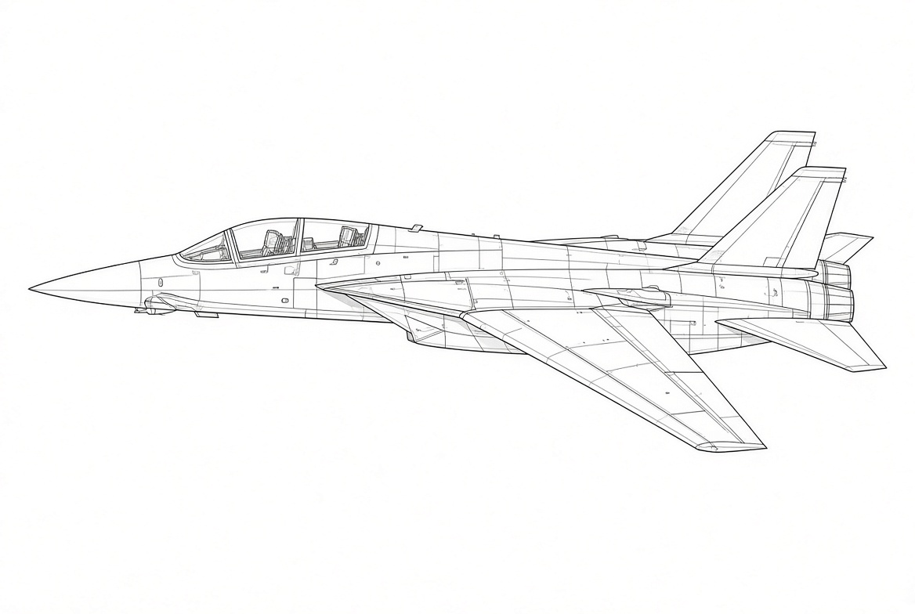
Side elevation — forward/takeoff sweep, matching the carrier aircraft
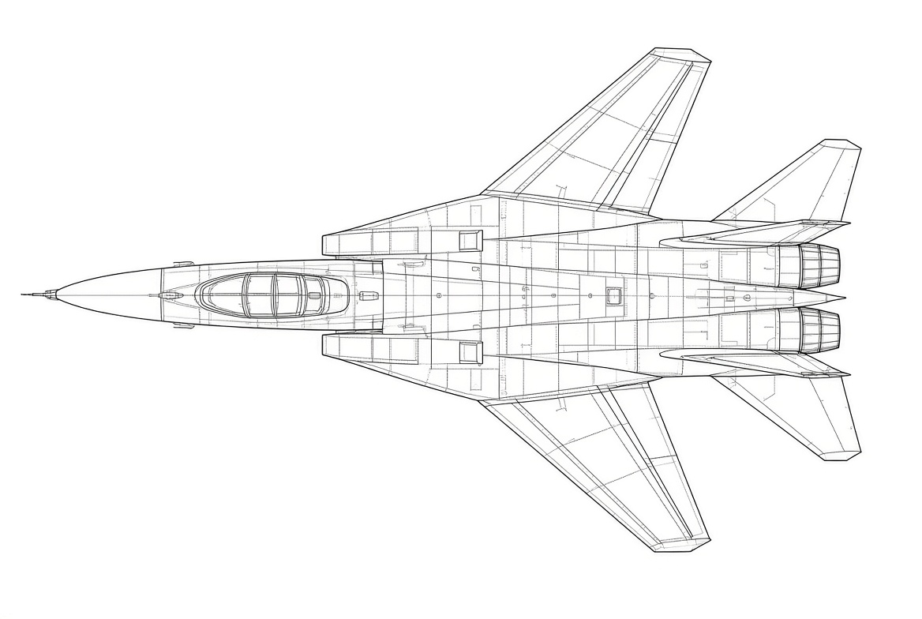
Top plan view — same airframe, forward wing position

Carrier Launch
Primary artistic reference. The same aircraft on the catapult at dusk.
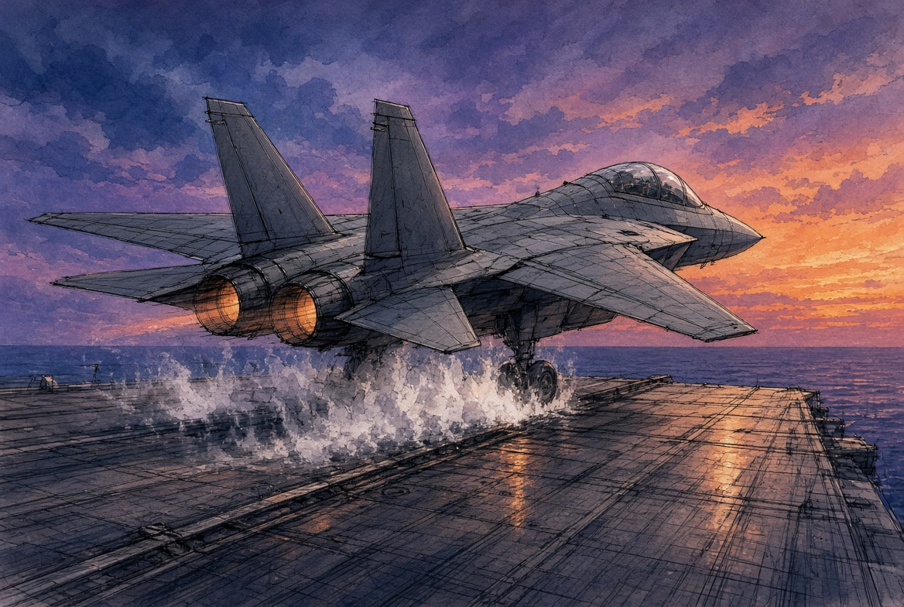
Catapult launch — the visual identity reference for the technical drawings above

Cockpit Concept
Early sketch aligned with the gameplay presentation model: green monochrome HUD, left status, right fused radar/nav, pilot + RIO.
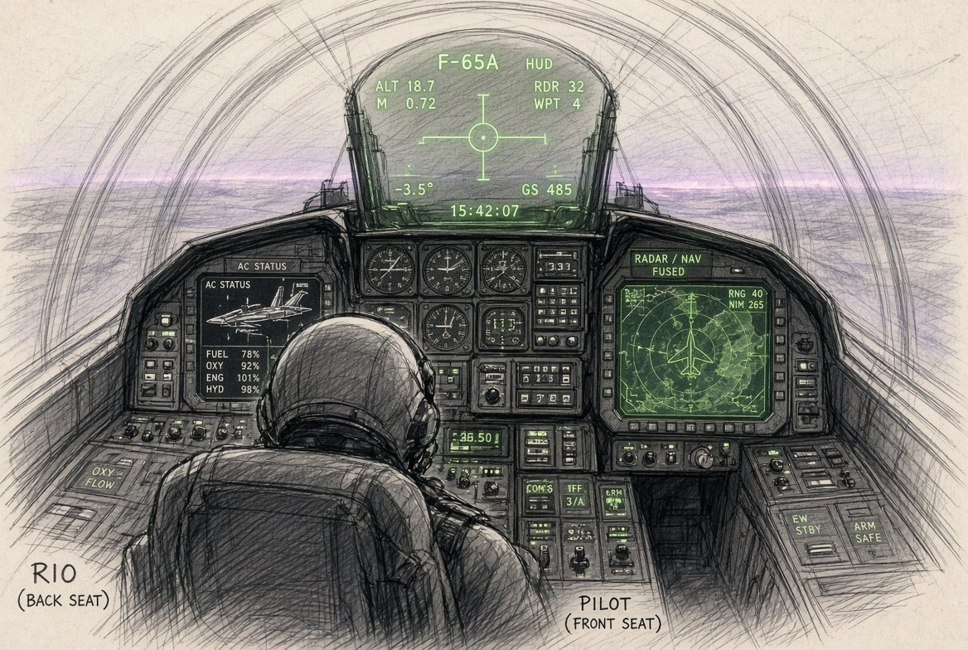
Cockpit — pilot forward, RIO aft, green HUD and dual displays

Status
This paper supplies the product origin, tone, and early visual framing for Main Concept v1.6. The lore is intentionally light and slightly tongue-in-cheek: a nostalgic president gets the swing-wing interceptor he wanted, the Navy still does classic power projection, and the other side is doing the island-grab playbook. The flying, the systems, and the combat remain serious. Detailed flight model, sensors, weapons, and campaign content stay with the white papers and Gameplay Supplement. No additional mission narrative is authorized here.
End of Product Story Paper

