ABSTRACT
Human Activity Recognition (HAR) is becoming increasingly important in the fast-evolving landscapes of wearable sensors, smart applications, and the Internet of Things (IoT) paradigms. HAR is rapidly gaining importance, especially in health monitoring, elderly and infant care, fitness tracking, and security. Machine learning (ML) and Deep Learning (DL) methods are used significantly for HAR problems. ML and DL methods often face four significant problems. Firstly, they lack the adaptability to evolve network architectures dynamically, which is vital in complex tasks like HAR. Secondly, classical ML and DL methods could fall short in comprehensively navigating potential solution spaces. Thirdly, f inding optimal hyperparameters is a computationally expensive process, and lastly, expert knowledge is required to configure the hyperparameters. This paper proposes the NeuroHAR, a transformative neuroevolutionary method for HAR, to address these problems. NeuroHAR integrates feedforward deep neural networks (FDNN) with evolutionary algorithms. The highlights of NeuroHAR include its dynamic optimization of network architectures and hyperparameters. It is simple to configure and computationally efficient. Due to its adaptable design, it offers a more flexible and robust solution that handles task complexities better than traditional methods. Results are promising, which is evidence of the effectiveness of the proposed NeuroHAR, which outperformed the explicit contender, the state-of-the-art Grid Search approach. NeuroHAR and Grid Search evaluated 900 and 1080 models in Case I. Even with broader hyperparameter ranges in Case II, NeuroHAR still executed 900 models, whereas Grid Search would need over 2 billion models, which proves the computational efficiency of NeuroHAR.

- INTRODUCTION
  - About Deep Learning
Deep learning (also known as deep structured learning) is part of a broader family of machine learning methods based on artificial neural networks with representation learning. Learning can be supervised, semi-supervised or unsupervised.
Deep-learning architectures such as deep neural networks, deep belief networks, deep reinforcement learning, recurrent neural networks and convolutional neural networks have been applied to fields including computer vision, speech recognition, natural language processing, machine translation, bioinformatics, drug design, medical image analysis, climate science, material inspection and board game programs, where they have produced results comparable to and in some cases surpassing human expert performance.
Artificial neural networks (ANNs) were inspired by information processing and distributed communication nodes in biological systems. ANNs have various differences from biological brains. Specifically, artificial neural networks tend to be static and symbolic, while the biological brain of most living organisms is dynamic (plastic) and analogue.
The adjective "deep" in deep learning refers to the use of multiple layers in the network. Early work showed that a linear perceptron cannot be a universal classifier, but that a network with a non-polynomial activation function with one hidden layer of unbounded width can. Deep learning is a modern variation which is concerned with an unbounded number of layers of bounded size, which permits practical application and optimized implementation, while retaining theoretical universality under mild conditions. In deep learning the layers are also permitted to be heterogeneous and to deviate widely from biologically informed connectionist models, for the sake of efficiency, trainability and understandability, whence the "structured" part.
Artificial neural networks
Artificial neural networks (ANNs) or connectionist systems are computing systems inspired by the biological neural networks that constitute animal brains.

Such systems learn (progressively improve their ability) to do tasks by considering examples, generally without task-specific programming. For example, in image recognition, they might learn to identify images that contain cats by analyzing example images that have been manually labeled as "cat" or "no cat" and using the analytic results to identify cats in other images. They have found most use in applications difficult to express with a traditional computer algorithm using rule-based programming.
An ANN is based on a collection of connected units called artificial neurons, (analogous to biological neurons in a biological brain). Each connection (synapse) between neurons can transmit a signal to another neuron. The receiving (postsynaptic) neuron can process the signal(s) and then signal downstream neurons connected to it. Neurons may have state, generally represented by real numbers, typically between 0 and 1. Neurons and synapses may also have a weight that varies as learning proceeds, which can increase or decrease the strength of the signal that it sends downstream.
Typically, neurons are organized in layers. Different layers may perform different kinds of transformations on their inputs. Signals travel from the first (input), to the last (output) layer, possibly after traversing the layers multiple times.
The original goal of the neural network approach was to solve problems in the same way that a human brain would. Over time, attention focused on matching specific mental abilities, leading to deviations from biology such as backpropagation, or passing information in the reverse direction and adjusting the network to reflect that information.
Neural networks have been used on a variety of tasks, including computer vision, speech recognition, machine translation, social network filtering, playing board and video games and medical diagnosis.
As of 2017, neural networks typically have a few thousand to a few million units and millions of connections. Despite this number being several order of magnitude less than the number of neurons on a human brain, these networks can perform many tasks at a level beyond that of humans.

Deep neural networks
A deep neural network (DNN) is an artificial neural network (ANN) with multiple layers between the input and output layers. There are different types of neural networks but they always consist of the same components: neurons, synapses, weights, biases, and functions. These components functioning similar to the human brains and can be trained like any other ML algorithm.
For example, a DNN that is trained to recognize dog breeds will go over the given image and calculate the probability that the dog in the image is a certain breed. The user can review the results and select which probabilities the network should display (above a certain threshold, etc.) and return the proposed label. Each mathematical manipulation as such is considered a layer,[citation needed] and complex DNN have many layers, hence the name "deep" networks.
DNNs can model complex non-linear relationships. DNN architectures generate compositional models where the object is expressed as a layered composition of primitives. The extra layers enable composition of features from lower layers, potentially modeling complex data with fewer units than a similarly performing shallow network. For instance, it was proved that sparse multivariate polynomials are exponentially easier to approximate with DNNs than with shallow networks.
Deep architectures include many variants of a few basic approaches. Each architecture has found success in specific domains. It is not always possible to compare the performance of multiple architectures, unless they have been evaluated on the same data sets.
DNNs are typically feedforward networks in which data flows from the input layer to the output layer without looping back. At first, the DNN creates a map of virtual neurons and assigns random numerical values, or "weights", to connections between them. The weights and inputs are multiplied and return an output between 0 and 1. If the network did not accurately recognize a particular pattern, an algorithm would adjust the weights. That way the algorithm can make certain parameters more influential, until it determines the correct mathematical manipulation to fully process the data.
Recurrent neural networks (RNNs), in which data can flow in any direction, are used for applications such as language modeling. Long short-term memory is particularly effective for this use.
Convolutional deep neural networks (CNNs) are used in computer vision. CNNs also have been applied to acoustic modeling for automatic speech recognition (ASR).
1.2 About the Project
The Internet of Things (IoT) and Smart Cities are closely interlinked paradigms. IoT means technological infrastructure comprising sensors, actuators, and networking technologies. At the same time, Smart cities consist of intelligent applications that leverage sensed data from IoT infrastructures and intelligent algorithms to make sustainable decisions that improve the daily lives and in a broader context, the prosperity of the societies.
Human Activity Recognition (HAR) can be essential to Smart City’s goals. HAR provides valuable human behavioral insights that help optimize various aspects of urban life through smart applications. HAR has numerous applications as depicted in such as monitoring, urban planning, health and well being, security, transportation and traffic management, smart home integration, and social and behavioral analysis. Various sensors, including cameras and edge devices, can capture human activities. ML and DL are at the core of analyzing HAR data to find previously unknown patterns and enhance decision-making.
Traditional ML and DL methods are at the core of analyzing HAR data to find hidden insights that lead to enhanced decision-making. However, these methods face four significant problems that are also highlighted in several previous papers. These problems are: (1) expert knowledge is required to configure the hyperparameters of these algorithms for optimal results, (2) they cannot evolve their architectures dynamically, (3) they might struggle to cover and navigate the breadth of available solution spaces fully, and (4) hyperparameter tuning is a computationally expensive and time-consuming process.
This work addresses the above problems and subsequently improves the accuracy of HAR and computational efficiency on a complex dataset by introducing a neuro evolutionary-based method that integrates ‘‘neuro,’’ which refers to the deep artificial neural networks (DANN), and ‘‘evolutionary,’’ which refers to the evolutionary algorithms that are used to tune the DANN’s hyperparameters.
1.3 OBJECTIVE OF PROJECT
The aim of this project is to develop an efficient Human Activity Recognition (HAR) system for health monitoring by implementing NeuroHAR, a neuroevolutionary approach that integrates Feedforward Deep Neural Networks (FDNN) with evolutionary algorithms to accurately recognize and classify human activities using data collected from wearable sensors and IoT devices. The system aims to improve activity detection performance, optimize neural network parameters automatically, and enhance the reliability of health monitoring applications.

- LITERATURE SURVEY
HAR has become an important research area from two perspectives. Firstly, HAR can have a wide area of applications across domains. Secondly, it is of greater commercial importance to the industry. HAR has many applications in healthcare, smart education, and security. It aids in patient monitoring, enhances learning, and ensures safety for the elderly and infants. HAR’s versatility is crucial in addressing diverse needs across these areas. The advancements in ML and DL power HAR methods to enable the automatic detection and classification of human activities. This field has grown significantly in recent years, which can be attributed to the large-scale inception of wearable devices and smartphones, which have sophisticated sensors capable of capturing movement data. HAR methods are broadly segregated into two categories: traditional machine learning-based methods and advanced deep learning-based methods. In the following subsections, ML and DL methods, and their optimization in the area of HAR are discussed.
The work aims to develop a transformative neuro evolutionary method for HAR that integrates feedforward deep neural networks with evolutionary algorithms, optimizing network architectures and hyperparameters dynamically in complex HAR tasks within smart cities and IoT environments, particularly in health monitoring, elderly and infant care, fitness tracking, and security.
The evolution of HAR methods using Support Vector Machines (SVM) demonstrates significant advancements in accuracy and efficiency. Kusumaetal.’sapproach, which enhances the classification of static and dynamic activities through SVM with hyperparameter tuning, achieved a remarkable accuracy of 96.26%. Complementing this, Qian et al. introduced a method utilizing an SVM multi-class classifier with binary tree architecture, incorporating advanced feature extraction techniques for improved activity classification. Chathuramali and Rodrigo addressed the challenges of long training times and large feature vectors, optimizing SVM for better computational efficiency.
Finally, Anguita et al.’s method, tailored for smartphone inertial sensors, demonstrates a cost-effective, hardware-friendly approach that maintains accuracy while reducing computational demands, illustrating the diverse applications and continual innovation in the field of HAR using SVM. Random Forest (RF) works in two stages. In the first multiple decision trees, the classifier was applied to subsets of the data. In the second phase, bagging is performed on the decisions of these classifiers.
The Gradient Boosting Machine (GBM) is a highly effective classifier but comes with significant computational demands. Several strategies have been developed to mitigate this challenge and reduce the computational cost associated with the GBM. To address this, Zhang et al. proposed an efficient, semi-supervised learning approach for HAR based on semi-supervised Light GBM as a robust classifier to enhance recognition accuracy and robustness with less labeled data. Similarly, Shao et al. and Csizmadia et al. proposed more variants of LightGBM. Simpler classifiers, such as Naïve Bayes and K-nearest neighbors (KNN), are also widely used in HAR. Maswadi et al. employed the traditional Naive Bayes classifier to accurately predict human activities such as sitting, standing, walking, sitting down, and standing up. Similarly, Shen and Fang introduced an advanced iteration of the Naive Bayes classifier, specifically the Gaussian Naive Bayes variant, which is optimized for enhanced performance in HAR.

3. SYSTEM ANALYSIS
3.1 EXISTING SYSTEM
- The systems for Human Activity Recognition (HAR) primarily rely on traditional machine learning techniques such as decision trees, support vector machines, and k-nearest neighbors.
- However, they struggle with scalability and adaptability in handling complex, dynamic tasks like HAR.
- These systems also face challenges in efficiently tuning hyperparameters and require significant manual intervention.
3.1.1 DISADVANTAGES OF EXISTING SYSTEM
- These systems often struggle to handle large-scale datasets, especially when dealing with diverse and complex human activities, leading to performance degradation.
- These models may not be well-suited for real-time applications where rapid decision-making is essential, as they may lack the speed and efficiency.
3.2 PROPOSED SYSTEM
- The NeuroHAR system introduces a neuroevolutionary framework for Human Activity Recognition by combining feedforward deep neural networks with evolutionary algorithms.
- In this approach, evolutionary strategies are used to automatically optimize the network architecture and parameters, reducing the dependence on manual tuning and domain expertise.
3.2.1 ADVANTAGES OF PROPOSED SYSTEM
- Automatically optimizes network architecture and parameters using evolutionary algorithms, minimizing manual tuning.
- Improves recognition accuracy by effectively learning complex patterns from wearable sensor data.
3.3 FEASIBILITY STUDY
3.3.1 Technical Feasibility
For the NeuroHAR-based Human Activity Recognition system, the project is technically feasible because the necessary technologies and tools are readily available. The system can be implemented using modern programming languages such as Python, along with machine learning and deep learning libraries like TensorFlow, Keras, or PyTorch for building Feedforward Deep Neural Networks (FDNN). Evolutionary algorithms can be implemented using available optimization libraries. The project utilizes data from wearable sensors or publicly available HAR datasets, which can be processed and analyzed using standard data preprocessing techniques.
3.3.2 Economic Feasibility
The proposed NeuroHAR-based Human Activity Recognition (HAR) system is economically feasible because it requires minimal financial investment. The project mainly uses open-source software and tools such as Python programming language and machine learning frameworks like TensorFlow, Keras, or PyTorch, which are freely available. Therefore, there is no need to purchase expensive software licenses. The dataset required for training the model can be obtained from publicly available Human Activity Recognition datasets or from wearable sensor devices that are already widely used in smart devices and health monitoring systems.
3.3.3 Operational Feasibility
Operational feasibility refers to the extent to which the proposed system will operate effectively within the existing environment and whether it will be accepted and used by the intended users. The proposed NeuroHAR-based Human Activity Recognition (HAR) system is operationally feasible because it is designed to work with data collected from wearable sensors and smart devices that are already widely used in healthcare and IoT applications. The system can automatically analyze sensor data and identify different human activities such as walking, sitting, standing, and other daily movements.
3.4 MODULES
- Admin
- User
3.5 SOFTWARE REQUIREMENT SPECIFICATION
3.5.1 Functional Requirements
The main purpose of functional requirements within the requirement specification document is to define all the activities or operations that take place in the system. But the general functional requirements arrived at the end of the interaction with the users are listed bellow
This project provides:
- Allows Admin to login into the system
- Allows Admin to load and process data using spark
- Allows Admin to train ML algorithms
- Allows user to Register and login into the system
- Allows user to prediction health using csv and manual parameters
3.5.2 Non-functional requirements
The major non-functional Requirements of the system are as follows
Usability
The system is designed with completely automated process hence there is no or less user intervention.
Reliability
The system is more reliable because of the qualities that are inherited from the chosen platform java. The code built by using java is more reliable.
Performance
This system is developing in the high level languages and using the advanced front-end and back-end technologies it will give response to the end user on client system with in very less time.
Supportability
The system is designed to be the cross platform supportable. The system is supported on a wide range of hardware and any software platform, which is having JVM, built into the system.
Implementation
The system is implemented in web environment using struts framework. The apache tomcat is used as the web server and windows xp professional is used as the platform.
Interface the user interface is based on Struts provides HTML Tag
3.6 SOFTWARE AND HARDWARE REQUIREMENTS
3.6.1 Software Requirements
Operating System : Windows 10 64 bit
Programming language : Python
Front End : HTML, CSS
Back End : MySQL 5.0
Framework : Django
Server : Xampp
3.6.2 Hardware Requirements
Processor : I3
RAM : 4 GB
Hard Disk : 500 GB

4. SYSTEM DESIGN
4.1 INTRODUCTION
The most creative and challenging phase of the life cycle is system and design. The term design describes a final system and the process by which it is developed. It refer to the technical specifications that will be applied in implementation the candidate system. The design may be defined as “the process of applying various techniques and principles for the purpose of defining a device, a process or a system in sufficient details to permit its physical realization”.
The design’s goal is how the output is to be produced and in what format samples of the output and input are also presented. Second input data and database files have to be designed to meet the requirements of the proposed output. The processing phase is handled through the program construction and testing. Finally details related to justification of the system and an estimate of the impact of the candidate system on the users and the organization are documented and evaluated by management as a step toward implementation.
The importance of software design can be stated in a single word “Quality”. Design provides us with representation of software that can be assessed for quality. Design is the only way that we can accurately translate a customer’s requirements into a finished software product or system without design we risk building an unstable system, that might fail it small changes are made or may be difficult to test, or one who’s quality can’t be tested. So it is an essential phase in the development of a software product.
4.2 SDLC METHODOLOGY
The document ply vital role in the development of life cycle (SDLC) as it describes the complete requirement of the system. It means for use by developers and will be the basic during testing phase. Any changes made to the requirements in the future will have to go through formal change approval process.
SPIRAL MODEL was defined by Barry Boehm in his 1988 article, “A spiral model of Software Development and Enhancement.
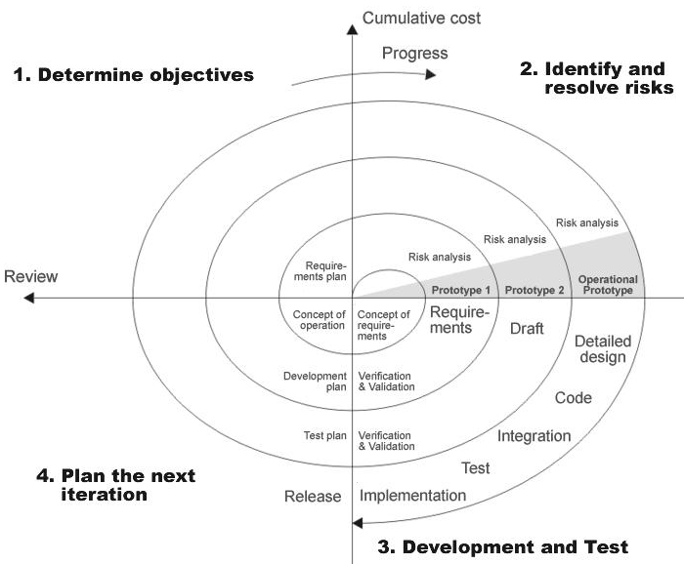
Stages in SDLC
- Requirement Gathering
- Analysis
- Designing
- Coding
- Testing
- Maintenance
Requirements Gathering stage
The requirements gathering process takes as its input the goals identified in the high-level requirements section of the project plan. Each goal will be refined into a set of one or more requirements. These requirements define the major functions of the intended application, define operational data areas and reference data areas, and define the initial data entities. Major functions include critical processes to be managed, as well as mission critical inputs, outputs and reports. A user class hierarchy is developed and associated with these major functions, data areas, and data entities. Each of these definitions is termed a Requirement. Requirements are identified by unique requirement identifiers and, at minimum, contain a requirement title and textual description.
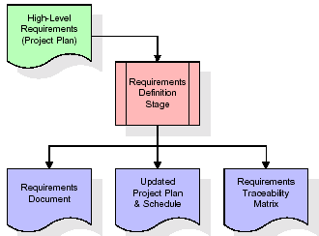
These requirements are fully described in the primary deliverables for this stage: the Requirements Document and the Requirements Traceability Matrix (RTM). The requirements document contains complete descriptions of each requirement, including diagrams and references to external documents as necessary. Note that detailed listings of database tables and fields are not included in the requirements document.
The title of each requirement is also placed into the first version of the RTM, along with the title of each goal from the project plan.
The purpose of the RTM is to show that the product components developed during each stage of the software development lifecycle are formally connected to the components developed in prior stages.
In the requirements stage, the RTM consists of a list of high-level requirements, or goals, by title, with a listing of associated requirements for each goal, listed by requirement title. In this hierarchical listing, the RTM shows that each requirement developed during this stage is formally linked to a specific product goal.
The outputs of the requirements definition stage include the requirements document, the RTM, and an updated project plan.
- Feasibility study is all about identification of problems in a project.
- No. of staff required to handle a project is represented as Team Formation, in this case only modules are individual tasks will be assigned to employees who are working for that project.
- Project Specifications are all about representing of various possible inputs submitting to the server and corresponding outputs along with reports maintained by administrator
Analysis Stage:
The planning stage establishes a bird's eye view of the intended software product, and uses this to establish the basic project structure, evaluate feasibility and risks associated with the project, and describe appropriate management and technical approaches.
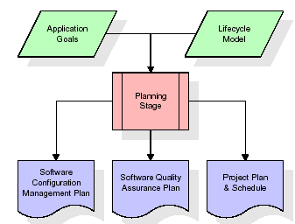
The most critical section of the project plan is a listing of high-level product requirements, also referred to as goals. All of the software product requirements to be developed during the requirements definition stage flow from one or more of these goals. The minimum information for each goal consists of a title and textual description, although additional information and references to external documents may be included. The outputs of the project planning stage are the configuration management plan, the quality assurance plan, and the project plan and schedule, with a detailed listing of scheduled activities for the upcoming Requirements stage, and high level estimates of effort for the out stages.
The design stage takes as its initial input the requirements identified in the approved requirements document. For each requirement, a set of one or more design elements will be produced as a result of interviews, workshops, and/or prototype efforts. Design elements describe the desired software features in detail, and generally include functional hierarchy diagrams, screen layout diagrams, tables of business rules, business process diagrams, pseudo code, and a complete entity-relationship diagram with a full data dictionary. These design elements are intended to describe the software in sufficient detail that skilled programmers may develop the software with minimal additional input.
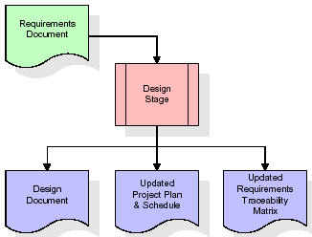
When the design document is finalized and accepted, the RTM is updated to show that each design element is formally associated with a specific requirement. The outputs of the design stage are the design document, an updated RTM, and an updated project plan.
The development stage takes as its primary input the design elements described in the approved design document. For each design element, a set of one or more software artifacts will be produced. Software artifacts include but are not limited to menus, dialogs, data management forms, data reporting formats, and specialized procedures and functions. Appropriate test cases will be developed for each set of functionally related software artifacts, and an online help system will be developed to guide users in their interactions with the software.
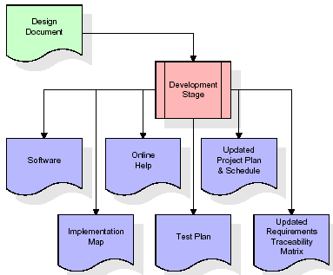

The RTM will be updated to show that each developed artifact is linked to a specific design element, and that each developed artifact has one or more corresponding test case items. At this point, the RTM is in its final configuration. The outputs of the development stage include a fully functional set of software that satisfies the requirements and design elements previously documented, an online help system that describes the operation of the software.
An implementation map that identifies the primary code entry points for all major system functions, a test plan that describes the test cases to be used to validate the correctness and completeness of the software, an updated RTM, and an updated project plan.

Integration & Test Stage
During the integration and test stage, the software artifacts, online help, and test data are migrated from the development environment to a separate test environment. At this point, all test cases are run to verify the correctness and completeness of the software. Successful execution of the test suite confirms a robust and complete migration capability. During this stage, reference data is finalized for production use and production users are identified and linked to their appropriate roles.
The final reference data (or links to reference data source files) and production user list are compiled into the Production Initiation Plan.
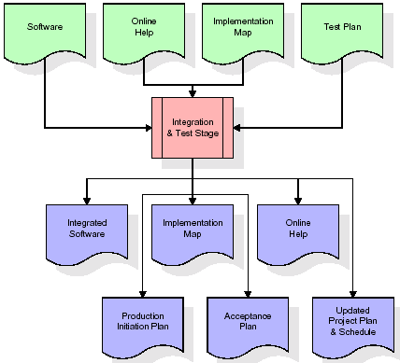
The outputs of the integration and test stage include an integrated set of software, an online help system, an implementation map, a production initiation plan that describes reference data and production users, an acceptance plan which contains the final suite of test cases, and an updated project plan.
Installation & Acceptance Test
During the installation and acceptance stage, the software artifacts, online help, and initial production data are loaded onto the production server. At this point, all test cases are run to verify the correctness and completeness of the software. Successful execution of the test suite is a prerequisite to acceptance of the software by the customer.
After customer personnel have verified that the initial production data load is correct and the test suite has been executed with satisfactory results, the customer formally accepts the delivery of the software.
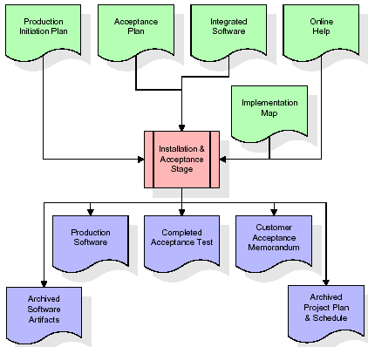
The primary outputs of the installation and acceptance stage include a production application, a completed acceptance test suite, and a memorandum of customer acceptance of the software. Finally, the PDR enters the last of the actual labor data into the project schedule and locks the project as a permanent project record. At this point the PDR "locks" the project by archiving all software items, the implementation map, the source code, and the documentation for future reference.
Maintenance
Outer rectangle represents maintenance of a project, Maintenance team will start with requirement study, understanding of documentation later employees will be assigned work and they will undergo training on that particular assigned category.

4.2 SYSTEM ARCHITECTURE
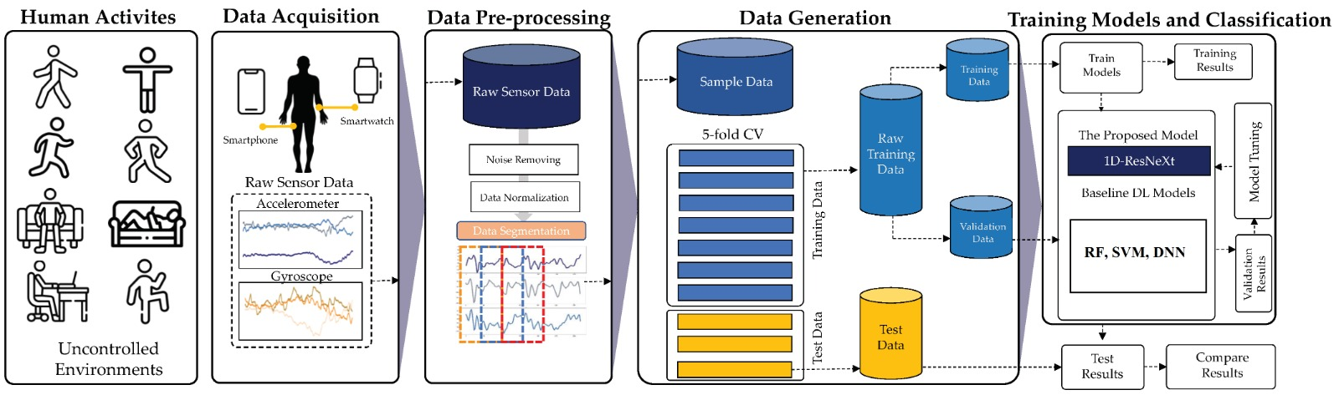
Fig. 4.1: System Overview
4.3 INPUT & OUTPOUT REPRESENTETION

Input design:
Input design includes data mediums used for inputting data and validations that are to be done during data entry. Different messages regarding data are given to guide users during data entry. Validation checks are done for each input.
Data entry screens are designed so that the system interacts with the user in providing an effective dialogue. Fields in the screen are logically arranged to help the user.
The design is the process of converting the user-originated inputs into a compute-based format. The goal of the input design is to make the data entry easier, logical and free from error. Errors in the input data are controlled by input design.
The application has been developed in a user-friendly manner. The windows have been designed in such a way that during the processing the cursor is placed in the position where the data must be entered. If any of the data going into the system is wrong then the process and output will magnify these errors.
The decisions made during design of input are:
- To achieve the highest possible level of accuracy.
- To provide a list of possible choices and help while accepting the input for an important field wherever possible outputs from computer system are required primarily to communicate the results of processing to the users. They are also used to provide a permanent copy of these results for later consultation/verification.

Output Design:
Output refers to the results and information that are generated by the system. Output is the main reason for developing the system and based on this, the usefulness and applicability of system are evaluated.
Outputs from computer systems are required primarily to communicate the results of processing to users. Efficiently designed outputs enhance the understandability of the information.
According to the requirements of the system, various types of outputs are considered and designed as follows.
Internal outputs, whose destination is within the organization and which require careful design because they are the user’s main interface with the computer.
Interactive outputs, in which the user communication with the Computer is essential.
4.4 UML DIAGRAMS
The overall logical structure of a database can be expressed graphically by an E-R diagram. The relative simplicity and pictorial clarity of this diagramming technique may well account in large part for the widespread use of the E-R model. Such a diagram consists of the following major components.
Rectangles:Represent Entity Sets.
Ellipses:Represent attributes.
Diamonds:Represent relationship sets
Lines:Link attributes to entity sets and entity sets
4.3.1 DATA FLOW DIAGRAM
A graphical tool used to describe and analyze the moment of data through a system manual or automated including the process, stores of data, and delays in the system.
Data Flow Diagrams are the central tool and the basis from which other components are developed. The transformation of data from input to output, through processes, may be described logically and independently of the physical components associated with the system. The DFD is also knowasa data flow graph or a bubble chart.
DFDs are the model of the proposed system. They clearly should show the requirements on which the new system should be built.
Later during design activity this is taken as the basis for drawing the system’s structure charts. The Basic Notation used to create a DFD’s are as follows:
1. Dataflow: Data move in a specific direction from an origin to a destination.

Process: People, procedures, or devices that use or produce (Transform) Data. The physical component is not identified.

- Source: External sources or destination of data, which may be People, programs,organizations or other entities.

4. Data Store: Here data are stored or referenced by a process in the System.

4.3.2 UML DIAGRAMS:
Unified Modeling Language is a language available to perform modeling of software. A model is simplification of reality. A model provides the blue print of the system, model encompasses detailed plans.
Building blocks of the UML
The vocabulary of the UML encompasses three kinds of building blocks.
- Things.
- Relationships.
- Diagrams.
Things in the UML
Things are the abstractions that are first-class citizen in a model.
There are four kinds of things in the UML.
- Structure things.
- Behavioral things.
- Grouping things.
- Annotational things.
These things are the basic object-oriented building blocks of the UML. You use them to write well-formed models.
Relationships in the UML
Thingscan be connected to logically are physically with the help of relationship in object oriented modeling.These are four kinds of relationships in the UML.
- Dependency.
- Association.
- Generalization.
- Realization.
Diagrams in the UML
A diagram is a graphical representation of a set of elements. These are nine kinds of diagrams in the UML.
- Class diagram. 6. Activity diagram.
- Object diagram 7. Component diagram.
- Usecase diagram. 8. State chart diagram.
- Sequence diagram. 9. Deployment diagram.
- Collaboration diagram

USECASE DIAGRAM
Use case diagram shows a set of usecases and actors (a special kind of class) and their relationship. Usecase diagrams address the static usecase view of a system.
These diagrams are especially important in organizing and modeling the behavioral of a system both sequence and collaboration diagrams are kind of interaction diagram.
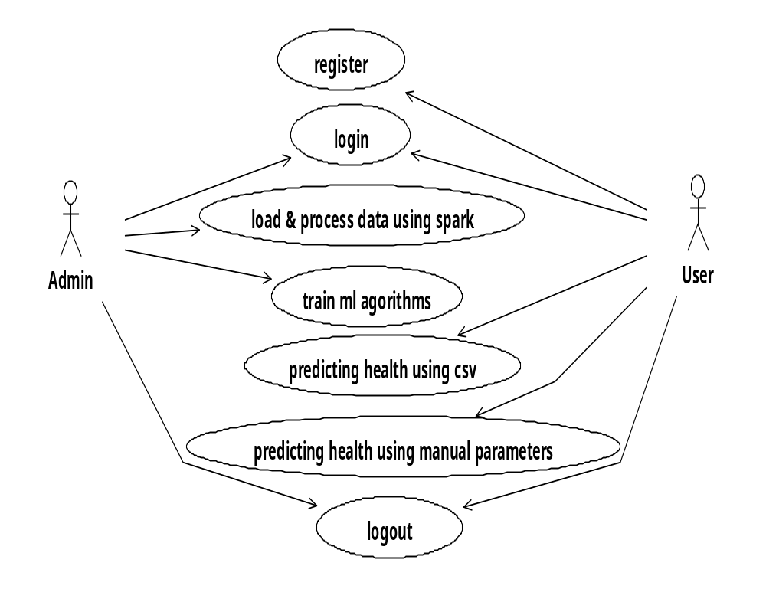
Fig. 4.2: Use-case Diagram

CLASS DIAGRAM:
Class diagrams area unit the foremost common diagrams employed in UML. Category diagram consists of categories, interfaces, associations and collaboration. Category diagrams primarily represent the thing directed read of a system that is static in nature. Active category is employed in a very category diagram to represent the concurrency of the system.
Class diagram represents the thing orientation of a system. Therefore it's usually used for development purpose. This can be the foremost wide used diagram at the time of system construction.

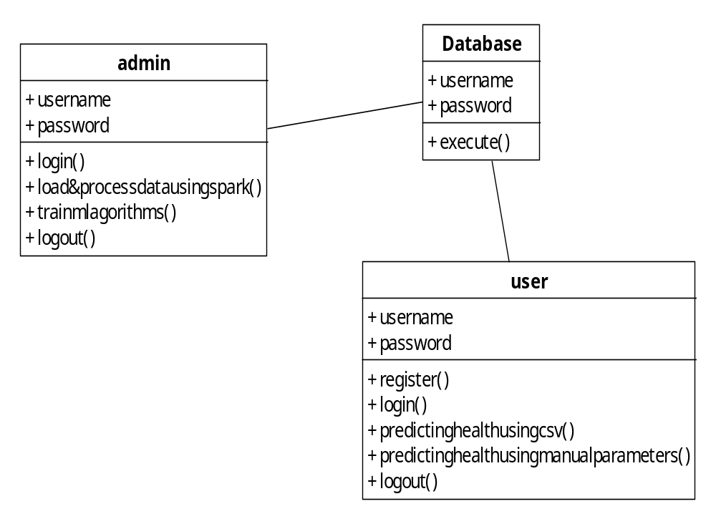
Fig. 4.3: Class Diagram

SEQUENCE DIAGRAM
A sequence diagram in Unified Modeling Language (UML) is a kind of interaction diagram that shows how processes operate with one another and in what order. It is a construct of a Message Sequence Chart. Sequence diagrams are sometimes called event diagrams, event scenarios, and timing diagrams.
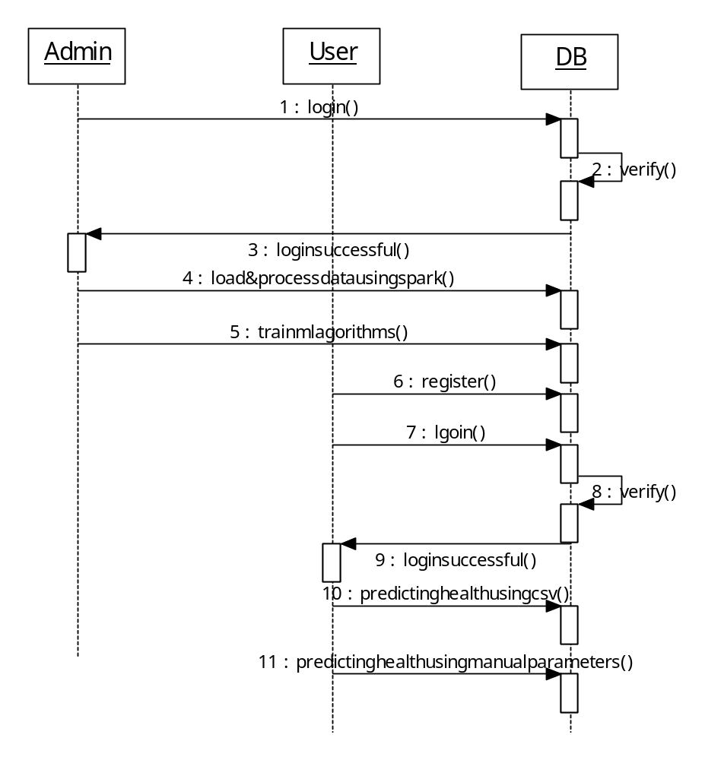
Fig. 4.4: Sequence Diagram

ACTIVITY DIAGRAM
Activity diagrams are graphical representations of workflows of stepwise activities and actions with support for choice, iteration and concurrency. In the Unified Modeling Language, activity diagrams can be used to describe the business and operational step-by-step workflows of components in a system. An activity diagram shows the overall flow of control

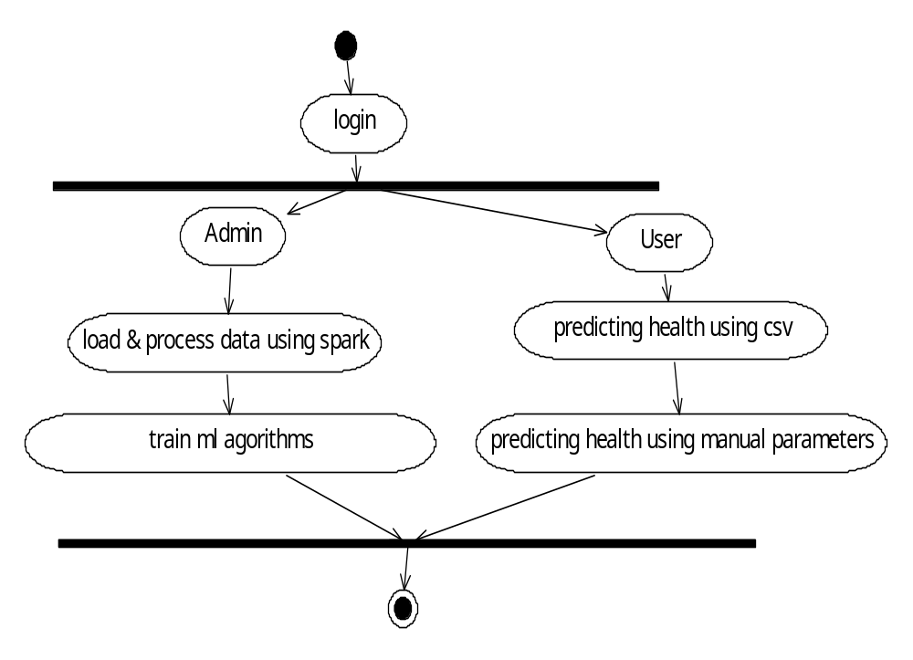
Fig. 4.5: Activity Diagram

4.4 MODULE DESCRIPTION:
Admin
- In this module admin can login with valid username and password after login successful can perform some operations: can load load and process the data and train ml algorithms.
User
- In this module user can register and login with valid username and password after login successful perform some operations are: can predicting health using csv and predicting health using manual parameters.
4.5 Algorithm
Random Forest:
- It generates multi decision trees from which each decision tree uses a part of data sample and predicts the result.
- Then the result which was achieved by maximum number of trees is considered as the final prediction.
- Random forest is a Supervised Learning algorithm which uses ensemble learning method for classification and regression.
Support Vector Machine:
- In machine learning, support-vector machines (SVMs, also support-vector networks) are supervised learning models with associated learning algorithms that analyze data for classification and regression analysis. An SVM training algorithm builds a model that assigns new examples to one category or the other, making it a non-probabilistic binary linear classifier.
Decision tree
- Trees are constructed through an algorithmic approach that identifies ways to split the data set based on different conditions.
- It is one of the most widely used practical methods for supervised learning.
- These are non-parametric method used for both classification and regression.

5. SYSTEM IMPLIMENTATION
5.1 INTRODUCTON
This mapping permits forward engineering: The generation of code from a UML model into a programming language. The reverse is also possible: You can reconstruct a model from an implementation back into the UML. Reverse engineering is not magic. Unless you encode that information in the implementation, information is lost when moving forward from models to code. Reverse engineering thus requires tool support with human intervention.
5.2 TECHNOLOGY DESCRIPTION
Introduction to Python
Python is an interpreted, high-level, general-purpose programming language. Created by Guido van Rossum and first released in 1991, Python's design philosophy emphasizes code readability with its notable use of significant whitespace. Its language constructs and object-oriented approach aim to help programmers write clear, logical code for small and large-scale projects. Python is dynamically typed and garbage-collected. It supports multiple programming paradigms, including structured (particularly, procedural), object-oriented, and functional programming. Python is often described as a "batteries included" language due to its comprehensive standard library. Python was conceived in the late 1980s as a successor to the ABC language. Python 2.0, released in 2000, introduced features like list comprehensions and a garbage collection system capable of collecting reference cycles. Python 3.0, released in 2008, was a major revision of the language that is not completely backward-compatible, and much Python 2 code does not run unmodified on Python 3. The Python 2 language, i.e. Python 2.7.x, was officially discontinued on 1 January 2020 (first planned for 2015) after which security patches and other improvements will not be released for it.[32][33] With Python 2's end-of-life, only Python 3.5.x and later are supported. Python interpreters are available for many operating systems. A global community of programmers develops and maintains CPython, an open source[35] reference implementation. A non-profit organization, the Python Software Foundation, manages and directs resources for Python and CPython development.
SYNTAX AND SEMANTICS
Python is meant to be an easily readable language. Its formatting is visually uncluttered, and it often uses English keywords where other languages use punctuation.
Unlike many other languages, it does not use curly brackets to delimit blocks, and semicolons after statements are optional. It has fewer syntactic exceptions and special cases than C or Pascal.
Indentation
Main article: Python syntax and semantics § Indentation
Python uses whitespace indentation, rather than curly brackets or keywords, to delimit blocks. An increase in indentation comes after certain statements; a decrease in indentation signifies the end of the current block. Thus, the program's visual structure accurately represents the program's semantic structure. This feature is sometimes termed the off-side rule, which some other languages share, but in most languages indentation doesn't have any semantic meaning.
Statements and control flow
Python's statements include (among others):
The assignment statement (token '=', the equals sign). This operates differently than in traditional imperative programming languages, and this fundamental mechanism (including the nature of Python's version of variables) illuminates many other features of the language. Assignment in C, e.g., x = 2, translates to "typed variable name x receives a copy of numeric value 2". The (right-hand) value is copied into an allocated storage location for which the (left-hand) variable name is the symbolic address. The memory allocated to the variable is large enough (potentially quite large) for the declared type. In the simplest case of Python assignment, using the same example, x = 2, translates to "(generic) name x receives a reference to a separate, dynamically allocated object of numeric (int) type of value 2." This is termed binding the name to the object. Since the name's storage location doesn't contain the indicated value, it is improper to call it a variable.
Names may be subsequently rebound at any time to objects of greatly varying types, including strings, procedures, complex objects with data and methods, etc. Successive assignments of a common value to multiple names, e.g., x = 2; y = 2; z = 2 result in allocating storage to (at most) three names and one numeric object, to which all three names are bound.
Since a name is a generic reference holder it is unreasonable to associate a fixed data type with it. However at a given time a name will be bound to some object, which will have a type; thus there is dynamic typing.
- The if statement, which conditionally executes a block of code, along with else and elif (a contraction of else-if).
- The for statement, which iterates over an iterable object, capturing each element to a local variable for use by the attached block.
- The while statement, which executes a block of code as long as its condition is true.
- The try statement, which allows exceptions raised in its attached code block to be caught and handled by except clauses; it also ensures that clean-up code in a finally block will always be run regardless of how the block exits.
- The raise statement, used to raise a specified exception or re-raise a caught exception.
- The class statement, which executes a block of code and attaches its local namespace to a class, for use in object-oriented programming.
- The def statement, which defines a function or method.
- The with statement, from Python 2.5 released in September 2006, which encloses a code block within a context manager (for example, acquiring a lock before the block of code is run and releasing the lock afterwards, or opening a file and then closing it), allowing Resource Acquisition Is Initialization (RAII)-like behavior and replaces a common try/finally idiom.
- The break statement, exits from the loop.
- The continue statement, skips this iteration and continues with the next item.
- The pass statement, which serves as a NOP. It is syntactically needed to create an empty code block.
- The assert statement, used during debugging to check for conditions that ought to apply.
- The yield statement, which returns a value from a generator function. From Python 2.5, yield is also an operator. This form is used to implement coroutines.
The import statement, which is used to import modules whose functions or variables can be used in the current program. There are three ways of using import: import <module name> [as <alias>] or from <module name> import * or from <module name> import <definition 1> [as <alias 1>], <definition 2> [as <alias 2>],
The print statement was changed to the print() function in Python 3.
Python does not support tail call optimization or first-class continuations, and, according to Guido van Rossum, it never will. However, better support for coroutine-like functionality is provided in 2.5, by extending Python's generators. Before 2.5, generators were lazy iterators; information was passed unidirectionally out of the generator. From Python 2.5, it is possible to pass information back into a generator function, and from Python 3.3, the information can be passed through multiple stack levels.
EXPRESSIONS
Some Python expressions are similar to languages such as C and Java, while some are not:
Addition, subtraction, and multiplication are the same, but the behavior of division differs. There are two types of divisions in Python. They are floor division (or integer division) // and floating point/division. Python also added the ** operator for exponentiation.
From Python 3.5, the new @ infix operator was introduced. It is intended to be used by libraries such as NumPy for matrix multiplication.
From Python 3.8, the syntax :=, called the 'walrus operator' was introduced. It assigns values to variables as part of a larger expression.
In Python, == compares by value, versus Java, which compares numerics by valueand objects by reference. (Value comparisons in Java on objects can be performed with the equals() method.) Python's is operator may be used to compare object identities (comparison by reference). In Python, comparisons may be chained, for example a <= b <= c.
Python uses the words and, or, not for its boolean operators rather than the symbolic &&, ||, !used in Java and C.
Python has a type of expression termed a list comprehension. Python 2.4 extended list comprehensions into a more general expression termed a generator expression.
Anonymous functions are implemented using lambda expressions; however, these are limited in that the body can only be one expression.
Conditional expressions in Python are written as x if c else y (different in order of operands from the c ? x : y operator common to many other languages).
Python makes a distinction between lists and tuples. Lists are written as [1, 2, 3], are mutable, and cannot be used as the keys of dictionaries (dictionary keys must be immutable in Python). Tuples are written as (1, 2, 3), are immutable and thus can be used as the keys of dictionaries, provided all elements of the tuple are immutable. The + operator can be used to concatenate two tuples, which does not directly modify their contents, but rather produces a new tuple containing the elements of both provided tuples. Thus, given the variable t initially equal to (1, 2, 3), executing t = t + (4, 5) first evaluates t + (4, 5), which yields (1, 2, 3, 4, 5), which is then assigned back to t, thereby effectively "modifying the contents" of t, while conforming to the immutable nature of tuple objects. Parentheses are optional for tuples in unambiguous contexts.
Python features sequence unpacking wherein multiple expressions, each evaluating to anything that can be assigned to (a variable, a writable property, etc.), are associated in the identical manner to that forming tuple literals and, as a whole, are put on the left hand side of the equal sign in an assignment statement.
The statement expects an iterable object on the right hand side of the equal sign that produces the same number of values as the provided writable expressions when iterated through, and will iterate through it, assigning each of the produced values to the corresponding expression on the left.
Python has a "string format" operator %. This functions analogous to printf format strings in C, e.g. "spam=%s eggs=%d" % ("blah", 2) evaluates to "spam=blah eggs=2".
In Python 3 and 2.6+, this was supplemented by the format() method of the str class, e.g. "spam={0} eggs={1}".format("blah", 2). Python 3.6 added "f-strings": blah = "blah"; eggs = 2; f'spam={blah} eggs={eggs}'.
Python has various kinds of string literals:
Strings delimited by single or double quote marks. Unlike in Unix shells, Perl and Perl-influenced languages, single quote marks and double quote marks function identically. Both kinds of string use the backslash (\) as an escape character. String interpolation became available in Python 3.6 as "formatted string literals".
Triple-quoted strings, which begin and end with a series of three single or double quote marks. They may span multiple lines and function like here documents in shells, Perl and Ruby.
Raw string varieties, denoted by prefixing the string literal with an r. Escape sequences are not interpreted; hence raw strings are useful where literal backslashes are common, such as regular expressions and Windows-style paths. Compare "@-quoting" in C#.
Python has array index and array slicing expressions on lists, denoted as a[key], a[start:stop] or a[start:stop:step]. Indexes are zero-based, and negative indexes are relative to the end. Slices take elements from the start index up to, but not including, the stop index. The third slice parameter, called step or stride, allows elements to be skipped and reversed. Slice indexes may be omitted, for example a[:] returns a copy of the entire list. Each element of a slice is a shallow copy.
In Python, a distinction between expressions and statements is rigidly enforced, in contrast to languages such as Common Lisp, Scheme, or Ruby. This leads to duplicating some functionality. For example:
List comprehensions vs. for-loops
Conditional expressions vs. if blocks
The eval() vs. exec() built-in functions (in Python 2, exec is a statement); the former is for expressions, the latter is for statements.
Statements cannot be a part of an expression, so list and other comprehensions or lambda expressions, all being expressions, cannot contain statements. A particular case of this is that an assignment statement such as a = 1 cannot form part of the conditional expression of a conditional statement. This has the advantage of avoiding a classic C error of mistaking an assignment operator = for an equality operator == in conditions: if (c = 1) { ... } is syntactically valid (but probably unintended) C code but if c = 1: ... causes a syntax error in Python.
METHODS
Methods on objects are functions attached to the object's class; the syntax instance. method(argument) is, for normal methods and functions, syntactic sugar for Class. method(instance, argument). Python methods have an explicit self parameter to access instance data, in contrast to the implicit self (or this) in some other object-oriented programming languages (e.g., C++, Java, Objective-C, or Ruby).
APPLICATIONS OF PYTHON
As mentioned before, Python is one of the most widely used language over the web. I'm going to list few of them here:
Easy-to-learn − Python has few keywords, simple structure, and a clearly defined syntax. This allows the student to pick up the language quickly.
Easy-to-read − Python code is more clearly defined and visible to the eyes.
Easy-to-maintain − Python's source code is fairly easy-to-maintain.
A broad standard library − Python's bulk of the library is very portable and cross-platform compatible on UNIX, Windows, and Macintosh.
Interactive Mode − Python has support for an interactive mode which allows interactive testing and debugging of snippets of code.
Portable − Python can run on a wide variety of hardware platforms and has the same interface on all platforms.
Extendable − You can add low-level modules to the Python interpreter. These modules enable programmers to add to or customize their tools to be more efficient.
Databases − Python provides interfaces to all major commercial databases.
GUI Programming − Python supports GUI applications that can be created and ported to many system calls, libraries and windows systems, such as Windows MFC, Macintosh, and the X Window system of Unix.
Scalable − Python provides a better structure and support for large programs than shell scripting.
INSTALLATION STEPS OF PYTHON
Installing and using Python on Windows 10 is very simple. The installation procedure involves just three steps:
- Download the binaries
- Run the Executable installer
- Add Python to PATH environmental variables
To install Python, you need to download the official Python executable installer. Next, you need to run this installer and complete the installation steps. Finally, you can configure the PATH variable to use python from the command line.
Step 1: Download the Python Installer binaries
- Open the official Python website in your web browser. Navigate to the Downloads tab for Windows.
- Choose the latest Python 3 release. In our example, we choose the latest Python 3.7.3 version. Click on the link to download Windows x86 executable installer if you are using a 32-bit installer.
- In case your Windows installation is a 64-bit system, then download Windows x86-64 executable installer.
Step 2: Run the Executable Installer
- Once the installer is downloaded, run the Python installer.
- Check the Install launcher for all users check box. Further, you may check the Add Python 3.7 to path check box to include the interpreter in the execution path.
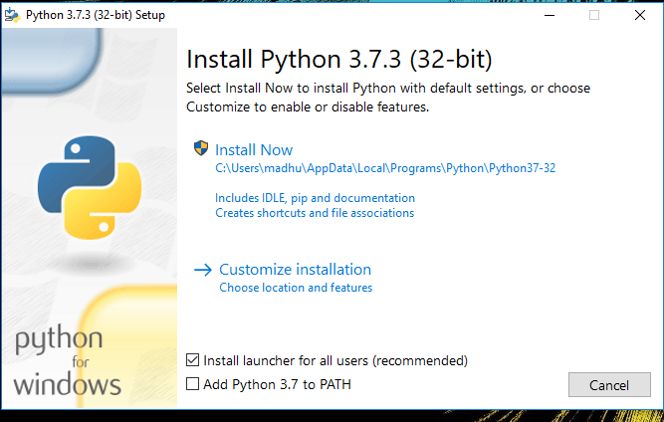
- Select Customize installation.
Choose the optional features by checking the following check boxes:
- Documentation
- pip
- tcl/tk and IDLE (to install tkinter and IDLE)
- Python test suite (to install the standard library test suite of Python)
- Install the global launcher for `.py` files. This makes it easier to start Python
- Install for all users.
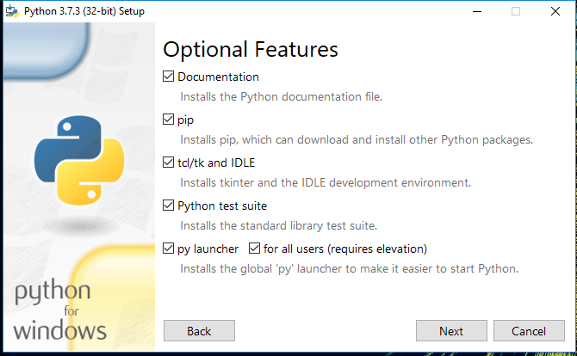
Click Next.
- This takes you to Advanced Options available while installing Python. Here, select the Install for all users and Add Python to environment variables check boxes.
Optionally, you can select the Associate files with Python, Create shortcuts for installed applications and other advanced options. Make note of the python installation directory displayed in this step. You would need it for the next step.
After selecting the Advanced options, click Install to start installation.
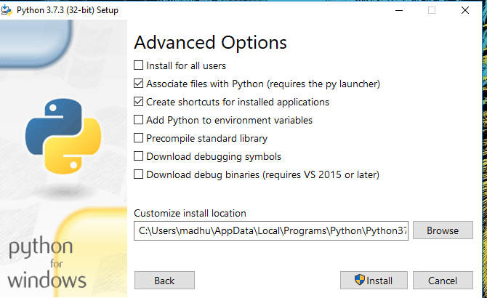

- Once the installation is over, you will see a Python Setup Successful window.
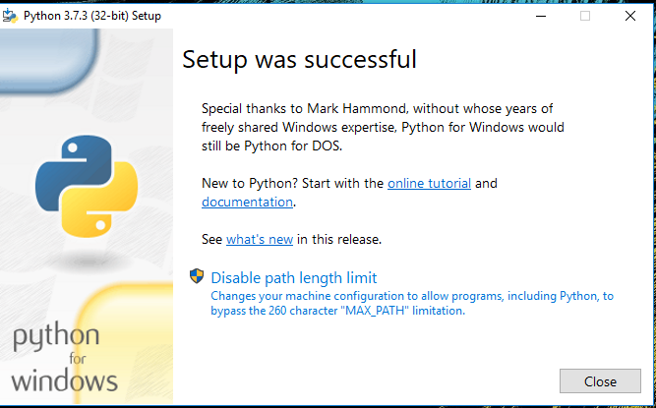
Step 3: Add Python to environmental variables
The last (optional) step in the installation process is to add Python Path to the System Environment variables. This step is done to access Python through the command line. In case you have added Python to environment variables while setting the Advanced options during the installation procedure, you can avoid this step. Else, this step is done manually as follows.
In the Start menu, search for “advanced system settings”. Select “View advanced system settings”. In the “System Properties” window, click on the “Advanced” tab and then click on the “Environment Variables” button.
Locate the Python installation directory on your system. If you followed the steps exactly as above, python will be installed in below locations:
- C:\Program Files (x86)\Python37-32: for 32-bit installation
- C:\Program Files\Python37-32: for 64-bit installation
The folder name may be different from “Python37-32” if you installed a different version. Look for a folder whose name starts with Python.
Append the following entries to PATH variable as shown below:
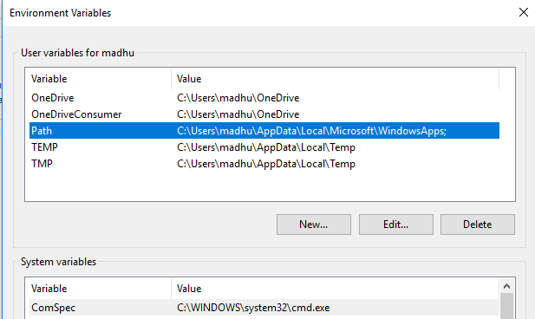
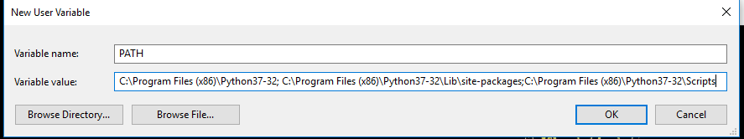
Step 4: Verify the Python Installation
You have now successfully installed Python 3.7.3 on Windows 10. You can verify if the Python installation is successful either through the command line or through the IDLE app that gets installed along with the installation. Search for the command prompt and type “python”. You can see that Python 3.7.3 is successfully installed.
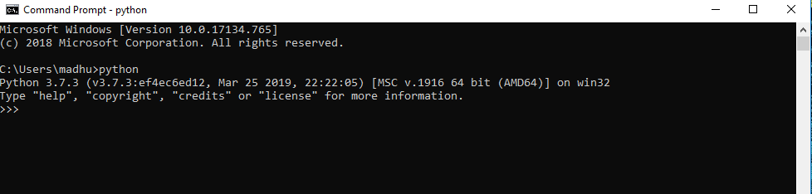
An alternate way to reach python is to search for “Python” in the start menu and clicking on IDLE (Python 3.7 64-bit). You can start coding in Python using the Integrated Development Environment(IDLE).
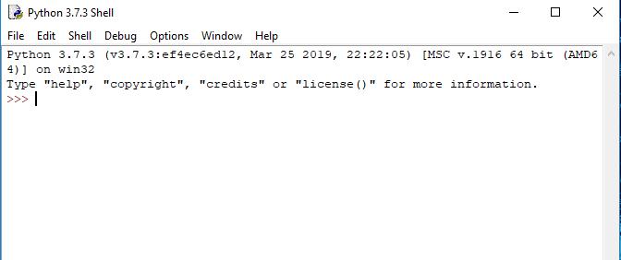
Uses
Since 2003, Python has consistently ranked in the top ten most popular programming languages in the TIOBE Programming Community Index where, as of February 2020, it is the third most popular language (behind Java, and C). It was selected Programming Language of the Year in 2007, 2010, and 2018.
- An empirical study found that scripting languages, such as Python, are more productive than conventional languages, such as C and Java, for programming problems involving string manipulation and search in a dictionary, and determined that memory consumption was often "better than Java and not much worse than C or C++".
- Large organizations that use Python include Wikipedia, Google, Yahoo!, CERN, NASA, Facebook, Amazon, Instagram, Spotify and some smaller entities like ILM and ITA. The social news networking site Reddit is written entirely in Python.
- Python can serve as a scripting language for web applications, e.g., via mod_wsgi for the Apache web server. With Web Server Gateway Interface, a standard API has evolved to facilitate these applications. Web frameworks like Django, Pylons, Pyramid, TurboGears, web2py, Tornado, Flask, Bottle and Zope support developers in the design and maintenance of complex applications. Pyjs and IronPython can be used to develop the client-side of Ajax-based applications.
- SQLAlchemy can be used as data mapper to a relational database. Twisted is a framework to program communications between computers, and is used (for example) by Dropbox.
- Libraries such as NumPy, SciPy and Matplotlib allow the effective use of Python in scientific computing, with specialized libraries such as Biopython and Astropy providing domain-specific functionality. SageMath is a mathematical software with a notebook interface programmable in Python: its library covers many aspects of mathematics, including algebra, combinatorics, numerical mathematics, number theory, and calculus.
- Python has been successfully embedded in many software products as a scripting language, including in finite element method software such as Abaqus, 3D parametric modeler like FreeCAD, 3D animation packages such as 3ds Max, Blender, Cinema 4D, Lightwave, Houdini, Maya, modo, MotionBuilder, Softimage, the visual effects compositor Nuke, 2D imaging programs like GIMP, Inkscape, Scribus and Paint Shop Pro, and musical notation programs like scorewriter and capella. GNU Debugger uses Python as a pretty printer to show complex structures such as C++ containers. Esri promotes Python as the best choice for writing scripts in ArcGIS. It has also been used in several video games, and has been adopted as first of the three available programming languages in Google App Engine, the other two being Java and Go.
- Python is commonly used in artificial intelligence projects with the help of libraries like TensorFlow, Keras, Pytorch and Scikit-learn. As a scripting language with modular architecture, simple syntax and rich text processing tools, Python is often used for natural language processing.
- Many operating systems include Python as a standard component. It ships with most Linux distributions, AmigaOS 4, FreeBSD (as a package), NetBSD, OpenBSD (as a package) and macOS and can be used from the command line (terminal). Many Linux distributions use installers written in Python: Ubuntu uses the Ubiquity installer, while Red Hat Linux and Fedora use the Anaconda installer. Gentoo Linux uses Python in its package management system, Portage.
- Python is used extensively in the information security industry, including in exploit development.
- Most of the Sugar software for the One Laptop per Child XO, now developed at Sugar Labs, is written in Python. The Raspberry Pi single-board computer project has adopted Python as its main user-programming language.
- Due to Python's user-friendly conventions and easy-to-understand language, it is commonly used as an intro language into computing sciences with students. This allows students to easily learn computing theories and concepts and then apply them to other programming languages.
- LibreOffice includes Python, and intends to replace Java with Python. Its Python Scripting Provider is a core feature[169] since Version 4.0 from 7 February 2013.
- Python is a general-purpose, popular programming language, and it is used in almost every technical field. The various areas of Python use are given below.
- Data Science: Data Science is a vast field, and Python is an important language for this field because of its simplicity, ease of use, and availability of powerful data analysis and visualization libraries like NumPy, Pandas, and Matplotlib.
- Desktop Applications: PyQt and Tkinter are useful libraries that can be used in GUI - Graphical User Interface-based Desktop Applications. There are better languages for this field, but it can be used with other languages for making Applications.
- Console-based Applications: Python is also commonly used to create command-line or console-based applications because of its ease of use and support for advanced features such as input/output redirection and piping.
- Mobile Applications: While Python is not commonly used for creating mobile applications, it can still be combined with frameworks like Kivy or BeeWare to create cross-platform mobile applications.
- Software Development: Python is considered one of the best software-making languages. Python is easily compatible with both from Small Scale to Large Scale software.
- Artificial Intelligence: AI is an emerging Technology, and Python is a perfect language for artificial intelligence and machine learning because of the availability of powerful libraries such as TensorFlow, Keras, and PyTorch.
- Web Applications: Python is commonly used in web development on the backend with frameworks like Django and Flask and on the front end with tools like JavaScript HTML and CSS.
- Enterprise Applications: Python can be used to develop large-scale enterprise applications with features such as distributed computing, networking, and parallel processing.
- 3D CAD Applications: Python can be used for 3D computer-aided design (CAD) applications through libraries such as Blender.
- Machine Learning: Python is widely used for machine learning due to its simplicity, ease of use, and availability of powerful machine learning libraries.
- Computer Vision or Image Processing Applications: Python can be used for computer vision and image processing applications through powerful libraries such as OpenCV and Scikit-image.
- Speech Recognition: Python can be used for speech recognition applications through libraries such as SpeechRecognition and PyAudio.
- Scientific computing: Libraries like NumPy, SciPy, and Pandas provide advanced numerical computing capabilities for tasks like data analysis, machine learning, and more.
- Education: Python's easy-to-learn syntax and availability of many resources make it an ideal language for teaching programming to beginners.
- Testing: Python is used for writing automated tests, providing frameworks like unit tests and pytest that help write test cases and generate reports.
- Gaming: Python has libraries like Pygame, which provide a platform for developing games using Python.
- IoT: Python is used in IoT for developing scripts and applications for devices like Raspberry Pi, Arduino, and others.
- Networking: Python is used in networking for developing scripts and applications for network automation, monitoring, and management.
- DevOps: Python is widely used in DevOps for automation and scripting of infrastructure management, configuration management, and deployment processes.
- Finance: Python has libraries like Pandas, Scikit-learn, and Statsmodels for financial modeling and analysis.
- Audio and Music: Python has libraries like Pyaudio, which is used for audio processing, synthesis, and analysis, and Music21, which is used for music analysis and generation.
- Writing scripts: Python is used for writing utility scripts to automate tasks like file operations, web scraping, and data processing.Python has wide range of libraries and frameworks widely used in various fields such as machine learning, artificial intelligence, web applications, etc. We define some popular frameworks and libraries of Python as follows.
- Web development (Server-side) - Django Flask, Pyramid, CherryPy
- GUIs based applications - Tkinter, PyGTK, PyQt, PyJs, etc.
- Machine Learning - TensorFlow, PyTorch, Scikit-learn, Matplotlib, Scipy, etc.
- Mathematics - NumPy, Pandas, etc.
- BeautifulSoup: a library for web scraping and parsing HTML and XML
- Requests: a library for making HTTP requests
- SQLAlchemy: a library for working with SQL databases
- Kivy: a framework for building multi-touch applications
- Pygame: a library for game development
- Pytest: a testing framework for Python Django
- REST framework: a toolkit for building RESTful APIs
- FastAPI: a modern, fast web framework for building APIs
- Streamlit: a library for building interactive web apps for machine learning and data science
- NLTK: a library for natural language processing
Python Functions
- Lambda Function - A lambda function is a small, anonymous function that can take any number of arguments but can only have one expression. Lambda functions are often used in functional programming to create functions "on the fly" without defining a named function.
- Recursive Function - A recursive function is a function that calls itself to solve a problem. Recursive functions are often used in functional programming to perform complex computations or to traverse complex data structures.
- Map Function - The map() function applies a given function to each item of an iterable and returns a new iterable with the results. The input iterable can be a list, tuple, or other.
- Filter Function - The filter() function returns an iterator from an iterable for which the function passed as the first argument returns True. It filters out the items from an iterable that do not meet the given condition.
- Reduce Function - The reduce() function applies a function of two arguments cumulatively to the items of an iterable from left to right to reduce it to a single value.
- functools Module - The functools module in Python provides higher-order functions that operate on other functions, such as partial() and reduce().
- Currying Function - A currying function is a function that takes multiple arguments and returns a sequence of functions that each take a single argument.
- Memoization Function - Memoization is a technique used in functional programming to cache the results of expensive function calls and return the cached Result when the same inputs occur again.
- Threading Function - Threading is a technique used in functional programming to run multiple tasks simultaneously to make the code more efficient and faster.
Python Modules
- Math: Gives users access to mathematical constants and pi and trigonometric functions.
- Datetime: Provides classes for a simpler way of manipulating dates, times, and periods.
- OS: Enables interaction with the base operating system, including administration of processes and file system activities.
- Random: The random function offers tools for generating random integers and picking random items from a list.
- JSON: JSON is a data structure that can be encoded and decoded and is frequently used in online APIs and data exchange. This module allows dealing with JSON.
- Re: Supports regular expressions, a potent text-search and text-manipulation tool.
- Collections: Provides alternative data structures such as sorted dictionaries, default dictionaries, and named tuples.
- NumPy: NumPy is a core toolkit for scientific computing that supports numerical operations on arrays and matrices.
- Pandas: It provides high-level data structures and operations for dealing with time series and other structured data types.
- Requests: Offers a simple user interface for web APIs and performs HTTP requests.
Python File I/O
- Files are used to store data in a computer disk. In this tutorial, we explain the built-in file object of Python. We can open a file using Python script and perform various operations such as writing, reading, and appending. There are various ways of opening a file. We are explained with the relevant example. We will also learn to perform read/write operations on binary files.
- Python's file input/output (I/O) system offers programs to communicate with files stored on a disc. Python's built-in methods for the file object let us carry out actions like reading, writing, and adding data to files.
- The open() method in Python makes a file object when working with files. The name of the file to be opened and the mode in which the file is to be opened are the two parameters required by this function. The mode can be used according to work that needs to be done with the file, such as "r" for reading, "w" for writing, or "a" for attaching.
- After successfully creating an object, different methods can be used according to our work. If we want to write in the file, we can use the write() functions, and if you want to read and write both, then we can use the append() function and, in cases where we only want to read the content of the file we can use read() function. Binary files containing data in a binary rather than a text format may also be worked with using Python. Binary files are written in a manner that humans cannot directly understand. The rb and wb modes can read and write binary data in binary files.

- SYSTEM TESTING
6.1 INTRODUCTION
Software Testing is a critical element of software quality assurance and represents the ultimate review of specification, design and coding, Testing presents an interesting anomaly for the software engineer
Testing Objectives include:
- Testing is a process of executing a program with the intent of finding an error
- A good test case is one that has a probability of finding an as yet undiscovered error
- A successful test is one that uncovers an undiscovered error
Testing Principles:
- All tests should be traceable to end user requirements
- Tests should be planned long before testing begins
- Testing should begin on a small scale and progress towards testing in large
- Exhaustive testing is not possible
- To be most effective testing should be conducted by a independent third party
6.2 Testing Strategies
A Strategy for software testing integrates software test cases into a series of well planned steps that result in the successful construction of software. Software testing is a broader topic for what is referred to as Verification and Validation. Verification refers to the set of activities that ensure that the software correctly implements a specific function Validation refers he set of activities that ensure that the software that has been built is traceable to customer’s requirements.
Unit Testing:
Unit testing focuses verification effort on the smallest unit of software design that is the module. Using procedural design description as a guide, important control paths are tested to uncover errors within the boundaries of the module. The unit test is normally white box testing oriented and the step can be conducted in parallel for multiple modules.
Integration Testing:
Integration testing is a systematic technique for constructing the program structure while conducting test to uncover errors associated with the interfacing. The objective is to take unit tested methods and build a program structure that has been dictated by design.
Top-down Integration:
Top down integrations an incremental approach to construction of program structure. Modules are integrated by moving downward through the control hierarchy, beginning with the main control program. Modules subordinate to the main program are incorporated in the structure either in the breath-first or depth-first manner.
Bottom-up Integration:
This method as the name suggests, begins construction and testing with atomic modules i.e., modules at the lowest leveling the program structure. Because the modules are integrated in the bottom up manner the processing required for the modules subordinate to a given level is always available and the need for stubs is eliminated.
Validation Testing:
At the end of integration testing software ids completely assembled as a package. Validation testing is the next stage which can be defined as successful when the software functions in the manner reasonably expected by the customer. Reasonable expectations are those defined in the software requirements specifications. Information contained in those sections form a basis for validation testing approach.
System Testing:
System testing is actually a series of different tests whose primary purpose is to fully exercise the computer-based system. Although each test has a different purpose, all work to verify that all system elements have been properly integrated to perform allocated function.
TC. No | Test Case | Input | Expected Output | Observed Output | Result
1 | Login | Enter Wrong User Name and Password | Invalid Login Details | User name and Password are invalid | Pass
2 | Login | Enter User Name and Password | Login Successful | Login Successful | Pass
3 | Mobile Number | Enter Alphanumeric characters | Mobile number must be digits only | Mobile number in 10 digits only | Fail
4 | Upload file | Browse file | file uploaded successfully | file Uploaded successful | Pass
6.3 TEST CASES

- EXPERIMENTAL RESULTS

- APPENDIX

- CONCLUSION AND FUTURE SCOPE
9.1 CONCLUSION
IoT and smart city paradigms have moved beyond their infancy, making HAR more relevant in the fast-evolving landscape. As discussed in this work, HAR has various critical applications in IoT, including health monitoring, elderly and infant care, fitness tracking, and security. ML and DL-based methods are at the forefront of solving problems related to HAR. However, significant challenges include the inability to evolve network architectures dynamically, diffi culty searching potential solution spaces, the computationally expensive process of hyperparameter tuning, and the need for algorithm experts to configure parameters. NeuroHAR is proposed in this work to address the HAR problem. The highlights of NeuroHAR include finding optimal parameters while minimizing computation. It is flexible and does not require expert knowledge for parameter tuning. To validate the performance of Neuro HAR, recently released and popular HARTHandHAR70plusdatasets have been merged to make datasets more challenging, which is another highlight of the work. In NeuroHAR, MLP performs the deep learning task, which involves understanding and classifying complex human activity patterns. MLP is accurate and can be used in real-time tasks such as HAR.
9.2 FUTURE ENHANCEMENT
In future, the proposed NeuroHAR-based Human Activity Recognition system can be further improved by incorporating several advanced features and technologies. The system can be extended to support real-time activity monitoring using live data from wearable sensors and smart devices. It can also be integrated with mobile applications to provide users and healthcare professionals with easy access to activity reports, alerts, and health monitoring information.
Further improvements can include the use of advanced deep learning models such as Convolutional Neural Networks (CNN) and Long Short-Term Memory (LSTM) networks to enhance the accuracy and efficiency of activity recognition. The system can also be connected with cloud-based platforms to store and process large volumes of sensor data for large-scale health monitoring.
10. REFERENCES
[1] Bzai, F. Alam, A. Dhafer, M. Bojović, S. M. Altowaijri, I. K. Niazi, and R. Mehmood, ‘‘Machine learning-enabled Internet of Things (IoT): Data, applications, and industry perspective,’’ Electronics, vol. 11, no. 17, p. 2676, Aug. 2022.
[2] F. Alam, R. Mehmood, I. Katib, N. N. Albogami, and A. Albeshri, ‘‘Data fusion and IoT for smart ubiquitous environments: A survey,’’ IEEE Access, vol. 5, pp. 9533–9554, 2017, doi: 10.1109/ACCESS.2017. 2697839.
[3] F. Fereidoonian, F. Firouzi, and B. Farahani, ‘‘Human activity recognition: From sensors to applications,’’ in Proc. Int. Conf. Omni-Layer Intell. Syst. (COINS), Aug. 2020, pp. 1–8, doi: 10.1109/COINS49042.2020. 9191417.
[4] L. Yang and A. Shami, ‘‘On hyperparameter optimization of machine learning algorithms: Theory and practice,’’ Neurocomputing, vol. 415, pp. 295–316, Nov. 2020, doi: 10.1016/j.neucom.2020.07.061.
[5] N. C. Thompson, K. Greenewald, K. Lee, and G. F. Manso, 2021, ‘‘Deep learning’s diminishing returns,’’ IEEE Spectrum. [Online]. Available: https://spectrum.ieee.org/deep-learning-computational-cost
[6] R. Hossain and D. Timmer, ‘‘Machine learning model optimization with hyper parameter tuning approach,’’ Global J. Comput. Sci. Technol., vol. 21, no. 2, p. 31, 2021.
[7] M. G. Morshed, T. Sultana, A. Alam, and Y.-K. Lee, ‘‘Human action recognition: A taxonomy-based survey, updates, and opportunities,’’ Sensors, vol. 23, no. 4, p. 2182, Feb. 2023, doi: 10.3390/s23042182.
[8] F. Alam, A. Almaghthawi, I. Katib, A. Albeshri, and R. Mehmood, ‘‘IResponse: An AI and IoT-enabled framework for autonomous COVID 19 pandemic management,’’ Sustainability, vol. 13, no. 7, p. 3797, Mar. 2021, doi: 10.3390/su13073797.
[9] R. Mehmood, F. Alam, N. N. Albogami, I. Katib, A. Albeshri, and S. M. Altowaijri, ‘‘UTiLearn: A personalised ubiquitous teaching and learning system for smart societies,’’ IEEE Access, vol. 5, pp. 2615–2635, 2017, doi: 10.1109/ACCESS.2017.2668840.
[10] A. Ganesan, A. Paul, and H. Seo, ‘‘Elderly people activity recognition in smart grid monitoring environment,’’ Math. Problems Eng., vol. 2022, pp. 1–12, Mar. 2022, doi: 10.1155/2022/9540033.
[11] R. K. Pearson, ‘‘Child activity recognition using accelerometer and RFID reader,’’ Int. J. Res. Eng. Sci., vol. 2, no. 6, pp. 14–21,2005.[Online].Available: https://www.academia.edu/10135403/Child_Activity_Recognition_Using_Accelerometer_and_RFID_Reader
[12] Z. Hussain, M. Sheng, and W. E. Zhang, ‘‘Different approaches for human activity recognition: A survey,’’ 2019, arXiv:1906.05074.
[13] A. Logacjov, K. Bach, A. Kongsvold, H. B. Bårdstu, and P. J. Mork, ‘‘HARTH: A human activity recognition dataset for machine learning,’’ Sensors, vol. 21, no. 23, p. 7853, Nov. 2021, doi: 10.3390/s21237853.
[14] W. A. Kusuma, A. E. Minarno, and N. D. N. Safitri, ‘‘Human activity recognition utilizing SVM algorithm with gridsearch,’’ in Proc. AIP Conf., 2022, Art. no. 030002, doi: 10.1063/5.0096708.
[15] H.Qian,Y.Mao,W.Xiang, and Z.Wang,‘‘Recognition of human activities using SVM multi-class classifier,’’ Pattern Recognit. Lett., vol. 31, no. 2, pp. 100–111, Jan. 2010, doi: 10.1016/j.patrec.2009.09.019.
[16] K. G. Manosha Chathuramali and R. Rodrigo, ‘‘Faster human activity recognition with SVM,’’ in Proc. Int. Conf. Adv. ICT Emerg. Regions (ICTer), Dec. 2012, pp. 197–203, doi: 10.1109/ICTer.2012.6421415.
[17] D. Anguita, A. Ghio, L. Oneto, X. Parra, and J. L. Reyes-Ortiz, ‘‘Human activity recognition on smartphones using a multiclass hardware-friendly support vector machine,’’ in Ambient Assisted Living and Home Care (Lecture Notes in Computer Science), vol. 7657. Berlin, Germany: Springer, 2012, pp. 216–223, doi: 10.1007/978-3-642-35395-6_30.
[18] L. Xu, W. Yang, Y. Cao, and Q. Li, ‘‘Human activity recognition based on random forests,’’ in Proc. 13th Int. Conf. Natural Comput., Fuzzy Syst. Knowl. Discovery (ICNC-FSKD), Jul. 2017, pp. 548–553, doi: 10.1109/FSKD.2017.8393329.
[19] Z. Feng, Y. Shi, D. Zhou, and L. Mo, ‘‘Research on human activity recog nition based on random forest classifier,’’ in Proc. IEEE Int. Conf. Control, Electron. Comput. Technol. (ICCECT), Apr. 2023, pp. 1507–1513, doi: 10.1109/ICCECT57938.2023.10140545.
[20] Y. Zhang, X. Zhao, and Z. Li, ‘‘Facilitated and enhanced human activity recognition via semi-supervised LightGBM,’’ in Proc. IEEE Globecom Workshops (GC Wkshps, Dec. 2020, pp. 1–6, doi: 10.1109/GCWk shps50303.2020.9367452.

