Divide and Conquer
1)What is Divide and Conquer:
Divide: Divide means dividing problems into small problem.
Conquer:{Won} All sub problems mix it and won the solution
. 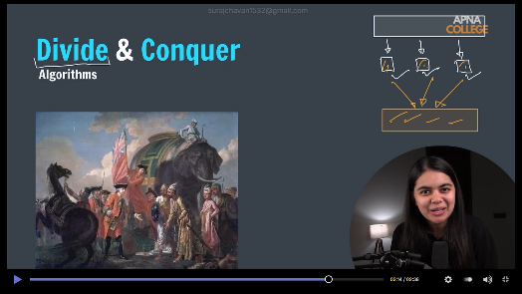
2)

