INT315 : CLUSTER COMPUTING
PROJECT REPORT
School Club Memberships:
Bipartite Graph Analysis and Visualization using PySpark
A Cluster Computing Project Featuring Spark DataFrame Graph Modelling, Degree-Based Popularity Analysis, and Interactive Network Visualization

SCHOOL OF COMPUTER SCIENCE AND ENGINEERING
LOVELY PROFESSIONAL UNIVERSITY
Submitted by: SURAJ KUMAR PRAJAPATI
Registration No: 12307977
roll no - 41
Section: K23MB
Course Code: INT 315
Under the Guidance of
Richa Ma’am
Discipline of CSE/IT
Lovely School of Computer Science and Engineering
Lovely Professional University, Phagwara

1. Introduction
Many real-world datasets can be expressed as networks: people connected to groups, customers connected to products, or pages connected by links. Studying the structure of such a network reveals patterns that are hard to see in plain tables. A bipartite graph is a special kind of network whose vertices fall into two separate sets, and edges only connect a vertex of one set to a vertex of the other.
This project analyses school and university club memberships as a bipartite graph. One set of vertices represents students and the other set represents clubs; an edge between a student and a club means that the student is a member of that club. The analysis is implemented with Apache Spark through its Python API (PySpark), so the same program can scale from this small dataset to very large ones. Spark is a cluster computing framework: the program here runs in local mode (local[*]) using all CPU cores of one machine, and the same DataFrame code can run unchanged on a multi-node cluster by pointing the Spark master to a cluster manager.

Problem statement
- Load a dataset of students and their club memberships.
- Construct a bipartite graph with students and clubs as the two sets of nodes.
- Identify the most popular club, i.e. the club with the most student connections.
- Find the students who are members of more than one club.
- Visualize the student-club membership network.

Approach
The three CSV files are loaded into Spark DataFrames. The graph is represented the same way GraphFrames does it: a vertices DataFrame (262 rows: 250 students and 12 clubs) and an edges DataFrame (438 rows: one per membership). The degree of a vertex, which is the number of edges attached to it, is computed with Spark groupBy aggregations. For a club vertex the degree is its number of members, and for a student vertex it is the number of clubs joined. Finally, NetworkX and Matplotlib draw the graph as a PNG image, and a self-contained HTML page lets the user explore the network interactively by hovering over nodes.

Tools and technologies
Tool | Purpose
Python 3.12 | Programming language
PySpark 3.5.1 | Loading data, building vertex/edge DataFrames, degree and aggregation queries
NetworkX | Graph layout for the visualization
Matplotlib | Static PNG dashboard (network + popularity chart)
HTML / CSS / JavaScript | Interactive, offline network page (network.html)

2. Dataset Link
The dataset was prepared specifically for this project and is stored as three related CSV files in the data folder of the project:
File | Rows | Columns | Description
students.csv | 250 | 8 | One row per student
clubs.csv | 12 | 6 | One row per club
memberships.csv | 438 | 6 | One row per student-club membership (graph edges)

Dataset link: [Paste your GitHub / Google Drive link to the data folder here]

students.csv
Column | Meaning | Example
student_id | Unique student ID | S001
name | Student name | Pooja Mehta
gender | Male / Female | Female
program | Degree programme | MCA
year | Year of study (1-4) | 3
city | Home city | Amritsar
state | Home state | Punjab
cgpa | Cumulative grade point average | 8.01

clubs.csv
Column | Meaning | Example
club_id | Unique club ID | C01
club_name | Name of the club | Coding Club
category | Technical, Cultural, Sports, ... | Technical
founded_year | Year the club started | 2015
faculty_mentor | Faculty in charge | Dr. Rajesh Sharma
meeting_day | Weekly meeting day | Fri

memberships.csv
Column | Meaning | Example
student_id | Student (edge start) | S001
club_id | Club (edge end) | C07
join_date | Date the student joined | 2024-07-30
role | Member, Volunteer, Core Team, Coordinator | Member
attendance_pct | Attendance percentage (45-100) | 52
active | Currently active (Yes / No) | Yes

3. Source Code
File: main.py (PySpark analysis and visualization)
"""
School / University Club Memberships - Bipartite Graph Analysis with PySpark
Author : Suraj Kumar Prajapati (Roll No. 41)

What this program does
1. Loads students, clubs and memberships from CSV files (PySpark DataFrames)
2. Builds a bipartite graph -> vertices = students + clubs, edges = memberships
3. Finds the most popular club (club vertex with the highest degree)
4. Finds students who are members of multiple clubs (student vertices with degree > 1)
5. Visualises the network (PNG dashboard + interactive HTML page)

Run: python main.py
"""
import json
import os
import sys

os.environ.setdefault("PYSPARK_PYTHON", sys.executable)
os.environ.setdefault("PYSPARK_DRIVER_PYTHON", sys.executable)

import matplotlib
matplotlib.use("Agg")
import matplotlib.pyplot as plt
import networkx as nx
from pyspark.sql import SparkSession
from pyspark.sql import functions as F

BASE = os.path.dirname(os.path.abspath(__file__))
DATA = os.path.join(BASE, "data")
OUT = os.path.join(BASE, "output")
os.makedirs(OUT, exist_ok=True)

# ---------------------------------------------------------------- Spark session
spark = (SparkSession.builder.appName("ClubMembershipGraph").master("local[*]")
.config("spark.ui.enabled", "false")
.config("spark.sql.shuffle.partitions", "4")
.getOrCreate())
spark.sparkContext.setLogLevel("ERROR")

line = "=" * 64

# ---------------------------------------------------------------- 1. Load dataset
students = spark.read.csv(os.path.join(DATA, "students.csv"), header=True, inferSchema=True)
clubs = spark.read.csv(os.path.join(DATA, "clubs.csv"), header=True, inferSchema=True)
members = spark.read.csv(os.path.join(DATA, "memberships.csv"), header=True, inferSchema=True)

print(line)
print(" 1. DATASET LOADED")
print(line)
print(f"students.csv : {students.count():>4} rows x {len(students.columns)} columns")
print(f"clubs.csv : {clubs.count():>4} rows x {len(clubs.columns)} columns")
print(f"memberships.csv : {members.count():>4} rows x {len(members.columns)} columns")
students.show(5, truncate=False)

# ---------------------------------------------------------------- 2. Bipartite graph
# Vertices : every student and every club (a 'type' column keeps the two sides apart)
# Edges : one edge per membership (student --member_of--> club)
v_students = students.select(F.col("student_id").alias("id"), F.col("name"), F.lit("student").alias("type"))
v_clubs = clubs.select(F.col("club_id").alias("id"), F.col("club_name").alias("name"), F.lit("club").alias("type"))
vertices = v_students.unionByName(v_clubs)
edges = members.select(F.col("student_id").alias("src"), F.col("club_id").alias("dst"),
F.lit("member_of").alias("relationship"), "role", "attendance_pct", "active")

n_students, n_clubs = v_students.count(), v_clubs.count()
n_edges = edges.count()
print(line)
print(" 2. BIPARTITE GRAPH CONSTRUCTED")
print(line)
print(f"Vertices : {vertices.count()} ({n_students} students + {n_clubs} clubs)")
print(f"Edges : {n_edges} (student -> club memberships)")

# Degree of every vertex = number of edges touching it
club_degree = edges.groupBy("dst").agg(F.count("*").alias("members"),
F.round(F.avg("attendance_pct"), 1).alias("avg_attendance"))
student_degree = edges.groupBy("src").agg(F.count("*").alias("num_clubs"))

# ---------------------------------------------------------------- 3. Most popular club
popularity = (club_degree.join(clubs, club_degree.dst == clubs.club_id)
.select("club_name", "category", "members", "avg_attendance")
.orderBy(F.desc("members")))
top_count = popularity.agg(F.max("members")).first()[0]
top_clubs = popularity.filter(F.col("members") == top_count).collect()

print(line)
print(" 3. MOST POPULAR CLUB")
print(line)
for r in top_clubs:
print(f"Most popular club: {r['club_name']} with {r['members']} members")
print("\nClub popularity ranking:")
popularity.show(truncate=False)

# ---------------------------------------------------------------- 4. Students in multiple clubs
multi = (student_degree.filter(F.col("num_clubs") > 1)
.join(edges.join(clubs, edges.dst == clubs.club_id)
.groupBy("src").agg(F.concat_ws(", ", F.sort_array(F.collect_list("club_name"))).alias("clubs")),
"src")
.join(students, student_degree.src == students.student_id)
.select("student_id", "name", "program", "num_clubs", "clubs")
.orderBy(F.desc("num_clubs"), "student_id"))
n_multi = multi.count()
no_club = n_students - student_degree.count()

print(line)
print(" 4. STUDENTS WHO ARE MEMBERS OF MULTIPLE CLUBS")
print(line)
print(f"{n_multi} of {n_students} students are in more than one club.")
print("\nTop 15 (most clubs first):")
multi.show(15, truncate=False)

dist = (student_degree.groupBy("num_clubs").agg(F.count("*").alias("students")).orderBy("num_clubs"))
print("Clubs-per-student distribution:")
dist.show()
print(f"Students with no club: {no_club}")

# ---------------------------------------------------------------- bonus: club overlap
a, b = edges.alias("a"), edges.alias("b")
overlap = (a.join(b, (F.col("a.src") == F.col("b.src")) & (F.col("a.dst") < F.col("b.dst")))
.groupBy(F.col("a.dst").alias("club1"), F.col("b.dst").alias("club2"))
.agg(F.count("*").alias("shared_students"))
.join(clubs.select(F.col("club_id").alias("club1"), F.col("club_name").alias("name1")), "club1")
.join(clubs.select(F.col("club_id").alias("club2"), F.col("club_name").alias("name2")), "club2")
.select("name1", "name2", "shared_students").orderBy(F.desc("shared_students")))
print(line)
print(" 5. BONUS: CLUB PAIRS SHARING THE MOST STUDENTS")
print(line)
overlap.show(5, truncate=False)

# ---------------------------------------------------------------- save results (CSV)
popularity.toPandas().to_csv(os.path.join(OUT, "club_popularity.csv"), index=False)
multi.toPandas().to_csv(os.path.join(OUT, "multi_club_students.csv"), index=False)
overlap.toPandas().to_csv(os.path.join(OUT, "club_overlap.csv"), index=False)

# ---------------------------------------------------------------- 5. Visualisation
vp = vertices.toPandas()
ep = edges.select("src", "dst").toPandas()
deg_students = student_degree.toPandas().set_index("src")["num_clubs"].to_dict()
deg_clubs = club_degree.toPandas().set_index("dst")["members"].to_dict()
spark.stop()

name = dict(zip(vp["id"], vp["name"]))
G = nx.Graph()
for _, r in vp.iterrows():
G.add_node(r["id"], bipartite=0 if r["type"] == "student" else 1, kind=r["type"])
G.add_edges_from(ep.itertuples(index=False, name=None))
club_ids = [n for n, d in G.nodes(data=True) if d["kind"] == "club"]
stud_ids = [n for n, d in G.nodes(data=True) if d["kind"] == "student"]
isolated = [n for n in stud_ids if G.degree(n) == 0]
G.remove_nodes_from(isolated) # students with no club are left out of the picture
stud_ids = [n for n in stud_ids if n in G]
best = top_clubs[0]["club_name"]
best_id = [k for k, v in name.items() if v == best][0]

# Layout: clubs on a ring, students pulled between the clubs they belong to
ring = nx.circular_layout(club_ids, scale=1.0)
pos = nx.spring_layout(G, pos=ring, fixed=club_ids, k=0.28, iterations=200, seed=41)

palette = {1: "#8fbfee", 2: "#378add", 3: "#1b4f8a", 4: "#0b2a52"}
fig, axes = plt.subplots(1, 2, figsize=(19, 9), gridspec_kw={"width_ratios": [2.1, 1]})
ax = axes[0]
nx.draw_networkx_edges(G, pos, ax=ax, alpha=0.18, width=0.6, edge_color="#666666")
nx.draw_networkx_nodes(G, pos, nodelist=stud_ids, ax=ax, node_size=[40 + 22 * G.degree(n) for n in stud_ids],
node_color=[palette[min(G.degree(n), 4)] for n in stud_ids], linewidths=0)
nx.draw_networkx_nodes(G, pos, nodelist=club_ids, ax=ax, node_size=[300 + 28 * deg_clubs.get(n, 0) for n in club_ids],
node_color=["#1d9e75" if n == best_id else "#d85a30" for n in club_ids],
edgecolors="white", linewidths=1.5)
import matplotlib.patheffects as pe
for n in club_ids: # club names drawn with a white outline so they stay readable
ax.text(pos[n][0], pos[n][1], name[n].replace(" Club", ""), ha="center", va="center", fontsize=10,
fontweight="bold", color="#111111", zorder=10,
path_effects=[pe.withStroke(linewidth=3.5, foreground="white")])
ax.set_title("Student - Club Membership Network (bipartite graph)", fontsize=15, fontweight="bold")
ax.axis("off")
from matplotlib.lines import Line2D
ax.legend(handles=[Line2D([], [], marker="o", ls="", color="#1d9e75", ms=12, label=f"Most popular club ({best})"),
Line2D([], [], marker="o", ls="", color="#d85a30", ms=12, label="Other clubs"),
Line2D([], [], marker="o", ls="", color=palette[1], ms=7, label="Student - 1 club"),
Line2D([], [], marker="o", ls="", color=palette[2], ms=8, label="Student - 2 clubs"),
Line2D([], [], marker="o", ls="", color=palette[3], ms=9, label="Student - 3 clubs"),
Line2D([], [], marker="o", ls="", color=palette[4], ms=10, label="Student - 4 clubs")],
loc="lower left", fontsize=9, frameon=True)

import pandas as pd
pop = pd.read_csv(os.path.join(OUT, "club_popularity.csv")).sort_values("members")
ax2 = axes[1]
ax2.barh(pop["club_name"], pop["members"], color=["#1d9e75" if n == best else "#d85a30" for n in pop["club_name"]])
for i, v in enumerate(pop["members"]):
ax2.text(v + 0.5, i, str(v), va="center", fontsize=10)
ax2.set_title("Club popularity (number of members)", fontsize=15, fontweight="bold")
ax2.set_xlabel("Members")
ax2.spines[["top", "right"]].set_visible(False)
plt.tight_layout()
plt.savefig(os.path.join(OUT, "network_dashboard.png"), dpi=110)
plt.close()

# Interactive, fully offline HTML (hover / tap a node to highlight its connections)
xs = [pos[n][0] for n in G]; ys = [pos[n][1] for n in G]
minx, maxx, miny, maxy = min(xs), max(xs), min(ys), max(ys)
W, H, PAD = 900, 700, 40
def sx(x): return round(PAD + (x - minx) / (maxx - minx) * (W - 2 * PAD), 1)
def sy(y): return round(PAD + (y - miny) / (maxy - miny) * (H - 2 * PAD), 1)
payload = {
"best": best,
"nodes": [{"id": n, "name": name[n], "kind": G.nodes[n]["kind"], "x": sx(pos[n][0]), "y": sy(pos[n][1]),
"deg": G.degree(n)} for n in G],
"edges": [[u, v] for u, v in G.edges()],
"stats": {"students": n_students, "clubs": n_clubs, "memberships": n_edges, "multi": n_multi},
"ranking": pop.sort_values("members", ascending=False)[["club_name", "members"]].values.tolist(),
}
html = open(os.path.join(BASE, "dashboard_template.html"), encoding="utf-8").read()
html = html.replace("__DATA__", json.dumps(payload))
open(os.path.join(OUT, "network.html"), "w", encoding="utf-8").write(html)

print(line)
print(" 6. VISUALISATION SAVED")
print(line)
print("output/network_dashboard.png (static picture)")
print("output/network.html (interactive - open in your browser)")
print("output/club_popularity.csv, multi_club_students.csv, club_overlap.csv")

4. Screenshot of the Source Code
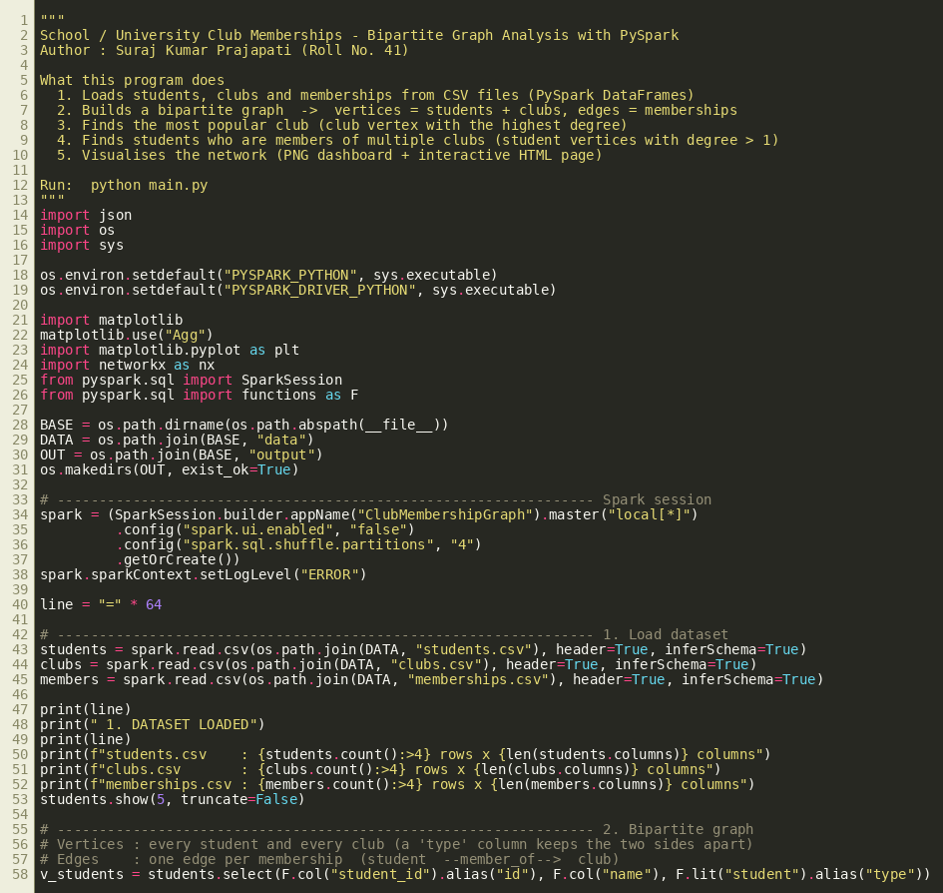
Figure 1: main.py (part 1 of 4)

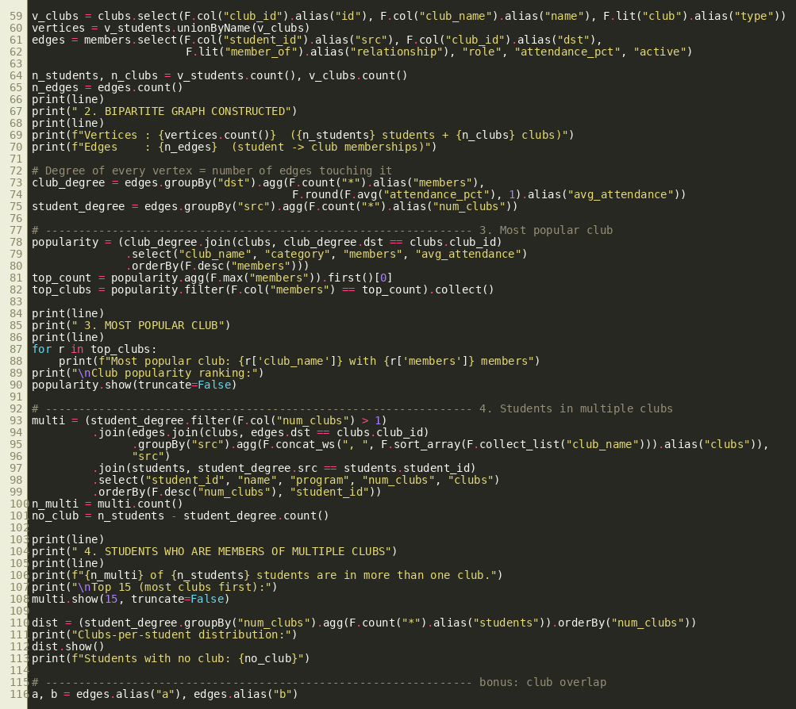
Figure 2: main.py (part 2 of 4)

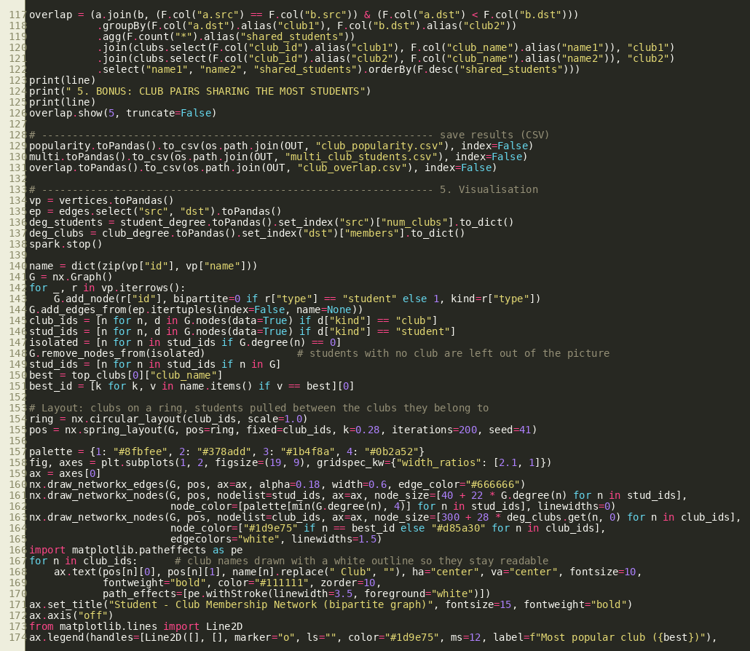
Figure 3: main.py (part 3 of 4)

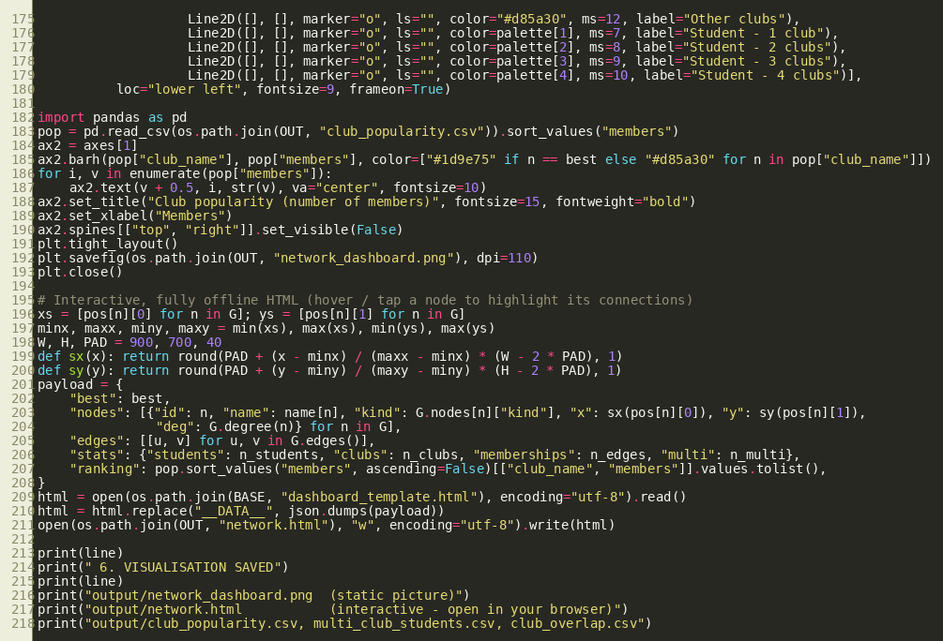
Figure 4: main.py (part 4 of 4)

5. Output Screenshot
The program is started with "python main.py". The terminal output below was produced by that run.
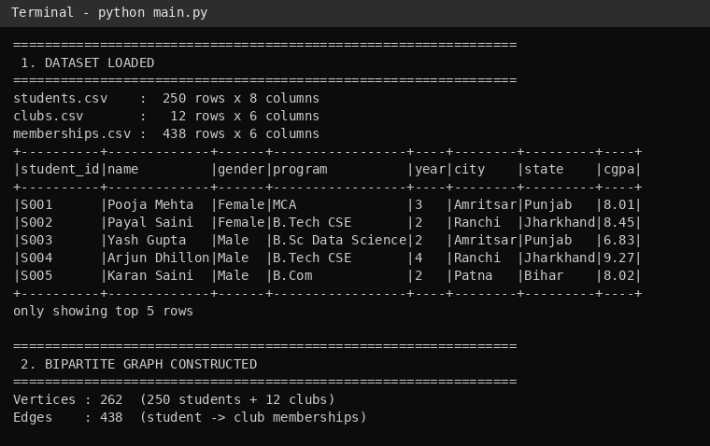
Figure 5: Terminal output - dataset loaded and bipartite graph constructed
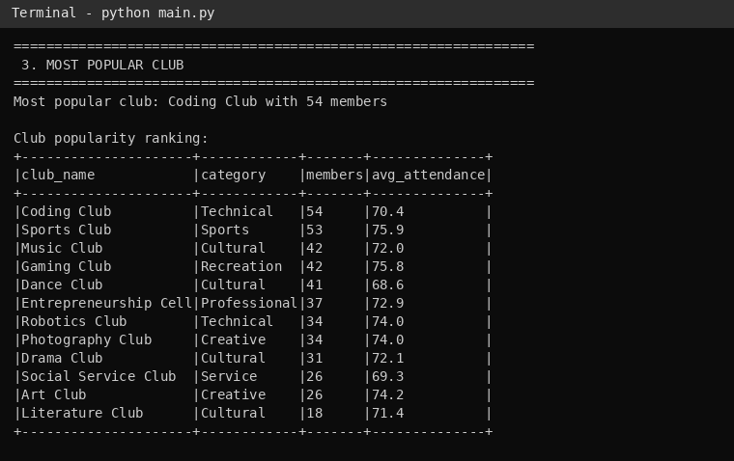
Figure 6: Terminal output - most popular club

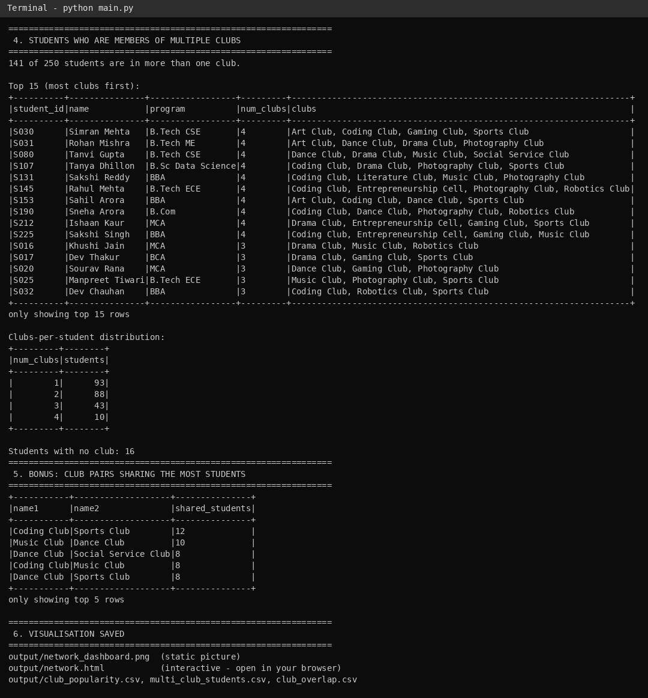
Figure 7: Terminal output - students in multiple clubs, distribution and club overlap

The static visualization (output/network_dashboard.png) shows the whole network. Clubs are the large nodes, students are the small nodes, and darker students belong to more clubs. The most popular club is highlighted in green.
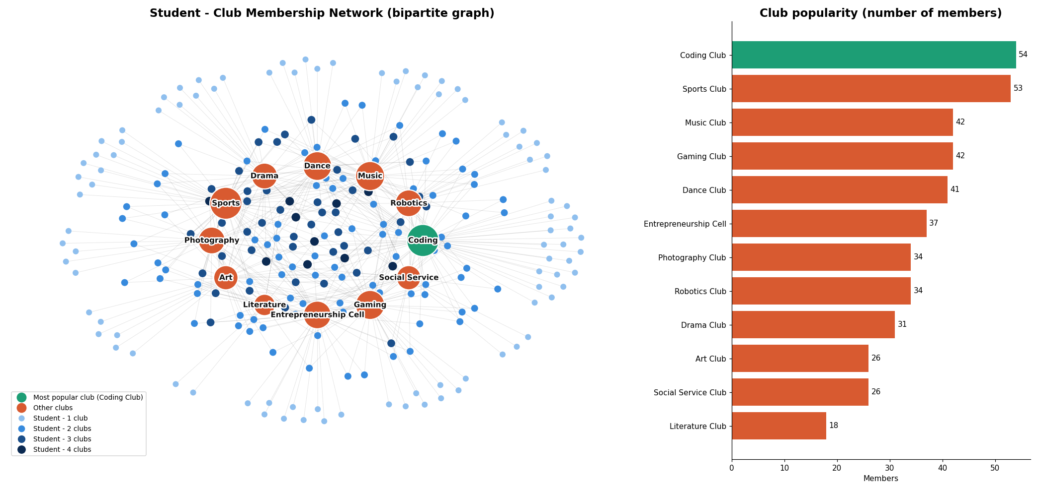
Figure 8: Student-club membership network and club popularity chart

The interactive page (output/network.html) opens in any browser. Hovering over a club or student highlights its connections; here the most popular club, Coding Club, is selected.
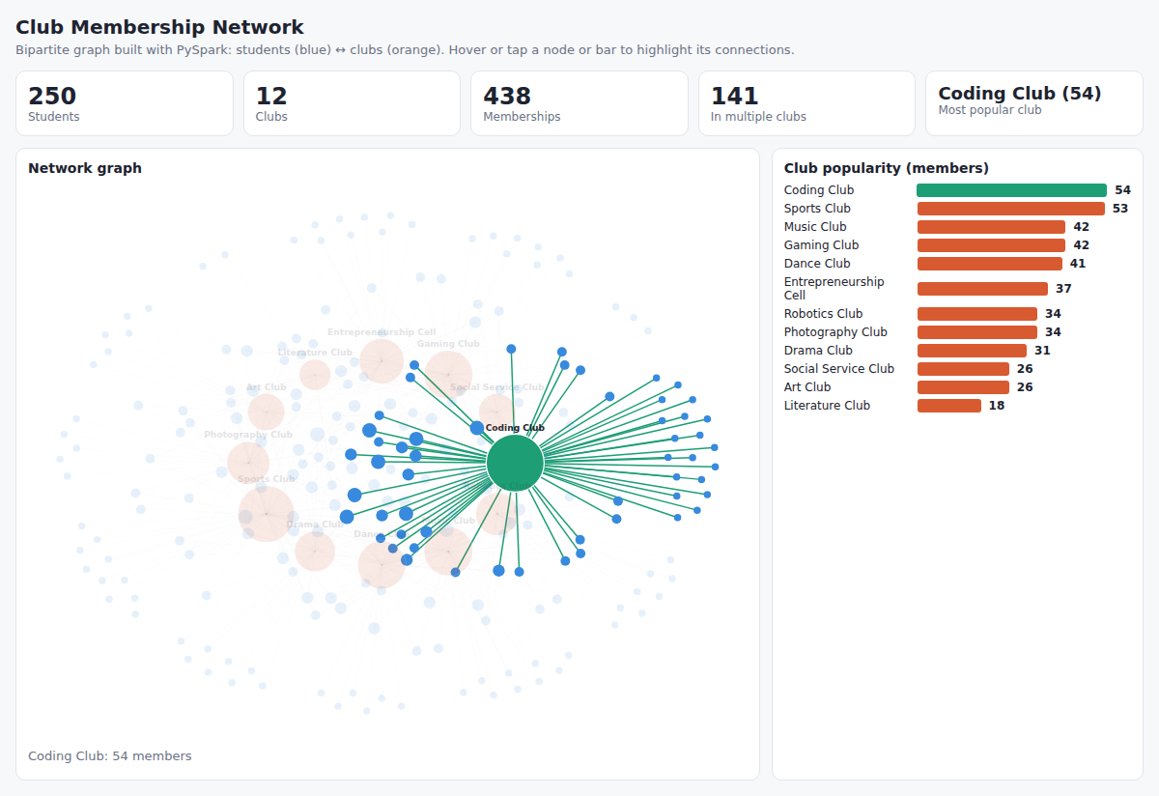
Figure 9: Interactive network page (network.html)

6. Results and Conclusion

Key findings
- The graph has 262 vertices (250 students + 12 clubs) and 438 edges.
- Coding Club is the most popular club with 54 members, followed closely by Sports Club with 53.
- 141 of the 250 students (56%) belong to more than one club; 10 students belong to four clubs.
- 93 students are in exactly one club and 16 students are not in any club.
- The pair of clubs sharing the most students is Coding Club and Sports Club (12 students).

Conclusion
Representing memberships as a bipartite graph makes the required questions easy to answer: the degree of a club vertex gives its popularity, and the degree of a student vertex shows how many clubs the student has joined. PySpark performs these computations with simple aggregations, so the approach scales to much larger datasets. The visualization makes the overlap between clubs visible at a glance, which can help the university plan joint events and encourage students who are not yet in any club to participate.

