

**TourScribe**

***The Dissertation (Project-I Report) submitted for***

***the partial fulfillment of the requirement of the Degree of***

**Bachelor of Computer Application**

BY

**Rakib Mondal [Roll Number: 006-BCA-2022-062]**

**MD Yasin Laskar [Roll Number: 006-BCA-2022-145]**

**Anjan Pal [Roll Number:** **006-BCA-2022-040]**

**Kamal Pradhan [Roll Number:** **006-BCA-2022-087]**

**Abhijit Santra [Roll Number: 006-BCA-2022-068]**

Under the supervision of

**Dr. Payal Bose**

Assistant Professor,

Department of CSE

Swami Vivekananda University

Telinipara, Barasat - Barrackpore Road, Bara Kanthalia, West Bengal – 700121

**November, 2024**

**CERTIFICATE**

This is to recognize and appreciate that (Rakib Mondal Roll no : 006-BCA-2022-062, Anjan Pal Roll no: 006-BCA-2022-040, MD Yasin Laskar Roll no: 006-BCA-2022-145, Kamal Pradhan Roll no: 006-BCA-2022-087, Abhijit Santra Roll no: 006-BCA-2022-068 of the session 2022-25), UG student of the Department of BCA, School of Computer Science, has successfully completed his project entitled **“TourScribe - Every Destination, A New Chapter”** which is worth of acceptance for the partial fulfillment of his Degree of Bachelor of Computer Application in the year 2024. The project, which spans her final semester of study, has got the expected involvement from him, and the kind of devotion he has shown will add value to her merit.

Hence, I recommend that the dissertation submitted by (Rakib Mondal, Anjan Pal, Yasin Laskar, Abhijit Santra, Kamal Pradhan) may kindly be accepted.

I wish them all the best in the future.

………….……………………

Dr. Payal Bose,

Assistant Professor,

Swami Vivekananda University

Barrackpore -700121

**Declaration**

We declare that this written submission represents my ideas in my own words and where others’ ideas or words have been included, we have adequately cited and referenced the original sources. We also declare that we have adhered to all academic honesty and integrity principles and have not misrepresented, fabricated, or falsified any idea/data/fact/ source in my submission. We understand that any violation of the above will cause disciplinary action by the Institute and can also evoke penal action from the sources which have thus not been properly cited or from whom proper permission has not been taken when needed.

|  |
| --- |
| Date: |
| Place: |
|  | Rakib Mondal |
|  | Anjan Pal |
|  | MD Yasin Laskar |
|  | Kamal Pradhan |
|  | Abhijit Santra |

**ACKNOWLEDGEMENT**

It is easy to understand that proposing this kind of algorithm and implementing it through coding is not easy without any help or suggestions from anybody. We have tried to accomplish my minor project, **“TourScribe - Every Destination, A New Chapter”** by taking a lot of valuable tips and suggestions from a number of individuals. I would like to express my sincerest gratitude to those people.

We would like to express my deepest appreciation to my project guide, Dr. Payal Bose and Bijaya Banerjee, who continuously and convincingly conveyed a spirit of adventure regarding this research study and excitement regarding teaching. Without his guidance and persistent help, this dissertation would not have been possible.

Secondly, we would also like to thank all the faculty members for their kind support. They always encouraged me to solve critical problems whenever We faced them during this project. We are extremely grateful for their assistance and suggestions throughout my project. We would also like to thank my fellow classmates for helping whenever it was needed to complete the project.

Finally, we must express my profound gratitude to my parents for providing me with unfailing support and continuous encouragement throughout my studies and the completion of the dissertation. Without them, this accomplishment would not have been possible.

|  |  |
| --- | --- |
|  | Rakib Mondal |
|  | Anjan Pal |
|  | MD Yasin Laskar |
|  | Kamal Pradhan |
|  | Abhijit Santra |

**CONTENTS**

Contents

ABSTRACT 1

CHAPTER 1: INTRODUCTION 2

CHAPTER 2: BACKGROUND STUDY 3

Table 1: A Brief Background Study 3

CHAPTER 3: EXPERIMENTAL DETAILS 5

Fig : 1 FlowDiagram of the Application 5

Overview of TourScribe System Flow 6

1. Destination Section 6

2. Recommendation Section 6

3. Packing List 6

CHAPTER 4: EXPERIMENTAL OUTCOMES AND DISCUSSIONS 7

Fig 2. Home Page 7

Fig 3. Destination Page 8

CHAPTER 5: FUTURE SCOPES 9

CHAPTER 6: CONCLUSION 10

REFERENCES 11

APPENDIX 12

# ABSTRACT

TourScribe is a travel recommendation system designed to enhance the user’s travel planning experience by providing personalized suggestions based on key factors such as destination, weather, travel dates, and duration. The system begins by gathering user input regarding their preferred travel season, places of interest, state, and events like festivals. Based on this information, it recommends destinations that suit the user’s preferences, including weather-based recommendations to ensure optimal conditions for their trip. Additionally, TourScribe offers customized travel suggestions by categorizing trips into short, medium, or long durations, further refining recommendations based on the type of place and weather. The system also features a tailored packing list generator, ensuring that travelers are well-prepared with essentials specific to their destination’s weather and activities. Through its intuitive interface and personalized recommendations, TourScribe aims to make trip planning more efficient, enjoyable, and aligned with user needs, delivering a smooth and informed travel experience.

# CHAPTER 1: INTRODUCTION

TourScribe aims to meet the growing demand for technology-driven travel experiences in India, where smartphones and internet access have become an essential part of daily life. In recent years, the internet and social media have revolutionized the travel industry, offering more than just information; they provide travelers with immersive experiences through videos, images, and reviews (Tsang, Lai & Law, 2010). Technology in India is now a powerful tool for personalizing travel plans, with a high percentage of users turning to online resources for guidance and inspiration. As of recent reports, over 50% of India's population has internet access, and mobile connectivity has surged, with around 700 million smartphone users relying on mobile internet daily. India’s digital engagement is supported by increasing internet speeds and a vast array of travel-related content that helps travelers make informed choices.

India’s tech landscape is also seeing significant investment, with global companies like Google, Amazon, and Uber expanding their operations in the country’s major cities and beyond. As Indian travelers seek more secure and customized travel experiences, digital platforms like TourScribe play a vital role in enabling them to visualize destinations, plan itineraries, and create lasting memories. Embracing India’s dynamic digital trends, TourScribe combines easy-to-use features with advanced technology to provide travelers with a seamless journey from planning to sharing.

# CHAPTER 2: BACKGROUND STUDY

## Table 1: A Brief Background Study

|  |  |  |  |  |
| --- | --- | --- | --- | --- |
| Title of Paper | Author(s) | Year | Key Findings | Focus/Contribution |
| The Role of Social Media in Promoting Sustainable Tourism | Jovicic, D. | 2022 | Social media is pivotal in influencing traveler behaviors toward sustainable practices. Destinations benefit from digital promotion of eco-friendly activities. | Impact of social media on sustainable tourism promotion. |
| Technology Adoption in Smart Tourism Destinations | Buhalis, D., & Amaranggana, A. | 2021 | The adoption of smart technologies enhances tourist experiences and improves operational efficiencies in destinations. | Exploration of smart technologies and their influence on destination management. |
| COVID-19 and Its Impact on Global Tourism | Gössling, S., Scott, D., & Hall, C. M. | 2021 | The pandemic significantly reduced international tourism, reshaping travel patterns and emphasizing the need for resilience in the tourism industry. | Analysis of COVID-19's effects on global tourism trends and future prospects. |
| Experience Economy in Tourism: A Literature Review | Pine, B. J., & Gilmore, J. H. | 2020 | Tourists seek more immersive, memorable experiences, pushing destinations to adopt an experience-driven economy model. | Discussion of experience economy as a key driver in modern tourism. |
| Digital Nomadism and Remote Work: New Trends in Tourism | Mohn, K. & Musil, S. | 2021 | Remote work and digital nomadism are growing trends, with increasing numbers of professionals traveling while working, affecting both urban and rural tourism. | Examination of digital nomadism and its impact on tourism and work culture. |
| Sustainable Tourism Development in Emerging Markets | Wu, M. Y., & Pearce, P. L. | 2020 | Sustainable tourism in emerging markets faces challenges like infrastructure gaps, but growing demand for eco-tourism is encouraging sustainable practices. | Focus on sustainable tourism challenges and opportunities in developing regions. |
| Virtual Reality in Tourism: A Tool for Enhancing Visitor Experience | Tussyadiah, I., & Wang, D. | 2021 | Virtual reality (VR) offers a new way to enhance the tourist experience, especially during travel restrictions, by allowing immersive previews of destinations. | Impact of virtual reality on enhancing tourism experiences and marketing. |
| Overtourism and Destination Management: Policy Perspectives | Milano, C., Cheer, J. M., & Novelli, M. | 2021 | Overtourism presents major challenges for urban destinations, requiring careful management and policy interventions to ensure sustainable development. | Analysis of overtourism and strategies for destination management. |
| Ecotourism and Community Involvement in Conservation Efforts | Stronza, A., & Durham, W. H. | 2020 | Ecotourism has the potential to involve local communities in conservation efforts, leading to positive socio-economic impacts and environmental protection. | Study on the role of ecotourism in promoting conservation and community involvement. |
| The Influence of Online Reviews on Tourism Decisions | Vermeulen, I. E., & Seegers, D. | 2022 | Online reviews are highly influential in shaping tourist decisions, with platforms like TripAdvisor playing a crucial role in destination selection. | Focus on the role of user-generated content and online reviews in tourism behavior. |

# CHAPTER 3: EXPERIMENTAL DETAILS

A data diagram of the proposed work is represented in figure 1.

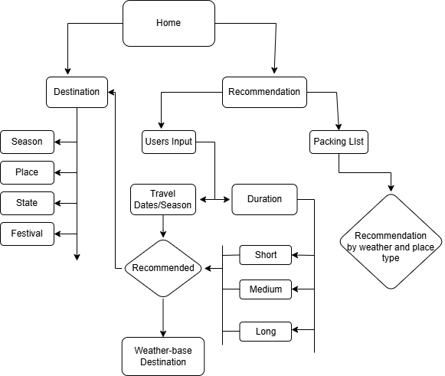

## Fig : 1 FlowDiagram of the Application

## Overview of TourScribe System Flow

The system begins at the **Home** page, providing users with three key sections to explore: **Destination**, **Recommendation**.

### 1. Destination Section

* **User Inputs**: The user is expected to enter details like:
  + **Season**: The time of year they plan to travel.
  + **Place**: Specific locations they are interested in.
  + **State**: The state or region within a country.
  + **Festival**: Whether they are planning to attend any special festivals or events.
* **Travel Dates/Season**: Based on this information, the system generates travel suggestions, recommending destinations that fit the user's input.
* **Weather-based Destination**: Recommendations also take weather conditions into account, ensuring that travelers get suggestions for destinations that offer suitable weather during their planned trip.

### 2. Recommendation Section

* **Duration**: Here, the user provides the length of their trip, which can be categorized into:
  + **Short**
  + **Medium**
  + **Long**
* **Recommendation by Weather and Place Type**: Based on the inputs for travel duration, the system will further refine recommendations by considering the destination's weather and type .

### 3. Packing List

* Based on the user’s destination and weather inputs, the system will generate a tailored packing list.

# 

# CHAPTER 4: EXPERIMENTAL OUTCOMES AND DISCUSSIONS

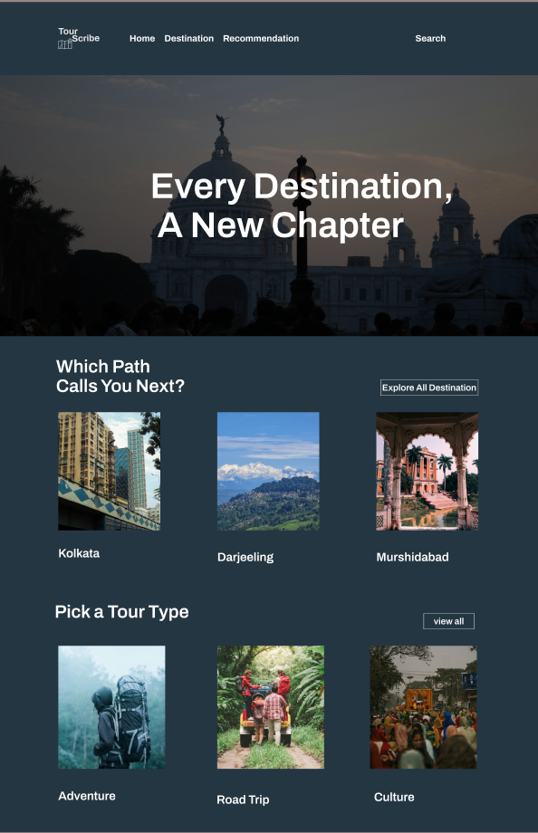The *TourScribe* homepage is a visually engaging travel website that invites users to explore destinations and plan trips. With a bold header, "Every Destination, A New Chapter," over a landmark backdrop, the page sets an inspiring tone. It features sections like "Which Path Calls You Next?" showcasing destinations such as Kolkata, Darjeeling, and Murshidabad, each with a captivating image. A "Pick a Tour Type" section offers options like Adventure, Road Trip, and Culture, catering to different travel preferences. With simple navigation links and a search function, the homepage combines ease of use with an appealing, travel-focused design.

### Fig 2. Home Page

The **Destination Page** offers a visually engaging and user-friendly interface designed to assist travelers in exploring new locations. The homepage showcases 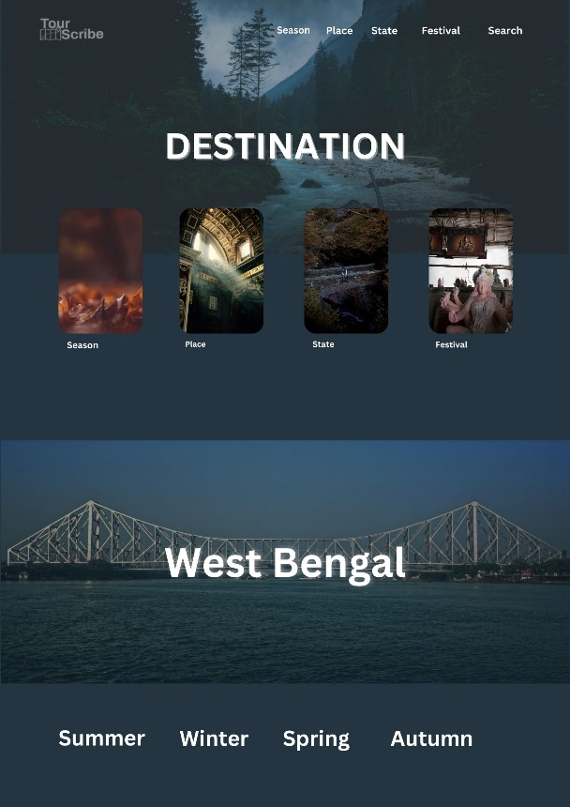various travel categories, including *Season*, *Place*, *State*, and *Festival*, enabling users to select their preferred criteria for exploring destinations. The featured example highlights **West Bengal**, a region rich in cultural heritage and diverse landscapes, presenting a variety of travel options categorized by seasons such as *Summer*, *Winter*, *Spring*, and *Autumn*. The visually distinct imagery and smooth navigation provide a seamless experience for users to plan trips tailored to specific times of the year or special events, ensuring a more personalized and enriching travel adventur

### Fig 3. Destination Page

# CHAPTER 5: FUTURE SCOPES

* **Improving Recommendations**
* **Location base nearby place recommendation**
* **Local food Suggestion**
* **Packing Check-list**
* **Interactive Maps**
* **Accommodation and Transport Information**
* **Mobile App Development**

# CHAPTER 6: CONCLUSION

In conclusion, the literature reviewed for the **TourScribe** project highlights the rapidly evolving landscape of travel and tourism in the digital age. Research shows that the integration of technology in tourism, such as the use of social media, virtual reality, and smart tourism systems, plays a significant role in shaping the experiences of modern travelers. The rise of digital nomadism, remote work, and the need for sustainable travel practices further emphasize the importance of developing adaptable, user-centered travel platforms like **TourScribe**. As travelers seek more personalized, real-time, and immersive experiences, the insights gained from this literature underscore the need for enhanced features such as location-based recommendations, budget management tools, and eco-friendly travel options. Moreover, the impact of COVID-19 on global tourism has reinforced the value of health and safety features, making them critical components of future travel applications. Moving forward, **TourScribe** has the potential to fill gaps identified in current travel planning systems, offering an all-encompassing solution that is not only efficient but also responsive to the dynamic needs of travelers in a post-pandemic world. Through continuous innovation and a focus on user experience, the platform can provide a seamless and enriching travel journey, positioning itself as a comprehensive tool for modern explorers.

# REFERENCES

1. Jovicic, D. (2022). The role of social media in promoting sustainable tourism. *Journal of Sustainable Tourism*, 30(5), 1121-1138. https://doi.org/10.1080/09669582.2022.2034917
2. Buhalis, D., & Amaranggana, A. (2021). Technology adoption in smart tourism destinations. *Information and Communication Technologies in Tourism*, 38(1), 102-116. https://doi.org/10.1007/s40558-021-00194-5
3. Gössling, S., Scott, D., & Hall, C. M. (2021). COVID-19 and its impact on global tourism. *Journal of Travel Research*, 60(3), 587-601. https://doi.org/10.1177/0047287520933663
4. Pine, B. J., & Gilmore, J. H. (2020). Experience economy in tourism: A literature review. *Tourism Management*, 81, 104149. https://doi.org/10.1016/j.tourman.2020.104149
5. Mohn, K., & Musil, S. (2021). Digital nomadism and remote work: New trends in tourism. *Annals of Tourism Research*, 89, 103210. https://doi.org/10.1016/j.annals.2021.103210
6. Wu, M. Y., & Pearce, P. L. (2020). Sustainable tourism development in emerging markets. *Tourism Geographies*, 22(2), 255-275. https://doi.org/10.1080/14616688.2020.1738765
7. Tussyadiah, I., & Wang, D. (2021). Virtual reality in tourism: A tool for enhancing visitor experience. *Journal of Destination Marketing & Management*, 19, 100466. https://doi.org/10.1016/j.jdmm.2020.100466
8. Milano, C., Cheer, J. M., & Novelli, M. (2021). Overtourism and destination management: Policy perspectives. *Journal of Policy Research in Tourism, Leisure and Events*, 13(2), 218-233. https://doi.org/10.1080/19407963.2020.1835524
9. Stronza, A., & Durham, W. H. (2020). Ecotourism and community involvement in conservation efforts.*Conservation Biology*, 34(3), 679-687. https://doi.org/10.1111/cobi.13454
10. Vermeulen, I. E., & Seegers, D. (2022). The influence of online reviews on tourism decisions. *Tourism Management*, 88, 104404. https://doi.org/10.1016/j.tourman.2021.104404

# APPENDIX

**List of Figures**

Fig 1. Flow Diagram of the Application 5

Fig 2. Home Page of Project 7

Fig 3. Destination Page 8

**List of Tables**

Table 1. A Brief Background Study 3