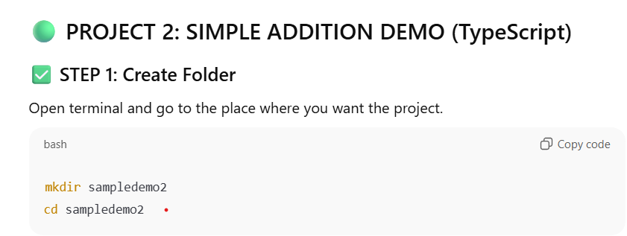
mkdir sampledemo2
cd sampledemo2
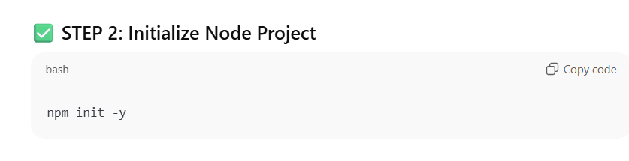
npm init -y
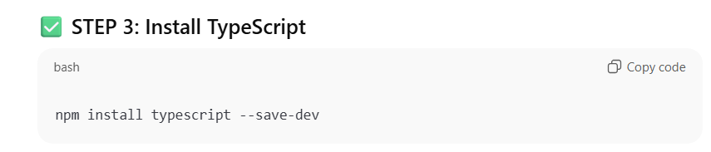
npm install typescript --save-dev
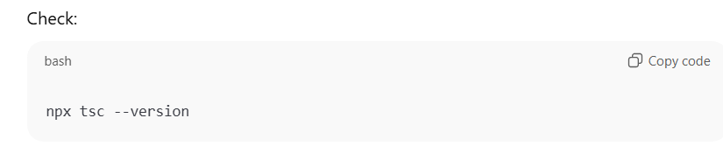
npx tsc –version
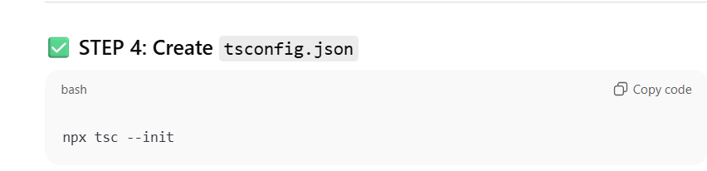
npx tsc –init
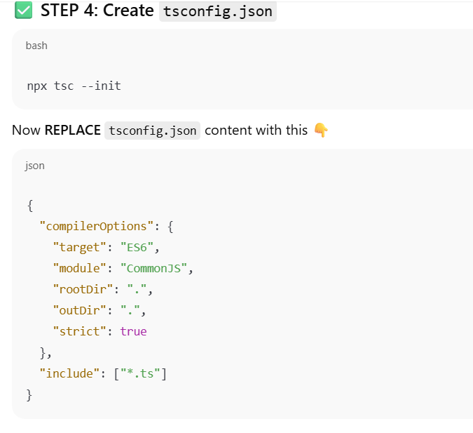

Code writing
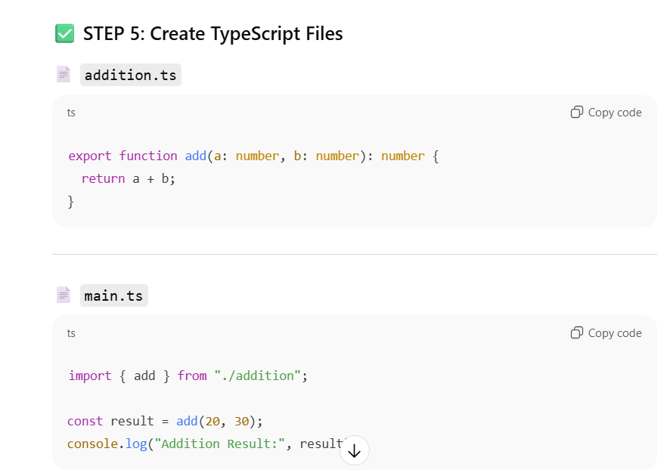
Till now no js is imported
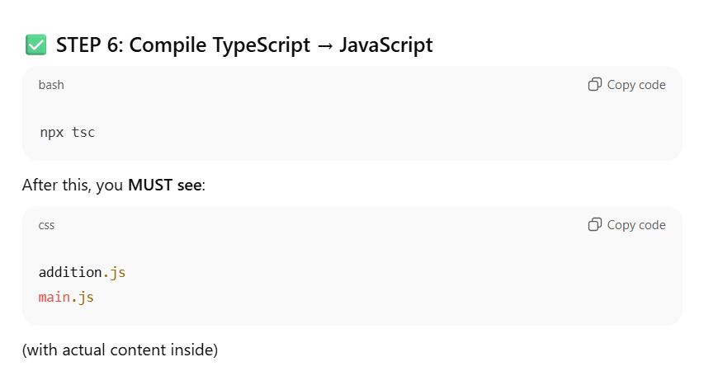
npx tsc
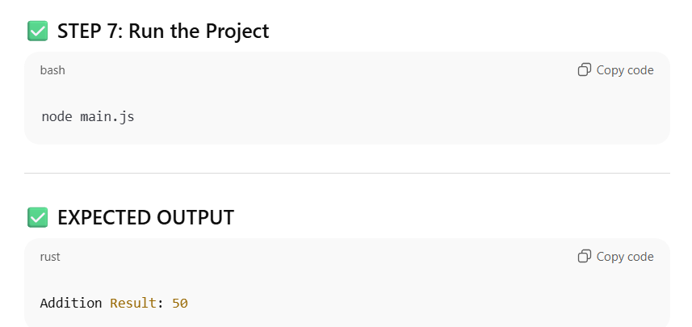
node main.js

