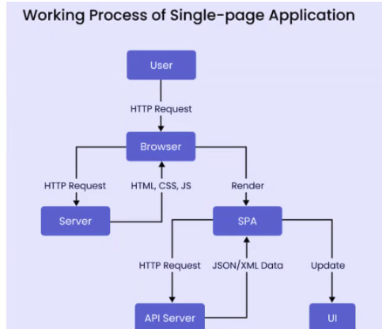



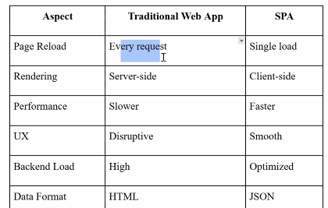
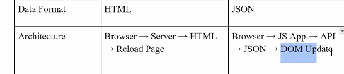

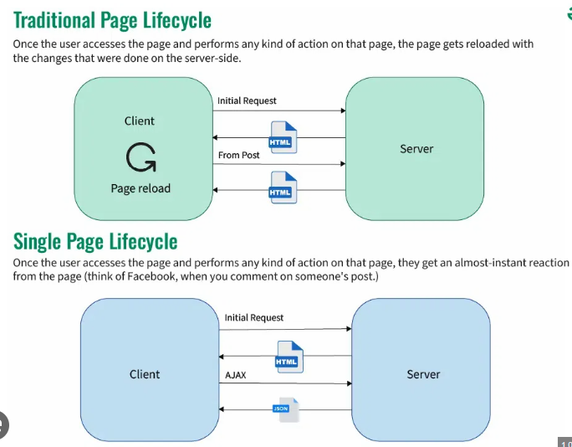
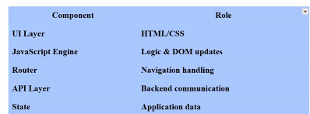

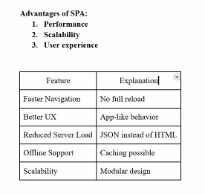
Performance Benefits:
- Faster page transitions
- Efficient API usage
- Reduced bandwidth consumption
Best Practices while working SPA:
- Lazy loading components(load components when needed)
- Optimize API calls
- Use browser caching
- Minimize DOM re rendering

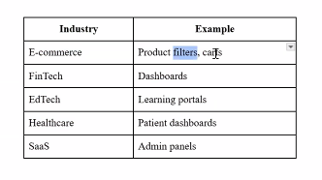

dotnet new react -n MyReactSPA
dotnet new angular -n MyAngularSPA
index.html (loaded once)
↓
main.js (routing logic)
↓
JSON / JS objects
↓
DOM updates





