Scope:
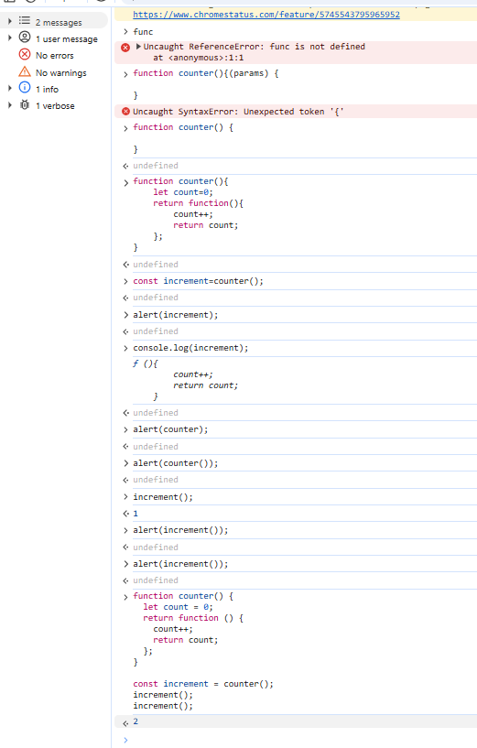

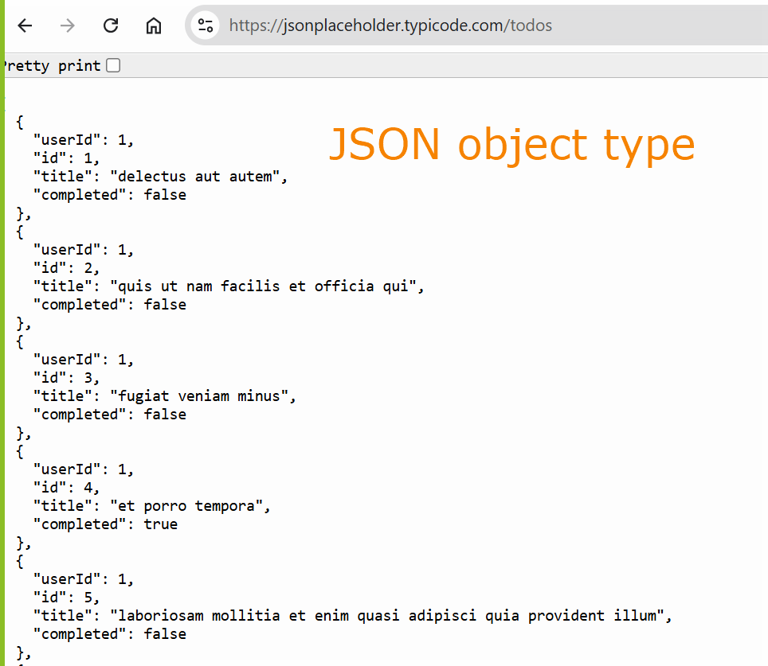

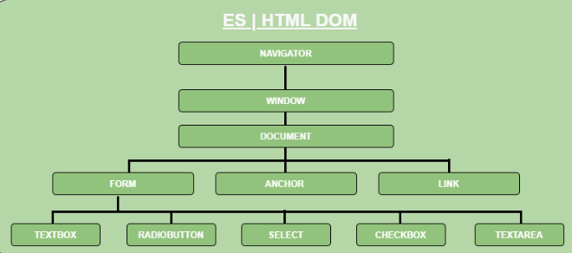
- Navigator: The browser. Eg: Netscape Navigator, Internet Explorer, Opera, Mosaic etc.

- Window: The browser's window.

- Form: The DOM hierarchy continues downward to encompass individual elements of the form.
