https://www.sebastien-lempens.com/

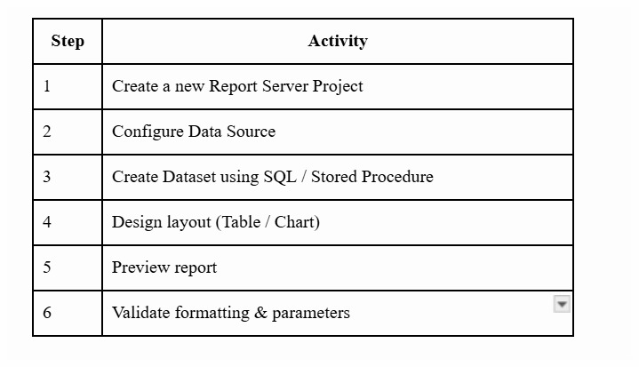

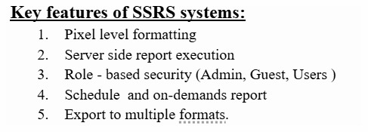

AspectﾠSSRSﾠPower BI
Report TypeﾠPaginated, pixel-perfectﾠInteractive dashboards
Data HandlingﾠServer-side SQL executionﾠIn-memory (VertiPaq)
VisualizationﾠLimitedﾠRich, modern visuals
User InteractionﾠLowﾠHigh
SchedulingﾠStrongﾠLimited (via service)
ExportﾠExcellentﾠModerate
Best ForﾠOperational reportsﾠBusiness insights

