https://learn.microsoft.com/en-us/training/paths/control-spending-manage-bills/

CRM = system that helps businesses build better customer relationships using data.

https://ifttt.com/

https://learn.microsoft.com/en-us/collections/30ensp73ok7k43

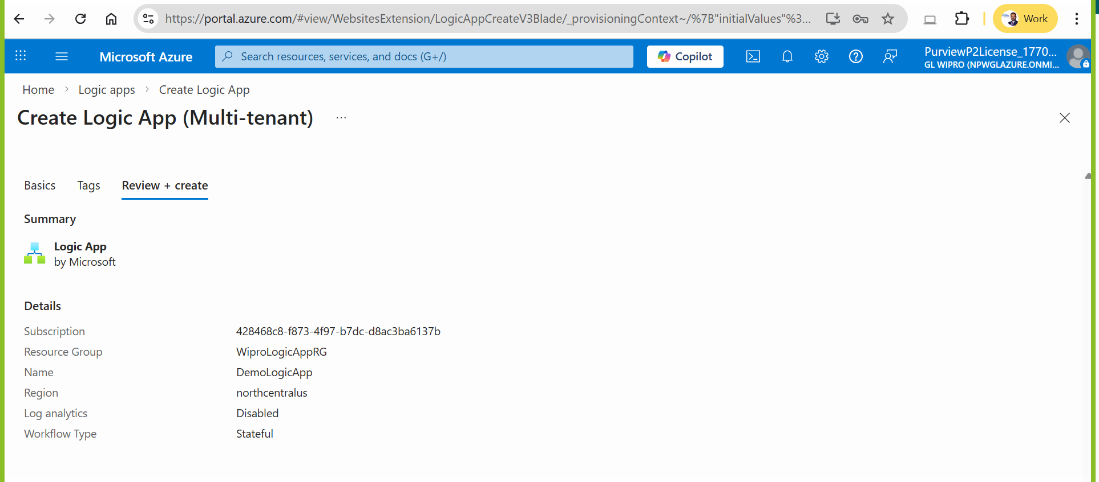

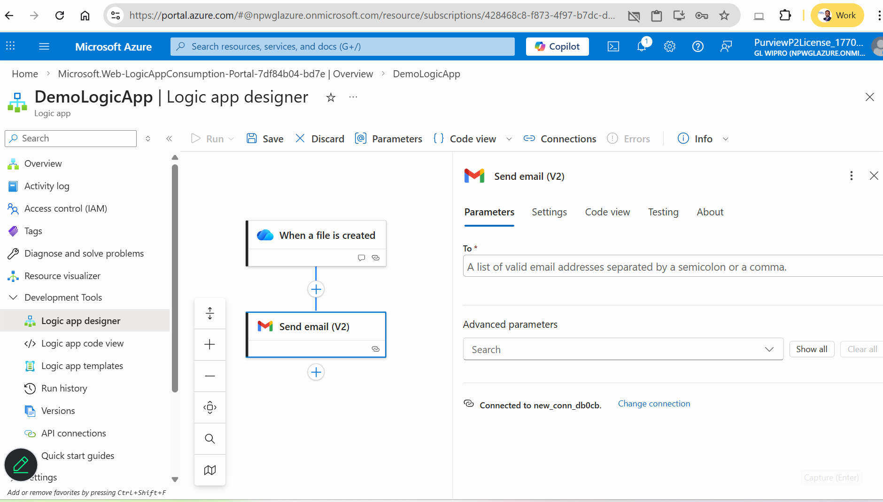

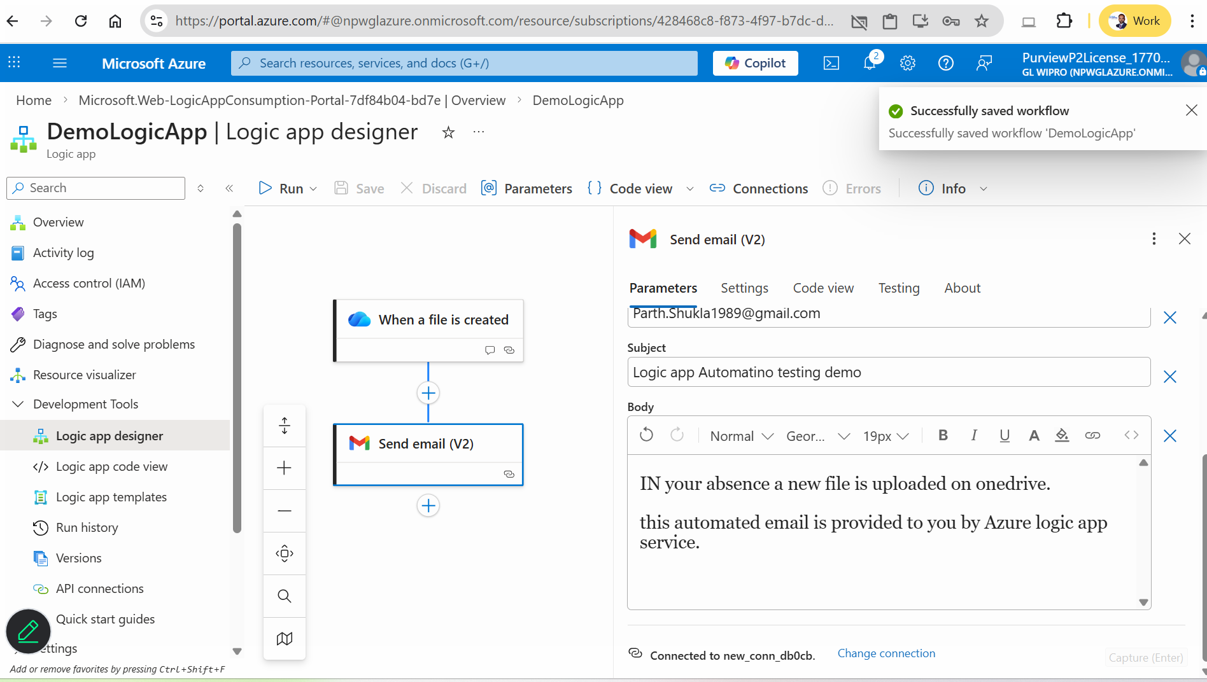

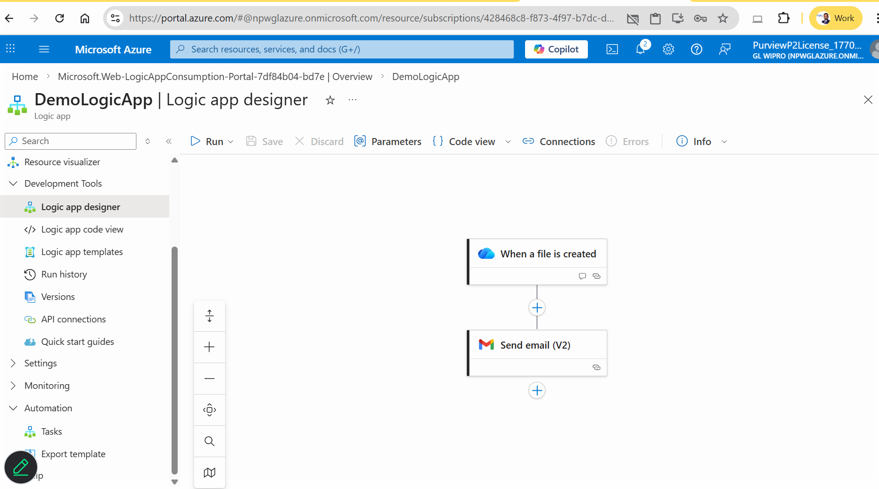

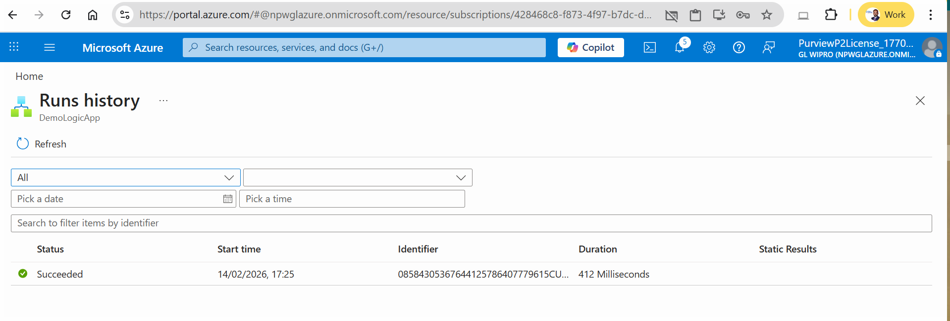

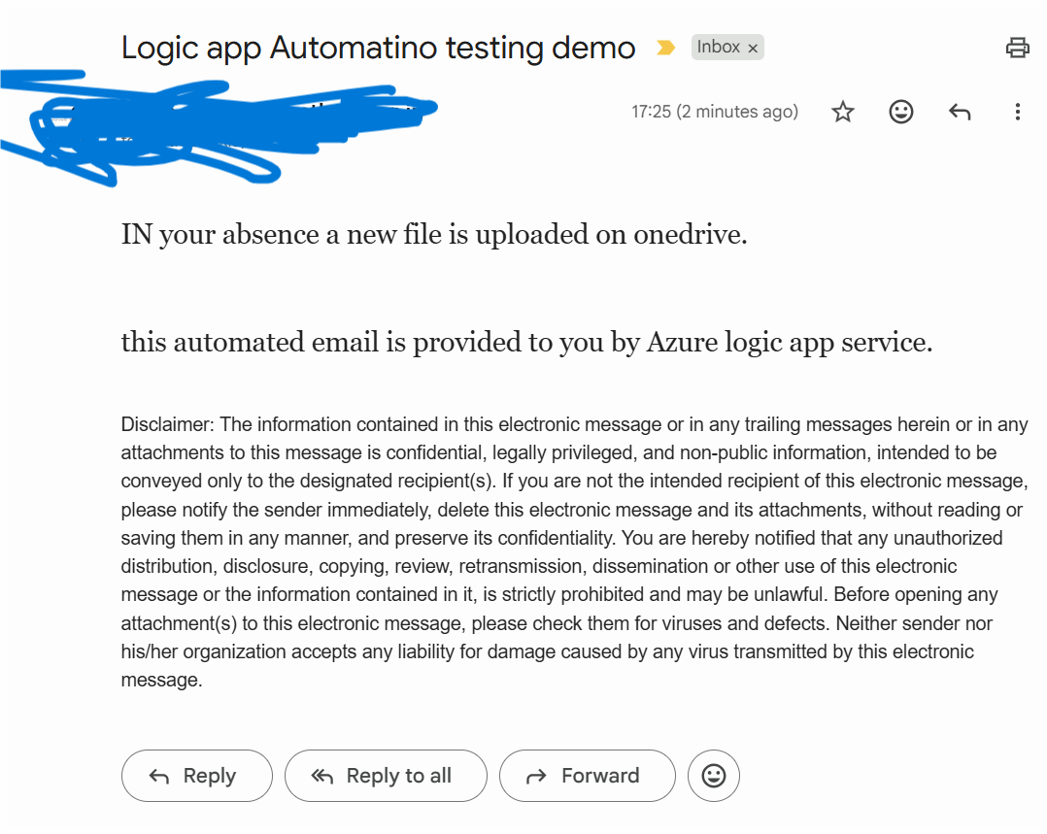

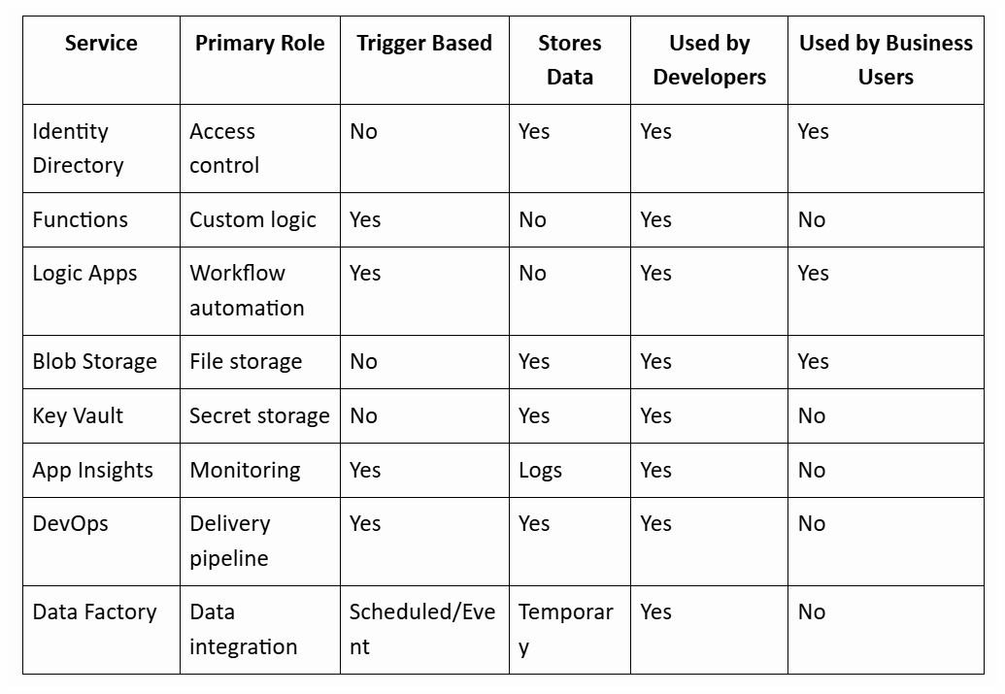

https://comparecloud.in/

Azure Key Vault (Security Layer)
Definition
Secure secrets management service.
Stores:
- API keys
- connection strings
- certificates
- passwords
Why Important for CRM
Integrations require credentials. Storing them in code is unsafe.
Best Practices
- Never store secrets in code
- Use managed identities
- Rotate secrets regularly
- Restrict vault access

Azure Blob Storage (Data Storage Layer)
Definition
Object storage service for storing unstructured data.
CRM Uses
- store attachments
- documents
- logs
- exports
- media files
Comparison vs Database Storage
Blob StorageﾠDatabase
Stores filesﾠStores structured data
CheapﾠExpensive
ScalableﾠLimited
Best for documentsﾠBest for records
Best Practices
- Use private containers
- Apply lifecycle rules
- Enable encryption
- Use SAS tokens instead of public links

