

**Department of Computer Science and Engineering**

PROJECT REPORT

TOPIC: INTELLIGENT CHATBOT

Submitted by: Surbhi Gusain

Univ.rn:2014903

Sec : ML

Class rn:34

Submitted To: DR. Vishen Gupta

# INTRODUCTION

As things are being automated all over the world, chatbots play a major role in this automation.

In the very initial entry of chatbot, people were curious and anxious about the influence of this technology and how it’s going to affect the future of enterprise and business. Many brands are already utilizing chatbot to experience advancement and benefits out of it. Failure to adopt this technology in your business can lead you to lag behind the competitive world. Hence, it’s time to catch up advanced technology as soon as possible.

Chatbots are everywhere ,in the shopping stores, in your mobile phone, for an telephonic conversation, integrated with websites ,for handling customers at beginning level or intermediate level.

A chatbot is an intelligent piece of software that is capable of communicating and performing actions similar to a human. Chatbots are used a lot in customer interaction, marketing on social network sites and instantly messaging the client. There are two basic types of chatbot models based on how they are built; Retrieval based and Generative based models.

AI as a field is very interesting and further having a lot of professional discussions about the topic through our project work.

DESCRIPTION

I created a multipurpose chatbot for doing various day to day functions as devices like google’s alexa and iphone’s siri would do.

In this project i explored how a chatbot can give information to user for anything user could ask. In the first iteration of the project i created a chatbot function to introduce itself. In the second iteration I wanted to explore the use of chatbots through multiple functions like opening youtube ,translating language, doing small talk and much more. In the final iteration, iteration three, i improved and created functions for the chatbot for web searching for any phrase, integrated google calender for scheduling appointment ,automated sending mails etc.

BACKGROUND

Chatbots has emerged as a hot topic in the latest years, and it is used by numerous companies in various areas - help desk tools, automatic telephone answering systems, e-commerce and so on. Even though the technology has been around since the 60’s (Atwell & Shawar, 2007).

the task whereby an automated machine (such as a computer) answers arbitrary questions formulated in natural language. QA systems are especially useful in situations in which a user needs to know a very specific piece of information and does not have the time—or just does not want—to read all the available documentation related to the search topic in order to solve the problem at hand”. (Molla & Vicedo, 2007).

MOTIVATION

Virtual assistant chatbots combine virtual assistant services with chatbot functionality. Also known as intelligent virtual assistants (IVAs) and virtual agents, they upgrade the traditional virtual assistant experience to be more advanced and personalized than ever before. In fact, you may have already interacted with this technology if you’ve ever used Amazon’s Alexa or Apple’s Siri.

Benefits of using virtual assistant chatbots for customer service include

Real-time customer assistance

Better customer engagement and trust

Better visibility and analytics

Increased lead generation

Virtual AI assistance technology is being at such a pace that in upcoming time we could have multiple Chatbots like SOPHIA at different places of the world.

**This upcoming Scope of this technology motivated me to develop my virtual AI assistant with many general purpose features.**

METHODOLOGY

For creating general purpose chatbot:-

Step 1: Install required libraries in the terminal or command prompt

For the robot to listen to our voice/speech: pip install speechRecognition

To speak out, or text to speech :pip install pyttsx3

For advance control on browser: pip install pywhatkit

To get wikipedia data :pip install wikipedia

To get funny jokes: pip install pyjokes

To send email from system: pip install smtplib

To translate language:pip install googletrans

To use audio feature:pip install pyaudio

To convert text to speech: pip install gTTs

To playing audio : pip install playsound

Step 2: Import required libraries

Import the libraries from above installed modules:

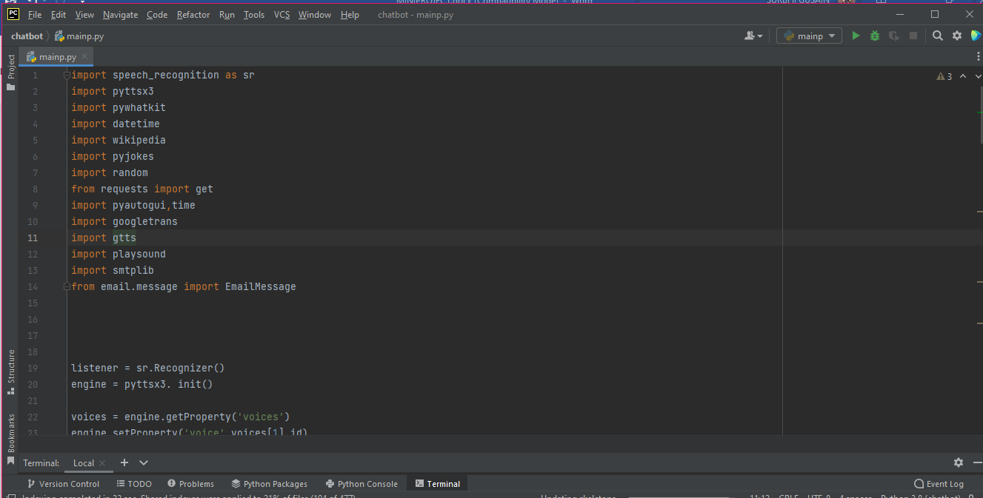

Step 3: Define Functions for features:

Feature1: Introduction

The virtual assistant introduces itself when the program is initiated.

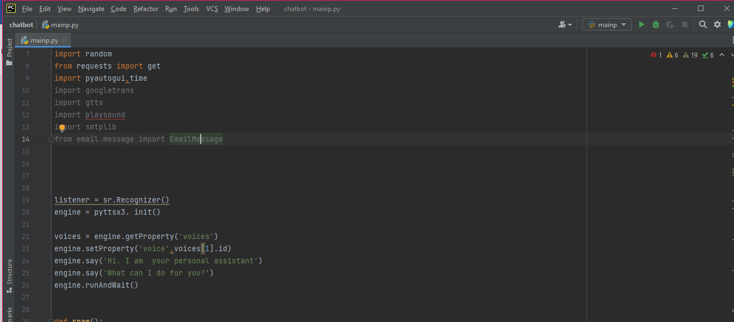

Feature3: Get You a joke

Tells you a random joke using pyjokes library.

Feature4: Let you play a song by opening You tube automatically

When input a song name as a command, this chatbot automatically opens youtube

And plays the song

Feature5: Tells you about the person

Informs you about the person when you say ”who is/what is” as an input through Wikipedia

Feature6: Tells you the current Time and date

Tells you the current date and time when “date” or “time” is detected in command

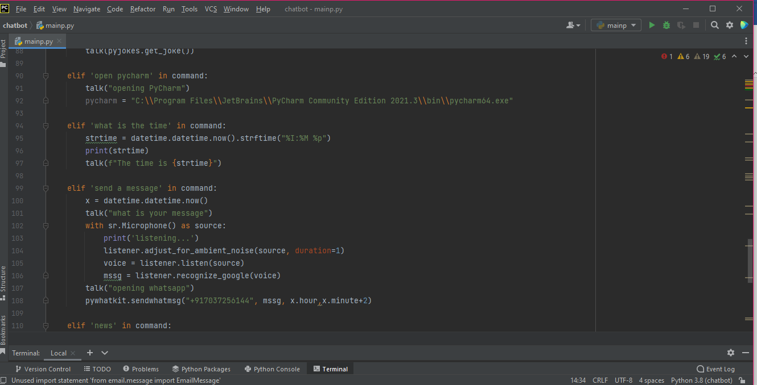

Feature8: Automated email

Automatically sends email to the desired email address without opening the email using SMTP

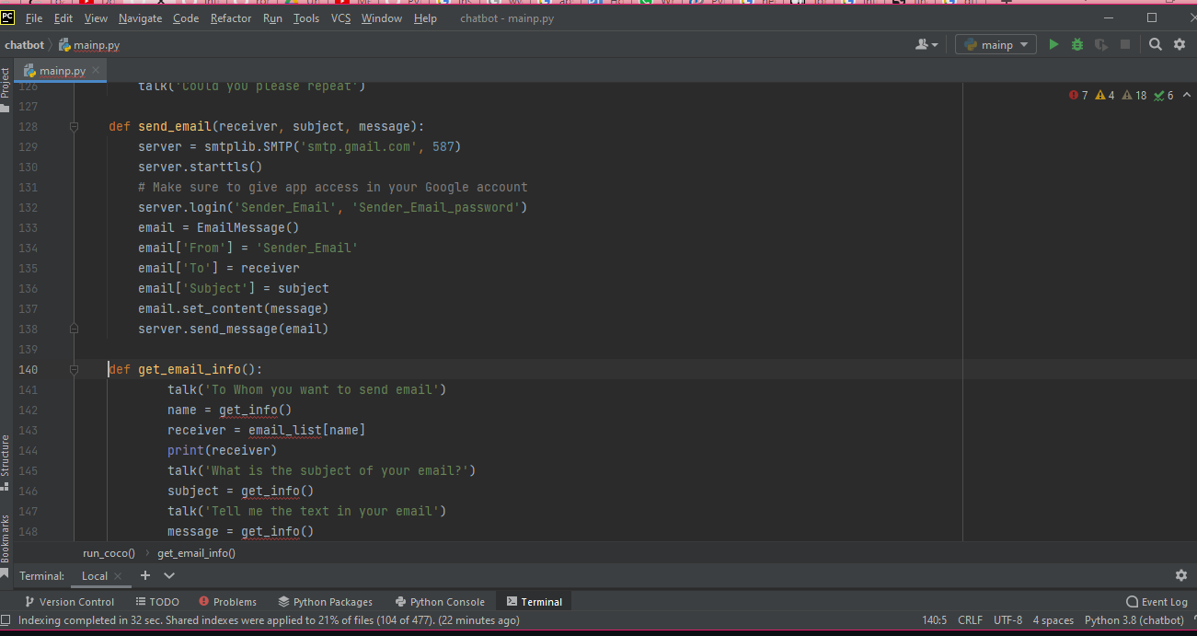

Feature10: Screenshot Feature

Lets you take a screenshot of your screen and save it to the mentioned path

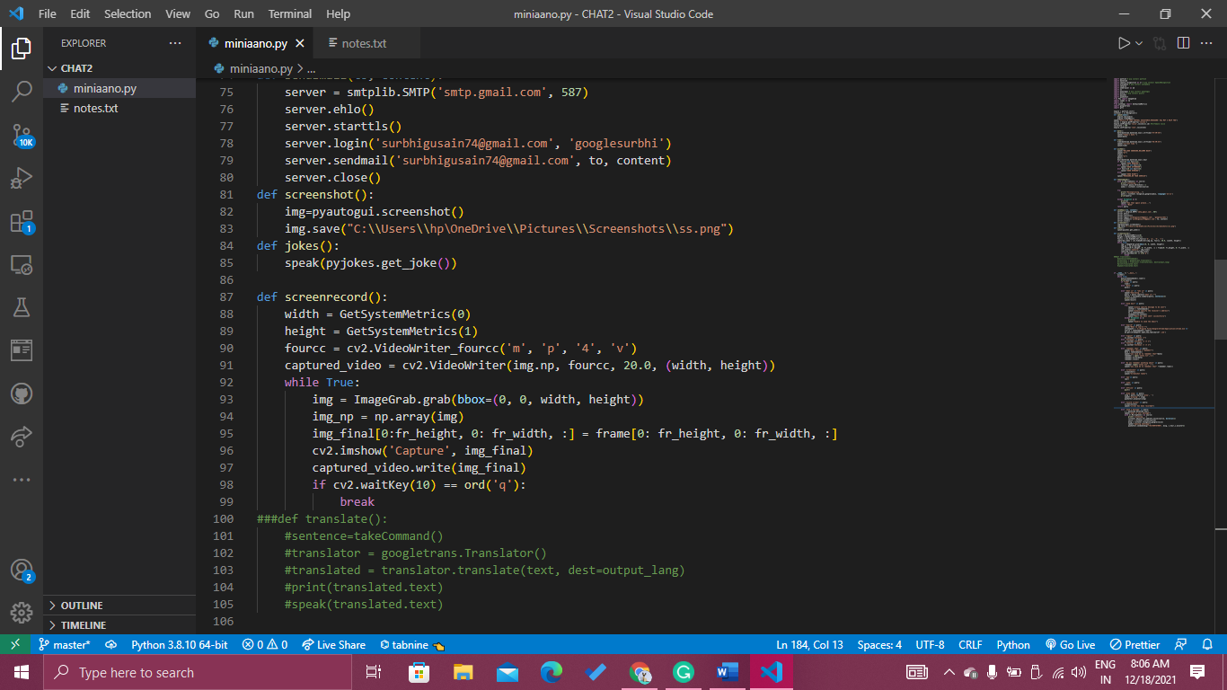

Feature11: Lets you take notes

This AI virtual Assistant lets you take notes in a separate notes file and recall the notes file content when asked to remember them

Feature10: Lets you logout ,shutdown or restart the system

Using the os library function we can access our system and can shutdown ,logout or restart our system

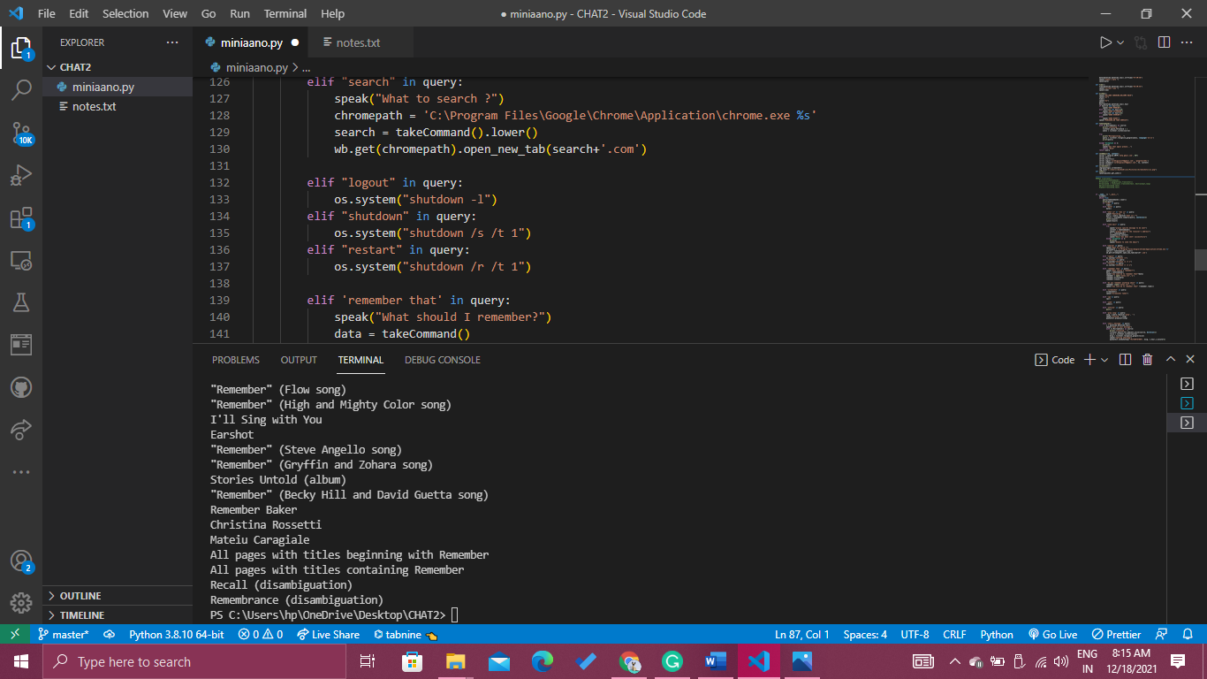

REFERENCES

Author: Surbhi GUSAIN

Resources: You tube Channels

Wikipedia

[https://www.247.ai/resources/articles/ai-virtual-assistant

GitHub