|  |  |
| --- | --- |
| EXP NO: 1(A) | Downloading and installing Hadoop |
|  |
| DATE: |  |

**AIM: -**

**BACKGROUND THEORY: -**

# **PROCEDURE: -**

* Switch to superuser mode using sudo su.
* Update all packages with sudo yum update -y.
* Install Java with sudo yum install java-11-openjdk-devel -y or sudo yum install java-1.8.0-amazon-corretto-devel -y.
* Verify the Java installation using java -version.
* Navigate to /usr/local/ using cd /usr/local/.
* Download Hadoop with sudo wget https://downloads.apache.org/hadoop/common/hadoop-3.3.6/hadoop-3.3.6.tar.gz.
* Extract the Hadoop archive using sudo tar -xvzf hadoop-3.3.6.tar.gz.
* Rename the extracted folder with sudo mv hadoop-3.3.6 hadoop.
* Edit the .bashrc file to add Hadoop and Java environment variables.
* Reload the .bashrc file with source ~/.bashrc and verify Hadoop installation using hadoop version.

# **CODING: -**

* sudo su
* sudo  yum update -y
* sudo yum install java-11-openjdk-devel -y **or** sudo yum install java-1.8.0-amazon-corretto-devel -y
* java -version
* cd /usr/local/
* sudo wget https://downloads.apache.org/hadoop/common/hadoop-3.3.6/hadoop-3.3.6.tar.gz
* sudo tar -xvzf hadoop-3.3.6.tar.gz
* sudo mv hadoop-3.3.6 hadoop
* sudo nano ~/.bashrc
  + # Hadoop variables
  + export HADOOP_HOME=/usr/local/hadoop
  + export PATH=$PATH:$HADOOP_HOME/bin:$HADOOP_HOME/sbin
  + # Java variables
  + export JAVA_HOME=$(readlink -f /usr/bin/java | sed "s:/bin/java::")
  + export PATH=$PATH:$JAVA_HOME/bin
* source ~/.bashrc
* hadoop version

# **OUTPUT: -**

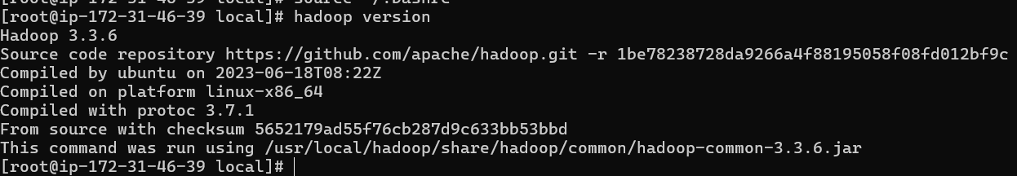

# **RESULT: -**