# Constructors in Java

* Constructor is block of codes is similar to method.
* It is called when an instance is created.
* At the time of constru can create memory for the object is allocated in the memory.
* Which is used to initialize the object.
* Every time an object is created using new() key word,,at least one constur is called.
* If there is no constr available in class ,then it calls a default constr,in such a case java compiler provides a default constructor by default.
* TWO TYPES OF CONSTRUCTORS ARE:
* 1).no-arg constructor (Default constructor)
* 2). parameterized constructor

### **Rules for creating Java constructor**

There are two rules defined for the constructor.

1. Constructor name must be the same as its class name
2. A Constructor must have no explicit return type
3. A Java constructor cannot be abstract, static, final, and synchronized

### **What is the purpose of a default constructor?**

The default constructor is used to provide the default values to the object like 0, null, etc., depending on the type.

### **What is the purpose of Constructor class?**

Java provides a Constructor class which can be used to get the internal information of a constructor in the class. It is found in the java.lang.reflect package.

## **Difference between constructor and method in Java**

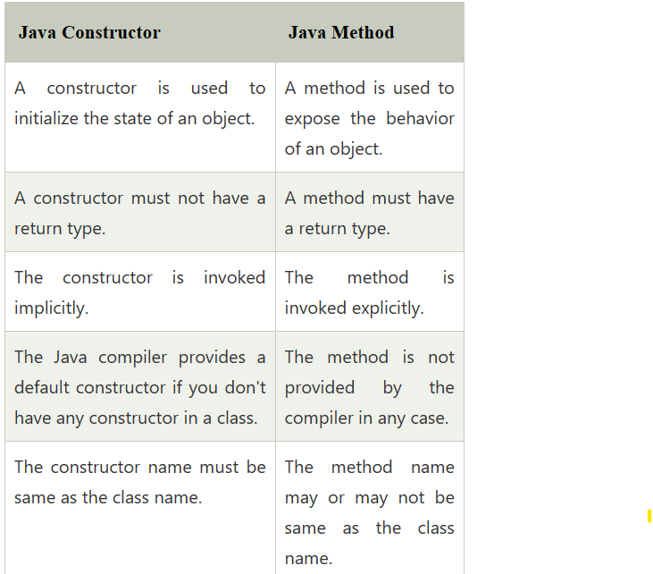

## **Constructor Overloading in Java**

In Java, a constructor is just like a method but without return type. It can also be overloaded like Java methods.

Constructor [overloading in Java](https://www.javatpoint.com/method-overloading-in-java) is a technique of having more than one constructor with different parameter lists. They are arranged in a way that each constructor performs a different task. They are differentiated by the compiler by the number of parameters in the list and their types.