A Minor Project Proposal on
Cyber Surakshya: A Multi-Agent Autonomous
AI Framework
for Real-Time Integrated Cyber Defense

Submitted in Partial Fulfillment of the Requirements for the Degree of
Bachelor of Engineering in Information Technology
under Pokhara University

Submitted by:
Prakanda Sapkota, 221514

Surya Pokhrel, 221521
Sandesh Pokhrel,221518
Bikram Thapa, 221503

Date:
31th May, 2026



Department of INFORMATION TECHNOLOGY
NEPAL COLLEGE OF INFORMATION TECHNOLOGY
Balkumari, Lalitpur, Nepal

Abstract
Cybersecurity threats have grown significantly in scale and sophistication, overwhelming traditional signature-based detection tools and human-operated Security Operations Centers. This project proposes Cyber Surakshya, a lightweight Multi-Agent Autonomous AI Framework for real-time integrated cyber defense. The framework employs five specialized software agents Detection, Analysis, Decision, Response, and Coordinator that communicate through an event-driven pipeline to detect, analyze, and respond to network threats autonomously. Rather than training large language models from scratch, the system leverages pre-existing open-source LLMs such as Llama 3 and Mistral (served locally via Ollama) to provide contextual threat reasoning and natural language explanations. Intrusion detection models are trained on the CICIDS2017 dataset using scikit-learn classifiers and a PyTorch-based anomaly detector. Automated responses include IP blocking, firewall rule updates, and analyst notifications. The system is built using Python, FastAPI, React.js, and containerized with Docker, making it deployable on standard academic hardware.

Keywords: Multi-Agent System, Intrusion Detection, LLM, Anomaly Detection, Autonomous Cyber Defense, FastAPI, CICIDS2017, Ollama, Docker

TABLE OF CONTENTS
Abstract I
Table of Figures II
List of Tables III
1. Introduction 1
1.1 Problem Statement 1
1.2 Project Objectives 1
1.3 Significance of Study 2
1.4 Scope and Limitation 2
2. Literature Review 4
3. Methodology 6
3.1 Theoretical Foundation of Core Intelligence Models 6
1. Random Forest 6
2. Extra Trees (Extremely Randomized Trees) 6
3. HistGradientBoosting 7
4. Reinforcement Learning for Adaptive Decision-Making 7
5. Large Language Model (LLM) 8
6. LLM Orchestration 9
3.3 Team Roles and Responsibilities 10
3.4 Sprint Plan 10
3.5 System Architecture 11
3.6 Technical Implementation 12
4. Tools and Technologies 14
4.1 Core Processing 14
4.2 LLM Integration 14
4.3 Multi-Agent Orchestration 14
4.4 Backend and API 14
4.5 Network Monitoring and Security Tools 14
4.6 Frontend 14
4.7 Deployment 14
5. System Diagrams 15
5.1 Schema / ER Diagram 15
5.2 Use Case Diagram 17
6. Gantt Chart 18
7. Workload Distribution 19
8. Proposed Performance Analysis Methodology and Validation Scheme 19
8.1 Feasibility Study 19
8.2 Evaluation Metrics 19
9. Proposed Deliverables 20
10. References 21

Table of Figures
FIGURE 1 SCRUM FRAMEWORK…………………………………………………10
FIGURE 2 SYSTEM ARCHITECTURE OVERVIEW………………………………11
FIGURE 3 ACTIVITY DIAGRAM…………………………………………………..13
FIGURE 4 SCHEMA / ER DIAGRAM………………………………………………16
FIGURE 5 USE CASE DIAGRAM………………………………………………….17

List of Tables
TABLE 1 GANTT CHART………………………………………………………….18
TABLE 2 WORKLOAD DISTRIBUTION…………………………………………19

1. Introduction
Modern organizations face an increasing volume and variety of cyber threats from automated port scans and brute-force attacks to sophisticated multi-stage intrusions. Conventional defense mechanisms such as signature-based Intrusion Detection Systems (IDS) and manual Security Operations Center (SOC) workflows struggle to keep pace: they cannot detect novel attacks lacking prior signatures, and human analysts are routinely overwhelmed by thousands of daily alerts, most of which are false positives.
Recent advances in machine learning, deep learning, and large language models (LLMs) present an opportunity to automate the most labor-intensive aspects of cyber defense. Multi-agent systems offer a natural architectural fit each agent handles a focused responsibility (detection, analysis, decision, response) and they coordinate through a shared communication layer to produce an end-to-end autonomous defense pipeline.
This project proposes Cyber Surakshya, a practical multi-agent cyber defense framework built using Python, FastAPI, pre-trained LLMs , scikit-learn, and PyTorch. The system is scoped for a 2.5-month development timeline, targeting a functional proof-of-concept deployable on student hardware using Docker.

1.1 Problem Statement
Modern enterprise networks are increasingly exposed to advanced cyber threats such as sophisticated attacks, zero-day vulnerabilities, and automated intrusions that traditional security systems struggle to handle effectively. Existing cybersecurity solutions often operate in separate layers, where threat detection, log analysis, and incident response are disconnected, causing delays and reducing overall efficiency. Most systems depend heavily on human security analysts to validate alerts and respond to incidents, which increases response time and allows attackers to exploit vulnerabilities further. Additionally, traditional rule-based and signature-based methods frequently generate high false alarms and lack the ability to understand the full context of complex multi-stage attacks. Another major limitation is the absence of adaptive learning, as many systems rely on static rules and cannot automatically improve from previously encountered threats. Therefore, there is a need for an intelligent, integrated, and adaptive cybersecurity framework capable of real-time threat detection, contextual analysis, automated response, and continuous learning to improve enterprise cyber defense effectiveness.

1.2 Project Objectives

- To develop an intelligent multi-agent cybersecurity framework for end-to-end threat management, integrating machine learning-based anomaly detection, LLM-driven contextual threat analysis, and reinforcement learning-based adaptive response mechanisms for real-time cyberattack detection, prevention, and mitigation.

- To design a coordinated and adaptive security architecture capable of synchronizing communication between intelligent agents, optimizing decision-making processes, and continuously improving detection and response strategies through feedback-driven adaptive learning.
- To evaluate and compare the proposed framework with traditional cybersecurity systems using benchmark datasets such as the CICIDS2017 Dataset, analyzing performance in terms of detection accuracy, false positive rate, contextual threat understanding, response effectiveness, and overall end-to-end detection-to-response capability.

1.3 Significance of Study
- Reduces reliance on human analysts for routine alert triage, significantly lowering response time from hours to seconds.
- Applies LLMs in a practical, resource-efficient manner using pre-trained models via Ollama rather than expensive training infrastructure.
- Provides an open-source, containerized cyber defense framework suitable for small organizations and academic labs in Nepal with limited cybersecurity budgets.
- Produces an end-to-end evaluated system using the CICIDS2017 benchmark, enabling direct performance comparison with published literature.
- Serves as a reusable research foundation for future work in autonomous security, agentic AI, and network defense at NCIT and Pokhara University.

1.4 Scope and Limitation
Scope:
- To focus on network-level cyber threat detection by analyzing network traffic, protocol flows, and packet features using benchmark datasets such as the CICIDS2017 Dataset.
- To simulate a multi-agent cybersecurity environment consisting of Detection, Analysis, Decision, Response, and Coordinator agents for integrated threat management.
- To implement an automated hybrid response mechanism combining rule-based decisions and reinforcement learning for intelligent threat mitigation.
- To incorporate an adaptive learning process that continuously improves detection models and security policies based on resolved cyber incidents.

Limitations:
- The system is tested in a controlled laboratory environment using replayed traffic; live production deployment is not within scope.
- LLM inference using a 7B-parameter quantized model introduces 2–5 second latency per reasoning query, making it unsuitable for per-packet decisions; it operates at the decision-support level only.
- The detection model is trained exclusively on CICIDS2017; novel attack vectors absent from this dataset may not be detected reliably.
- Automated response is limited to network-layer controls; application-layer and physical infrastructure controls are out of scope.

2. Literature Review
The field of autonomous cyber defense has increasingly explored the use of multi-agent systems and reinforcement learning to improve real-time threat detection and response capabilities. Wiebe et al. [1] introduced a cooperative Multi-Agent Reinforcement Learning (MARL) framework where defensive agents learn cybersecurity strategies from scratch within simulated environments. Their work demonstrated that collaborative agents can independently develop defensive tactics without predefined attack signatures, highlighting the effectiveness of reinforcement learning in dynamic cyber environments. Similarly, Contractor et al. [2] extended this concept by enabling MARL agents to communicate with one another during cyber defense tasks. Their findings showed that inter-agent communication significantly improves coordination, resource sharing, and overall defense effectiveness in autonomous security operations. However, both studies are primarily limited to simulation-based environments and focus mainly on reinforcement learning coordination without integrating contextual reasoning mechanisms such as Large Language Models (LLMs) or real-world benchmark intrusion datasets. These limitations motivate the inclusion of a dedicated Coordinator Agent and structured communication layer in the proposed framework to enable synchronized decision-making across multiple intelligent entities.
Recent research has also investigated the integration of supervised learning and reinforcement learning to create more adaptive and generalized cyber defense agents. Farooq and Kunz [3] proposed a hybrid framework combining supervised learning with reinforcement learning to train a generic defensive cyber agent capable of adapting across multiple network topologies and attack scenarios. Their approach demonstrated improved learning efficiency compared to standalone reinforcement learning systems and highlighted the importance of combining predictive intelligence with adaptive behavior. Likewise, Wilson et al. [4] explored MARL-based cybersecurity for maritime operational technology systems, demonstrating that reinforcement learning can effectively support threat mitigation within critical infrastructures. Despite their strong contributions, these studies primarily focus on adaptive decision-making and lack advanced semantic reasoning capabilities for interpreting system logs or understanding attack context. Additionally, they do not incorporate a complete end-to-end pipeline connecting threat detection, contextual analysis, and automated response execution. These gaps support the need for a unified architecture that combines machine learning detection models with intelligent reasoning and adaptive response strategies.
The emergence of Large Language Models (LLMs) has introduced new possibilities for contextual cybersecurity reasoning and autonomous threat analysis. Castro et al. [5] conducted one of the first empirical studies evaluating LLMs, including GPT-4 and Llama 2, as autonomous cyber defenders in the CybORG CAGE 4 simulation environment. Their findings revealed that pre-trained LLMs can successfully interpret network states, reason about cyber threats, and recommend defensive actions without requiring task-specific training. Similarly, Ahmed et al. [6] proposed a hierarchical cybersecurity framework in which reinforcement learning agents generate defense actions that are subsequently evaluated by LLM-based critics before execution. This architecture demonstrated improved decision quality and reduced unsafe responses in autonomous cyber defense systems. However, both approaches depend heavily on proprietary or cloud-hosted LLM infrastructures, increasing operational cost and limiting practical deployment flexibility. Furthermore, neither framework integrates a dedicated anomaly detection layer based on machine learning models for network traffic analysis. These limitations justify the proposed system’s use of locally deployable intelligence models combined with LLM-based reasoning to improve practicality and contextual understanding.
Several recent studies emphasize the importance of self-learning, orchestration, and adaptive intelligence in modern cybersecurity architectures. Erigha et al. [7] proposed self-learning autonomous cyber defense agents for Security Operations Centers (SOCs), emphasizing real-time threat monitoring and automated incident handling. Likewise, Xu et al. [8] introduced the L2M-AID framework, which combines LLM semantic reasoning with multi-agent reinforcement learning for industrial cyber-physical defense, achieving improved detection accuracy and operational stability. Although these studies represent important advancements toward autonomous cyber defense, they still face limitations in achieving complete integration across detection, reasoning, coordination, and response layers within a unified framework. Existing literature consistently reveals three major research gaps: (1) the absence of a fully integrated end-to-end cybersecurity pipeline connecting detection, reasoning, decision-making, and automated response; (2) excessive reliance on proprietary or impractical AI infrastructures; and (3) evaluation predominantly within simulated environments rather than benchmark intrusion datasets. Therefore, the proposed framework aims to address these limitations by developing a practical, adaptive, and multi-agent autonomous cybersecurity system capable of real-time detection, contextual analysis, coordinated response, and continuous learning.

3. Methodology

3.1 Theoretical Foundation of Core Intelligence Models
The proposed multi-agent cybersecurity framework integrates multiple Artificial Intelligence (AI) approaches to enable intelligent threat detection, contextual analysis, and automated response. The framework combines ensemble machine learning models, deep reinforcement learning, Large Language Models (LLMs), and orchestration mechanisms to create a coordinated cybersecurity defense system. Each model contributes a unique theoretical capability toward understanding network behavior and responding to cyber threats.

1. Random Forest
The Random Forest algorithm is an ensemble machine learning model that operates by constructing multiple independent decision trees and combining their predictions to improve classification reliability. The theoretical foundation of Random Forest lies in the principle of collective decision-making, where multiple weak learners work together to produce a stronger and more stable prediction.
Each decision tree in the forest independently analyzes input features and creates branching decisions based on selected attributes. During this process, the model introduces randomness by selecting subsets of features and training samples, ensuring that individual trees develop different decision structures. Rather than depending on a single pathway for classification, the algorithm aggregates outputs from all trees through a majority voting mechanism.
The ensemble structure helps reduce model variance and minimizes overfitting, which commonly occurs when a single decision tree memorizes training patterns too closely. Since many independent trees participate in prediction, the model becomes more robust to noise and uncertainty within data distributions.
Theoretically, Random Forest is particularly effective in handling nonlinear relationships among variables because different trees capture different feature interactions simultaneously. This characteristic makes the algorithm suitable for environments where behavioral patterns are diverse and difficult to represent through simple statistical rules.

2. Extra Trees (Extremely Randomized Trees)
The Extra Trees algorithm, also known as Extremely Randomized Trees, is another ensemble learning model based on collections of decision trees. While conceptually similar to Random Forest, its theoretical distinction lies in the introduction of higher levels of randomness during tree construction.
Instead of searching for the most optimal split point at each decision node, Extra Trees randomly selects splitting thresholds for chosen features. This increased randomness forces the model to create highly diverse tree structures, reducing dependency on specific feature distributions.
The theoretical motivation behind this design is that greater structural diversity among decision trees improves the model’s generalization ability. Since individual trees are intentionally randomized, the ensemble becomes less sensitive to data irregularities and less prone to overfitting.
Extra Trees operates on the assumption that aggregating many highly randomized classifiers can still reveal stable underlying patterns within complex datasets. The averaging of predictions across multiple trees reduces prediction variance and improves overall robustness.
From a theoretical perspective, this model emphasizes diversity over optimization, making it useful in situations where decision boundaries are highly complex and variable.

3. HistGradientBoosting
The HistGradientBoosting model is a gradient boosting algorithm designed to improve prediction performance through sequential error correction. Its theoretical basis originates from the concept of boosting, where multiple weak predictive models are combined incrementally to form a stronger learner.
Unlike parallel ensemble methods, HistGradientBoosting constructs trees sequentially. Each new model is designed specifically to minimize the errors generated by previous models. This iterative correction mechanism gradually improves predictive accuracy by focusing learning efforts on previously misclassified patterns.
The algorithm relies on gradient optimization principles, where prediction errors are represented mathematically and reduced through successive adjustments. Each iteration attempts to optimize a predefined loss function, allowing the model to converge toward increasingly accurate outcomes.
A distinctive theoretical characteristic of HistGradientBoosting is its use of histogram-based feature partitioning. Instead of processing continuous numerical values individually, the algorithm groups values into bins or intervals. This discretization reduces computational complexity while preserving meaningful feature relationships.
Theoretically, HistGradientBoosting excels at capturing nonlinear relationships and subtle feature interactions because each sequential stage continuously refines the model’s understanding of hidden data structures.

4. Reinforcement Learning for Adaptive Decision-Making
The framework incorporates Reinforcement Learning (RL) as an adaptive learning mechanism for intelligent cybersecurity response. Reinforcement Learning is a branch of machine learning based on the concept of learning through interaction with an environment.
The theoretical foundation of RL originates from behavioral psychology, where an agent learns optimal actions by receiving rewards or penalties based on its decisions. Rather than learning from labeled examples, the system continuously explores possible actions and evaluates their outcomes.
An RL system typically consists of four fundamental components:
- Agent – the decision-making entity
- Environment – the system in which actions occur
- Actions – possible decisions available to the agent
- Reward Signal – feedback indicating success or failure
The agent observes the current environmental state, selects an action, and receives feedback in the form of rewards or penalties. Through repeated interactions, the model gradually learns a policy that maximizes long-term rewards.
In cybersecurity contexts, this theoretical mechanism enables systems to adapt dynamically to changing threat environments rather than relying solely on predefined responses. Reinforcement Learning supports continuous improvement and autonomous decision-making under uncertainty.
A commonly used RL approach is the Deep Q-Network (DQN), which combines reinforcement learning with neural networks to estimate the value of actions within complex environments.

5. Large Language Model (LLM)
A Large Language Model (LLM) is a deep neural network architecture designed to understand, process, and generate human language. The theoretical foundation of LLMs is based on transformer architecture, which enables contextual reasoning across large sequences of text.
LLMs are trained on extensive collections of textual and code-based information to learn linguistic structures, semantic relationships, contextual meaning, and logical dependencies between words and sentences.
The model functions through a mechanism called self-attention, which allows it to determine relationships between different parts of an input sequence simultaneously. Instead of processing text sequentially like traditional recurrent models, transformers analyze entire contexts in parallel, enabling stronger contextual understanding.
Theoretically, an LLM operates by predicting the most probable next sequence of tokens based on learned statistical and semantic relationships. However, beyond simple prediction, modern LLMs demonstrate advanced capabilities such as:
- Semantic reasoning
- Contextual understanding
- Pattern recognition in textual information
- Summarization and interpretation
- Knowledge synthesis
In cybersecurity environments, the theoretical importance of LLMs lies in their ability to analyze unstructured textual information such as logs, alerts, incident descriptions, and threat reports, transforming fragmented information into meaningful contextual intelligence.

6. LLM Orchestration
While Large Language Models possess strong reasoning capabilities, they function primarily as inference systems and do not independently coordinate external software components. To address this limitation, the framework incorporates an LLM Orchestration Layer.
The theoretical role of orchestration is to act as a coordination mechanism that enables interaction between language models, machine learning systems, software agents, and operational tools.
LLM orchestration manages:
- Context handling
- Prompt construction
- Information routing
- State synchronization
- Structured output generation
Instead of allowing unrestricted model outputs, orchestration frameworks guide model behavior through structured prompts and controlled execution pipelines. The system maintains contextual continuity across multiple interactions, enabling the model to reason consistently during extended operational processes.
Another important theoretical function of orchestration is output standardization. Since LLMs naturally produce free-form text, orchestration mechanisms convert responses into structured formats that other system components can interpret consistently.
Theoretically, orchestration transforms isolated language intelligence into coordinated system intelligence, enabling seamless communication among multiple agents within a distributed framework.

Given the 2.5-month project duration and a four-member team, we adopt an Agile development methodology using a simplified Scrum framework. Agile's iterative sprint model allows us to develop, test, and demo system components in short cycles essential when individual agents (detection, LLM reasoning, response) each have independent integration risks. Each sprint is one week long with a planning session, daily standups, and a sprint review at the end.

3.2 Agile Development Approach

Agile facilitates iterative and incremental development. Our four-member team will work in short, weekly sprints. Each sprint will consist of sprint planning, development, testing, and sprint review.
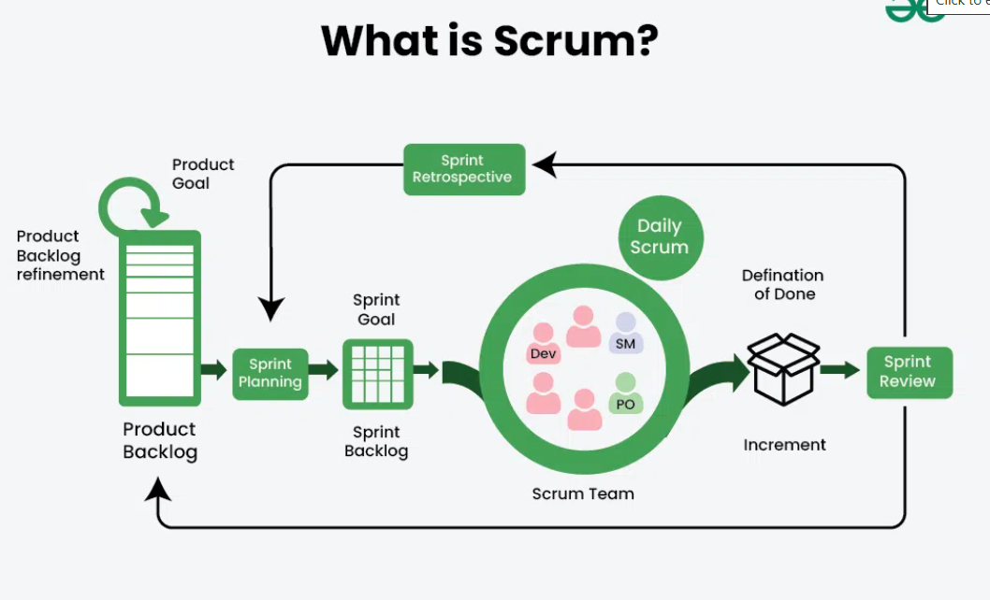
Fig 1: Scrum Framework

3.3 Team Roles and Responsibilities
Role | Responsibilities
Scrum Master | Organizes sprint meetings, tracks progress, removes blockers
Product Owner | Manages requirements, acceptance criteria, demo coordination
ML/AI Developer | Detection Agent (CICIDS2017 model), anomaly detector, LLM integration (Ollama)
Backend/DevOps | FastAPI agents, Docker Compose, Suricata integration, Response Agent

3.4 Sprint Plan
The project is divided into ten weekly sprints across 2.5 months:
- Sprint 1 (Week 1): Requirements, environment setup, CICIDS2017 download and EDA, Docker skeleton.
- Sprint 2 (Week 2): Data preprocessing pipeline; RF/XGBoost classifier training and evaluation on CICIDS2017.
- Sprint 3 (Week 3): Zeek integration for real-time flow extraction; Detection Agent FastAPI wrapper.
- Sprint 4 (Week 4): Analysis Agent alert correlation, MITRE ATT&CK mapping, severity scoring.
- Sprint 5 (Week 5): Ollama setup ; LLM prompt engineering for threat reasoning.
- Sprint 6 (Week 6): Decision Agent rule-based + LLM-assisted action selection; Coordinator Agent .
- Sprint 7 (Week 7): Response Agent iptables, Suricata rule update, alert notification API.
- Sprint 8 (Week 8): End-to-end pipeline integration; Redis message bus; full agent communication testing.
- Sprint 9 (Week 9): React.js dashboard; performance benchmarking; baseline comparisons.
- Sprint 10 (Week 10): Bug fixing, documentation, demo video, final report, defense preparation.

3.5 System Architecture
Cyber Surakshya consists of five agents communicating via a Redis pub/sub message bus, exposed through a FastAPI REST layer, and monitored via a React dashboard. The high-level architecture is shown below:

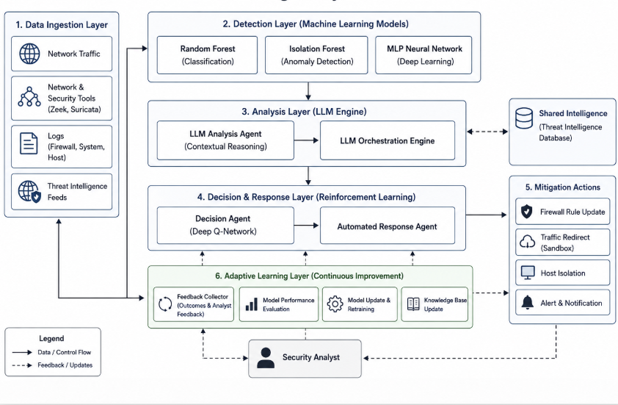
Fig 2: Cyber Surakshya System Architecture Overview

3.6 Technical Implementation
- Detection Agent (ML Anomaly Engine): This agent continuously processes streaming network data. It uses an optimized supervised and unsupervised hybrid model (e.g., Random Forest combined with Isolation Forest or a deep neural network) to flag statistical deviations and payload anomalies against standard baselines.
- Analysis Agent (LLM Reasoning Layer): When the Detection Agent triggers an alert, the Analysis Agent parses the raw log outputs, contextual payloads, and historical network logs. Utilizing a specialized, local open-source LLM, it translates raw alerts into a semantic breakdown detailing intent, severity, and threat type.
- Decision Agent (Rule + RL Hybrid Engine): This agent ingests the structured threat assessment from the Analysis Agent. It routes clear, high-severity threats through a deterministic rule-based matrix for instant containment, while mapping unknown or multi-stage vectors to a Deep Q-Network (DQN) or Proximal Policy Optimization (PPO) model to determine the mathematically optimal mitigation policy.
- Response Agent (Automated Execution Layer): This agent interacts directly with the network simulation environment. It executes the precise commands issued by the Decision Agent, such as updating IPTables, terminating malicious processes, or isolating compromised host nodes.
- Coordinator Agent (Orchestration Plane): Acting as the communication core, this agent manages message queues, synchronizes states, passes JSON payloads securely between agents, and prevents data conflicts or execution deadlocks.
- Adaptive Learning Layer (Feedback Loop): Once a threat is resolved, this layer extracts the complete execution history, telemetry logs, and response outcome metrics. It dynamically adjusts routing rules, adds refined indicators to the firewall matrix, and triggers incremental background retraining of the Detection Agent's anomaly weights.

3.7 Activity Diagram
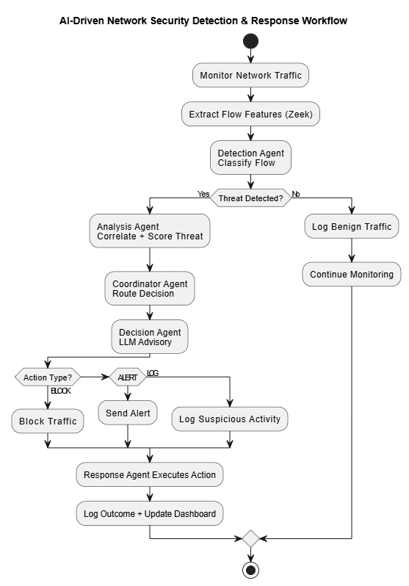
Fig 3: Activity Diagram Cyber Surakshya Threat Response Flow

4. Tools and Technologies

4.1 Core Processing
Python 3.11 serves as the primary implementation language for all agents and ML pipelines. scikit-learn provides the Random Forest and XGBoost classifiers along with preprocessing utilities. PyTorch is used for the lightweight Autoencoder anomaly detector. NumPy and pandas handle dataset preprocessing and feature engineering.

4.2 LLM Integration
Ollama is used to locally serve pre-trained quantized LLMs without internet dependency or API cost. LangChain provides the prompt templating and JSON output parsing layer between the Decision Agent and the Ollama inference server.

4.3 Multi-Agent Orchestration
CrewAI is used for the Coordinator Agent to manage task delegation, agent state, and priority queuing. Redis (pub/sub) provides the asynchronous message bus for inter-agent event passing with JSON-schema-defined message envelopes.

4.4 Backend and API
FastAPI (Python) exposes each agent as an independent microservice with REST endpoints. Pydantic models enforce strict input/output schemas. PostgreSQL stores alert events, action logs, and configuration data. MongoDB stores unstructured threat intelligence data from external feeds.

4.5 Network Monitoring and Security Tools
Zeek performs deep packet inspection and generates connection logs with flow-level statistics used as real-time feature inputs to the Detection Agent. Suricata runs in IDS/IPS mode for initial signature-based alerting and is updated by the Response Agent. Wireshark is used for traffic capture and PCAP replay in evaluation.

4.6 Frontend
React.js builds the analyst monitoring dashboard with components for live alert feeds, agent status indicators, incident timeline, and threat statistics. Axios handles REST API communication with the backend. Chart.js renders detection rate and response time metrics. The dashboard is served as a static build from an Nginx container.

4.7 Deployment
Docker and Docker Compose containerize all components (one container per agent, plus Redis, PostgreSQL, MongoDB, Ollama, Zeek, Suricata, Nginx). The full stack is deployed on Ubuntu 22.04 LTS. MLflow tracks model training experiments and stores model artifacts. Git / GitHub manages version control.

Category | Technology / Tool
Language | Python 3.11
ML / DL | scikit-learn, PyTorch, XGBoost, NumPy, pandas
LLM (pre-trained) | Ollama
Agent Framework | LangChain, Redis Pub/Sub
Backend API | FastAPI, Pydantic
Database | PostgreSQL (structured)
Network Tools | Zeek, Suricata, Wireshark
Frontend | React.js, Chart.js, Axios, Nginx
Deployment | Docker, Docker Compose, Ubuntu 22.04
ML Tracking | MLflow

Table: Technology Stack Summary

5. System Diagrams

5.1 Schema / ER Diagram
Raw_log: Stores collected raw network/system logs from different sources.

Asset: Maintains information about devices or systems such as IP address, hostname, operating system, and criticality level.

Flow_record: Converts parsed logs into structured network flow records containing source/destination IPs, ports, packet counts, and timestamps and links traffic flows to related assets.

Detection_event : Stores AI/ML-based threat detection results including anomaly score, classification label, confidence score, severity, and MITRE technique mapping.

Response_action: Records automated or manual security responses triggered by detection events such as blocking IPs or isolating hosts.Includes execution results and LLM rationale.

Analyst_case: Supports human analyst investigations and case management for detected incidents.

Notification: Handles alerts and notifications sent after response actions, including delivery status and communication channel.

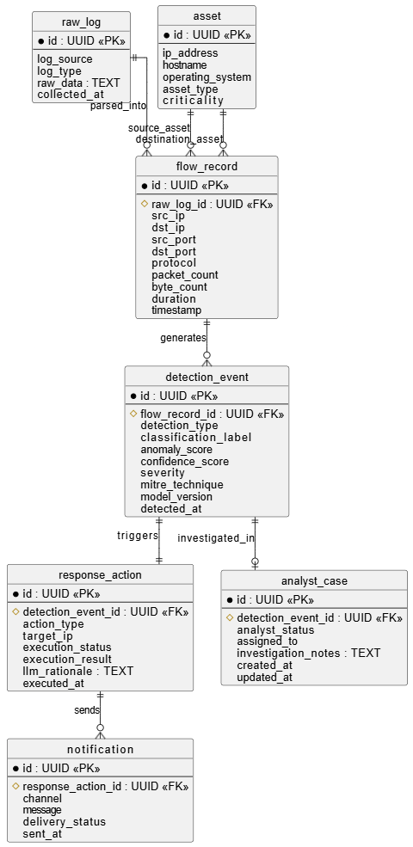

Fig 4: Schema / ER Diagram

5.2 Use Case Diagram
The system serves three actors: the Network (as the source of traffic events), the Analyst (who receives alerts and can override actions), and the Admin (who manages user accounts and system configuration).

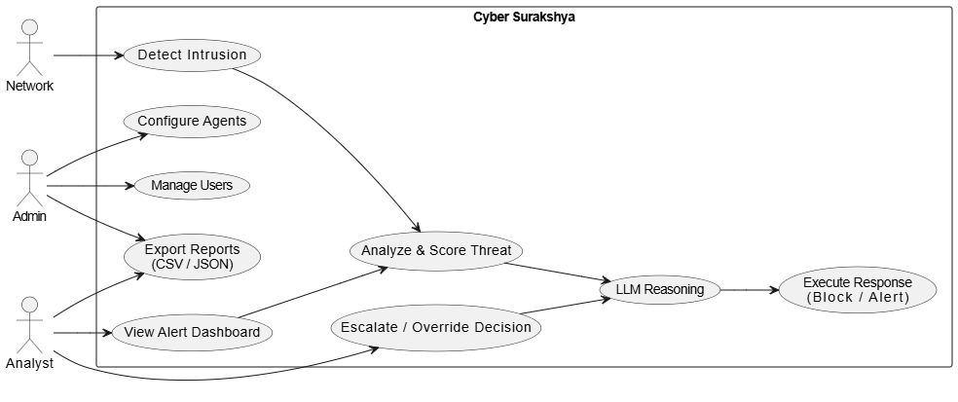
Fig 5: Use Case Diagram

6. Gantt Chart

ID | Task | W1 | W2 | W3 | W4 | W5 | W6 | W7 | W8 | W9 | W10
1 | Requirement Analysis & Setup | ██ | █
2 | CICIDS2017 Preprocessing & Model Training |  | ██ | ██
3 | Detection Agent + Zeek Integration |  |  | ██ | ██
4 | Analysis Agent + MITRE Mapping |  |  |  | ██ | █
5 | LLM Setup (Ollama + Prompt Eng.) |  |  |  |  | ██ | ██
6 | Decision + Coordinator Agent |  |  |  |  |  | ██ | ██
7 | Response Agent + iptables/Suricata |  |  |  |  |  |  | ██ | █
8 | Full Integration + Redis Message Bus |  |  |  |  |  |  |  | ██ | █
9 | Dashboard + Evaluation + Benchmarking |  |  |  |  |  |  |  |  | ██ | ██
10 | Documentation, Report & Defense Prep |  |  |  |  |  |  |  |  | █ | ██

Table 1: Gantt Chart (10 Weeks / 2.5 Months)

7. Workload Distribution

Member | Role and Responsibilities
Surya Pokhrel | ML/AI Lead CICIDS2017 preprocessing, RF/XGBoost training, anomaly detector, Ollama LLM integration
Bikram Thapa | Backend Lead FastAPI agent services, Redis message bus, PostgreSQL schema, Docker Compose configuration
Prakanda Sapkota | Security/DevOps Zeek integration, Suricata Response Agent, iptables automation, network lab setup
Sandesh Pokhrel | Frontend/Docs React.js dashboard, Chart.js, final report writing, presentation, demo video

Table 2: Workload Distribution

8. Proposed Performance Analysis Methodology and Validation Scheme

8.1 Feasibility Study
- Technical Feasibility: The team will leverage accessible, open-source python infrastructure including scikit-learn and PyTorch for building detection models, Stable-Baselines for reinforcement learning components.
- Data Feasibility: The framework utilizes the fully verified, open-access CICIDS2017 dataset, which contains comprehensive PCAPs and labeled CSV logs reflecting diverse modern cyberattacks (including DoS, DDoS, Brute Force, and Infiltration).

8.2 Evaluation Metrics
The framework's performance will be quantified using the following engineering metrics:
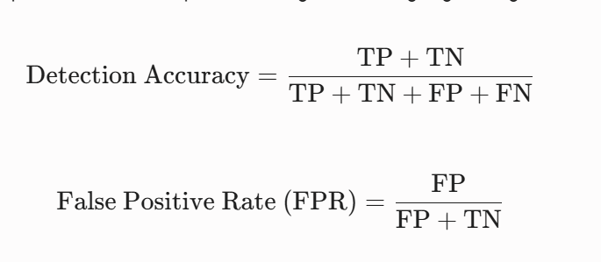
- Response Time : Defined as the total elapsed duration from the exact millisecond an anomaly hits the network layer to the successful execution of the mitigation containment command by the Response Agent.
- System Efficiency: Measured by tracking memory consumption, network messaging overhead, and CPU utilization across agent coordination pools.

8.3 Validation Scheme
The prototype will be validated through an isolated network simulator testbed. The system will ingest labeled attack traffic from the CICIDS2017 dataset. The validation process will evaluate:
- The classification accuracy and error rates of the isolation detection model.
- The precision and processing latency of the LLM parser.
- The ability of the RL agent to successfully select containment actions that isolate malicious traffic without shutting down legitimate simulated background protocols, minimizing processes disruptions.

9. Proposed Deliverables
- Functional Software Suite: The project will deliver an operational, containerized multi-agent software system that can be deployed instantly via Docker Compose to detect, analyze, and counter cyber threats in real time.
- Trained Intelligence Models: It will include a complete set of pre-trained and saved artificial intelligence models, tracking their accuracy against standard datasets within a centralized MLflow management registry.
- Interactive Security Dashboard: A live Grafana-based security console will be provided to visually map out ongoing threat timelines, monitor agent operational statuses, and log automated firewall containment actions.
- Technical Documentation: Comprehensive engineering manuals will accompany the project, detailing the underlying software architecture, programmatic API specifications, and clear guides for system deployment and model retraining.
- Academic Thesis and Evaluation Report: Finally, the team will produce an official academic project report and performance evaluation paper written in strict compliance with Pokhara University Project III guidelines to mathematically validate the framework's response speed and efficiency.

References
- Wiebe, J., Al Mallah, R., & Li, L. (2023). Learning cyber defence tactics from scratch with multi-agent reinforcement learning. arXiv.
- Contractor, F., Li, L., & Al Mallah, R. (2025, July 12–15). Learning to communicate in multi-agent reinforcement learning for autonomous cyber defence. In Proceedings of the 2025 International Conference on Machine Learning and Cybernetics (ICMLC).
- Farooq, M., & Kunz, T. (2025). Combining supervised and reinforcement learning to build a generic defensive cyber agent. Journal of Cybersecurity and Privacy, 5(?), ?–?.
- Wilson, A., Menzies, R., Morarji, N., Foster, D., Mont, M. C., Turkbeyler, E., & Gralewski, L. (2024). Multi-agent reinforcement learning for maritime operational technology cyber security.
- Xu, T., Wen, Z., Zhao, X., Wang, J., Li, Y., & Liu, C. (2025, October 8–11). Large language models are autonomous cyber defenders [Conference details not provided].
- Ahmed, H., Iqbal, S., Pinto Neto, E. C., Buffett, S., Sultana, M., & Taylor, A. (2025, October 27–29). Autonomous multi-agent cyber defense: A novel approach using reinforcement learning with hierarchical LLM critics. In Proceedings of the 2025 Cyber Awareness and Research Symposium (CARS).
- N. S., & S. K. (2025, December 12–14). Self-learning autonomous cyber defense agents in AI-empowered security operations [Exact title approximated from: Artificial Intelligence-Powered Cybersecurity Reinforcement Agents: Self-Supervised Deep Representation Learning Using High-Dimensional Real-Time Attack Mitigation Techniques]. In Proceedings of the 2025 IEEE 5th International Conference on ICT in Business Industry & Government (ICTBIG).
- Xu, T., Wen, Z., Zhao, X., Wang, J., Li, Y., & Liu, C. (2025, October 8–11). L2M-AID: Autonomous cyber-physical defense by fusing semantic reasoning of large language models with multi-agent reinforcement learning. In Proceedings of the 2025 IEEE 24th International Conference on Trust, Security and Privacy in Computing and Communications (TrustCom).

