

ITA1416-ETHICAL HACKING
SLOT B
Dr. K RAMESH KUMAR
PRESENTED BY:
SURU SAI KEERTHI [192424368]
1 | netsh interface show interface
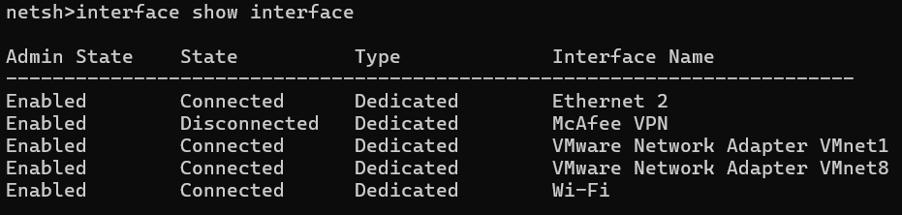
2. netsh interface ipv4 show interfaces
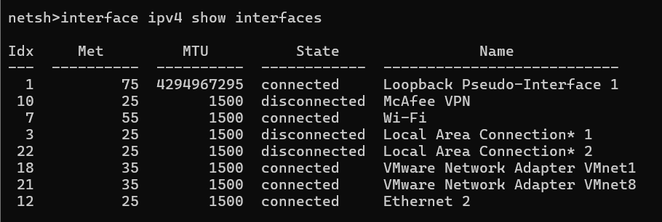
3. netsh interface ipv6 show interfaces
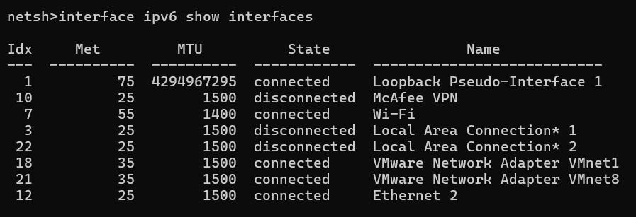

4. netsh interface ip show config
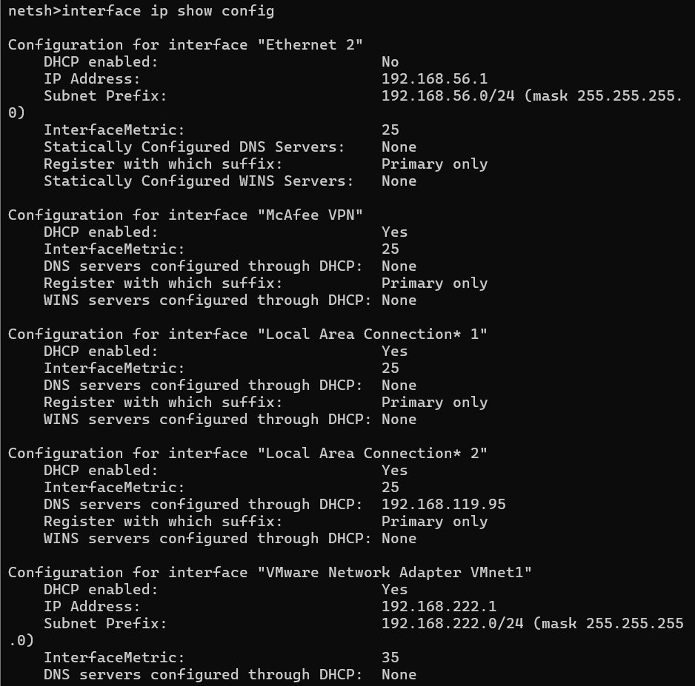
5. netsh interface ipv4 show config
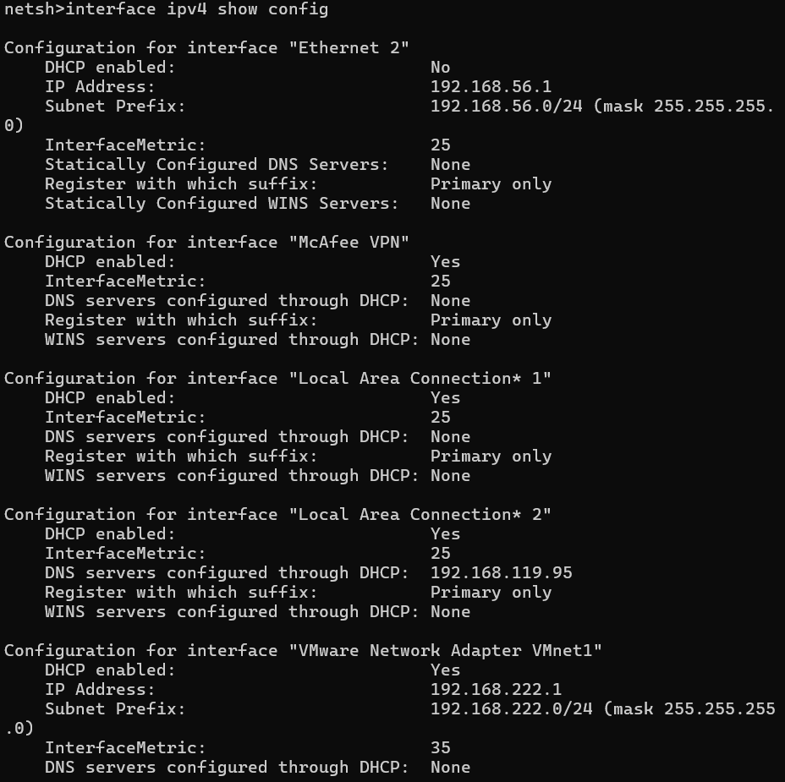
6. interface ipv6 show addresses
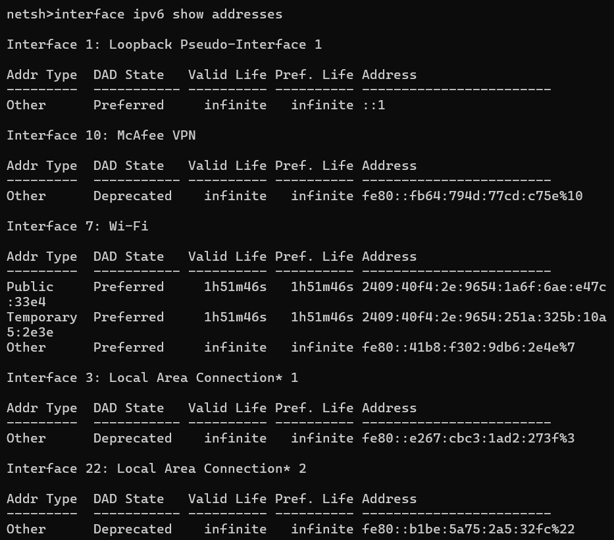
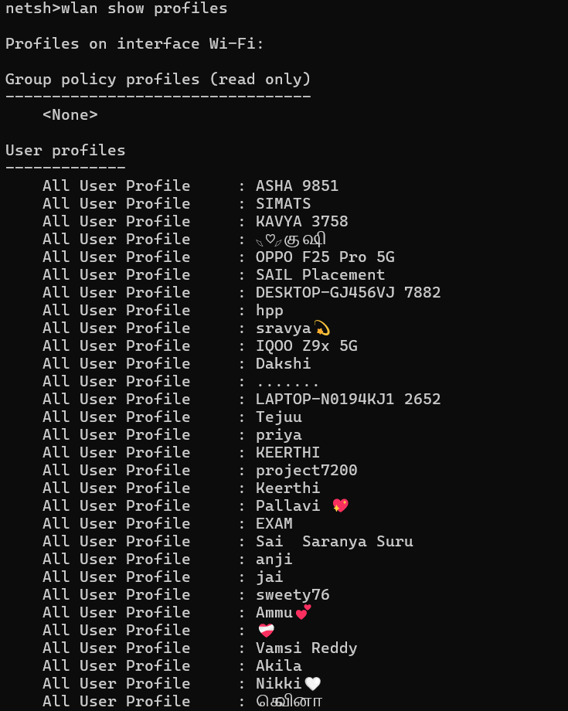
7. wlan show profiles

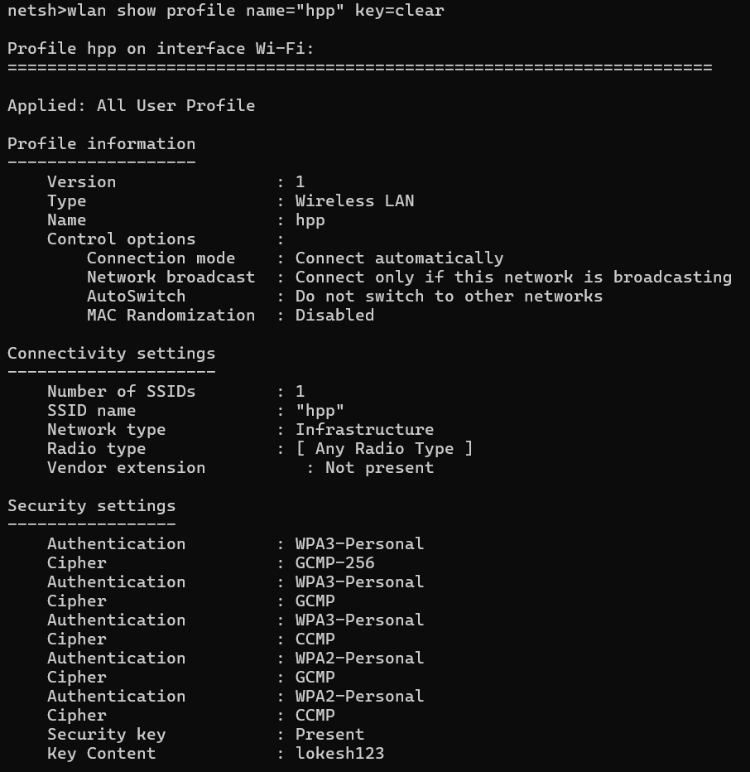
8. wlan show profile name="WiFi_Name" key=clear

9. wlan show drivers
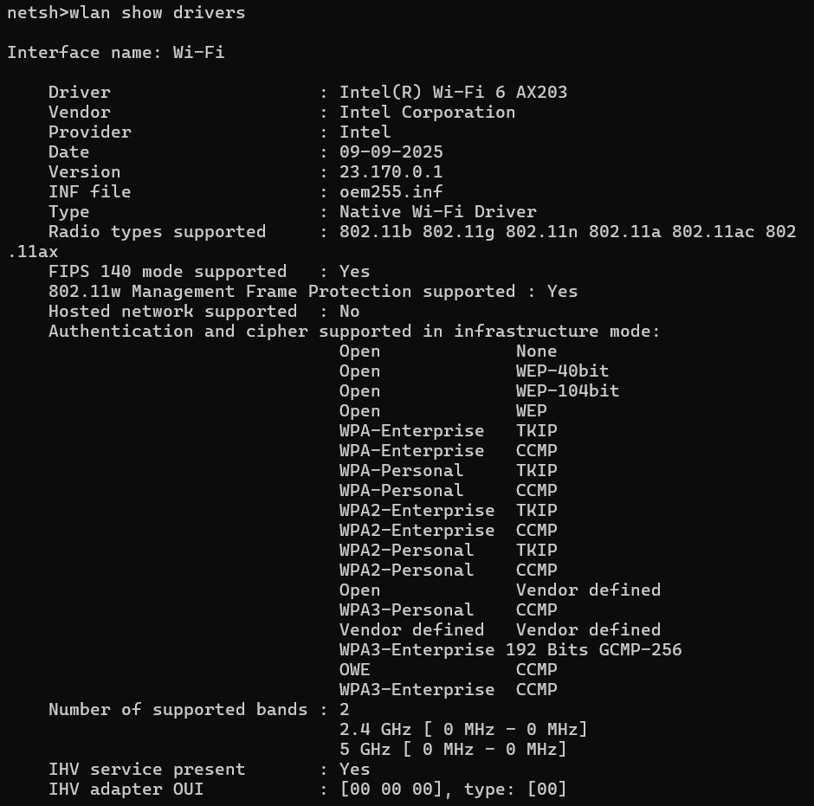

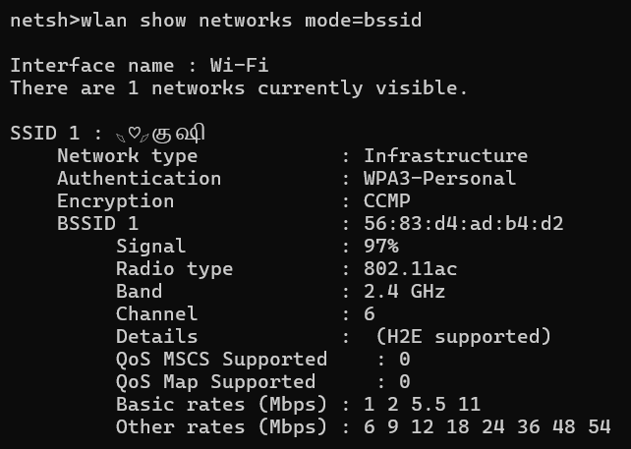
10. wlan show networks mode=bssid

11. advfirewall show currentprofile
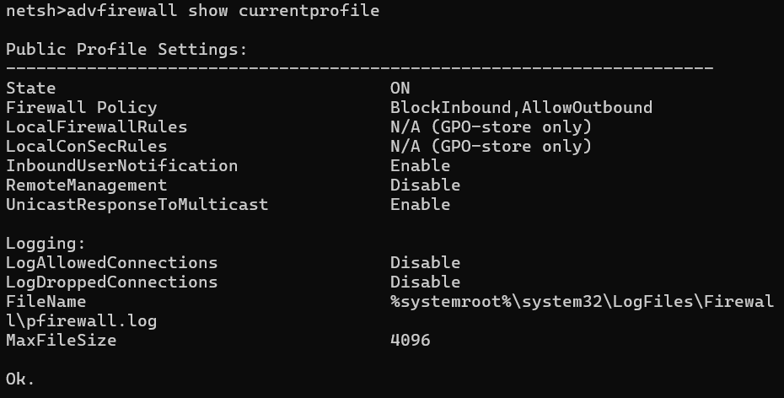
12. advfirewall show allprofiles
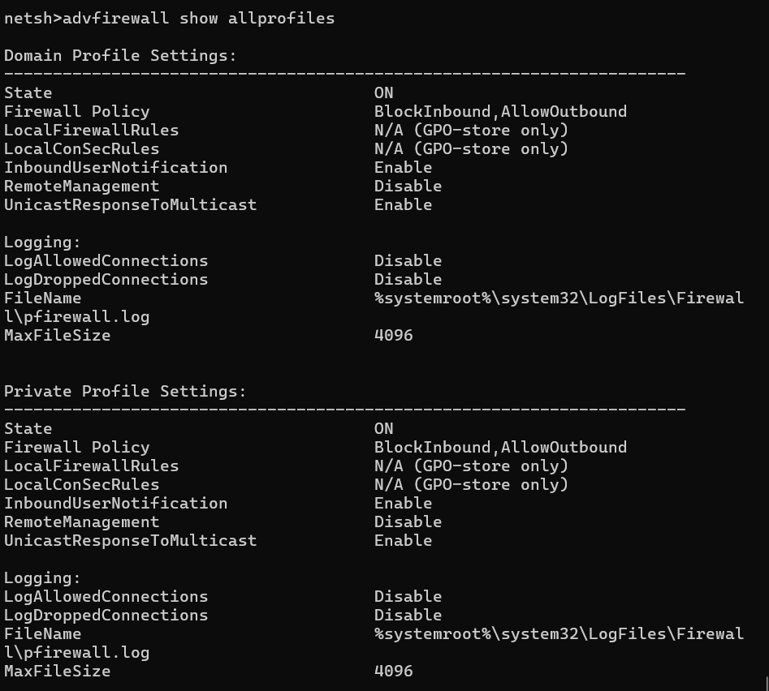
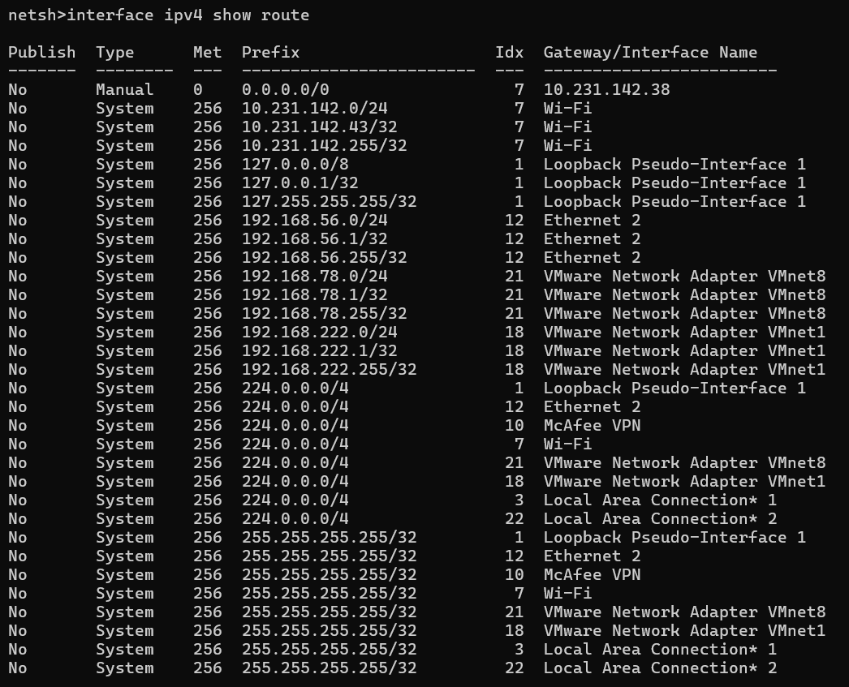
13. interface ipv4 show route

14. int tcp show global
