TOTAL LOAN APPLICATIONS:

SELECT COUNT(id) AS total_loan_applications FROM bank_loan_data;



MTD LOAN APPLICATIONS:

SELECT COUNT(id) AS MTD_total_loan_applications FROM bank_loan_data

WHERE MONTH(issue_date) = 12 AND YEAR(issue_date) = 2021;

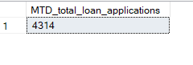

PMTD LOAN APPLICATIONS:

SELECT COUNT(id) AS PMTD_total_loan_applications FROM bank_loan_data

WHERE MONTH(issue_date) = 11 AND YEAR(issue_date) = 2021;



TOTAL FUNDED AMOUNT:

SELECT SUM(loan_amount) AS total_funded_amount FROM bank_loan_data;



MTD TOTAL FUNDED AMOUNT:

SELECT SUM(loan_amount) AS MTD_total_funded_amount FROM bank_loan_data

WHERE MONTH(issue_date) = 12 AND YEAR(issue_date) = 2021;

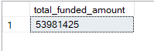

MTD TOTAL FUNDED AMOUNT:

SELECT SUM(loan_amount) AS PMTD_total_funded_amount FROM bank_loan_data

WHERE MONTH(issue_date) = 11 AND YEAR(issue_date) = 2021;

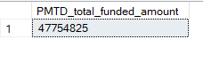

TOTAL AMOUNT RECEIVED:

SELECT SUM(total_payment) AS Total_Amount_Received FROM bank_loan_data;



MTD TOTAL AMOUNT RECEIVED:

SELECT SUM(total_payment) AS MTD_Total_Amount_Received FROM bank_loan_data

WHERE MONTH(issue_date) = 12 and YEAR(issue_date) = 2021;

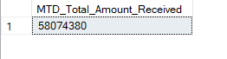

PMTD TOTAL AMOUNT RECEIVED:

SELECT SUM(total_payment) AS PMTD_Total_Amount_Received FROM bank_loan_data

WHERE MONTH(issue_date) = 11 and YEAR(issue_date) = 2021;



AVERAGE INTEREST RATE:  
  
SELECT AVG(int_rate) * 100 AS Avg_interest_rate FROM bank_loan_data;

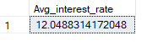

MTD AVERAGE INTEREST RATE:

SELECT ROUND(AVG(int_rate),4) * 100 AS MTD_Avg_interest_rate FROM bank_loan_data

WHERE MONTH(issue_date) = 12 and YEAR(issue_date) = 2021;



MTD AVERAGE INTEREST RATE:

SELECT ROUND(AVG(int_rate),4) * 100 AS PMTD_Avg_interest_rate FROM bank_loan_data

WHERE MONTH(issue_date) = 11 and YEAR(issue_date) = 2021;



AVERAGE DTI:

SELECT ROUND(AVG(dti),4) * 100 AS Avg_dti from bank_loan_data;



MTD AVERAGE DTI:

SELECT ROUND(AVG(dti),4) * 100 AS MTD_Avg_dti from bank_loan_data

WHERE MONTH(issue_date) = 12 AND YEAR(issue_date) = 2021;



PMTD AVERAGE DTI:

SELECT ROUND(AVG(dti),4) * 100 AS MTD_Avg_dti from bank_loan_data

WHERE MONTH(issue_date) = 11 AND YEAR(issue_date) = 2021;



GOOD LOAN PERCENTAGE:

SELECT

(COUNT(CASE WHEN loan_status = 'Fully Paid' OR loan_status = 'Current' THEN id END) * 100)

/

COUNT(id) AS Good_loan_percentage

FROM bank_loan_data;

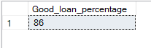

GOOD LOAN APPLICATIONS:

SELECT COUNT(id) FROM bank_loan_data

WHERE loan_status = 'Fully Paid' OR loan_status = 'Current';



GOOD LOAN FUNDED AMOUNT:

SELECT SUM(loan_amount) AS Good_loan_funded_amount FROM bank_loan_data

WHERE loan_status = 'Fully Paid' OR loan_status = 'Current';



GOOD LOAN RECEIVED AMOUNT:

SELECT SUM(total_payment) AS Good_loan_received_amount FROM bank_loan_data

WHERE loan_status = 'Fully Paid' OR loan_status = 'Current';



BAD LOAN PERCENTAGE:

SELECT

(COUNT(CASE WHEN loan_status = 'Charged off' THEN id END) * 100.0)

/

COUNT(id) AS Bad_loan_percentage

FROM bank_loan_data;



BAD LOAN APPLICATIONS:

SELECT COUNT(id) AS Bad_loan_applications FROM bank_loan_data

WHERE loan_status = 'Charged off';



BAD LOAN FUNDED AMOUNT:

SELECT SUM(loan_amount) AS Bad_loan_funded_amount FROM bank_loan_data

WHERE loan_status = 'Charged off';



BAD LOAN RECEIVED AMOUNT

SELECT SUM(total_payment) AS Bad_loan_received_amount FROM bank_loan_data

WHERE loan_status = 'Charged off';

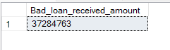

LOAN STATUS:

SELECT

loan_status,

COUNT(id) AS total_loan_applications,

SUM(total_payment) AS total_amount_received,

SUM(loan_amount) AS Total_funded_amount,

AVG(int_rate * 100) AS Interest_rate,

AVG(dti * 100) AS DTI

FROM

bank_loan_data

GROUP BY

loan_status;

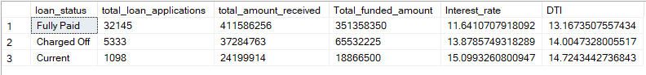

MTD LOAN STATUS:

SELECT

loan_status,

SUM(total_payment) AS MTD_total_amount_received,

SUM(loan_amount) AS MTD_Total_funded_amount

FROM

bank_loan_data

WHERE MONTH(issue_date) = 12

GROUP BY

loan_status;

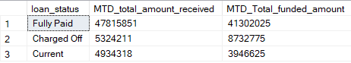

MONTHLY DATA:

SELECT

MONTH(issue_date) AS Month_no,

DATENAME(MONTH, issue_date) AS Month_name,

COUNT(id) AS Total_loan_applications,

SUM(loan_amount) AS Total_funded_amount,

SUM(total_payment) AS total_received_amount

FROM bank_loan_data

GROUP BY MONTH(issue_date), DATENAME(MONTH, issue_date)

ORDER BY MONTH(issue_date);

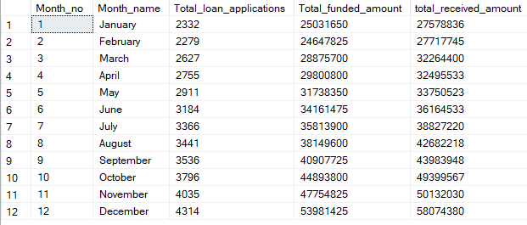

ADDRESS STATE:

SELECT

address_state,

COUNT(id) AS Total_loan_applications,

SUM(loan_amount) AS Total_funded_amount,

SUM(total_payment) AS total_received_amount

FROM bank_loan_data

GROUP BY address_state

ORDER BY SUM(total_payment) DESC;

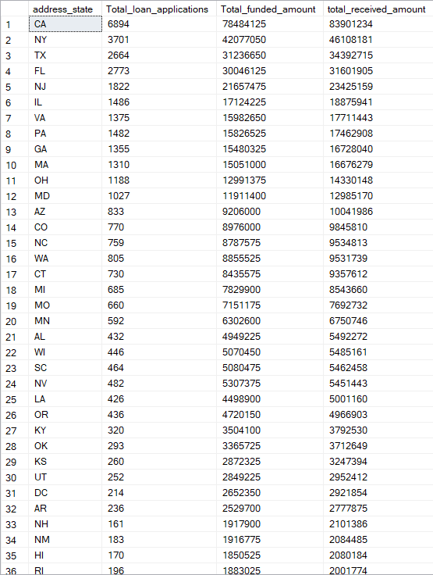

TERM:

SELECT

term,

COUNT(id) AS Total_loan_applications,

SUM(loan_amount) AS Total_funded_amount,

SUM(total_payment) AS total_received_amount

FROM bank_loan_data

GROUP BY term

ORDER BY term;

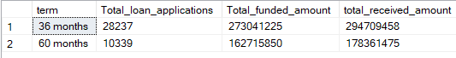

EMPLOYEE LENGTH:

SELECT

emp_length,

COUNT(id) AS Total_loan_applications,

SUM(loan_amount) AS Total_funded_amount,

SUM(total_payment) AS total_received_amount

FROM bank_loan_data

GROUP BY emp_length

ORDER BY COUNT(id) DESC;

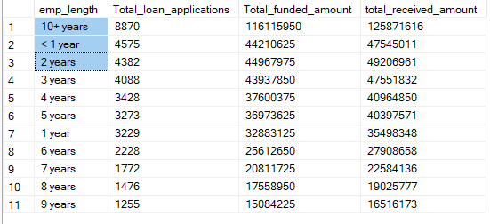

PURPOSE:

SELECT

purpose,

COUNT(id) AS Total_loan_applications,

SUM(loan_amount) AS Total_funded_amount,

SUM(total_payment) AS total_received_amount

FROM bank_loan_data

GROUP BY purpose

ORDER BY COUNT(id) DESC;

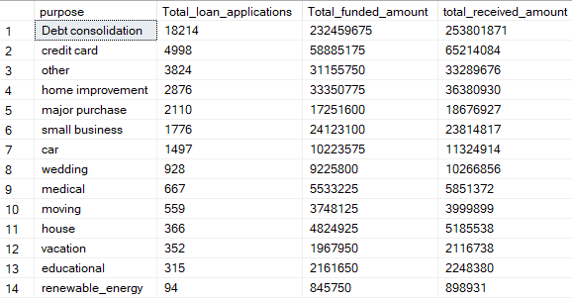

HOME OWNERSHIP:

SELECT

home_ownership,

COUNT(id) AS Total_loan_applications,

SUM(loan_amount) AS Total_funded_amount,

SUM(total_payment) AS total_received_amount

FROM bank_loan_data

GROUP BY home_ownership

ORDER BY COUNT(id) DESC;

