Wireframe

1. Introduction

The wireframe document provides an overview of the user interface design for the Mushroom Classification System. This document outlines the various screens, components, and interactions within the system.

2. Wireframe Screens

2.1 Mushroom Input Screen

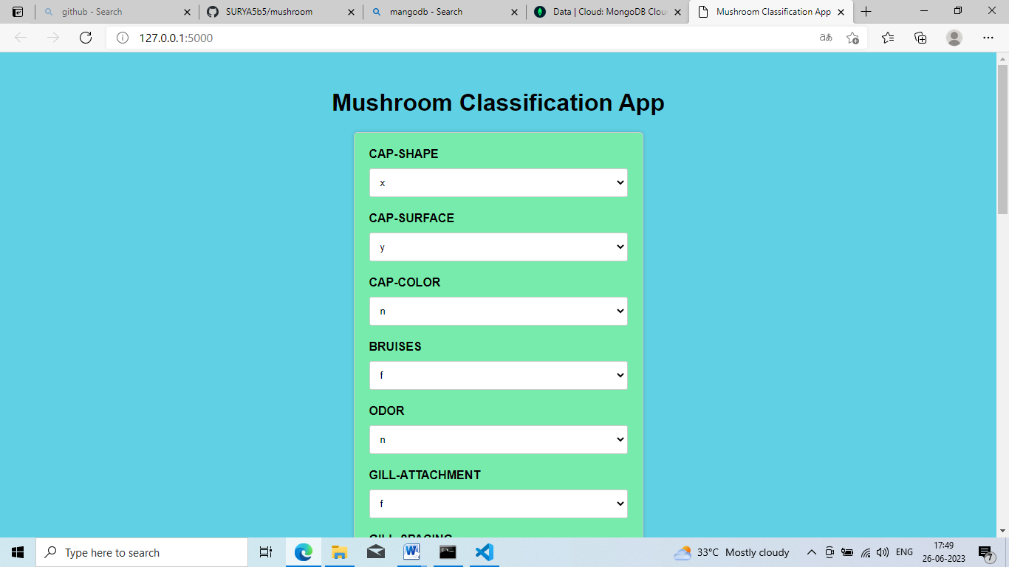 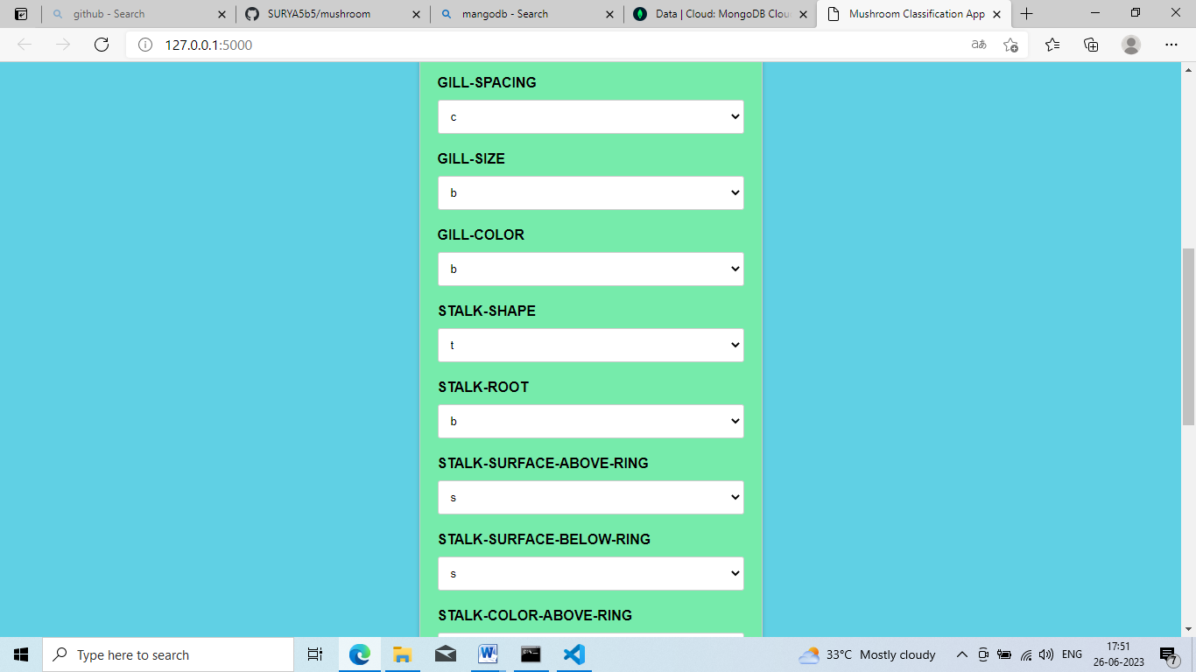 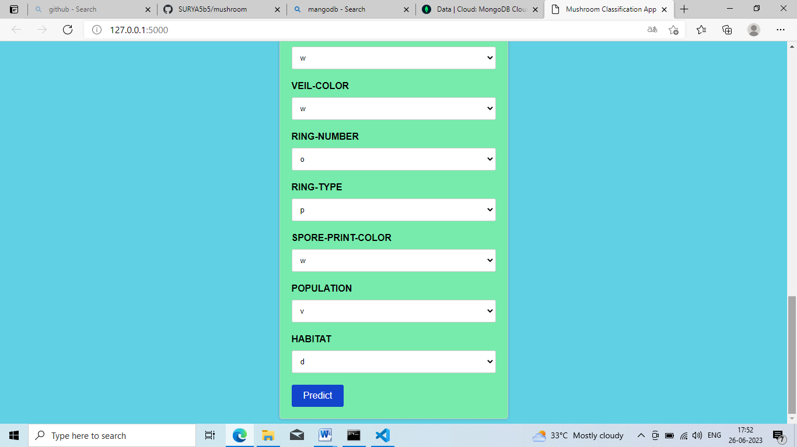

Description: The home screen serves as the landing page for the Mushroom Classification System. The mushroom input screen allows users to provide the attributes and characteristics of a mushroom for classification.

Each input dropdown having some features user needs to select when he wants to check that mushrooms features like gill-colour,gill-shape,Habitat etc.,

2.2 Classification Results Screen

(a) If Mushroom is poisinous:-

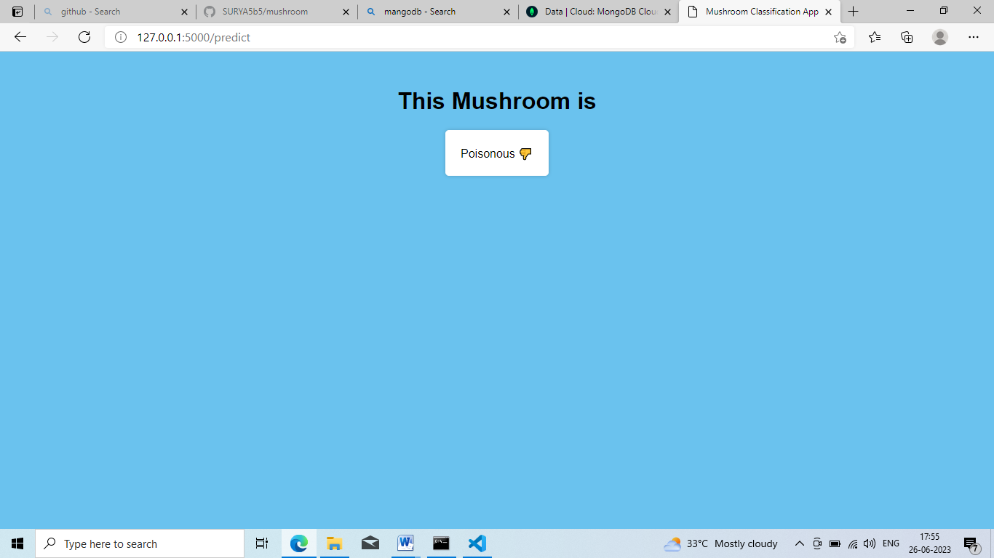

(b) When Mushroom is edible:-

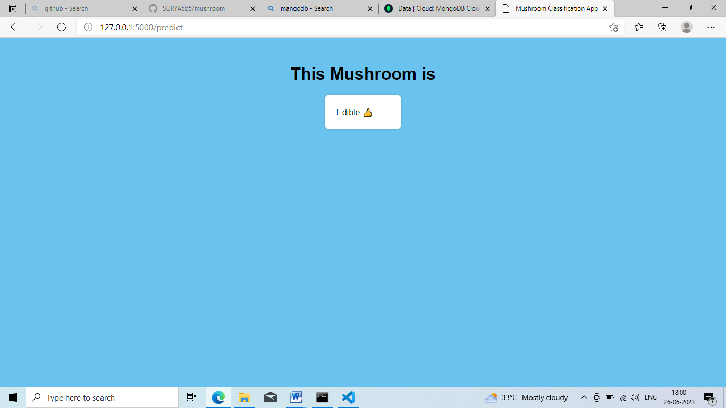

Description: The classification results screen displays the predicted mushroom species based on the provided attributes.

After giving all the attributes to the form than click the Predict button and result form should be appeared.

The result in two ways if result should be poisonous(a) screen will be printed and if result is edible screen(b) is appeared.

3. Wireframe Interactions

3.1 Train Model Route



Description: The train route initiates the training process for the mushroom classification model.

Interaction: When the train route is initiated, the system validates the training data and starts the model training process. Once the training is complete it redirects to the homepage.

3.2 Predict Button

Description: The Predict button triggers the classification process after the user has provided the mushroom attributes.

Interaction: When the predict button is clicked, the system validates the input, sends the data to the server for processing, and displays the classification results on the Classification Results screen.

4. Conclusion

The wireframe document provides a visual representation of the user interface design for the Mushroom Classification System. It outlines the screens, components, and interactions necessary to facilitate user input and display classification results. This document serves as a reference for the development team to implement the system's user interface effectively.

----------------------------------------Thank you----------------------------------------------