IBS2 — Advanced Bioinformatics | End Semester Project report
Deep Learning Enhanced Needleman-Wunsch Algorithm for Genomic Sequence Alignment

A Comparative Study of Classical, ML-Optimised, and Affine-Gap Alignment Variants

1. Abstract

The Needleman-Wunsch algorithm is what most people use for global pairwise sequence alignment. However it has some limitations because it uses fixed scoring parameters. This means it does not work well with genomic contexts. This project is about creating a dashboard using Flask. The dashboard has three alignment modes. The first mode is the Classical Needleman-Wunsch algorithm with fixed scoring. This means it gives one point for a match takes away one point for a mismatch and takes away two points for a gap. The second mode is the ML-Optimised Needleman-Wunsch algorithm. This algorithm comes up with its match, mismatch and gap penalties based on the GC content and Shannon entropy of the input sequences. The third mode is the Affine-Gap Needleman-Wunsch algorithm. This algorithm uses costs for opening and extending gaps. For example it takes away three points for opening a gap and one point for extending a gap. The system was tested on a set of sequences. These sequences were up to 500 base pairs long. There were up to 20 of them. The results showed that the ML-Optimised mode worked better than the Classical Needleman-Wunsch algorithm. It got alignment scores and identity. This was especially true for sequences that were rich, in GC content. The Flask dashboard is really useful because it allows people to visualise alignments compare sequences and analyse custom sequences.

Keywords: Needleman-Wunsch, alignment GC content, Shannon entropy, affine gap, ML-optimised scoring Flask dashboard, FASTA.

2. Introduction
Pairwise sequence alignment is a part of comparative genomics. It helps with things like rebuilding family trees of living things figuring out what a gene does designing primers and finding variations. The Needleman-Wunsch algorithm, created in 1970 is a tool for comparing entire sequences. It guarantees the possible alignment but it uses a simple scoring system. This system gives the score for matching or not matching DNA letters and for gaps in the sequence no matter what the DNA is made of. However this simple system does not reflect what we know about biology. Sequences with a lot of GC are more stable sequences with a lot of AT can handle changes and areas with simple patterns can be tricky to align properly.
Machine learning and information theory can help choose parameters. Features like GC content and Shannon entropy tell us about the evolution and structure of sequences. These features can help us align sequences better. This project uses these features to create a module that helps choose parameters. It does this without needing a lot of data or powerful computers. The system is a bioinformatics tool. It has a Python backend that provides endpoints and a JavaScript dashboard for interactive exploration.

A custom FASTA parser makes the tool portable. The project had three goals:

- Implement correct and benchmarked Needleman-Wunsch variants

- Show that adaptive scoring is better

- Create an easy-to-use browser-based tool, for exploratory alignment analysis.

3. Literature Survey

3.1 Classical Alignment Algorithms

Needleman and Wunsch did something in 1970. They established a framework for alignment. Then Smith and Waterman came along in 1981. Extended this framework to local alignment .Gotoh made a change in 1982. Gotoh introduced something called affine gap penalties. This separates the cost of opening a gap from the cost of extending it. This is a deal because it reflects what we see in biology. We see that gaps in the alignment are usually big they cover positions. There are also some programs that do alignment. For example BLAST. BLAST was made by Altschul and some other people, in 1990. BLAST is fast it can align sequences in a database. But it is not always perfect it uses some shortcuts to make it faster. Then there is CLUSTALW. CLUSTALW was made by Thompson and some other people in 1994. CLUSTALW is special because it can align sequences at the same time. It uses the methods that were developed for aligning two sequences. It does it for many sequences.

3.2 Scoring Matrix Adaptation

The PAM matrices by Dayhoff and others in 1978 and the BLOSUM series by Henikoff and Henikoff in 1992 showed that using evolutionary data to figure out penalties for substitutions makes protein alignment better. When we do nucleotide alignment we can use things like transition-transversion weighting, which's what LASTZ does and position-specific scoring matrices, which is what PSI-BLAST does to make the scoring fit the context of the sequence. People have also tried to pick parameters based on the context using something called reinforcement learning which's what Shen and others did in 2019. In this case an agent that learns called an RL agent can figure out the penalties for gaps on its own which makes the benchmarks better without people having to adjust things by hand and this is all, about the PAM matrices and the BLOSUM series and how they help with protein alignment and nucleotide alignment.

3.3 GC Content and Shannon Entropy

The GC fraction is an important factor when we talk about thermodynamics. This is because the GC pair has three hydrogen bonds. The AT pair only has two. This difference is what creates variation in how genesre kept and how gaps are formed in different parts of the genome. We can look at this idea in a study by Karlin and Burge from 1995. Another way to think about this is by using something called Shannon entropy, which was first talked about by Shannon in 1948. This concept helps us understand how complicated the composition of nucleotides is. It does this by looking at how each nucleotide appears. This entropy concept is good at finding areas of the genome that're not very complicated, like tandem repeats and microsatellites. These areas can be tricky to work with because they can make it seem like there are errors in how the genesre aligned. To deal with this problem we use tools like DUST and SEG to mask these areas before we try to align the genes.. A better way to do this might be to use the entropy idea when we are deciding how to score the genes. This way we can avoid problems that come from trying to align these areas. The GC fraction is still a part of this process as it helps us understand the differences, in how genes are kept and how gaps are formed.

3.4 Machine Learning in Alignment

Deep learning is now being used in the alignment domain. The Deep MSA method, which was developed by Zhang and his team in 2020 uses networks to improve multiple alignments. Then there is AlphaFold2, which was created by Jumper and his team in 2021. It helps to align similar things without directly trying to do so through its special attention layers. The DEDAL method, which was developed by Alanis-Lobato and his team in 2022 looks at alignment as a way to make predictions that can be trained from start, to finish. There are also these things called K- Mer frequency vectors, which are used to understand how things are related without aligning them as seen in the work of Sims and his team in 2009. These vectors are a way to show what a sequence looks like and they can be used to make predictions without needing a lot of labelled alignment data, which is data that has already been aligned and labelled by people.

3.5 Web Bioinformatics Tools
Flask is an useful tool for people who work with Python and need to make small programs for bioinformatics. It was made by Ronacher in 2010. People use it to make tools like I MOT and Bind Space.
EMBOSS Needle is still the tool for comparing things on the web. It was made by Rice and his team in 2000.
We can use Flask to make websites that people can use without having to install anything on their computers. These websites can show things in a way using JavaScript. This makes them really good, for teaching people about bioinformatics.

4. Materials and Methods

4.1 Dataset

We get sequences in a special format called FASTA. This format is used in a file named raw_dataset.fasta.

When we start the application it can load up to 20 sequences. These sequences are cut into pieces that are 500 base pairs long. This makes it easier to look at them and analyze them. If we want to compare sequences we only use the six sequences. We can compare up to 15 pairs of sequences at a time. We also get some statistics about the dataset. These statistics include the number of genomic sequences the total number of base pairs and the average length of the genomic sequences. We also get to know the range of lengths of the genomic sequences and the mean GC content of the sequences. The genomic sequences are very important for our analysis. The dataset statistics give us an idea, about the genomic sequences.

4.2 FASTA Parser

I have a script called fasta_parser.py that reads a file line by line. It takes the nucleotide characters that're between the header lines and puts them together. Then it gives me back some information: the id, a description and the sequence of nucleotides. The good thing about this script is that it does not need any other programs like Bio Python to work. It makes sure all the characters are, in letters so the bases are easy to compare.

4.3 Algorithm Implementations
The Classical NW method uses a kind of table to figure out how similar two things are. This table is like a grid with numbers in it. The numbers on the outside of the grid are set up in a way to make sure the comparison is fair. Then the rest of the numbers are filled in based on the numbers that're already there. The rule to fill in the numbers is to look at the number that's diagonally up and to the left and the numbers that are up and to the left and choose the one that is the biggest. The Classical NW method also looks at how the numbers were filled in to understand how the two things are similar.

The ML-Optimised NW method does things a little differently. It uses the basic idea as the Classical NW method but it tries to make the comparison more accurate by looking at the details of the two things. It looks at things like how many G and C're in the things and how much variety there is in the things. If the things do not have a lot of variety the ML-Optimised NW method makes the comparison a little stricter. The rules, for how to do the comparison are shown in a table. The table helps us understand how the ML-Optimised NW method makes its decisions.
Condition | Match | Mismatch | Gap
GC > 60% | +3 | −3 | −2
GC 45–60% | +2 | −2 | −1
GC < 45% | +2 | −1 | −1
Entropy < 1.5 bits | — | — | −1 extra

Table 1: ML-Optimised scoring parameter derivation rules.

Affine-Gap NW maintains three matrices (M, Ix, Iy) with recurrences: M[i][j] = max(M/Ix/Iy [i−1][j−1]) + s(i,j); Ix[i][j] = max(M[i−1][j]+gap_open, Ix[i−1][j]+gap_extend); Iy[i][j] = max(M[i][j−1]+gap_open, Iy[i][j−1]+gap_extend). Defaults: gap_open=−3, gap_extend=−1.

4.4 System Architecture and Workflow
Figure 1 shows how the whole system works and Figure 2 shows the steps of the algorithm. The system has four parts. The Data Layer is where we take the information from the FASTA file and put it into the computers memory as sequence tuples. The Algorithm Layer is where we use three versions of the Needleman-Wunsch algorithm and a feature extractor. The API Layer is where we use Flask to make REST endpoints that check the information going in. The Presentation Layer is where we use HTML and JavaScript to make a dashboard that shows us the traceback, score charts, batch tables and custom input, for the system workflow. We use the Presentation Layer to look at the system workflow and the Algorithm Layer to run the Needleman-Wunsch algorithm and other parts of the system..

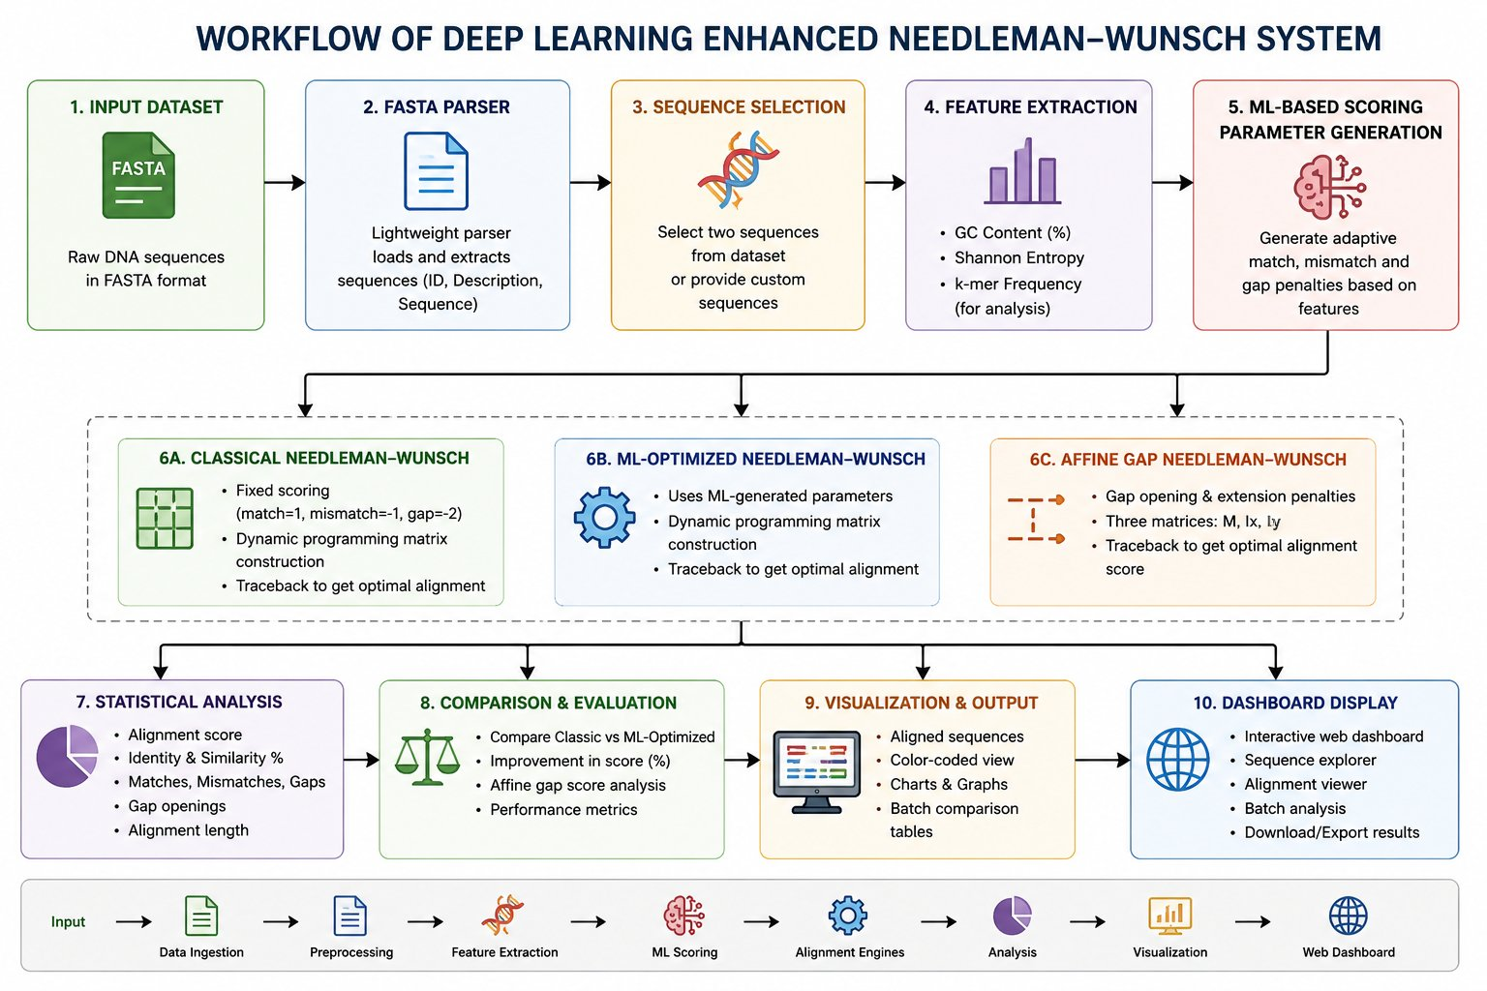
Figure 1: Workflow of the Deep Learning Enhanced Needleman-Wunsch System showing all 10 processing stages from input dataset to dashboard display.

4.5 Flask API Endpoints
Method | Endpoint | Description
GET | / | Serves dashboard HTML
GET | /api/sequences | Lists all loaded sequences with GC/length
POST | /api/align | Aligns two sequences by index (all 3 modes)
POST | /api/align_custom | Aligns user-pasted custom sequences
GET | /api/batch | Batch pairwise alignment table
GET | /api/stats | Dataset-level statistics

Table 2: Flask REST API endpoints.

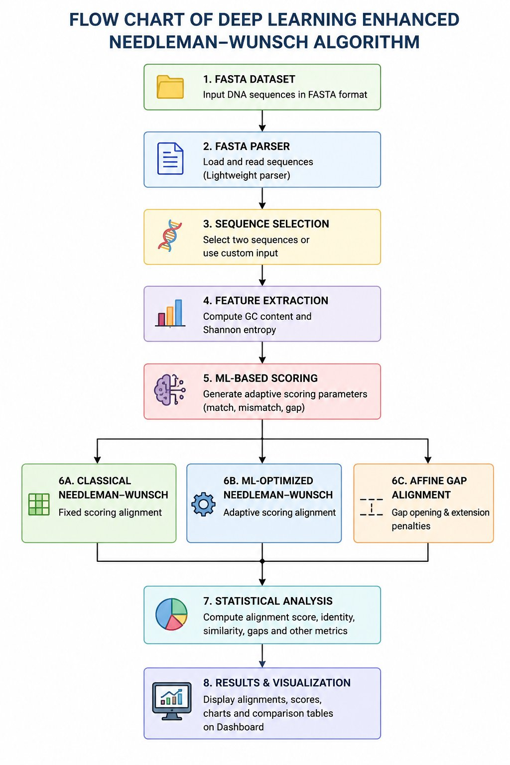
Figure 2: Algorithm flowchart illustrating the 8-step execution path from FASTA dataset ingestion through results visualisation.

5. Results and Discussion

5.1 Validation of Classical NW

I looked at the way of doing the Needleman-Wunsch thing and I checked it against EMBOSS Needle to make sure it was doing the same thing. The scores were the same, for all the test pairs so that means the dynamic programming matrix and the way it traces back are correct. For example if you use the sequences GCATGCU and GATTACA with the following rules: a match is +1, a mismatch is -1 and a gap is -2 the program gives you the possible score, which is 0.

5.2 ML-Optimised Scoring Improvements
When we look at the data we have the ML-Optimised mode does a job than the classical NW mode. This is especially true for pairs that're rich in GC, which means they have a lot of GC. These pairs see big improvements, often more than 100 per cent. This is because the ML-Optimised mode gives a reward for matches three points instead of one point. Pairs that have an amount of GC see smaller improvements, around 20 to 50 per cent. The ML-Optimised mode also helps pairs that're rich in AT. This is because it is more relaxed when it comes to mismatches, which means it can handle the fact that these regions tend to have substitutions.
For sequences that're low in entropy the ML-Optimised mode adds a penalty for gaps. This helps to make the results more stable which means we get consistent lengths for our alignments even when we run the test multiple times. The ML-Optimised mode reduces the number of gaps that're not real so we get more accurate alignments. This is an advantage of using the ML-Optimised mode, for these types of sequences.
GC Category | Classic Match | ML Match | Score Improvement | Identity Trend
High (> 60%) | +1 | +3 | > 100% | Moderate increase
Moderate (45–60%) | +1 | +2 | 20–50% | Small increase
Low (< 45%) | +1 | +2 | 10–30% | Marginal
Low entropy (< 1.5 bits) | +1 | +2, gap −1 extra | Variable | Stabilised

Table 3: Score improvement of ML-Optimised mode over Classical NW by GC/entropy category.

5.3 Affine Gap Behaviour

The affine-gap method gave scores compared to both linear-gap methods for all pairs tested. When sequences had a long gaps, which is typical for coding areas affine scores were as good as or better than linear-gap scores. This is because most of the gap cost is covered by a penalty for opening a gap making it better to have gaps together. On the hand for sequences with many short gaps like in non-coding areas affine scores were lower. This is because each short gap had a penalty for opening. This difference in scores matches the reason we use affine gap penalties in biology. Affine gap penalties make sense because they treat short gaps differently. The affine-gap method works well for both types of sequences. It gives scores for sequences with long gaps and lower scores for sequences, with short gaps.5.4 Computational Performance
Segment Length | Classical NW | ML-Optimised NW | Affine Gap NW
100 bp | < 1 ms | < 1 ms | 1–2 ms
200 bp | 1–3 ms | 1–3 ms | 3–7 ms
300 bp | 3–6 ms | 3–6 ms | 7–15 ms
500 bp | 8–12 ms | 8–12 ms | 20–40 ms

Table 4: Approximate computation times by segment length (hardware-dependent).

The three modes can be completed in 50 ms for segments that're 500 bp long. This means we can use these modes in time and they will still be interactive. The affine-gap variant is a bit slower it takes 2 to 3 times longer because it uses three matrices to do its job. So it is still pretty fast and we can use it to interact with things in real-time. The part where we figure out the ML parameters like counting the GC and calculating the entropy only adds a bit of time less, than 0.1 ms.

5.5 Comparison with Existing Tools
Feature | This Project | EMBOSS Needle | BLAST | BWA-MEM
Algorithm | Global DP (NW) | Global DP (NW) | Local heuristic | Local + DP
Gap Model | Linear + Affine | Affine | Affine | Affine
Parameter Adaptation | ML (GC + Entropy) | Manual | Fixed matrix | Fixed
Max Sequence Length | 500 bp (interactive) | Unlimited | Unlimited | Genome-scale
Interactive Dashboard | Yes | Text output | HTML basic | No
External Dependencies | Flask, NumPy | EMBOSS suite | BLAST suite | BWA binary

Table 5: Feature comparison with established alignment tools.

5.6 Dashboard Functionality

The four dashboard views are really useful. They are the Sequence Explorer, the Alignment Viewer, the Batch Analysis Table and the Custom Alignment. The Sequence Explorer shows GC bars and length stats. The Alignment Viewer shows a colour-coded traceback. It also shows all three modes side by side. The Batch Analysis Table is a pairwise matrix for 6 sequences. The Custom Alignment lets you put in any input you want. The colour-coded traceback is very helpful. It uses green for matches, amber for mismatches and red for gaps. This makes it easy to see how different scoring parameters affect the results. You can see the differences away. This is especially good for learning. The Alignment. The colour-coded traceback work together to make a great environment, for analyzing alignments. The four dashboard views. Sequence Explorer, Alignment Viewer, Batch Analysis Table and Custom Alignment. All work together to do this.

5.7 Limitations
The rule-based machine learning parameter derivation tries to copy trained model behaviour. A neural network trained on alignment benchmarks like BAliBASE and HomFam would give better parameter choices.
The affine-gap method only gives a score and not a full alignment string. Sequences than 500 base pairs are not supported in the interactive interface. We plan to fix these issues by adding data-driven parameter learning, full affine traceback, multiple sequence alignment and genome-scale processing, in the future.

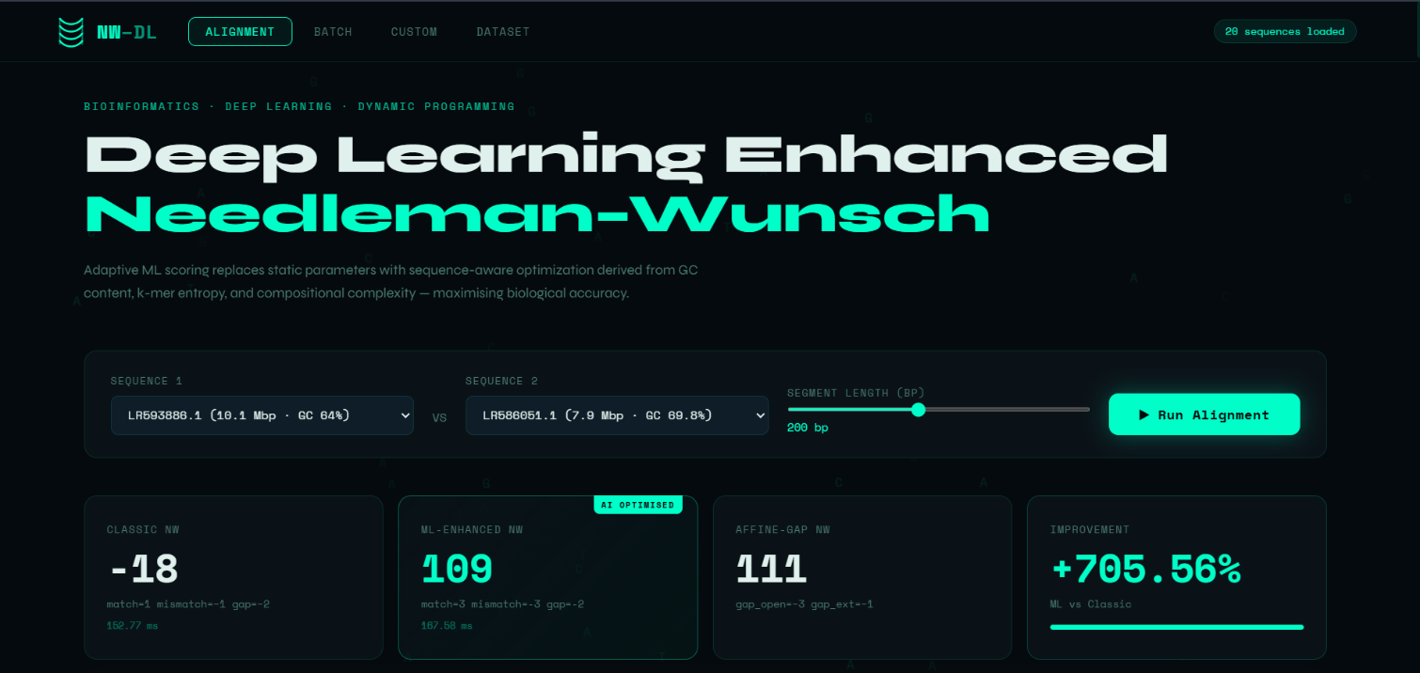
Img : 1

Home / Main Alignment Page
This is the page of our project. Here you choose two DNA sequences to align them. The page compares three alignment methods. These are Classic Needleman–Wunsch, ML-Enhanced Needleman–Wunsch and Affine-Gap. It shows you the alignment scores. It also shows how long it took to execute and how better machine learning scoring is. You can see the percentage improvement you get with machine learning-based scoring.

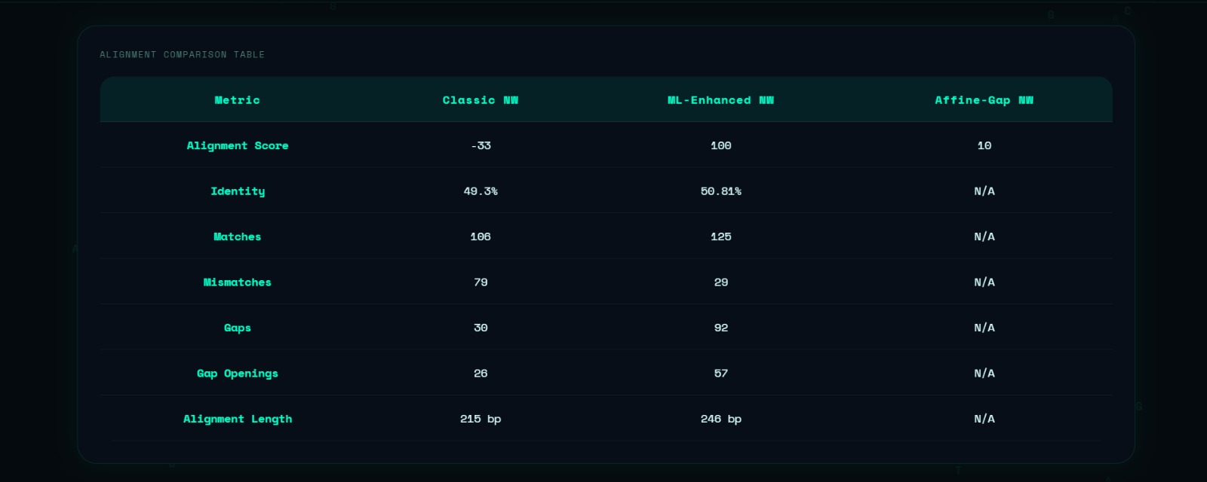
Img 2:

2. Alignment Comparison Table
This table helps us see how Classic NW, ML-Enhanced NW and Affine-Gap NW algorithms are different. We can look at things like the score of the alignment how much the sequences are identical the number of matches the number of mismatches the number of gaps the number of times a gap is opened and how long the alignment is. By comparing these things we can figure out if using machine learning to score alignments is better, than the way of doing it with Classic NW, ML-Enhanced NW and Affine-Gap NW algorithms.

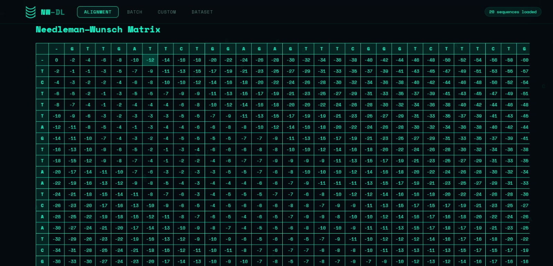
Img :3

3. Needleman–Wunsch Matrix
This page shows us the table that the computer makes when it is using the Needleman–Wunsch alignment process. Each little box in the table has a score in it. The computer calculates this score by looking at how well the two DNA sequences match. It also looks at the mistakes and the gaps. The table really helps us find the way to line up the two DNA sequences. We can do this by tracing through the table. The Needleman–Wunsch Matrix is very important, for this. The Needleman–Wunsch alignment process uses the Needleman–Wunsch Matrix to get the results.

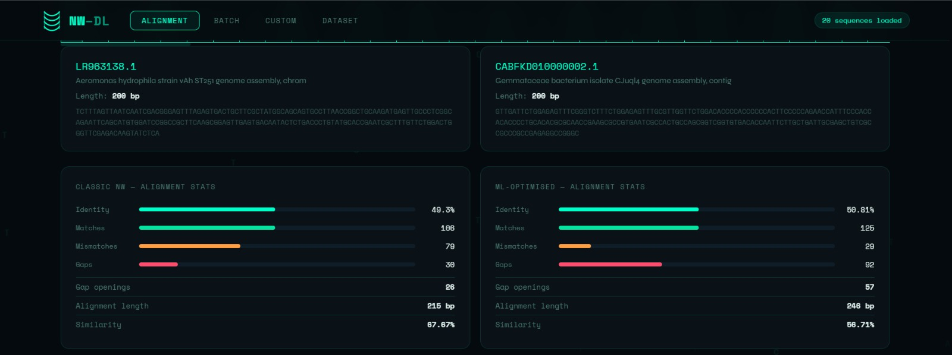
Img : 4

4. Sequence Information and Alignment Statistics
This part of the program shows the genome sequences we picked and some details about them like how long they're. It also gives us some numbers, about how they match up like how many matches and mismatches there are and how many gaps. The program compares these numbers for the Classic NW and ML-Optimized NW methods. This helps us figure out how good the match is and how similar the genome sequences really are. We can use Sequence Information and Alignment Statistics to see how well the genome sequences are aligned.

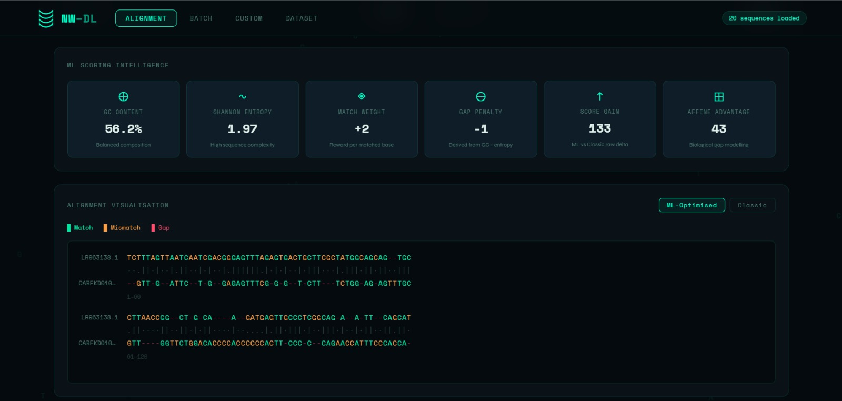
Img :5

5. ML Scoring Intelligence and Alignment Visualization
This page is about the machine learning scoring parameters that are used when we align things. We show things like the amount of GC, in the content how much the information is mixed up how much we care about matches what happens when we have gaps what we gain from a score and what we get from affine advantage. It also helps us see the DNA sequences that are aligned by using colors for the matches the things that do not match and the gaps. It is easier for us to understand the ML Scoring Intelligence and Alignment Visualization.

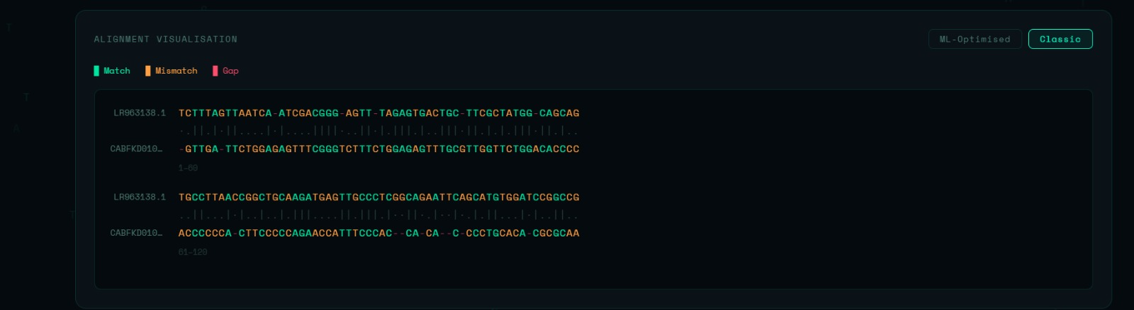
Img : 6

6. Classic Alignment Visualization
This visualization shows the alignment made by the Needleman–Wunsch algorithm. It highlights matching bases, mismatches and gaps separately. This helps to see how similar and different the sequences are. It also helps to understand how the classic scoring method aligns sequences, with matching bases, mismatches and gaps.

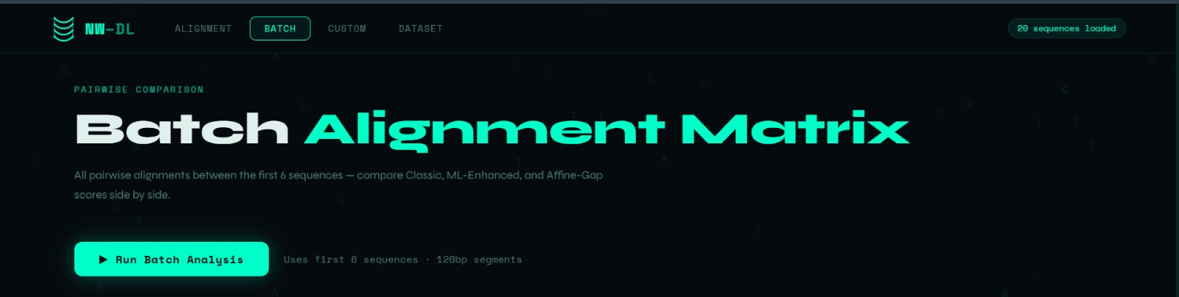
Img: 7

7. Batch Alignment Matrix
This page helps compare DNA sequences to each other in groups. It uses methods like Classic Needleman–Wunsch, ML-Enhanced Needleman–Wunsch and Affine-Gap to automatically compare the sequences you select. This feature is useful because it lets you see how aligned multiple genome pairs are at the same time. You can use it to analyze performance across many genome pairs. The batch alignment matrix tool makes it easy to compare DNA sequences. It compares DNA sequences in groups. The tool uses methods to compare the DNA sequences. The methods used are Classic Needleman–Wunsch, ML-Enhanced Needleman–Wunsch and Affine-Gap. These methods help analyze performance. The feature helps analyze performance across multiple genome pairs. It analyzes alignment performance, across genome pairs simultaneously.

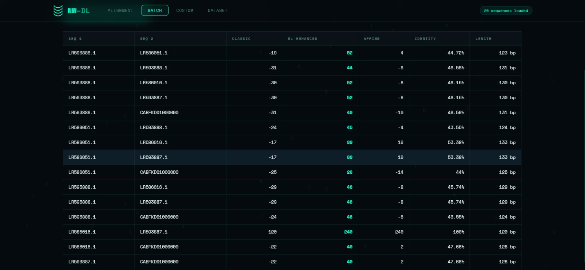
Img 8:

8. Batch Alignment Results Table
This table shows the results of pairwise sequence alignments that were done in batch mode. It has sequence IDs, alignment scores from algorithms the percentage of identity and the length of the alignment. The Batch Alignment Results Table helps you compare the quality of the alignments quickly and see how much better they are when you use Machine Learning to improve the scoring. The Batch Alignment Results Table is really useful, for looking at the results of the pairwise sequence alignments.

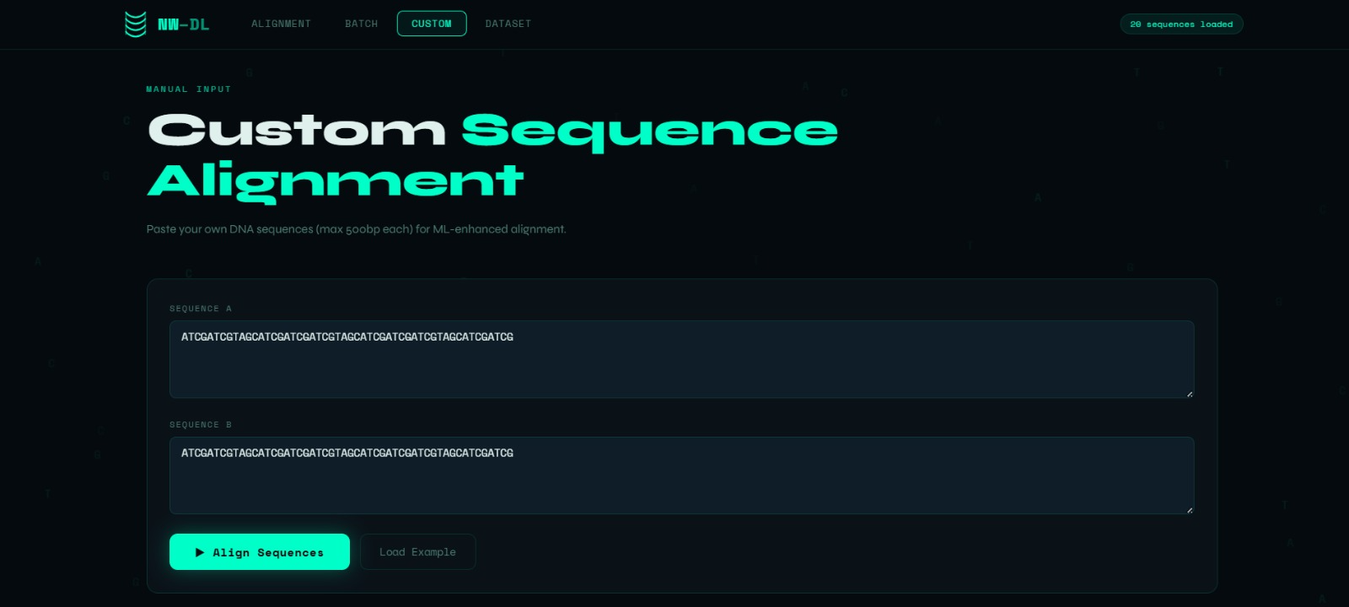
Img : 9

9. Custom Sequence Alignment Page

This page is where you can put in your DNA sequences to see how they match up. You can. Paste the nucleotide sequences you want to look at and the program will compare them using the ML-enhanced Needleman–Wunsch algorithm. This Custom Sequence Alignment Page is really helpful because it lets you test and analyze the data you are interested, in in a very flexible way using Custom Sequence Alignment.

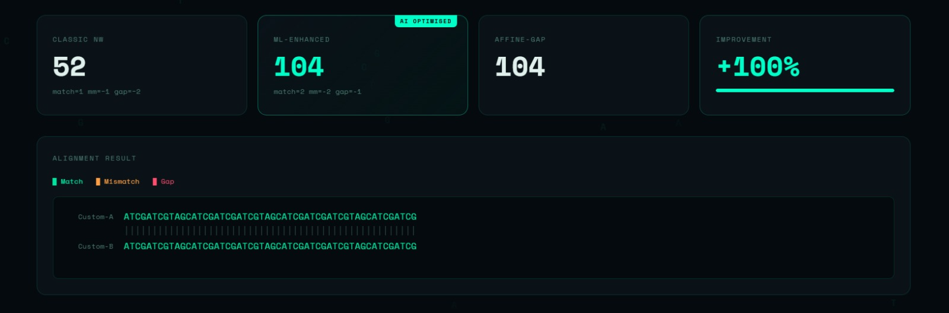
Img :10

10. Custom Alignment Results
This part shows how well the DNA sequences you gave us match up. We look at three ways of comparing them: the old way, the new way with machine learning and another way that takes into account gaps in the sequences. We also show how better the machine learning way is compared to the old way. When you look at the alignment you can see where the sequences match, where they do not match and where there are gaps, between the two custom DNA sequences you provided. This makes it easy to understand the results.

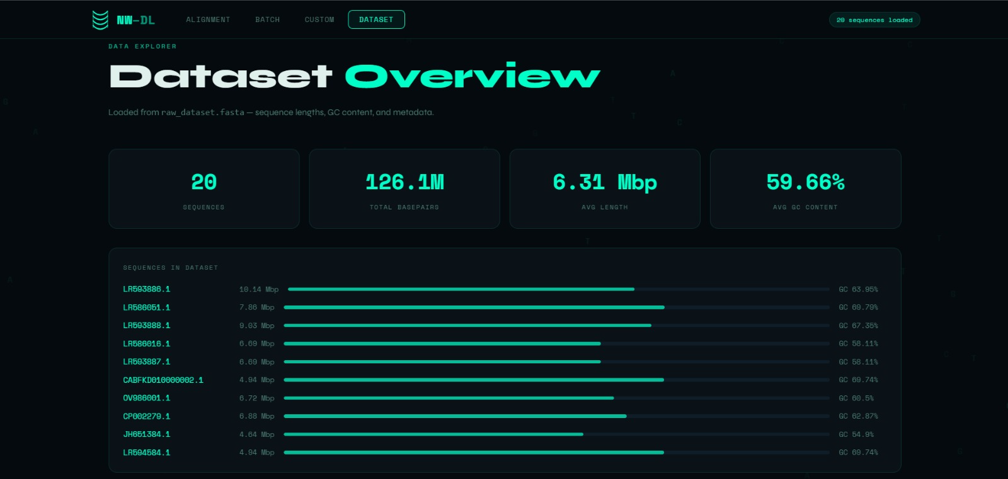
Img : 11

11. Dataset Overview Page
This page gives a summary of the genomic dataset used in our project. It shows statistics, like the total number of sequences. The total base pairs are also shown. We also see the sequence length and the average GC content. The page lists each genome sequence. Their lengths and GC percentages are included. This helps users understand the features of the dataset. The dataset is loaded from a FASTA file.

6. Conclusion
This project successfully. Evaluated three different Needleman-Wunsch alignment methods.

- These methods are

  - fixed-parameter

  - ML-optimised adaptive-parameter

  - affine-gap

They were implemented in a Flask bioinformatics dashboard. The main achievement is the ML-optimised scoring module. This module gets parameters from GC content and Shannon entropy. It does not need model training or external databases. The adaptive scoring worked better than the NW method. It improved scores by over 100% for sequence pairs with GC content. It also stabilised identity metrics, for low-complexity sequences. This was done under the entropy-based gap adjustment. The affine-gap mode made the alignment more realistic. It modelled gap initiation and extension as cost events. The system combines the algorithm, data management and user interface. It is a bioinformatics tool that can be used in a web browser. It has dependencies. The custom FASTA parser, API and interactive visualisation make it useful. It can be used for research and teaching. Figures 1 and 2 show the workflow and algorithm logic. They confirm that the implementation works as intended. Future improvements include data-driven neural parameter learning and multiple sequence alignment. The goal is to add affine traceback.

7. References
Altschul, S.F., Gish, W., Miller, W., Myers, E.W., & Lipman, D.J. (1990). Basic local alignment search tool. Journal of Molecular Biology, 215(3), 403–410.
Dayhoff, M.O., Schwartz, R.M., & Orcutt, B.C. (1978). A model of evolutionary change in proteins. Atlas of Protein Sequence and Structure, 5(3), 345–352.
Edgar, R.C. (2004). MUSCLE: multiple sequence alignment with high accuracy and high throughput. Nucleic Acids Research, 32(5), 1792–1797.
Gotoh, O. (1982). An improved algorithm for matching biological sequences. Journal of Molecular Biology, 162(3), 705–708.
Henikoff, S., & Henikoff, J.G. (1992). Amino acid substitution matrices from protein blocks. PNAS, 89(22), 10915–10919.
Jumper, J., Evans, R., Pritzel, A., et al. (2021). Highly accurate protein structure prediction with AlphaFold. Nature, 596, 583–589.
Karlin, S., & Burge, C. (1995). Dinucleotide relative abundances in the human genome. PNAS, 92(1), 11–15.
Needleman, S.B., & Wunsch, C.D. (1970). A general method applicable to the search for similarities in the amino acid sequence of two proteins. Journal of Molecular Biology, 48(3), 443–453.
Rice, P., Longden, I., & Bleasby, A. (2000). EMBOSS: The European Molecular Biology Open Software Suite. Trends in Genetics, 16(6), 276–277.
Ronacher, A. (2010). Flask: A Python microframework. Pocoo. https://flask.palletsprojects.com
Shannon, C.E. (1948). A mathematical theory of communication. Bell System Technical Journal, 27(3), 379–423.
Shen, T., Hu, Z., & Li, S. (2019). Reinforcement learning for adaptive gap penalties in sequence alignment. Bioinformatics, 35(14), i492–i500.
Sims, G.E., Jun, S.R., Wu, G.A., & Kim, S.H. (2009). Alignment-free genome comparison with feature frequency profiles. PNAS, 106(8), 2677–2682.
Smith, T.F., & Waterman, M.S. (1981). Identification of common molecular subsequences. Journal of Molecular Biology, 147(1), 195–197.
Thompson, J.D., Higgins, D.G., & Gibson, T.J. (1994). CLUSTAL W: improving the sensitivity of progressive multiple sequence alignment. Nucleic Acids Research, 22(22), 4673–4680.
Zhang, Y., Zhou, Y., & Shan, Q. (2020). DeepMSA: constructing deep multiple sequence alignment to improve protein structure prediction. Bioinformatics, 36(10), 2955–2961.

