GIT Document

Git stands for Global information tracking system and also Git is a popular version control system.

Git is a distributed version control system designed to track changes in source code during software development. It allows multiple developers to work collaboratively on projects, managing changes efficiently.

It is used for:

* Tracking code changes
* Tracking who made changes
* Coding collaboration

**Step-1 :**

open browser and type git download

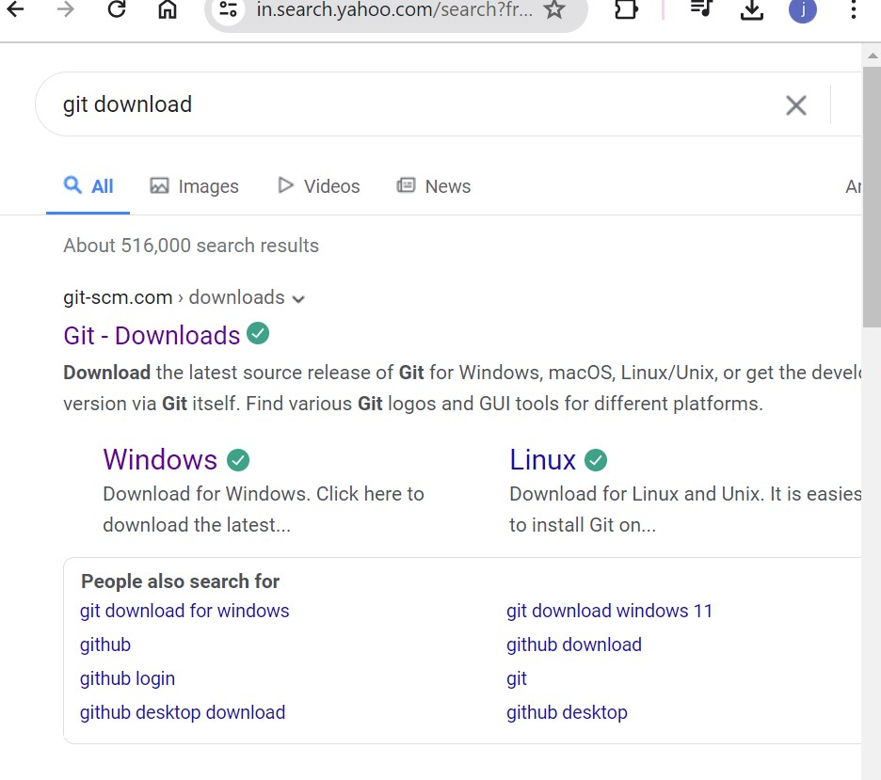

**Step-2 :**

Click on downloads

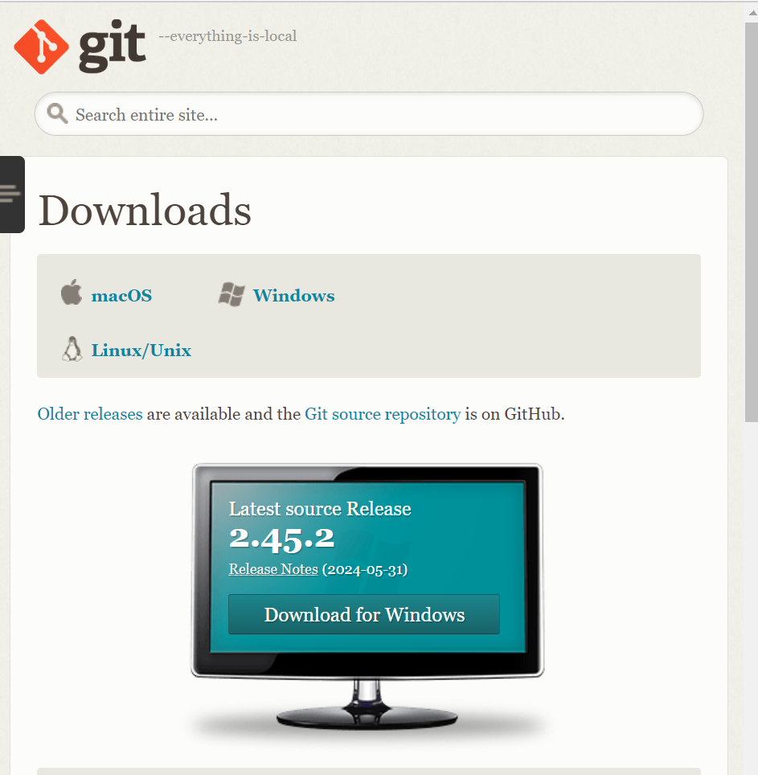

Now the git is downloaded

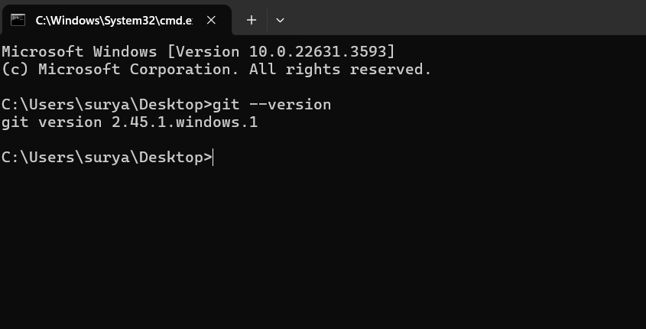

**Basic Commands in git :**

**Ls:** List files and directories

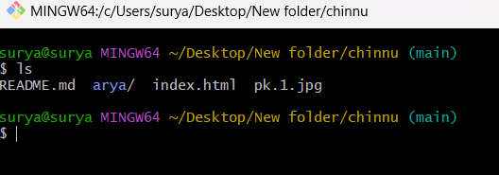

**mkdir:** Creating new folder

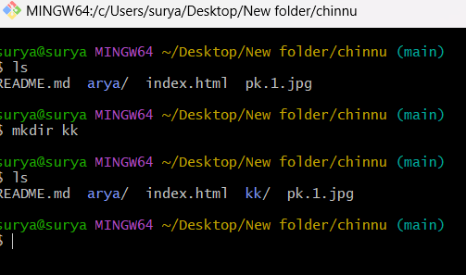

**rm**: To remove file

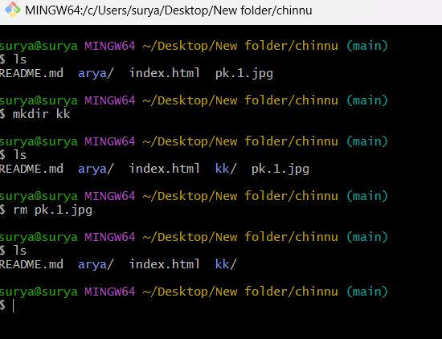

rmdir:To remove directory

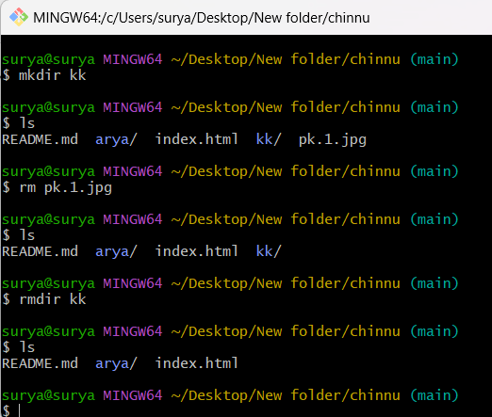

**Cd:** Used to go into the folder

**Cd ..** : used to come outside of one folder

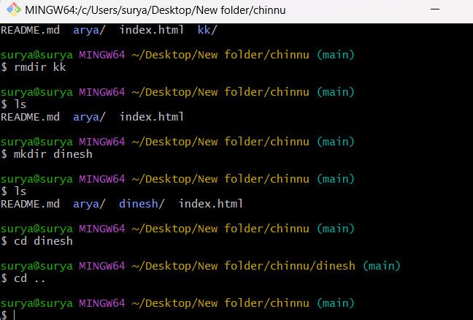

**Research topic :**

• **git init:** Initializes a new Git repository. This command is used to create a new local repository in the specified directory.

**• git clone url:** Clones an existing Git repository from a remote server to your local machine. This command is used to download a repository from a URL.

**• git add filename:** Stages changes (new, modified, or deleted files) to be included in the next commit. You can specify a single file, multiple files, or use a wildcard.

**• git status:** Displays the state of the working directory and staging area. It shows which changes have been staged, which haven't, and which files are not being tracked by Git.

• **git branch:** Lists, creates, or deletes branches. Running it without arguments lists all the branches in the repository.

**• git commit -m "msg:** Records changes to the repository with a descriptive message. The -m option allows you to specify the commit message inline.

• **git push:** Uploads local repository content to a remote repository. By default, it pushes the current branch to its upstream branch.

• **git pull:** Fetches and integrates changes from a remote repository into the current branch. It is essentially a combination of git fetch followed by git merge.