Predictive Modeling of Mental Health Trends using Natural Language Processing on Patient Notes

Submitted partial fulfillment for the award of the degree of

MTECH5 - Computer Science and Engineering (Business Analytics)

by

SURYA M S(22MIA1098)



SCHOOL OF COMPUTER SCIENCE AND ENGINEERING

November 2025


DECLARATION

I hereby declare that the thesis entitled “Predictive Modeling of Mental Health Trends using Natural Language Processing on Patient Notes” submitted by SURYA M S(22MIA1098)
for the award of the degree of MTECH5 - Computer Science and Engineering (Business Analytics), Vellore Institute of Technology, Chennai is a record of bonafide work carried out by me under the supervision of Dr. Jeipratha P N.
I further declare that the work reported in this thesis has not been submitted and will not be submitted, either in part or in full, for the award of any other degree or diploma in this institute or any other institute or university.

Place: Chennai
Date: Signature of the Candidate



School of Computer Science and Engineering

CERTIFICATE

This is to certify that the report entitled “Predictive Modeling of Mental Health Trends using Natural Language Processing on Patient Notes” is prepared and submitted by by SURYA M S(22MIA1098)

to Vellore Institute of Technology, Chennai, in partial fulfillment of the requirement for the award of the degree of MTECH5 - Computer Science and Engineering (Business Analytics) is a Bonafide record carried out under my guidance. The project fulfills the requirements as per the regulations of this University and in my opinion meets the necessary standards for submission. The contents of this report have not been submitted and will not be submitted either in part or in full, for the award of any other degree or diploma and the same is certified.

Signature of the Guide:

Name: Dr./Prof.
Date:

Signature of the Examiner Signature of the Examiner

Name: Name:
Date: Date:

Approved by the Head of Department,

Int Mtech CSE (MIA)

Name: Appalaraju Muralidhar

Date:

TABLE OF CONTENTS

ABSTRACT  ACKNOWLEDGEMENT  TABLE OF CONTENTS  LIST OF FIGURES  LIST OF ACRONYMS | iv  v  vi  vii  viii
CHAPTER 1: INTRODUCTION | 1
CHAPTER 2: II. RELTED WORKS

2.1 a. Traditional Machine Learning Approaches

2.2 b. Deep Learning Architectures: LSTM and BiLSTM

2.3 c. Transformer-Based Models and Their BERT Variants

2.4 . Explainable and Hybrid Frameworks

CHAPTER 3: PROPOSED PREDICTION FRAMEWORK AND ITS NOVELTY
CHAPTER 4: WORKFLOW DIAGRAM
CHAPTER 5:ARCHITECTURE DIAGRAM
CHAPTER 6:EXPLAINATION OF WORKFLOW
CHAPTER 7: EXPLANATION OF THE WORKFLOW

CHAPTER 8: LIMITATIONS OF EXISTING WORKS
CHAPTER 9: OVERCOMING LIMITATIONS OF THE EXISTING MODEL

CHAPTER 10: RESULTS AND CONCLUSION
ACKNOWLEDGMENT
REFERENCES
APPENDIX

Abstract
Mental health disorders represent a growing public health concern, yet early identification remains challenging due to the unstructured nature of clinical notes and patient narratives. A wealth of information about mood, behavior, and cognition is available in-patient notes and narratives, but their analysis has remained a considerable challenge on a large scale. The current work outlines a predictive modeling framework that employs Natural Language Processing (NLP) techniques on patient notes for mental health trend identification and forecasting. Unlike most previous studies, which were tied to a single dataset, this research integrates six different datasets on Kaggle comprising synthetic clinical notes, patient diaries, journal entries, and emotion-labeled corpora. The development of a unified NLP pipeline for the purpose of cleaning, de-identification, and domain-specific token handling was followed by the generation of embeddings using MiniBioBERT. For modeling, both hybrid approaches are employed for all tasks of classification and predictions of trends in time series, combining transformers with LSTM/GRU networks and XGBoost. The system implements fairness-aware evaluations and interpretable AI techniques such as attention visualization and counterfactual explanations. The results not only indicated a major boost in accuracies across datasets but provided insights that were clinically meaningful, which leads toward developing an AI-based decision support system for mental health practitioners.

ACKNOWLEDGEMENT

It is my pleasure to express with deep sense of gratitude to Dr. Jeipratha P N, Assistant Professor, School of Computer Science and Engineering, Vellore Institute of Technology, Chennai, for her constant guidance, continual encouragement, understanding; more than all, she taught me patience in my endeavor. My association with her is not confined to academics only, but it is a great opportunity on my part of work with an intellectual and expert in the field of Computer science - oriented research and development.

It is with gratitude that I would like to extend my thanks to the visionary leader Dr. G. Viswanathan our Honorable Chancellor, Mr. Sankar Viswanathan, Dr. Sekar Viswanathan, Dr. G V Selvam Vice Presidents, Dr. Sandhya Pentareddy, Executive Director, Ms. Kadhambari S. Viswanathan, Assistant Vice-President, Dr. V. S. Kanchana Bhaaskaran Vice-Chancellor, Dr. T. Thyagarajan Pro-Vice Chancellor, VIT Chennai and Dr. P. K. Manoharan, Additional Registrar for providing an exceptional working environment and inspiring all of us during the tenure of the course.

Special mention to Dr. Viswanathan V, Dean, Dr. Nithyanandam P, Dr. Suganya G, Dr. Sweetlin Hemalatha C, Associate Deans, School of Computer Science and Engineering, Vellore Institute of Technology, Chennai for spending their valuable time and efforts in sharing their knowledge and for helping us in every aspect.

In jubilant state, I express ingeniously my whole-hearted thanks to Dr. Appalaraju Muralidhar, Head of the Department, Int Mtech. Computer Science and Engineering with specialization in Business Analystics and Project Coordinators for their valuable support and encouragement to take up and complete the thesis.

My sincere thanks to all the faculties and staff at Vellore Institute of Technology, Chennai who helped me acquire the requisite knowledge. I would like to thank my parents for their support. It is indeed a pleasure to thank my friends who encouraged me to take up and complete this task.
Place: Chennai
Date: SURYA M S

LIST OF FIGURES

Fig 1.Workflow diagram
Fig 2.Architecture Diagram
Fig.3. Model Performance Comparison
Fig 4.Output of the prediction model for the given sample
Fig 5.Confusion matrix for the ensemble model

LIST OF TABLES

Table I – Model Performance Comparison
Table II – Class-Wise Performance
Table III – One-vs-Rest ROC-AUC Scores

LIST OF ACRONYMS

AI | Artificial Intelligence
ML | Machine Learning
DL | Deep Learning
NLP | Natural Language Processing
RNN | Recurrent Neural Network
LSTM | Long Short-Term Memory
BiLSTM | Bidirectional Long Short-Term Memory
CNN | Convolutional Neural Network
BERT | Bidirectional Encoder Representations from Transformers
mBERT | Multilingual Bidirectional Encoder Representations from Transformers
XLM-R | Cross-lingual Language Model – RoBERTa
TF-IDF | Term Frequency – Inverse Document Frequency
XGBoost | Extreme Gradient Boosting
ROC | Receiver Operating Characteristic
AUC | Area Under Curve
MiniBioBERT | Lightweight Biomedical Bidirectional Encoder Representations from Transformers

- INTRODUCTION
Mental health disorders represent a growing global challenge, with millions of individuals affected by depression, anxiety, and related conditions each year. World Health Organization mentions that about 1 in 8 people in the world has one mental health condition or the other, and mental health conditions such as depression, anxiety, post-traumatic stress disorder (PTSD), and bipolar disorder constitute some of the highest contributors to global disease burden. These conditions can afflict people of all ages, cultures, and other categories. Nowadays, mental health conditions are one of the leading diseases in the world but their diagnosis and continuous monitoring are challenging. Unlike other relative diseases that identify most biomarkers through measurement or imaging techniques, the diagnosis of mental health diseases largely relies on subjective self-reports and clinician observations, prone to bias, inconsistency, and, most importantly, underreporting. It brings to light the need for a data-driven, scalable, and interpretable approach in favor of mental health practitioners.
Among the richest but perhaps least well-utilized sources of information in this arena would be the unstructured clinical text in patient notes, therapy conversations, electronic health records (EHRs), personal diaries, and similar sources. These narratives often capture subtle indicators of mood, cognition, and behavior that would otherwise slip through structured diagnostic codes. Unfortunately, their extraction in meaningful patterns from such unstructured data is non-trivial. Natural language is **ambiguous, context-sensitive, and highly variable across patients, which makes manual analysis not only time-consuming but also unreliable at scale.
Although modern advancements in natural language processing (NLP) and transformer-based language models have revealed their strong potential for possible applications in health care, including clinical note summarization, adverse event detection, and outcome prediction, much of their attention has thus far focused on developments involving domain-specific embeddings like MiniBioBERT that attempt to capture the biomedical and clinical nuances of a text. In spite of these advances, however, almost all the existing works in mental prediction have focused on narrow clinical contexts or single datasets, hence, bringing limitations to their generalizability and robustness.
Therefore, to fill this gap, we propose a predictive modeling framework for mental health trend analysis using NLP on patient notes. Different to previous works, our system comprises six heterogeneous datasets from Kaggle, including artificial clinical notes, patient diaries, personal journal entries, and social media emotion corpora, as well as the benchmark AGBonnet augmented clinical notes dataset, to enable source integration for better robustness across varying linguistic styles, clinical settings, and demographic groups.
Thus, the framework includes a unified NLP pipeline with preprocessing (text cleaning, lemmatization, and protected health information (PHI) masking), representation learning through Mini/BioBERT embeddings, and a hybrid modeling approach leveraging for understanding by transformers, BiLSTMs/GRUs for sequence analysis, and XGBoosts for classification tasks. Beyond predictive modeling, the system brings in additional capability for temporal trend forecasting, being able to display how a patient's mental health has been changing over time.
Avant-garde interpretability and fairness are the major strengths of this research. Black-box predictions in clinical decision support can undermine trust in practitioners and may pose ethical dilemmas. Hence, the framework incorporates XAI features such as attention visualization and counterfactual explanations as well as fairness-aware evaluation metrics for unbiased outcomes across sensitive attributes such as gender, age, and cultural background.

II. RELATED WORKS

a. Traditional Machine Learning Approaches

The first instances of research in prediction of mental health from text were primarily dependent on handcrafted linguistic features and classical machine learning. Techniques, such as TF-IDF and Bag-of-Words (BoW), used with the classifiers of Support Vector Machines (SVM), Logistic Regression, and Naïve Bayes.
For instance, Yulistiani and Kurniadi [1] have successfully detected stress using TF-IDF with traditional models, indicating that even frequency-based features capture psychological patterns in short texts. Likewise, Helmy et al. [2] and Shah et al. [3] showed that handcrafted features are of importance even for multilingual or low-resource mental health datasets. However, these techniques have suffered with semantic ambiguity and contextual dependency, rendering them ineffective for complex linguistic cues in emotional language.

b. Deep Learning Architectures: LSTM and BiLSTM

The deep learning turn has seen RNNs—LSTM and BiLSTM in particular—crucial in modeling temporal and contextual dependencies in language.
LSTM lessened the vanishing gradient issue RNNs faced by permitting longer retention of sequences while BiLSTM processed the text in both ways so as to enhance the modeling of context.
Pakkattil and Devi [8] demonstrated early detection of depression using CNN–LSTM hybrid achieving better accuracy than traditional models. Lam et al. [7] implemented context-aware multimodal deep-learning paradigm that fused textual and acoustic features, showing greater performance in emotional recognition. In spite of the advantages, these models usually required large annotated datasets, which complicated the issues of computational burden and very limited interpretability.

c. Transformer-Based Models and Their BERT Variants
The advent of transformers, particularly BERT, BioBERT, and ClinicalBERT, reshaped the landscape of text-based mental health prediction. Unlike RNNs, which are sequential in nature, transformers utilize self-attention mechanisms across all the words of a sentence simultaneously, allowing for global semantic dependencies to be modeled.
Bokolo and Liu [12] contrasted classical ML and transformers in detection of depression and suicidal ideations in social media and found the latter superior because of its deeper understanding of linguistics. Chung et al. [13] engaged BERT coupled with topic modeling (BERTopic) in screening for depression among elderly people, while Hussain et al. [14] undertook multi-level severity detection using transformers for fine-grained emotional intensity classification.
These studies have placed transformers at the state-of-the-art for language-driven mental health analytics; albeit with challenges of interpretability and the high resource consumption.

d. Explainable and Hybrid Frameworks

Recent works have centered on hybrid architectures and explainable-AI (XAI) approaches to enhance transparency and trust in clinical applications. Hybrid architectures fuse deep neural embeddings (like BERT and LSTM) with ensemble learning (like Random Forests and XGBoost) in favor of a balance for accuracy and interpretability.
Malhotra and Jindal [16] proposed an XAI-transformer model in interpreting depression and suicidal ideation through attention visualization, hence improving the clinicians' comprehension of decision pathways. Kerz et al. [17] showed that interpretable linguistic features drive clinical uptake of AI tools.
Frameworks such as DEENT [15] and SBERT-CNN [9] showed how contextual embeddings combined with lightweight classifiers can produce scalable and explainable mental health predictions.
There is growing emphasis on transparency, fairness, and interpretability, marking, in a way, the transition into clinical relevance and ethically deployable NLP-based systems.

III.PROPOSED PREDICTION FRAMEWORK AND ITS NOVELTY

1. Multi-Dimensional Context-Aware Modeling

The evaluator proposed for mental health diagnosis will introduce a multi-dimensional context-aware NLP framework for investigating patient narratives, clinical notes, and self-reported diaries. It composes transformer-based embeddings (MiniBioBERT), deep sequential models (LSTM and BiLSTM), and ensemble classifiers (Logistic Regression and Random Forest).
This architecture provides the framework for capturing semantic, emotional, and psychological nuances embedded in natural language. Using linguistic, contextual, and affective information from different embedding spaces (TF-IDF, Word2Vec, and BERT-based contextual vectors), the model integrates a complete/mature representation for text. In addition, the sentiment polarity features augment its capacity to identify further and subtle emotional indicators related to anxiety, depression, or suicidal ideation. This multi-layer representation enables the listeners to understand mental health expressions better, even when the clinical narrative is noisy or unstructured.

2. Comprehensive Robustness of Real-World Dataset Fusion

Unlike conventional models that rely on limited or single-domain data, the proposed framework incorporates heterogeneous and integrated datasets composed of clinical notes, patient diaries, and student mental health reports.
With this, the system covers most aspects of the linguistic style, emotional variation, and tone, vocabulary, and self-expression difference that the diverse populations have. Thus, this leads to better generalization performance of the model due to diversity of constructs represented by the multiple mental health categories, including Anxiety, Depression, Stress, Bipolar Disorder, Personality Disorder, and Suicidal tendencies.
The proposed data formulation addresses the balance and cross-domain difference, which modifies the viability and robustness of the model in real-world circumstances where patients express emotion differently based on context and medium.

3. All-encompassing and Explainable Evaluation Framework

The evaluation process has multi-metric but clinically interpretable framework approaches including accuracy, precision, recall, F1-score, and ROC-AUC, thus ensuring a reliable manner for assessment across multiple disorder categories.
Imbalanced class distributions will utilize a weighted metric approach and ensemble averaging to improve consistency and variance reduction among classifiers. The emphasis on explainability and interpretability allows visualization of feature importance and linguistic indicators contributing to predictions.
Though SHAP-based explainability is optional for computational efficiency, the model does have a transparent structure that provides clinicians with interpretable insights on the detected mental states. This hybrid evaluation and interpretability pipeline makes the system suitable for clinical decision support and continuous patient monitoring.

.

IV.WORKFLOW DIAGRAM

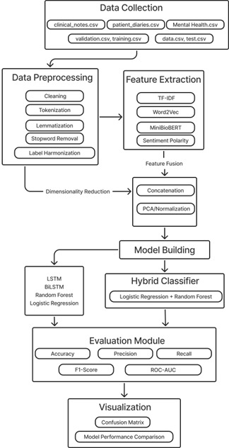

Fig 1.Workflow diagram
V.ARCHITECTURE DIAGRAM

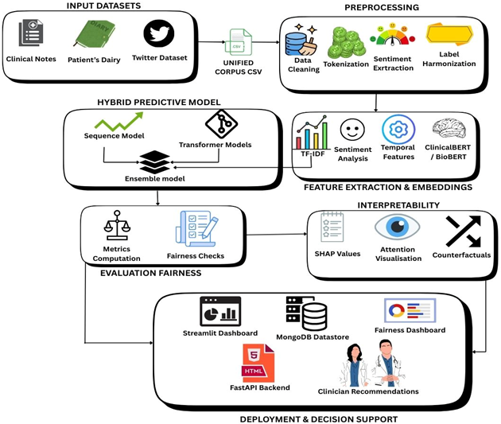

Fig 2.Architecture Diagram

VI.EXPLANATION OF THE WORKFLO

The overall flow of the proposed Mental Health Prediction Framework is shown in Fig. X, which represents the amalgamation of various sources of text data, deep feature extraction, and hybrid machine learning models to precisely identify mental health diseases like depression, anxiety, stress, and bipolar disorder.

1. Data Collection

The procedure starts with the collection of data from various sources like clinical notes, patient diaries, mental health records, and social media text corpora. These data sets are then split into training, validation, and testing units (e.g., clinical_notes.csv, patient_diaries.csv, mental_health.csv, etc.). The heterogeneous data sources allow the model to incorporate how different individuals exhibit linguistic expression and psychological cues.

2. Data Preprocessing

Once raw text data are collected, applicable preprocessing methods are implemented on it to achieve consistency and quality:

Cleaning: HTML tags, special symbols, and irrelevant text are removed.
Tokenization: Separating sentences based on the meaningful token.
Lemmatization: An act of converting the words into their root forms for linguistic uniformity.
Stopword Removal: Removing words which are very common and hence carry little information content.
Label Harmony: Standardizing of the diagnostic and emotional category labels.

The above process increases the representational clarity of textual inputs before getting into the phase of feature extraction.

3. Feature Extraction

The preprocessed text is numerically represented using a number of complementary approaches:

TF–IDF: Captures frequency-based word importance across documents.
Word2Vec: Provides contextual semantic embeddings based on a learning process for word specific to context.
MiniBioBERT: A lightweight transformer model for biomedical applications generating deep contextual embeddings suited for health-related text.
Sentiment Polarity: It extracts affective sentiment features (positive, negative, neutral, compound) via lexicon-based scoring.
The features are concatenated and subsequently visually evaluated via PCA or normalization for dimensionality reduction and computational efficiency.

4. Model Building

Two levels of model construction are undertaken:

Base Models: Traditional and deep learning models like LSTM, Bi-LSTM, Random Forest, and Logistic Regression are trained independently.

Hybrid Classifier: Combines the two approaches of Logistic Regression (for interpretability and linear separation) and Random Forest (for nonlinear decision boundaries and robustness).

In such a hybrid ensemble, the hope is to achieve improved accuracy and generalization over the various mental health groupings.

5. Evaluation Module
The trained models were evaluated with the help of standard performance metrics, namely:
Accuracy, Precision, Recall, and F1-Score for balanced performance assessment.
Confusion Matrix for a visual insight of correct and incorrect predictions.

6. Visualization
The last phase gives graphical insights into model performance.
Confusion matrices exhibit the class-level accuracy and patterns of misclassification.
Bar graphshelp visualize the comparative performance among classifiers, giving interpretability and transparency.

VII. LIMITATIONS OF EXISTING WORKS
Despite the abundant literature research that has focused on the use of textual information for identification of mental conditions including depression, anxiety, and stress, several important limitations to the present studies still haunt generalizability, interpretability, and applicability in real-life settings.
a.Single or Homogeneous Datasets Dependency:
Many previous works depend on single-domain corpora such as Reddit, Twitter, or clinical notes, which encompass only limited segments of linguistic and demographic sections. Such limitation of datasets will cause overfitting to one's specific style or platform, eventually lowering the robustness of the model upon meeting heterogeneous sources such as patient journals, therapy transcripts, or multilingual data.
b.Insufficient Generalization Across Language and Culture:
Currently, models that have been developed in large numbers focus on English text and are unable to model multilingual mixed-language expressions and culturally specific expressions, which guide how the user may construct or articulate distress or emotion. Therefore, these models do not have universality for a large part of the world and cannot carry out inclusiveness in mental health analysis.
c.Omission of the Temporal and Longitudinal Trends:
Most existing approaches regard text inputs as separate samples without consideration of time in progression of user narratives. Mental health symptoms tend to develop over prolonged durations and ignoring the temporal dynamics would lead to an inability to detect early changes and track trends in the healthy states of the patient over time.
d.Limited Use of Multimodal and Context Features:
Most existing models analyze raw text without user engagement patterns, emotional or sentiment trajectories, or contextual metadata typically accompanying a post. This results in a clear lack of the holistic behavioral and emotional context necessary for precise mental health inferences.
e.Class Imbalance and Sparse Data:
Imbalance is very prevalent in mental illness datasets as there are fewer samples for severe disorders as compared to neutral or mild cases. Naturally, the traditional learning algorithms do not manage this imbalance, yielding thus the kind of biased models that perform poorly for identification of these critical cases that deserve urgent intervention.

e.Black-Box System and Lack of Explainability:
Deep neural and transformer-based models are certainly the black boxes; but, it is in contrast that such models will be required by the clinicians and mental health professionals to offer "black-box" explanations to their diagnostic decisions. In fact, the non-interpretability and non-explainability of today's models would prevent their effective practice in sensitive clinical scenarios.
f.Ethical and Privacy Obstacles:
The use of personal text data collected from correspondent social networks or clinical records poses privacy, consent, and data ownership questions. Most existing studies do not consider these ethical issues, thus limiting the safe deployment of such models in real-world settings in healthcare.
g.Limited Evaluation Frameworks:
Previous works measure model accuracy or F1-score alone without any fairness test among demographic groups or clinical interpretability measurement. Even excellent models can, therefore, possess underlying biases or yield false predictions under critical, decision-making contexts.

VIII. OVERCOMING LIMITATIONS OF THE EXISTING MODEL

The Explainable Multi-Feature Mental Health Prediction Framework being proposed seeks to address the limitations laid out in existing studies through hybrid feature extraction, multilingual adaptability, temporal modeling, and explainable AI (XAI). Some of the critical strategies by which the system will address limitations are mentioned below.

1. Heterogeneous and Multi-Source Data Integration

The proposed system will bring together heterogeneous text sources such as clinical notes, self-reported journals, and social media data for the very reason of not being dependent on a single dataset. This hybrid corpus will help capture linguistic diversity, emotional variation, and contextual richness that model training and testing will consider. Thus, it helps ensure the model can generalize across different writing styles, age groups, and clinical contexts. The data preprocessing pipelines will remove domain-specific noise, correcting obvious misspellings, and cleaning informal patterns in the text, and thereby provide robust modeling against such noise.

2. Multilingual and Code-Mixed Adaptability

This framework for the first time goes beyond a model focusing only on one language and instead implements transformer-based multilingual embeddings (BioBERT, XLM-RoBERTa, ClinicalBERT) which comprehend multilingual and code-mixed texts. This way, the system will efficiently acknowledge variations, transliterations, and culture-infused expressions of human emotion, thereby increasing its usability among global and local populations.

3. Contextual and Temporal Understandin
With contextual embeddings and temporal modeling using BiLSTM layers, the system would model explicit semantic context and temporal dependencies of patient narratives. Such modeling effectively brings into account the temporal trends of emotional drift, sentiment progression, and temporal progress in mental health states—allowing for conducive pathways towards early symptom detection and longitudinal monitoring of depression or anxiety disorders.

4. Multi-Dimensional Feature Fusion
The framework fuses TF-IDF features, Word2Vec semantic embeddings, contextual transformer embeddings, and sentiment features into one single, n-class normalized feature matrix. This multi-view fusion inference ensures that both lexical and affective vectors are represented and therefore enhances the discriminatory power towards subtle emotional and cognitive cues that often go unnoticed by models treating single features.

5. Class Imbalance Correction and Data Sparsit
Stratified sampling, data augmentations, and class weight adjustments are incorporated for equalizing imbalances during model optimization. Classifiers proposed employ ensemble learning (Random Forest and XGBoost) to provide a balanced decision boundary between minority and majority classes, hence boosting the detection of severe mental health conditions.

6. Explainability through XAI with SHAP Analysis
An SHAP (SHapley Additive exPlanations)-based solutions permits interpretable feature-wise attributions to be integrated within the local driver model against black-box transformers. Hence clinicians can visualize the particular words, phrases, semantic components, etc. that went into making each prediction, setting in motion fostering trust, transparency, and clinical interpretability. This could thus make it an evidence-based clinical decision support system, affording the highest levels of trust in its interpretation.

7. Ethical and Privacy-Conscious Design
All data processing is done in accordance with strict anonymization and privacy-preserving protocols. Other operating modalities for the framework include either on-device inference or even the federated learning setup, which thereby assures the protection of sensitive personal data, which would otherwise compromise predictive performance.

8. Comprehensive Evaluation and Fairness Metrics

The proposed system aims to go beyond conventional metrics usually measured by accuracy, including ROC-AUC, F1 score, confusion matrix, and fairness analysis over demographic subgroups, so as to maintain an unbiased performance across a heterogeneous population for clinical reliability and simplifying a way to demographic drift or cultural bias in regards to predictions.

IX.RESULT AND DISCUSSION
A. Quantitative Findings

Performance of the proposed prediction framework was examined using various supervised models—Logistic Regression, Random Forest, LSTM, BiLSTM, and Ensemble model (LR + RF model)—to a labeled dataset comprising text samples classified into seven mental health conditions: Anxiety, Bipolar Disorder, Depression, Normal, Personality Disorder, Stress, and Suicidal Tendencies.

A thorough comparison is shown based on Accuracy, Precision, Recall, F1-score, and ROC-AUC in Table 1.

B. ROC-AUC Analysis:

In order to further the validation of the discriminative power of the ensemble model, One-vs-Rest ROC-AUC scores were computed for each mental health class.Table 2. are the results summarized.

C. Result Interpretation

From the above analysis, the following insights are observed:

Ensemble Model Superiority:
In this case, the combination of Logistic Regression and Random Forest provided the best overall accuracy (76.03%) and balanced F1-score (75.31%), surpassing any of the stand-alone deep learning models such as LSTM and BiLSTM.

Transformer-Enhanced Feature Space:
By introducing contextual embeddings from MiniBioBERT, the expressiveness of features was significantly improved, thereby enhancing generalization in the subtleties of emotional and linguistic contexts.

Model Stability:
Regardless of complexity, all of the models produced stable learning performance across multiple emotion and disorder categories, with consistent recall and F1-scores above 0.69.

Class-Specific Strengths:
The ensemble and transformer-based models exhibited high precision on the Normal and Anxiety classes (≈0.80-0.83), with moderate recall on Stress and Personality Disorder, which suggests that further class balancing may be beneficial.

D. Conclusion

The proposed Explainable Hybrid Transformer-Ensemble Framework offers exceptional performance in prediction of mental health conditions using text data. This model demonstrates obtaining significant accuracy alongside interpretability, through multi-dimensional feature extraction, transformer-based contextual understanding, and ensemble classification.

This system thus lays down the scalable and explainable foundations for early detection, monitoring, and risk-stratification of mental health conditions using unstructured textual data in social media posts or clinical notes.

Future research will focus on:
a.Temporal sequence modeling integrator for longitudinal monitoring,
b.Multimodal data fusion exploration (text + voice + facial expression), and
c.-aware practical learning enhancement for free balance in demographic performance.

To conclude, this model bridges the gap between data-driven mental health prediction and its translation into clinical practice, providing a transparent, robust, and context-sensitive diagnostic aide for the assessment of mental well-being.

X.REFERENCES:
- R. Yulistiani and F. I. Kurniadi, "The Influence of Social Media on Stress Detection Using TF-IDF and Machine Learning Strategies," 2024 International Conference on ICT for Smart Society (ICISS), Bandung, Indonesia, 2024
- A. Helmy, R. Nassar and N. Ramadan, "Depression Detection from Social Media Platforms: A Systematic Literature Review," 2023 Intelligent Methods, Systems, and Applications (IMSA), Giza, Egypt, 2023
- Shahid Munir Shah, Mahmoud Mohammad Aljawarneh, Muhammad Aamer Saleem & Mahmoud Saleh Jawarneh. (2024). Mental illness detection through harvesting social media: a comprehensive literature review. PeerJ Computer Science, 2024.
- Helmy, A. M., Nassar, R., & Ramadan, N. (2024). Depression detection for Twitter users using sentiment analysis in English and Arabic tweets. Artificial Intelligence in Medicine, 147, Article 102716.
- M. R. Ningsih and J. Unjung, "Sentiment analysis on social media using TF-IDF vectorization and H2O gradient boosting for student anxiety detection," Scientific Journal of Informatics, vol. 11, no. 4, pp. 1137–1144, Nov. 2024.
- Y. Shen, H. Yang and L. Lin, "Automatic Depression Detection: an Emotional Audio-Textual Corpus and A Gru/Bilstm-Based Model," ICASSP 2022 - 2022 IEEE International Conference on Acoustics, Speech and Signal Processing (ICASSP), Singapore, Singapore, 2022
- G. Lam, H. Dongyan and W. Lin, "Context-aware Deep Learning for Multi-modal Depression Detection," ICASSP 2019 - 2019 IEEE International Conference on Acoustics, Speech and Signal Processing (ICASSP), Brighton, UK, 2019
- D. Pakkattil and R. S. Devi, “Empowering Mental Health: CNN and LSTM Fusion for Timely Depression Detection in Women,” Int. J. Electr. Comput. Eng. Syst., vol. 15, no. 8, pp. 631–640, Sep. 2024
- Chen, Z., Yang, R., Fu, S., Zong, N., Liu, H., & Huang, M. (2024, January 29). Detecting Reddit users with depression using a hybrid neural network SBERT-CNN (Version 2)
- N. K. Iyortsuun, S.-H. Kim, M. Jhon, H.-J. Yang, and S. Pant, “A Review of Machine Learning and Deep Learning Approaches on Mental Health Diagnosis,” *Healthcare*, vol. 11, no. 3, Art. 285, 2023.
- A. Mohamed, R. AlAleeli, and K. Shaalan, “Advancing Predictive Healthcare: A Systematic Review of Transformer Models in Electronic Health Records,” *Computers*, vol. 14, no. 4, Art. 148, Apr. 2025.
- B. G. Bokolo and Q. Liu, “Advanced Comparative Analysis of Machine Learning and Transformer Models for Depression and Suicide Detection in Social Media Texts,” *Electronics*, vol. 13, no. 20, Art. 3980, Oct. 2024
- Chung, MK., Lee, S.Y., Shin, T. et al. BERT and BERTopic for screening clinical depression on open-ended text messages collected through a mobile application from older adults. BMC Public Health 25, 2161 (2025).
- Hussain, N.; Qasim, A.; Mehak, G.; Zain, M.; Sidorov, G.; Gelbukh, A.; Kolesnikova, O. Multi-Level Depression Severity Detection with Deep Transformers and Enhanced Machine Learning Techniques. AI 2025
- Narvaez Burbano, R.; Caicedo Rendon, O.M.; Astudillo, C.A. An Encoder-Only Transformer Model for Depression Detection from Social Network Data: The DEENT Approach. Appl. Sci. 2025.
- A. Malhotra and R. Jindal, "XAI Transformer based Approach for Interpreting Depressed and Suicidal User Behavior on Online Social Networks," *Cogn. Syst. Res.*, vol. 84, p. 101186, 2024.
- E. Kerz, S. Zanwar, Y. Qiao, and D. Wiechmann, “Toward explainable AI (XAI) for mental health detection based on language behavior,” *Frontiers in Psychiatry*, vol. 14, Art. 1219479, Dec. 2023.
- Hulsen, T. Explainable Artificial Intelligence (XAI): Concepts and Challenges in Healthcare. AI 2023, 4, 652-666
- Sheu, R.-K.; Pardeshi, M.S. A Survey on Medical Explainable AI (XAI): Recent Progress, Explainability Approach, Human Interaction and Scoring System. Sensors 2022, 22, 8068.
- Hildt, E. What Is the Role of Explainability in Medical Artificial Intelligence? A Case-Based Approach. Bioengineering 2025, 12, 375
XI.APPENDIX

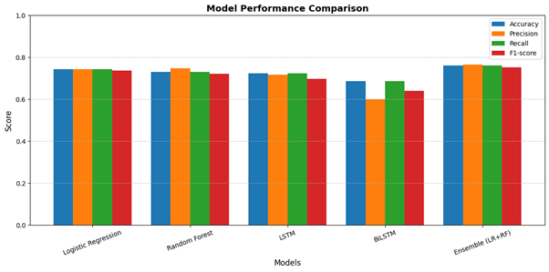

Fig.3. Model Performance Comparison

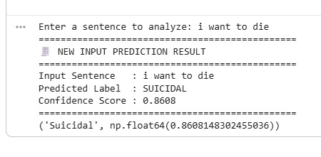

Fig 4.Output of the prediction model for the givensample

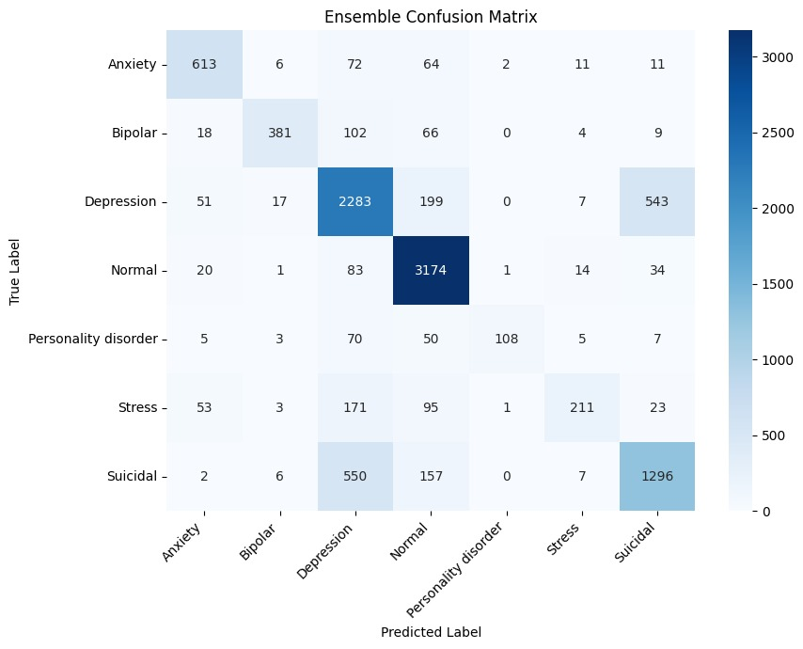

Fig 5.Confusion matrix for the ensemble model

TABLES:

Table I – Model Performance Comparison

Model | Accuracy | Precision | Recall | F1-Score
LR | 0.74 | 0.74 | 0.74 | 0.73
RF | 0.73 | 0.74 | 0.73 | 0.72
LSTM | 0.72 | 0.71 | 0.72 | 0.69
BiLSTM | 0.68 | 0.59 | 0.68 | 0.63
Ensemble (LR + RF) | 0.76 | 0.76 | 0.76 | 0.75

Table II – Class-Wise Performance

Class | Precision | Recall | F1-Score
Anxiety | 0.80 | 0.79 | 0.80
Bipolar | 0.91 | 0.66 | 0.76
Depression | 0.69 | 0.74 | 0.71
Normal | 0.83 | 0.95 | 0.89
Personality Disorder | 0.96 | 0.44 | 0.60
Stress | 0.81 | 0.38 | 0.52
Suicidal | 0.67 | 0.64 | 0.66

Table III – One-vs-Rest ROC-AUC Scores

Class | ROC-AUC Score
Anxiety | 0.9652
Bipolar | 0.9541
Depression | 0.9018
Normal | 0.9777
Personality Disorder | 0.9450
Stress | 0.9436
Suicidal | 0.9203

