**SUN TRACKING SOLAR PANEL**

**Project Report**

**Microcontroller and its Application (ECE3003)**

**Group members:**

**S SHANKAR NARAYANAN 15BEC1031**

**SURYA VAMSI 15BEC1127**

**J RITHESH 15BEC1105**

**Name of faculty**:**PROF.BALAMURUGAN MS**

**SCHOOL OF ELECTRONICS AND COMMUNICATION ENGINEERING (SENSE)**



MAY 2017

**CERTIFICATE**

This is to certify that the Project work entitled “SUN TRACKING SOLAR PANEL” that is being submitted by “RITHESH, SHANKAR, SURYAVAMSI,**”**for CAL in B. Tech Microcontroller and its Application ECE 3003is a record of bonafide work done under my supervision. The contents of this Project work have not been submitted for any other CAL course.

**Place: Chennai**

**Date: 04 MAY 2017**

**Signature of Students:**

**S SHANKAR NARAYANAN**

**RITHESH**

**SURYAVAMSI**

**Signature of Faculty:**

**PROF.BALAMURUGAN MS**

**ACKNOWLEDGEMENTS**

We have taken efforts in this project. However, it would not have been possible without the kind support from our SENSE professor PROF.BALAMURUGAN who guided us and our VIT university which supported us throughout the project I would like to extend my sincere thanks to all of them.

I am highly indebted to SCHOOL OF ELECTRONICS AND COMMUNICATION ENGINEERING (SENSE) for their guidance and constant supervision as well as for providing necessary information regarding the project & also for their support in completing the project.

I would like to express my gratitude towards my friends and lab staffs for their kind co-operation and encouragement which help me in completion of this project.

.

My thanks and appreciations also goes to people who have willingly helped me out with their ability

**SIGNATURE:**

**S SHANKAR**

**RITHESH**

**SURYAVAMSI**

**AIM**:

The main objective of this project is to make a solar panel that is able to track the sun’s position and automatically align itself in a perpendicular profile to get maximum solar energy which makes it a very efficient system to harness renewable energy.

1. **Introduction:**

This kind of sun-tracking solar panel makes use of a LDR to get the input, a LM324 to compare the voltages from LDR , and of course a 8051 micro-controller which makes this possible.

NOTE: In our project we have eliminated the use of L293D and the Stepper Motor over Servo motor owing to low power use and more precise rotation.

1. **Block diagram:**

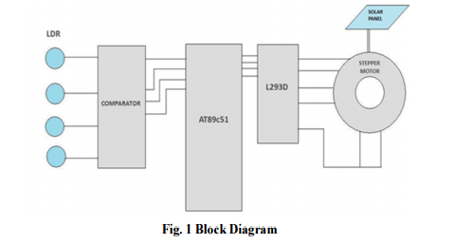

1. **Components used:**

* Atmel AT89C51 Microcontroller
* LM324 Comparator
* 2 W Solar Panel
* Servo Motor
* LDR
* Resistor(10KΩ,1KΩ)
* Capacitor(10µF,33µF)
* Crystal Oscillator(11.0592 Mhz)
* 5V and 6V power supply

1. **Circuit Diagram:**

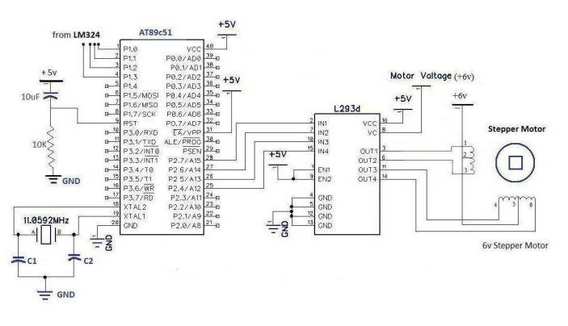

1. **Technical specifications (Datasheet):**

**LM324 Comparator:**

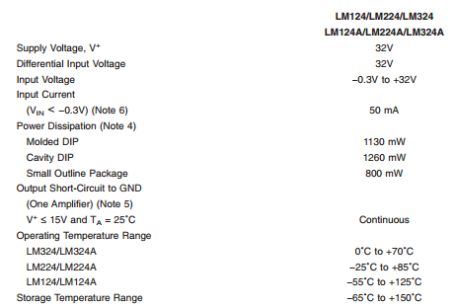

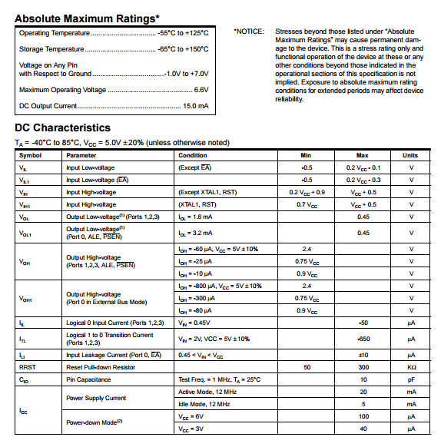Atmel 8051c51:

1. **Working:**

  When light falls on the LDR ,each of them is assigned to a particular logical level with which the LM324 comparator does its job and references them based on the reference voltage,in this case 0 means low and 5 means high.

The role of the LM324 is to get the inputs from the LDR a so that the inputs can be converted into logical states for use in 8051 micro-controller.

Coming to the Micro-Controller,its job is to put all these together viz

* Getting input
* Converting input to logical level
* Implementing Logical level in machine level language
* Sending information
* Real-Time implementation in Servo Motor

The Servo Motor rotates with a 30 degree at every logical level.

There are 7 logic states by which it is implemented for 4 LDR’s.

1. **Simulation results using PROTEUS:**

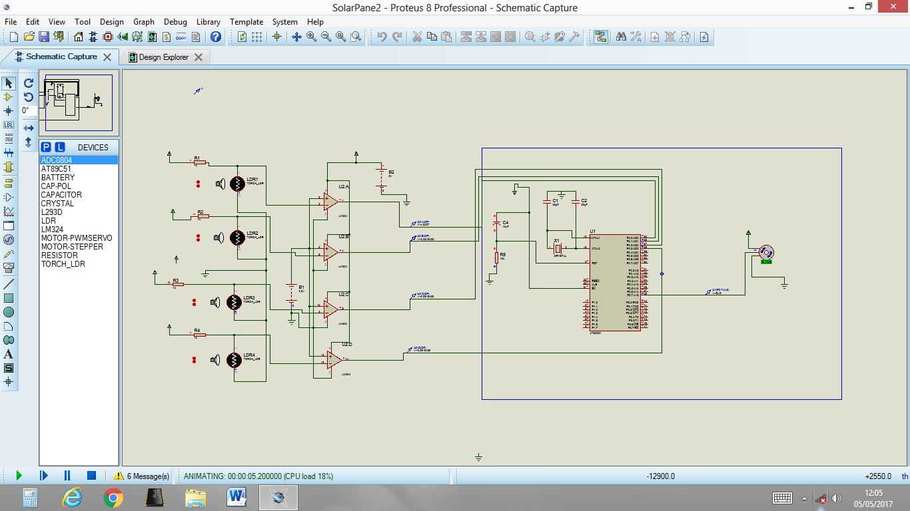

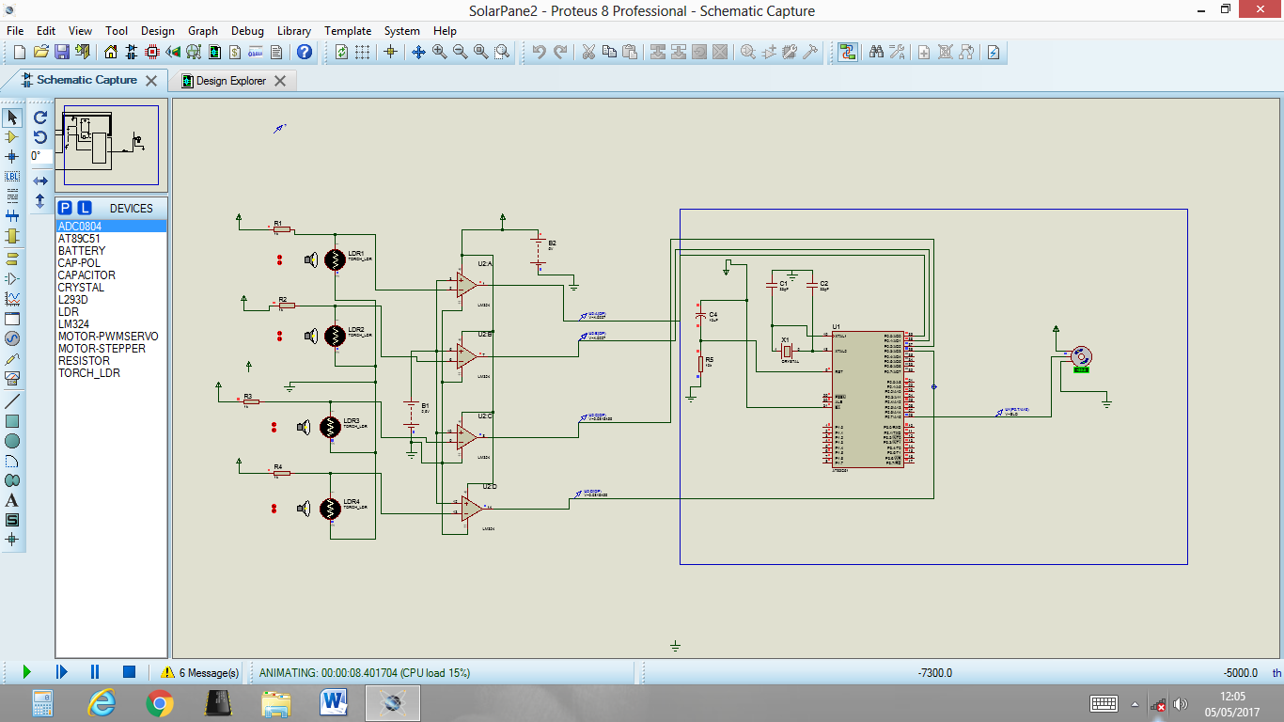

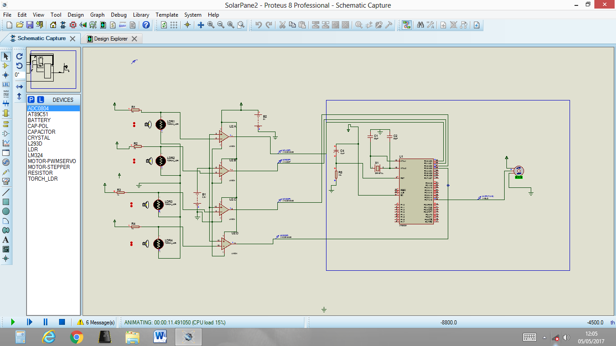

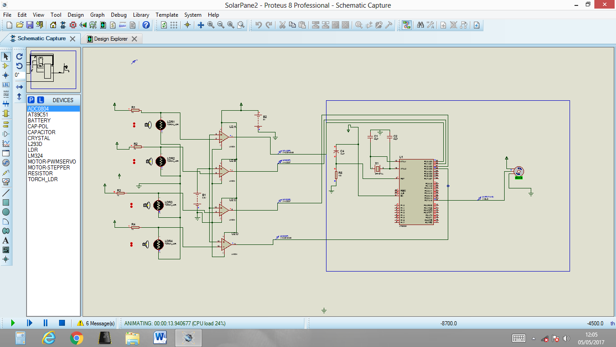

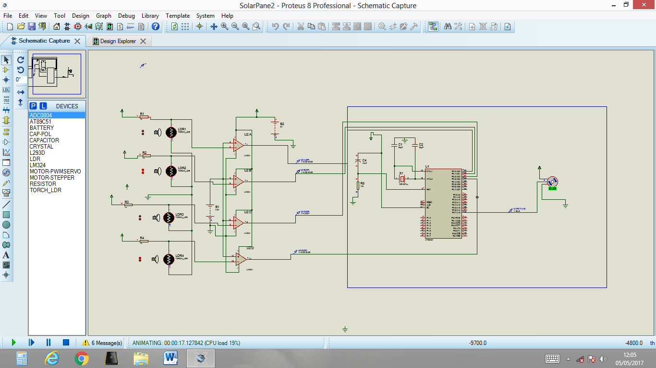

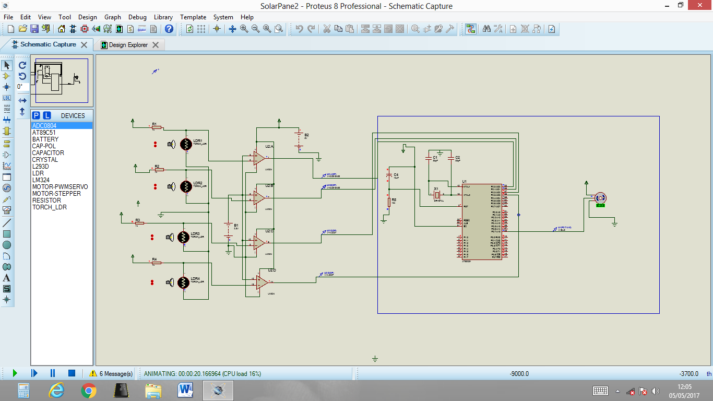

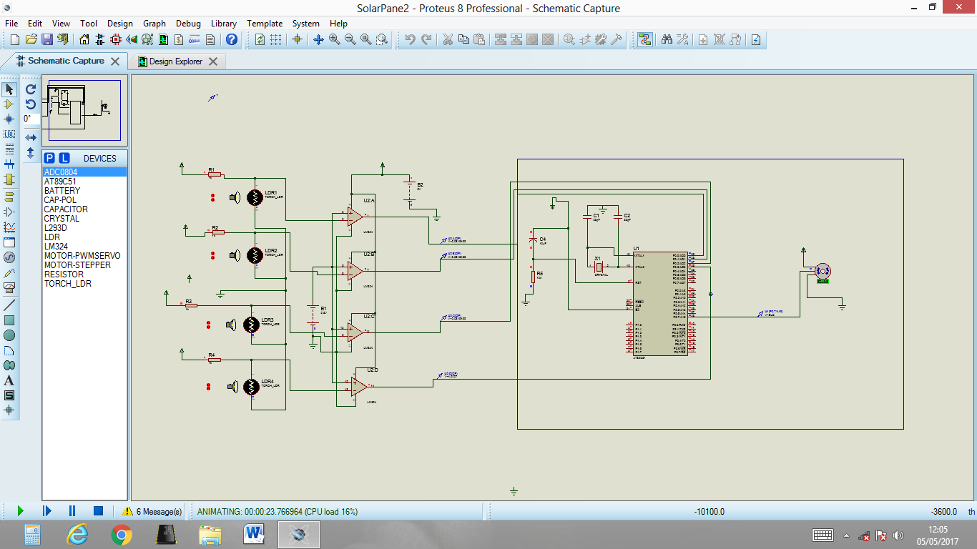

1. **Project photo:**

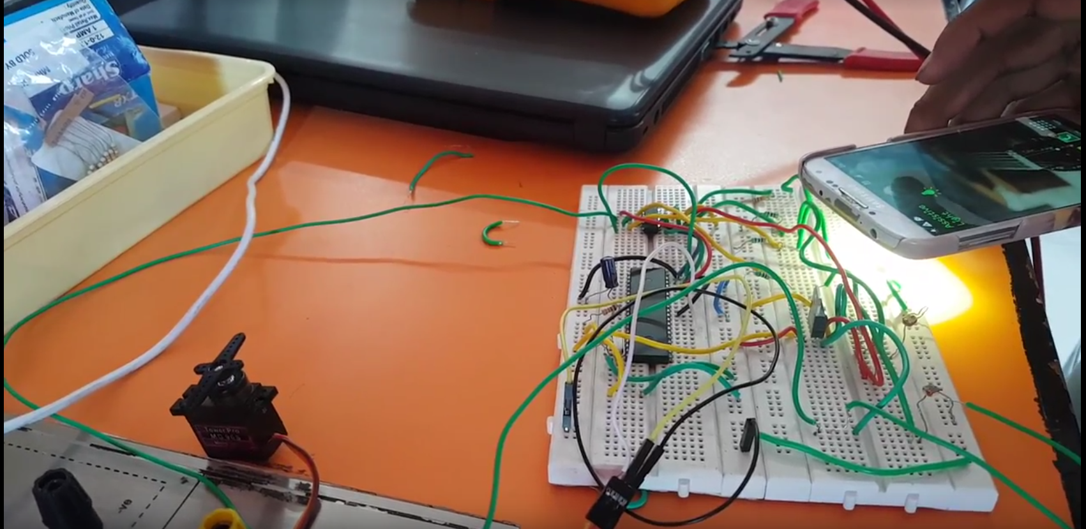

1. **REFERENCES:**

**Micro-Controller and its Application -Massidi**