Homework Chapter 2 - Mark Cappiello

1. Flip a fair coin nine times and write down the number of heads obtained. Now repeat this process 100,000 times. Obviously you don’t want to have to do that by hand, so create the necessary lines of R code to do it for you. Hint: You will need both the rbinom() function and the table() function. Write down the results and explain in your own words what they mean.

# Set seed for reproducibility  
set.seed(123)  
  
# Number of trials  
num_trials <- 100000  
  
# Number of coin flips per trial  
num_flips <- 9  
  
# Probability of getting a head (for a fair coin)  
prob_head <- 0.5  
  
# Simulate the trials  
results <- rbinom(num_trials, num_flips, prob_head)  
  
# Summarize the results  
summary_table <- table(results)  
  
# Print the summary table  
print(summary_table)

## results  
## 0 1 2 3 4 5 6 7 8 9   
## 179 1717 6969 16479 24915 24431 16384 6980 1774 172

# Optional: Plot the distribution of the results  
barplot(summary_table, main="Distribution of Number of Heads in 9 Coin Flips",  
 xlab="Number of Heads", ylab="Frequency", col="lightblue", border="black")

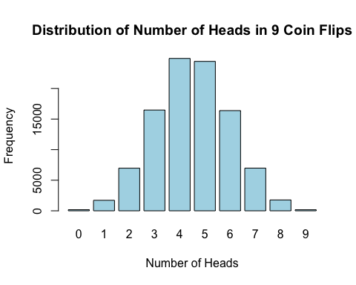

Explanation of the Code

Setting Seed: set.seed(123) ensures that the results are reproducible. Different seeds will yield different random sequences.

Defining Variables: num_trials: The number of times we repeat the process (100,000 times).

num_flips: The number of coin flips per trial (9 flips).

prob_head: The probability of getting a head in a single flip (0.5 for a fair coin).

Simulating Trials: rbinom(num_trials, num_flips, prob_head) simulates 100,000 trials of flipping a coin 9 times each and counts the number of heads in each trial.

Summarizing Results: table(results) creates a frequency table of the number of heads obtained in each trial. Printing and Plotting: The summary table is printed and optionally plotted to visualize the distribution of the number of heads.

1. Using the output from Exercise 1, summarize the results of your 100,000 trials of nine flips each in a bar plot using the appropriate commands in R. Convert the results to probabilities and represent that in a bar plot as well. Write a brief interpretive analysis that describes what each of these bar plots signifies and how the two bar plots are related. Make sure to comment on the shape of each bar plot and why you believe that the bar plot has taken that shape. Also make sure to say something about the center of the bar plot and why it is where it is.

# Convert frequencies to probabilities  
probabilities <- summary_table / num_trials  
  
# Bar plot for frequencies  
barplot(summary_table,   
 main="Distribution: Heads in 9 Coin Flips (Frequencies)",  
 xlab="Number of Heads", ylab="Frequency",   
 col="lightblue", border="black")

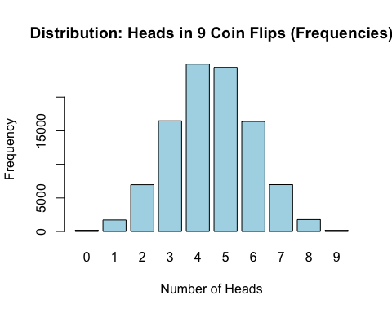

# Bar plot for probabilities  
barplot(probabilities,   
 main="Distribution: Heads in 9 Coin Flips (Probabilities)",  
 xlab="Number of Heads", ylab="Probability",   
 col="lightgreen", border="black")

