IST-686 Textbook Ch 02 - Reasoning with Probability

### Outcome Tables

Use R to produce random binomial trials

table(rbinom(n=100,size=6,prob=0.5))

##   
## 1 2 3 4 5   
## 11 31 28 22 8

rbinom finction witout table()

rbinom(n=100,size=6,prob=0.5)

## [1] 2 0 2 1 1 3 2 2 2 4 2 1 3 3 3 1 3 4 2 3 3 4 5 3 4 0 2 3 3 4 3 5 3 4 6 2 4  
## [38] 5 2 3 1 3 3 2 4 2 1 4 4 4 3 2 2 4 4 0 4 1 4 3 2 4 3 3 1 1 1 2 3 5 4 2 3 3  
## [75] 2 3 4 3 4 2 2 4 6 3 3 3 1 3 1 1 3 4 1 5 5 4 3 2 2 3

### Visualize the Distribution

hist(rbinom(n=100,size=6,prob=0.5))

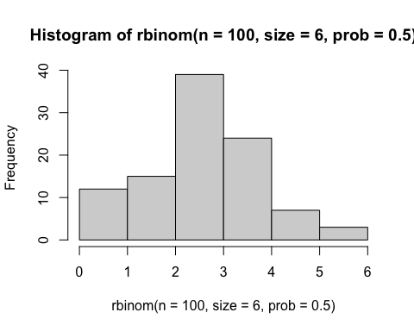

hist(rbinom(n=1000,size=6,prob=0.5))

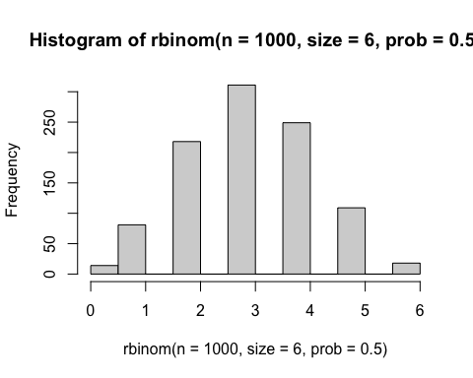

barplot(table(rbinom(n=100, size=6, prob=0.5)))

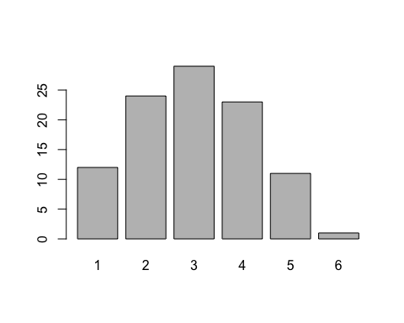

### Visualize the Distribution– more

# Generate the data  
data <- rbinom(n=100, size=6, prob=0.5)  
  
# Create a frequency table  
freq_table <- table(data)  
  
# Plot the frequency table  
barplot(freq_table,   
 main="Frequency of Number of Successes",   
 xlab="Number of Successes",   
 ylab="Frequency",   
 col="lightblue",   
 border="black")

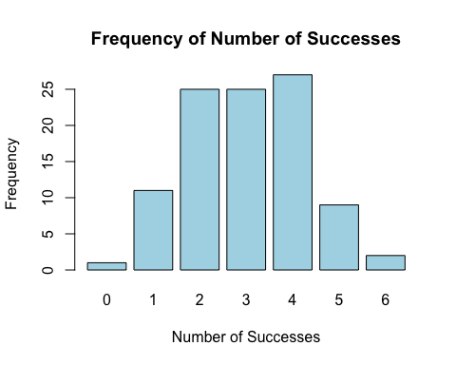

table(rbinom(n=1000,size=6,prob=0.5))/1000

##   
## 0 1 2 3 4 5 6   
## 0.017 0.080 0.247 0.332 0.223 0.085 0.016

barplot(table(rbinom(n=100,size=6,prob=0.5))/1000)

