**TYPOGRAPHY**

**h1 (title/header)**

Font family: Open sans

Weight: light 300

*Size: 2rem?*

*color: rgb(148,17,40,0) maroon ?*

**h2 (page title)**

Font family: Open sans

Weight: normal 400

*Size: 1.5rem?*

*color: black ?*

**body**

Font family: Open sans

Weight: normal 400

Size: 1rem

color: black

**nav bar**

Font family: Open sans

Weight: normal 400

Size: 1.5rem

color: white

**footer**

Font family: Open sans

Weight: normal 400

Size: .8rem

color: black

**LINKS**

**a:link**

color: rgb(148,17,40,0) maroon

text-decoration: none;

**a:active**

text-decoration: none;

**a:visited**

text-decoration: none;

**a:hover**

color: rbg(120,120,120,0)

text-decoration: none;

**COLORS**

**header (background-color)**

rgb (238, 208, 144) cream color

**nav bar (background-color)**

rgb(148,17,40,0) maroon

**background-color (page)**

rgb (240,240,240,0) light gray

**footer (background color)**

rgb (220, 220, 220,0) darker gray

**SITE ARCHITECTURE**

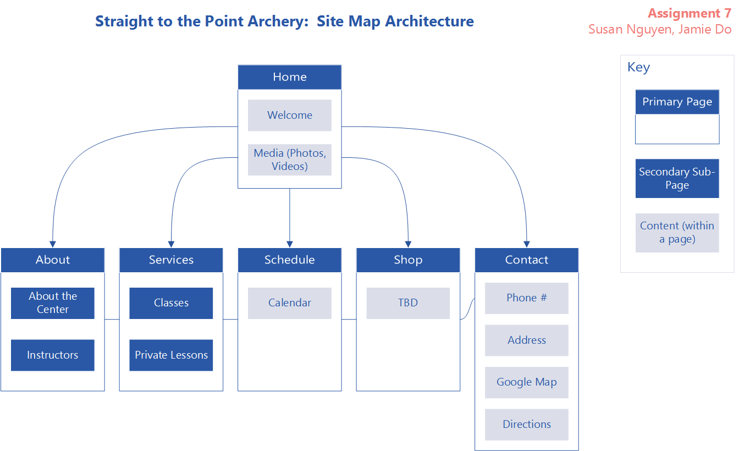

**PAGE1.HTML WIREFRAME/SKETCH**

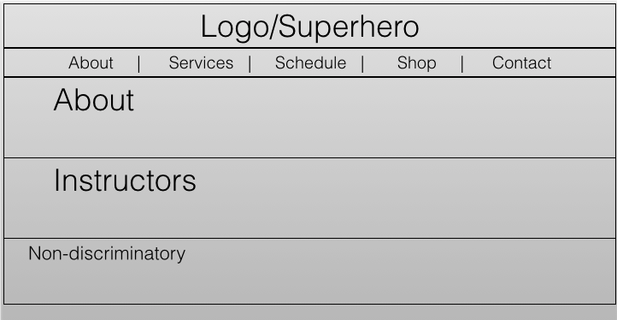

**SERVICES.HTML WIREFRAME/SKETCH**

