Setup ClamSAP on SLES

Preparation
Both ClamAV and ClamSAP packages must be installed on the application host.

>zypper in clamav clamsap

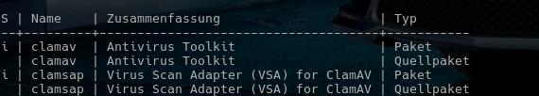
After installation it is recommended to check if the necessary libraries are in place (by default in /usr/lib64).

Start the clamd service:

> systemctl start clamd
> systemctl status clamd

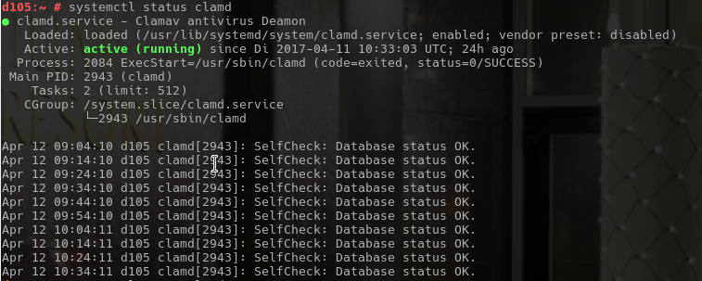

Set up and implement

Creating Virus Scan Group
Log on to the SAP through SAP GUI. Please note that DDIC and SAP* users are not appropriate, as the virus scanner has to be cross-client configured.

Use transaction „VSCANGROUP“ to create a Virus Scan Group:

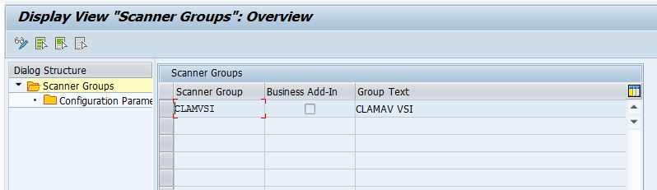

Click on the button to switch from the view mode to change. A warning message of cross-client tables pops up and can be acknowledged.

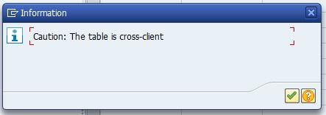
Then the table becomes editable, select the first empty row, and fill in the fields (Scanner Group and Group Text). Do not tick the „Business Add-in“ checkbox.
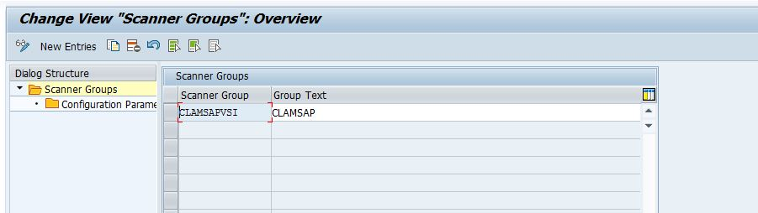
The form will be saved by pressing the button or Ctrl+S.

Setup the library
Call the transaction „VSCAN“ in SAP GUI and use the button to switch from the view mode to change mode, and acknowledge the warning of cross-client tables.
Afterwards a „New entries“ button will show up right next to it, which will be used to add a new virus scanner. Fill in the form accordingly:
- Provider Type: Adapter (Virus Scan Adapter)
- Provider Name: VSA_<HOSTNAME> (eg.: VSA_SAPSERVER)
- Scanner Group: Use the scanner group name as it was already given in the previous step (eg.: CLAMSAPVSI)
- Server: <hostname>_<SID>_<instance_number> (eg.: SAPSERVER_P04_00)
- Adapter Path: libclamsap.so
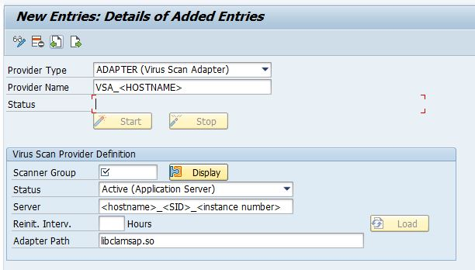
The form will be saved by pressing the button or Ctrl+S.

Engaging ClamSAP
In transaction VSCAN, after the entry has been saved, the ClamSAP can be engaged, by pressing the „Start“ button.
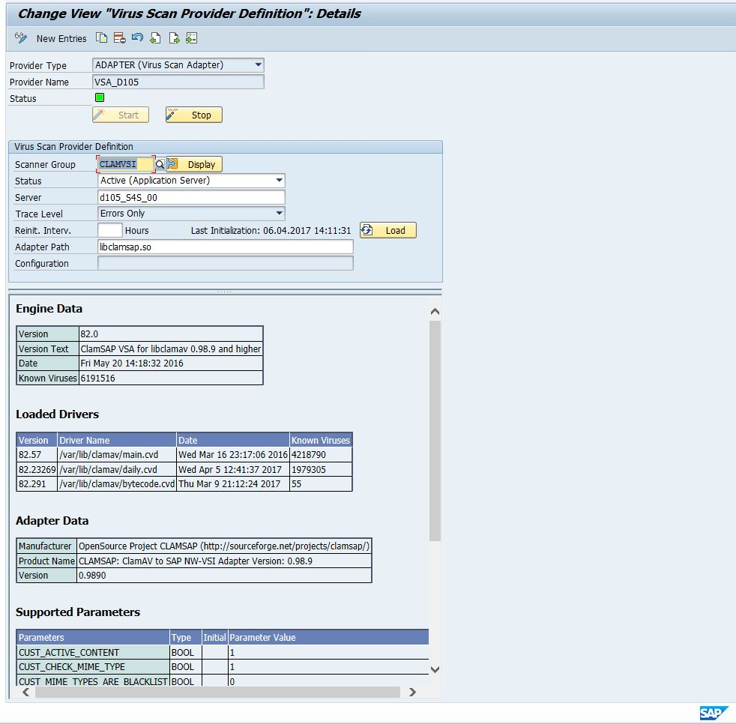
Below the form a summary will be showed, including details of running ClamAV and ClamSAP.
Table of contents
Preparation 1
Set up and implement 2
Creating Virus Scan Group 2
Setup the library 3
Engaging ClamSAP 4

