How to add more SAP instances to an existing SUSE cluster for S/4HANA or NetWeaver?
Back from TechEd India I was able to continue my work on a new Best Practices document to make SAP workloads high available. I'm happy for the feedback that I got on the TechEd, SAPPHIRE and SUSECON this year. We try to take care of all of them and this and up into a better Best Practices guide for all partners and customers. I would like to announce a new coming Best Practices next year (2020) which will describe how to extent the cluster configuration with more than one SAP instance or SAP HANA DB. I'll name that paper in the following text as Multi-SID paper. This fit into the statement SAP go green in multiple ways. Firstly use compute resources much more efficient. Secondly using SUSE as OS to install the SAP application on top of it.

Running more than one S/4HANA or NetWeaver central instances in the same cluster!
For SAP central instances (ASCS/ERS) we have published multiple Best Practices:
https://documentation.suse.com/sbp/all/single-html/SAP_HA740_SetupGuide_AWS/
sap_netweaver_availability_cluster_740_setup_guide
https://documentation.suse.com/sbp/all/single-html/SAP_S4HA10_SetupGuide-SLE12/
https://documentation.suse.com/sbp/all/single-html/SAP_S4HA10_SetupGuide-SLE15/
Such a cluster looks like this simplified picture:

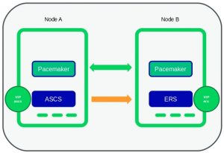
The question which has reached us is if we would support like the setup below?
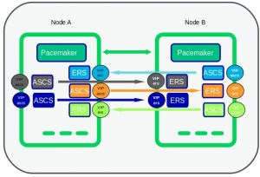
The Answer is simple: Yes we do.

What could you expect in 2020 for your SAP workloads?
Therefore we started together with Azure and proved and verified multiple scenarios for SAP central instances running in one cluster. The document is mostly finished and has a draft status. We will do some chapter restructuring and adding necessary general information before we can publish it.
We will cover e.g.
- Multi-SID setups for ENSA1 in a two node cluster
- Multi-SID setups for ENSA1 in a multi node cluster
- Multi-SID setups for ENSA2 in a two node cluster
- Multi-SID setups for ENSA2 in a multi node cluster
- Multi-SID setups for ENSA1 and ENSA2 in a two node cluster
- Multi-SID setups for ENSA1 and ENSA2 in a multi node cluster
- Multiple HANA SR DB pairs running in one cluster (not planed for the first release)
In short as known from all our other documentation this will be free available on our SUSE Best Practices website. It can be easily adapt to all other infrastructure platform using the SUSE "base" Best Practice. As a result most of our partner will adapt this and provide their own documentation or have a joined documentation with us. In summary the new paper describes the additional step to extend an running cluster for ASCS / ERS with additional installed ASCS / ERS instances. In other words I can see that the guide is repeating the steps which we have done for the first instance with less adaptions.
Most importantly I hope this guide will point this out and show the things which you should take care for.

This is Bernd for SAP LinuxLab St. Leon-Rot Germany

