The dataset was explored to understand its structure, data types, and available attributes. The dataset contains demographic, lifestyle, and medical information related to heart disease prediction. No missing or inconsistent values were observed during exploration.
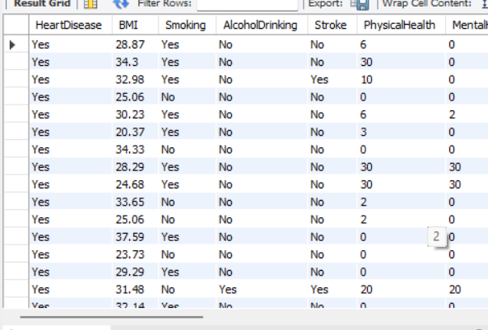
Since the objective is to analyze factors influencing heart disease, the complete dataset was retained without removing any records.
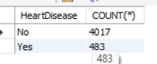

Validation was performed by comparing summary statistics generated in Tableau with SQL query results. The values matched successfully, confirming the accuracy of the imported dataset.
The Heart Disease dataset was reviewed before visualization to ensure it was suitable for analysis. Since the dataset had already been pre-cleaned, no additional preprocessing such as handling missing values, duplicate removal, or outlier treatment was required. The dataset structure, field names, data types, and value distributions were verified using SQL queries. Relevant attributes such as age category, gender, BMI, smoking status, physical activity, diabetes, and heart disease status were retained for analysis. Field names were made more readable where necessary, and data types were validated to ensure compatibility with Tableau. Finally, summary statistics generated in SQL were compared with Tableau outputs to confirm data integrity before developing the visualizations.

