**Steps for creating a C++Applications in Qt**

1. Click on the "**Qt Creator**" icon which opens the below window.

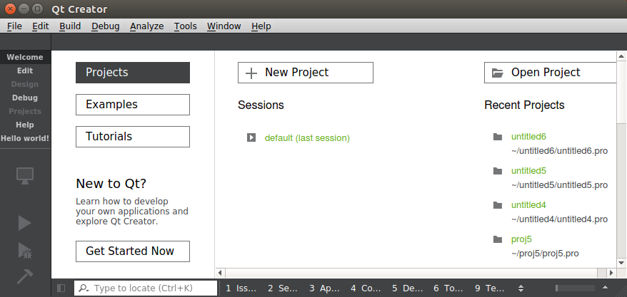

2. Click on "**+ New Project**" button which opens the below window.

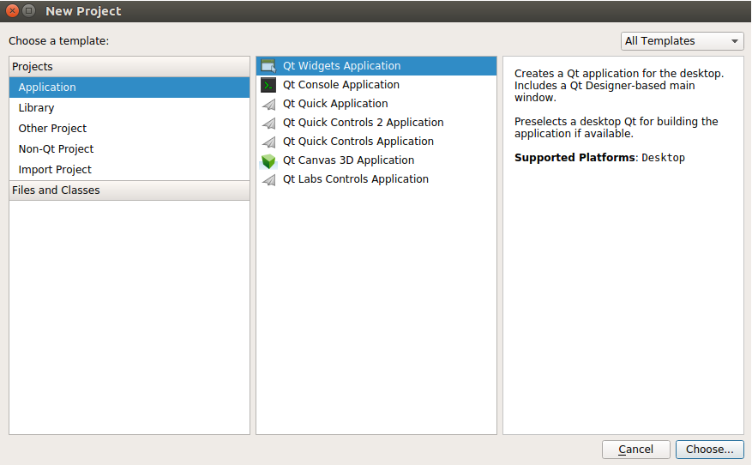

3. Click on "**Non-Qt Project**" and select "**Plain C++ Application**" and then click Choose button below.

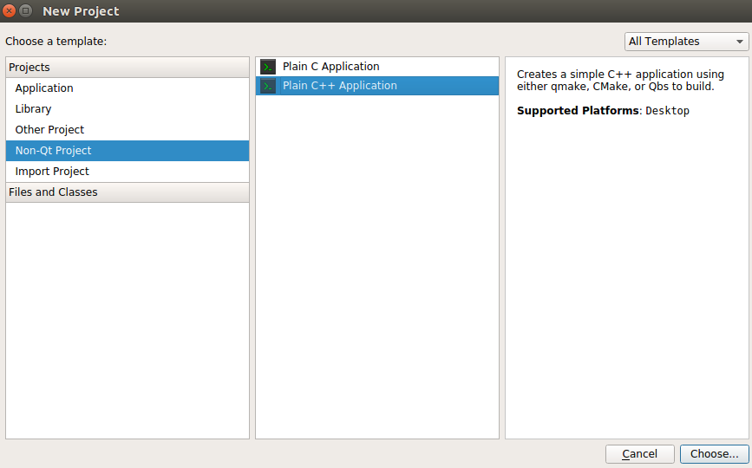

4. A window appears as shown below. In that give a name for the project example - "**Project_1**" and select the path and click "**Next**".

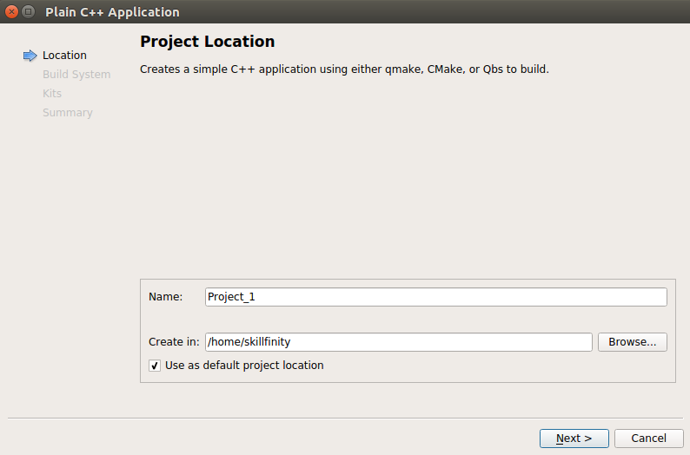

5. A window appears as shown below asking to select the build system. It has three build systems. Select "**qmake**" and click "**Next**"

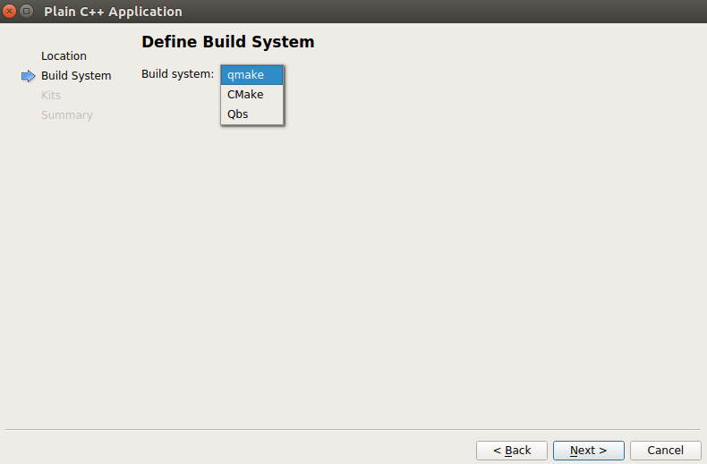

6. A window appears as shown below which asks to select the Kit. Make sure that "**Desktop Qt 5.7.0 GCC 64-bit**" is checked and then click "**Next**"

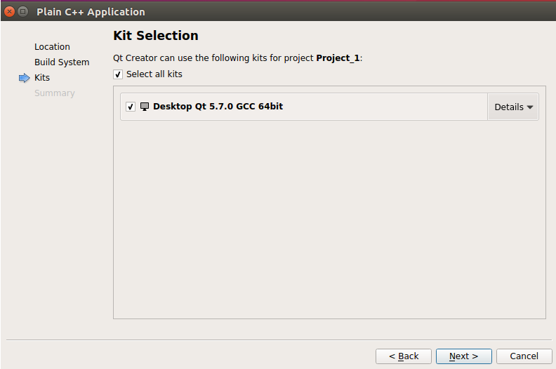

7. A window displaying the summary appears as shown below. Make sure it is correct and then click "**Finish**" else click "**Back**" and modify the things as explained from Step 1-6.

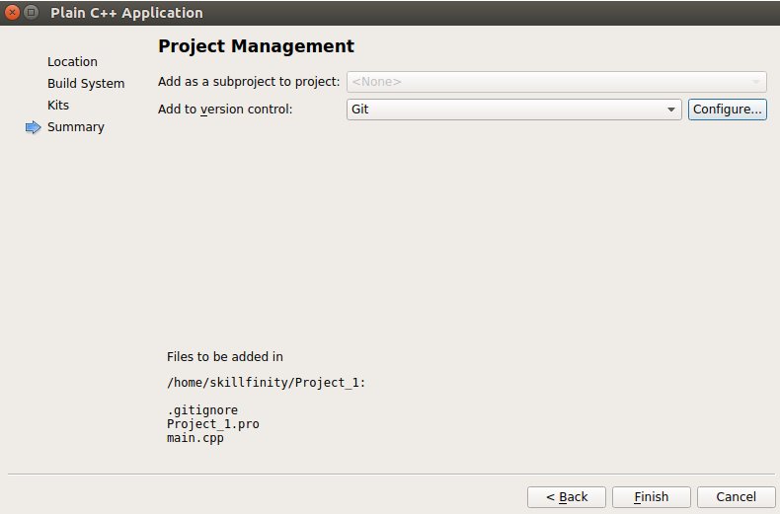

8. The main window appears where you can write your C++ programs. On the selection, "Hello World" program appears. Delete the arguments "int argc" and "char *argv[]" leaving it as "int main()".

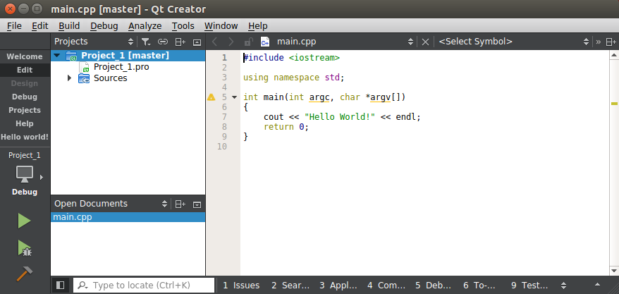

9. Save the file "**Project_1**" and then Select the "**Build**" Menu opton on the toolbar. In that select “**Build All”** or press "**Ctrl+Shift+B**".

10. Finally select the "**Build**" Menu option on the toolbar and then select "**Run**" or press **Ctrl+R**" to run the program. The terminal pops up displaying the output as shown below.

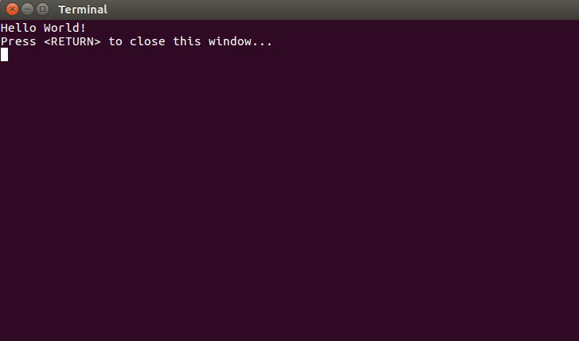

**Adding Classes to your program**

1. Select **File->New File or Project** from the tool bar. A window appears as shown below. In that select "**C++**" and in the adjacent column select "**C++ Class"** and then click on "**Choose**".

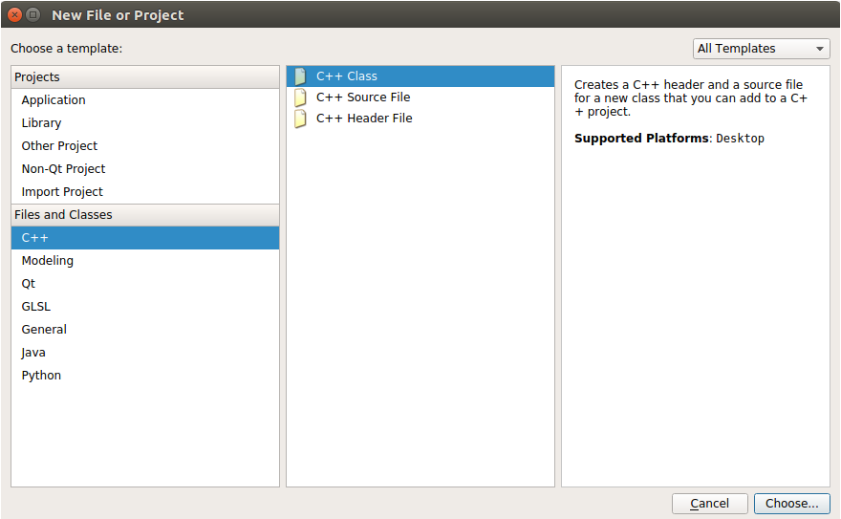

2. A window appears in that give the name for the class example "Employee". You can see that a header file and a source file is created with the given name. Then click on "**Next**".

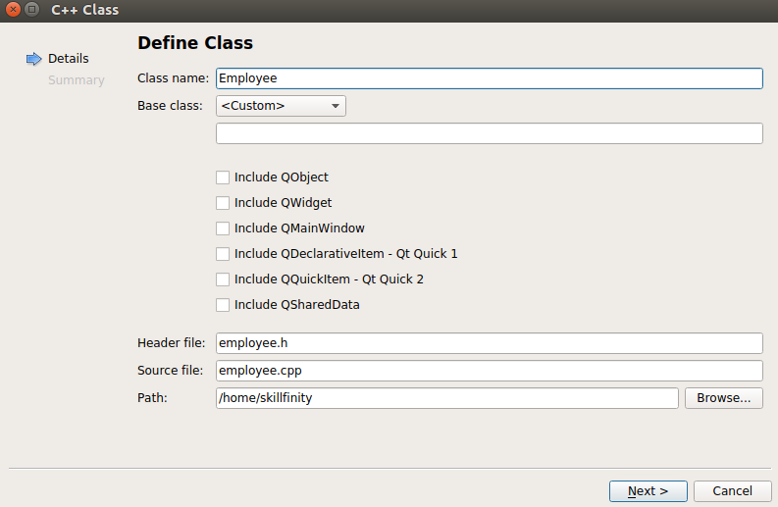

3. A summary window appears as shown below. Click on "**Finish".**

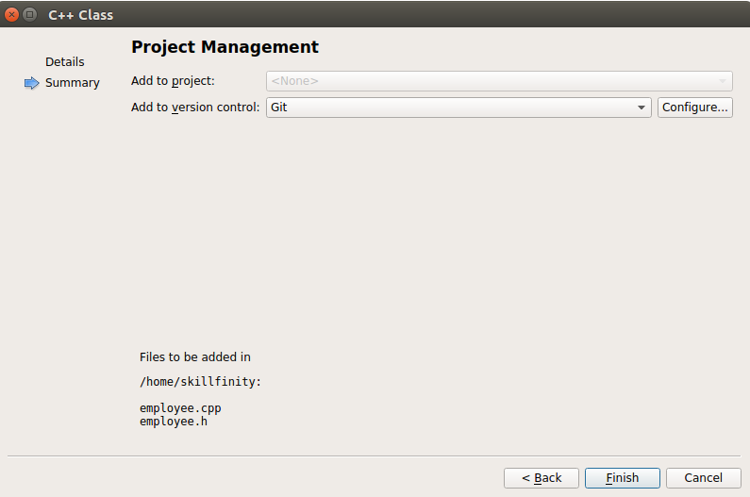

4. Use the source files in the link below as reference for development.

<https://github.com/Skillfinity/PEP1/tree/master/SourceCodeReference>

Follow the coding guidelines mentioned in the file for all your development.