**Create Database:**

CREATE DATABASE ecom;

**ERD:**

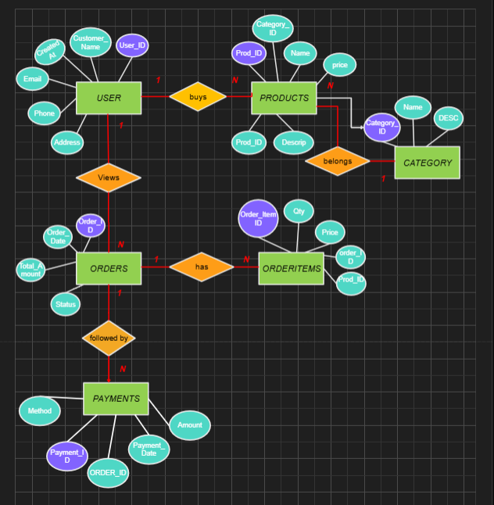

**Create Tables:**

* **USER Table:**  
    
  CREATE TABLE Users (

User_ID INT PRIMARY KEY AUTO_INCREMENT,

Customer_Name VARCHAR(50) NOT NULL,

Email VARCHAR(50) NOT NULL,

Phone CHAR(10),

Address VARCHAR(50),

created_At DATETIME DEFAULT CURRENT_TIMESTAMP

);

This table keeps track of customers, their contact info, and when they were added to the system. You can now **add, view, or manage users** in the e-commerce database.

* **Categories Table:**

CREATE TABLE Categories (

category_id INT PRIMARY KEY AUTO_INCREMENT,

name VARCHAR(100) NOT NULL,

description TEXT

);

This table is used to **group products** into categories like a mobile phone, and link it to a category from this table.

* **Products Table:**

CREATE TABLE Products (

product_ID INT PRIMARY KEY AUTO_INCREMENT,

Product_Name VARCHAR(50) NOT NULL,

Description TEXT,

price DECIMAL(10,2) NOT NULL,

category_ID INT,

created_At DATETIME DEFAULT CURRENT_TIMESTAMP,

FOREIGN KEY (category_ID) REFERENCES Categories(category_id)

);

This table stores each product’s name, price, description, category, and when it was added. It ensures that products are **properly grouped by category**.

* **Orders table:**

CREATE TABLE Orders (

order_id INT PRIMARY KEY,

user_id INT,

order_date DATETIME DEFAULT CURRENT_TIMESTAMP,

total_amount DECIMAL(10,2),

status VARCHAR(50),

FOREIGN KEY (user_id) REFERENCES Users(User_ID)

);

This table keeps track of **every order** placed in your system including **who ordered**, **when**, **how much it cost**, and the **status** of the order.

* **OrderItems table**:

CREATE TABLE OrderItems (

order_item_id INT PRIMARY KEY,

order_id INT,

product_id INT,

quantity INT,

price DECIMAL(10,2),

FOREIGN KEY (order_id) REFERENCES Orders(order_id),

FOREIGN KEY (product_id) REFERENCES Products(product_ID)

);

This table tracks **which products are in each order**, how many were bought, and at what cost.

* **Payments table:**

CREATE TABLE Payments (

payment_id INT PRIMARY KEY AUTO_INCREMENT,

order_id INT,

payment_date DATETIME DEFAULT CURRENT_TIMESTAMP,

amount DECIMAL(10,2),

payment_method VARCHAR(50),

status VARCHAR(50),

FOREIGN KEY (order_id) REFERENCES Orders(order_id)

);

This table records **how and when each order was paid**, how much was paid, and the **status** of the payment.

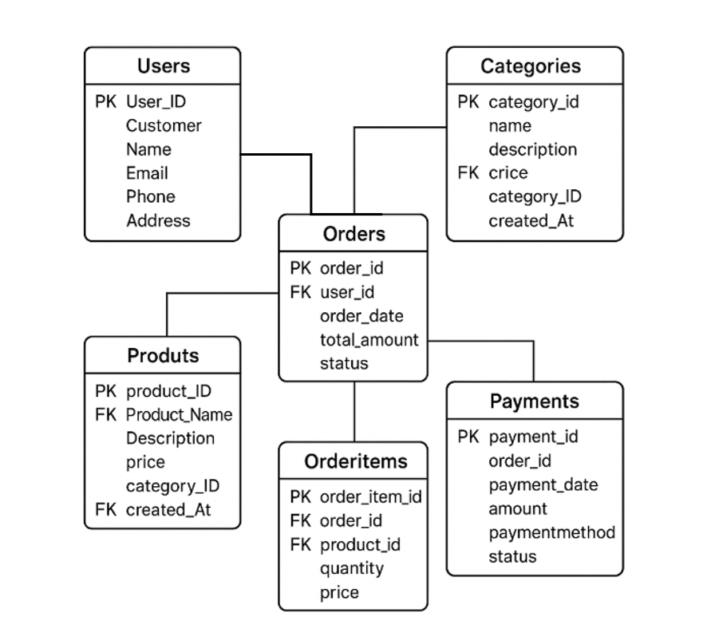

* **Inseted Values in different tables:**

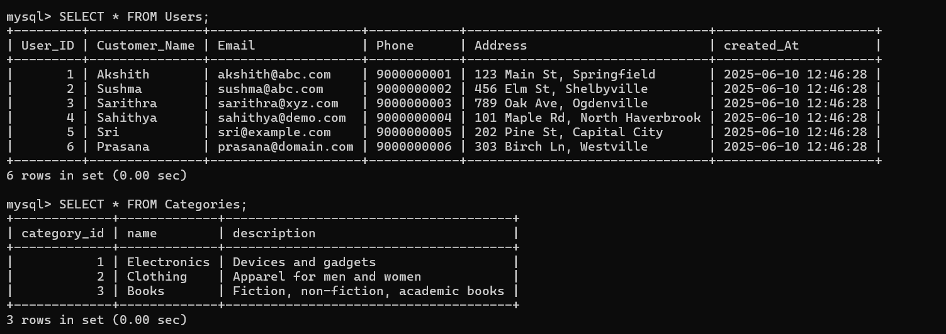

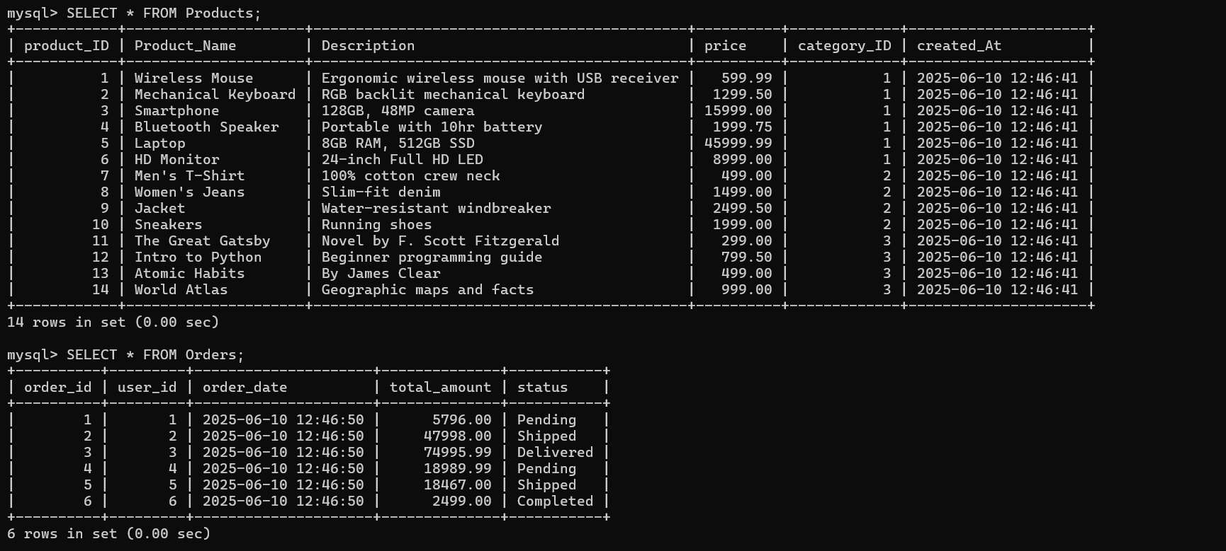

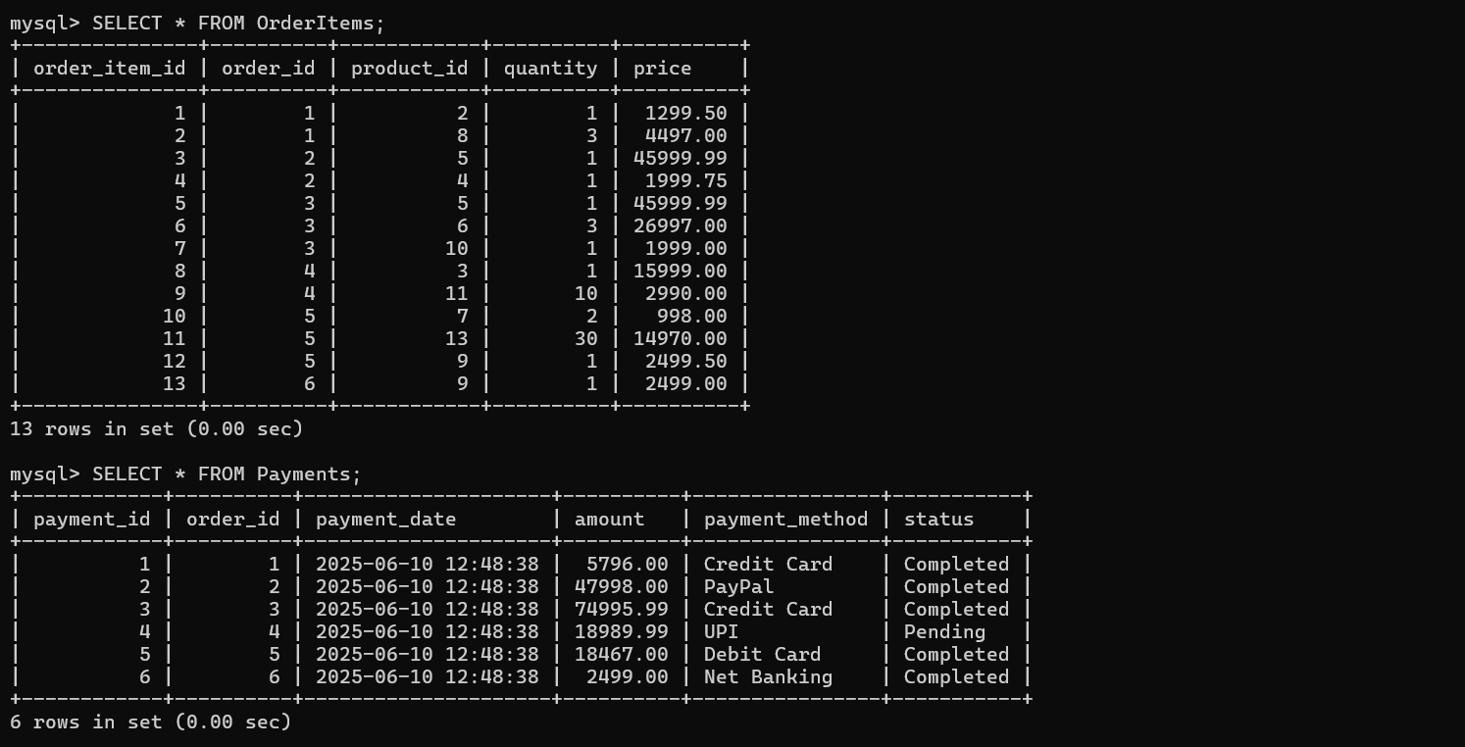

**Aggregate functions:**

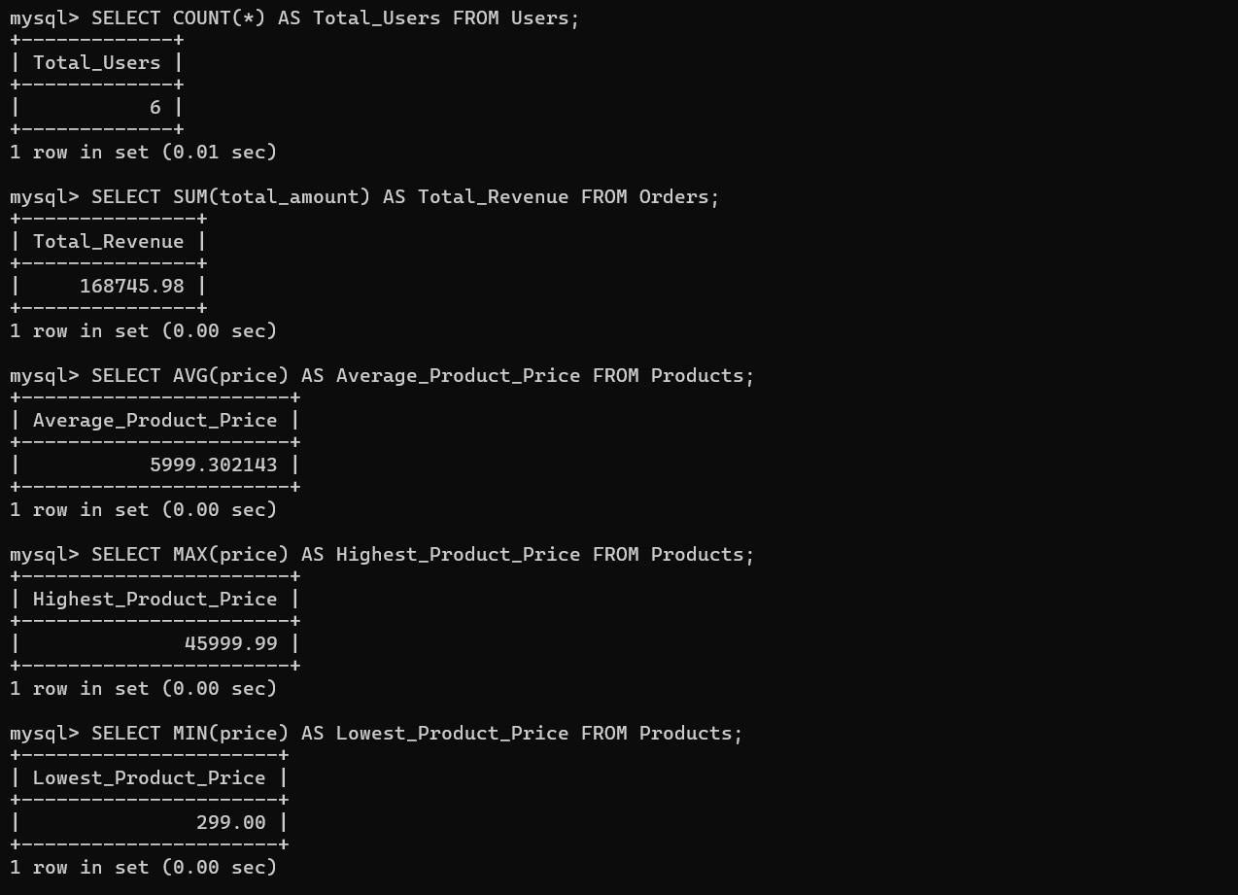

**JOINS:**

Inner & Left: 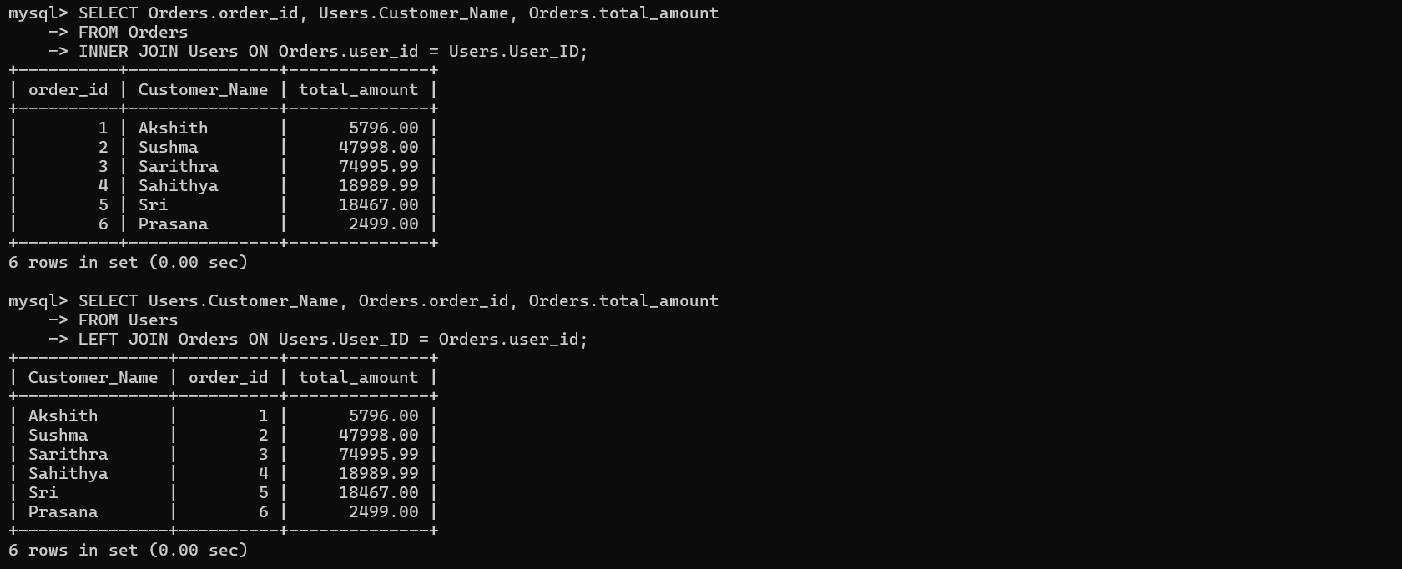

Right:

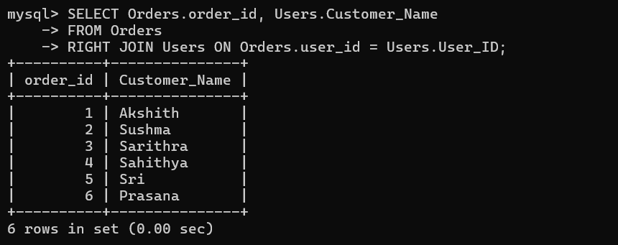

Cross:

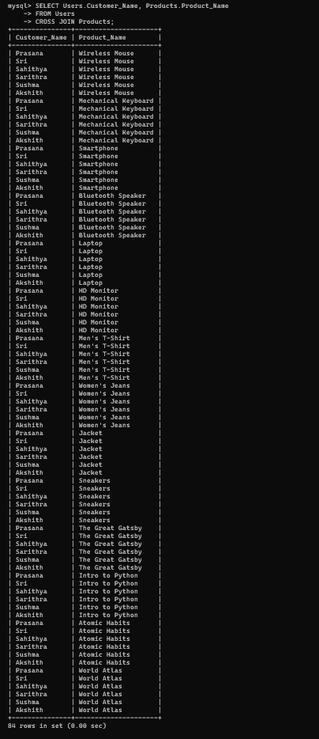

**Operators:**

Comparison & AND / OR & BETWEEN Operator:

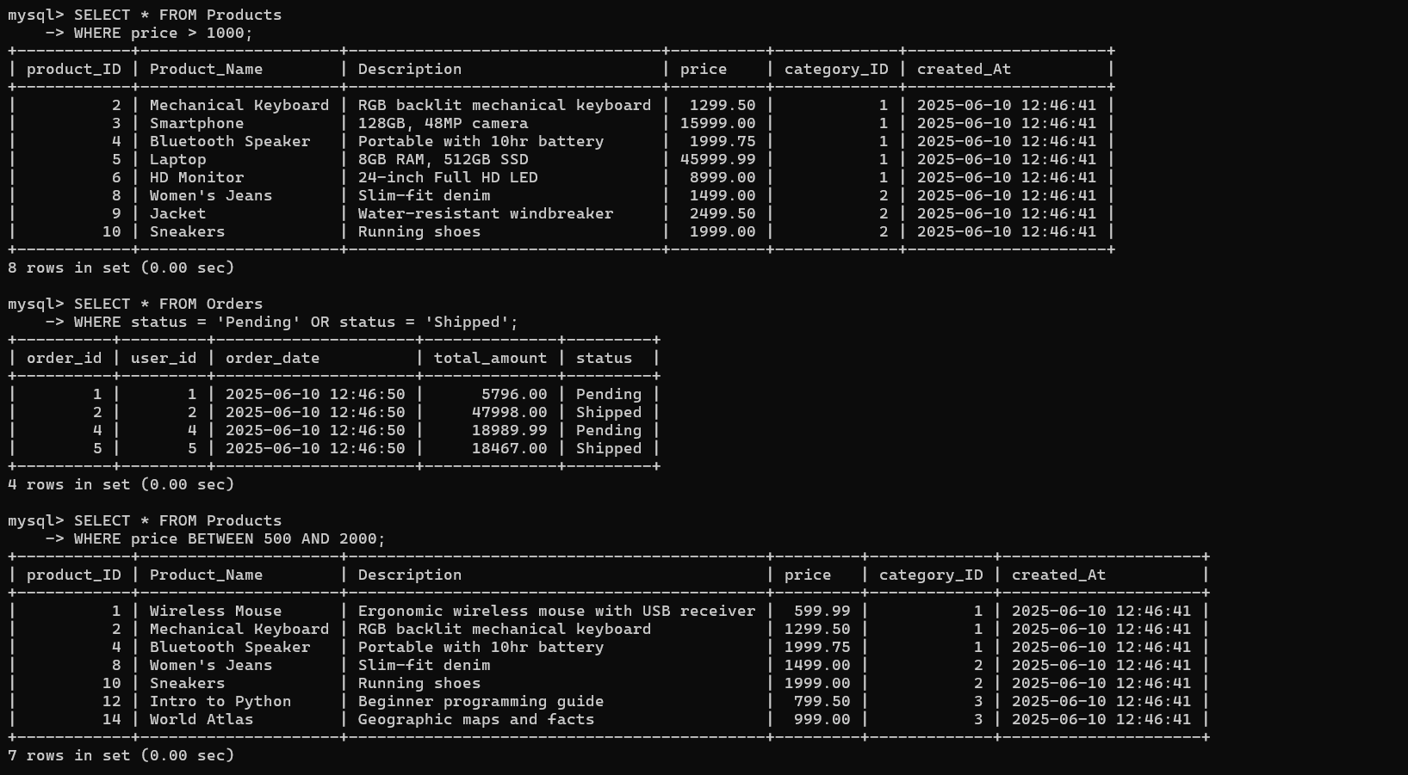

IN & LIKE & IS NULL / IS NOT NULL:

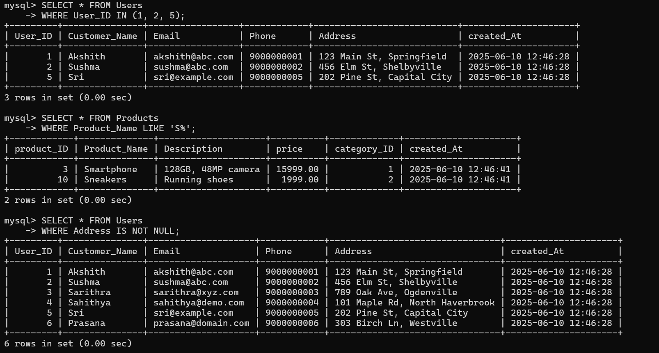

Arithmetic Operator:

