AI - Assisted Flexible Work & Life Balance Request System into clear stages, showing how employees interact with AI to request, justify, and track flexible work arrangements.

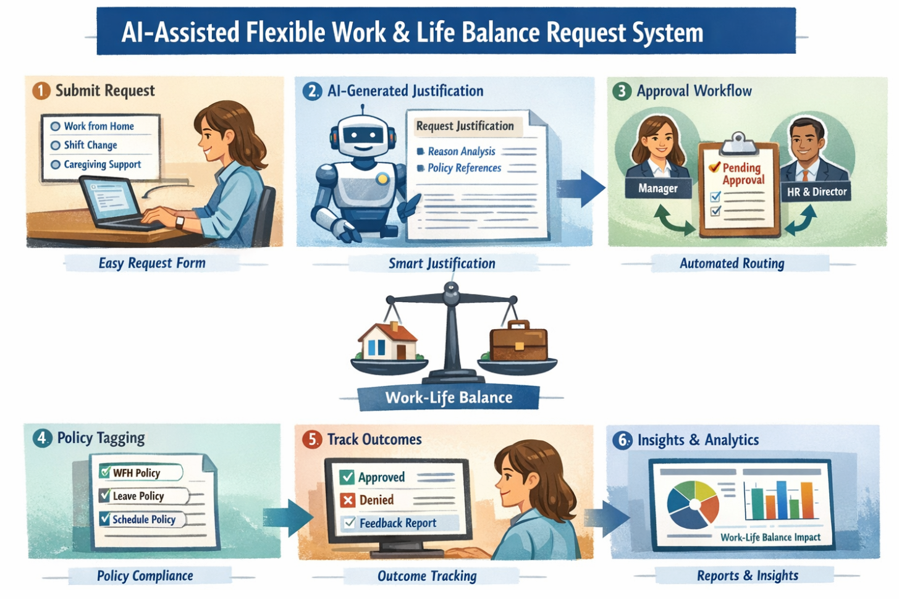
- Submit Request → Employees initiate requests (WFH, shift changes, caregiving support) via an intuitive form.
- AI-Generated Justification → AI converts informal reasoning into a professional justification aligned with company policies.
- Approval Workflow → Requests are routed automatically to managers/HR based on hierarchy and type.
- Policy Tagging → Each request is tagged with relevant policies for compliance and transparency.
- Track Outcomes → Employees see approvals, denials, and feedback for future improvement.
- Insights & Analytics → AI provides dashboards showing the impact of flexible arrangements on work-life balance.

