Assignment Report: NCF Implementation

1. Introduction

The primary objective of this assignment was to reconstruct three distinct types of recommendation system models based on relevant research papers. These models were evaluated for their performance in a movie recommendation task.

2. Assignment Requirements and Dataset

Requirements: Python 3.8 or later

Dataset: The dataset utilized for this assignment is the *MovieLens* dataset.

3.Description of the files in the directory:

Dataset/: Contains datasets for training and testing.

data_utils.py: Utility functions for dataset handling.

evaluate.py: Evaluation functions for model performance.

model.py: Implementations of recommendation models.

run_model.py: Main script for training and evaluating models.

4. Results

Upon completing the implementation of the entire model, I conducted a comprehensive analysis and evaluation of the model's training process. I utilized the following parameter settings during training: predictive factor of 8, 30 epochs, top_k evaluation metric set to 10, and a batch size of 64.

Visualized the HR@10 and NDCG@10 metrics of the model throughout the training process.

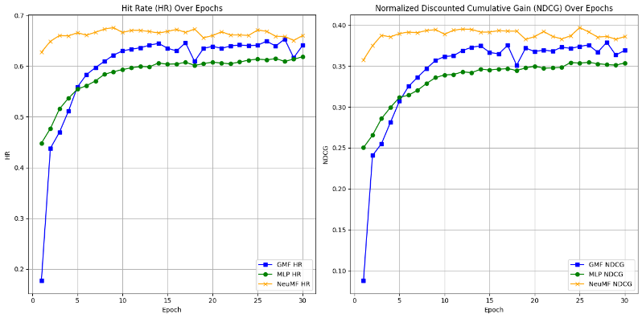

5. Conclusion

In summary, due to time constraints, I did not compare the results using different predictive factors. However, the overall performance of our model closely aligns with the findings reported in the original paper.

6. References

He, Xiangnan, et al. "Neural collaborative filtering." Proceedings of the 26th international conference on world wide web. 2017.

Code reference: https://github.com/pyy0715/Neural-Collaborative-Filtering