Apollon
Monday, March 16, 2020
11:31 AM

Apollon (AP pull on)
Keywords: The multiplier: Expansion and spreading; growth and increase. Science, commerce, trade, industry, peaceful efforts.

From <http://junojuno2.tripod.com/tnps.htm>

APOLLON Expansiveness, science, trade, commerce, success

APOLLON: Distance, expansion, distribution; enlargement, multiples. Commerce. Science.

From <http://midpointobservatory.blogspot.com/2007/12/keywords.html>

APOLLON
Multiplicity, expansiveness, ‘many irons in the fire’ (sometimes too many), science, peace, great success, commerce, distant career opportunities and contacts with foreigners. The ‘big picture’, instead of details.

From <http://straightwoo.com/2016/06/26/the-hypothetical-trans-neptunian-planets/>

Apollon: Apollon’s theme is possibility. It represents abundance, prosperity, fertiity, and expansion, and operates by and large through the Law of Attraction and creative manifestation ( “reap what you sow” ). Apollon encourages big hopes and dreams, and often rewards such positivity with tangible results. Its energy is directed toward conquering dull, monotonous mundanity.

From <https://astral-obscura.tumblr.com/post/142857341058/uranian-astrology-the-hypothetical-planets>

APOLLON

Like Jupiter--Distance and expansion
• Expansion by multiplying, extending, expanding, distributing; marketing; popularizing
• Commerce: these attributes are ingredients of successful commerce
Apollon is part of other pictures for success: Sun=Apollon and Apollon/Vulcanus

From <http://midpointobservatory.blogspot.com/2007/12/keywords.html>

Apollon
Apollon (Ap Pull On)
The multiplier: expansion and spreading; growth and increase. Science; commerce; trade;
industry; peaceful efforts. The glyph is a combination of Jupiter and Gemini, and Apollon is
truly a Superduper Jupiter.

From <http://www.linda-goodman.com/ubb/Forum24/HTML/224579-2.html>

Apollon (AP pull on)
Keywords: The multiplier: Expansion and spreading; growth and increase. Science, commerce, trade, industry, peaceful efforts.
Represented by the glyphs for Jupiter and Gemini, Apollon is that which indicates "a lot of" or "more than one" of anything. It has close connections with the worlds of commerce, science, and education, and can also symbolize success, expansion, and foreign countries.
As the planet of foreign lands and other "distant places" (especially in combination with the Ascendant or 0 degrees Aries), Apollon ought to be well positioned in the horoscope of Neil Armstrong, the first man to set foot on the Moon. And indeed, it is. Armstrong's natal Ascendant (18 degrees Gemini) falls exactly conjunct his 0 degrees Aries/Apollon midpoint (18 degrees Gemini). Apollon's associations with science and success can also be seen in the triple conjunction (at 0 degrees Libra) that was being formed by transiting Jupiter, Uranus, and Apollon at the time of the astronauts' historic lunar landing in 1969.

From <https://www.astrologysoftware.com/resources/articles/uranian.asp>

APOLLON: Multiple interests and developments; many irons in the fire; more than one; combining; career opportunities; travel or study associates; long distance/cosmopolitan connections; divided interests.

From <https://themercurialdevils.tumblr.com/page/2>

Where Apollon is placed in a chart we have expanded wisdom, understanding and an evenness of temperament. In Greek mythology Apollon was referred to as the Sun god or the god of wisdom and prophecy. He knew how to deal effectively with everything that was dark; shadowy powers and threats, the sick, or those needing of assistance. Anywhere he came into contact with these he quickly went into action. He had a calming composure, an ability to ease tension, and brought a wisdom and an awareness that was healing. So with Apollon we have a magnanimous disposition, a heightened or expanded consciousness.

From <http://theuranianastrologer.com/apollon-1>

In the symbol of Apollon we have the planet Jupiter with the glyph of Gemini contained within so we get the faith and expansion of Jupiter combined with the thinking, communication and diversabilities of Gemini. So together we have an expansive wisdom, understanding and an evenness of temperament. In Greek mythology Apollon was referred to as the Sun god or the god of wisdom and prophecy. He knew how to deal effectively with everything that was dark; shadowy powers and threats, and the sick or the needing of assistance. Anywhere he came into contact with this he quickly went into action. He had a calming composure, an ability to ease tension and bring a wisdom and awareness that was healing. So with Apollon we have this heightened or expanded consciousness. Let’s take a look at Apollon in a few charts.

BONO
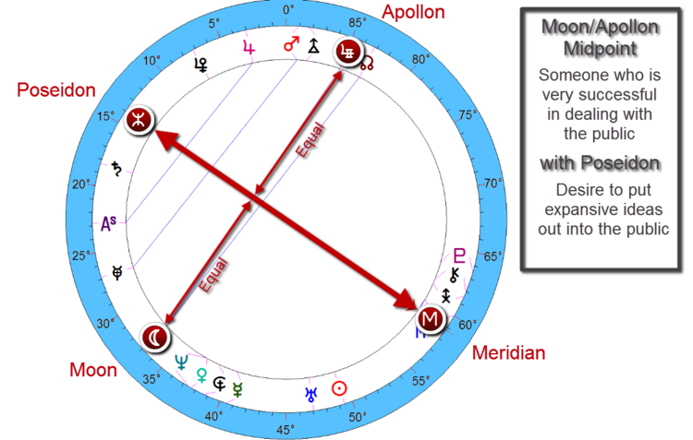
BONO NATAL BIRTH CHART ~ MAY 10, 1960 @ 2:00 AM DUBLIN, IRELAND
This first chart is the chart of Bono, the front man for the band U2. In Bono’s chart one of the major midpoint structures around his Meridian, and remember the Meridian is a “snapshot of the soul,” it’s the point of individuality from the soul’s essence, we get a Moon/Apollon midpoint. Moon/Apollon around the Meridian can be a very successful aspect, remember the Apollon wants to expand, and the Moon is not only the emotions and the mother, but the Moon also deals with the “public.” So Moon/Apollon is someone who can be very successful in dealing with the public. Moon/Apollon can also represent someone who is quite open, warm, generous and highly sentient.
But what really adds dynamism to this Moon/Apollon midpoint structure is that it also hooks in with Poseidon. Poseidon deals with enlightenment and the illuminations of ideas and ideals. It is very receptive and wants to illuminate out in the form of higher understanding and wisdom. So the Poseidon combined with that Moon/Apollon is someone who is a truth seeker, someone quite perceptive and wants to ever "broaden" their knowledge and understanding, someone who is benevolent with the desire to put his expansive ideals/ideas out into the public, exchange and shine the light on them with the wider world.
Bono is actually one of the world’s foremost philanthropists, but it’s really his “ability” to enlist allies from a diverse spectrum; from government to media to the business world to religious organizations, and his ability to do this is the quintessential Apollon energy.

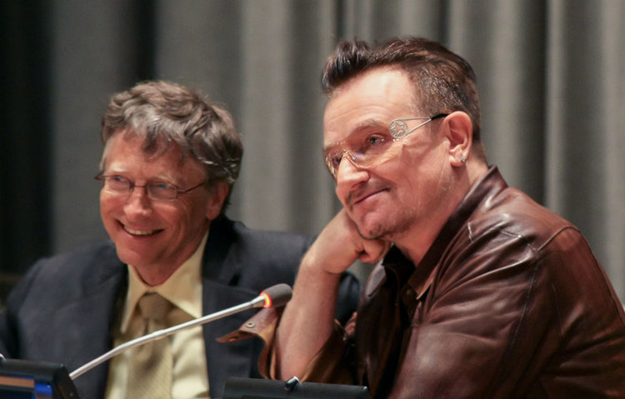
BILL GATES & BONO

BARACK OBAMA
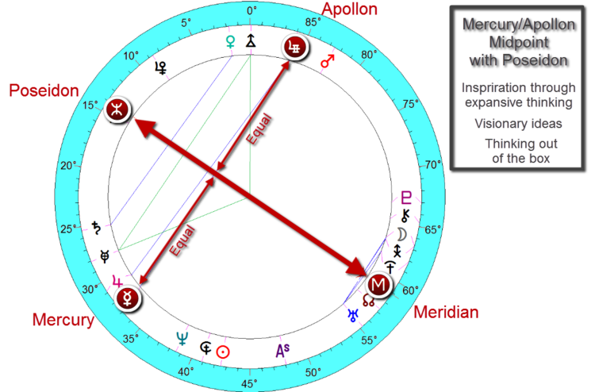
BARACK OBAMA NATAL BIRTH CHART ~ AUGUST 4, 1961 @ 7:24 PM HONOLULU, HAWAII
This next chart is the chart of Barack Obama. Now Barack Obama has a Mercury/Apollon midpoint structure around his Meridian. So Mercury deals with thinking, communication, and with the Apollon we get expansive thinking, someone who is free and open minded. And so on its own, the Mercury/Apollon midpoint on his Meridian can be someone who is broad minded, gifted with dialogue, fertile in thinking and communication, and very conceptual.
Obama also has something remarkably similar to Bono in that they both have Poseidon on the Meridian axis which means that it's part of that Mercury/Apollon midpoint structure as well. This is a lovely combination. Remember the Poseidon is enlightenment, an illumination of ideas, it’s someone who wants to shine the light on something. So this is someone who wants to expand by thinking out of the box, a powerful orator with visionary ideas. Although at the time of writing this he is experiencing rather low public approval, he will probably be much more successful out of office, more like a Jimmy Carter, where he can use his energy to inspire through his visionary thinking.



From <http://theuranianastrologer.com/apollon-1>

