Duads
Wednesday, April 22, 2020
12:24 AM

Calculating Duad and Dwad charts
Duads are twelve 2.5 degree segments of a zodiac sign. Each duad starts with the zodiac sign and then progresses through each of the following signs in order. E.g. If the zodiac sign is Sagittarius, then the first 2 degrees 30 minutes will be the Sagittarius duad of Sagittarius, the second 2 degrees 30 minutes will be the Capricorn duad of Sagittarius, the third 2 degrees 30 minutes will be the Aquarius duad of Sagittarius .. and so on. (Click to see Duad Table )
There is a second kind of division where the 1st dwad of any sign is the Aries dwad, the 2nd is the Taurus dwad .. and so on. These are easy to calculate on a computer because they are the 12th harmonic chart.
CALCULATING THE DUAD CHART BY HAND OR WITH CALCULATOR
As each duad is a “mini sign” the 2½ degrees it covers can be converted into the 30 degrees of a normal zodiac sign and make a whole new duad chart. It is relatively simple to calculate the duad zodiac degree by taking the start of the duad degree away from the degree of the planet and then converting that degree into the zodiac degree within that duad.
For example: Adam’s natal Sun is 8Scorpio23. This is the Aquarius duad of Scorpio and that duad starts at 7.30° Scorpio
08.23 – 07.30 = 0.53
So Adam’s Sun duad is 0° 53’ into the Aquarius duad. Using a calculator that calculates in units of 60, you can multiply 0° 53’ x 12 and this will give you 10°.36’ Therefore Adam’s duad Sun is 10° 36’ of Aquarius.
You can follow the same method for all the other planets and angles in the chart to make up a duad chart. The duad chart has the Ascendant in the same position as that of the natal chart, but the MC and IC can be in any house in the duad chart. Mercury and Venus can be anywhere in the duad chart, they don’t have to be close to the Sun.
Following this the dwad chart is quite easy to calculate as the planets and angles will be in the same degree as that of the duad chart, but usually in a different dwad sign.
DUAD CALCULATOR
Australian research astrologer Ray Murphy has been kind enough to design this little duad calculator for me. All you have to do is put in the degree and sign of each planet and it will automatically calculate its duad position. If you want to use it you will need to download it to your own computer, save it and then open it.
DUADS PROGRAM
Highlight the planet then enter its degree and minute, then click its sign. Continue doing this until all planets and angles have been covered and then click the Calculate button under the DUADS column. The program will automatically calculate the duad.
USING SOLAR FIRE DELUXE or SOLAR FIRE GOLD
Esoteric Technologies were kind enough to incorporate the calculation of duad charts in their program.
To calculate the duad chart, highlight the natal chart on the first page of Solar Fire, then go to the “Chart” menu, click Vedic and then Vedic D12 Dwadashama. Click OK. The computer will ask you if you want to use Vedic settings click NO and you will have your duad chart.
To calculate the dwad chart, go to the Chart menu on the top left hand side, then click ‘Harmonics, Transform..’ then click Harmonic Chart. In the box above titled ‘Harmonic’ put in 12 and then click OK. You then have the 12th harmonic chart, which is the dwad chart.

From <http://aliceportman.com/calculating-duad-and-dwad-charts/>

Duads in relationships and family
Duads are twelve 2.5 degree segments of a zodiac sign. Each duad starts with the zodiac sign and then progresses through each of the following signs in order. E.g. If the zodiac sign is Sagittarius, then the first 2 degrees 30 minutes will be the Sagittarius duad of Sagittarius, the second 2 degrees 30 minutes will be the Capricorn duad of Sagittarius, the third 2 degrees 30 minutes will be the Aquarius duad of Sagittarius .. and so on. (Click to see Duad Table )
There is a second kind of division where the 1st dwad of any sign is the Aries dwad, the 2nd is the Taurus dwad .. and so on. These are easy to calculate on a computer because they are the 12th harmonic chart.
(See article on calculating duads and a little duad calculator in The duad System menu).
For the sake of convenience I call the first type of division ‘duads’ and the second type of division ‘dwads’.
The duad of the sign considerably affects the way the sign works. For example: The duad of your Ascendant will colour the qualities of the Ascendant and the way you use your ascendant sign. E.g. If someone has the Cancer duad of Sagittarius rising they will use the Sagittarian energy quite differently to someone who has the Scorpio duad of Sagittarius rising. They will even look quite different. Both will present a more “watery” feel than Sagittarius Ascendant normally does.
SUBRULER
This can be taken further. The person who has the Cancer duad of Sagittarius rising will have the ruler of Cancer, the Moon, as the sub-ruler of the Ascendant. The position of the Moon and its aspects would be important, particularly if the Moon aspects Jupiter, the ruler of Sagittarius, or aspects the Ascendant itself.
SIGN- HOUSE:
The zodiac sign that is the same as the duad and the house it rules will also be important. If someone has the Scorpio duad of Sagittarius rising, then it is likely that the 12th house is ruled by the sign Scorpio and this increases the importance of that house.
The duads are important for all planetary and angle placements and particularly important for the Sun, Moon, Moon’s Nodes , Ascendant-Descendant, MC-IC , Vertex– antiVertex , angular planets and the ruling planet.
In my research on this system I found that these positions also described planets and angles in the charts of parents, grandparents and other members of the family. For example:
A mother may have the Sun in the sign Gemini, her child may have the Sun in the Gemini duad of any sign. This child may have a child with the Sun in the 3rd (Gemini) dwad of a sign.
Taking this back a generation— you can have the mother with her Sun in Gemini in the Scorpio duad (12.5-15 degrees of Gemini). Her father may have the Sun in Scorpio. This duad is the 6th (Virgo) dwad of Gemini, so her mother may have the Sun in Virgo, And/or one of her other children may have the Sun in Virgo.
The Sun, Moon, angles and Nodes can be interchangeable (particularly the Ascendant – Moon and Sun-MC) so a person can have the Moon in the same sign as a parent’s Sun’s duad, or the Ascendant in the same sign as the mother’s Moon’s duad, and so on ….
In a family a parent or child may have their Sun conjunct the other’s MC or IC, giving a very strong tie between these two people. There is also a particularly strong correlation between the duad of a parent’s Sun and the child’s MC or IC or vice versa.
I have found there is a consistent and easily traceable connection between the position of the planets and angles in zodiac signs and duads from generation to generation. Also, there is often a strong affinity between the people who carried this sign/duad flow in the different generations. E.g. a grandparent may have their Sun in Aquarius and the grandchild have their Sun in the Aquarius duad of Taurus. This will tend to give an attraction and a feeling of affinity between the two.
So: Zodiac signs their duads and dwads are an astrological map of genetic inheritance within a family.
RELATIONSHIPS:
The duads show your instinctive attraction towards a person. The reason why is because these zodiac signs run through the family genes, the person will also attract and be attracted to non-family members with the Sun, Moon, Angles or Nodes in these signs. Therefore: People frequently marry people who fit this criteria.
For a woman the duads of your Sun, Moon, Mars, Ascendant and Nodes are usually the main significators of attraction to the opposite sex. E.g. if a woman has her Sun in Cancer in the Libra duad and the 4th duad (Cancer), she will be instinctively drawn to Libran and Cancerian men, or, to a lesser extent, people with the Moon, Mars, Angles or North Node in Libra or Cancer.
For a man, the duads of your Sun, Moon, Venus, Ascendant and Nodes are the main significators of attraction towards the opposite sex. E.g. if a man has his Moon in Taurus in the Taurus duad and 1st (Aries) duad of Taurus his instincts will draw him to women with the Moon or Venus in Taurus or Aries, or to a lesser extent, the Sun, Angles or Nodes in that sign.
SEXUAL ATTRACTION:
A woman will find a man sexy if he has Mars in the same sign as her Mars duad. E.g. a woman whose Mars is at 1Virgo39 will have Mars in the Virgo duad and 1st (Aries) dwad, so she is likely to find men with Mars in Virgo or Aries sexy.
A man will find a woman sexy if she has her Venus or Moon in the same sign as his Venus or Moon duad. E.g. a man with his Venus at 16Libra23 in the Aries duad and 7th (Libra) dwad of Libra will find women with Venus in Aries and Venus in Libra quite beautiful. He will also like women with the Moon in Aries or Libra.
The Nodes are important for emotional connection between people. These connections show very strongly in marriage and family charts. E.g. A person with the North Node at 4Taurus58 in the Gemini duad and 2nd (Taurus) dwad, will be drawn to those who carry Gemini and/or Taurus in their Sun, Moon, Ascendant, MC and/or Vertex. This may indicate a soul connection. These signs will also run through the family.
If someone does not have the zodiac sign or duads that your genetic patterning requires, there is less likely to be any deep, instinctual level of attraction. You may like or dislike them according to the synastry of their chart and yours, but there is not the “kick” that starts a relationship.
Therefore: In relationship and synastry charts, the duads are the first step in assessing whether someone will be attracted to another.
EXAMPLES:
This is Prince Charles natal chart:
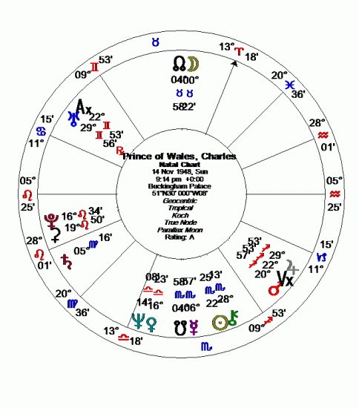
This is Prince Charles duad chart (for greater visibility click charts to enlarge them)
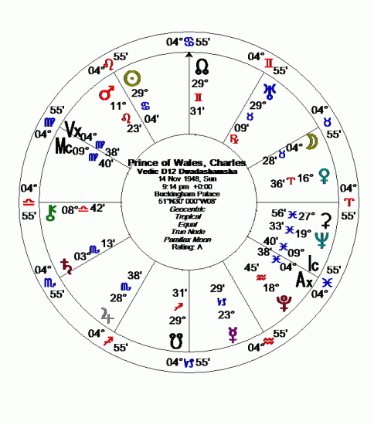
Prince Charles has his Sun is the Cancer duad of Scorpio. This will tell us two things:
1. The sign Cancer runs through his family
2. He will be very drawn to people with the Sun in Cancer or Cancer Moon, Angles or Nodes.
This is Prince Charles dwad chart:
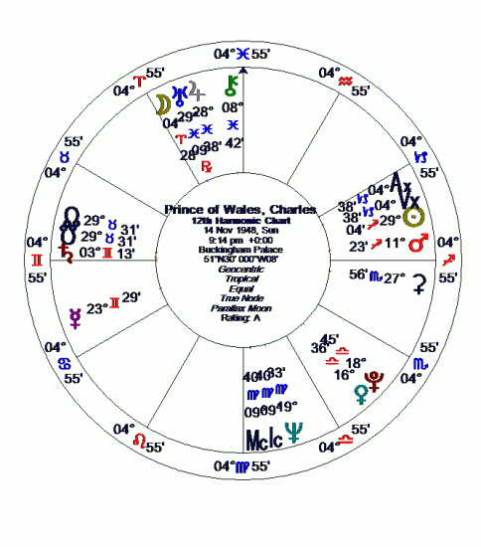
Prince Charles has his Sun in the 9th (Sagittarius) duad of Scorpio This tells us that:
1. The sign Sagittarius runs through his family.
2. He will be drawn to those with the Sun in Sagittarius and to a lesser extent, the Sun in the 9th house, or the Moon, Nodes or angles in Sagittarius
FAMILY PATTERNS
To illustrate how a planetary energy can run throughout a family I will use the current Royal Family and have chosen Saturn to illustrate this example as it is the planet of duty, discipline and responsibility, three qualities that are much admired in this family line. (see table 2).
Charles mother, Queen Elizabeth II (born 21 April 1926, 2.40 am, London, England) has her Saturn at 24Scorpio26, in the Leo duad and the Capricorn dwad of Scorpio. click to see natal, duad and dwad charts: Queen Elizabeth II
Charles father, Prince Philip (born 10th June 1921, 10.00 am Corfu, Greece) has his Saturn at 18Virgo19 in the Scorpio duad and Gemini dwad of Virgo. (click to see natal, duad and dwad charts) Prince Philip
His Saturn duad is the same as the zodiac sign of Saturn in Queen Elizabeth’s natal chart, giving a strong affinity on a Saturnian level.
Prince Charles (born 14 November 1948, 9.14 pm, Buckingham Palace, England) has his Saturn at 5Virgo18, in the Aries duad and Scorpio dwad of Virgo. (see above charts) His Saturn is in the same zodiac sign as his father’s. The Scorpio dwad is the same as his mother’s Saturn in Scorpio.
Princess Anne (born 15th August 1950, 11.50 am, London, England) has her Saturn at 18Virgo49—conjunct her father, Prince Philip’s Saturn at 18Virgo19, Like him she has her Saturn in the Scorpio duad and Gemini dwad. Like him her Scorpio dwad resonates to her mother’s Saturn in Scorpio. (click to see natal, duad and dwad charts) Princess Anne
Prince Andrew (born 19th February 1960, 3.30 pm, London, England) has his Saturn at 14Capricorn55 in the Gemini Duad and Virgo dwad of Capricorn. (click to see natal, duad and dwad charts) Prince Andrew Saturn in Capricorn resonates to his mother’s Capricorn dwad. Saturn in the Virgo dwad resonates to his father’s, Charles and Anne’s Saturn in Virgo.
Prince Edward (born 10th March 1964, 8.20 pm, Buckingham Palace, England) has his Saturn at 28Aquarius26 in the Capricorn duad and Pisces dwad of Aquarius. (click to see natal, duad and dwad charts) Prince Edward This resonates with his mother’s Capricorn dwad, but otherwise doesn’t fit so well into the family pattern. His Pisces dwad is the opposite sign to the strong Virgo energy. His Saturn in Aquarius is in the opposite sign to his mother’s Saturn duad of Leo so he is carrying the same Saturn genetic material, but opposite to the general thread of the family.
Princess Diana (born 1st July 1961, 7.45 pm, Sandringham, England) has her Saturn at 27Capricorn48 in the Sagittarius duad and Pisces dwad of Capricorn. (click to see natal, duad and dwad charts ). Princess Diana Notice that her Saturn in Capricorn resonates quite nicely to the Queen’s dwad Saturn.
Overall we get quite a strong thread of a Scorpio, Virgo and Capricorn sense of duty running throughout the family.
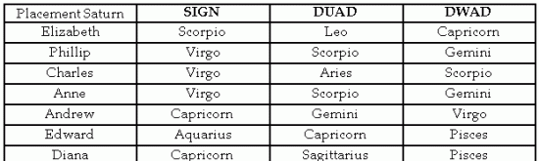
Table 2.
THREE GENERATIONS;
Let’s look at the charts of Queen Elizabeth II, her son, Prince Charles and her grandson, Prince Harry (born 15th September 1984, 4.20 pm, London, England).
Prince Harry has his Saturn in Scorpio the same sign as his grandmother – and in a very similar position in the natal chart. Harry has Saturn in the duad of Aries , the same as his father , Charles, and brother, William . His Saturn in the Virgo dwad resonates nicely with his father’s natal Saturn in Virgo. His father’s dwad Scorpio Saturn resonates with Harry’s natal Saturn in Scorpio. (click to see natal, duad and dwad charts) Prince Harry
Prince William’s Saturn doesn’t fit the family theme. He has it in Libra, in the Aries duad and Libra dwad. (click to see natal, duad and dwad charts) Prince William
His father, Prince Charles, has his Saturn in the Aries duad, as does his brother Prince Harry, but that is all. Where does his Saturn in Libra come from? His great-uncle, King Edward VIII has his Saturn in Libra. Like his great-Uncle, he may find his sense of duty towards his partner outweighs his sense of duty to his position in life.
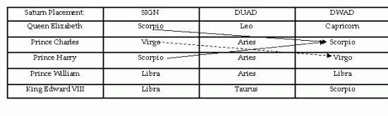
Table 3.
If you examine the natal duad and dwad charts of this family you will find a number of close connections, most within an degree. These show how different members of the family connect to each other. It will be the subject of another article.
VERTEX CONNECTIONS;
The Vertex axis seems to be connected to destined associations so should work very strongly in the royal family as they feel they are destined to this responsibility.
If we look at the Vertex connections in this family line we can see a very interesting flow:
Queen Elizabeth has her Vertex at 0Virgo21: Prince Charles has his Vertex at 22Sagittarius55 in the Virgo duad which resonates with his mother’s Vertex in Virgo
Prince Philip has his Vertex at 6Capricorn07: Prince Charles has his Vertex in the Capricorn dwad of Sagittarius, which resonates with his father’s Vertex in Capricorn.
Prince William has his Vertex at 12Leo08 in the Sagittarius duad of Leo. His father, Prince Charles, has his Vertex in Sagittarius. William’s dwad is the Leo duad of Leo and his mother, Princess Diana, had her Vertex in Leo.
King George VI, Queen Elizabeth’s father, has his Vertex at 27Taurus11 in the Pisces duad (click to see natal, duad and dwad charts) King George VI This is the same sign as Queen Elizabeth’s anti-Vertex. Prince Harry, his great-grandson, has his Vertex in the Taurus duad of Leo
Interestingly, King Edward VIII has his Vertex in Virgo, the same sign as Queen Elizabeth II, and she wouldn’t have become Queen unless he abdicated. (click to see natal, duad and dwads charts) King Edward VIII
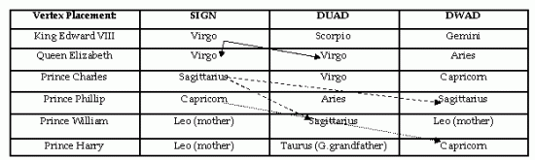
Table 4.

From <http://aliceportman.com/190/>

Duad Charts describe the differences in Twins
Astrologers have found the charts of twins of very great interest. Twins are often born very close to each other in time, and therefore often have the same or very close to the same energy imprint at the moment of their first breath—yet so many identical twins are very different in character, even though they look the same.
One of my great interests in Astrology is genetic inheritance shown through the planets, signs and aspects. For example, a member of one generation of a family may be born with Neptune on an angle, one of their children may have a Pisces Ascendant, Sun or Moon, and their grandchild may have an emphasised twelfth house, so we have a consistent flow of planet, sign and house throughout the generations. Other members of the family are likely to have their Sun, Moon and/or ruler of an angle in aspect to Neptune, so you could say the family has a Neptune theme running throughout.
Whilst refining this system I thought I would check decanates (the division of the sign of the zodiac into three separate sections) and duads (the division of the sign of the zodiac into twelve 2°30’ sections). I was both fascinated and astonished to find that the duad system clearly described, in detail, the genetic inheritance of a family line.
Duads
Each sign of the zodiac can be divided into twelve 2°30’ sections and each of these sections are a little mini sign.
To illustrate: the first 2°30’ section of Aries is the Aries duad of Aries, the next 2°30’ section (2°30’ – 5°) is the Taurus duad of Aries, the next 2°30’ section (5° – 7°.30’) is the Gemini duad of Aries, and so on.
The first duad of Taurus (0° – (2°30’ ) us the Taurus duad of Taurus, the next (2°30’ – 5°) is the Gemini duad of Taurus, the next (5° – 7°.30’) is the Cancer duad of Taurus and so on.
So each sign starts with its own duad and moves through the zodiac in order of the signs (click to see Duad Table).
A person will be very drawn to those who carry in their natal chart the same sign as their duad.
E.g. Someone who has the Sun in the Aquarian duad of Cancer will be very drawn to Aquarians and those with the Moon in Aquarius, even though this is not a sign that is normally considered compatible with Cancerians. It is quite likely they will have an Aquarian parent, grandparent or child.
To calculate duad charts see article on calculating duads and dwads in The Duad System Menu there is also a little duad calculator that is free to download if you wish. http://aliceportman.com/?p=606
Twins
Whilst studying the charts of twins, both identical and non-identical, that were born very close together in time, I found that the duad chart for each twin clearly showed their differing natures and to an extent, the different experiences they have in life. This article will use the charts of identical twins, Adam and Bryan, to illustrate how the duad chart system works.
You can click the charts to enlarge them.
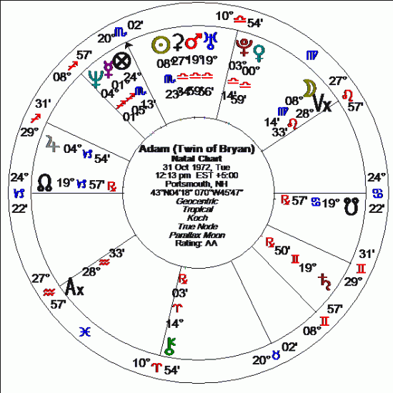

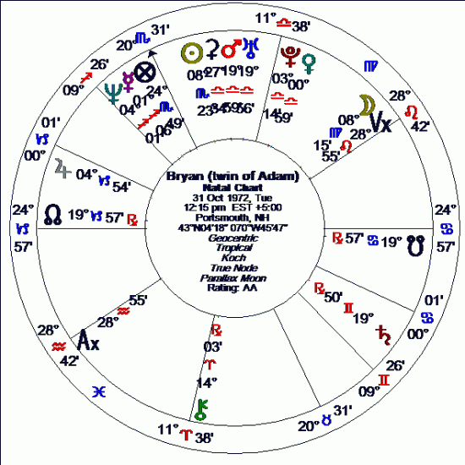
As you can see, these two charts are nearly identical. Adam has an Ascendant of 24 Capricorn 21 and Bryan has an Ascendant of 24 Capricorn 57, so even the degree is the same for each person. Likewise, Adam has a MC of 20Scorpio01 and Bryan has a MC of 20Scorpio30. Adam has a Vertex of 28Leo32 and Bryan’s Vertex is 28Leo55
It would be hard to get charts that are more identical, but these two twins have quite different lives. One is the father of two children, the other is having difficulty starting a family. Each would receive the same transits, progressions and directions at the same time but why would these produce different results?
Duad charts give the answer!
Adam’s duad chart
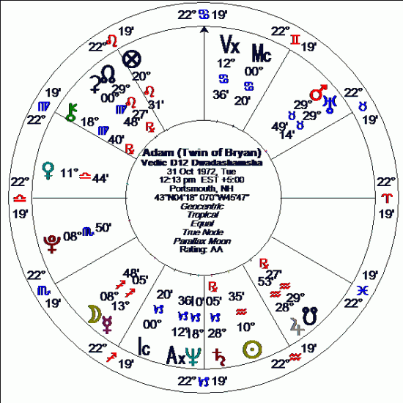
Adam’s duad Ascendant is 22Libra12, indicating that he will be drawn to those with Libra rising and planets in Libra, particularly if they are around 22°. He has no close aspect to this Ascendant, so no planets are influencing the way Libra rising expresses itself. This Ascendant will give charm and a desire for beauty and harmony in his life.
The ruler of the Ascendant, Venus, is in Libra in the 12th house, suggesting that he would value his privacy and require quiet times to regenerate his energy. Venus is trine the duad Aquarian Sun, increasing his charm and harmonious presentation to others.
His duad MC is 00Cancer07 indicating a desire to work with the public and/or nurture others. Ceres is in close sextile to this MC, suggesting that the nurturing tendency would be quite strong and perhaps gives an interest in cooking (Cancer) healthy foods (Ceres in Virgo). The duad MC is also sextile the North Node, giving an interest in working with others, perhaps in community or family groups.
The ruler of the MC is the Moon in Sagittarius in the 2nd house conjunct Mercury, giving a need to make money (2nd house) through communication and/or trade (Mercury). As Mercury is ruler of the 9th and 12th, this could perhaps involve publishing or overseas interests.
Adam’s Vertex is 12Cancer29, quincunx Mercury which increases the power of this planet. It is also square Venus, increasing the power of his Venus in Libra, and adding to his charm.
These signs and degrees would always be important for Adam and may respond quite strongly to transits. He would find that he had a particular affinity to members of the family who have their natal planets or angles on his duad degrees and would be attracted to those whose natal chart echoed his duad chart in some way .
Bryan’s duad chart
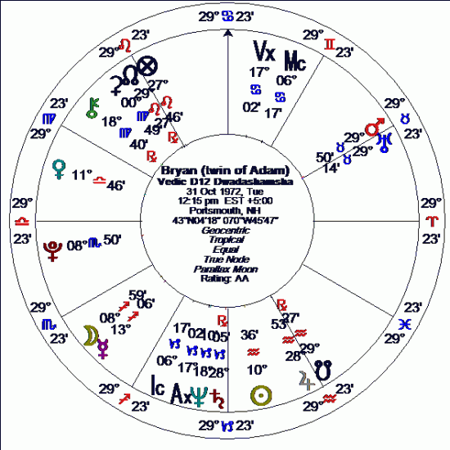
Bryan also has a Libra Ascendant, Cancer MC and Leo Vertex in his duad chart, but the degrees are different and this difference brings into play an entirely different focus in life.
Bryan has the difficult, temperamental and stubborn duad Mars-Uranus conjunction in Taurus quincunx his duad Ascendant. It is also on the cusp of his duad 8th house, bringing pressure in the areas of joint finances. This configuration is square the North Node, further suggesting that there would be difficulties with financial affairs involving family, groups, and partnerships, particularly as Mars rules the 7th cusp and 2nd cusp.
Bryan has duad Saturn in Capricorn square his duad Libra Ascendant, bringing some restrictions into his ability to express himself harmoniously, and as Saturn is in his duad 3rd house, perhaps some problems in dealing with siblings. Saturn is also quincunx the North Node suggesting flexibility and adjustment is needed in all situations connected to siblings and family.
On the plus side, Bryan has duad Jupiter trine duad Ascendant and conjunct duad 5th cusp. This is helpful in self expression and beneficial for producing children. As it is conjunct duad South Node, it suggests that he has a karmic connection to his children. Jupiter is ruler of his duad third house, so he would love his brother, despite the difficulties described by Saturn in the third conjunct 4th cusp.
Bryan will be more responsive to the 28-30° placements with transits etc., than his brother Adam, as these are brought into prominence by his duad Ascendant degree.
So you can see that even with a birth time difference of only two minutes, the duad charts describe two very different people, with Bryan having a duad chart that shows a great deal more pressure and tension than Adam’s. Each duad chart emphasises different degrees and therefore different planetary placements.
Powerpoints
These are shown when duad planets and angles connect to planets in the natal chart. They put much greater emphasis on both the duad and the natal planet, so when transits, progressions and directions activate these positions there is often a strong reaction.
Adam’s natal chart is on the inside and his duad chart is on the outside of this wheel.
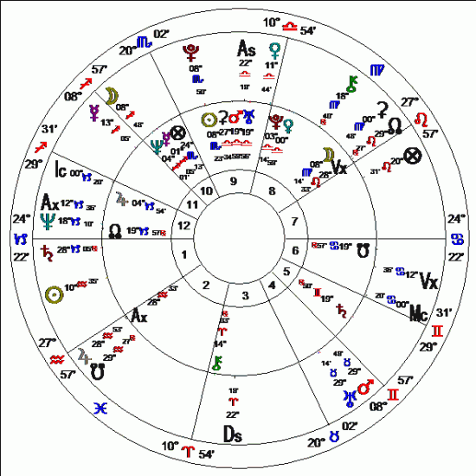

You can see that the duad Pluto is conjunct natal Scorpio Sun at 8-9 Scorpio. This puts considerable emphasis on both the natal and duad placement. This degree will be highly responsive to transits etc.
Likewise, duad North Node is conjunct natal Vertex at 28-29Leo, emphasising this degree for transits etc. As this degree also resonates to the Ascendant in Bryan’s duad chart, the transit triggers may affect him a little more than his brother Adam.
Adam’s duad MC is square natal Venus, so the natal Venus would resonate more to Adam when activated by transits, progression and directions.
Bryan’s natal chart is in the inside and his duad chart on the outside of this wheel.
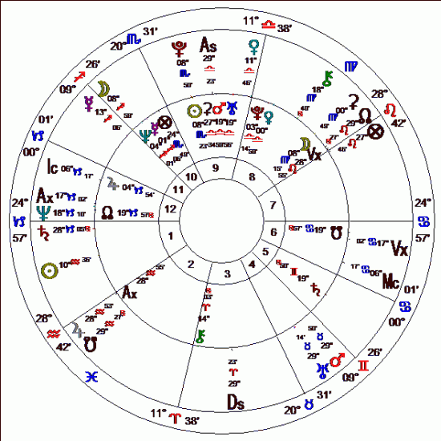

From <http://aliceportman.com/duads-duad-charts-show-the-differences-between-twins/>

An Easy Way with Duads
by guest astrologer Alice McDermott
Alice McDermott is an eminent Australian astrologer who, as Alice Portman, has consulted and taught astrology professionally for 35 years. In 1984, she received her Professional Member of the Federation of Australian Astrologers (PMFAA) qualification and became Examiner of the FAA in 1986-88
Duads or Dwads are both correct ways of spelling the division of each sign of the
zodiac into twelve 2°30' segments, making a mini zodiac within each sign.
Each sign starts the duad division with its own sign: for example if you have a planet or angle at 2° of Cancer, it is in the first, Cancer duad of Cancer; if you have a planet or angle at 2°31' of Cancer, it is in the second, Leo duad of Cancer; if you have a planet or angle at 5° 10' of Cancer it is in the third, Virgo duad of Cancer, and so on. You can access a Duad Table which shows these divisions here: http://aliceportman.com/wp-content/uploads/2009/11/Duad-Table1.pdf
There is a second kind of division where the 1st dwad of any sign is the Aries dwad, the 2nd is the Taurus dwad .. and so on. These are easy to calculate on a computer because they are the 12th harmonic chart.
For convenience in differentiation I spell the first type of division 'duads' and the
second type of division 'dwads'.
To illustrate let us look at the duads and dwads of the birth chart of Noel Tyl born on the 31st December 1936, 3.57 pm, West Chester, PA.
His Ascendant is 0Cancer03, so it is in the first (Aries) dwad and Cancer duad of
Cancer.
His Sun is 10Capricorn02, just in the 5th (Leo) dwad and Taurus duad of Capricorn.
His Moon is 27Leo23, at the tail end of the 11th (Aquarius) dwad and Gemini duad of
Leo.
His MC is 7Pisces01 in the 3rd (Gemini) dwad and Taurus duad of Pisces.
His Mean North Node is 23Sagitarius33 in the 10th (Capricorn) dwad and Virgo duad of Sagittarius .. and so on.
Duads in Relationships
To a very great extent the duads describe the type of person to whom you are drawn for various reasons. Those who carry in their natal chart the Sun, Moon, Ascendant, MC, Nodal Axis or Vertex axis in the same sign as your relevant duad or dwad can have a very strong impact.
The type of attraction is described by the planet involved, so if you are drawn to
someone who manifests the duads of your Moon, it is likely you want to nurture
them; if you are drawn to someone who manifests the duads of your Sun it is likely you will find they shine for you.
Noel would find he is drawn to the thought processes of those who have their Mercury in Sagittarius and/or those with Mercury in Pisces as these are the duad
and dwad of his natal Mercury at 29Capricorn23. He would find those with Venus in Scorpio and those with Venus in Capricorn very attractive or magnetic, as these are the duad and dwad of his natal Venus at 23Aquarius55. --For friendships with men, he would be drawn to those with Mars in Leo and those with Mars in Aquarius as these are the duad and dwad of his natal Mars at 27Libra16.
The duads of the Vertex axis are particularly powerful as those who carry these
signs can open doors of quite different realities in your life. For example, my own
Vertex duad degree is exactly conjunct the Sun of my ex-husband, who was from a different country, class and culture to my own.
Of course a lot can depend on the condition of your natal planet or angle. If there
are traumas connected to any placement then you might find you are repelled by
rather than attracted to those whose natal charts manifest that planet's duad.
However, you will still draw them into your life.
Duads in the Family
I think the duads describe the genetic flow in a family line, particularly the duads of
the MC-IC, Sun, Moon, Ascendant and Nodes.
For example, The duads or dwads of your Sun and Moon can describe the Sun sign or Moon sign of a parent, if these don't then in a natural birth the MC-IC, and their duads will describe the Sun sign of at least one of the parents and sometimes both. A parent or grandparent will often have the Ascendant, Moon or Nodes in the sign or the duad of the sign of the Ascendant or Descendant.
There is always an interchange between the sign and duads of the Moon and
Ascendant-Descendant of parent and child in a natural birth. --For example, Noel has the Moon in the Gemini duad of Leo, so it is highly likely his mother and/or father had an Ascendant-Descendant of either Leo or Gemini or the Leo or Gemini duad of any sign rising.
So from duads you can see which qualities are genetically inherited from which
parent and their family line, as well as the qualities you pass through to your
children.
If the birth was not natural but had some form of medical assistance or the baby was stuck in the birth canal during labor, then you may not find this pattern in the family line. The person would still be drawn to those whose natal chart echoed his or her duads and perhaps find these people more like 'family' than their own.
Duad Charts
As the duads describe a mini zodiac within each sign, it is easy to work out a
separate duad chart. The method can be seen here: http://aliceportman.com/?p=606
These charts refine the duad attraction to very close to the degree - so the closer a person's natal planet is to your duad degree the stronger the draw. For example, well-known Australian astrologer Jill Amery (1 May 1944, 2.50 am, Adelaide, Australia) has her duad Saturn at 15Pisces55 - very close to Noel's natal Saturn at 17Pisces21. As both Jupiter and Saturn describe 'The Teacher, Jill was very drawn to Noel's concise astrological methods and attained a Highest Honor Degree through his Master's Certification Course. --There are a number of other strong connections between them as well, including Noel's duad Vertex axis straddling Jill's natal MC-IC, describing a 'destined' association.
Basil Fearrington (1st August 1954, 7.31 pm, Philadelphia, PA) - a famous pupil of Noel's - has his duad Jupiter exactly conjunct Noel's natal Jupiter, describing a powerful and beneficial 'teacher-pupil' connection. He also has many other connections, all describing an important and destined association.
Synastry
Duad-to-natal synastry is much more powerful and often more compulsive than natal-to-natal synastry and is the precursor to natal synastry. If the duad or dwad
connections to each other's natal are not there, you are just not very drawn to that person regardless of how powerful your natal to natal synastry seems.
If there are exact degree connections in duad to natal synastry, then the relationship and/or association tend to be close. It will strongly respond to transits over that
degree.
Composite and Davison charts
The duads of these charts are particularly important. Time and time again I have
Found that they echo the natal placements of the people involved - often to the degree.
The closer a composite duad degree is to an individual's natal degree, the stronger the draw of the relationship is to that person.
These charts can often supply what is missing in the duad-to-natal connections in synastry. E.g. one person's duad may require the other to have the Sun or Moon in Aquarius, but this is not the case, however the Relationship chart does have that placement thus supplying the missing quality.

From <http://www.noeltyl.com/techniques/100930.html>

