Kronos
Monday, March 16, 2020
11:31 AM

Kronos (KROW nos)
Keywords: Superiority: the highest quality attainable; the ultimate in authority; standard of excellence; undisputed expert.

From <http://junojuno2.tripod.com/tnps.htm>

KRONOS Authority, mastery, ability, perfection, the professional

KRONOS: Leader, boss, cop to king, leading families, experts, boards. Physical elevation

From <http://midpointobservatory.blogspot.com/2007/12/keywords.html>

Kronos indicates elevated matters, both literally and figuratively. Thus, Kronos may represent, on one hand, mountains and airships and, on the other, leaders, executives, and government authorities. It may symbolize authority and expert status as well as the questioning of authority and expertise.

From <https://encyclopedia2.thefreedictionary.com/Kronos>

KRONOS
Mountains, airships, leaders, executives, the government and government officials, nobility, mastery, fathers, independence. An authority or expert, and also the questioning of authorities or expertise. Anything superior or above average. VIP’s.
The hypothetical Kronos is in Hillary Clinton’s 7th House of marriage and partners, conjunct to her North Node. At prima faccie, this talks about her marriage to Bill Clinton, and potentially, her own Presidency.

From <http://straightwoo.com/2016/06/26/the-hypothetical-trans-neptunian-planets/>

Kronos: Kronos is supposedly the highest of the eight Transneptunian levels, representing superconsciousness and the core of the spiritual plane. Kronos is the apex self, continuously asking the question “are you ready?” to encourage us toward refining our souls. It is almost a full circle, but Kronos is more peaceful and wise than Hades as the culmination of your experiences rather than the beginning of them all. Kronos is rarely tapped into.

From <https://astral-obscura.tumblr.com/post/142857341058/uranian-astrology-the-hypothetical-planets>

Kronos (KROW nos)
Keywords: Superiority: the highest quality attainable; the ultimate in authority; standard of excellence; undisputed expert.
Bearing the Greek name for the original ruler of the gods (later known as Saturn to the Romans), Kronos symbolizes all figures of authority (both heads of state and heads of households), and anything that is similarly "superior," "high up," or "at the top." Issues of independence (being one's own boss), parenting (becoming an authority figure in the family), and success (making it to the top of one's profession) are all Kronos-related concerns.
As the planet of kings, presidents, prime ministers, and corporate directors (especially in combination with the Sun), Kronos figures prominently in the charts of many top politicians and other people in high office. England's Queen Elizabeth has Kronos (6 degrees Taurus) widely conjunct her natal Sun (0 degrees Taurus) and exactly semi-square her natal Sun/Moon midpoint (21 degrees Gemini), while her eldest son, Prince Charles, has his Kronos (22 degrees Taurus) exactly opposite his natal Sun (22 degrees Scorpio). Ronald Reagan's progressed Sun was conjunct progressed Kronos when he was elected to the presidency in 1980, and transiting Kronos was conjunct George Bush's natal Sun during his term of office eight years later. But the influence of Kronos isn't restricted solely to the world of politics. Sun-Kronos contacts can describe the people who have risen to the top of a variety of professions, and combinations of these same two planets can also signify the proud parent.

From <https://www.astrologysoftware.com/resources/articles/uranian.asp>

KRONOS: Authoritative positions; questioning of competency; having differences of opinion; dealing with “red tape”, timing or jumping bureaucratic hoops; laws; police; legislators; the father; executives; governmental leaders; events through people in the public eye; measurements (especially of height;) rising, altitude, flights; overhead/above. Assessment of your own competency.

From <https://themercurialdevils.tumblr.com/page/2>

KRONOS
by Eileen Nauman, DHM(UK), EMT-B
Copyright 1998 Eileen Nauman
All Rights Reserved

RULER SHIPS IN MEDICAL ASTROLOGY

Symbol:
The "cross of matter" with a crescent Moon over the top of it.The ability to protect those under your care or authority. The ability to bring change about, and physical manifestation to those you love, care or protect. Authority with the blessing of the Creator.
MEDICAL RULERSHIPS OF KRONOS:
1. Illness or health problems with one's father, or a male, older figure in the family (grandfather, uncle, etc.)
2. Medical mal-practice suite being brought against a health practitioner.
3. Government (state or federal) "raid" on a health practitioner.
4. Legal problems of a medical nature being brought to one's doorstep to contend with (if you are a health practitioner) or thinking of bringing a lawsuit (if you are the patient) against a health practitioner.
5. Bureaucracy meddling in matters of medicine, health, and alternative medicine (and you are the consumer).
6. A doctor who is at the top of his/her peer group. A specialist who has decades of experience at his/her specialty.
7. The health practitioner is older and may be male or female (crone/menopausal).
8. Governmental research project that has to do with testing in a health or medical area.
9. Laws governing the practice of medicine and alternative medicine in a state as well as federal mandates.
10. Medical insurance companies.
11. Medicare.
12. Any state, federal, or country/government-runned health care (social security, Medicare, as examples).
13. Lawyer who practices medical and health cases.
14. Going to court over a legal matter (may involve health issue or not).
15. President of a hospital, nursing home, or hospice.
16. Political group who pushes new legal/law legislation for health or medicine practices.
17. Health and medical licensing board (state) that you may have joined, have input with or you are being asked to stop practicing, or there is a problem in how you practice.
18. Ultimate medical authority(ies).
19. A person who is the 'best' at their health/medical trade--be it traditional or alternative medicine of some kind, such as homeopathy, acupuncture, Naturopathic doctor, Reiki, massage, etc.
20. Leader in their health field. Health advocates. Health/medical lobbyist in state and federal legislation.
21. Judicial judgment being passed in a health/medical matter that isbrought to court.
22. Legal confrontations involving health/medicine.

23. The American Medical Assn. (AMA). The use and abuse of power of traditional medicine against alternative medicine practitioners.
PSYCHOLOGICAL UNDERPINNINGS OF KRONOS
1. Likes to be in authority; to be seen as the lead authority in some 'thing.' A higher octave of SATURN.
2. A specialist in a given area who is the master of their trade/vocation.
3. Strict, conservative, authoritarian. Is not flexible. They are absolute about boundaries with themselves and others.
4. Unable to be flexible at a moment's notice. They are 'fixed-rut' people. If they get thrown out of their rut, they flounder, get stressed out easily and are very unhappy and let everyone know it.
5. The authoritarian symbol; the "boss", the leader, the head of the family, etc.
6. Wants to be self-sufficient. Does not want to 'lean' on others. Would hate being placed in a nursing home. Would rather live and die at 'home' instead of at a hospital.
7. At their best, may be a leader (world-class) in humanitarian and philanthropic endeavors toward the world. They work for humanity. The rest are corporate leaders/raiders, president, senator, judge, or a leader in their particular vocation/career slot.
8. They 'follow the rules' and abide by the 'laws' of the land.
9. At their finest, they are of unimpeachable integrity and the highest of moral fiber. At their worst, they are the opposite.
10. They often work in state or government jobs; police, justice-of-the-peace, municipal workers, etc.
11. They hold the vision for a place of peace with integrity, honor and true justice for all. A utopian dream.
12. Administrators. Good with discipline, organization, and common sense.
13. Because they are leaders, they may have a lot of pride. "Pride goeth before a fall." They can't admit they are sick, or ill. They may "hide it". They may not be able to show their emotions, either. Poor at communicating personal, emotional information to others
PSYCHOTHERAPY CONSIDERATIONS FOR KRONOS
1. Working via a therapist to understand the power of the father in our lives.
2. Father-figure problems/old tapes/conditional patterns that need to be looked at and come to terms with.
3. Soul recovery and extraction that will address father-figure issues.

4. Seeking out the best in their field to have medical or health information from.
5. Utilizing a specialist who is the very 'best' in their field; especially in the realm of surgery.
6. Doing research, in-depth, to understand the entirety of their disease process, the options that are available--doing research engenders some control over your own life and this is very important to a Kronos person.
7. Doing things in a logical, step-by-step sequence.
8. Conservative or traditional methods to get well will appeal to this person--NOT the more alternative medicine methods. They are 'set' in their ways and are not open to, or flexible about, the newer, more natural ways to heal that are available to us today.
9. Trusting the authority in which you place yourself under.
FLOWER and GEMSTONE ESSENCE CONSIDERATIONS FOR KRONOS
1. Petrified Sequoia --so they do not take everything so personally (and therefore have a pound of flesh torn from them) at work. This will help them rise above things and be Zen-like without being disconnected from what is going on.
2. Cottonwood Tree --when they have over worked and abused the privilege of their body, or they've taken hit after hit and are reeling, but still moving forward when they should rest. For Life's devastation's.

3. Chaparral --for a deep, deep internal cleansing to keep them free from cancer or other deeply rooted diseases. Also supports immune system.Should be used every 6 months as a 'tune-up' for 30 days.
4. Colville's Columbine --to reconnect their heart with their mind so they begin to think and act/react in a more balanced manner.
5. Phal. Stone Pinto Orchid --for those who work too hard and don't know when to quit and go out and "play." This balances out their work vs. playroutine. It helps to re balance Type A behavior into a more moderate,less stressful pace.
6. Yellow Bearded Iris --to release old thought/condition patterns of a mental variety. Helps with any harbored negative emotion that stunts our growth. The ability to 'see' or 'perceive' on a much more macrocosmic level.
7. Century Plant --to create a breakthrough in the person's mental construct so they can get out of it and widen their mental horizon/construct of reality. For those who adhere to some fixed, rigid belief.
8. Hollygrape --for those who are mentally rigid and incapable of looking or appreciating or respecting anyone else's 'take' on reality/belief system. Adds flexibility to one's limited thought processes and helps the person to see the greater macrocosm instead of their own microcosm. For those who have harsh prejudices of any kind against any person, country or
idea.
9. Colville's Columbine --to link the power of living in their head back with their emotions and emotional life/capability via their heart. Both must be in place in order to advance spiritually.
10. Aquamarine --to soothe a fractious and taut central nervous system. Also helps the person to sleep and addresses insomnia from a "squirrel's cage" mind that won't shut off and stop thinking.
11. Almond Blossom --to help bring back the playful child side of an adult (or child) that may have been lost.
12. Black Tourmaline --if caught up in the stress of a lawsuit, to get rid of the tremendous stress associated with it and to use it when in court to protect from the negativity and emotions of others around you.
13. Tree Peony --to address very deep seated emotional issues;
particularly surrounding "heart" issues, that just won't rise due to power
of repression/suppression of the person.
14. Peridot --powerful immune supporter for those who operate under
tremendous, constant stress.

From <http://junojuno2.tripod.com/medastro.htm>

KRONOS

Authority figures
Government: cop to king
Royalty, aristocracy
Leaders
Influential
Physical elevation.

From <http://midpointobservatory.blogspot.com/2007/12/keywords.html>

Planetary Kronos within an astrological chart is all about things that are high up, literally and figuratively. Authority, heads of state, government, integrity, highest attainable qualities, everything above average, the boss, the expert, bureaucracies and independence. On the other end of the spectrum we could be dealing with tyranny, big time criminals or despotic rulers.
The symbol for Kronos is the cross of matter with the Moon over the top of it indicating the protection and care of those who are under your authority.

Kronos in Astrology. The planet of all things high up, literally and figuratively.

From <http://theuranianastrologer.com/kronos>

With any planetary energy there’s always duality, but the duality within Kronos is explicitly illuminated within Greek myth, and within the natal birth chart Kronos seems to operate in similar fashion.
Kronos in Greek mythology was the king of the Titans and of the gilded age. He was mothered by Gaia and fathered by the powerful Uranus. Kronos’s father Uranus was a tyrannical man who feared that his children would someday usurp his power. This is a pretty common theme in psychology with the fears of one generation replacing the next. So Uranus did his best to eclipse and squash his children’s power base. This patriarchal domination triggered Kronos to develop a strong self-reliance and a real personal authority, but at the same time he’s still hooked into that family cycle, that family story, and inflicts the same dominance and cruelty onto his father by castrating him.
Kronos’s mother Gaia proceeds to tell him that yet again he’s fallen prey to the family prophecy and that he too will die at the hands of his own son. To prevent this from happening Kronos devours all of his children, except for one, Zeus, who was taken away at birth and replaced with a stone wrapped in a baby blanket which Kronos proceeds to swallow. When Zeus was old enough he drugs his father Kronos who then throws-up all of his siblings who go on to overthrow Kronos and send him down into Tartarus, the lowest part of Hades and the equivalent of Hell.
Again, there are always two sides to any planetary energy and depending on a person's birth chart it can fall at either extreme or usually somewhere in the middle. For Kronos, on one hand we have a powerful authority figure, someone who is in a leadership position and presides over the gilded age, on the other hand we have a tyrannical figure who castrated his father and swallowed his own children.
So Kronos is about all things that are high up, literally and figuratively. Authority, heads of state government, integrity, highest attainable qualities, illustrious, everything that is above average, the boss, the expert, bureaucracies and independence. On the flip side of Kronos we could be dealing with tyranny, big time criminals or despotic rulers.
The symbol for Kronos is the cross of matter with the moon over the top of it, indicating the protection and care of those who are under your authority. Let’s take a look at a few chart of Kronos at work.

First Powered Flight
This first chart is an event and falls into the “literal” category for Kronos in that it is chart of the first powered flight that took place in 1903 at 10:35 am in Kill Devil Hills, North Carolina. It’s literal because when we look at the Meridian, it represents the event, the actual snapshot of energies at the “moment" of flight at 10:35 am. Kronos is illuminated here by being precisely on the Meridian. So Meridian/Kronos, we have things that are “literally” high up.
On a side note, in the 9/11 terrorist attacks on the twin towers of the World Trade Center in New York, the planet Kronos sat exactly on the Cardinal axis, or world axis, illuminating again dealing with things "high up" as well as ..the towers, the planes, and the tyranny or wickedness of the perpetrators.
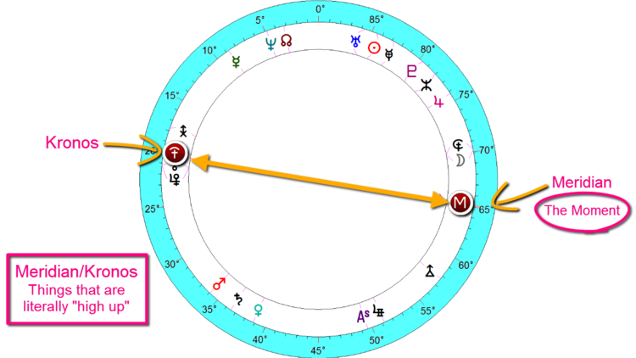
FIRST POWERED FLIGHT - DECEMBER 17, 1903, 10:35 AM KILL DEVIL HILLS, NORTH CAROLINA

Queen Elizabeth
The next chart is of Queen Elizabeth. Queen Elizabeth has a Venus/Kronos midpoint structure around her Meridian, the Meridian being a "snapshot" of the soul and point of individuality. So the planet Venus deals with relationship, affection, fondness, love, harmony, togetherness as well as what we “value.” So when Venus/Kronos get together we get someone who is a “benevolent ruler, someone who is helpful, kind and charitably disposed.
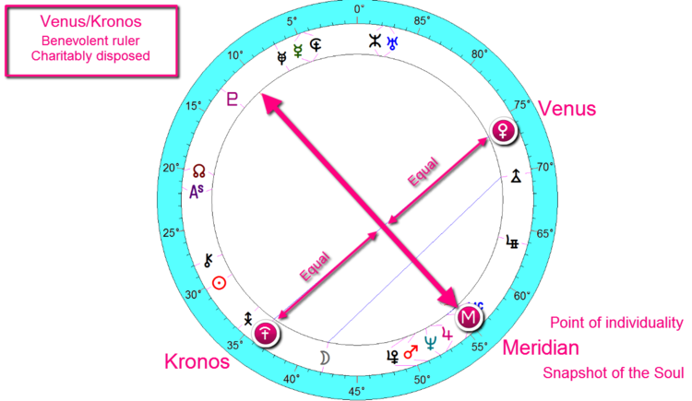
QUEEN ELIZABETH ~ APRIL 21, 1926 @ 2:40 AM LONDON, ENGLAND

Adolf Hitler
With Adolf Hitler we get a Hades/Kronos midpoint structure around the Meridian (see chart below). Now Hades can drag whatever it touches into the underworld so here we have a negative manifestation of Kronos as Hades pulls the executive, authoritarian power of the Kronos into a very dark place. This is someone whose power has been thwarted in early (or past life) primal ways, so that the person is operating from a foundation of powerlessness and this is where despotic rulers get their tyranny. Negatively manifesting Hades/Kronos is not only corrupt leadership and government, but also integrity, which means we will not be getting someone of the highest character. In fact, in Uranian astrology the Hades/Kronos can be the formula for a big time criminal.
Hades/Kronos can certainly operate positively as well, as in a very fine surgeon, therapist, or someone who is exceptional in a Hades type profession.

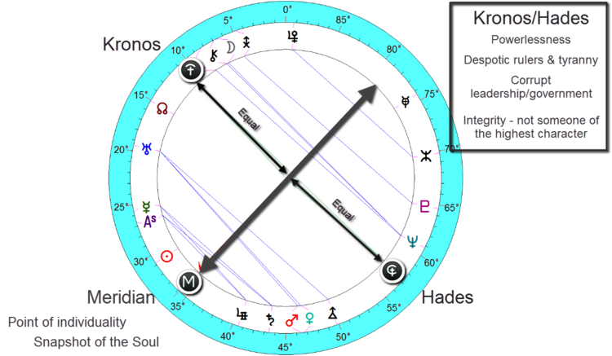

From <http://theuranianastrologer.com/kronos>

