Document relations

in

SUTI Standard



**TABLE of CONTENT**

1. Objective with this document 3

2. Short summary of SUTI documents (The SUTI Standard) 3

3. Self Declarations 5

3.1 General objectives 5

3.2 Guidelines for Provider Self Declarations 5

3.3 Guidelines for Client Self Declarations 5

3.3.1 Description of the organization 5

3.3.2 Fundamentals of business where SUTI is essential 5

3.3.3 Flows 6

3.3.4 Essential use of information elements 6

3.3.4.1 General documentation guidelines for information elements 6

3.3.4.2 Possible essential information elements to document in an order application 6

3.3.4.2.1 Use of id-elements 6

3.3.4.2.2 Use of other elements 6

3.3.5 Communication methods and Techniques 8

3.3.6 Contact information 8

3.3.7 Changes in the documentation 8

3.3.8 Current live SUTI-connections (not mandatory) 8

4. Guidelines for a Tender which includes SUTI connections 8

5. Understanding the SUTI documents 9

5.1 Understanding and interpreting the documents from a client view 9

5.2 Understanding and interpreting the documents from a provider view 9

6. Alterations 9

# Objective with this document

The SUTI standard consists of all documents under File Archives on medlem.suti.se (the member pages). Below you will find a short description of each of those documents.

A user of the standard will in tenders or other document refer to use of the standard. The SUTI organization however has the ambition that such references shall comply with the standard and has therefore decided to give guidelines how to make such documentations and references.

One specific such document is a so called Self Declaration. The Self Declaration is a structured way for a user to make its own (Self) documentation (Declaration) in order to describe the use of SUTI for a given situation. The ambition is that all implementations of SUTI-connections has at least one Self declaration and that each Client stores such a Self Declaration on member pages before start of use of a new type of SUTI connection.

The objective of this document is to specify the general structure of such a Self Declaration and relate it to other documents in SUTI.

Since this document is new from SUTI 2016 it will take several years before we will see the above described ambition fulfilled. Already today there are several good or very good examples on documents that has had the same ambition. These examples has been a very good inspiration when building the new structure of the Self declaration.

# Short summary of SUTI documents (The SUTI Standard)

Messages

The document gives a short definition of each type of message that exists in the SUTI-standard. In the definition it will state who may send and what action the message is likely to trigger when received.

Message flow

The document is only a visual abbreviation in a flow chart form of Messages. In addition it gives an indication of sequence of messages.

Schema (xsd)

The xml-schema that each message shall comply with. It also holds a lot of text with information regarding use of certain elements. Every implementation of a good SUTI should comply with the schema and a validation of messages should leave no errors.

Use Cases

Links above documents together describing how SUTI can be used in good SUTI manner for solving different situations. The document assumes that the reader is familiar with the messages as described in the previously mentioned documents.

It contains three different types of use specifications:

* Different type of flows, either broader flows describing general use cases or pieces of flows solving smaller functions
* Use of elements with examples and some requirements to be considered using SUTI in a good manner. From 2016 it also includes earlier documents specifically describing use of identities and specific resource definitions.
* General technical issues.

Document relations  
The document you are presently reading (this)

Attribute List

Is the SUTI source for attributes

The picture below gives an overview of the scope of this document an summarizes all documents. In addition may be mentioned that there is a new document named Introduction to SUTI. It has replaced the very first SUTI document describing SUTI when it was still a project.

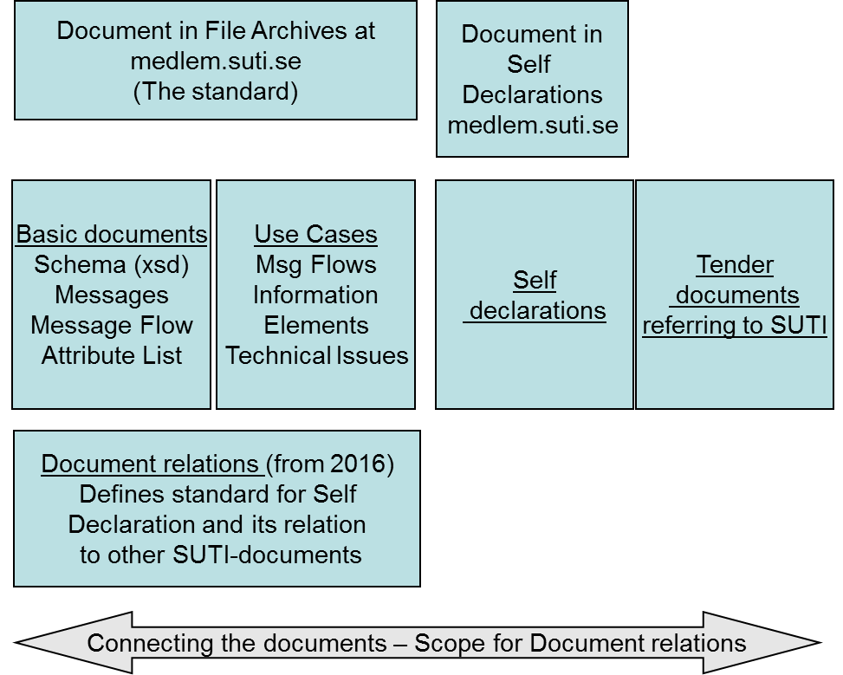

# Why Client Self Declarations

If you are in a client organization in a manager position or in a position responsible for making a tender for Demand Responsive Traffic using SUTI (because you heard its good) you may ask why should we invest making a Client Self Ceclaration?!

Consider first the picture below

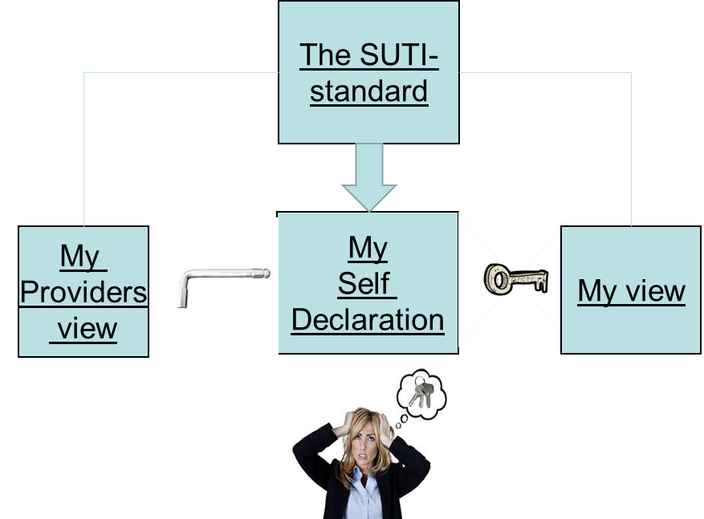

We believe you understand that your view of the world is the world of your travelers and you might be ware of that the providers might have some different views taking care of a fleet of vehicles with drivers that must have very precise instuctions how to act.

You will have to design a key that will work for you and will work for all your providers. Grand luck you have the SUTI demands of a Client Self Declaration to relay on. It is a key-element that has been workd out in very close cooperation with the major actors in the Demand Responsive Traffic market in the Nordic Countries and their software vendors.

As a client you will be expected to have the following benefits from making a Client Self Declaration

* You secure you optimize the understandings among your providers of what you want to accomplish
* You know that your description has a wide acceptance among your providers
* You will minimize potential problemsituations in your realations with your providers
* You will make a one-time effort that will payoff very quickly
* You can minimize the technical descriptions in your tenders
* You know that you are likely to get offers with a lower amount of riskminimization

The construction of a Client Self Declaration requires that you in addition to know-how of your demands also have a know-how of the SUTI-standard. Today you will find such competence most likely at your software vendor but also by many other companies in the Nordic market for Demand Responsive Traffic. Thus the obstacles to achieve a Client Self Declaration today is fairly low.

Lets therefore move to the SUTI-demands or SUTI guidelines as maybe being a better descrition.

# SUTI guidelines for Self Declarations

## General objectives

First of all, it is majorly the Client that makes a Self Declaration (also called Client Self Declaration). A provider system can only declare that it can support to be used as a provider system for the specific Client Self Declaration. This will be a specific form of Self Declaration.

The objectives of a Client Self Declaration is that it should hold a general and over time stable description of how an organization uses SUTI to accomplish its missions.

The readers are mainly to be expected to be provider system manufacturers. For this group the document shall give enough information to be able to judge their effort to support an implementation in compliance with the document.

For the organization submitting the Client Self Declaration it shall function as a document that can be referred to in its different tenders.

The SUTI technical committee will read and comment each Client Self Declaration. A wise action can therefore be to ask the SUTI technical committee to get input when launching a new Client Self Declaration.

## Guidelines for Provider Self Declarations

The providers should normally limit their documentation to a declaration of the type of SUTI-connections that is supported. It should contain following parts

* Type of connections supported
* Example of implemented SUTI-connections including specifications of who is client and who is provider
* Reference to Client Self Declarations including any restrictions

A Provider Self Documentation will not be commented by SUTI Technical Committee but the providers are encouraged to make the declaration available on SUTI member pagers.

## Guidelines for Client Self Declarations

With the general objectives in mind SUTI have decided to set the some guidelines as a tool for organizations that will declare their use of SUTI connections.

The Client Self Declarations are naturally expressed in the native language of the organization therefore you will also find a typical Scandinavian phrase for each of the sections (in paragraphs).

The guidelines are structured in the same way as a Client Self Declaration is supposed to be structured. The chapters below are therefore expected to be chapters and subchapters in a Client Self Declaration.

The structure was worked out in close cooperation with Flex Danmark. At the same time they worked out their Self Declaration SUTI worked out the general guidelines that are presented in this document**. A wise action can therefore be to read the Self Declaration of Flex Danmark in parallel to read this chapter.**

### Description of the organization

The submitting organization should in a few paragraphs describe the organization. If the organization has such description e.g. on a web-page the description can be very short just referring to that web-page (with an URL).

### Fundamentals of business where SUTI is essential

Since SUTI acts in an environment where we have a client that act as a representative for customers and travelers and providers holding one or more vehicles that will serve these travelers, there will always be a business contract between the client and the providers. These contracts can vary a lot from hiring a specific vehicle for a period to buy individual trips on a spot market of vehicle-fleets.

Therefore the fundamentals of the operation should be stated with:

* Who are the customers
* Who are the travelers and what is their general requirements
* How do we collect the trips we intend to send to providers with SUTI
* What type of business will we do with my providers and what do we request from them
* How do we generally support that business and do we have essential fundamentals like logical vehicles or other support-tools
* What software do we use
* If possible an example of a type of contract that will typical for the Self Declaration (not the legal document, just a few words describing the contract – who, where, when, scope of operation)

### Flows

This is not one big flow chart. It shall contain a flowchart for each of all single interactions between the clientsystem and the providersystem. For each of these interactions there shall be additional text stating:

* Objective of the interaction
* Trigger of the interaction
* Specific conditions at send time (if any) (not specific use of information elements, that will follow later)
* Demands on action at provider/client
* Demands on response
* What if no response
* Notification of similar description in SUTI Use Cases
* Any further comments vital in the interaction
* Example of request and response

However to be able to get a fast overview the chapter will start with a list of all exchanged and treated messages.

It is essential that **all** flows are documented.

### Essential use of information elements

#### General documentation guidelines for information elements

There is no need to go through all information elements. Such documentation will be in excess. From the examples in the flows the reader will find most of what is necessary. In this chapter the essentials shall be lifted and explained. Below you will find examples of such essentials.

Observe that you don’t have to state requirements that is already documented in SUTI Use Cases Chapter 3. It is fine that you simply define that you comply with these requirements. If you don’t you should however state in which cases your specification do not comply with these SUTI Use cases.

SUTI can be used for a number of different type of operations such as orders, repetitive orders, accounting and questions and answers. Below is a list of potential essential facts that may be documented for an application including orders.

For a Client Self Declaration of an accounting application you will find a good picture of such a documentation in the Use Case which is very extensive.

For Client Self Declaration of repetitive orders there will be required some further information elements that might be necessary to comment. However even for such type of SUTI application you will find extensive documentation In SUTI Use Cases.

For documentation in this chapter examples may not be necessary since most items will be found in the examples found in the Flows. The documentation is therefore mainly plain text. However to be precise in documentation exact naming of elements and attributes as they are defined in SUTI schema should be used.

#### Possible essential information elements to document in an order application

##### Use of id-elements

To begin with: it is not necessary to describe the general use of id-elements. It is assumed that all implementations of SUTI comply with the rules for use of id-elements carefully documented in Use Cases in a separate chapter,

What must be commented is when the logic requires specific sources and specific representation. The value attribute in the id-element is a character representation. Normally the source in itself will set limits for representation of values, If the sources are client specific and they need some kind of mapping or other action by provider such descriptions must be clearly documented.

It is specifically wise to document the use of idOrder since this element is exchanged and must be stored by both client and provider using both the source of client and source of provider.

What should absolutely not be included? The answer is obviously that the contents of any specific sources that is subject to dynamic change shall be avoided. If such sources exists they shall be kept documented but in the Self Declaration it is enough that they are generally described and there is a link to where the actual content can be found.

##### Use of other elements

The term we below refer to an actual Self Declaration. The questions are structured mostly from the SUTI Schema structure.

If you feel that below list is extensive you can do two different ways. First way just select items that you really want to inform about. Second way is to copy list. The items is turned as questions. Answer each item simply except for items where you want to enlarge your story.

At msg-level

* What will be the structure of orgReceiver
* Is there any referencesTo that is essential and are in addition to the SUTI Use Case Chapter 3
* Does any of the Time stamps have any specific meaning

At order-level

* How do we use agreement and potentially idAgreement
* Do we use product and If so what is the implications
* Is there any interpretations for process tags that we use and like to highlight

At economy in order

* Do we have price and if so is there a general implication or is the use dependent of agreement
* Do we use priceResponsible and what do we expect from provider
* Do we use payment and if so do we have specific use of e.g. idEkinfo or other element

At resource in order

* Have we transformed all demands regarding all travelers into capacity and attributes or do the provider-system have to do that (which is not good SUTI)
* Do we use id:s in any particular way
* Do we use vehicleStartPosition and if so how shall the provider system use this information (mandatory or guideline)

At node level

* What type of addresses will be present
* How is the addresses verified
* Does the addresses comply with SUTI Use Cases
* How is timesNode used and specifically what type of timeTypes is used
* What type of content do we have
* Are there any essential content information elements to highlight
* Do we use any content identifications
* Do we use connection and if so how shall the provider system use this information
* Is there any specific demands for visibility to driver regarding any node information
* Do we use node process tags

For order reject

* How is order reject handled
* Which reasons will be accepted and how shall they be presented

For order changes (the method of order change shall be reflected in a flow)

* What will be the reasons for order change
* Will we accept changes of order by the provider
* What will happen if the provider cannot by some reason fulfill a started and accepted order

For dispatch

* Which are the demands specifically details on vehicle or driver

For submitting of vehicle positions

* What type of formats is supported
* What happens if coordinates cannot be available

For events (4010)

* Is there any critical events that need to be highlighted
* If we use events which timeTypes are we requesting

For direct communication with driver or provider traffic control operator

* What is potential reasons for this type of functions

When report and or delivery message is used (observe that such flows must in such a case be present in the Flows section)

* What is the requests for such messages

For use of attributes to vehicle, driver or content

* Include reference to a web-page containing actual list of attributes
* Is there any specific non common attributes especially if they are requested to be presented to driver or otherwise be handled very specifically by provider
* Is there any other sources than the SUTI source (should be avoided)

### Communication methods and Techniques

This chapter shall describe how the provider will communicate with client. The documentation shall be very precise. A link to web-pages where the documentation is found is also acceptable.

It is essential that the client documents how tests can be performed including what type of actions is necessary. If there are test protocols that need to be performed in order to migrate to production environment there should be links to such information.

### Contact information

States who is responsible for the information. It gives the reader a possibility to ask for more. It will also set a wider credibility to the document.

### Changes in the documentation

It is recommended that the documentation have version numbers. First version shall have version 1.0. When doing minor text changes these should be documented in a way similar to what is done in the rest of SUTI documentation. The changed document will then be given a new version like 1.1.

If there are major changes like adding of a new flow it is recommended that this is marked by adding to the primary version number e.g. 2.0.

### Current live SUTI-connections (not mandatory)

It gives a sense of the extensions of the connections. Could also be a link.

# Guidelines for a Tender which includes SUTI connections

The most vital guideline is that there is a Client Self Declaration and that the Tender refers to this declaration. It can be done either as a referral or by including the declaration as an appendix.

If this is the case then a normal Tender will not need any further SUTI-specification.

A few other experiences has been notified to be of great value if they are specifically documented. Please observe that this items may not at all have any impact on the SUTI implementation but widens the understanding of an implementation of the Tender. When the term agreement is used below it refers to an agreement that will be set based on the tender.

* The provider systems are generally very closely integrated with the hardware and software in the vehicles. Any requirements for new hardware or new use of existing hardware (e.g. use of readers for new type of cards or other equipment) should be carefully documented. If such registrations will be represented in SUTI-communications it should be clearly documented
* If the tender requires specific actions by drivers in the car and these actions shall be documented by provider system they should be carefully and precise documented
* In case that any situation regarding economical information in the Tender is described, as e.g. fines, it would of course be most precise if such texts relates to an exact description how the information is collected or calculated from the SUTI messages referring to the types of messages/events and the type of information used. Using wording like “delayed more than 10 minutes” is imprecise if it does not relay to such a precise definition.
* In case the Tender requires that some essential information elements is used very specific such essential information elements shall be documented in the tender. This is especially vital if some elements becomes mandatory or is required to have specific values.
* For an operation there will always be unexpected situations that is not documented. It would be wise to describe a procedure for describing and deciding of such situations, that both parties can relay to.
* What will be the test and acceptance conditions before going live
* What is required going live, e.g. specific demands on communications
* Description of the technical organization for test and live operations of SUTI-links

# Understanding the SUTI documents

## Understanding and interpreting the documents from a client view

As a client you have the responsibility that the connections you plan will be good SUTI. Most manufacturers in Scandinavia providing systems to providers have implemented wide areas of SUTI. Most likely none has everything but many have very much functions implemented.

If you plan a new implementation of a SUTI-connection you should think in terms of a Client Self Declaration and work yourself backwards through Use Cases back to Messages and Schema. Before you launch your plan finally it is wise to finalize a first version of your Self Declaration.

If you are a member of SUTI you are always welcome to ask the Technical Committee if you find situations that is not clearly described or maybe not described at all. Your questions may be base for improvement or enlargement of the standard. At least it will result in an improvement of the documentation.

## Understanding and interpreting the documents from a provider view

If you are a provider that plans to change system and operate in The Scandinavian market you will definitely ask the system manufacturer of the capability in SUTI since it is the dominating connection method with a wide range of clients.

If you are a new manufacturer planning to implement SUTI you would of course do it from the perspective of supporting a Client Self Declaration. Even for you it is wise to work yourself backwards in the documentation from Self Declaration back to Use Cases and further to Messages and Schema.

# Alterations