SUTI Use Cases



**TABLE of CONTENT**

1. Use Cases general Description and Use 6

2. Use cases 7

2.1 Order 7

2.1.1 Order flow 7

2.1.1.1 Basic flow 7

2.1.1.2 Typical flow 9

2.1.1.3 Extensive flow 11

2.1.1.4 Extensive flow with traffic control 13

2.1.1.5 Multiple client order combined into a shared provider order 15

2.1.1.6 Resource allocation followed by traffic control 17

2.1.1.7 Resource order followed by traffic control 17

2.1.1.8 Order Trading 17

2.1.1.9 Development of order 18

2.1.1.10 PreeOrder with preeOrder flag “PROVIDER” 19

2.1.1.11 PreeOrder with preeOrder flag “CLIENTCONFIRM” 20

2.1.2 Additional processes 22

2.1.2.1 Order status 22

2.1.2.2 Alteration in dispatch with dispatch reject 23

2.1.2.3 Alteration in dispatch with new dispatch proposal 24

2.1.2.4 Resource allocation 25

2.1.2.4.1 The requested resource is not available 25

2.1.2.4.2 The requested resource is available 25

2.1.2.5 Use Case request a fixed price and how to place an order 26

2.1.2.6 General 26

2.1.3 Order events Client 29

2.1.3.1 Order/node cancellation 29

2.1.3.1.1 Order/node cancelation accept 29

2.1.3.1.2 Order/node cancellation accepted with consequence 29

2.1.3.1.3 Order/node cancellation reject 29

2.1.3.2 Order alteration 29

2.1.3.3 Late order 31

2.1.3.3.1 The hard way orderReject (Client is responsible for the order) 31

2.1.3.3.2 The softer way pickup confirmation (Provider is responsible for the order) 31

2.1.4 Order events Provider 32

2.1.4.1 Order reject 32

2.1.4.2 Order reject request 32

2.1.4.3 Node events 33

2.1.4.3.1 Pickup confirmation using estimated time 33

2.1.4.3.2 Pickup confirmation using vehicleataddress 33

2.1.4.3.3 Pickup confirmation using passengerinvehicle 33

2.1.4.4 Request for additional or corrected node information 35

2.2 Repetetive Orders 36

2.2.1 SUTI message OrderTemplate 2800 36

2.2.2 SUTI message OrderTemplateConfirmation 2801 39

2.2.3 SUTI message ScheduleElementConfirmation 2810 41

2.2.4 SUTI message ConfirmationOfRecievedMessage 7099 42

2.2.5 SUTI message ScheduleElementConfirmation 2810 43

2.2.6 SUTI message ReStart 7021 44

2.2.7 SUTI message RequestForTrafficInformation 4000 45

2.2.8 SUTI message RequestedTrafficInformation 4001 46

2.2.9 SUTI message Pickup Confirmation 4010 49

2.2.10 SUTI message Order reject request 2005 50

2.2.11 SUTI message Orderstatus 2531 51

2.2.12 SUTI message RequestForOrderInformation 6810 53

2.2.13 SUTI message RequestedOrderInformation 6800 54

2.2.14 SUTI message RequestGeograhpyinformation 1050 58

2.2.15 SUTI message TransferGeograhpyinformation 1051 58

2.2.16 SUTI message Keepalive 7000 58

2.2.17 SUTI message Keepalive 7001 59

2.2.18 SUTI message RequestForOrderInfo 2540 60

2.2.19 SUTI message OrderInfo 2541 63

2.2.20 Flowcharts 65

2.2.21 Ej implementerade delar 68

2.3 SUTI flagstops 69

2.3.1 Flagstop forløb 69

2.3.2 Flagstops i SUTI 69

2.3.2.1 Authorization 69

2.3.2.2 Bookingen 69

2.4 Delivery Note and associated messages 71

2.4.1 How to request a Msg 6500 Delivery Note 71

2.4.1.1 Request for Msg 6500 by using process element in a Msg 2000 71

2.4.1.2 Request for Msg 6500 by using process element in a Msg 2901 71

2.4.1.3 Request for Msg 6500 by sending a Msg 6510 71

2.4.1.4 Responding to a Msg 6510 with a Msg 6511 72

2.4.2 Sending a Msg 6500 Delivery Note 72

2.4.3 Answering a Msg 6500 73

2.4.3.1 Msg 6501 deliveryNoteAccept 73

2.4.3.2 Msg 6502 deliveryNoteReject 74

2.4.3.3 Msg 6503 deliveryNoteWait 74

2.5 Accounting 78

2.5.1 Basic Accounting from Provider to Client 78

2.5.1.1 General 78

2.5.1.2 Flow chart 79

2.5.1.3 Information content 79

2.5.2 Direct accounting from client to provider 83

2.5.2.1 General 83

2.5.2.2 Flow chart 83

3. Use of information elements 84

3.1 General descriptions 84

3.1.1 General use of information elements 84

3.1.2 ID (Identification elements) Structures and Usage in SUTI 84

3.1.2.1 Background 84

3.1.2.3 Rules for usage of attribute source 85

3.1.2.5 SUTI Id Description 86

3.1.3 Resorce description 87

3.1.3.1 GENERAL 87

3.1.3.1.1 VEHICLE GENERAL 87

3.1.3.1.2 DRIVER GENERAL 87

3.1.3.2 SEATING PROPERTIES in VEHICLE 88

3.1.3.2.1 DIRECTION 88

3.1.3.2.2 ACCESS 88

3.1.3.2.3 LEGSPACE 88

3.1.3.3 SEATING POSITION in VEHICLE 89

3.1.3.3.1 ROW 89

3.1.3.3.2 PLACE IN A ROW 89

3.1.3.4 ATTRIBUTES on VEHICLE 90

3.1.3.5 ATTRIBUTES on DRIVER 90

3.1.3.6 EXAMPLE of CONFIGURATION 91

3.1.3.6.1 NORMAL CONFIGURATION 91

3.1.3.6.2 ALTERNATIVE CONFIGURATION 92

3.1.3.6.3 SPECIAL CONFIGURATION STRETCHER 93

3.1.3.6.4 SPECIAL CONFIGURATION WHEELCHAIR 94

3.2 List of Information elements 95

3.2.1 Agreement 95

3.2.1.1 General 95

3.2.1.2 Minimum requirements 95

3.2.2 idMsg 95

3.2.2.1 General 95

3.2.2.2 Minimum requirements 95

3.2.3 idOrder 95

3.2.3.1 General 95

3.2.3.2 Minimum requirements 95

3.2.4 infoTimeStamp 95

3.2.4.1 General 95

3.2.4.2 Minimum requirements 96

3.2.5 msgTimeStamp 96

3.2.5.1 General 96

3.2.5.2 Minimum requirements 96

3.2.6 orgReceiver 96

3.2.6.1 General 96

3.2.6.2 Minimum requirements 96

3.2.7 orgSender 96

3.2.7.1 General 96

3.2.7.2 Minimum requirements 96

3.2.8 referencesTo 96

3.2.8.1 General 96

3.2.8.2 Minimum requirements 96

3.2.9 addressNode 97

3.2.9.1 General 97

3.2.9.2 Minimum requirements 98

3.2.10 geographicLocation 98

3.2.10.1 General 98

3.2.10.2 Minimum requirements 98

3.2.12 Event types 99

3.2.12.1 General 99

3.2.12.2 Minimum requirements 99

3.2.12.2.1 Event Type: 1701 invehicle (alt passengerinvehicle) 99

3.2.12.2.2 Event Type: 1702 exitvehicle (alt passengerdropped) 99

3.2.12.2.3 Event Type: 1703 noshow 99

3.2.12.2.4 Event Type: 1704 parcelinvehicle 99

3.2.12.2.5 Event Type: 1705 parceldropped 99

3.2.12.2.7 Event Type: 1706 action done 100

3.2.12.2.8 Event Type: 1707 navigationdone 100

3.2.12.2.9 Event Type: 1708 cancelatdoor 100

3.2.12.2.10 Event Type: 1709 vehicleatnode 100

3.2.12.2.11 Event Type: 1710 infotocontent 100

3.2.12.2.12 Event Type: 1711 dispatchconfirmationsent 101

3.2.12.2.13 Event Type: 1712 delayconfirmationsent 101

3.2.12.2.14 Event Type: 1713 arrivalconfirmationsent 101

3.2.12.2.15 Event Type: 1714 start 101

3.2.12.2.16 Event Type: 1715 stop 101

3.2.12.2.18 Event Type: 1716 acceptOrder 102

3.2.12.2.19 Event Type: 1717 vehicleexitNode 102

4. Technical issues 103

4.1 Communication 103

5. Alterations 104

5.1 Rev 1 2011-06-23 104

5.2 Rev 2 2012-03-02 104

5.3 Rev 3 2012-03-16 104

5.4 Rev 4 Version 2013 2012-10-30 104

5.5 Rev 5 Version 2013 2013-03-04 104

5.6 Rev 6 Version 2013.1 2013-05-29 104

5.7 Rev 7 Version 2014.1 2015-01-09 104

5.8 Rev 8 Version 2015-2015-04-13 104

5.9 Rev 9 Version 2015. 2015-09-08 104

# Use Cases general Description and Use

# Use cases

## Order

### Order flow

#### Basic flow

**General**

This flow can be used when the client only has the need to send orders to the provider and has no need for knowledge about how the order proceeds by the provider. With the addition of other Order Events (see below) like Order/node cancellation a fairly general simple order process can be maintained.

**Recommended Solution**

|  |  |  |  |
| --- | --- | --- | --- |
|  | **Client** | **Provider** | **Comment** |
| 1 | Sends MSG2000 |  | Sent with a unique order id. |
| 2 |  | Receives MSG2000 | Stores the order with an unique order id. |
| 3 |  | Immediately sends a MSG2001 as acceptance | Shall be sent without any delay.  Both order ids shall be sent in ReferecesTo.  After this point the Provider has taken the ownership of the order and can’t use msg 2002 if he for some reason cant finished the order. Instead the Provider has to use msg 2005 Order reject request. |
| 4 | Receives MSG2001 |  | Stores the order id from the provider including the source used. |

**Flow chart**

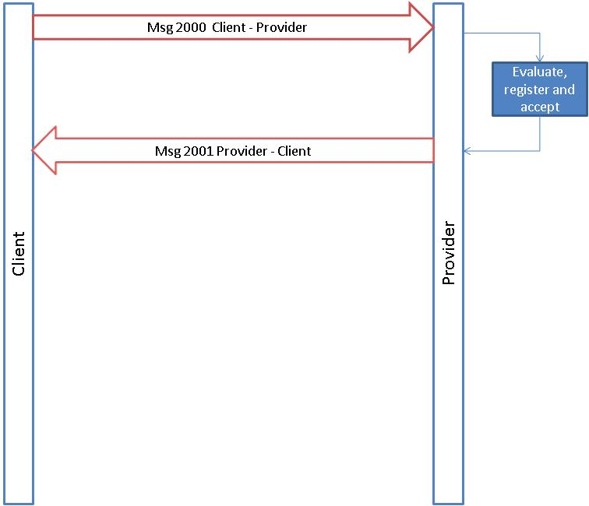

#### Typical flow

**General**

This flow can be used when the client has the need to send orders to the provider and need information about how the process continues at each node and has to know how the order was fulfilled. As for Basic Flow additions of Order Events forms the process to a general order process.

**Recommended Solution**

|  |  |  |  |
| --- | --- | --- | --- |
|  | **Client** | **Provider** | **Comment** |
| 1 | Sends MSG2000 |  | Sent with a unique order id. |
| 2 |  | Receives MSG2000 | Stores the order with a unique order id. |
| 3 |  | Immediately sends a MSG2001 as acceptance | Shall be sent without any delay.  Both order ids shall be sent in ReferecesTo.  After this point the Provider has taken the ownership of the order and can’t use msg 2002 if he for some reason cant finished the order. Instead the Provider has to use msg 2005 Order reject request. |
| 4 | Receives MSG2001 |  | Stores the order id from the provider including the source used. |
| 5 |  | Sends MSG3003 | Shall be sent after a vehicle has accepted the order. Shall include information about the identity of the vehicle |
| 6 |  | Sends MSG4010 for node number 1 | At least one message shall be sent for each node |
| 8 |  | Sends MSG4010 for node number 2 |  |
| 9 |  | Sends MSG 6001 Order report | Shall be sent as soon as the receipt is printed out in the vehicle (order completed) |

**Flow chart**

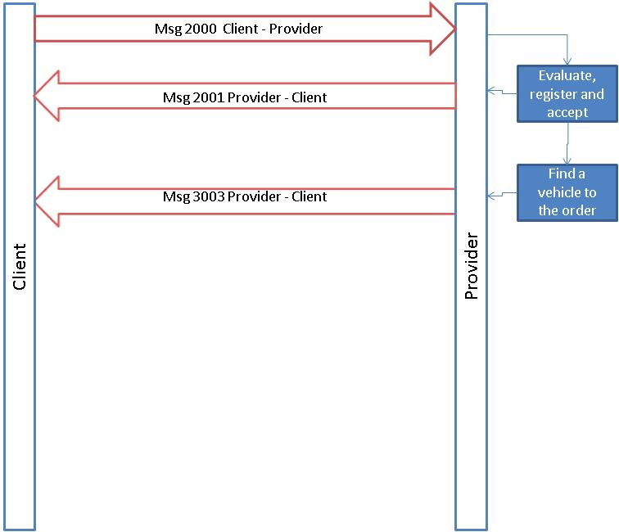

#### Extensive flow

**General**

This flow can be used when the client has the need to control and accept the resources that the provider suggests for each order. In addition the use of Delivery Note includes the possibility to exchange information necessary to handle the fulfilment of the agreement and its economical consequences. As for Basic Flow additions of Order Events forms the process to a general order process.

**Recommended Solution**

|  |  |  |  |
| --- | --- | --- | --- |
|  | **Client** | **Provider** | **Comment** |
| 1 | Sends MSG2000 |  | Sent with a unique order id. |
| 2 |  | Receives MSG2000 | Stores the order with a unique order id. |
| 3 |  | Immediately sends a MSG2001 as acceptance | Shall be sent without any delay.  Both order ids shall be sent in ReferecesTo.  After this point the Provider has taken the ownership of the order and can’t use msg 2002 if he for some reason cant finished the order. Instead the Provider has to use msg 2005 Order reject request. |
| 4 | Receives MSG2001 |  | Stores the order id from the provider including the source used. |
| 5 |  | Sends MSG3000 | Shall include the suggested vehicle |
| 6 | Sends MSG3002 as approval of the suggested vehicle |  |  |
| 7 |  | Sends MSG3003 | Shall be sent after a vehicle has accepted the order. Shall include information about the identity of the vehicle |
| 8 |  | Sends MSG4010 for node number 1 | 1709 vehicleatnode |
| 9 |  | Sends MSG4010 for node number 1 | 1701 passengerinvehicle |
| 10 |  | Sends MSG4010 for node number 2 | 1702 passengerdropof  8 to 10 shall be repeated for each set of nodes. |
| 11 |  | Sends MSG 6001 Order report | Shall be sent as soon as the receipt is printed out in the vehicle (order completed) |
| 12 |  | Sends 6500 delivery note |  |
| 13 | Sends MSG6501 deliverynoteaccept |  |  |

**Flow chart**

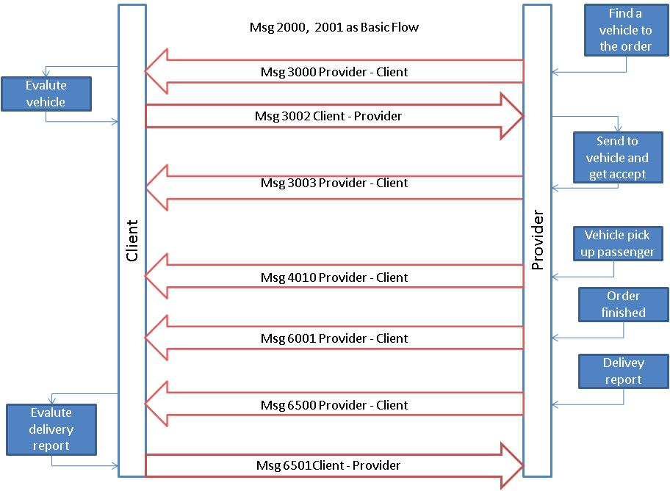

#### Extensive flow with traffic control

**General**

This flow can be used when the client has an agreement that the provider shall put resources available to the client. When the resource is available the client will add work to each vehicle by providing more nodes. The client will end the process by a separate message (4020). The method for starting the process can differ but generally the first node is always present in the initial order as is represented in this flow.

The client must always accept the suggested resources before starting the process to pick-up first node.

As for other flows above additions of Order Events forms the process to a general order process. Normally this is restricted to 2010 (Order cancellation request) prior to accept of resources (3002).

**Recommended Solution**

|  |  |  |  |
| --- | --- | --- | --- |
|  | **Client** | **Provider** | **Comment** |
| 1 | Sends MSG2000 |  | Sent with a unique order id. |
| 2 |  | Receives MSG2000 | Stores the order with a unique order id. |
| 3 |  | Immediately sends a MSG2001 as acceptance | Shall be sent without any delay.  Both order ids shall be sent in ReferecesTo.  After this point the Provider has taken the ownership of the order and can’t use msg 2002 if he for some reason cant finished the order. Instead the Provider has to use msg 2005 Order reject request. |
| 4 | Receives MSG2001 |  | Stores the order id from the provider including the source used. |
| 5 |  | Sends MSG3000 | Shall include the suggested vehicle |
| 6 | Sends MSG3002 as approval of the suggested vehicle |  |  |
| 7 |  | Sends MSG3003 | Shall be sent after a vehicle has accepted the order. Shall include information about the identity of the vehicle |
| 8 |  | Sends MSG4000 |  |
| 9 | Sends MSG4001 |  | 8 to 9 will be repeated for all nodes until the last node has been sent. |
| 8 |  | Sends MSG4010 for node number 1 | 1709 vehicleatnode |
| 9 |  | Sends MSG4010 for node number 1 | 1701 passengerinvehicle |
| 8 |  | Sends MSG4000 |  |
| 9 | Sends MSG4020 |  |  |
| 10 |  | Sends MSG4010 for node number 2 | 1702 passengerdropof  8 to 10 shall be repeated for each set of nodes. |
| 11 |  | Sends MSG 6001 Order report | Shall be sent as soon as the receipt is printed out in the vehicle (order completed) |
| 12 |  | Sends 6500 delivery note |  |
| 13 | Sends MSG6501 deliverynoteaccept |  |  |

**Flow chart**

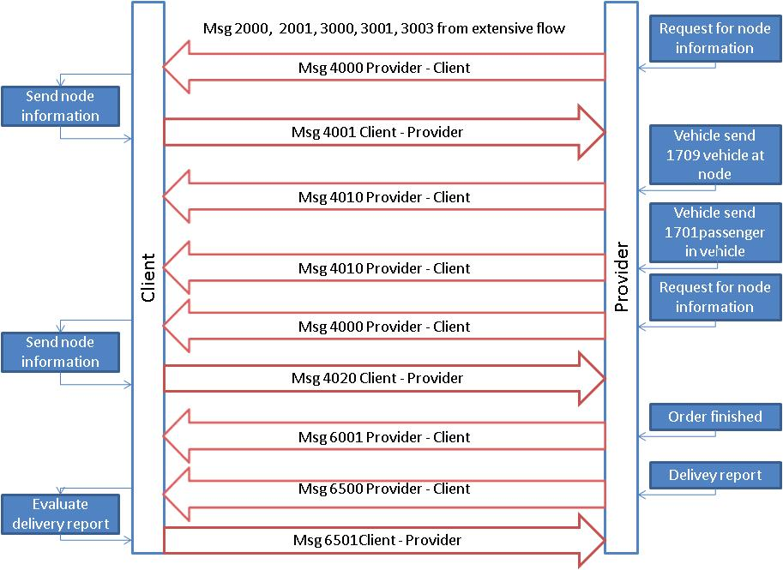

#### Multiple client order combined into a shared provider order

**General**

This describes a typical flow where the provider combines two orders from the client into a new combined order to be performed in a single resource. This flow can only be used if the client has set the allowRouting-flag in process to true and the orders are restricted to one combination of pick-up/drop-off for each content.

**Recommended Solution**

|  |  |  |  |
| --- | --- | --- | --- |
|  | **Client** | **Provider** | **Comment** |
| 1 | Sends MSG2000 for first order |  | Sent with a unique order id. |
| 2 |  | Receives MSG2000 for first order | Stores the order with a unique order id. |
| 3 |  | Immediately sends a MSG2001 as acceptance for first order | Shall be sent without any delay.  Both order ids shall be sent in ReferecesTo.  After this point the Provider has taken the ownership of the order and can’t use msg 2002 if he for some reason cant finished the order. Instead the Provider has to use msg 2005 Order reject request. |
| 4 | Receives MSG2001 for first order |  | Stores the order id from the provider including the source used. |
| 5 | Sends MSG2000 for second order |  | Sent with a unique order id. |
| 6 |  | Receives MSG2000 for second order | Stores the order with a unique order id. |
| 7 |  | Immediately sends a MSG2001 as acceptance for second order | Shall be sent without any delay.  Both order ids shall be sent in ReferecesTo. |
| 8 | Receives MSG2001 for second order |  | Stores the order id from the provider including the source used. |
| 9 |  | Sends MSG2040 | Shall include id of the linked orders together and the id of the combined order |
| 10 | Receives MSG2040 |  | Stores the order information and after that be prepared to handle the new order information |
| 11 |  | Sends MSG3003 | Shall be sent after a vehicle has accepted the order. Shall include information about the identity of the vehicle Shall refer to the combined order id and all of the suborder ids. |
| 12 |  | Sends MSG4010 for node number 1 suborder 1. | At least one message shall be sent for each node. Shall refer to the order id and the id of the suborder that includes the original node (suborder 1). This is normally node number 1 in the combined order. |
| 13 |  | Sends MSG4010 for node number 1 suborder 2. | At least one message shall be sent for each node. Shall refer to the order id and the id of the suborder that includes the original node (suborder 2). This is normally node number 2 in the combined order. |
| 14 |  | Sends MSG4010 for node number 2 suborder 1 | At least one message shall be sent for each node. Shall refer to the order id and the id of the suborder that includes the original node (suborder 1). This is normally node number 3 in the combined order. |
| 15 |  | Sends MSG4010 for node number 2 suborder 2 | At least one message shall be sent for each node. Shall refer to the order id and the id of the suborder that includes the original node (suborder 2). This is normally node number 4 in the combined order. |
| 16 |  | Sends MSG 6001 Order report | Shall be sent as soon as the receipt is printed out in the vehicle (order completed). Shall refer to the combined order id and all of the suborder ids |

This way to handle multiple orders is restricted to orders with only 1 pickup and 1 dropoff node.

**Flow chart**

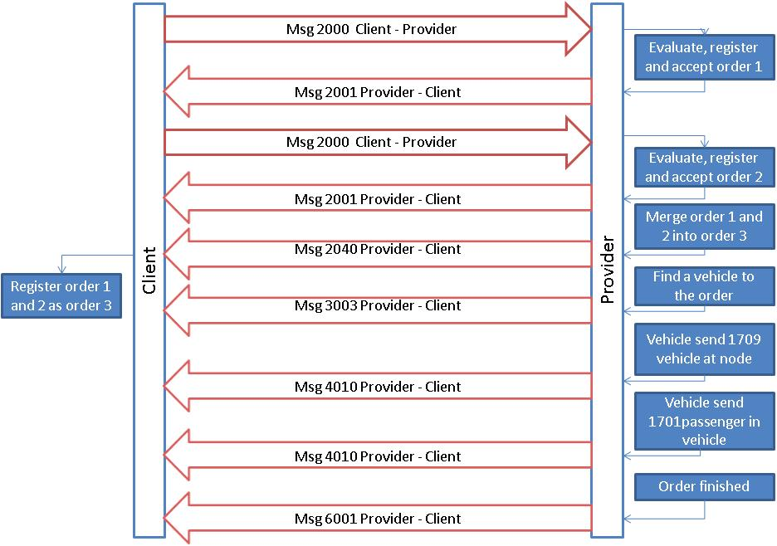

#### Resource allocation followed by traffic control

To be added. Dynamic traffic control for a hub area.

#### Resource order followed by traffic control

To be added. Dynamic traffic control for a hub area.

#### Order Trading

**General**

Order trading is in itself a fairly simple flow as described below. The dynamics of the flow is that it contains sending of order to multiple Providers that may offer vehicles according to specifications given in the order. Ultimately one of the orders will be accepted and all others cancelled.

**Recommended solution**

|  |  |  |  |  |
| --- | --- | --- | --- | --- |
|  | **Client** | **Provider 1** | Provider 2 | **Comment** |
| 1 | Sends MSG2000 |  |  | Sent with a unique order id. |
| 2 |  | Receives MSG2000 | Receives MSG2000 | Stores the order with a unique order id. |
| 3 |  | Immediately sends a MSG2001 as acceptance | Immediately sends a MSG2001 as acceptance | Shall be sent without any delay.  Both order ids shall be sent in ReferecesTo.  After this point the Provider has taken the ownership of the order and can’t use msg 2002 if he for some reason cant finished the order. Instead the Provider has to use msg 2005 Order reject request. |
| 4 | Receives MSG2001  Receives MSG2001 |  |  | Stores the order id from the provider including the source used. |
| 5 |  | Sends MSG3000 |  | Shall include the suggested vehicle |
| 6 | Sends MSG3002 as approval of the suggested vehicle |  |  |  |
| 7 |  | Sends MSG3003 |  | Shall be sent after a vehicle has accepted the order. Shall include information about the identity of the vehicle |
| 8 | Sends MSG 2010 Order Cancellation |  |  |  |
| 9 |  |  | Receives MSG 2010 |  |
| 10 |  |  | Sends MSG 2010 Order Cancellation Accepted |  |
| 11 |  |  |  |  |
| 12 |  |  |  |  |
| 13 |  |  |  |  |

When using the order trading, the start location tag can be used to give the Client a sophisticated opportunity to choose “the closest” vehicle. The vehicle start position can be setup as following example.

<vehiclestartLocation typeOfCoordinate="WGS-84" lat=”58.39193” long=”13.42448” precision="10">

<vehicleDistance range="1500">

<startTime>

<time timeZone="1" time="2010-08-18T07:00:00"/>

</startTime>

<stopTime>

<time timeZone="1" time="2010-08-18T07:00:30"/>

</stopTime>

</vehicleDistance>

<vehicleDistance range="5000">

<startTime>

<time timeZone="1" time="2010-08-18T07:00:31"/>

</startTime>

<stopTime>

<time timeZone="1" time="2010-08-18T07:01:00"/>

</stopTime>

</vehicleDistance>

</vehiclestartLocation>

This allows the Provider that has a vehicle in a distance closer than 1500 meter radius to send a Msg 3000 between 07:00:00 and 07:00:30. If no vehicle is available no Msg 3000 can be sent. However between 07:00:31 and 07:01:00 Providers having a vehicle between 1500 and 5000 meter radius can send a Msg 3000.

#### Development of order

To be added.

#### PreeOrder with preeOrder flag “PROVIDER”

**General**

PreeOrder is a preebooked order submitted to the Provider and cannot have the timetype as soon as possible. The preebooked order can either be sent as a part of Msdg 2800 repetitive order or as a single order Msg 2000. In both cases the process flag preeorder must be used. In the flow bellow Msg 2000 will be used. For Msg 2800 see chapter 2.1.11.

In this case the provider has the control and is the part that signals that no more alterations will be accepted by sending Msg 2050 Order freeze to the Client.

**Recommended solution**

|  |  |  |  |
| --- | --- | --- | --- |
|  | **Client** | **Provider** | **Comment** |
| 1 | Sends MSG2000 with process preeOrder flag “PROVIDER” used |  | Sent with a unique order id. |
| 2 |  | Receives Msg 2000 | Stores the order with a unique order id. |
| 3 |  | Immediately sends a MSG2001 as acceptance for first order | Shall be sent without any delay.  Both order ids shall be sent in ReferecesTo.  After this point the Provider has taken the ownership of the order and can’t use msg 2002 if he for some reason cant finished the order. Instead the Provider has to use msg 2005 Order reject request. |
| 4 | Receives MSG2001 |  | Stores the order id from the provider including the source used. |
| 5 | The Client make an alteration by sending Msg 2070 with process flag preeOrder “PROVIDER” used. |  | Sent with the same orderId as the original order. |
| 6 |  | Receives Msg 2070 | Replace old order with the new order. |
| 7 |  | Immediately sends a MSG2071 as acceptance for first order | Shall be sent without any delay. |
| 8 | Receives MSG2071 for altered order |  | Stores the order id from the provider including the source used. |
| 9 |  | Sends Msg 2050 | At this point no more alterations are allowed. If need to alter an order arise after this point, the Client has to cancel the order and send a new order. |
|  | Receives MSG 2050 |  |  |

**Flow chart**

#### PreeOrder with preeOrder flag “CLIENTCONFIRM”

**General**

PreeOrder is a preebooked order submitted to the Provider and cannot have the timetype as soon as possible. The preebooked order can either be sent as a part of Msdg 2800 repetitive order or as a single order Msg 2000. In both cases the process flag preeorder must be used. In the flow bellow Msg 2000 will be used. For Msg 2800 see chapter 2.1.11.

In this case the Client has the control and shall either confirm the pree booking with a Msg 2000 or cancel the pree booking with Msg 2010. If the Client doesn’t do this the order will be converted to an order by the Provider and sent on dispatch.

**Recommended solution**

|  |  |  |  |
| --- | --- | --- | --- |
|  | **Client** | **Provider** | **Comment** |
| 1 | Sends MSG2000 with process preeOrder flag “CLIENTCONFIRM” used |  | Sent with a unique order id. |
| 2 |  | Receives Msg 2000 | Stores the order with a unique order id. |
| 3 |  | Immediately sends a MSG2001 as acceptance for first order | Shall be sent without any delay.  Both order ids shall be sent in ReferecesTo. |
| 4 | Receives MSG2001 |  | Stores the order id from the provider including the source used. |
| 5 | The Client make an alteration by sending Msg 2070. |  | Sent with the same orderId as the original order. |
| 6 |  | Receives Msg 2070 | Replace old order with the new order. |
| 7 |  | Immediately sends a MSG2071 as acceptance for first order | Shall be sent without any delay. |
| 8 | Receives MSG2071 for altered order |  | Stores the order id from the provider including the source used. |
|  | Sends Msg 2000 to confirm the pree booking |  | The Client send msg 2000 to confirm that the preebooking shall be converted to order. After this point the Client cant alter the order. . If need to alter an order arise after this point, the Client has to cancel the order and send a new order. |
| 3 |  | Immediately sends a MSG2001 as acceptance of the conversion of the pree booking into an order. | Shall be sent without any delay.  Both order ids shall be sent in ReferencesTo. |
|  |  |  |  |
| 9 |  | Sends Msg 2050 | At this point no more alterations are allowed. If need to alter an order arise after this point, the Client has to cancel the order and send a new order. |
|  | Receives MSG 2050 |  |  |

**Flow chart**

#### Order Forwarded

**General**

Order Forward is udet to forward an order to a third party (Provider B) and the keep track of this order at all involved parties.

**Recommended solution**

|  |  |  |  |  |
| --- | --- | --- | --- | --- |
|  | **Client** | **ProviderA / Client forwarder** | **Provider B** | **Comment** |
| 1 | Sends MSG2000 to Provider A with process allowForward set to True |  |  | Sent with a unique order id. |
| 2 |  | Receives Msg 2000 from Client |  | Stores the order with a unique order id. |
| 3 |  | Immediately sends a MSG2001 to Clientas acceptance for first order |  | Shall be sent without any delay.  Both order ids shall be sent in ReferecesTo. |
| 4 | Receives MSG2001 from Provider A |  |  | Stores the order id from the provider including the source used. |
| 5 |  | Sends MSG 2030 to Client with full information about Provider B in referencesTo. |  | Sent with full information abot the intended provider (Provider B) |
|  | Receives MSG 2030 from Provider A |  |  | Stores information. |
|  | Sends MSG 2032 to Provider A to accept |  |  | Sent immediately if Client accept the proposed Provider (Provider B) |
|  |  | Receives MSG 2032 from Client |  | Recieves and stores information |
|  |  | Sends MSG 2000 to Provider B with full information about Client and Provider A in referencesTo.. |  | Sent with a unique order id including idOrder grom Client and information abour Client.. |
|  |  |  | Receives Msg 2000 from Client forwarder | Stores the order with a unique order id including information from Client. |
|  |  |  | Immediately sends a MSG2001 to Client forwarder as acceptance for first order with full information about idOrder and organisation in referencesTo | Shall be sent without any delay.  All order ids shall be sent in ReferecesTo |
|  |  | Receives MSG2001 from Provider B |  | Stores the order with a unique order id including information from boothClient and Provider B. |
|  |  | Immediately sends a MSG2001 to Client as acceptance for first order. Shall include all information abour order and organisation from both Provider A and Provider B in referencesTo. |  |  |
|  | Receives MSG2001 from Provider B and stores all information about idOrder and organisations from referencesTo |  |  | Stores the order with a unique order id including information from booth Provider A and Provider B. |

After this is completed every message from Client shall be sent though Provider A via Client forwarder to Provider B and every message from Provider B shall be sent though Client forwarder via Provider A to Client. Every message shall hane full information about involved order id’s and organisations in referencesTo.

**Flow Chart**



### Additional processes

#### Order status

**General**

This process is simple. The client ask for the information the provider has of a specified order and the provider sends this information to the client. This process can be used for several reasons:

* the clients has not received appropriate messages in due time and need to secure its information status on an order
* the client has received a request from a traveller on a node and wants to secure its information status on an order
* the client has had a failure and wants to secure its information status on an order

Observe in process below the provider sends a 2531 with the requested order information. There is an alternative that the provider sends 2532 in case the order is not registered by the provider.

**Recommended Solution**

|  |  |  |  |
| --- | --- | --- | --- |
|  | **Client** | **Provider** | **Comment** |
|  |  |  |  |
| n | Sends MSG2530 |  | Request for order status. |
| n+1 |  | Receives MSG2530 | Receive and generate a response to the request |
| n+2 |  | Sends MSG2531 | The message shall be sent without delay. |
| n+3 | Receives MSG2531 |  |  |

**Flow chart**



#### Alteration in dispatch with dispatch reject

**General**

These described process alternatives comes into action when the client must accept a suggested resource and the first suggestion is not accepted by client.

The client must set the process flag dispatch=”true” and dispatchResponsible=”client” in its initial order to make this process possible.

As seen below the provider initiate by sending its proposed resources. The client must answer immediately with either msg 3002, as described in the flow-chapter, or with 3001 in case the suggested resource is not accepted.

If the answer is 3001, the provider should send a new alternative suggestion with a new 3000.

This continues until the client answers with a 3002 or the provider has no more suggestions. In this case the provider should send 2005 Order reject request.

**Recommended Solution**

|  |  |  |  |
| --- | --- | --- | --- |
|  | **Client** | **Provider** | **Comment** |
|  |  |  |  |
| n |  | Sends MSG3000 | Shall include id of the suggested vehicle. |
| n+1 | Receives MSG3000 |  | Receive and evaluate if the suggested vehicle is ok. |
| n+2 | Sends MSG3001 |  | The suggested vehicle is not ok |
| n+3 |  | Receive MSG3001 | Receive and start the procedure of finding a new vehicle |
| n+4 |  | Sends MSG3000 | Shall include id of the new suggested vehicle. |
| n+5 | Receives MSG3000 |  | Receive and evaluate if the suggested vehicle is ok. |
| n+6 | Sends MSG3002 |  | The suggested vehicle is ok |
| n+7 |  | Receive MSG3002 | Receive and send the order out to the suggested vehicle |
|  |  |  |  |

**Flow chart**



#### Alteration in dispatch with new dispatch proposal

**General**

This process comes into action when the provider wants to change the resources of an order. It requires that there already exist a dispatch to a vehicle. This can either be accepted by client as in the preceding paragraph or just released to client in case the client does not have the option to accept dispatch (dispatchResponsible=”provider”).

For this last case the process is simple. The provider sends a new 3000 and the client stores the new alternative. Last 3000 will be the final result.

In case the client must accept the dispatch proposal a new process of the same kind as in paragraph above will take place.

**Recommended Solution**

|  |  |  |  |
| --- | --- | --- | --- |
|  | **Client** | **Provider** | **Comment** |
|  |  |  |  |
| n |  | Sends MSG3000 | Shall include id of the suggested vehicle. |
| n+1 | Receives MSG3000 |  | Receive and evaluate if the suggested vehicle is ok. |
| n+2 | Sends MSG3002 |  | The suggested vehicle is ok |
| n+3 |  | Receive MSG3002 | Receive and send the order out to the suggested vehicle |
| n+4 |  |  | *Suggested vehicle not available.* |
| N+5 |  | Sends MSG3000 | Shall include id of the suggested vehicle. |
| n+6 | Receives MSG3000 |  | Receive and evaluate if the suggested vehicle is ok. |
| n+7 | Sends MSG3002 |  | The suggested vehicle is ok |
| n+8 |  | Receive MSG3002 | Receive and send the order out to the suggested vehicle |
|  |  |  | *Suggested vehicle available.* |
|  |  |  |  |

**Flow chart**



#### Resource allocation

**General**

Resource allocation is used when the client wishes to either inquire if there is a resource available at a certain time in a certain place. Message 1920, 1921 and 1922 shall be used in this case.

##### The requested resource is not available

|  |  |  |  |
| --- | --- | --- | --- |
|  | **Client** | **Provider** | **Comment** |
| n | Sends MSG 1920 |  | Shall contain the necessary data to the provider should be able to answer the question.. |
| n+1 |  | Receives MSG 1920 | Receive and evaluate if the requested resource is available. |
| n+2 |  | Sends MSG 1922 | The requested resource is not available. |
| n+3 | Receives MSG 1922 |  | Receive the information that requested resource is not available. |

**Flow chart**



##### The requested resource is available

|  |  |  |  |
| --- | --- | --- | --- |
|  | **Client** | **Provider** | **Comment** |
| n | Sends MSG 1920 |  | Shall contain the necessary data to the provider should be able to answer the question.. |
| n+1 |  | Receives MSG 1920 | Receive and evaluate if the requested resource is available. |
| n+2 |  | Sends MSG 1921 | The requested resource is available. |
| n+3 | Receives MSG 1921 |  | Receive the information that requested resource is available. |

**Flow chart**



#### Use Case request a fixed price and how to place an order

#### General

This flow can be used for a client to ask a provider for a fixed price.

|  |  |  |
| --- | --- | --- |
| **Client** | **Provider** | **Comment** |
| Sends Msg 1501 | Answer with 1601 | Provider creates an Authorization key to client as a security measure |
| Sends Msg 2000 |  | If the client accepted the price send an order with the Authorization key received in msg 1601 in referencesTo |
|  | Answer with msg 2001 or msg 2002 | If everything is ok then accept the order, or if the Authorization key is invalid then reject the order. |

Example Message 1501 “Request for Price”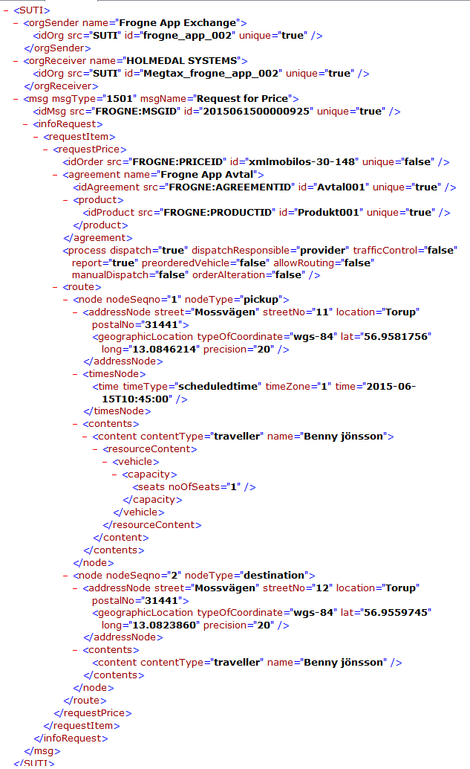

Example of the answer from provider message 1601 “Price response”. And the security key that the client should have in the message 2000 “Order”. This key is something the provider calculates, for example with the address locations, timesNode in the request message 1501.

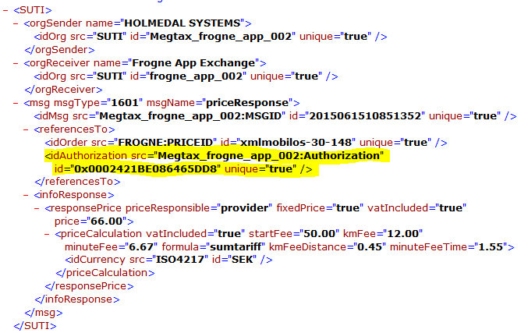

Example of the order message 2000, if the client want to book the transport.

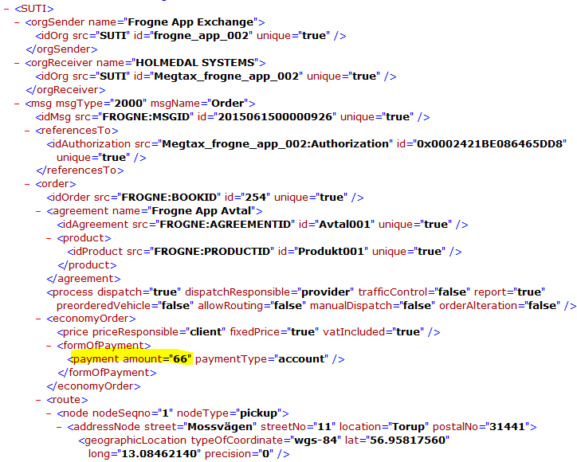

### Order events Client

#### Order/node cancellation

Order/node cancelation can only be sent by the Client.

In the case of node cancelation it’s necessary to provide the node in referencesTo.

The different conditions that regulate the different answers shall be agreed upon in the agreement.

##### Order/node cancelation accept

In the simplest case a message 2010/2020 is sent from the Client to the Provider and the Provider accepts the cancelation with a message 2011/2021 without any delay. The message need to have the attribute cancelationAcceptance set to TRUE and cancelationConsequence set to FALSE.

In such a case the Client cannot send the same order with the same idOrder. Should the Client do so the Provider should without any delay answer with 2003 orderreject and the rejectreason shall be 2513 ordercancelled.

##### Order/node cancellation accepted with consequence

This alternative shall be used if the Provider has started using resources that can be base for a claim on the Client. The message need to have the attribute cancelationAcceptance set to TRUE and cancelationConsequence set to TRUE. The accepted reasons for an acceptance with consequences shall be agreed upon in the agreement.

The economical consequence shall be stated in economycancellation

##### Order/node cancellation reject

This alternative shall be used if the Provider can’t cancel the order. Reason for this can be that the order has already begun or the order is already finished. The accepted reasons for a rejection shall be agreed upon in the agreement.

#### Order alteration

An accepted way to make an alteration of an already accepted order is as follows.

The Client sends a new updated order with the same idOrder as the old one. This order shall have a referencesTo that includes the Providers idOrder. If the execution of the order hasn’t started the Provider just replaces the old order with the new one. If the execution has started and a msg 4010 pickup has been sent for a node it’s impossible to alter this node. In this case only future alterations will be accepted. This way of doing an alteration give the possibility to do alterations after the execution of the order has started. If this way is used to handle an alteration need to be agreed upon by both Client and Provider in the agreement. If the new altered order should exceed some limit agreed upon in the agreement it’s impossible to use msg 2002 order reject as the Provider has accepted the ownership of the order. Msg 2002 can only be used to reject the original order. After the acceptance of the order the Provider has the responsibility for the order and must use msg 2005 order reject request after the acceptance of the order. If this method is used the process flagg orderAlteration should be set to TRUE.

Another accepted way of doing an alteration is to send a msg 2010 order cancelation followed by a new order. This order must not include any reference to the Providers old idOrder. In this case it’s not possible to make alterations after the execution of the order has started.

***To be discussed***: *The technical committee has a suggestion to handle the last case. If the Client want to alter an order after the execution has started it could be possible to use a new set of messages, node reject request that is built in the same way as order reject request. If the Client wants’ to alter a node in a order that has been started the Client send a msg 2020 node cancelation and after the acceptance from the provider the Client sends a msg 4001 that includes the new node information.*

*The technical committee also suggests that addition of nodes to an existing order by sending a msg 4001 with new node information without the Providers system sending a msg 4000 to request such information.*

#### Late order

A late order is an order that is sent from Client to provider after it actually should have been performed or the scheduled time is “impossible” to reach. .It’s necessary that this is regulated in the agreement.

In the SUTI standard the times on a node has the following timetypes. In the text below we use pickup but it’s appropriate for other eventtypes.

|  |  |  |
| --- | --- | --- |
| 2105 | scheduled | This is the scheduled time for the vehicle to be at the pickup address. This normally the same time as the time that the Traveler and Client have agreed upon to be the pickup time. Thus this is the latest time that the traveler expects the vehicle to be on the pickup address. |
| 2106 | promised | In case where is a difference between the scheduled time and the time given to the Traveler the Client has the option to submit this agreed time by using 2106 promised. Both 2106 promised and 2105 scheduled must be included in the message in this case. |
| 2108 | asap | This is used for an immediate order where the Client and the Traveler has agreed that the vehicle shall be at the pickup address as soon as possible after the set time. Thus the set time could either be the booking time or a “best guess” from the Client and it is normally the earliest time that the vehicle shall be on the pickup address. |
| 2107 | estimated | This is a value that can be used from either client or Provider depending of the situation. The value means that has been an estimation of a new time for pickup. This is a “best guess” and not related to promise to the Traveler and/or agreement.. |
| 2104 | actual | It’s the actual time of the event. This must be submitted by the Provider. |
|  | Timetype not specified | In this case the default value is the same as 2104 actual e.g. in the message block. |

There are two ways to handle a late order. The way to handle these two ways shall be specified and agreed upon in the agreement.

##### The hard way orderReject (Client is responsible for the order)

The Provider shall use IdRejectreason 2505 to late. The Client has the option to send the order back with the same idOrder with appropriate alterations. An appropriate alteration should be to change the value of timetype from scheduledtime to asaptime or send a new scheduledtime within an acceptable timeframe.

##### The softer way pickup confirmation (Provider is responsible for the order)

The provider sends a message 4010 pickup confirmation. The message shall contain at least a

asap timetype with the value of time set to the earlier given scheduled time. And in the best of worlds the message should also contain an estimated time.

### Order events Provider

#### Order reject

An order reject shall be sent without any delay and the reasons for an order reject shall be agreed upon in the agreement and no order accept shall be sent. If the reasons for reject aren’t specified in the agreement every order reject shall include a reject reason.

#### Order reject request

Order reject request can only be sent after that the Provider has accepted the order is within the agreement.

Sending the order reject request is done then the provider wishes that should not to any part be handled by the provider. The reason for this can be lack of capacity. If this is the case the message should contain idrejectreason 2504 nocapacity. The Client should without no delay answer with any of the messages 2006 order reject request accepted or 2007 order reject request rejected depending on the agreement situation.

**Flow chart**



There is a special case of order reject that may occur depending on agreement situation. This is handling of a request from the Traveler to cancel the order made directly to provider. This situation can occur when the provider has the authority to handle such requests. The procedure is the same as above but the idrejectreason should be 2506 travellerrequest. The provider must in both cases wait for the answer from the Client before setting the order status to cancel.

**Flow chart**



#### Node events

##### Pickup confirmation using estimated time

|  |  |  |  |
| --- | --- | --- | --- |
|  | **Client** | **Provider** | **Comment** |
|  |  |  |  |
| n |  | Sends MSG4010 | Shall include the node number and a timetype containing attribute 2107 estimatedtime. |

**Flow chart**



##### Pickup confirmation using vehicleataddress

|  |  |  |  |
| --- | --- | --- | --- |
|  | **Client** | **Provider** | **Comment** |
|  |  |  |  |
| n |  | Sends MSG4010 | Shall include the node number and a timetype containing attribute 2104 actualtime. |

**Flow chart**



##### Pickup confirmation using passengerinvehicle

|  |  |  |  |
| --- | --- | --- | --- |
|  | **Client** | **Provider** | **Comment** |
|  |  |  |  |
| n |  | Sends MSG4010 | Shall include the node number and a timetype containing attribute 2104 actualtime. |

**Flow chart**



#### Request for additional or corrected node information

If the information in a node in an order or a node in requested traffic information is incomplete it is possible to send a msg 4000 to request for additional or corrected information for instance the need of information about accurate positions or correct addresses. To request more information send a 4000 with idNode in referencesTo set to the node in question.

**Flow chart**



## Repetetive Orders

### SUTI message OrderTemplate 2800

<?xml version=*"1.0"* encoding=*"ISO-8859-1"* ?>

<SUTI>

<orgSender name=*"HDSKOL"*>

<idOrg src=*"SUTI:idLink"* id=*"HDSKOL_0001"* unique=*"true"*/>

</orgSender>

<orgReceiver name=*"PLANET"*>

<idOrg src=*"SUTI:idLink"* id=*"PLANET_0001"* unique=*"true"*/>

</orgReceiver>

<msg msgType=*"2800"* msgName=*"orderTemplate"*>

<idMsg src=*"HDSKOL_0001:MsgId"* id=*"20131125NNNNNNNN"* unique=*"true"*/>

<orderTemplate>

<idOrderTemplate src=*"HDSKOL_0001:TurIdNr"* id=*"238"* unique=*"true"* orderTemplateName=*"A1"*/>

<orderTemplateCalendar>

<validPeriod validFrom=*"2012-01-01T00:00:00"* validTo=*"2015-12-31T23:59:59"*/>

</orderTemplateCalendar>

<orderTemplateAgreement>

<idAgreement src=*"HDSKOL_0001:FGrupp"* id=*"empty"* unique=*"true"* />

<product>

<idProduct src=*"HDSKOL_0001:GruppKundId"* id=*"HD-SKOL"* unique=*"true"* />

</product>

</orderTemplateAgreement>

<scheduleElements>

<scheduleElement scheduleElementSequenceNbr=*"1"* scheduleElementFunction=*"Update"* scheduleElementResponse=*"J"*>

<scheduleElementDate date=*"2013-12-09"*/>

<scheduleElementReferencesTo>

<idOrder src=*"PLANET_0001:BestNr"* id=*"486"* unique=*"false"*/>

<idOrder src=*"HDSKOL_0001:HD_OrderNr"* id=*"0"* unique=*"true"*/>

</scheduleElementReferencesTo>

<scheduleElementRoute>

<!-- nodeType="1803" => "pickup" -->

<node nodeSeqno=*"1"* nodeType=*"1803"*>

<addressNode addressName=*"Gruvgatan 1"*>

<idZone src=*"HDSKOL_0001:Omr"* id=*"11601"* unique=*"true"*/>

</addressNode>

<timesNode>

<!-- timeType="2101” => "scheduledtime" -->

<!-- timeType="2102” => "estimatedtime" -->

<!-- timeType="2103” => "promisedtime" -->

<time timeZone=*"1"* time=*"2013-12-09T08:00:00"* timeType=*"2101"*/>

</timesNode>

<contents>

<!-- contentType="1001" => traveller -->

<content contentType=*"1001"* name=*"empty"*>

<resourceContent>

<vehicle>

<idVehicle src=*"HDSKOL_0001:TrTill"* id=*"0000_00"* unique=*"true"*/>

<capacity>

<seats noOfSeats=*"3"*/>

</capacity>

</vehicle>

</resourceContent>

</content>

</contents>

</node>

<!-- nodeType="1804" => "destination" -->

<node nodeSeqno=*"2"* nodeType=*"1804"*>

<addressNode addressName=*"*VÄSTRA HAGASKOLAN "*>

<idZone src=*"HDSKOL_0001:Omr"* id=*"21501"* unique=*"true"* />

</addressNode>

<timesNode>

<time timeZone=*"1"* time=*"2013-12-09T08:30:00"* timeType=*"2101"*/>

</timesNode>

<contents>

<!-- contentType="1001" => traveller -->

<content contentType=*"1001"* name=*"empty"*>

<resourceContent>

<vehicle>

<idVehicle src=*"HDSKOL_0001:TrTill"* id=*"0000_00"* unique=*"true"*/>

<capacity>

<seats noOfSeats=*"3"*/>

</capacity>

</vehicle>

</resourceContent>

</content>

</contents>

</node>

</scheduleElementRoute>

</scheduleElement>

</scheduleElements>

</orderTemplate>

</msg>

</SUTI>

| SUTI Message 2800 | Kommentar |
| --- | --- |
| <orgSender name=*"HDSKOL"*>  <idOrg src=*"SUTI:idLink"* id=*"HDSKOL_0001"* unique=*"true"*/>  *</orgSender>* | Information om vem som skickar meddelandet.  Attribut name och id anges.  Attributet id används sedan i src för att tala om vem som “äger” parametern ex.  *src="HDSKOL_0001:FGrupp"* |
| <orgReceiver name=*"PLANET"*>  <idOrg src=*"SUTI:idLink"* id=*"PLANET_0001"* unique=*"true"*/>  *</orgReceiver>* | Information om vem som tar emot meddelandet.  Attribut name och id anges.  Attributet id används sedan i src för att tala om vem som “äger” parametern ex.  src=*"PLANET_0001:BestNr"* id=*"486"* |
| msgType=*"2800"* | SUTI nod <msg/> |
| msgName=*"orderTemplate"* | SUTI nod <msg/> |
| *<idMsg src="HDSKOL_0001:MsgId" id="20131125NNNNNNNN" unique="true"/>* | Unikt id på aktuellt meddelande, anges som datum + nummer på 8 tecken |
| orderTemplateName=*"A1"* | SUTI nod <idOrderTemplate/>  Namn på turen |
| src=*"HDSKOL_0001:TurIdNr"* id=*"238"* | SUTI nod <idOrderTemplate/>  Unikt id för turen |
| *src="HDSKOL_0001:GruppKundId" id="HD-SKOL"* | SUTI nod <idProduct/>  GruppKundId = Grupptillstånd, fakturamottagare |
| *scheduleElementResponse="J"* | SUTI nod <scheduleElement/> |
| *validFrom="2012-01-01T00:00:00"* | SUTI nod <validPeriod/>, anges med tid |
| *validTo="2015-12-31T23:59:59"* | SUTI nod <validPeriod/>, anges med tid |
| *src="HDSKOL_0001:FGrupp" id=""* | SUTI nod <idAgreement/> |
| src=*"HDSKOL_0001:TrTill"* id=*"0000_00"* | SUTI nod <idVehicle/> |
| *scheduleElementSequenceNbr="1"* | SUTI nod <scheduleElement/> |
| scheduleElementFunction=*"Update"* | SUTI nod <scheduleElement/>, U anges som *"Update"*, B anges som *"Delete"* och I anges som *"Insert"* |
| date=*"2013-12-09"* | SUTI nod <scheduleElementDate/>  För fasta dagar anges inte datum utan noden <scheduleElementWeekday/> används där den angivna dagen har värdet = *"true"*  För icke fasta dager används noden  <scheduleElementDate/> och datumet anges som date=*"2013-12-09"* |
| src=*"PLANET_0001:BestNr"* id=*"486"* | SUTI nod <idOrder/> |
| src=*"HDSKOL_0001:HD_OrderNr"* id=*"0"* | SUTI nod <idOrder/> |
| noOfSeats=*"3"* | SUTI nod <seats/> |
| addressName=*"Gruvgatan 1"* | SUTI nod <addressNode/> |
| src=*"HDSKOL_0001:Omr"* id=*"11601"* | SUTI nod <idZone/> |
| time=*"2013-12-09T08:00:00"* | SUTI nod <time/> det kan finnas flera <time/> noder under noden <timesNode/> med olika timeType attribut. |
| addressName=*"*VÄSTRA HAGASKOLAN "* | SUTI nod <addressNode/> |
| src=*"HDSKOL_0001:Omr"* id=*"21501"* | SUTI nod <idZone/> |
| *time="2013-12-09T08:30:00"* | SUTI nod <time/> det kan finnas flera <time/> noder under noden <timesNode/> med olika timeType attribut. |

### SUTI message OrderTemplateConfirmation 2801

<?xml version=*"1.0"* encoding=*"ISO-8859-1"* ?>

<SUTI>

<orgSender name=*"PLANET"*>

<idOrg src=*"SUTI:idLink"* id=*"PLANET_0001"* unique=*"true"*/>

</orgSender>

<orgReceiver name=*"HDSKOL"*>

<idOrg src=*"SUTI:idLink"* id=*"HDSKOL_0001"* unique=*"true"*/>

</orgReceiver>

<msg msgType=*"2801"* msgName=*"orderTemplateconfirmation"*>

<idMsg src=*"PLANET_0001:MsgId"* id=*"20131125NNNNNNNN"* unique=*"true"*/>

<orderTemplate>

<idOrderTemplate src=*"HDSKOL_0001:TurIdNr"* id=*"238"* unique=*"true"* orderTemplateName=*"A1"*/>

<orderTemplateCalendar/>

<scheduleElements>

<scheduleElement scheduleElementSequenceNbr=*"1"* scheduleElementFunction=*"Insert"*>

<scheduleElementDate date=*"2013-04-30"*/>

<scheduleElementReferencesTo>

<idOrder src=*"PLANET_0001:BestNr"* id=*"0"* unique=*"false"*/>

<idRejectReason src=*"PLANET_0001:Txt"* id=*"Kan ej inplaneras"* unique=*"false"*/>

</scheduleElementReferencesTo>

</scheduleElement>

<scheduleElement scheduleElementSequenceNbr=*"2"* scheduleElementFunction=*"Insert"*>

<scheduleElementDate date=*"2013-05-02"*/>

<scheduleElementReferencesTo>

<idOrder src=*"PLANET_0001:BestNr"* id=*"12189"* unique=*"false"*/>

</scheduleElementReferencesTo>

</scheduleElement>

<scheduleElement scheduleElementSequenceNbr=*"3"* scheduleElementFunction=*"Insert"*>

<scheduleElementDate date=*"2013-05-03"*/>

<scheduleElementReferencesTo>

<idOrder src=*"PLANET_0001:BestNr"* id=*"25105"* unique=*"false"*/>

</scheduleElementReferencesTo>

</scheduleElement>

</scheduleElements>

</orderTemplate>

</msg>

</SUTI>

|  |  |
| --- | --- |
| SUTI Message 2801 | Kommentar |
| <orgSender name=*"PLANET"*>  <idOrg src=*"SUTI:idLink"* id=*"PLANET_0001"* unique=*"true"*/>  *</orgSender>* | Information om vem som skickar meddelandet.  Attribut name och id anges.  Attributet id används sedan i src för att tala om vem som “äger” parametern ex.  *src="PLANET_0001:BestNr"* |
| <orgReceiver name=*"HDSKOL"*>  <idOrg src=*"SUTI:idLink"* id=*"HDSKOL_0001"* unique=*"true"*/>  *</orgReceiver>* | Information om vem som tar emot meddelandet.  Attribut name och id anges.  Attributet id används sedan i src för att tala om vem som “äger” parametern ex.  *src="HDSKOL_0001:TurIdNr"* |
| msgType=*"2801"* | SUTI nod <msg/> |
| msgName=*"orderTemplateconfirmation"* | SUTI nod <msg/> |
| *<idMsg src="PLANET_0001:MsgId" id="20131125NNNNNNNN" unique="true"/>* | Unikt id på aktuellt meddelande, anges som datum + nummer på 8 tecken |
| orderTemplateName=*"A1"* | SUTI nod <idOrderTemplate/> |
| src=*"HDSKOL_0001:TurIdNr"* id=*"238"* | SUTI nod <idOrderTemplate/> |
| *scheduleElementSequenceNbr="1"* | SUTI nod <scheduleElement/> |
| scheduleElementFunction=*"Insert"* | SUTI nod <scheduleElement/>, U anges som *"Update"*, B anges som *"Delete"* och I anges som *"Insert"* |
| Date=*"2013-04-30"* | SUTI nod <scheduleElementDate/>  För fasta dagar anges inte datum utan noden <scheduleElementWeekday/> används där den angivna dagen har värdet = *"true"*  För icke fasta dager används noden  <scheduleElementDate/> och datumet anges som date=*"2013-12-09"* |
| src=*"PLANET_0001:Txt"* id=*"Kan ej inplaneras"* | SUTI nod <idRejectReason/> |
| src=*"PLANET_0001:BestNr"* id=*"0"* | SUTI nod <idOrder/> |

### SUTI message ScheduleElementConfirmation 2810

<?xml version=*"1.0"* encoding=*"ISO-8859-1"* ?>

<SUTI>

<orgSender name=*"PLANET"*>

<idOrg src=*"SUTI:idLink"* id=*"PLANET_0001"* unique=*"true"*/>

</orgSender>

<orgReceiver name=*"HDSKOL"*>

<idOrg src=*"SUTI:idLink"* id=*"HDSKOL_0001"* unique=*"true"*/>

</orgReceiver>

<msg msgType=*"2810"* msgName=*"scheduleElementConfirmation"*>

<idMsg src=*"PLANET_0001:MsgId"* id=*"20131125NNNNNNNN"* unique=*"true"*/>

<scheduleElementOrderList>

<scheduleElementOrder>

<scheduleElementOrderReferencesTo>

<idOrder src=*"PLANET_0001:BestNr"* id=*"486"* unique=*"false"*/>

<idOrderTemplate src=*"HDSKOL_0001:TurIdNr"* id=*"238"* unique=*"true"*/>

</scheduleElementOrderReferencesTo>

<scheduledElementOrderDate date=*"2013-12-09"*/>

</scheduleElementOrder>

<scheduleElementOrder>

<scheduleElementOrderReferencesTo>

<idOrder src=*"PLANET_0001:BestNr"* id=*"487"* unique=*"false"*/>

<idOrderTemplate src=*"HDSKOL_0001:TurIdNr"* id=*"238"* unique=*"true"*/>

</scheduleElementOrderReferencesTo>

<scheduledElementOrderDate date=*"2013-12-10"*/>

</scheduleElementOrder>

</scheduleElementOrderList>

</msg>

</SUTI>

|  |  |
| --- | --- |
| SUTI Message 2810 | Kommentar |
| <orgSender name=*"PLANET"*>  <idOrg src=*"SUTI:idLink"* id=*"PLANET_0001"* unique=*"true"*/>  *</orgSender>* | Information om vem som skickar meddelandet.  Attribut name och id anges.  Attributet id används sedan i src för att tala om vem som “äger” parametern ex.  *src="PLANET_0001:BestNr"* |
| <orgReceiver name=*"HDSKOL"*>  <idOrg src=*"SUTI:idLink"* id=*"HDSKOL_0001"* unique=*"true"*/>  *</orgReceiver>* | Information om vem som tar emot meddelandet.  Attribut name och id anges.  Attributet id används sedan i src för att tala om vem som “äger” parametern ex.  *src="HDSKOL_0001:TurIdNr"* |
| msgType=*"2810"* | SUTI nod <msg/> |
| msgName=*"scheduleElementConfirmation"* | SUTI nod <msg/> |
| *<idMsg src="PLANET_0001:MsgId" id="20131125NNNNNNNN" unique="true"/>* | Unikt id på aktuellt meddelande, anges som datum + nummer på 8 tecken |
| src=*"HDSKOL_0001:TurIdNr"* id=*"238"* | SUTI nod <idOrderTemplate/> |
| src=*"PLANET_0001:BestNr"* id=*"486"* | SUTI nod <idOrder/> |
| date=*"2013-12-09"* | SUTI nod <scheduledElementOrderDate/> |

### SUTI message ConfirmationOfRecievedMessage 7099

<?xml version=*"1.0"* encoding=*"ISO-8859-1"* ?>

<SUTI>

<orgSender name=*"HDSKOL"*>

<idOrg src=*"SUTI:idLink"* id=*"HDSKOL_0001"* unique=*"true"*/>

</orgSender>

<orgReceiver name=*"PLANET"*>

<idOrg src=*"SUTI:idLink"* id=*"PLANET_0001"* unique=*"true"*/>

</orgReceiver>

<msg msgType=*"7099"* msgName=*"ConfirmationOfReceivedMessage"*>

<idMsg src=*"HDSKOL_0001:MsgId"* id=*"20131125NNNNNNNN"* unique=*"true"*/>

<referencesTo>

<idOrder src=*"PLANET_0001:BestNr"* id=*"486"* unique=*"false"*/>

<!-- idRejectReason skickas vid eventulla fel -->

<idRejectReason src=*"HDSKOL_0001:Txt"* id=*"Eventuell fel text"* unique=*"false"*/>

</referencesTo>

</msg>

</SUTI>

|  |  |
| --- | --- |
| SUTI Message 7099 | Kommentar |
| <orgSender name=*"HDSKOL"*>  <idOrg src=*"SUTI:idLink"* id=*"HDSKOL_0001"* unique=*"true"*/>  *</orgSender>* | Information om vem som skickar meddelandet.  Attribut name och id anges.  Attributet id används sedan i src för att tala om vem som “äger” parametern ex.  *src="HDSKOL_0001:MsgId"* |
| <orgReceiver name=*"PLANET"*>  <idOrg src=*"SUTI:idLink"* id=*"PLANET_0001"* unique=*"true"*/>  *</orgReceiver>* | Information om vem som tar emot meddelandet.  Attribut name och id anges.  Attributet id används sedan i src för att tala om vem som “äger” parametern ex.  *src="PLANET_0001:BestNr"* |
| msgType=*"7099"* | SUTI nod <msg/> |
| msgName=*"ConfirmationOfReceivedMessage"* | SUTI nod <msg/> |
| *<idMsg src="HDSKOL_0001:MsgId" id="20131125NNNNNNNN" unique="true"/>* | Unikt id på aktuellt meddelande, anges som datum + nummer på 8 tecken |
| src=*"PLANET_0001:BestNr"* id=*"486"* | SUTI nod <idOrder/> skickar tillbaka det Bestnr som vi fick i msg 2810. |
|  | Om svaret INTE är OK skickas *<idRejectReason src="HDSKOL_0001:Txt" id="Eventuell fel text" unique="false"/>*  *Om svaret är OK skickas inte noden <idRejectReason/>* |
|  | Om svaret INTE är OK skickas *<idRejectReason src="HDSKOL_0001:Txt" id="Eventuell fel text" unique="false"/>*  *Om svaret är OK skickas inte noden <idRejectReason/>* |

### SUTI message ScheduleElementConfirmation 2810

<?xml version=*"1.0"* encoding=*"ISO-8859-1"* ?>

<SUTI>

<orgSender name=*"PLANET"*>

<idOrg src=*"SUTI:idLink"* id=*"PLANET_0001"* unique=*"true"*/>

</orgSender>

<orgReceiver name=*"HDSKOL"*>

<idOrg src=*"SUTI:idLink"* id=*"HDSKOL_0001"* unique=*"true"*/>

</orgReceiver>

<msg msgType=*"2810"* msgName=*"scheduleElementConfirmation"*>

<idMsg src=*"PLANET_0001:MsgId"* id=*"20131125NNNNNNNN"* unique=*"true"*/>

<scheduleElementOrderList>

<scheduleElementOrder orderListClosed=*"true"*>

<scheduledElementOrderDate date=*"2013-12-09"*/>

</scheduleElementOrder>

</scheduleElementOrderList>

</msg>

</SUTI>

|  |  |
| --- | --- |
| SUTI Message 2810 | Kommentar |
| <orgSender name=*"PLANET"*>  <idOrg src=*"SUTI:idLink"* id=*"PLANET_0001"* unique=*"true"*/>  *</orgSender>* | Information om vem som skickar meddelandet.  Attribut name och id anges.  Attributet id används sedan i src för att tala om vem som “äger” parametern ex.  *src="PLANET_0001:MsgId"* |
| <orgReceiver name=*"HDSKOL"*>  <idOrg src=*"SUTI:idLink"* id=*"HDSKOL_0001"* unique=*"true"*/>  *</orgReceiver>* | Information om vem som tar emot meddelandet.  Attribut name och id anges. |
| msgType=*"2810"* | SUTI nod <msg/> |
| msgName=*"scheduleElementConfirmation"* | SUTI nod <msg/> |
| *<idMsg src="HDSKOL_0001:MsgId" id="20131125NNNNNNNN" unique="true"/>* | Unikt id på aktuellt meddelande, anges som datum + nummer på 8 tecken |
| orderListClosed=*"true"* | SUTI nod <scheduleElementOrder/> |
| date=*"2013-12-09"* | SUTI nod <scheduledElementOrderDate/> |

### SUTI message ReStart 7021

<?xml version=*"1.0"* encoding=*"ISO-8859-1"* ?>

<SUTI>

<orgSender name=*"PLANET"*>

<idOrg src=*"SUTI:idLink"* id=*"PLANET_0001"* unique=*"true"*/>

</orgSender>

<orgReceiver name=*"HDSKOL"*>

<idOrg src=*"SUTI:idLink"* id=*"HDSKOL_0001"* unique=*"true"*/>

</orgReceiver>

<msg msgType=*"7021"* msgName=*"ReStart"*>

<idMsg src=*"PLANET_0001:MsgId"* id=*"20131125NNNNNNNN"* unique=*"true"*/>

</msg>

</SUTI>

|  |  |
| --- | --- |
| SUTI Message 7021 | Kommentar |
| <orgSender name=*"PLANET"*>  <idOrg src=*"SUTI:idLink"* id=*"PLANET_0001"* unique=*"true"*/>  *</orgSender>* | Information om vem som skickar meddelandet.  Attribut name och id anges.  Attributet id används sedan i src för att tala om vem som “äger” parametern ex.  *src="PLANET_0001:MsgId"* |
| <orgReceiver name=*"HDSKOL"*>  <idOrg src=*"SUTI:idLink"* id=*"HDSKOL_0001"* unique=*"true"*/>  *</orgReceiver>* | Information om vem som tar emot meddelandet.  Attribut name och id anges. |
| msgType=*"7021"* | SUTI nod <msg/> |
| msgName=*"ReStart"* | SUTI nod <msg/> |
| *<idMsg src="PLANET_0001:MsgId" id="20131125NNNNNNNN" unique="true"/>* | Unikt id på aktuellt meddelande, anges som datum + nummer på 8 tecken |

### SUTI message RequestForTrafficInformation 4000

<?xml version=*"1.0"* encoding=*"ISO-8859-1"* ?>

<SUTI>

<orgSender name=*"PLANET"*>

<idOrg src=*"SUTI:idLink"* id=*"PLANET_0001"* unique=*"true"*/>

</orgSender>

<orgReceiver name=*"HDSKOL"*>

<idOrg src=*"SUTI:idLink"* id=*"HDSKOL_0001"* unique=*"true"*/>

</orgReceiver>

<msg msgType=*"4000"* msgName=*"RequestForTrafficInformation"*>

<idMsg src=*"PLANET_0001:MsgId"* id=*"20131125NNNNNNNN"* unique=*"true"*/>

<referencesTo>

<idOrder src=*"HDSKOL_0001:HD_OrderNr"* id=*"1254505"* unique=*"true"*/>

<idOrderTemplate src=*"HDSKOL_0001:TurIdNr"* id=*"238"* unique=*"true"*/>

</referencesTo>

<manualDescriptionMsg sendtoInvoice=*"false"* sendtoVehicle=*"false"* sendtoOperator=*"false"* manualText=*"AltLayout=N"* vehicleConfirmation=*"false"*/>

</msg>

</SUTI>

|  |  |
| --- | --- |
| SUTI Message 4000 | Kommentar |
| <orgSender name=*"PLANET"*>  <idOrg src=*"SUTI:idLink"* id=*"PLANET_0001"* unique=*"true"*/>  *</orgSender>* | Information om vem som skickar meddelandet.  Attribut name och id anges.  Attributet id används sedan i src för att tala om vem som “äger” parametern ex.  *src="PLANET_0001:MsgId"* |
| <orgReceiver name=*"HDSKOL"*>  <idOrg src=*"SUTI:idLink"* id=*"HDSKOL_0001"* unique=*"true"*/>  *</orgReceiver>* | Information om vem som tar emot meddelandet.  Attribut name och id anges.  Attributet id används sedan i src för att tala om vem som “äger” parametern ex.  *src="HDSKOL_0001:TurIdNr"* |
| msgType=*"4000"* | SUTI nod <msg/> |
| msgName=*"RequestForTrafficInformation"* | SUTI nod <msg/> |
| *<idMsg src="PLANET_0001:MsgId" id="20131125NNNNNNNN" unique="true"/>* | Unikt id på aktuellt meddelande, anges som datum + nummer på 8 tecken |
| src=*"HDSKOL_0001:HD_OrderNr"* id=*"1254505"* | SUTI nod <idOrder/> |
| src=*"HDSKOL_0001:TurIdNr"* id=*"238"* | SUTI nod <idOrderTemplate/> |
| sendtoVehicle=*"true"*  *sendtoOperator="false"* | SUTI nod <manualDescriptionMsg/> |
| sendtoVehicle=*"false"*  *sendtoOperator="true"* | SUTI nod <manualDescriptionMsg/> |
| manualText=*"AltLayout=N"* | SUTI nod <manualDescriptionMsg/> |
| Saknas | Behövs inte då vi alltid skall svara |

### SUTI message RequestedTrafficInformation 4001

<?xml version=*"1.0"* encoding=*"ISO-8859-1"* ?>

<SUTI>

<orgSender name=*"HDSKOL"*>

<idOrg src=*"SUTI:idLink"* id=*"HDSKOL_0001"* unique=*"true"*/>

</orgSender>

<orgReceiver name=*"PLANET"*>

<idOrg src=*"SUTI:idLink"* id=*"PLANET_0001"* unique=*"true"*/>

</orgReceiver>

<msg msgType=*"4001"* msgName=*"RequestedTrafficInformation"*>

<idMsg src=*"HDSKOL_0001:MsgId"* id=*"20131125NNNNNNNN"* unique=*"true"*/>

<referencesTo>

<!-- Reference to the message that this message answers. -->

<idMsg src=*"PLANET_0001:MsgId"* id=*"20131125NNNNNNNN"* unique=*"true"*/>

</referencesTo>

<orderTemplate>

<idOrderTemplate src=*"HDSKOL_0001:TurIdNr"* id=*"238"* unique=*"true"* orderTemplateName=*"A1"*/>

<orderTemplateCalendar/>

<scheduleElements>

<scheduleElement scheduleElementSequenceNbr=*"1"*>

<scheduleElementReferencesTo>

<idOrder src=*"HDSKOL_0001:HD_OrderNr"* id=*"27641"* unique=*"true"*/>

</scheduleElementReferencesTo>

<scheduleElementRoute>

<!-- nodeType="1803" => "pickup" -->

<node nodeSeqno=*"1"* nodeType=*"1803"*>

<addressNode addressName=*"Frångatan 1"* postalNo=*"12345"*>

<manualDescriptionAddress sendtoInvoice=*"false"* sendtoVehicle=*"true"* sendtoOperator=*"true"* manualText=*"#H:08:00#Frångatan 1#PN: 12345#Adr.Anm"* vehicleConfirmation=*"true"*/>

<attributeAddress>

<attribute>

<idAttribute src=*"HDSKOL_0001:AdrAnm"* id=*"Adr.Anm"* unique=*"false"*/>

</attribute>

</attributeAddress>

</addressNode>

<timesNode>

<!-- timeType="2101" => scheduledtime -->

<time timeZone=*"1"* time=*"2013-12-09T08:00:00"* timeType=*"2101"*/>

</timesNode>

<contents>

<!-- contentType="1001" => traveller -->

<content contentType=*"1001"* name=*"Elev 1"*>

<attributeContent>

<attribute>

<idAttribute src=*"HDSKOL_0001:ElevAnm"* id=*"Elev Anm."* unique=*"true"*/>

</attribute>

<attribute>

<idAttribute src=*"HDSKOL_0001:FAnm"* id=*"Elev Adr. Anm."* unique=*"false"*/>

</attribute>

</attributeContent>

<!-- sendtoVehicle and sendtooperator values according to the 4000 -->

<manualDescriptionContent sendtoVehicle=*"true"* sendtoOperator=*"false"* sendtoInvoice=*"false"* vehicleConfirmation=*"true"* manualText=*"#ELEV 1#Elev Adr. Anm.#Elev Anm."*/>

</content>

</contents>

</node>

<!-- nodeType="1803" => "pickup" -->

<node nodeSeqno=*"2"* nodeType=*"1803"*>

<addressNode addressName=*"ABC gatan 1"* postalNo=*"41476"*>

<manualDescriptionAddress sendtoInvoice=*"false"* sendtoVehicle=*"true"* sendtoOperator=*"true"* manualText=*"#H:08:15#ABC gatan 1#PN: 41476#Adr.Anm"* vehicleConfirmation=*"true"*/>

<attributeAddress>

<attribute>

<idAttribute src=*"HDSKOL_0001:AdrAnm"* id=*"Adr.Anm"* unique=*"false"*/>

</attribute>

</attributeAddress>

</addressNode>

<timesNode>

<!-- timeType="2101" => scheduledtime -->

<time timeZone=*"1"* time=*"2013-12-09T08:15:00"* timeType=*"2101"*/>

</timesNode>

<contents>

<!-- contentType="1001" => traveller -->

<content contentType=*"1001"* name=*"Elev 2"*>

<attributeContent>

<attribute>

<idAttribute src=*"HDSKOL_0001:ElevAnm"* id=*"Elev Anm."* unique=*"true"*/>

</attribute>

<attribute>

<idAttribute src=*"HDSKOL_0001:FAnm"* id=*"Elev Adr. Anm."* unique=*"false"*/>

</attribute>

</attributeContent>

<!-- sendtoVehicle and sendtooperator values according to the 4000 -->

<manualDescriptionContent sendtoVehicle=*"true"* sendtoOperator=*"false"* sendtoInvoice=*"false"* vehicleConfirmation=*"true"* manualText=*"#ELEV 2#Elev Adr. Anm.#Elev Anm."*/>

</content>

</contents>

</node>

<!-- nodeType="1804" => "destination" -->

<node nodeSeqno=*"2"* nodeType=*"1804"*>

<addressNode addressName=*"SKOLGATAN 1"* postalNo=*"43651"*>

<manualDescriptionAddress sendtoInvoice=*"false"* sendtoVehicle=*"true"* sendtoOperator=*"true"* manualText=*"#L:08:30#SKOLGATAN 1#PN: 43651#Adr.Anm"* vehicleConfirmation=*"true"*/>

<attributeAddress>

<attribute>

<idAttribute src=*"HDSKOL_0001:AdrAnm"* id=*"Adr.Anm"* unique=*"true"*/>

</attribute>

</attributeAddress>

</addressNode>

<timesNode>

<!-- timeType="2101" => scheduledtime -->

<time timeZone=*"1"* time=*"2013-12-09T08:30:00"* timeType=*"2101"*/>

</timesNode>

<contents>

<!-- contentType="1001" => traveller -->

<content contentType=*"1001"* name=*"Elev 1"*>

<attributeContent>

<attribute>

<idAttribute src=*"HDSKOL_0001:ElevAnm"* id=*"Elev Anm."* unique=*"true"*/>

</attribute>

<attribute>

<idAttribute src=*"HDSKOL_0001:TAnm"* id=*"Elev Adr. Anm."* unique=*"false"*/>

</attribute>

</attributeContent>

<!-- sendtoVehicle and sendtooperator values according to the 4000 -->

<manualDescriptionContent sendtoVehicle=*"true"* sendtoOperator=*"false"* sendtoInvoice=*"false"* vehicleConfirmation=*"true"* manualText=*"#ELEV 1#Elev Adr. Anm.#Elev Anm."*/>

</content>

<content contentType=*"1001"* name=*"Elev 2"*>

<attributeContent>

<attribute>

<idAttribute src=*"HDSKOL_0001:ElevAnm"* id=*"Elev Anm."* unique=*"true"*/>

</attribute>

<attribute>

<idAttribute src=*"HDSKOL_0001:TAnm"* id=*"Elev Adr. Anm."* unique=*"false"*/>

</attribute>

</attributeContent>

<!-- sendtoVehicle and sendtooperator values according to the 4000 -->

<manualDescriptionContent sendtoVehicle=*"true"* sendtoOperator=*"false"* sendtoInvoice=*"false"* vehicleConfirmation=*"true"* manualText=*"#ELEV 2#Elev Adr. Anm.#Elev Anm."*/>

</content>

</contents>

</node>

</scheduleElementRoute>

</scheduleElement>

</scheduleElements>

</orderTemplate>

</msg>

</SUTI>

|  |  |
| --- | --- |
| SUTI Message 4001 | Kommentar |
| <orgSender name=*"HDSKOL"*>  <idOrg src=*"SUTI:idLink"* id=*"HDSKOL_0001"* unique=*"true"*/>  *</orgSender>* | Information om vem som skickar meddelandet.  Attribut name och id anges.  Attributet id används sedan i src för att tala om vem som “äger” parametern ex.  *src="HDSKOL_0001:MsgId"* |
| <orgReceiver name=*"PLANET"*>  <idOrg src=*"SUTI:idLink"* id=*"PLANET_0001"* unique=*"true"*/>  *</orgReceiver>* | Information om vem som tar emot meddelandet.  Attribut name och id anges.  Attributet id används sedan i src för att tala om vem som “äger” parametern ex.  *src="PLANET_0001:MsgId"* |
| msgType=*"4001"* | SUTI nod <msg/> |
| msgName=*"RequestedTrafficInformation"* | SUTI nod <msg/> |
| *<idMsg src="PLANET_0001:MsgId" id="20131125NNNNNNNN" unique="true"/>* | Unikt id på aktuellt meddelande, anges som datum + nummer på 8 tecken |
| orderTemplateName=*"A1"* | SUTI nod <idOrderTemplate/> |
| src=*"HDSKOL_0001:TurIdNr"* id=*"238"* | SUTI nod <idOrderTemplate/> |
| src=*"HDSKOL_0001:HD_OrderNr"* id=*"27641"* | SUTI nod <idOrder/> |

Kommentar:

Notera för att ta fram hela körordertexten för ordern skall följande atttibut värden adderas.

<node nodeSeqno=*"1"*

<manualDescriptionAddress manualText=*"#H:08:00#Frångatan 1#PN: 12345#Adr.Anm"* />

*<manualDescriptionContent manualText="#ELEV 1#Elev Adr. Anm.#Elev Anm."* />

</node>

<node nodeSeqno=*"2"*

<manualDescriptionAddress manualText=*"#H:08:15#ABC gatan 1#PN: 41476#Adr.Anm"* />

*<manualDescriptionContent manualText="#ELEV 2#Elev Adr. Anm.#Elev Anm."* />

</node>

<node nodeSeqno=*"2"*

<manualDescriptionAddress manualText=*"#L:08:30#SKOLGATAN 1#PN: 43651#Adr.Anm"* />

*<manualDescriptionContent manualText="#ELEV 1#Elev Adr. Anm.#Elev Anm."* />

*<manualDescriptionContent manualText="#ELEV 2#Elev Adr. Anm.#Elev Anm."* />

</node>

### SUTI message Pickup Confirmation 4010

*<?xml version="1.0" encoding="UTF-8"?>*

<SUTI>

<orgSender name=*"PLANET"*>

<idOrg src=*"SUTI:idLink"* id=*"PLANET_0001"* unique=*"true"*/>

</orgSender>

<orgReceiver name=*"HDSKOL"*>

<idOrg src=*"SUTI:idLink"* id=*"HDSKOL_0001"* unique=*"true"*/>

</orgReceiver>

<msg msgType=*"4010"* msgName=*"PickupConfirmation"*>

<idMsg src=*"PLANET_0001:MsgId"* id=*"20131125NNNNNNNN"* unique=*"true"*/>

<referencesTo>

<idOrder src=*"HDSKOL_0001:HD_OrderNr"* id=*"27641"* unique=*"true"*/>

<idOrderTemplate src=*"HDSKOL_0001:TurIdNr"* id=*"238"* unique=*"true"*/>

</referencesTo>

<manualDescriptionMsg sendtoInvoice=*"false"* sendtoVehicle=*"false"* sendtoOperator=*"false"* manualText=*"AltLayout=N"* vehicleConfirmation=*"false"*/>

</msg>

</SUTI>

|  |  |
| --- | --- |
| SUTI Message 4010 | Kommentar |
| <orgSender name=*"PLANET"*>  <idOrg src=*"SUTI:idLink"* id=*"PLANET_0001"* unique=*"true"*/>  *</orgSender>* | Information om vem som skickar meddelandet.  Attribut name och id anges.  Attributet id används sedan i src för att tala om vem som “äger” parametern ex.  *src="PLANET_0001:MsgId"* |
| <orgReceiver name=*"HDSKOL"*>  <idOrg src=*"SUTI:idLink"* id=*"HDSKOL_0001"* unique=*"true"*/>  *</orgReceiver>* | Information om vem som tar emot meddelandet.  Attribut name och id anges.  Attributet id används sedan i src för att tala om vem som “äger” parametern ex.  *src="HDSKOL_0001:TurIdNr"* |
| msgType=*"4010"* | SUTI nod <msg/> |
| msgName=*"PickupConfirmation"* | SUTI nod <msg/> |
| *<idMsg src="PLANET_0001:MsgId" id="20131125NNNNNNNN" unique="true"/>* | Unikt id på aktuellt meddelande, anges som datum + nummer på 8 tecken |
| src=*"HDSKOL_0001:HD_OrderNr"* id=*"27641"* | SUTI nod <idOrder/> |
| src=*"HDSKOL_0001:TurIdNr"* id=*"238"* | SUTI nod <idOrderTemplate/> |
| sendtoVehicle=*"true"*  *sendtoOperator="false"* | SUTI nod <manualDescriptionMsg/> |
| sendtoVehicle=*"false"*  *sendtoOperator="true"* | SUTI nod <manualDescriptionMsg/> |
| manualText=*"AltLayout=N"* | SUTI nod <manualDescriptionMsg/> |
| Saknas | Behövs inte då vi alltid skall svara |

### SUTI message Order reject request 2005

*<?xml version="1.0" encoding="ISO-8859-1" ?>*

<SUTI>

<orgSender name=*"PLANET"*>

<idOrg src=*"SUTI:idLink"* id=*"PLANET_0001"* unique=*"true"*/>

</orgSender>

<orgReceiver name=*"HDSKOL"*>

<idOrg src=*"SUTI:idLink"* id=*"HDSKOL_0001"* unique=*"true"*/>

</orgReceiver>

<msg msgType=*"2005"* msgName=*"OrderRejectRequest"*>

<idMsg src=*"PLANET_0001:MsgId"* id=*"20131125NNNNNNNN"* unique=*"true"*/>

<orderTemplate>

<idOrderTemplate src=*"HDSKOL_0001:TurIdNr"* id=*"238"* unique=*"true"*/>

<orderTemplateCalendar/>

<scheduleElements>

<scheduleElement scheduleElementSequenceNbr=*"1"*>

<scheduleElementDate date=*"2013-08-20"*/>

<scheduleElementReferencesTo>

<idOrder src=*"HDSKOL_0001:HD_OrderNr"* id=*"27641"* unique=*"true"*/>

<idOrder src=*"PLANET_0001:BestNr"* id=*"486"* unique=*"false"*/>

<idDriver src=*"PLANET_0001:OperId"* id=*"BAL"* unique=*"true"*/>

</scheduleElementReferencesTo>

</scheduleElement>

</scheduleElements>

</orderTemplate>

</msg>

</SUTI>

|  |  |
| --- | --- |
| SUTI Message 2005 | Kommentar |
| <orgSender name=*"PLANET"*>  <idOrg src=*"SUTI:idLink"* id=*"PLANET_0001"* unique=*"true"*/>  *</orgSender>* | Information om vem som skickar meddelandet.  Attribut name och id anges.  Attributet id används sedan i src för att tala om vem som “äger” parametern ex.  *src="PLANET_0001:BestNr"* |
| <orgReceiver name=*"HDSKOL"*>  <idOrg src=*"SUTI:idLink"* id=*"HDSKOL_0001"* unique=*"true"*/>  *</orgReceiver>* | Information om vem som tar emot meddelandet.  Attribut name och id anges.  Attributet id används sedan i src för att tala om vem som “äger” parametern ex.  *src="HDSKOL_0001:TurIdNr"* |
| msgType=*"2005"* | SUTI nod <msg/> |
| msgName=*"OrderRejectRequest"* | SUTI nod <msg/> |
| *<idMsg src="PLANET_0001:MsgId" id="20131125NNNNNNNN" unique="true"/>* | Unikt id på aktuellt meddelande, anges som datum + nummer på 8 tecken |
| src=*"HDSKOL_0001:HD_OrderNr"* id=*"27641"* | SUTI nod <idOrder/> |
| src=*"HDSKOL_0001:TurIdNr"* id=*"238"* | SUTI nod <idOrderTemplate/> |
| src=*"PLANET_0001:BestNr"* id=*"486"* | SUTI nod <idOrder/> |
| date=*"2013-12-09"* | SUTI nod <scheduledElementOrderDate/> |
| src=*"PLANET_0001:OperId"* id=*"BAL"* | SUTI nod <idDriver/> |

### SUTI message Orderstatus 2531

<?xml version=*"1.0"* encoding=*"ISO-8859-1"* ?>

<SUTI>

<orgSender name=*"PLANET"*>

<idOrg src=*"SUTI:idLink"* id=*"PLANET_0001"* unique=*"true"*/>

</orgSender>

<orgReceiver name=*"HDSKOL"*>

<idOrg src=*"SUTI:idLink"* id=*"HDSKOL_0001"* unique=*"true"*/>

</orgReceiver>

<msg msgType=*"2531"* msgName=*"orderStatus"*>

<idMsg src=*"PLANET_0001:MsgId"* id=*"20131125NNNNNNNN"* unique=*"true"*/>

<orderTemplate>

<idOrderTemplate src=*"HDSKOL_0001:TurIdNr"* id=*"238"* unique=*"true"* orderTemplateName=*"A1"*/>

<orderTemplateCalendar/>

<orderTemplateAgreement>

<idAgreement src=*"HDSKOL_0001:GruppKundId"* id=*"HD-SKOL"* unique=*"true"*/>

</orderTemplateAgreement>

<scheduleElements>

<scheduleElement scheduleElementSequenceNbr=*"1"*>

<scheduleElementDate date=*"2013-08-20"*/>

<scheduleElementReferencesTo>

<idOrder src=*"PLANET_0001:BestNr"* id=*"486"* unique=*"false"*/>

</scheduleElementReferencesTo>

</scheduleElement>

</scheduleElements>

</orderTemplate>

</msg>

</SUTI>

|  |  |
| --- | --- |
| SUTI Message 2531 | Kommentar |
| <orgSender name=*"PLANET"*>  <idOrg src=*"SUTI:idLink"* id=*"PLANET_0001"* unique=*"true"*/>  *</orgSender>* | Information om vem som skickar meddelandet.  Attribut name och id anges.  Attributet id används sedan i src för att tala om vem som “äger” parametern ex.  *src="PLANET_0001:MsgId"* |
| <orgReceiver name=*"HDSKOL"*>  <idOrg src=*"SUTI:idLink"* id=*"HDSKOL_0001"* unique=*"true"*/>  *</orgReceiver>* | Information om vem som tar emot meddelandet.  Attribut name och id anges.  ex.  src=*"HDSKOL_0001:GruppKundId"* |
| msgType=*"2531"* | SUTI nod <msg/> |
| msgName=*"orderStatus"* | SUTI nod <msg/> |
| *<idMsg src="HDSKOL_0001:MsgId" id="20131125NNNNNNNN" unique="true"/>* | Unikt id på aktuellt meddelande, anges som datum + nummer på 8 tecken |
| *src="PLANET_0001:BestNr" id="90181"* |  |
| src=*"HDSKOL_0001:TurIdNr"* id=*"238"* | SUTI nod <idOrderTemplate/> |
| *orderTemplateName="A1"* | SUTI nod <idOrderTemplate/> |
| src=*"HDSKOL_0001:GruppKundId"* id=*"HD-SKOL"* | SUTI nod <idAgreement/>  GruppKundId = Grupptillstånd, fakturamottagare |
| date=*"2013-08-20"* | SUTI nod <scheduleElementDate/>  För fasta dagar anges inte datum utan noden <scheduleElementWeekday/> används där den angivna dagen har värdet = *"true"*  För icke fasta dager används noden  <scheduleElementDate/> och datumet anges som date=*"2013-08-20"* |

Kommentar:

HD-skol svar på msg 2531 är msg 2800 med scheduleElementFunction=*"Update"* eller *scheduleElementFunction="Delete"* beroende på om ordern finns i HD-skol.

### SUTI message RequestForOrderInformation 6810

<?xml version=*"1.0"* encoding=*"ISO-8859-1"* ?>

<SUTI>

<orgSender name=*"PLANET"*>

<idOrg src=*"SUTI:idLink"* id=*"PLANET_0001"* unique=*"true"*/>

</orgSender>

<orgReceiver name=*"HDSKOL"*>

<idOrg src=*"SUTI:idLink"* id=*"HDSKOL_0001"* unique=*"true"*/>

</orgReceiver>

<msg msgType=*"6810"* msgName=*"requestForOrderInformation"*>

<idMsg src=*"PLANET_0001:MsgId"* id=*"20131125NNNNNNNN"* unique=*"true"*/>

<scheduleElementOrderList>

<scheduleElementOrder>

<scheduleElementOrderReferencesTo>

<idOrder src=*"HDSKOL_0001:HD_OrderNr"* id=*"27641"* unique=*"true"*/>

<idOrder src=*"PLANET_0001:BestNr"* id=*"91181"* unique=*"false"*/>

<idOrderTemplate src=*"HDSKOL_0001:TurIdNr"* id=*"238"* unique=*"true"*/>

</scheduleElementOrderReferencesTo>

<scheduledElementOrderDate date=*"2013-08-20"*/>

</scheduleElementOrder>

</scheduleElementOrderList>

</msg>

</SUTI>

|  |  |
| --- | --- |
| SUTI Message 6810 | Kommentar |
| <orgSender name=*"PLANET"*>  <idOrg src=*"SUTI:idLink"* id=*"PLANET_0001"* unique=*"true"*/>  *</orgSender>* | Information om vem som skickar meddelandet.  Attribut name och id anges.  Attributet id används sedan i src för att tala om vem som “äger” parametern ex.  *src="PLANET_0001:MsgId"* |
| <orgReceiver name=*"HDSKOL"*>  <idOrg src=*"SUTI:idLink"* id=*"HDSKOL_0001"* unique=*"true"*/>  *</orgReceiver>* | Information om vem som tar emot meddelandet.  Attribut name och id anges.  Attributet id används sedan i src för att tala om vem som “äger” parametern ex.  *src="HDSKOL_0001:TurIdNr"* |
| msgType=*"6810"* | SUTI nod <msg/> |
| msgName=*"requestForOrderInformation"* | SUTI nod <msg/> |
| *<idMsg src="PLANET_0001:MsgId" id="20131125NNNNNNNN" unique="true"/>* | Unikt id på aktuellt meddelande, anges som datum + nummer på 8 tecken |
| src=*"HDSKOL_0001:HD_OrderNr"* id=*"27641"* | SUTI nod <idOrder/> |
| src=*"HDSKOL_0001:TurIdNr"* id=*"238"* | SUTI nod <idOrder/> |
| date=*"2013-08-20"* | SUTI nod <scheduleElementDate/>  För fasta dagar anges inte datum utan noden <scheduleElementWeekday/> används där den angivna dagen har värdet = *"true"*  För icke fasta dager används noden  <scheduleElementDate/> och datumet anges som date=*"2013-08-20"* |
| src=*"PLANET_0001:BestNr"* id=*"91181"* | SUTI nod <idOrder/> |

### SUTI message RequestedOrderInformation 6800

<?xml version=*"1.0"* encoding=*"ISO-8859-1"* ?>

<SUTI>

<orgSender name=*"HDSKOL"*>

<idOrg src=*"SUTI:idLink"* id=*"HDSKOL_0001"* unique=*"true"*/>

</orgSender>

<orgReceiver name=*"PLANET"*>

<idOrg src=*"SUTI:idLink"* id=*"PLANET_0001"* unique=*"true"*/>

</orgReceiver>

<msg msgType=*"6800"* msgName=*"requestedOrderInformation"*>

<idMsg src=*"HDSKOL_0001:MsgId"* id=*"20131125NNNNNNNN"* unique=*"true"*/>

<orderTemplate>

<idOrderTemplate src=*"HDSKOL_0001:TurIdNr"* id=*"238"* unique=*"true"* orderTemplateName=*"A1"*/>

<orderTemplateCalendar/>

<scheduleElements>

<scheduleElement scheduleElementSequenceNbr=*"1"*>

<scheduleElementReferencesTo>

<idOrder src=*"HDSKOL_0001:HD_OrderNr"* id=*"27641"* unique=*"true"*/>

<idOrder src=*"PLANET_0001:BestNr"* id=*"486"* unique=*"false"*/>

<!-- idRejectReason skickas vid eventulla fel -->

<idRejectReason src=*"PLANET_0001:Txt"* id=*"Eventuell fel text"* unique=*"false"*/>

</scheduleElementReferencesTo>

<scheduleElementRoute>

<!-- nodeType="1803" => "pickup" -->

<node nodeSeqno=*"1"* nodeType=*"1803"*>

<addressNode addressName=*"VILLAGATAN 3"*>

<idZone src=*"HDSKOL_0001:HOmr"* id=*"TRC002"* unique=*"true"* />

</addressNode>

<timesNode>

<!-- timeType="2101" => scheduledtime -->

<time timeZone=*"1"* time=*"2013-08-20T08:30:00"* timeType=*"2101"*/>

</timesNode>

<contents>

<!-- contentType="1001" => traveller -->

<content contentType=*"1001"* name=*"KALLE SVENSSON"*>

<idContent src=*"HDSKOL_0001:KId"* id=*"010101-1234"* unique=*"true"*/>

<attributeContent>

<attribute>

<idAttribute src=*"HDSKOL_0001:Bet"* id=*"TRSKOL"* unique=*"true"*/>

</attribute>

<attribute>

<idAttribute src=*"HDSKOL_0001:KostSt"* id=*"TRSKO1"* unique=*"true"*/>

</attribute>

<attribute>

<idAttribute src=*"HDSKOL_0001:Proc"* id=*"47.0"* unique=*"true"*/>

</attribute>

<attribute>

<idAttribute src=*"HDSKOL_0001:Bom"* id=*"N"* unique=*"true"*/>

</attribute>

</attributeContent>

</content>

</contents>

</node>

<!-- nodeType="1803" => "pickup" -->

<node nodeSeqno=*"2"* nodeType=*"1803"*>

<addressNode addressName=*"VILLAGATAN 18"*>

<idZone src=*"HDSKOL_0001:HOmr"* id=*"TRC002"* unique=*"true"* />

</addressNode>

<timesNode>

<!-- timeType="2101" => scheduledtime -->

<time timeZone=*"1"* time=*"2013-08-20T08:32:00"* timeType=*"2101"*/>

</timesNode>

<contents>

<!-- contentType="1001" => traveller -->

<content contentType=*"1001"* name=*"GRETA ERIKSSON"*>

<idContent src=*"HDSKOL_0001:KId"* id=*"020202-1234"* unique=*"true"*/>

<attributeContent>

<attribute>

<idAttribute src=*"HDSKOL_0001:Bet"* id=*"TRSKOL"* unique=*"true"*/>

</attribute>

<attribute>

<idAttribute src=*"HDSKOL_0001:KostSt"* id=*"TRSKO1"* unique=*"true"*/>

</attribute>

<attribute>

<idAttribute src=*"HDSKOL_0001:Proc"* id=*"53.0"* unique=*"true"*/>

</attribute>

<attribute>

<idAttribute src=*"HDSKOL_0001:Bom"* id=*"N"* unique=*"true"*/>

</attribute>

</attributeContent>

</content>

</contents>

</node>

<!-- nodeType="1804" => "destination" -->

<node nodeSeqno=*"3"* nodeType=*"1804"*>

<addressNode addressName=*"TROLLSKOLAN"*>

<idZone src=*"HDSKOL_0001:LOmr"* id=*"TRV018"* unique=*"true"* />

</addressNode>

<timesNode>

<!-- timeType="2101" => scheduledtime -->

<time timeZone=*"1"* time=*"2013-08-20T08:45:00"* timeType=*"2101"*/>

</timesNode>

<contents>

<!-- contentType="1001" => traveller -->

<content contentType=*"1001"* name=*"KALLE SVENSSON"*>

<idContent src=*"HDSKOL_0001:KId"* id=*"010101-1234"* unique=*"true"*/>

<attributeContent>

<attribute>

<idAttribute src=*"HDSKOL_0001:Bet"* id=*"TRSKOL"* unique=*"true"*/>

</attribute>

<attribute>

<idAttribute src=*"HDSKOL_0001:KostSt"* id=*"TRSKO1"* unique=*"true"*/>

</attribute>

<attribute>

<idAttribute src=*"HDSKOL_0001:Proc"* id=*"47.0"* unique=*"true"*/>

</attribute>

<attribute>

<idAttribute src=*"HDSKOL_0001:Bom"* id=*"N"* unique=*"true"*/>

</attribute>

</attributeContent>

</content>

<!-- contentType="1001" => traveller -->

<content contentType=*"1001"* name=*"GRETA ERIKSSON"*>

<idContent src=*"HDSKOL_0001:KId"* id=*"020202-1234"* unique=*"true"*/>

<attributeContent>

<attribute>

<idAttribute src=*"HDSKOL_0001:Bet"* id=*"TRSKOL"* unique=*"true"*/>

</attribute>

<attribute>

<idAttribute src=*"HDSKOL_0001:KostSt"* id=*"TRSKO1"* unique=*"true"*/>

</attribute>

<attribute>

<idAttribute src=*"HDSKOL_0001:Proc"* id=*"53.0"* unique=*"true"*/>

</attribute>

<attribute>

<idAttribute src=*"HDSKOL_0001:Bom"* id=*"N"* unique=*"true"*/>

</attribute>

</attributeContent>

</content>

</contents>

</node>

</scheduleElementRoute>

</scheduleElement>

</scheduleElements>

</orderTemplate>

</msg>

</SUTI>

|  |  |
| --- | --- |
| SUTI Message 6800 | Kommentar |
| <orgSender name=*"HDSKOL"*>  <idOrg src=*"SUTI:idLink"* id=*"HDSKOL_0001"* unique=*"true"*/>  *</orgSender>* | Information om vem som skickar meddelandet.  Attribut name och id anges.  Attributet id används sedan i src för att tala om vem som “äger” parametern ex.  *src="HDSKOL_0001:Bet"* |
| <orgReceiver name=*"PLANET"*>  <idOrg src=*"SUTI:idLink"* id=*"PLANET_0001"* unique=*"true"*/>  *</orgReceiver>* | Information om vem som tar emot meddelandet.  Attribut name och id anges.  Attributet id används sedan i src för att tala om vem som “äger” parametern ex.  *src="PLANET_0001:BestNr"* |
| msgType=*"6800"* | SUTI nod <msg/> |
| msgName=*"requestedOrderInformation"* | SUTI nod <msg/> |
| *<idMsg src="HDSKOL_0001 :MsgId" id="20131125NNNNNNNN" unique="true"/>* | Unikt id på aktuellt meddelande, anges som datum + nummer på 8 tecken |
| orderTemplateName=*"A1"* | SUTI nod <idOrderTemplate/> |
| src=*"HDSKOL_0001:TurIdNr"* id=*"238"* | SUTI nod <idOrderTemplate/> |
| src=*"HDSKOL_0001:HD_OrderNr"* id=*"27641"* | SUTI nod <idOrder/> |
| src=*"PLANET_0001:BestNr"* id=*"486"* | SUTI nod <idOrder/> |
|  | Om svaret INTE är OK skickas *<idRejectReason src="HDSKOL_0001:Txt" id="Eventuell fel text" unique="false"/>*  *Om svaret är OK skickas inte noden <idRejectReason/>* |
|  | Om svaret INTE är OK skickas *<idRejectReason src="HDSKOL_0001:Txt" id="Eventuell fel text" unique="false"/>*  *Om svaret är OK skickas inte noden <idRejectReason/>* |
| src=*"HDSKOL_0001:KId"* id=*"010101-1234"* | SUTI nod <idContent/> |
| name=*"KALLE SVENSSON"* | SUTI nod <content/> |
| time=*"2013-08-20T08:30:00"* | SUTI nod <time/> HTid eller LTid bestäms av nodeType |
| addressName=*"VILLAGATAN 3"* | SUTI nod <addressNode/> HAdr eller LAdr bestäms av nodeType |
| src=*"HDSKOL_0001:HOmr"* id=*"TRC002"* | SUTI nod <idZone/> |
| time=*"2013-08-20T08:45:00"* | SUTI nod <time/> HTid eller LTid bestäms av nodeType |
| addressName=*"TROLLSKOLAN"* | SUTI nod <addressNode/> HAdr eller LAdr bestäms av nodeType |
| src=*"HDSKOL_0001:Bet"* id=*"TRSKOL"* | SUTI nod <idAttribute/> |
| src=*"HDSKOL_0001:KostSt"* id=*"TRSKO1"* | SUTI nod <idAttribute/> |
| src=*"HDSKOL_0001:Proc"* id=*"53.0"* | SUTI nod <idAttribute/> |
| src=*"HDSKOL_0001:Bom"* id=*"N"* | SUTI nod <idAttribute/> |

### SUTI message RequestGeograhpyinformation 1050

To be implemented later

### SUTI message TransferGeograhpyinformation 1051

To be implemented later

### SUTI message Keepalive 7000

*<?xml version="1.0" encoding="ISO-8859-1" ?>*

<SUTI>

<orgSender name=*"PLANET"*>

<idOrg src=*"SUTI:idLink"* id=*"PLANET_0001"* unique=*"true"*/>

</orgSender>

<orgReceiver name=*"HDSKOL"*>

<idOrg src=*"SUTI:idLink"* id=*"HDSKOL_0001"* unique=*"true"*/>

</orgReceiver>

<msg msgType=*"7000"* msgName=*"Keepalive"*>

<idMsg src=*"PLANET_0001:MsgId"* id=*"20131125NNNNNNNN"* unique=*"true"*/>

</msg>

</SUTI>

|  |  |
| --- | --- |
| SUTI Message 7000 | Kommentar |
| <orgSender name=*"PLANET"*>  <idOrg src=*"SUTI:idLink"* id=*"PLANET_0001"* unique=*"true"*/>  *</orgSender>* | Information om vem som skickar meddelandet.  Attribut name och id anges.  Attributet id används sedan i src för att tala om vem som “äger” parametern ex.  *src="PLANET_0001:MsgId"* |
| <orgReceiver name=*"HDSKOL"*>  <idOrg src=*"SUTI:idLink"* id=*"HDSKOL_0001"* unique=*"true"*/>  *</orgReceiver>* | Information om vem som tar emot meddelandet.  Attribut name och id anges. |
| msgType=*"7000"* | SUTI nod <msg/> |
| msgName=*"Keepalive"* | SUTI nod <msg/> |
| *<idMsg src="HDSKOL_0001 :MsgId" id="20131125NNNNNNNN" unique="true"/>* | Unikt id på aktuellt meddelande, anges som datum + nummer på 8 tecken |

### SUTI message Keepalive 7001

*<?xml version="1.0" encoding="ISO-8859-1" ?>*

<SUTI>

<orgSender name=*"HDSKOL"*>

<idOrg src=*"SUTI:idLink"* id=*"HDSKOL_0001"* unique=*"true"*/>

</orgSender>

<orgReceiver name=*"PLANET"*>

<idOrg src=*"SUTI:idLink"* id=*"PLANET_0001"* unique=*"true"*/>

</orgReceiver>

<msg msgType=*"7001"* msgName=*"KeepAliveConfirmation"*>

<idMsg src=*"HDSKOL_0001:MsgId"* id=*"20131125NNNNNNNN"* unique=*"true"*/>

<referencesTo>

<idMsg src=*"PLANET_0001:MsgId"* id=*"20131125NNNNNNNN"* unique=*"true"*/>

<!-- idRejectReason skickas vid eventulla fel -->

<idRejectReason src=*"HDSKOL_0001:Txt"* id=*"Eventuell fel text"* unique=*"false"*/>

</referencesTo>

</msg>

</SUTI>

|  |  |
| --- | --- |
| SUTI Message 7001 | Kommentar |
| <orgSender name=*"PLANET"*>  <idOrg src=*"SUTI:idLink"* id=*"PLANET_0001"* unique=*"true"*/>  *</orgSender>* | Information om vem som skickar meddelandet.  Attribut name och id anges.  Attributet id används sedan i src för att tala om vem som “äger” parametern ex.  *src="PLANET_0001:MsgId"* |
| <orgReceiver name=*"HDSKOL"*>  <idOrg src=*"SUTI:idLink"* id=*"HDSKOL_0001"* unique=*"true"*/>  *</orgReceiver>* | Information om vem som tar emot meddelandet.  Attribut name och id anges. |
| msgType=*"7001"* | SUTI nod <msg/> |
| msgName=*"KeepAliveConfirmation"* | SUTI nod <msg/> |
| *<idMsg src="HDSKOL_0001:MsgId" id="20131125NNNNNNNN" unique="true"/>* | Unikt id på aktuellt meddelande, anges som datum + nummer på 8 tecken |
|  | Om svaret INTE är OK skickas *<idRejectReason src="HDSKOL_0001:Txt" id="Eventuell fel text" unique="false"/>*  *Om svaret är OK skickas inte noden <idRejectReason/>* |
|  | Om svaret INTE är OK skickas *<idRejectReason src="HDSKOL_0001:Txt" id="Eventuell fel text" unique="false"/>*  *Om svaret är OK skickas inte noden <idRejectReason/>* |

### SUTI message RequestForOrderInfo 2540

*<?xml version="1.0" encoding="ISO-8859-1" ?>*

<SUTI>

<orgSender name=*"PLANET"*>

<idOrg src=*"SUTI:idLink"* id=*"PLANET_0001"* unique=*"true"*/>

</orgSender>

<orgReceiver name=*"HDSKOL"*>

<idOrg src=*"SUTI:idLink"* id=*"HDSKOL_0001"* unique=*"true"*/>

</orgReceiver>

<msg msgType=*"2540"* msgName=*"RequestForOrderInfo"*>

<idMsg src=*"PLANET_0001:MsgId"* id=*"20131125NNNNNNNN"* unique=*"true"*/>

<orderTemplate>

<idOrderTemplate src=*"HDSKOL_0001:TurIdNr"* id=*"238"* unique=*"true"* orderTemplateName=*"A1"*/>

<orderTemplateCalendar/>

<scheduleElements>

<scheduleElement scheduleElementSequenceNbr=*"1"*>

<!-- Fasta dagar anges ej med datum utan som nedan -->

<scheduleElementWeekday monday=*"true"*/>

<scheduleElementReferencesTo>

<idOrder src=*"PLANET_0001:BestNr"* id=*"3412"* unique=*"false"*/>

<idOrder src=*"HDSKOL_0001:HD_OrderNr"* id=*"27641"* unique=*"true"*/>

</scheduleElementReferencesTo>

<scheduleElementRoute>

<!-- nodeType="1803" => "pickup" -->

<node nodeSeqno=*"1"* nodeType=*"1803"*>

<addressNode addressName=*"ABC-GATAN 5"*>

<idZone src=*"HDSKOL_0001:Omr"* id=*"OMR918"* unique=*"true"* />

</addressNode>

<timesNode>

<!-- Fast måndag = 1899-12-31, Fast tisdag = 1900-01-01 osv. -->

<time timeZone=*"1"* time=*"1899-12-31T08:20:00"* timeType=*"2101"*/>

</timesNode>

<contents>

<!-- contentType="1001" => traveller -->

<content contentType=*"1001"* name=*"empty"*>

<resourceContent>

<vehicle>

<capacity>

<seats noOfSeats=*"5"*/>

</capacity>

</vehicle>

</resourceContent>

</content>

</contents>

</node>

<!-- nodeType="1804" => "destination" -->

<node nodeSeqno=*"2"* nodeType=*"1804"*>

<addressNode addressName=*"SKOLGATAN 23"*>

<idZone src=*"HDSKOL_0001:Omr"* id=*"OMR311"* unique=*"true"* />

</addressNode>

<timesNode>

<time timeZone=*"1"* time=*"1899-12-31T08:55:00"* timeType=*"2101"*/>

</timesNode>

<contents>

<!-- contentType="1001" => traveller -->

<content contentType=*"1001"* name=*"empty"*>

<resourceContent>

<vehicle>

<capacity>

<seats noOfSeats=*"5"*/>

</capacity>

</vehicle>

</resourceContent>

</content>

</contents>

</node>

</scheduleElementRoute>

</scheduleElement>

</scheduleElements>

</orderTemplate>

</msg>

</SUTI>

|  |  |
| --- | --- |
| SUTI Message 2540 | Kommentar |
| <orgSender name=*"PLANET"*>  <idOrg src=*"SUTI:idLink"* id=*"PLANET_0001"* unique=*"true"*/>  *</orgSender>* | Information om vem som skickar meddelandet.  Attribut name och id anges.  Attributet id används sedan i src för att tala om vem som “äger” parametern ex.  *src="PLANET_0001:MsgId"* |
| <orgReceiver name=*"HDSKOL"*>  <idOrg src=*"SUTI:idLink"* id=*"HDSKOL_0001"* unique=*"true"*/>  *</orgReceiver>* | Information om vem som tar emot meddelandet.  Attribut name och id anges.  Attributet id används sedan I src för att tala om vem som ”äger” parametern  ex.  *src="HDSKOL_0001:TurIdNr"* |
| msgType=*"2540"* | SUTI nod <msg/> |
| msgName=*"RequestForOrderInfo"* | SUTI nod <msg/> |
| *<idMsg src="PLANET_0001:MsgId" id="20131125NNNNNNNN" unique="true"/>* | Unikt id på aktuellt meddelande, anges som datum + nummer på 8 tecken |
| monday=*"true"* | SUTI nod <scheduleElementWeekday/>  För fasta dagar anges inte datum utan noden <scheduleElementWeekday/> används där den angivna dagen har värdet = *"true"*  För icke fasta dager används noden  <scheduleElementDate/> och datumet anges som date=*"2013-08-20"* |
| src=*"HDSKOL_0001:TurIdNr"* id=*"238"* | SUTI nod <idOrderTemplate/> |
| src=*"HDSKOL_0001:HD_OrderNr"* id=*"27641"* | SUTI nod <idOrder/> |
| src=*"PLANET_0001:BestNr"* id=*"3412"* | SUTI nod <idOrder/> |
| orderTemplateName=*"A1"* | SUTI nod <idOrderTemplate/> |
| noOfSeats=*"5"* | SUTI nod <seats/> |
| addressName=*"ABC-GATAN 5"* | SUTI nod <addressNode/> |
| src=*"HDSKOL_0001:Omr"* id=*"OMR918"* | SUTI nod <idZone/> |
| time=*"1899-12-31T08:20:00"* | SUTI nod <time/>  Attributet time skall anges som datum + tid har löst detta genom att ange fast måndag = 1899-12-31  fast tisdag = 1900-01-01  fast onsdag = 1900-01-02  fast torsdag = 1900-01-03  fast fredag = 1900-01-04  fast lördag = 1900-01-05  fast söndag = 1900-01-06 |
| addressName=*"SKOLGATAN 23"* | SUTI nod <addressNode/> |
| src=*"HDSKOL_0001:Omr"* id=*"OMR311"* | SUTI nod <idZone/> |
| time=*"1899-12-31T08:55:00"* | SUTI nod <time/>  Attributet time skall anges som datum + tid har löst detta genom att ange fast måndag = 1899-12-31  fast tisdag = 1900-01-01  fast onsdag = 1900-01-02  fast torsdag = 1900-01-03  fast fredag = 1900-01-04  fast lördag = 1900-01-05  fast söndag = 1900-01-06 |

### SUTI message OrderInfo 2541

<?xml version=*"1.0"* encoding=*"ISO-8859-1"* ?>

<SUTI>

<orgSender name=*"HDSKOL"*>

<idOrg src=*"SUTI:idLink"* id=*"HDSKOL_0001"* unique=*"true"*/>

</orgSender>

<orgReceiver name=*"PLANET"*>

<idOrg src=*"SUTI:idLink"* id=*"PLANET_0001"* unique=*"true"*/>

</orgReceiver>

<msg msgType=*"2541"* msgName=*"RequestForOrderInfo"*>

<idMsg src=*"HDSKOL_0001:MsgId"* id=*"20131125NNNNNNNN"* unique=*"true"*/>

<referencesTo>

<!-- msgid that this message replies to -->

<idMsg *src="PLANET_0001:MsgId" id="20131125NNNNNNNN"* unique=*"true"*/>

<!-- idRejectReason skickas vid eventulla fel →

<idRejectReason src=*"PLANET_0001:Txt"* id=*"Eventuell fel text"* unique=*"false"*/>

</referencesTo>

<orderTemplate>

<idOrderTemplate src=*"HDSKOL_0001:TurIdNr"* id=*"238"* unique=*"true"* orderTemplateName=*"A1"*/>

<orderTemplateCalendar/>

<scheduleElements>

<scheduleElement scheduleElementSequenceNbr=*"1"*>

<!-- Fasta dagar anges ej med datum utan som nedan -->

<scheduleElementWeekday monday=*"true"*/>

<scheduleElementReferencesTo>

<idOrder src=*"PLANET_0001:BestNr"* id=*"3412"* unique=*"false"*/>

<idOrder src=*"HDSKOL_0001:HD_OrderNr"* id=*"27641"* unique=*"true"*/>

</scheduleElementReferencesTo>

<scheduleElementRoute>

<!-- nodeType="1803" => "pickup" -->

<node nodeSeqno=*"1"* nodeType=*"1803"*>

<addressNode addressName=*"ABC-GATAN 5"*>

<idZone src=*"HDSKOL_0001:Omr"* id=*"OMR918"* unique=*"true"* />

</addressNode>

<timesNode>

<!-- Fast måndag = 1899-12-31, Fast tisdag = 1900-01-01 osv. -->

<time timeZone=*"1"* time=*"1899-12-31T08:20:00"* timeType=*"2101"*/>

</timesNode>

<contents>

<!-- contentType="1001" => traveller -->

<content contentType=*"1001"* name=*""*>

<resourceContent>

<vehicle>

<capacity>

<seats noOfSeats=*"5"*/>

</capacity>

</vehicle>

</resourceContent>

</content>

</contents>

</node>

<!-- nodeType="1804" => "destination" -->

<node nodeSeqno=*"2"* nodeType=*"1804"*>

<addressNode addressName=*"SKOLGATAN 23"*>

<idZone src=*"HDSKOL_0001:Omr"* id=*"OMR311"* unique=*"true"* />

</addressNode>

<timesNode>

<time timeZone=*"1"* time=*"1899-12-31T08:55:00"* timeType=*"2101"*/>

</timesNode>

<contents>

<!-- contentType="1001" => traveller -->

<content contentType=*"1001"* name=*""*>

<resourceContent>

<vehicle>

<capacity>

<seats noOfSeats=*"5"*/>

</capacity>

</vehicle>

</resourceContent>

</content>

</contents>

</node>

</scheduleElementRoute>

</scheduleElement>

</scheduleElements>

</orderTemplate>

</msg>

</SUTI>

|  |  |
| --- | --- |
| SUTI Message 2541 | Kommentar |
| <orgSender name=*"HDSKOL"*>  <idOrg src=*"SUTI:idLink"* id=*"HDSKOL_0001"* unique=*"true"*/>  *</orgSender>* | Information om vem som skickar meddelandet.  Attribut name och id anges.  Attributet id används sedan i src för att tala om vem som “äger” parametern ex.  *src="HDSKOL_0001:MsgId"* |
| <orgReceiver name=*"PLANET"*>  <idOrg src=*"SUTI:idLink"* id=*"PLANET_0001"* unique=*"true"*/>  *</orgReceiver>* | Information om vem som tar emot meddelandet.  Attribut name och id anges.  Attributet id används sedan I src för att tala om vem som ”äger” parametern  ex.  *src="PLANET_0001:BestNr"* |
| msgType=*"2541"* | SUTI nod <msg/> |
| msgName=*"OrderInfo"* | SUTI nod <msg/> |
| *<idMsg src="HDSKOL_0001:MsgId" id="20131125NNNNNNNN" unique="true"/>* | Unikt id på aktuellt meddelande, anges som datum + nummer på 8 tecken |
|  | Om svaret INTE är OK skickas *<idRejectReason src="HDSKOL_0001:Txt" id="Eventuell fel text" unique="false"/>*  *Om svaret är OK skickas inte noden <idRejectReason/>* |
|  | Om svaret INTE är OK skickas *<idRejectReason src="HDSKOL_0001:Txt" id="Eventuell fel text" unique="false"/>*  *Om svaret är OK skickas inte noden <idRejectReason/>* |
| monday=*"true"* | SUTI nod <scheduleElementWeekday/>  För fasta dagar anges inte datum utan noden <scheduleElementWeekday/> används där den angivna dagen har värdet = *"true"*  För icke fasta dager används noden  <scheduleElementDate/> och datumet anges som date=*"2013-08-20"* |
| src=*"HDSKOL_0001:TurIdNr"* id=*"238"* | SUTI nod <idOrderTemplate/> |
| src=*"HDSKOL_0001:HD_OrderNr"* id=*"27641"* | SUTI nod <idOrder/> |
| src=*"PLANET_0001:BestNr"* id=*"3412"* | SUTI nod <idOrder/> |
| orderTemplateName=*"A1"* | SUTI nod <idOrderTemplate/> |
| noOfSeats=*"5"* | SUTI nod <seats/> |
| addressName=*"ABC-GATAN 5"* | SUTI nod <addressNode/> |
| src=*"HDSKOL_0001:Omr"* id=*"OMR918"* | SUTI nod <idZone/> |
| time=*"1899-12-31T08:20:00"* | SUTI nod <time/>  Attributet time skall anges som datum + tid har löst detta genom att ange fast måndag = 1899-12-31  fast tisdag = 1900-01-01  fast onsdag = 1900-01-02  fast torsdag = 1900-01-03  fast fredag = 1900-01-04  fast lördag = 1900-01-05  fast söndag = 1900-01-06 |
| addressName=*"SKOLGATAN 23"* | SUTI nod <addressNode/> |
| src=*"HDSKOL_0001:Omr"* id=*"OMR311"* | SUTI nod <idZone/> |
| time=*"1899-12-31T08:55:00"* | SUTI nod <time/>  Attributet time skall anges som datum + tid har löst detta genom att ange fast måndag = 1899-12-31  fast tisdag = 1900-01-01  fast onsdag = 1900-01-02  fast torsdag = 1900-01-03  fast fredag = 1900-01-04  fast lördag = 1900-01-05  fast söndag = 1900-01-06 |

### Flowcharts











### Ej implementerade delar

Sök elev telegram 120

*Ej implementerat*

Ersätts av SUTI message ?

*Ej implementerat*

Sök plan för ett fordon telegram 130

*Ej implementerat*

Ersätts av SUTI message ?

## SUTI flagstops

På SUTI konferencen i februar 2010 og i september 2010 diskuterede vi de nye telegrammer 2900 Authorization request og 2901 Authorization accept. Telegrammerne er beskrevet i dokumentet V2_3_EconomicalTransactions.pdf.

Trapeze vil gerne anvende disse telegrammer til en flagstop logik, og det kræver at der tilføjes et content element som beskriver kunden i Msg2900. Desuden er det nødvendigt med en ny subnodeType ved navn flagstop.

### Flagstop forløb

En kunde kommer ind i en taxi og kører sit smartcard igennem en kortlæser i taxien. Kortnummeret sendes til et client system som svarer tilbage med info om kunden og accept for om kunden kan køre en tur. Info skal bestå af kundens navn, adresse og saldo på kundens konto.

Hvis kunden ikke findes i client systemet eller kunden ikke må køre, svares der tilbage med en afvisning og en årsag til afvisningen.

Hvis kunden er godkendt til at køre en tur, samler taxien kunden op og sender de geografiske koordinater, kundenr og smartcardId til client systemet. Det svarer til at sende en enkelt node til client systemet, og noden udføres med det samme.

Når kunden senere sættes af, sendes node 2 som er kundens destination. I client systemet kan de to noder nu samles til en booking og prisen på turen kan bogføres på kundens konto.

### Flagstops i SUTI

#### Authorization

Flagstop forløbet består af to dele. Den første del er en autorisation, hvor en kunde godkendes til at køre en tur. Her kan vi anvende Msg2900 Authorization Request.

Indholdet i telegrammet skal være smartcardId (et kortnr). Det placeres under referencesTo i idAuthorization:

<referencesTo>

<idAuthorization id="12345678" src="trapezesoftware_Skånetrafiken_0001:smartCardId"></idAuthorization>

</referencesTo>

Msg2900 besvares med Msg2901 Authorization Accept. Til dette telegram skal der tilføjes et content element (SUTI/Msg/AuthorizationAccept/Content), så man kan angive en kundes navn og øvrige oplysninger som hører hjemme under content. Kundens hjemmeadresse og saldoen på kundens konto kan angives under manualDescriptionContent.

#### Bookingen

Den anden halvdel af flagstoppet er en booking som sammensættes af to nodes. Den første node dannes ud fra den geografiske position, hvor kunden stiger ind i bilen, og den anden node er adressen, hvor kunden sættes af. Pickup noden kan angives i order elementet i Msg2900 Authorization request, og i subnodeType angives det at det drejer sig om et flagstop:

<node nodeSeqno="1" nodeType="pickup" subnodeType="flagstop">

Efter at bilen modtager en Authorization Accept, sendes en Msg4010 Event Confirmation som bekræfter at kunden nu er i bilen og er klar til at køre.

Dropoff noden sendes fra bilen til clientsystemet, når kunden stiger ud af bilen. Det er en Msg4010 Event Confirmation hændelse igen med flagstop som subNodeType:

<pickupConfirmation eventType="passengerdropped">

<nodeConfirmed nodeType="destination" nodeSeqno="2" subnodeType="flagstop">

Når clientsystemet har modtaget flagstop destination noden, sender clientsystemet Msg4020 End of order. Og dermed er kommunikationen vedrørende flagstoppet slut.

Hvis der i Msg2901 Authorization request er angivet deliveryNote under process elementet:

<process allowRouting="false" trafficControl="true" dispatchResponsible="client" report="false" preorderedVehicle="false" dispatch="true" manualDispatch="false" deliveryNote="true"></process>

Så udvides flagstop kommunikationen med en Msg6500 deliveryNote og et tilhørende svar.

Se eksempler på telegrammer i filerne:

SUTI_Msg2900 Authorization request.xml

SUTI_Msg2901 Authorization Accept.xml

Msg4010_EventConfirmation_pickup.xml

Msg4010_EventConfirmation_destination.xml

Her er en skitse af message flow:

Client

Provider

Msg2900 Authorization request

OR

Msg2901 Authorization accept

Msg2902 Authorization reject

Msg4010 Event confirmation

Msg4010 Event confirmation

Msg4020 End of order

Msg6500 Delivery note (optional)

OR

Msg6501 Delivery note accept

Msg6502 Delivery note reject

## Delivery Note and associated messages

### How to request a Msg 6500 Delivery Note

A Msg 6500 can be requested in the following 3 ways.

#### Request for Msg 6500 by using process element in a Msg 2000

A Msg 6500 can be requested by using the attribute deliveryNoteRequest in Msg 2000 Order in the process element.

<process manualDispatch="false" dispatch="true" dispatchResponsible="provider" trafficControl="false" report="false" preorderedVehicle="false" allowRouting="false" deliveryNoteRequest="true"/>

#### Request for Msg 6500 by using process element in a Msg 2901

A Msg 6500 can be requested by using the attribute deliveryNoteRequest in Msg 2901 Order Authorization accept in the process element.

<process manualDispatch="false" dispatch="true" dispatchResponsible="provider" trafficControl="false" report="false" preorderedVehicle="false" allowRouting="false" deliveryNoteRequest="true"/>

#### Request for Msg 6500 by sending a Msg 6510

A Msg 6500 can be requested by sending a MSG 6510 deliveryNoteRequest to the provider.

<?xml version="1.0" encoding="UTF-8"?>

<SUTI xmlns:xsi="http://www.w3.org/2001/XMLSchema-instance" xsi:noNamespaceSchemaLocation="SUTI_MessageXSD_2_4_X_Inprogress.xsd">

<orgSender name="Skånetrafiken">

<idOrg src="SUTI:idlink" id="trapezesoftware_Skånetrafiken_0003" unique="true"/>

</orgSender>

<orgReceiver name="TaxiBilSyd">

<idOrg src="SUTI:idlink" id="Holmedal_TaxiBilSyd_0001" unique="true"/>

</orgReceiver>

<msg msgType="6510" msgName="deliveryNoteRequest">

<idMsg src="Trapezesoftware_Skånetrafiken_0003:MsgId" id="2011011312345678" unique="true"/>

<referencesTo>

<idMsg src="Holmedal_TaxiBilSyd_0001:MSGID" id="2011011315096979" unique="true"/>

<idVehicle src="Holmedal_TaxiBilSyd_0001:VehicleNumber" id="1808" unique="true"/>

</referencesTo>

</msg>

</SUTI>

#### Responding to a Msg 6510 with a Msg 6511

If the client requests a Msg 6500 by using a Msg 6510 the provider has the option to answer by sending a Msg 6511 deliveryNoteRequestReject. A Msg 6511 shall be sent immediately after a Msg 6510 has been received.

<?xml version="1.0" encoding="UTF-8"?>

<SUTI xmlns:xsi="http://www.w3.org/2001/XMLSchema-instance" xsi:noNamespaceSchemaLocation="SUTI_MessageXSD_2_4_X_Inprogress.xsd">

<orgSender name="TaxiBilSyd">

<idOrg src="SUTI:idlink" id="Holmedal_TaxiBilSyd_0001" unique="true"/>

</orgSender>

<orgReceiver name="Skånetrafiken">

<idOrg src="SUTI:idlink" id="trapezesoftware_Skånetrafiken_0003" unique="true"/>

</orgReceiver>

<msg msgType="6511" msgName="deliveryNoteRequestReject">

<idMsg src="Holmedal_TaxiBilSyd_0001:MSGID" id="2011011315096980" unique="true"/>

<referencesTo>

<idMsg src="rapezesoftware_Skånetrafiken_0003:MsgId" id="2011011312345678" unique="true"/>

<idVehicle src="Holmedal_TaxiBilSyd_0001:VehicleNumber" id="1808" unique="true"/>

</referencesTo>

</msg>

</SUTI>

### Sending a Msg 6500 Delivery Note

If requested a Msg 6500 shall be sent within 1 business day. This time limit can be altered if a mutual agreement between Client and Provider exists.

<?xml version="1.0" encoding="UTF-8"?>

<SUTI xmlns:xsi="http://www.w3.org/2001/XMLSchema-instance" xsi:noNamespaceSchemaLocation="SUTI_MessageXSD_2_4_X_Inprogress.xsd">

<orgSender name="TaxiBilSyd">

<idOrg src="SUTI:idlink" id="Holmedal_TaxiBilSyd_0001" unique="true"/>

</orgSender>

<orgReceiver name="Skånetrafiken">

<idOrg src="SUTI:idlink" id="trapezesoftware_Skånetrafiken_0003" unique="true"/>

</orgReceiver>

<msg msgType="6500" msgName="deliveryNote">

<idMsg src="Holmedal_TaxiBilSyd_0001:MSGID" id="2011011315096979" unique="true"/>

<deliveryNote>

<idReceipt id="12345" src="trapezesoftware_Skånetrafiken_0003:FakturaNr"></idReceipt>

<eventReportDeliveryNote>

<event eventType="pickup">

<subOrderEvent>

<idOrder id="12345" src="trapezesoftware_Skånetrafiken_0003:BookingId"></idOrder>

</subOrderEvent>

<eventContent contentType="companion" name="unknown">

<resourceContent>

<vehicle>

<capacity>

<seats noOfSeats="2" noOfItems="2"></seats>

</capacity>

</vehicle>

</resourceContent>

</eventContent>

</event>

</eventReportDeliveryNote>

<summaryReportDeliveryNote orderEnded="true" ></summaryReportDeliveryNote>

<economyReportDeliveryNote>

<!--Commentary: <economyReportDeliveryNote> WITHOUT nodeSeqno means that this is reported TOTAL-->

<formOfPayment>

<payment paymentType="account" amount="125.00">

<idCurrency src="ISO 4217" id="SEK" unique="false"/>

<vatAmountSpecification>

<totalVatAmount amountVat="25" amountInclVat="125" distance="23" duration="32">

<idAmount id="Total" src="Holmedal_TaxiBilSyd_0001:AmountId"></idAmount>

</totalVatAmount>

</vatAmountSpecification>

</payment>

<payment paymentType="socialservicefee" amount="50"></payment>

</formOfPayment>

</economyReportDeliveryNote>

<economyReportDeliveryNote nodeSeqno="2">

<!--Commentary: <economyReportDeliveryNote> WITH nodeSeqno means that this is presented a NOD. Note! Accounting should be done in the node where the traveller leaves the vehicle -->

<formOfPayment>

<payment paymentType="socialservicefee" amount="25.00">

<idCurrency src="ISO 4217" id="SEK" unique="false"/>

</payment>

</formOfPayment>

</economyReportDeliveryNote>

<economyReportDeliveryNote nodeSeqno="4">

<!--Commentary: <economyReportDeliveryNote> WITH nodeSeqno means that this is presented a NOD. Note! Accounting should be done in the node where the traveller leaves the vehicle -->

<formOfPayment>

<payment paymentType="socialservicefee" amount="25.00">

<idCurrency src="ISO 4217" id="SEK" unique="false"/>

</payment>

</formOfPayment>

</economyReportDeliveryNote>

</deliveryNote>

</msg>

</SUTI>

### Answering a Msg 6500

A Msg 6500 shall be answered within 1 business day. It’s possible to answer with Msg 6501 deliveryNoteAccept, Msg 6502 deliveryNoteReject or Msg 6503 deliveryNoteReject.

#### Msg 6501 deliveryNoteAccept

Msg 6501 shall be sent if the client accepts the information included in Msg 6500.

<?xml version="1.0" encoding="UTF-8"?>

<SUTI xmlns:xsi="http://www.w3.org/2001/XMLSchema-instance" xsi:noNamespaceSchemaLocation="SUTI_MessageXSD_2_4_X_Inprogress.xsd">

<orgSender name="Skånetrafiken">

<idOrg src="SUTI:idlink" id="trapezesoftware_Skånetrafiken_0003" unique="true"/>

</orgSender>

<orgReceiver name="TaxiBilSyd">

<idOrg src="SUTI:idlink" id="Holmedal_TaxiBilSyd_0001" unique="true"/>

</orgReceiver>

<msg msgType="6501" msgName="deliveryNoteAccept">

<idMsg src="rapezesoftware_Skånetrafiken_0003:MsgId" id="2011011312345678" unique="true"/>

<referencesTo>

<idMsg src="Holmedal_TaxiBilSyd_0001:MSGID" id="2011011315096979" unique="true"/>

<idVehicle src="Holmedal_TaxiBilSyd_0001:VehicleNumber" id="1808" unique="true"/>

</referencesTo>

</msg>

</SUTI>

#### Msg 6502 deliveryNoteReject

Msg 6501 shall be sent if the client doesn’t accept the information included in Msg 6500.

<?xml version="1.0" encoding="UTF-8"?>

<SUTI xmlns:xsi="http://www.w3.org/2001/XMLSchema-instance" xsi:noNamespaceSchemaLocation="SUTI_MessageXSD_2_4_X_Inprogress.xsd">

<orgSender name="Skånetrafiken">

<idOrg src="SUTI:idlink" id="trapezesoftware_Skånetrafiken_0003" unique="true"/>

</orgSender>

<orgReceiver name="TaxiBilSyd">

<idOrg src="SUTI:idlink" id="Holmedal_TaxiBilSyd_0001" unique="true"/>

</orgReceiver>

<msg msgType="6502" msgName="deliveryNoteReject">

<idMsg src="rapezesoftware_Skånetrafiken_0003:MsgId" id="2011011312345678" unique="true"/>

<referencesTo>

<idMsg src="Holmedal_TaxiBilSyd_0001:MSGID" id="2011011315096979" unique="true"/>

<idVehicle src="Holmedal_TaxiBilSyd_0001:VehicleNumber" id="1808" unique="true"/>

<idRejectReason id="Turen blev ikke kørt." src="Holmedal_TaxiBilSyd_0001:RejectReason"/>

</referencesTo>

</msg>

</SUTI>

#### Msg 6503 deliveryNoteWait

Msg 6501 shall be sent if the client can’t answer a msg 6500. The reason for this may include a sample of the message will occur.

If Msg 6503 is used, a Msg 6501 or Msg 6502 shall be sent within 2 business days after a msg 6503 has been sent. If the client doesn’t send a Msg 6501 or Msg 6502 within 2 business days, the provider shall consider the Msg as Approved. This time limit can be altered if a mutual agreement between Client and Provider exists.

<?xml version="1.0" encoding="UTF-8"?>

<SUTI xmlns:xsi="http://www.w3.org/2001/XMLSchema-instance" xsi:noNamespaceSchemaLocation="SUTI_MessageXSD_2_4_X_Inprogress.xsd">

<orgSender name="Skånetrafiken">

<idOrg src="SUTI:idlink" id="trapezesoftware_Skånetrafiken_0003" unique="true"/>

</orgSender>

<orgReceiver name="TaxiBilSyd">

<idOrg src="SUTI:idlink" id="Holmedal_TaxiBilSyd_0001" unique="true"/>

</orgReceiver>

<msg msgType="6503" msgName="deliveryNoteWait">

<idMsg src="rapezesoftware_Skånetrafiken_0003:MsgId" id="2011011312345678" unique="true"/>

<referencesTo>

<idMsg src="Holmedal_TaxiBilSyd_0001:MSGID" id="2011011315096979" unique="true"/>

<idVehicle src="Holmedal_TaxiBilSyd_0001:VehicleNumber" id="1808" unique="true"/>

</referencesTo>

</msg>

</SUTI>











## Accounting

### Basic Accounting from Provider to Client

#### General

This type of accounting is called Basic accounting since it is called by the Provider as a request for settlement of transports as it is the basic principle for settlement. The accounting is based on an agreement between Client and Provider.

All accounting in SUTI is based on settlement of **tours**. A tour is a transport with a defined vehicle, a defined driver with a start and end. The transport has normally been ordered in advance by the Client and the transport can contain one or more travelers (or other content). The tour is defined in the vehicle as one economic transaction.

The process is a continuous process and most probable on a daily basis.

The process has four clearly differentiated sub processes:

1. Daily process (Invoicing).  
   The Provider sends an accounting message containing one or several tours. Each tour can contain several suborders. The Client will accept the message and will start an automatic process to either accept or decline the invoice for each tour. Each decision is documented in a response message that shall contain exactly the same tours stating the decision for each tour. All accepted tours can be accounted by the Provider and the Provider shall expect a payment for the accepted tours.  
   For each tour where the accounting is not accepted there should always be a reason that is documented in an errorCode. The responsibility to further process the tour is now back to the Provider. Normally the Provider corrects the tour and will then resend the tour in a later message (most often together with new tours).  
   There is an option for the Client to decide that it will not make an automatic decision. In such a case the tour will be sent to a separate process called Reconsideration (see below). In such a case the tour will be neither set as accepted nor declined (rejected). It will be set as validate and the Client has then the responsibility to return with a later decision where it is either accepted or rejected (in a specific type of message).
2. Reconsideration  
   The process can either be initiated by Client as described above or by Provider if the Provider does not approve with a reject for a tour. This process is normally a process with more manual treatment. Therefore the use of it should be restricted by both parties.
3. Revaluation   
   This process is initiated by Client. It contains a change of decision for a tour. Normally this process is initiated because new information regarding a tour has been revealed later than at first acceptance. The message of revaluation should also be used for dealing with fines.  
   In case that the process of Fines is separate process by the client, the descisions regarding fines can also be sent in an own message, where the identification may differ.
4. Payment  
   The Client informs the Provider about the content of a specific payment. The message will only contain information witch messages (invoices) that is settled in a payment.

Decisions are always made exclusively by Client. A tour can be resent in many different message as long as it is not accepted. Sending a tour after is has been accepted should always be rejected unless it is the Revaluation process.

#### Flow chart

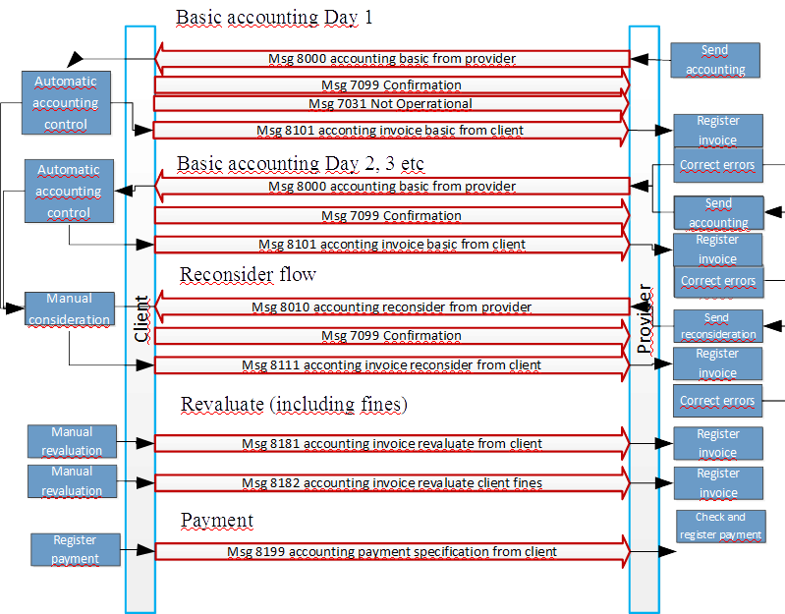

Observe that msg 7099 above has been specified only in a few of the different interactions. However it can be used in all interactions and it should be used as a technical acknowledgement if the processes are more batch oriented and the message are sent in a more online fashion.

#### Information content

The processes can easily be considered as sending files. If it is handled in such a way each file should only contain one message. The orgSender and orgReceiver should have been agreed in advance between the parties as for other SUTI communications.

Following general instructions regarding the content of the SUTI-elements should be followed in order for the communication to be considered as good use of SUTI.

**<msg>**

The attribute msgType decides in accordance with Flow chart above what type of message (”file”) that is sent. The specification of use is described in document Messages. Please note that msg 8000 shall only contain tours not yet accepted. To send an already accepted tour in msg 8000 shall result in error from client. On the other hand may a non-accepted (rejected) tour be sent many times (until it’s accepted or the Provider decides to treat the tour different.

A tour that is not accepted may also be sent in msg 8010. This is the msg that shall be used when the Provider considers that a reject is false or if the Provider has noted the tour for manual treatment. The process should be handled with restrictions as it normally results in a manual treatment and will therefore be more expensive to handle.

Following considerations should also be noted in msg-element

* idMsg, it holds the ”file-identity.” and should be kept and used in response
* infoTimeStamp shall exists hand shall hold the date of the ”youngest” tour in the msg. E.g. if file is sent daily it keeps the date of all the tours. Tours younger than the date shall be rejected with an error.
* referencesTo, shall hold the same value in an idMsg-element as the idMsg msg that it is a response to (as for other SUTI-msg’s. Please not that as well a 7099-msg as corresponding 8101-msg may hold this value, if the 7099-msg is used.
* account-element is mandatory

**<account>**

The msg will hold all remaining information in an account-element consisting of 5 elements

- an id idAccounting, where the value shall be decided by client. Only tours referring to this value of accounttype shall exist in msg.

- none, one or many tours inside the element tour

- the elements orgClient and orgProvider that shall hold necessary information regarding the Client and the Provider. The information shall hold the same type of quality as is requested in an invoicing process.

- a summary of the economic information for all tours presented inside the element economyReportAccounting. The element shall only consist of one element formOfPayment, which can hold several elements of type payment according to following rules

- msgs 8000 and 8010from Provider hold only one payment, that presents the requested total amount. This total shall be the sum of the payment for each tour. If the client finds that this is not true it shall return a msg 7030 Syntax Error instead of a msg 8101.

-the response msg from client 8101, 8111, 8181 and 8182 should contain two payment. One payment for the accepted tours and one for the rejected tours

- the msg 8199 contain one payment for each invoice paid

Each payment from provider including an accepted amount shall have an element idEkinfo having a src=”XX:InvoiceId” valu value=”invoiceno of client ” put in relevant information for each accounting. This id (or those id’s) will then also appear in msg 8199. XX is a SUTI-code for the client.

**<tour> (tur)**

This element is described in detail for each tour by provider while the client may only respond with referenceToTour, statusTour and economyReportTour for a tour. Each tour in a msg from provider shall be present in the response from the client. If not the provider shall send a msg 7030 as a response. (the msg is not presented in the Flow chart but is of course always a possible response option in all communications in SUTI)

The following is true regarding the responsibility to proceed in the invoicing process for a tour in Basic accounting.

- if the tour is rejected or not ready for accounting – provider has the

- if the tour is accepted – only client can revalidate the tour

- if the tour is in the Reconsideration process, i.e. set to validate by client or sent for reconsideration by provider – the responsibility is up to client to either accept or reject.

**<reterenceToTour>**

This element is mandatory for each tour. Id the tour has been submitted as an order by client it should contain the value of the idOrder that the tour has been sent as from client. The tour must have the value of the idOrder from the providers system. If the tour has been constructed in the providers system the values of the client’s idOrder must be present in suborderTour. The entire accounting is based on the value of the idOrder from the providers system. In case that the tour is constructed in the providers system and an idOrder is not present at start of accounting for a tour the client must add such an idOrder in the response. The combination of those two idOrder values is a unique combination in the accounting process.

It is the responsibility of the client and the provider to store the values of the identity and secure that they are not used in other tours in an accounting communication.

In case that the idOrder of the client is not know by Provider due to technical or or problems, the Provider ahall include the identity but set the value to zero (0).

**<statusTour>**

This element has three elements

1. idActivity, that is an element where src=”SUTI:idActivity” and the only values that must be used is listed in SUTI attribute list for idActivity. Following values (or their corresponding number) can be used  
   - invoice set by provider for a non-accepted tour  
   - accepted set by client when accounting for a tour is accepted  
   - rejected set by client when the accounting for a tour is rejected. The element idError must be present  
   - validate set by client when a tour is hold for revalidation  
   - revalidated set by client in the Revalidation process
2. idError of type id where src=”SUTI:idError” and any of the existing values in SUTI attribute list for idError can be used
3. manualDescriptionStatus, This is an element that can be used by provider and client to submit text regarding the tour. A possible use is for provider to submit more information in the msg 8010 (reconsideration). The element can used instead of an email-conversation. If it is used it should contain an infoTimeStamp to inform of the date and time the text was entered.

**<economyReportTour>**

This is the element that contain the economic information regarding the tour. At least one payment must be presented and it shall have the paymenttype with the value =1303 (account). It shall contain at least one vatAmountSpecification stating the value of the value added tax..

**<suborderTour>**

The recommendation is that the provider shall at least have one suborderTour for each tour. Inside this element the events of the suborder will be found. All information regarding the traveler (or other content) is also found i.e. requisition number and payment for social fee. It will also state the actual values of node-timing.

The addresses and times should always be the actual known from the providers system. The corresponding planned information it is assumed that the client knows from its own ordering system. All node addresses shall contain gps-positioning Only start and stop event must have other address-information regarding streets etc.

If there is an idOrder from client this information must be present.

To get a complete picture of the tour the information regarding the events must be collected from all suborders inside the tour. This mission is the responsibility of the client in order to get this complete picture.

Following events must be present in 8000 or 8010 msg’s.

1. start   
   Must include an eventContent. All present information regarding the content shall be present in this node e.g. a requisition number presented in an idContent. Payment of type socialfee shall be included in a payment in economyContent. If the content has other attributes these shall be present in attributeContent.  
   This event will hold actual values of pick-up address and pick-up time in eventAddress and eventTime. In case of several suborders some provider systems may only have one start event present. In such a case the content and start information for other suborders must be found in a passengerinvehicle event
2. stop  
   Contains actual delivery information for content. The same procedure as for start is possible. Stop may be replaced by passengerdropped at intermediate events.
3. acceptOrder  
   This event contains actual information of the time and position when the driver accepted the tour-mission. In case there are several suborders this event shall either be the same for all suborders or only be present in first suborder

These three events is best placed under eventTour, since they concerns the tour and is not specific to any content.

The provider system shall present all node events that exists without any restrictions. Following are examples of such events.

1. navigation  
   In case provider been ordered to have a navigation node.
2. vehicleatnode  
   To state when vehicle was on node
3. passengerinvehicle  
   Notification of information when a traveler has been registered as present in vehicle.
4. passengerdropped  
   Notification of information when traveler is registered as left the vehicle
5. noshow  
   To inform that traveler could not be found on pick-up address.

**<resourceTour>**

Information regarding vehicle and driver information is presented in this element

Regarding the vehicle the following elements shall be present

- idVechicle, this information shall be presented at least once with information regarding the internal number from the provider. However in some accounting other appearances may be necessary e.g. the national number (with src=”NO:idVehicle” (or corresponding with value= national licencenumber) or like in opgjör in Norway where the value of löyvenr must also be present (src ”NO:LöyveNummer”). In AttributesVehicle, should be presented the actual attributes that the provider has assigned the vehicle

- the elements taximeterType and taximeterSoftware should contain actual information regarding the taximeter

Regarding the driver following information shall be presented

- idDriver

- any attributeDriver

- the name of the driver in element name

**<calculationTour>**

This element consists of one or more elements of type calculationFare, each gives information regarding collected items from the taximeter or from the provider system.

Each calculationFare has a calculationType. Naming and source for this information is set by the provider but must be submitted to the client before first accounting. The client has the responsibility to map this information to useable items inside it system. The client must have accepted a new value before it may appear in an accounting.

For each calculationFare there are either a fixed amount (fixedPriceAmount) or a taximeterAmount. For taximeterAmount only values existing on the Nordic market can be presented. The provider shall without restrictions deliver such detailed taximeter information from its Please not that any start or stop information for the taximeter values is not stored in today’s system and cannot be presented

**<summaryReportTour>**

Used to give information regarding totals for duration and distance for the tour in the elements durationStart och distanceStart.

**<eventTour>**

There should only be three elements of this type. They hold information on the accept, start and stop of the tour. For furher information about events see general discussion eventSubOrder above.

### Direct accounting from client to provider

#### General

This accounting will be presented in more detail at launch of first such system. However the process has been designed and shall contain the structure you will find in Flow chart below.

It is based on the situation where the client has already sent information regarding the tour and also economic information in its ordering system. The process is always initiated by client. Normally such a msg 8102 will be a periodically msg containing all tours for a certain time period.

The information content may also differ from what has been described in Basic accounting, since it is based on information inside the client system.

#### Flow chart

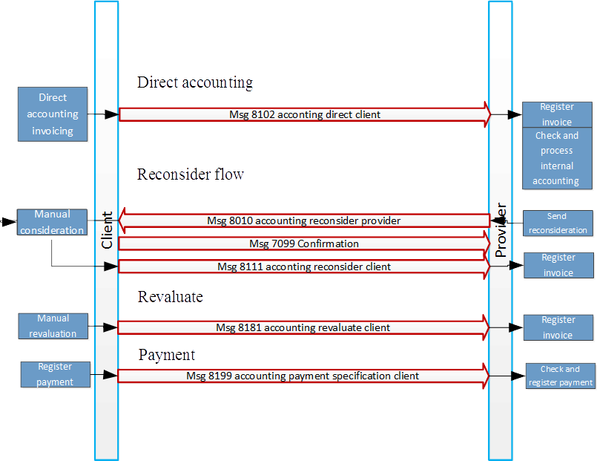

# Use of information elements

## General descriptions

### General use of information elements

Understanding and using of information has two aspects. One is obviously sending and receiving of a message.When, why and how to send messages to communicate information is described in chapter 2.

To understand and be able to fully use and treat a message the content must also be understanded.

This chapter will therefore concentrate on the content.

When building the SUTI standard it has been the ambition to reuse information elements in different situations and successively build an own standard of each information element.

This chapter is therefore dominated by a description of vital information elements in chapter 3.2. The list is prospected to be successively enlarged.

There ar however two different type of information elements that has had its own documentation in the SUTI standard. It is the id-elements and resource descriptions. These are of special interest. You will therefore find them deeply described in 3.1.2. and 3.1.3 below.

SUTI encourage use of international standards as far as it is possible. The use of the XML-structure has therefore been essential. AS far as it is possible also use of national and international sources is encouraged.

### ID (Identification elements) Structures and Usage in SUTI

#### Background

In SUTI there are a large number of different type instances that use Identification elements. There is a general ID-element (**idType**) that assure that all instances has the same structure. The parts are

Attribute **source**

This attribute is a description of the organisation and/or part of the organisation that keeps the original content of all possible values for the id. How to set **source** is described below.

Attribute **id**

This attribute hold one possible value from the source set above.

Attribute **unique**

This attribute has two possible values:

“Yes” tells that the **id** always uniquely identifies the same object.

“No” tells that several objects can have the same value. This may occur when the **id** is reused over time or that the **id** is applicable to several instances. One example of this may be that the id of a transport containing several orders is sent with the order. The **id** is not unique to the order.

There are many **idType**’s among the SUTI elements. We will not describe these here. We refer to the schema and the message-description for that. There are however one specific element **SUTIId** whose usage is described in detail below. If the usage of this element is not in correspondence with what is stated there the link can never be approved as a SUTI-link.

#### Rules for usage of attribute source

General sources

The value of the attribute **source** for the same source should obviously be the same wherever its used. In principle general type of sources like ISO, IATA etc should be preferred. In SUTI we have at present identified following general sources.

Links to referenced ISO standards

|  |  |  |
| --- | --- | --- |
| **Topic** | **Standard** | **Link** |
| Currency | ISO 4217 | <http://www.bsi-global.com/British_Standards/currency/index.xalter> |
| Language | ISO 639-2 | <http://www.loc.gov/standards/iso639-2/langcodes.html> |
| Country | ISO 3166-1 | <http://www.iso.org> |
| Time and Timezones | **ISO 8601** | <http://www.iso.org> |

For the attributes for description of different types of time we strongly emphasize use of “**ISO 8601” (**<http://www.iso.org>)**, even if these attributes are not of idType**

Member sources

The most vital idTypes are **idOrg**, used for **orgSender**, **orgReceiver** and **orgProvider**. Here you will find the description of a member or a partner to a member. These id’s should have a source “SUTI:idLink” if the values are set as the values of the link (“holmedal_hbgtaxi_001”) or be set with the structure “SUTI:idMember” (e.g. **source** “SUTI:holmedal” if the **id** is like “holmedal_hbgtaxi”). For description of **idLink** see full description below.

Each member in SUTI has its unique **idMember**, which is set when the member has been approved and paid. Each member keeps its own directory of its partners and systems.

A lot of sources derives from sources within the members organisation or partners to the member.

Some of these are very specific to the member e.g. I**dAgreement** and **idProduct**. There are no national or international sources to describe these id’s. Therefore the source must be some source by the member. A very natural way of expressing the source is ““idMember:idAgreement” and “idMember:idProduct”, e..g.”flygtaxi:idAgreement” and “flygtaxi:idProduct”. Unfortunately today the structure is not exactly like this. As long as the source is given like “idMember:somethingUniqueWithinTheMember” it will do until further, like “flygtaxi:Product”.

There are other examples of these type of sources which could be given by more than one **source** e.g. **idVehicle** and **idDriver**. These type of id’s could be described in two different ways, either from an internal source or from a general source. For idVehicle the **id** can be either the national registration number “ABC 123” or the internal number used by the provider “456”.

When using the internal id the **source** should be with the stucture “idMember:idPartner:idVehicle”, e.g. “holmedal:hbgtaxi:idVehicle”. Very many today use a structure like “holmedal_hbgtaxi_001:Vehicleno” for this purpose. There is a use of the “ValueOfAn_idLink:Vehicleno”. This is not incorrect but is in excess. The risk that there would be another source with the identical value is minimal.

When using national id’s these should refer to a national registry. In case these are a part of an international standardization unit the source should obviously be set as for general sources described above. In case these registries is just hold by a national organisation which could change over time we recommend use of more describing sources like “SE:idVehicle”, i.e. “National code ISO 3166-1:idVehicle”. SUTI will never allow any members to have idMember conflicting with the ISO 3166-1. Nor must not any use of such a shortening other than representing a national authority be set in conflict with ISO 3166-1. Thus this forms a good base for having these type of sources unique and the same for a long timeperiod. In Norway the same source is therefore is set as “NO:idVehicle”.

When setting the source to national sources for organisations or persons similarily use of “SE:idOrg” and “SE:idPerson” can be used.

#### SUTI Id Description

This section explains how to construct a complete SUTI Id and how to register a new SUTI link.

A SUTI Id is an important part of the SUTI link and the communication performed through the link. The SUTI Id is used to uniquely identify the Client and the Provider in a SUTI communication and give the Client system and the Provider system a tool to make sure that the other side is the correct side and it is the correct link that is used. This is very important if a system is using several links to one Client/Provider or to different Clients/Providers.

A SUTI-Id is built from 3 different parts:

1. The Id of the System supplier. This can be found in the document Memberids located at the SUTI member pages (<http://member.suti.se>). If the System Supplier is a new member of SUTI and haven’t had their Id distributed or issued, contact the Technical committee. If the System Supplier isn’t a member of SUTI an Id can not be issued until a the Supplier has become a member.

2. The Id of System owner (a partner to the member or a member itself). If the System Supplier is a new member of SUTI and haven’t had their Id distributed or issued, contact the Technical committee. If the System Supplier isn’t a member of SUTI an Id can not be issued until a the Supplier has become a member.

3. An Id that uniquely identifies this link at the Client’s or the Provider’s site.

These three are put together like this:

Id systemsupplier_Id System owner_unique Id

Example:

A SUTI link between a Netrevelation system at Netrevelation and an OTT system at Taxi Göteborg could look like this:

Netrevelation/Client

SUTI-ID:

Neterevelation_netrevelation_0001

Taxi Göteborg/Provider

SUTI-ID:

Ott_taxigbg_0001

Orgsender: netrevelation

Orgreciever: taxigbg

verSuti: 1.1.0

Orgsender: taxigbg

Orgreciever: netrevelation

verSuti: 1.1.0

### Resorce description

#### GENERAL

One of the most basic functions that must be standardized to get a SUTI-link to work, are how we describe the resources used for the transportation. If the Client doesn’t work with the same description of a vehicle that the Provider use, it’s impossible to send an order from the Client to the Provider with any possibility to provide a resource that is needed for the order. This document contains a way to describe resources needed to provide a transportation service.

Two major resources are used in order to provide a transportation service, a Vehicle and a Driver. This is the resources described in this document.

##### VEHICLE GENERAL

A vehicle has two sets of descriptions, Capacity and Attributes. Capacity describes the size of the vehicle, the number of passengers in the vehicle and attributes specifying a seat. Attributes specify functions and properties of the vehicle.

###### VEHICLE CAPACITY GENERAL

Many vehicles have the possibility to let the driver change the internal configuration very easily. This poses a problem if we shall be able to handle an order that demands a configuration that a vehicle can’t carry out in the normal configuration, but with very little effort, the driver can change the configuration of the vehicle to fit the demands in the order. We have a need for a description of the alternative configuration. This need for an alternative description gets even more important if we deal with orders involving travelers in wheelchairs or in stretchers.

Many of these vehicles have many combinations of seating and luggage space or seating and wheelchair space. A description of a vehicle that handles all the combinations of seat and space will be very extensive and too difficult to handle for both Client and Provider systems. To solve this problem we will deal with the possibility to have three descriptions of a vehicle: Normal, Alternative and Stretcher description. Normal will be the configuration a vehicle normally has. Alternative will be the configuration if all possibilities are used. Stretcher configuration will be the configuration that can handle a stretcher.

##### DRIVER GENERAL

A driver has only one set of descriptions: Attributes. Attributes of the driver specify skills and other properties of the driver.

#### SEATING PROPERTIES in VEHICLE

Three properties are used: Direction, Access and Legspace. A property for a seat can be F0C. The first character is the Direction ”F”, the second character is Access ”0” and the third character is Legspace ”C”.

##### DIRECTION

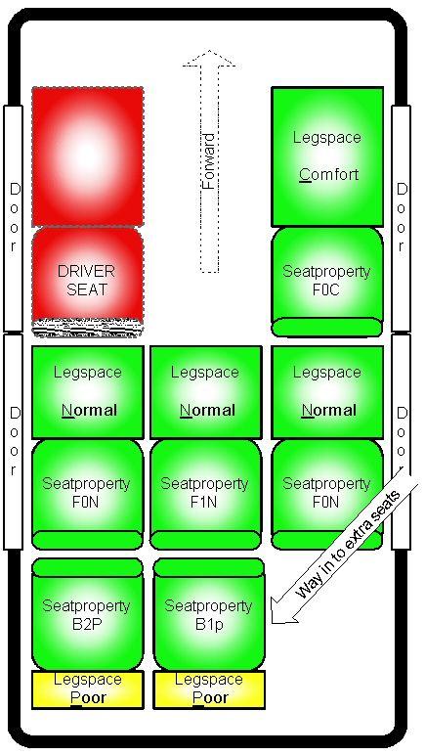

Figur 1 Seating properties in a vehicle

Indicates if the traveler will be facing Forward (”F”) or Backward (”B”) while seated in this seat.

##### ACCESS

Indicates how many sets the traveler has to pass over in order to reach his/her seat. This is indicated by a number from zero and up.

If it is a seat placed at a door in figure 1 the access property will be ”0”. If it's the middle seat in the back in figure 1 the access property will be ”1”. The left extra seat in figure 1 has the access property ”2” as the traveler have to pass over both the right back seat and the right extra seat.

##### LEGSPACE

Indicates the Legspace for the traveler while seated.

Comfort (”C”) = Good space, may be the seat beside the driver.

Normal (”N”) = Normal space, may be the seat behind the driver in a normal car.

Poor (”P”) = Very little legspace, may be an extra seat placed behind the normal back seat.

#### SEATING POSITION in VEHICLE

In certain orders the Client has a need to specify a certain seat in a vehicle. If the traveler has the need to sit in one of the front seat, the Client system must specify this to the Provider system in the order.

In order to facilitate this we have adopted a system derived from airline booking. The position of the seat is specified by a row and a place in that row. In order to specify a certain seat the Client system tells the Provider system in the order that a certain traveler shall be seated in a certain seat. This is done under the node section of the order message in which the pickup point of this traveler is specified. Here the client specify seat 1B, which mean that the traveler shall be seated next to the driver in the front seat.

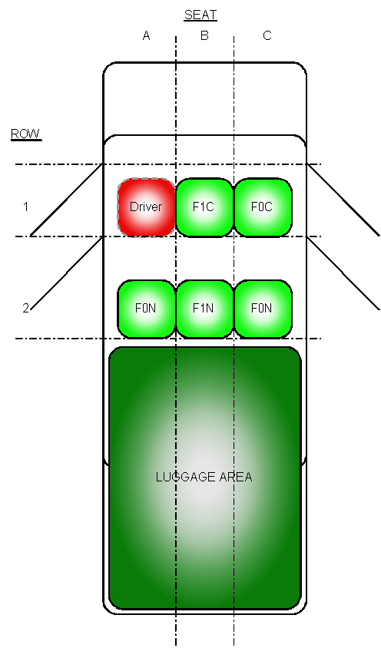

Figur 2 Seating cofiguration in vehicle

##### ROW

Row number is counted from the front toward the back of the vehicle. The first row is numbered 1, the second 2 and so on through the vehicle. This makes it possible to describe vehicles reaching from taxis through buses up to airplanes.

In row number 1 the seat reserved for the driver are not specified, to avoid booking this seat for passenger.

##### PLACE IN A ROW

Place are counted from left to right facing in a forward direction of the vehicle. Numbers are A,B,C and so on.

Place 1C in figure 2 will have the property F0C.

#### ATTRIBUTES on VEHICLE

Attributes on a vehicle specify functions and properties of the vehicle. A vehicle can have certain equipment required for special assignments or may be sanitized for travelers with allergies.

These attributes are managed by SUTI and kept in a public list for members to use.

#### ATTRIBUTES on DRIVER

Attributes on a driver can be special skills or education that the driver possesses. He may talk a certain language, he may have knowledge about first aid or CPR. Another attribute on a driver is if he/she has special security clearances for certain places such as airports, harbors or other restricted areas.

These attributes are managed by SUTI and kept in a public list for members to use.

#### EXAMPLE of CONFIGURATION

##### NORMAL CONFIGURATION



##### ALTERNATIVE CONFIGURATION

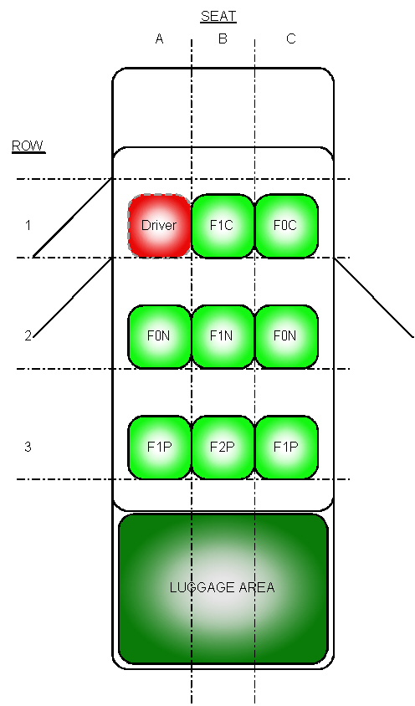

##### SPECIAL CONFIGURATION STRETCHER

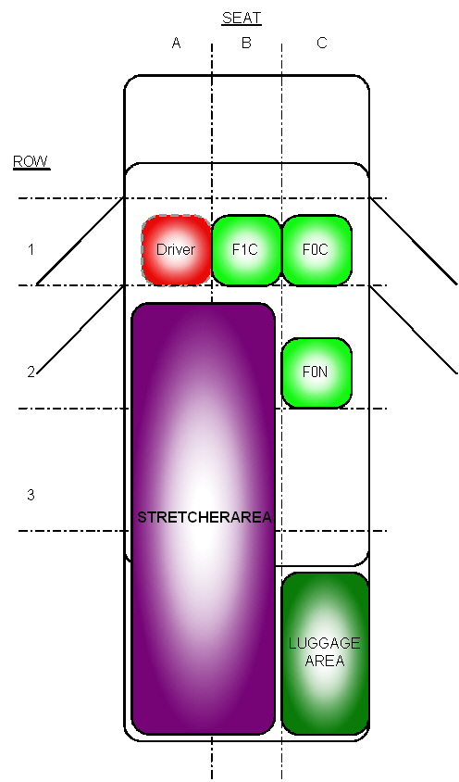

##### SPECIAL CONFIGURATION WHEELCHAIR

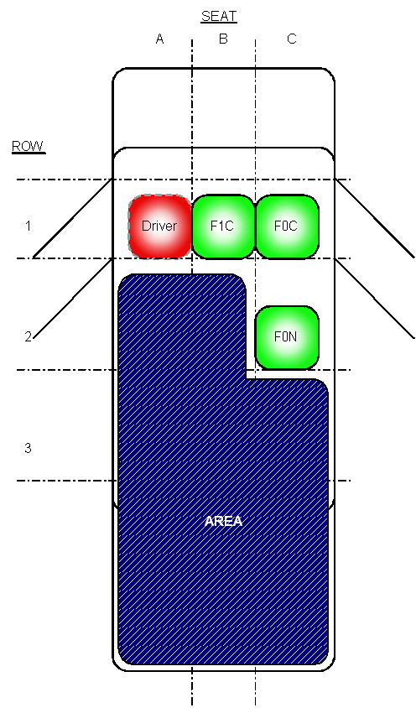

## List of Information elements

### Agreement

#### General

<agreement name="FLINK">

<idAgreement src="Flygtaxi:AGREEMENT" id="FLYGTAXI" unique="true" />

<product>

<idProduct src="Flygtaxi:PRODUCT" id="TAXI" unique="true" />

</product>

</agreement>

If idAgreement must be unique for each connected SUTI-link the source must refer to the complete link Id of this link (flygtaxi_flinksthlm_0001) and the range that contains agreementId at the client (AGREEMENT). But if idAgreement is unique within the Flygtaxi organization it’s possible to use the organizations SUTI id (Flygtaxi) and the range that contains agreementId at the client (AGREEMENT).

The same apply to idProducts. If idProducts must be unique for each connected SUTI-link the source must refer to the complete link Id of this link (flygtaxi_flinksthlm_0001) and the range that contains productId at the client (PRODUCT). But if idProducts is unique within the Flygtaxi organization it’s possible to use the organizations SUTI id (Flygtaxi) and the range that contains productId at the client (PRODUCT).

#### Minimum requirements

### idMsg

#### General

<idMsg src="flygtaxi_flinksthlm_0001:MSGID" id="2010081802070189" unique="true" />

If idMsg must be unique for each connected SUTI-link the source must refer to the complete link Id of this link (flygtaxi_flinksthlm_0001) and the range that contains messageId at the part that creates and sends the message (MSGID). But if idMsg is unique within the Flygtaxi organization it’s possible to use the organizations SUTI id (Flygtaxi) and the range that contains messageId at the part that creates and sends the message (MSGID).

#### Minimum requirements

### idOrder

#### General

<idOrder src="flygtaxi_flinksthlm_0001:MISSIONID" id="173438" unique="true" />

If idOrder must be unique for each connected SUTI-link the source must refer to the complete link Id of this link (flygtaxi_flinksthlm_0001) and the range that contains orderId at the client (MISSIONID). But if idOrder is unique within the Flygtaxi organization it’s possible to use the organizations SUTI id (Flygtaxi) and the range that contains orderId at the client (MISSIONID).

#### Minimum requirements

### infoTimeStamp

#### General

<infoTimeStamp>

<time timeAccuracy="1" timeZone="1" time="2010-08-18T08:02:26.29" timeType ="actual"/>

</ infoTimeStamp >

infoTimeStamp shall be used to timestamp the information that is sent in the message. It allows the provider for example to send a time with msg 5021 Requested Location telling at which time the location was valid. The timetype used shall be actual as it’s the actual time the information was valid.

#### Minimum requirements

### msgTimeStamp

#### General

<msgTimeStamp>

<time timeAccuracy="1" timeZone="1" time="2010-08-18T08:02:26.29" timeType ="actual"/>

</ msgTimeStamp >

msgTimeStamp shall be used to timestamp the sender’s creation of the message. The time type used shall be actual as it’s the actual time the message arrived.

#### Minimum requirements

### orgReceiver

#### General

<orgReceiver name="Stockholm Transfer">

<idOrg src="SUTI:idLink" id="tsys_flink_0001" unique="true" />

</orgReceiver>

The orgReceiver is the part that receives a certain message. This means that both Client and Provider can be orgReceiver depending on the message in question.

#### Minimum requirements

### orgSender

#### General

<orgSender name="Flink Stockholm">

<idOrg src="SUTI:idLink" id="flygtaxi_flinksthlm_0001" unique="true" />

</orgSender>

The orgSender is the part that sends a certain message. This means that both Client and Provider can be orgSender depending on the message in question.

#### Minimum requirements

### referencesTo

#### General

<referencesTo>

<idOrder src="**Holmedal_VejbyTaxi_0001:Bookings**" id="**117691-0**" />

<idOrder src="**trapezesoftware_Skånetrafiken_0002:BookingId**" id="**3872661**" />

<idMsg src="**trapezesoftware_Skånetrafiken_0002:MsgId**" id="**2009082411641113**" />

</referencesTo>

In a message that is being sent between Client and Provider referencesTo is used to indicate which order and which message that the sent message refers to. It’s a very good practice to use both the Clients idOrder and the Providers idOrder and at least the idMsg of the message that is being answered with this message. Another use of references To is to indicate that an order already has been sent to another Provider before it was sent to the Provider that just received it.

#### Minimum requirements

It is important that all SUTI systems comply with the use of <referencesTo> tag. The documentation for SUTI describes that at least these telegrams must use the tag <referencesTo>:

1020, 1021, 1022, 1023, 1024, 1025, 2000, 2001, 2002, 2003, 2010, 2011, 2012, 2013, 2030, 2031 2032, 2050, 3xxx, 4xxx, 5xxx, 6xxx

As a minimum, both Provider and Client in SUTI always include these elements in <referencesTo> tagged:

|  |  |
| --- | --- |
| <idOrder> | Reference for Provider SUTI idOrder |
| <idOrder> | Reference Client SUTI idOrder |
| <idMsg> | Reference to the idMsg being answered |

Has msg2030 (Order Forwarded) been used, one can further refer to <idOrderForward> from all systems that have received the order.

ReferencesTo tag may include several other elements. Use several elements when there is a need to specify information about the implementing party. Thus, telegrams 3xxx, 4xxx, 5xxx, 6xxx shall contain a reference to the Provider car which carry out the order via <idVehicle> element.

|  |  |
| --- | --- |
| <idVehicle> | Reference for Provider defined idVehicle |
| <idDriver> | Reference for Provider defined idDriver (tas eventuellt bort som minimum req. |

Note that both the Client and Provider must include all references in its communications.

*Client system must take note of idOrder and idVehicle from Provider system, and always include it with its own elements of <referencesTo>!*

Using elements <idRejectReason> or <idOrderStatus> there must be documentation of the values of the element can contain, and use only the values SUTI specification document.

|  |  |
| --- | --- |
| <idRejectReason> | Use of msg2002 (Order Reject). |
| <idOrderStatus> | Use of msg2531 (Order Status). |

(see, for example, referencesTo_example.xml)

### addressNode

#### General

The information in an address node is most vital for the operation between The Client and The Provider. The Client has the responsibility to provide the information with such a quality of the information that the Provider can fulfill the order without unnecessary treatment. Generally the Provider should automatically be able to do the following operations:

* Find suitable vehicle
* Allow driver/vehicle with information necessary to carry through without any further information including navigating to an address.

The Provider must have enough information in order to fulfill other obligations such as price setting and route planning etc.

It’s the Providers responsibility to check that the information is acceptable. In case the information is not acceptable the provider should always be able to reject the order returning reject reason 2515 addressinfonotsufficient

Below you find the structure of the address node including some good examples.

|  |  |
| --- | --- |
| addressName | Name of company or institution eg “Flygtaxi” |
| street | Street name eg “Drottningholmsvägen” |
| streetNo | Street number eg “37” |
| streetNoLetter | Sub number of a streetnumber eg “A” |
| location | Name of the city or part of the city eg “Stadshagen” |
| community | The municipality eg “Stockholms kommun” |
| postalNo | Postalcode eg “112 42” |
| country | The country eg “Sverige” |
| mapPage | Page containing the address in a map eg “123A4” |
| manualDescriptionAddress | Used to provide a further clarification of an address eg “Våning 1” |

#### Minimum requirements

At least one of either street in combination with streetNo and streetNoLetter or addressName shall be used.

A route description shall always be placed in manualDescriptionAddress, never in any other field.The fields street, streetNo and streetNoLetter shall be validated against an address database at the Client or an external database like Google or similar. The responsible part is the part that originally enters an address into the Client system or a pre system to the Client system

### geographicLocation

#### General

Iso standard: ISO 6709:2008

Resolution:

|  |  |
| --- | --- |
| Decimal degrees (55.123459) | Resolution |
| 1 | 100 km |
| 0.01 | 1 km |
| 0.001 * | 100 m |
| 0.0001 * | 10 m |
| 0.00001 * | 1 m |

*) A resolution of better than 100 meters is preferred, at least three decimals (0.001 decimal degrees).

#### Minimum requirements

A position must be specified for each address or navigation point so that it can be displayed in map or navigation software for the driver.

The format used shall be WGS-84 with decimal degrees.

*<geographicLocation lat=”58.39193” long=”13.42448” precision=”100”  typeOfCoordinate=”WGS-84” />*

### Event types

#### General

#### Minimum requirements

##### Event Type: 1701 invehicle (alt passengerinvehicle)

|  |  |
| --- | --- |
| Used in Msg | 4010 |
| Relation to | Node for pickup. |
| Description | This event is used to signal that the content has entered the vehicle at the pickup point. The signal shall be sent without delay after its triggered. Sent from Provider to Client. |
| Trigged by | Driver signals that the content has entered the vehicle by pressing a button or reading some type of id card presented by the content. |
| Used Timetype | Actual |
| Other demands |  |

##### Event Type: 1702 exitvehicle (alt passengerdropped)

|  |  |
| --- | --- |
| Used in Msg | 4010 |
| Relation to | Node for drop off. |
| Description | This event is used to signal that the content has left the vehicle at the end point. The signal shall be sent without delay after its triggered. Sent from Provider to Client. |
| Trigged by | Driver signals that the content has left the vehicle by pressing a button or reading some type of id card presented by the content. |
| Used Timetype | Actual |
| Other demands |  |

##### Event Type: 1703 noshow

|  |  |
| --- | --- |
| Used in Msg | 4010 |
| Relation to | Node for pickup. |
| Description | This event is used to signal that no content showed up. |
| Trigged by | Driver signals this by pressing a button or other device. |
| Used Timetype | Actual |
| Other demands | The behavior for the driver must be regulated either in a Self Declaration or a specific tender. |

##### Event Type: 1704 parcelinvehicle

This eventtype is equal to 1701 invehicle and we recommend the use of 1701 invehicle.

##### Event Type: 1705 parceldropped

This eventtype is equal to 1702 exitvehicle and we recommend the use of 1702 exitvehicle.

##### Event Type: 1706 action done

Use atnode och exitnode instead of action done?

|  |  |
| --- | --- |
| Used in Msg | 4010 |
| Relation to | Node for action |
| Description |  |
| Trigged by |  |
| Used Timetype |  |
| Other demands |  |

##### Event Type: 1707 navigationdone

Use atnode och exitnode instead of navigation done?

|  |  |
| --- | --- |
| Used in Msg |  |
| Relation to |  |
| Description |  |
| Trigged by |  |
| Used Timetype |  |
| Other demands |  |

##### Event Type: 1708 cancelatdoor

To be deleted! Use noshow instead or request a cancelation from provider!

|  |  |
| --- | --- |
| Used in Msg |  |
| Relation to |  |
| Description |  |
| Trigged by |  |
| Used Timetype |  |
| Other demands |  |

##### Event Type: 1709 vehicleatnode

|  |  |
| --- | --- |
| Used in Msg | 4010 |
| Relation to | All types of nodes. |
| Description | Signals that the vehicle has arrived at the node or is estimated to arrive at the node. |
| Trigged by | If the vehicle is at the node the driver signal this by using a button or other device in the vehicle. If it’s an estimated arrival at node either the driver or the provider system can send the signal. For the moment there are no standard how the signal shall be sent and who will send it. |
| Used Timetype | Actual, Estimated |
| Other demands |  |

##### Event Type: 1710 infotocontent

|  |  |
| --- | --- |
| Used in Msg | 4010 |
| Relation to | Node for pickup |
| Description | Signals that the provider has sent information to the content. |
| Trigged by | Provider system |
| Used Timetype | Actual time |
| Other demands |  |

##### Event Type: 1711 dispatchconfirmationsent

Ev som 1710

|  |  |
| --- | --- |
| Used in Msg | 4010 |
| Relation to |  |
| Description |  |
| Trigged by |  |
| Used Timetype |  |
| Other demands |  |

##### Event Type: 1712 delayconfirmationsent

Som 1710.

|  |  |
| --- | --- |
| Used in Msg | 4010 |
| Relation to |  |
| Description |  |
| Trigged by |  |
| Used Timetype |  |
| Other demands |  |

##### Event Type: 1713 arrivalconfirmationsent

|  |  |
| --- | --- |
| Used in Msg | 4010 |
| Relation to |  |
| Description |  |
| Trigged by |  |
| Used Timetype |  |
| Other demands |  |

##### Event Type: 1714 start

Uppdraget påbörjats.

|  |  |
| --- | --- |
| Used in Msg | 80xx |
| Relation to | Tour |
| Description |  |
| Trigged by |  |
| Used Timetype |  |
| Other demands |  |

##### Event Type: 1715 stop

|  |  |
| --- | --- |
| Used in Msg | 80xx |
| Relation to | Tour |
| Description |  |
| Trigged by |  |
| Used Timetype |  |
| Other demands |  |

##### Event Type: 1716 acceptOrder

|  |  |
| --- | --- |
| Used in Msg | 80xx |
| Relation to | Tour |
| Description |  |
| Trigged by |  |
| Used Timetype |  |
| Other demands |  |

##### Event Type: 1717 vehicleexitNode

|  |  |
| --- | --- |
| Used in Msg | 4010 |
| Relation to | All types of nodes. |
| Description |  |
| Trigged by |  |
| Used Timetype |  |
| Other demands |  |

# Technical issues

## Communication

The most efficient way to communicate between Client and Provider is to use two way socket communications where the Provider will be server for communication Client – Provider and the Client will be server for communication Provider – Client.

It is important that the communication between Client and Provider can handle messages that is a part of the SUTI standard but not handled by this particular Client or Provider without error or stop. Instead MSG 7030 or MSG 7031 shall be used to inform the other part that this message is part of the set of SUTI messages that this system handle.

# Alterations

## Rev 1 2011-06-23

Chapter 3 Msg 6500 and associated messages added.

## Rev 2 2012-03-02

Chapter 2 Use Cases added.

Earlier chapter 2 and 3 moved to chapter 3 Specific Use Cases in detail

## Rev 3 2012-03-16

Section 2.1 Order flow altered. Headers General, Recommended solution, Flow chart and Use of referencesTo has been added.

Order irregularities Client and order irregularities Provider has been altered to Order events Client and Order events Provider.

Sections for Best Practice have been added. These sections have been moved from document SUTI_2012_Messages.doc.

## Rev 4 Version 2013 2012-10-30

Section 2.1.6 to 2.1.9 added.

Section 2.2.4 added.

Section 3.8 extended.

Section 3.9 and 3.10 added.

## Rev 5 Version 2013 2013-03-04

Flow charts added in section 2.

## Rev 6 Version 2013.1 2013-05-29

Chapter 2.3.2 Order alterations has been updated.

## Rev 7 Version 2014.1 2015-01-09

Chapter 2.5 Oppgör added.

## Rev 8 Version 2015-2015-04-13

Alterations moved to end of document.

Chapter 1, Use Cases general Description and Use, added.

Section 5.1 Flagstops moved to 2.3.

Section 5.2 Delivery note and associated messages moved to 2.4

Section 2.5 Accounting added.

## Rev 9 Version 2015. 2015-09-08

Document ID_Structures has been inserted in Use Cases.

Document LinksToISOStandars has been inserted in Use Cases.

Document ResourceDescription has been inserted in Use Cases.

Description of EventTypes has been added to Use Cases.

Chapter 3 has bveen altered.

## Rev 10 Version 2016. 2016-02-26

Chapter 2.1.1.12 Order Forwarded has been added.

Chapter 3.2.8.2 has been altered. Reference to idOrderForward has been added.

Chapter 2.5 has been altered. Message 8182 has been added.