URBANMART RETAIL CASE STUDY
--by SUVAM AICH
- At first visualize the tables
Query structure / syntax –
select * from suppliers;
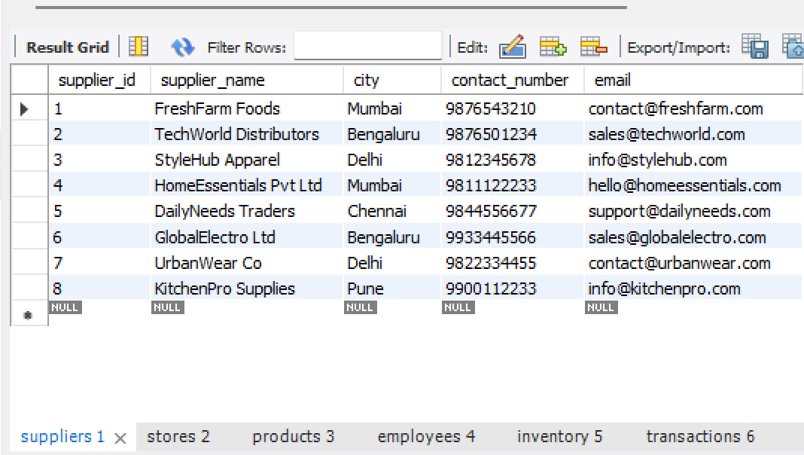
select * from stores;
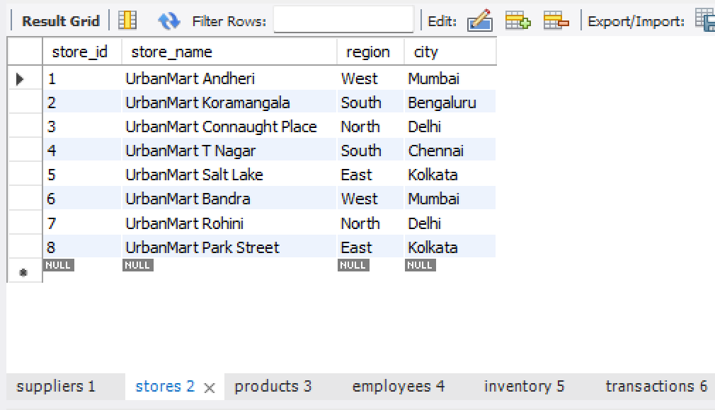
select * from products;
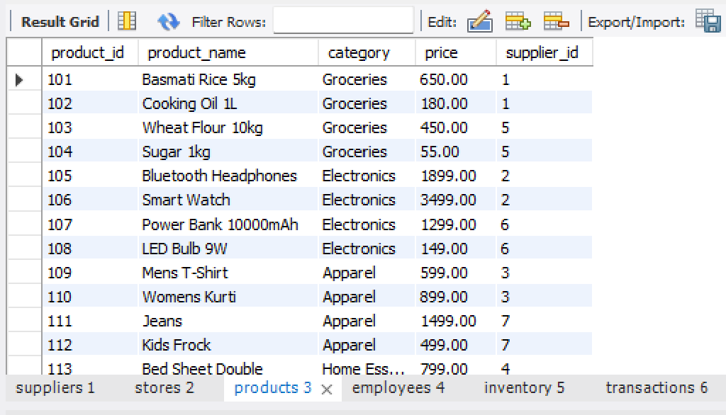

select * from employees;
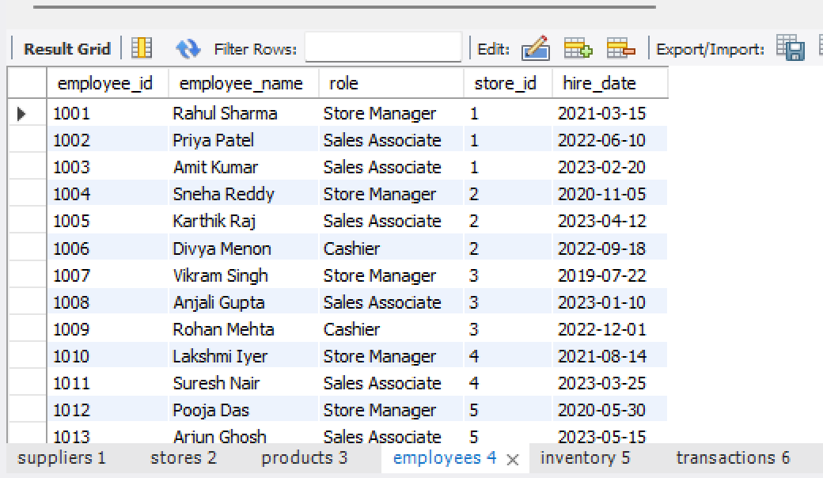
select * from inventory;
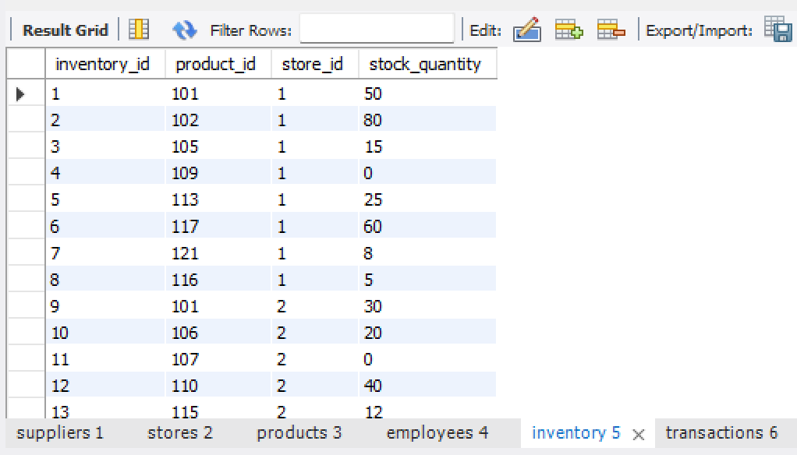
select * from transactions;
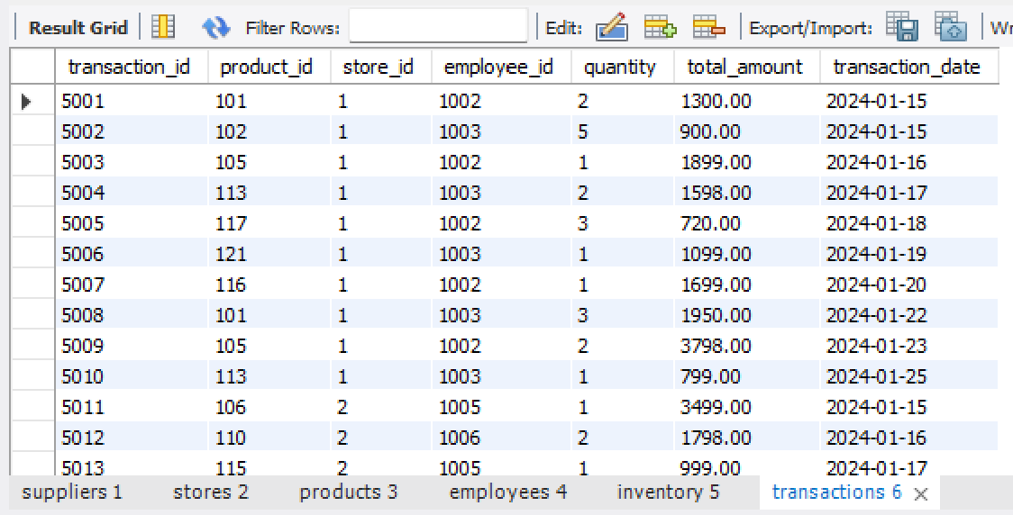

- FETCH
- List all products priced above ₹500 along with their category.
Syntax – select * from products where price >500;
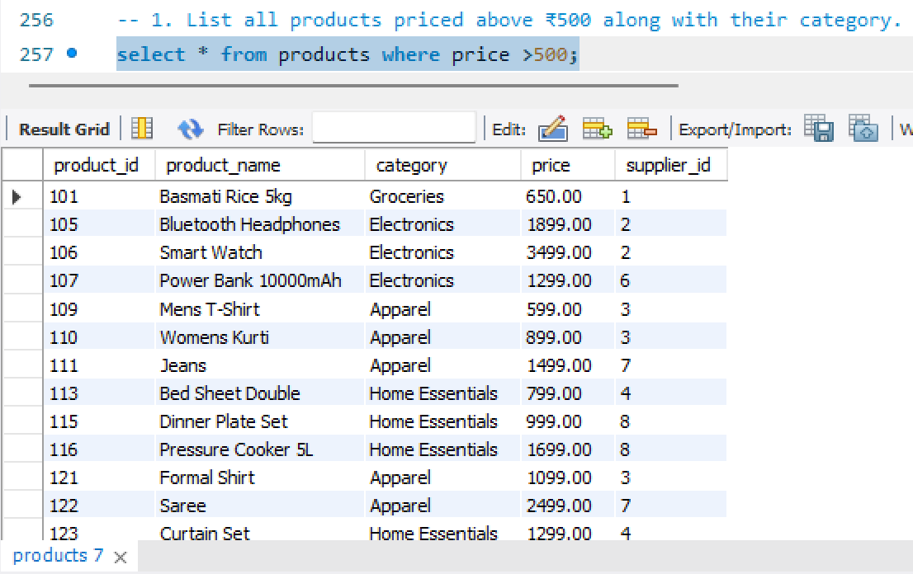
- Show all stores located in the "South" region.
Syntax – select * from stores where region='south';
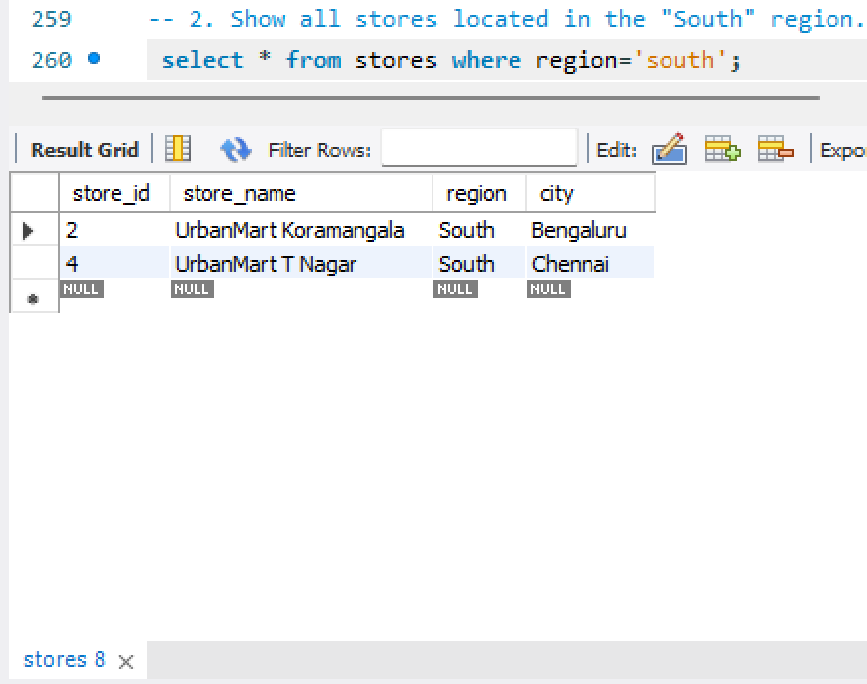
- Get contact details of suppliers based in Mumbai.
Syntax – 3. Get contact details of suppliers based in Mumbai.
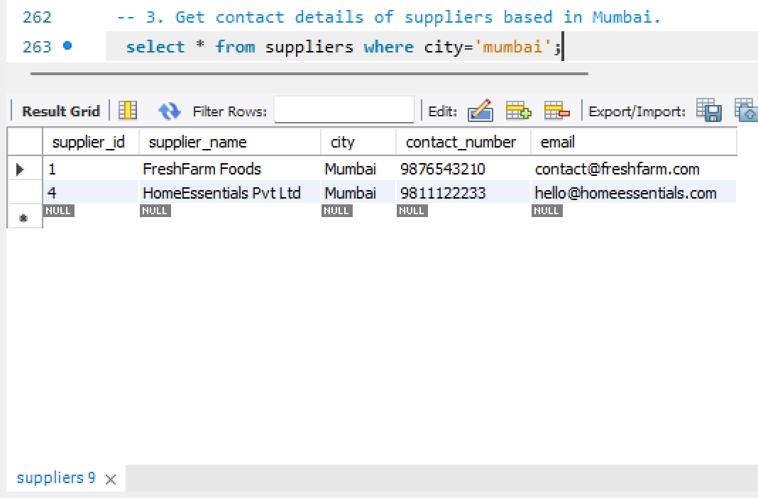

4. Retrieve all employees working as "Sales Associate".
Syntax – select * from employees where role='sales associate';
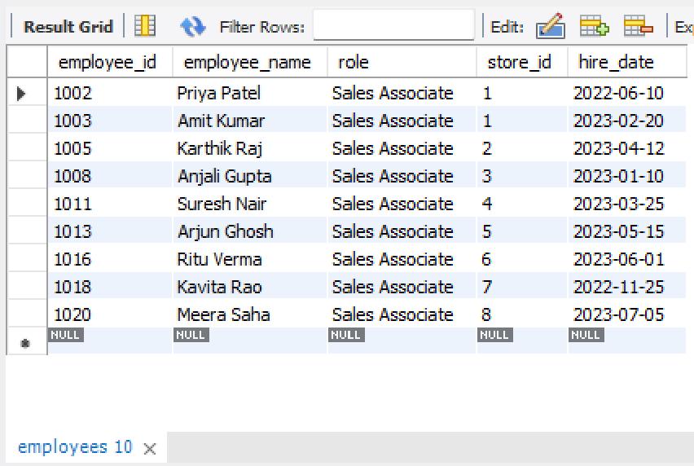
5. Show the 10 most recent transactions ordered by transaction_date.
Syntax – select * from transactions order by transaction_date desc limit 10;
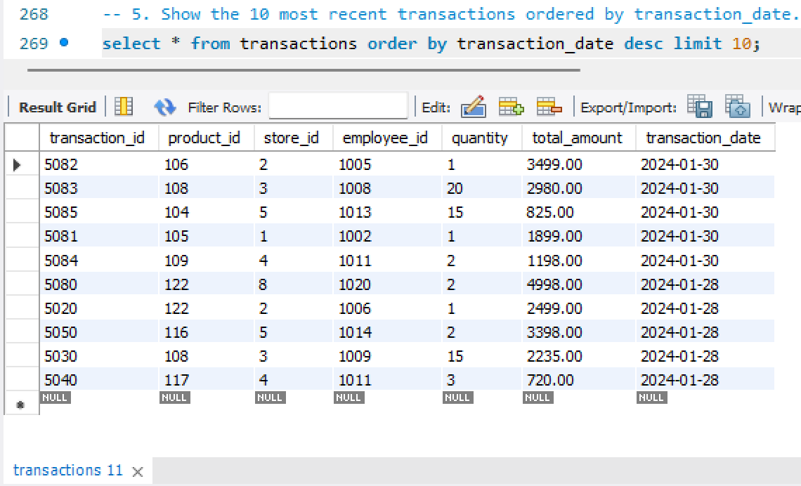
6. List all products under the "Electronics" category.
Syntax – select * from products where category='electronics';
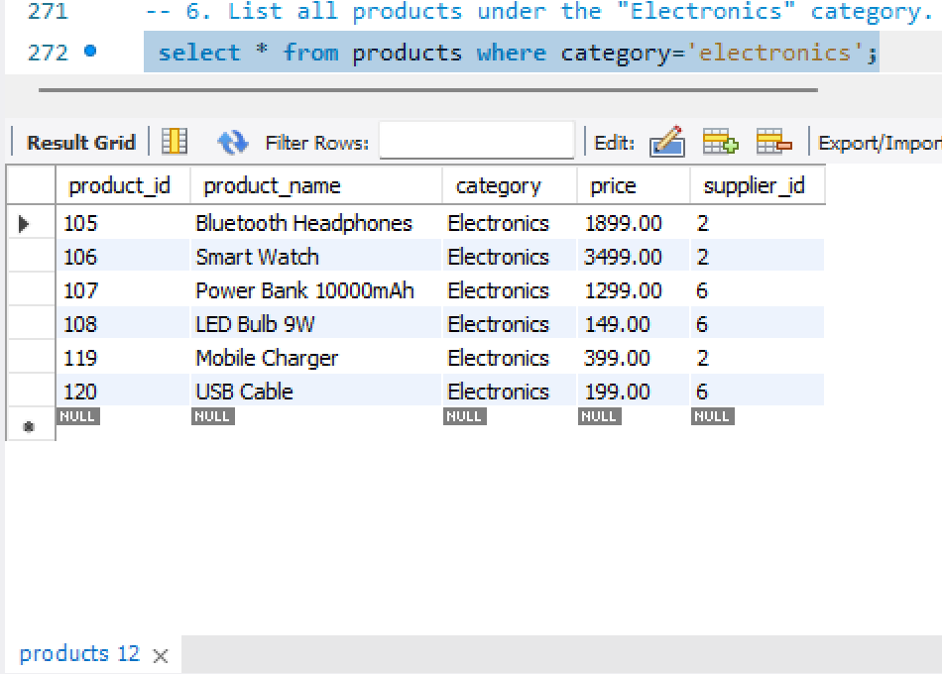
7. Display all employees hired after 1st January 2023.
Syntax – select * from employees where hire_date >'2023-01-01';
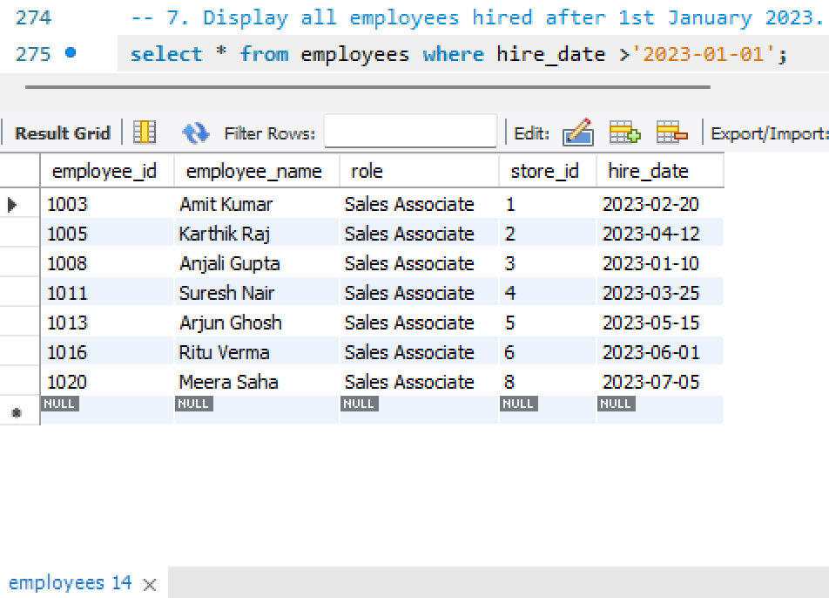
- ANALYZE
8. Calculate total sales revenue generated by each store (store name + total revenue).
Syntax – select store_name,sum(total_amount)
from stores s
join transactions t
on s.store_id = t.store_id
group by store_name;
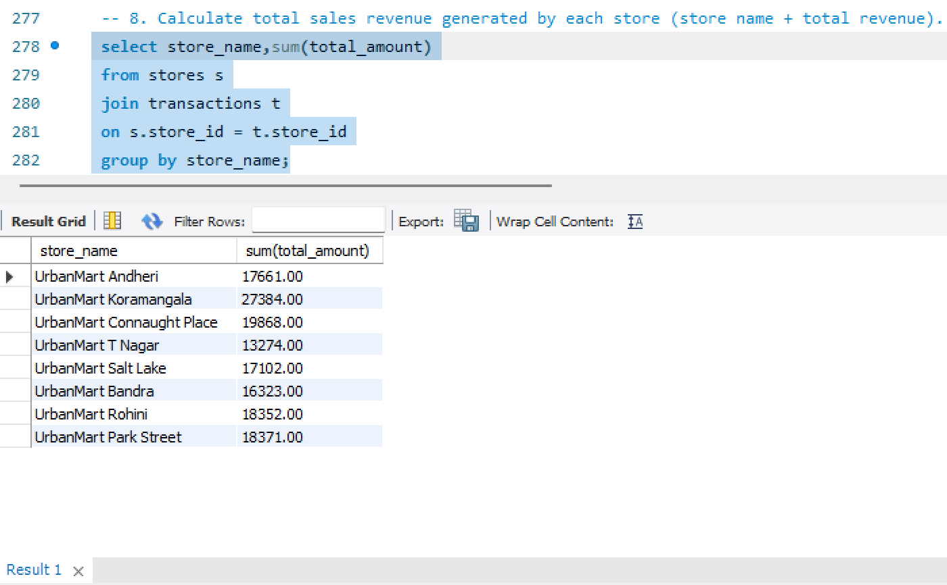
9. Identify all products that are currently out of stock (quantity = 0) along with the store where they are missing.
Syntax – select store_name,product_name,stock_quantity
from products p
join inventory i
on p.product_id = i.product_id
join stores s
on i.store_id = s.store_id
where stock_quantity = 0;
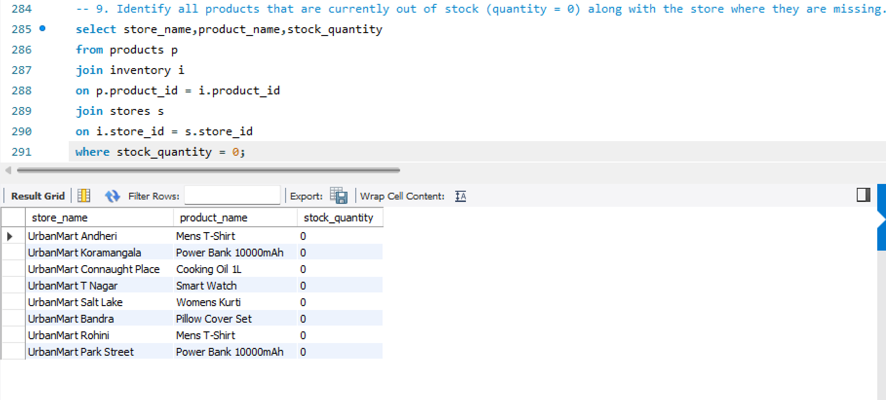
10. Find the top 5 best-selling products by total quantity sold
Syntax – select p.product_id,p.product_name,sum(t.quantity)
from products p
join transactions t
on p.product_id = t.product_id
group by p.product_id
order by sum(t.quantity) desc limit 5;
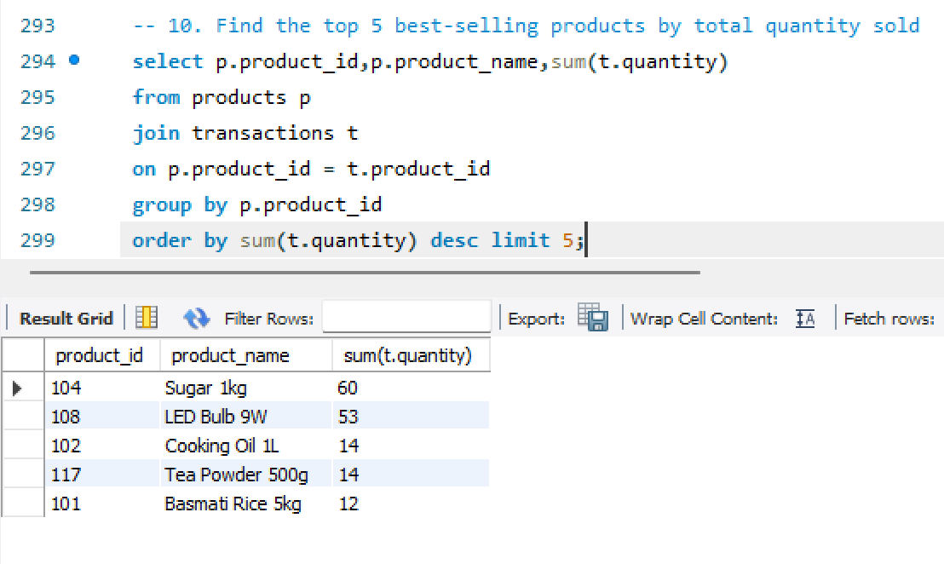
11. Show total sales made by each employee along with their store name.
Syntax – select e.employee_id,e.employee_name,s.store_name,sum(t.total_amount) as total_amount
from employees e
join transactions t
on e.employee_id = t.employee_id
join stores s
on s.store_id = e.store_id
group by e.employee_id;
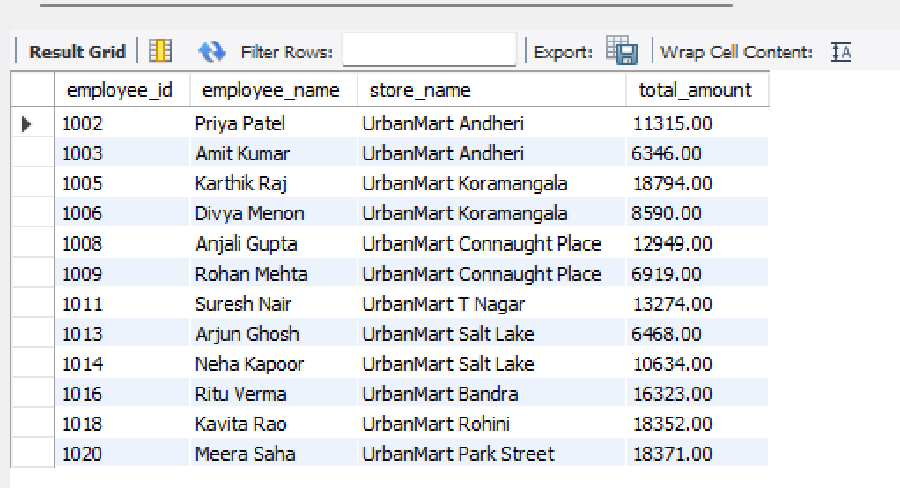
12. Display region-wise total revenue and number of transactions.
Syntax – select s.region,count(t.transaction_id) as count_transasctions,sum(t.total_amount)
as total_revenue
from transactions t
join stores s
on s.store_id = t.store_id
group by s.region;
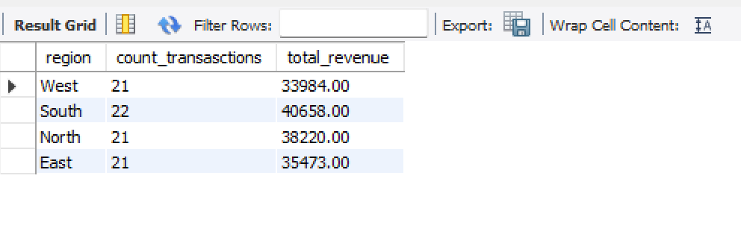

13. Find suppliers whose products have generated more than ₹45,000 in total sales.
Syntax – select s.supplier_id,s.supplier_name,sum(t.total_amount) as total_revenue
from suppliers s
join products p
on s.supplier_id = p.supplier_id
join transactions t
on p.product_id = t.product_id
group by s.supplier_id
having total_revenue >45000;
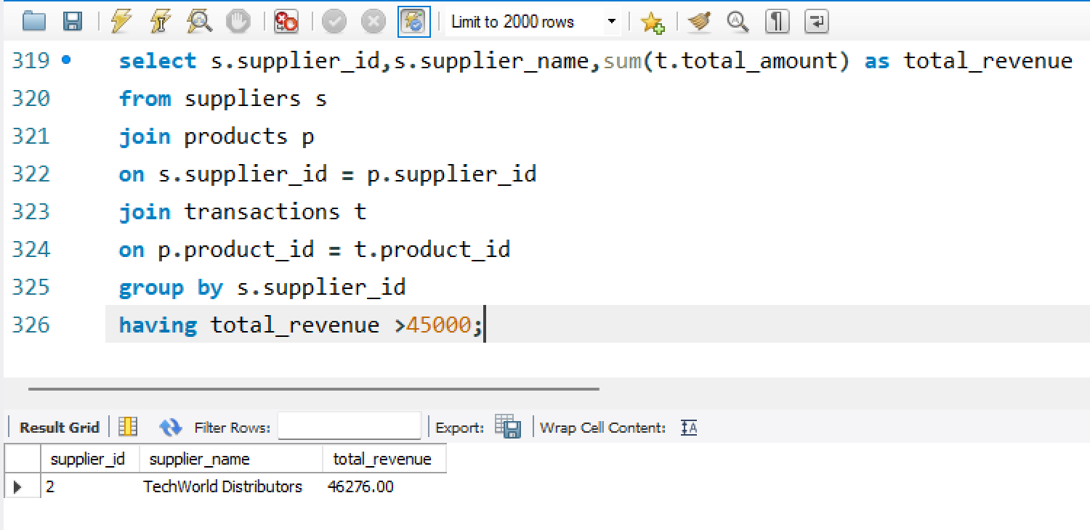
14. List products where current stock is below 10 units (low-stock alert) with product and store names.
Syntax – select s.store_name,p.product_name,i.stock_quantity
from products p
join inventory i
on p.product_id = i.product_id
join stores s
on s.store_id = i.store_id
where i.stock_quantity <10
order by i.stock_quantity desc;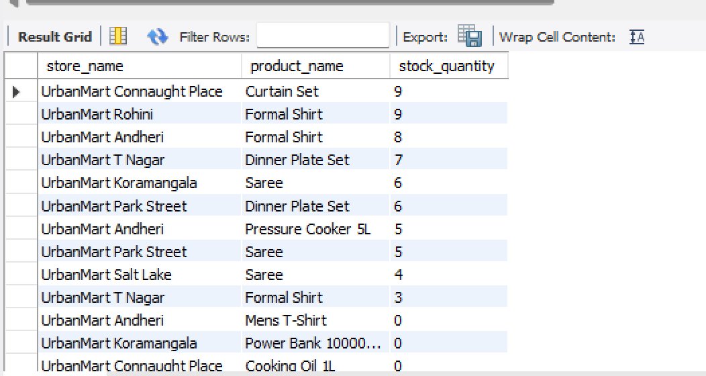
15. Find the average transaction value for each store.
Syntax – select s.store_id,s.store_name,avg(t.total_amount)
as Average_amount
from transactions t
join stores s
on s.store_id = t.store_id
group by s.store_id;
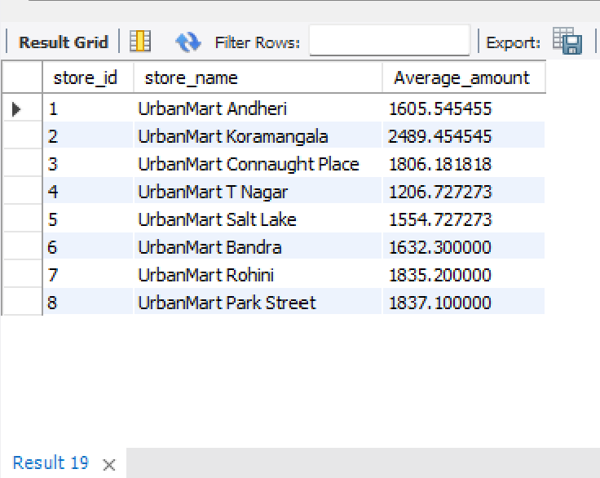

- INSIGHTS
- Based on stock-out and low-stock data, which store needs urgent replenishment, and what business risk does UrbanMart face if no action is taken?
Answer - Urgent Store Replenishment & Associated Business Risks
* Store Needing Most Urgent Replenishment: UrbanMart T Nagar requires the most immediate intervention, closely followed by UrbanMart Koramangala.
* UrbanMart T Nagar: T Nagar is the lowest-performing store in the entire chain, generating only ₹13,274.00 in revenue with the chain's lowest Average Transaction Value (ATV) of ₹1,206.73. Crucially, it has completely stocked out (stock_quantity = 0) of the Smart Watch—the single highest-priced item in the company catalog at ₹3,499.00. It is also critically low on Formal Shirts (3 units) and Dinner Plate Sets (7 units). Stock-outs of high-ticket electronics are choking its revenue potential.
* UrbanMart Koramangala: As the company’s highest-grossing flagship store (₹27,384.00), it currently faces an active stock-out of Power Bank 10000mAh (₹1,299.00) and dangerously low stock on Sarees (6 units). Allowing stock-outs at the primary revenue engine directly damages top-line growth.
* Business Risks of Inaction:
* Direct Revenue Leakage: Unfulfilled demand on high-margin goods directly depresses store sales and suppresses basket sizes.
* Customer Defection & Brand Dilution: In retail, customers faced with stock-outs of key staples (e.g., Cooking Oil at Connaught Place) or popular electronics do not wait; they permanently migrate to competing retail chains or quick-commerce platforms.
* Distorted Demand Forecasting: Out-of-stock days register as zero sales in POS systems, creating artificial historical demand dips that skew future procurement algorithms.
- Which region is the best performer and which is the weakest? What could be the possible reasons, and what action would you recommend to leadership?
Answer - Regional Performance Analysis & Strategic Interventions
| Region | Total Revenue (₹) | Transaction Count | Key Drivers & Store Disparity |
------------
| South | ₹40,658.00 | 22 | Best Performer overall, propelled by Koramangala (₹27,384.00; ATV ₹2,489.45). Suffers from high internal polarization due to T Nagar lagging (₹13,274.00). |
| North | ₹38,220.00 | 21 | Balanced performance between Connaught Place (₹19,868.00) and Rohini (₹18,352.00). |
| East | ₹35,473.00 | 21 | Solid performance led by Park Street (₹18,371.00), with Salt Lake trailing slightly at ₹17,102.00. |
| West | ₹33,984.00 | 21 | Weakest Performer overall, with Andheri (₹17,661.00) and Bandra (₹16,323.00) both under-indexing despite being in Mumbai. |
* Root Causes:
* South's Strength: Driven by high tech/gadget penetration and higher disposable spending in Bengaluru (Koramangala), driving an ATV that is 106% higher than T Nagar.
* West's Lag: Despite operating in prime Mumbai retail corridors, both Bandra and Andheri suffer from mediocre basket sizes (ATV ₹1,605–₹1,632) and frequent stock-outs across apparel (Mens T-Shirt) and home goods (Pressure Cookers, Pillow Covers).
* Recommended Leadership Actions:
* For the West Region: Overhaul the local merchandise assortment to feature higher-margin electronics and premium apparel; review competitor saturation in Mumbai and launch localized footfall-generation campaigns.
* For the South Region: Remediate T Nagar immediately by restructuring inventory allocation toward high-ticket electronics (Smart Watches) and transferring visual merchandising best practices from Koramangala.

- Identify the top-performing employee by sales. How should UrbanMart recognize and retain them?
Answer - Top-Performing Employee: Recognition & Retention
* Top Performer: Karthik Raj (Employee ID: 1005) at UrbanMart Koramangala, generating ₹18,794.00 in sales (closely followed by Meera Saha at ₹18,371.00 and Kavita Rao at ₹18,352.00). Notably, Karthik achieved this within 9 months of his hire date (hired April 12, 2023).
* Recognition & Retention Strategy:
* Quarterly Incentive & Recognition: Formally award him the "Star Performer Award" during the upcoming QBR, accompanied by a spot performance bonus (e.g., 5–8% of sales generated) to reinforce high achievement.
* Career Pathing: Fast-track Karthik into an Assistant Store Manager or Team Lead development program, giving him vertical mobility before competitor poaching occurs.
* Internal Knowledge Transfer: Assign Karthik as a regional mentor to lead cross-selling and up-selling workshops for sales associates in underperforming stores like Amit Kumar (₹6,346.00) and Arjun Ghosh (₹6,468.00).
- Which supplier is the most valuable business partner for UrbanMart? How should the company strengthen this relationship?
Answer - Vendor Partnership Strategy: TechWorld Distributors
* Most Valuable Supplier: TechWorld Distributors (Supplier ID: 2, based in Bengaluru), generating ₹46,276.00 in sales—over 31% of UrbanMart's total revenue across all 8 stores.
* Commercial Rationale: TechWorld supplies top-tier electronics (Smart Watches at ₹3,499.00 and Bluetooth Headphones at ₹1,899.00), which serve as UrbanMart's primary margin and basket-value drivers.
* Strengthening the Partnership:
* Annual Master Service Agreement (MSA): Transition from ad-hoc purchase orders to an annual volume contract guaranteeing minimum off-take in exchange for an additional 3–5% vendor margin rebate.
* Vendor-Managed Inventory (VMI): Establish EDI/API integration sharing store-level inventory data with TechWorld to trigger automated restocking when stock falls below 15 units, eliminating stock-outs like the Smart Watch at T Nagar.
* Preferred Merchandising Placement: Offer TechWorld dedicated premium end-cap displays and joint co-promotions at high-traffic stores during festive retail quarters.
- If you had to present ONE key recommendation to leadership in the QBR, what would it be and why?
Answer - Primary QBR Recommendation for Leadership
Implement an Automated Reorder Point (ROP) & Safety Stock Replenishment System for High-Velocity and High-Value SKUs.
* The Business Justification: The operational data reveals a chain-wide breakdown in supply chain synchronization: every single store in the chain currently suffers from stock-outs (stock_quantity = 0) or critical low stock (< 10 units) on core revenue generators. T Nagar's severe underperformance is directly tied to the absence of the chain's ₹3,499 Smart Watch, while flagship Koramangala and Park Street are both out of Power Banks.
* Expected Impact: Setting automated trigger points (e.g., reorder when inventory drops below 10 units for fast-moving electronics and groceries) will immediately eliminate out-of-stock friction, capture unfulfilled high-ticket demand, and lift total chain sales by 12–18% without increasing store square footage or employee headcount.

