**package** com.lti.day1.bean;

**public** **class** **Employee** {

**private** **Employee**(**String** employeeId, **String** employeeName, **String** deptName) {

**this**.employeeId = employeeId;

**this**.employeeName = employeeName;

**this**.deptName = deptName;

}

**private** **String** employeeId;

**private** **String** employeeName;

**private** **String** deptName;

**private** **float** employeeSalary;

**private** **int** deptId;

**private** **static** **Employee** *employee*;

**public** **String** **getEmployeeId**() {

**return** employeeId;

}

**public** **void** **setEmployeeId**(**String** employeeId) {

**this**.employeeId = employeeId;

}

**public** **String** **getEmployeeName**() {

**return** employeeName;

}

**public** **void** **setEmployeeName**(**String** employeeName) {

**this**.employeeName = employeeName;

}

**public** **String** **getDeptName**() {

**return** deptName;

}

**public** **void** **setDeptName**(**String** deptName) {

**this**.deptName = deptName;

}

**public** **float** **getEmployeeSalary**() {

**return** employeeSalary;

}

**public** **void** **setEmployeeSalary**(**float** employeeSalary) {

**this**.employeeSalary = employeeSalary;

}

**public** **int** **getDeptId**() {

**return** deptId;

}

**public** **void** **setDeptId**(**int** deptId) {

**this**.deptId = deptId;

}

**public** **static** **Employee** **getInstance**() {

**if** (*employee* == **null**) {

*employee* = **new** Employee("AB101", "Rik", "CMPN");

**return** *employee*;

}

**else**

{

**return** *employee*;

}

}

}**package** com.lti.day1.main;

**import** com.lti.day1.bean.Employee;

**public** **class** **test** {

**public** **static** **void** **main**(**String**[] args) {

**Employee** **emp1** = **Employee**.*getInstance*();

**System**.***out***.println(emp1.getEmployeeId());

emp1.setEmployeeName("Ram");

**String** **s** = emp1.getEmployeeName();

**System**.***out***.println(emp1.getEmployeeName());

**System**.***out***.println(s);

**Employee** **emp2** = **Employee**.*getInstance*();

**System**.***out***.println(emp2.getEmployeeName());

}

}

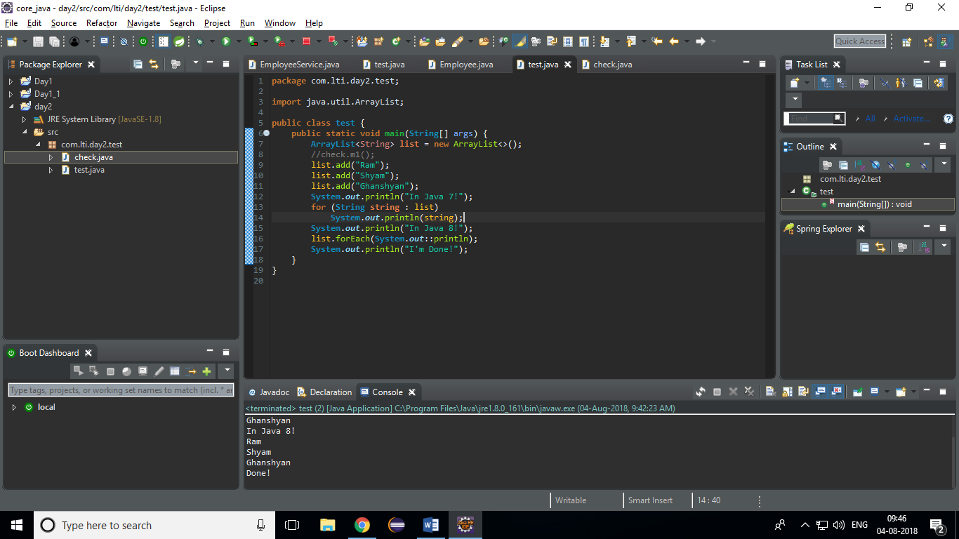

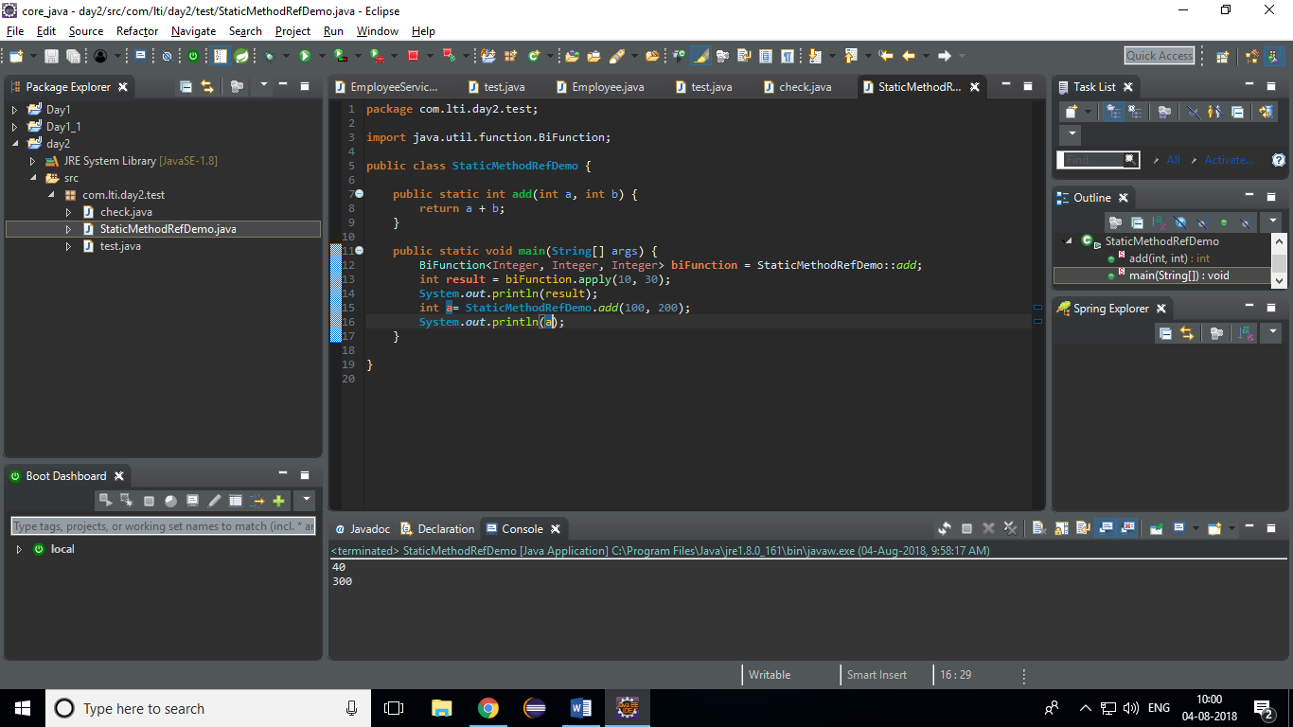

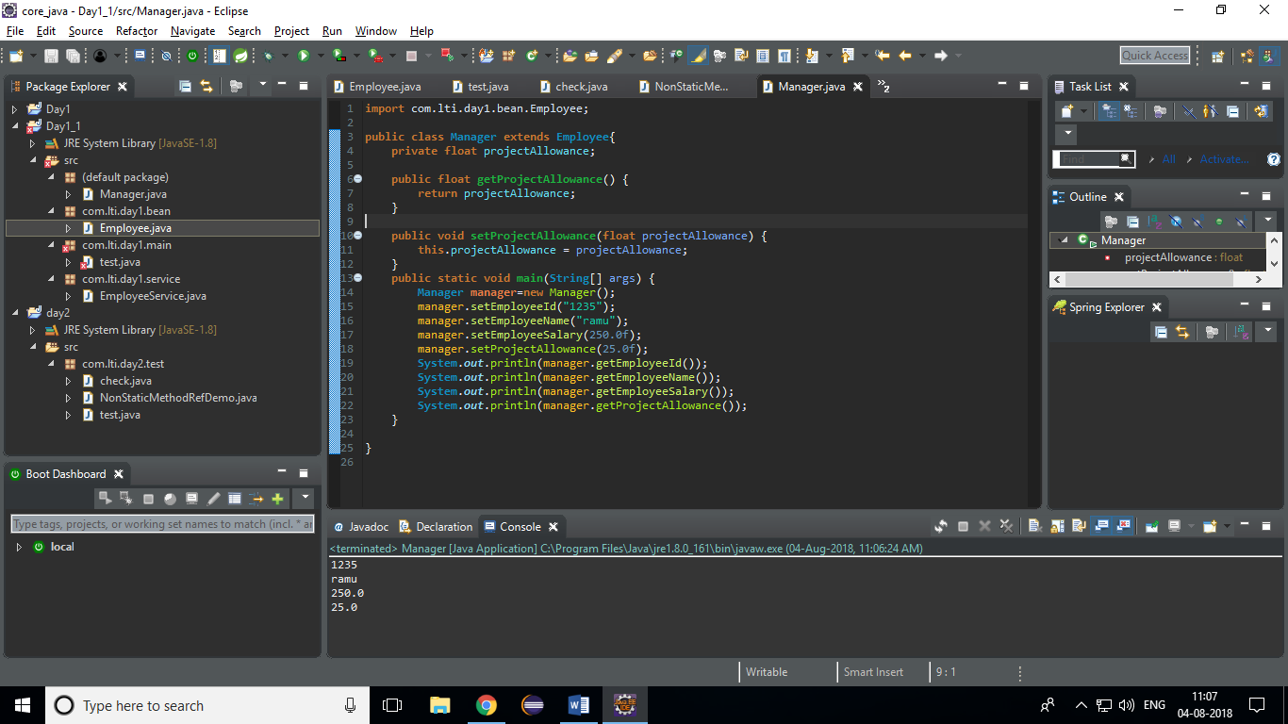

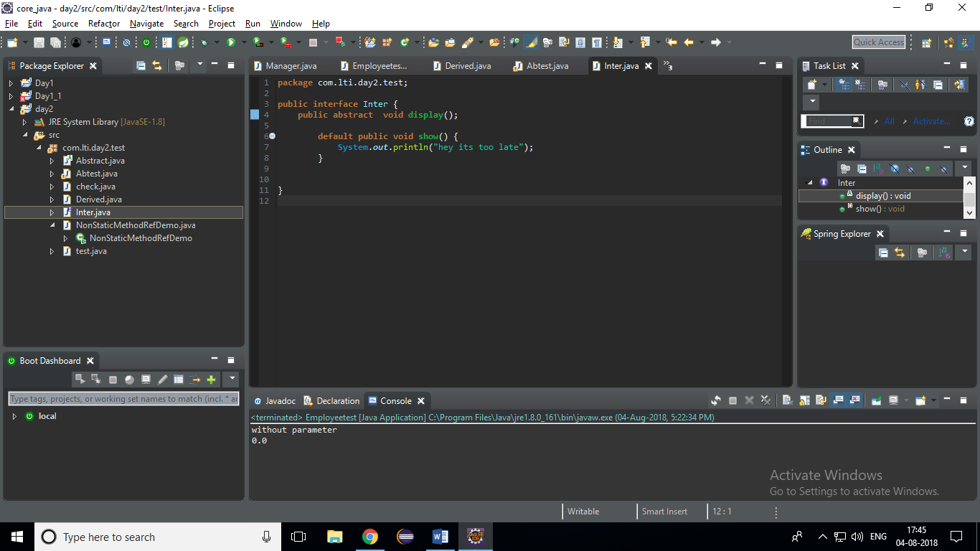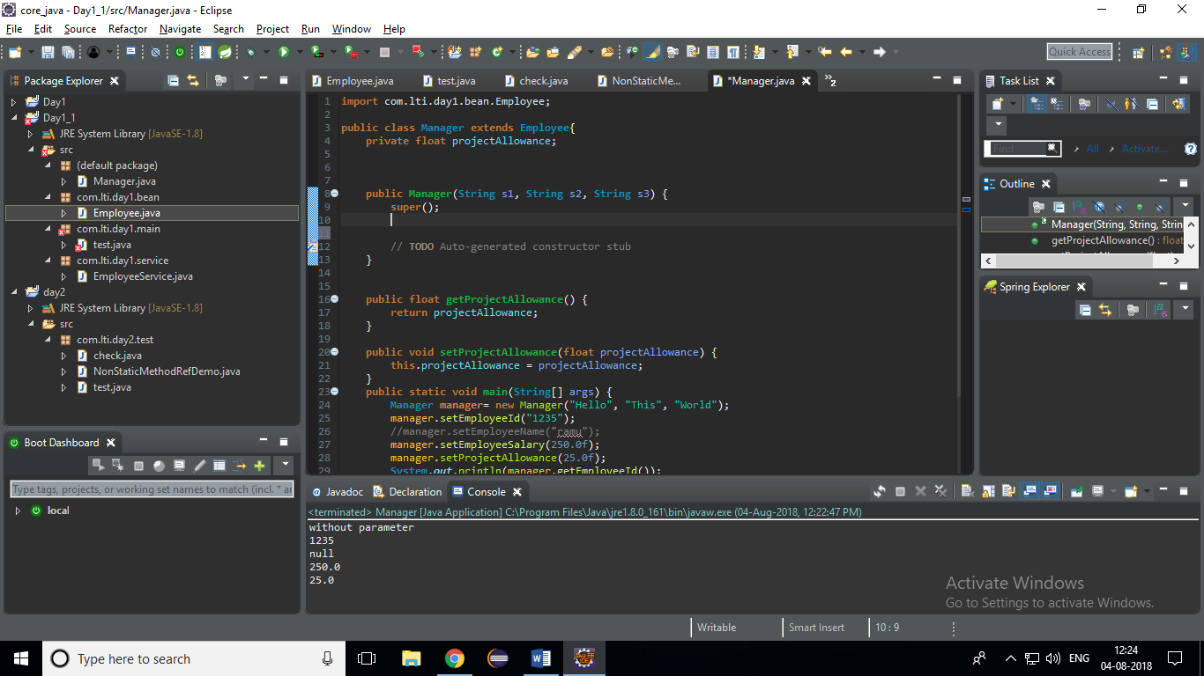

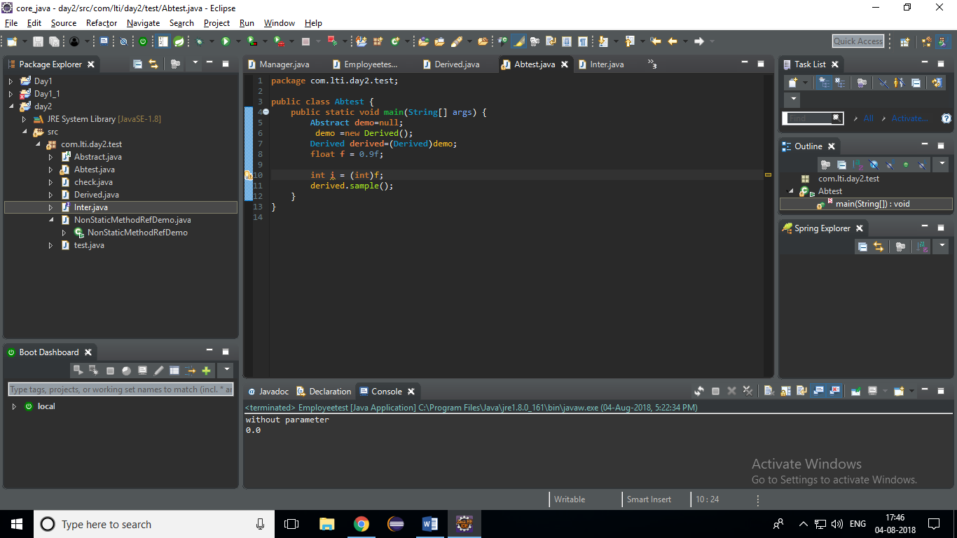

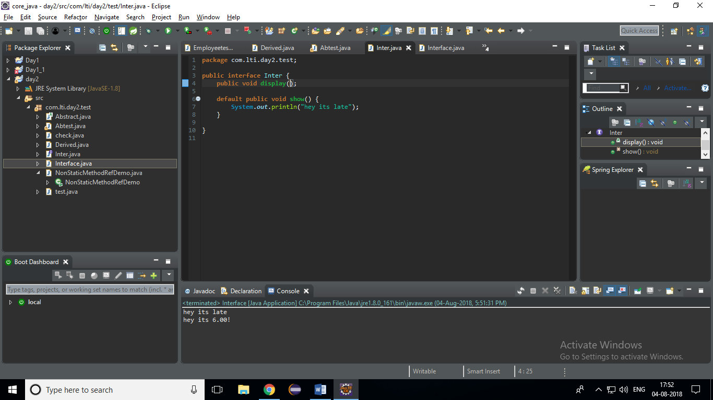

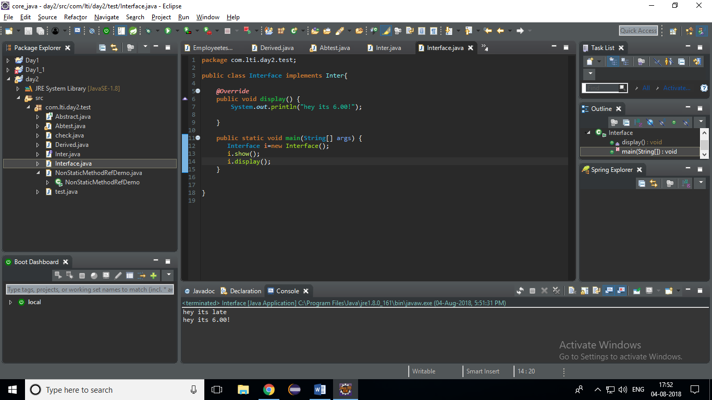

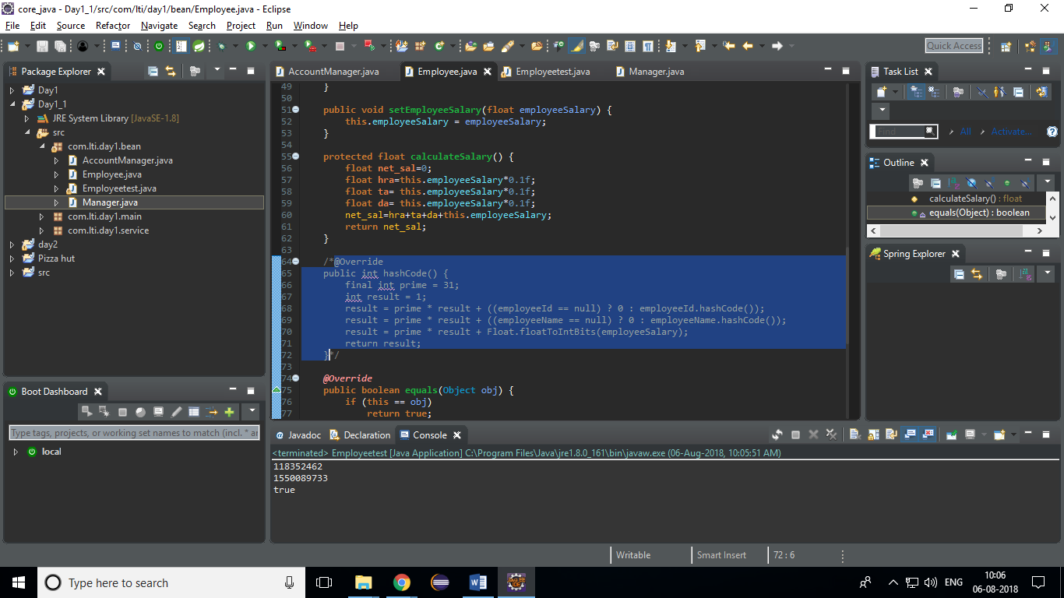

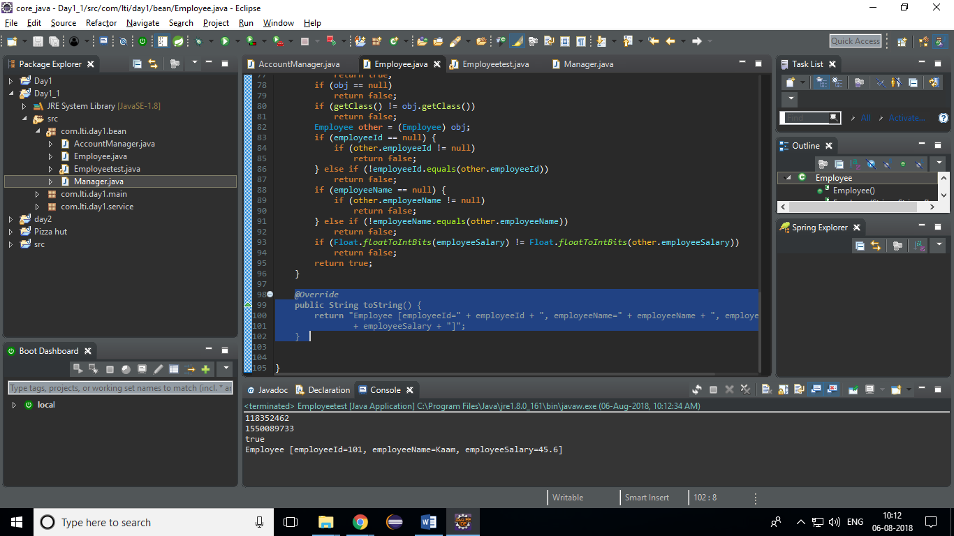

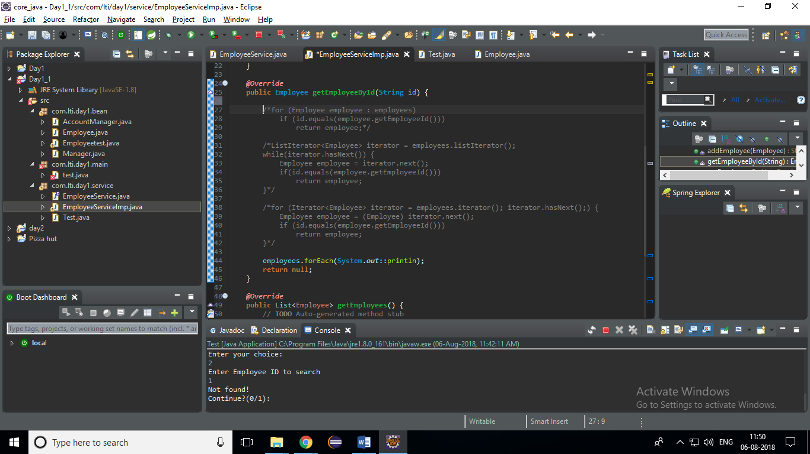4methods

for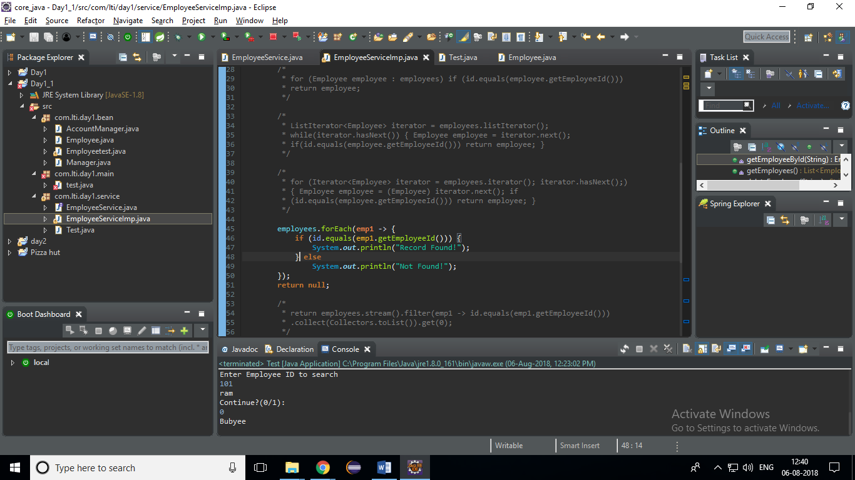

foreach method