MACHINE LEARNING
LAB – 1

Question 1 :
Create a NumPy array containing the integers from 1 to 20.
Perform the following operations:
1. Display the array.
2. Find the shape of the array.
3. Find the maximum and minimum values.
4. Calculate the mean and standard deviation.
5. Reshape the array into a 4 × 5 matrix.
6. Display the second row of the matrix.
7. Display the third column of the matrix.
Code :
import numpy as np
arr = np.arange(1, 21)
print(arr)
print("\nShape:", arr.shape)
print("Maximum value:", arr.max())
print("Minimum value:", arr.min())
print("Mean:", arr.mean())
print("Standard Deviation:", arr.std())
matrix = arr.reshape(4, 5)
print("\n4 * 5 Matrix:")
print(matrix)
print("\nSecond Row:")
print(matrix[1])
print("\nThird Column:")
print(matrix[:, 2])
Output :
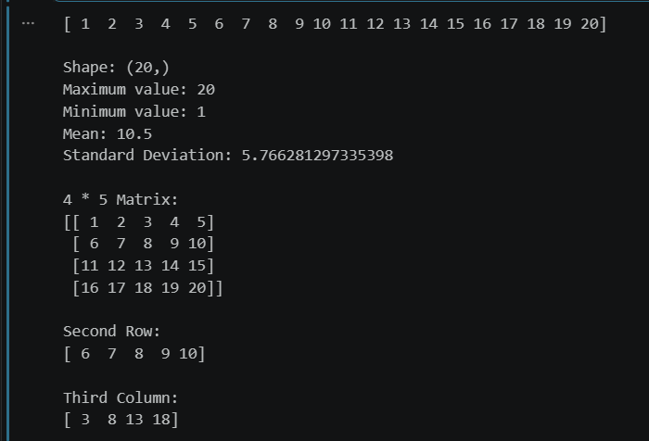

Question 2 :
Create two NumPy arrays:
A = [10, 20, 30, 40, 50]
B = [5, 10, 15, 20, 25]
Perform:
1. Addition of A and B.
2. Subtraction of B from A.
3. Element-wise multiplication.
4. Element-wise division.
5. Find the sum of all elements in A.
Code :
import numpy as np
A = np.array([10, 20, 30, 40, 50])
B = np.array([5, 10, 15, 20, 25])
print("Addition:", A + B)
print("Subtraction:", A - B)
print("Multiplication:", A * B)
print("Division:", A / B)
print("Sum of elements in A:", np.sum(A))
Output :
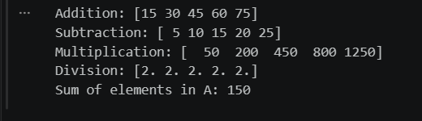
Question 3 :
Create a DataFrame using the following student data:
Roll No | Name | Marks
101 | Ravi | 85
102 | Priya | 92
103 | Kiran | 78
104 | Anu | 88
105 | Sita | 95
Perform the following operations:
1. Display the DataFrame.
2. Display the first three records.
3. Find the average marks.
4. Find the student with the highest marks.
5. Find the student with the lowest marks.
  - 6. Add a new column called "Grade" using:
  - o A for Marks ≥ 90
  - o B for Marks between 80 and 89
  - o C for Marks < 80
Code :
import pandas as pd
data = {
"Roll No": [101, 102, 103, 104, 105],
"Name": ["Ravi", "Priya", "Kiran", "Anu", "Sita"],
"Marks": [85, 92, 78, 88, 95]
}
df = pd.DataFrame(data)
print("DataFrame:")
print(df)
print("\nFirst Three Records:")
print(df.head(3))
print("\nAverage Marks:", df["Marks"].mean())
highest = df.loc[df["Marks"].idxmax()]
print("\nStudent with Highest Marks:")
print(highest)
lowest = df.loc[df["Marks"].idxmin()]
print("\nStudent with Lowest Marks:")
print(lowest)
def grade(mark):
if mark >= 90:
return "A"
elif mark >= 80:
return "B"
else:
return "C"
df["Grade"] = df["Marks"].apply(grade)
print("\nDataFrame with Grades:")
print(df)
Output :
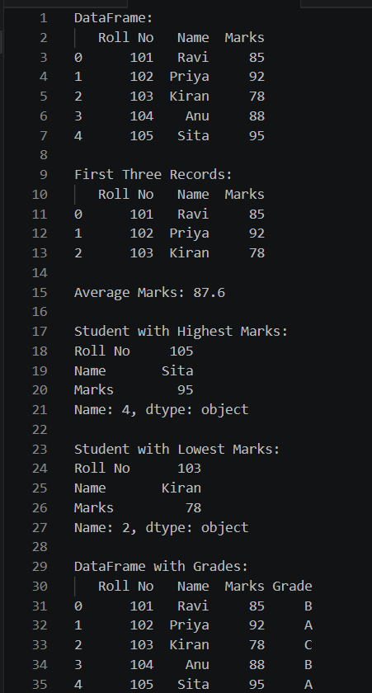

Question 4 :
Create a DataFrame containing the following information:
Product | Price | Quantity
Laptop | 50000 | 10
Mouse | 500 | 50
Keyboard | 1200 | 30
Monitor | 10000 | 15
Perform:
1. Calculate the total value of each product using:
Total Value = Price × Quantity
2. Add the Total Value column.
3. Find the product with the highest total value.
4. Calculate the overall inventory value.
Code :
import pandas as pd
data = {
"Product": ["Laptop", "Mouse", "Keyboard", "Monitor"],
"Price": [50000, 500, 1200, 10000],
"Quantity": [10, 50, 30, 15]
}
df = pd.DataFrame(data)
df["Total Value"] = df["Price"] * df["Quantity"]
print("DataFrame with Total Value:")
print(df)
highest = df.loc[df["Total Value"].idxmax()]
print("\nProduct with Highest Total Value:")
print(highest)
overall_value = df["Total Value"].sum()
print("\nOverall Inventory Value:", overall_value)
Output :
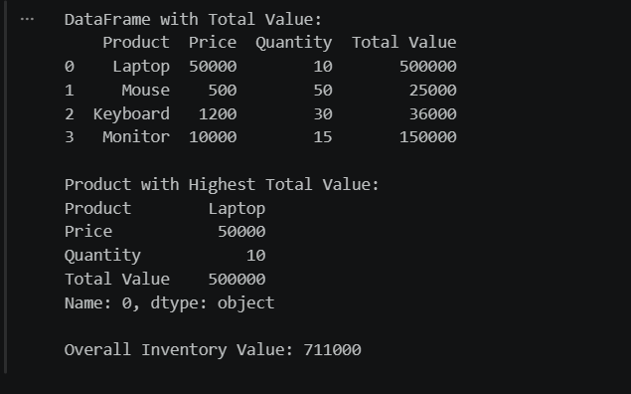

Question 5 :
Download the Iris dataset from Scikit-learn and perform the following:
1. Load the dataset into a Pandas DataFrame.
2. Display the first five records.
3. Find the number of rows and columns.
4. Display column names.
5. Check for missing values.
6. Generate summary statistics using describe().
7. Find the number of samples belonging to each class.
Code :
import pandas as pd
from sklearn.datasets import load_iris
iris = load_iris()
df = pd.DataFrame(iris.data, columns=iris.feature_names)
df["species"] = iris.target
df["species"] = df["species"].map({
0: "setosa",
1: "versicolor",
2: "virginica"
})
print("First Five Records:")
print(df.head())
print("\nShape of Dataset:")
print(df.shape)
print("\nColumn Names:")
print(df.columns)
print("\nMissing Values:")
print(df.isnull().sum())
print("\nSummary Statistics:")
print(df.describe())
print("\nSamples per Class:")
print(df["species"].value_counts())
Output :
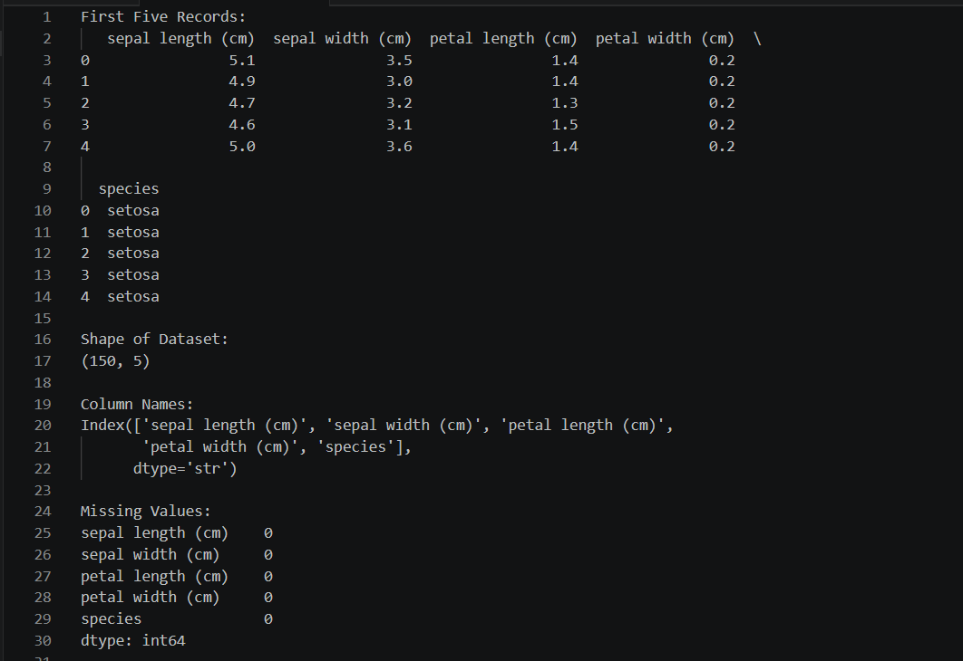

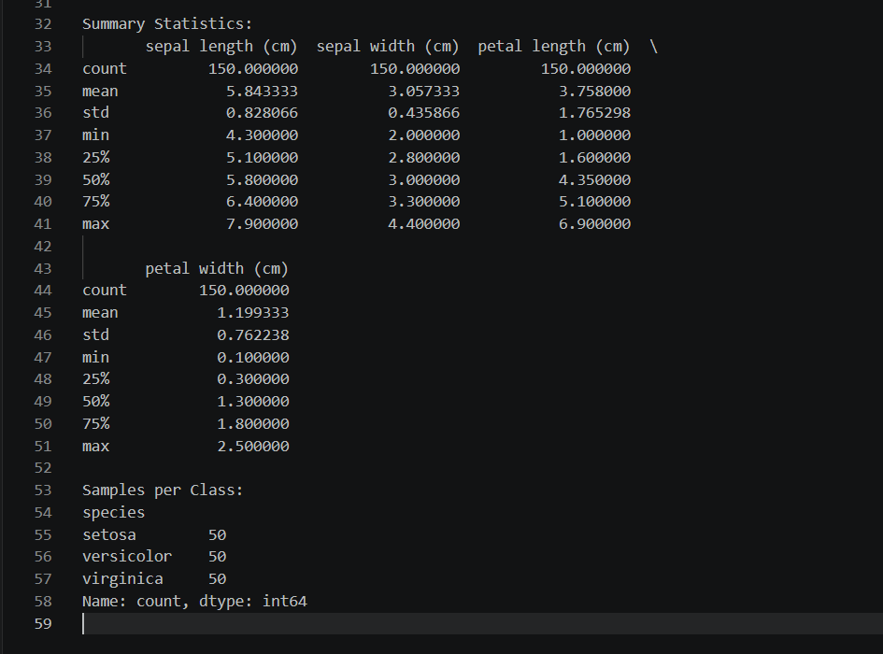

LAB – 2
Aim :
To perform exploratory data analysis (EDA) on a student performance dataset using Pandas and Matplotlib.
Dataset :
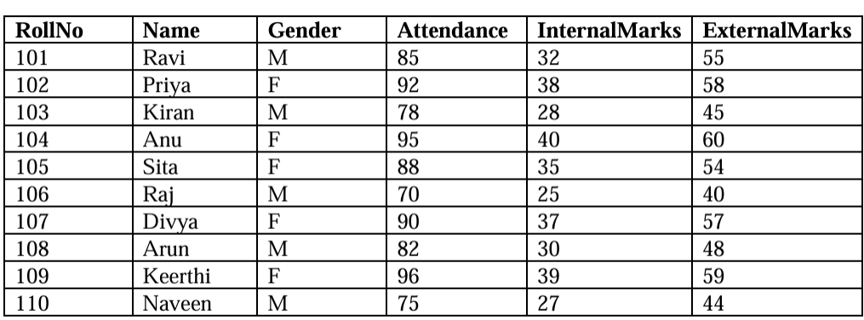

Tasks :
Task A: Dataset Loading and Inspection
• Import the necessary Python libraries.
• Load the dataset into a Pandas DataFrame.
• Display the first five records.
• Display the last five records.
• Find the total number of rows and columns.
• Display the names of all columns.
• Display the data type of each column.
• Generate dataset information using info().
Task B: Statistical Analysis
• Calculate the mean attendance of all students.
• Calculate the average Internal Marks.
• Calculate the average External Marks.
• Find the maximum Internal Marks.
• Find the minimum Internal Marks.
• Find the maximum External Marks.
• Find the minimum External Marks.
• Calculate the standard deviation of Internal Marks.
• Generate summary statistics using describe().
Task C: Data Manipulation
• Create a new column named TotalMarks.
• TotalMarks=InternalMarks+ExternalMarks
• Create a new column named Percentage. 1. Percentage=TotalMarks/100×100
• Display the updated DataFrame.
Task D: Filtering and Searching
• Display the details of students whose attendance is greater than 90%.
• Display the details of students whose TotalMarks exceed 90.
• Display the details of female students.
• Display the details of male students.
• Display students whose ExternalMarks are less than 50.
Task E: Ranking and Comparison
• Identify the student with the highest TotalMarks.
• Identify the student with the lowest TotalMarks.
• Display the top three performers based on TotalMarks.
• Display the bottom three performers based on TotalMarks.
• Determine how many students scored above the class average.
Task F: Group-wise Analysis
• Calculate the average TotalMarks of male students.
• Calculate the average TotalMarks of female students.
• Compare the average attendance of male and female students.
Task G: Data Visualization
• Plot a bar chart showing TotalMarks of all students.
• Plot a histogram of Attendance.
• Plot a pie chart showing the distribution of male and female students.
• Plot a scatter plot between Attendance and TotalMarks.
• Interpret the relationship between Attendance and TotalMarks.
Task H: Observations
• Write any three observations based on the analysis performed.
• State whether higher attendance appears to be associated with better academic performance.

Creating CSV file named student_data.csv :
import pandas as pd
import matplotlib.pyplot as plt
df = pd.read_csv("student_data.csv")
Output :
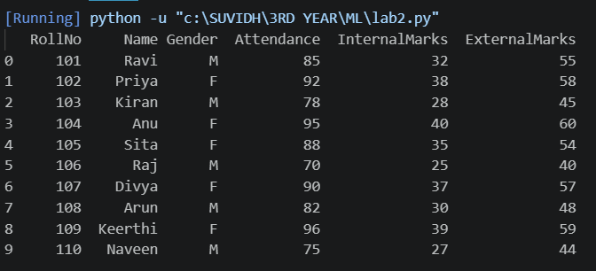

Code :

# Task A
print("First Five Records")
print(df.head())
print("\nLast Five Records")
print(df.tail())
print("\nRows and Columns")
print(df.shape)
print("\nColumn Names")
print(df.columns)
print("\nData Types")
print(df.dtypes)
print("\nDataset Information")
print(df.info())
# Task B
print("\nMean Attendance =", df["Attendance"].mean())
print("Average Internal Marks =", df["InternalMarks"].mean())
print("Average External Marks =", df["ExternalMarks"].mean())
print("Maximum Internal Marks =", df["InternalMarks"].max())
print("Minimum Internal Marks =", df["InternalMarks"].min())
print("Maximum External Marks =", df["ExternalMarks"].max())
print("Minimum External Marks =", df["ExternalMarks"].min())
print("Standard Deviation of Internal Marks =",
df["InternalMarks"].std())
print("\nSummary Statistics")
print(df.describe())
# Task C
df["TotalMarks"] = df["InternalMarks"] + df["ExternalMarks"]
df["Percentage"] = (df["TotalMarks"]/100)*100
print("\nUpdated DataFrame")
print(df)
# Task D
print("\nAttendance > 90")
print(df[df["Attendance"] > 90])
print("\nTotal Marks > 90")
print(df[df["TotalMarks"] > 90])

print("\nFemale Students")
print(df[df["Gender"]=="F"])
print("\nMale Students")
print(df[df["Gender"]=="M"])
print("\nExternal Marks < 50")
print(df[df["ExternalMarks"]<50])
# Task E
print("\nHighest Total Marks")
print(df.loc[df["TotalMarks"].idxmax()])
print("\nLowest Total Marks")
print(df.loc[df["TotalMarks"].idxmin()])
print("\nTop 3 Performers")
print(df.nlargest(3,"TotalMarks"))
print("\nBottom 3 Performers")
print(df.nsmallest(3,"TotalMarks"))
average = df["TotalMarks"].mean()
print("\nStudents Above Class Average")
print(df[df["TotalMarks"]>average])
print("Count =", len(df[df["TotalMarks"]>average]))
# Task F
print("\nAverage Total Marks of Male Students")
print(df[df["Gender"]=="M"]["TotalMarks"].mean())

print("\nAverage Total Marks of Female Students")
print(df[df["Gender"]=="F"]["TotalMarks"].mean())
print("\nAverage Attendance Gender-wise")
print(df.groupby("Gender")["Attendance"].mean())
# Task G
plt.figure(figsize=(8,5))
plt.bar(df["Name"],df["TotalMarks"])
plt.title("Total Marks")
plt.xlabel("Students")
plt.ylabel("Marks")
plt.show()
plt.figure(figsize=(6,5))
plt.hist(df["Attendance"],bins=5)
plt.title("Attendance Histogram")
plt.xlabel("Attendance")
plt.ylabel("Frequency")
plt.show()
gender_count=df["Gender"].value_counts()
plt.figure(figsize=(5,5))
plt.pie(gender_count,
labels=gender_count.index,
autopct="%1.1f%%")
plt.title("Gender Distribution")
plt.show()
plt.figure(figsize=(6,5))
plt.scatter(df["Attendance"],df["TotalMarks"])
plt.title("Attendance vs Total Marks")
plt.xlabel("Attendance")
plt.ylabel("Total Marks")
plt.show()
Output :
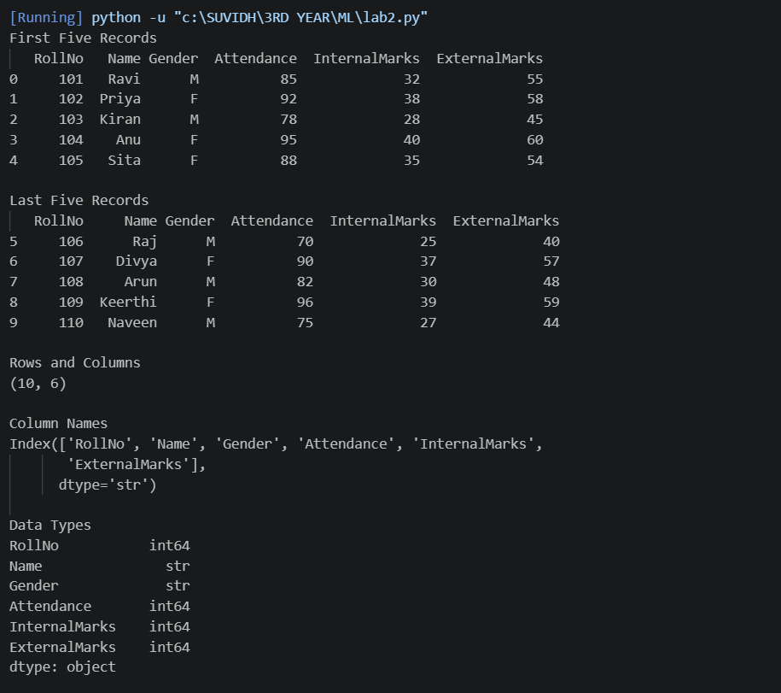
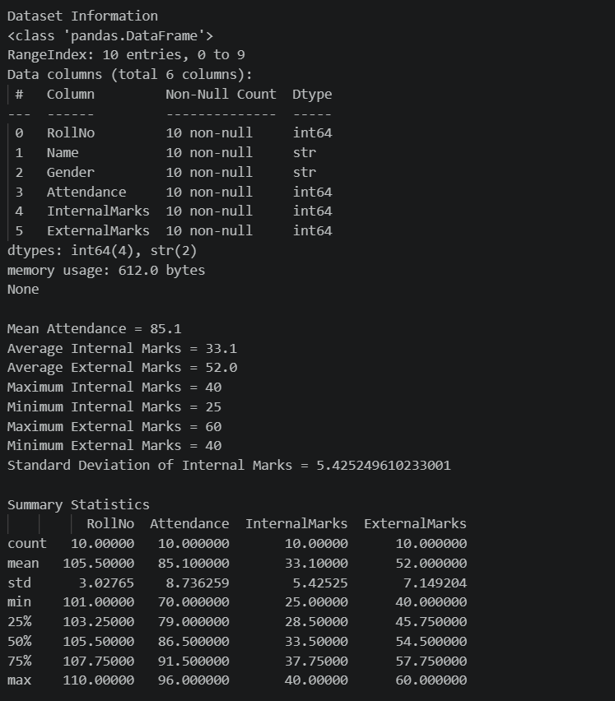
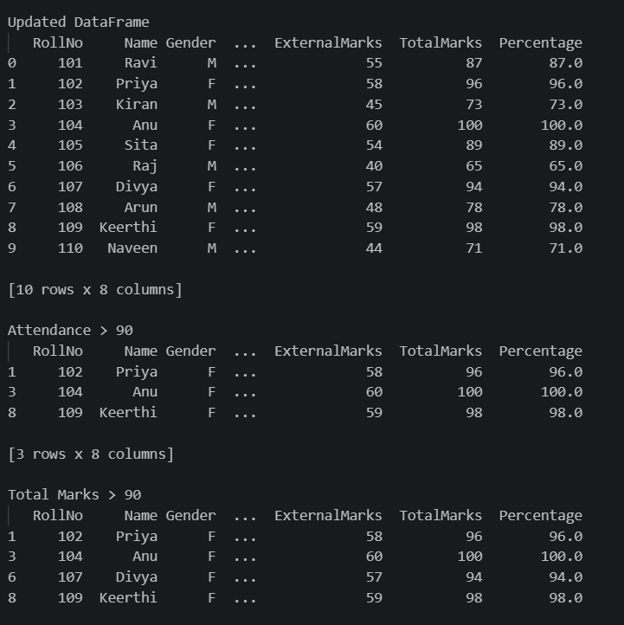
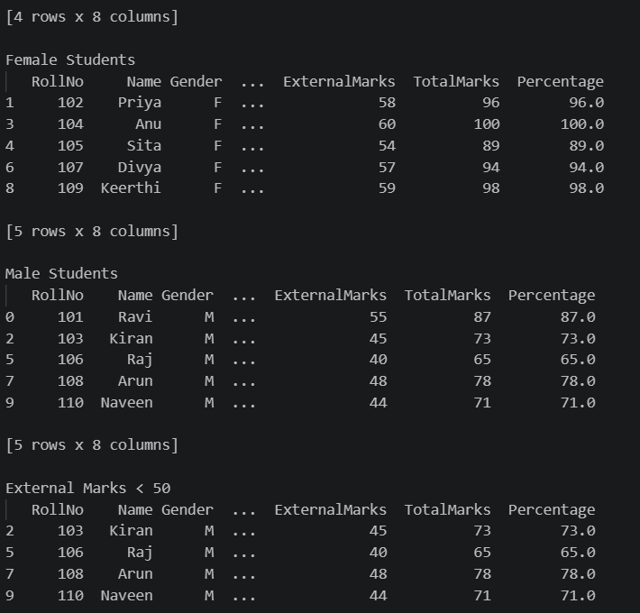
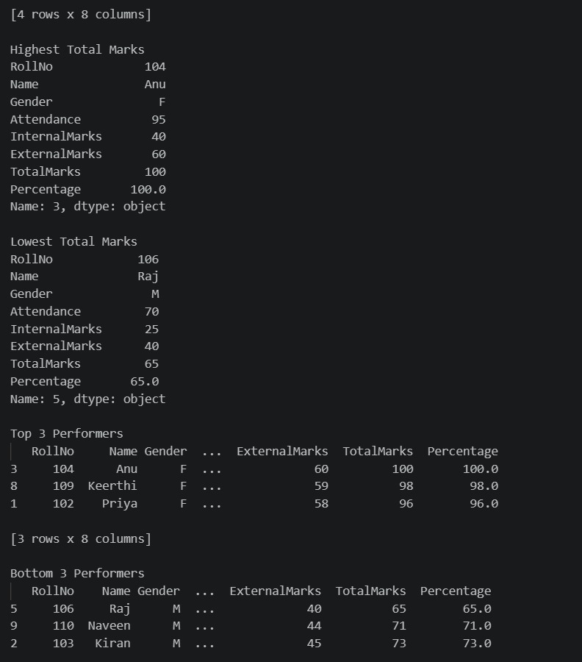
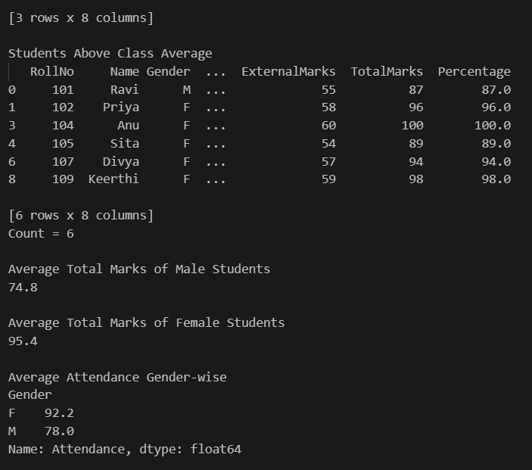
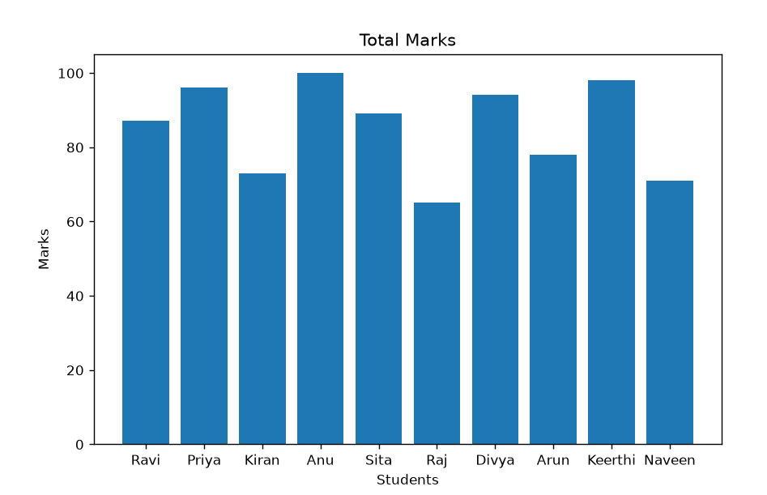
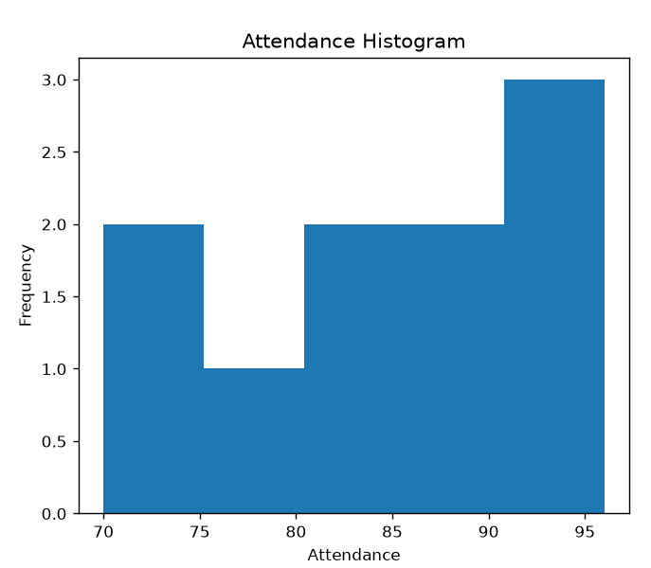
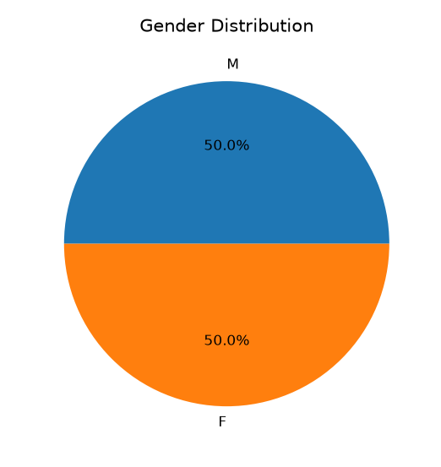
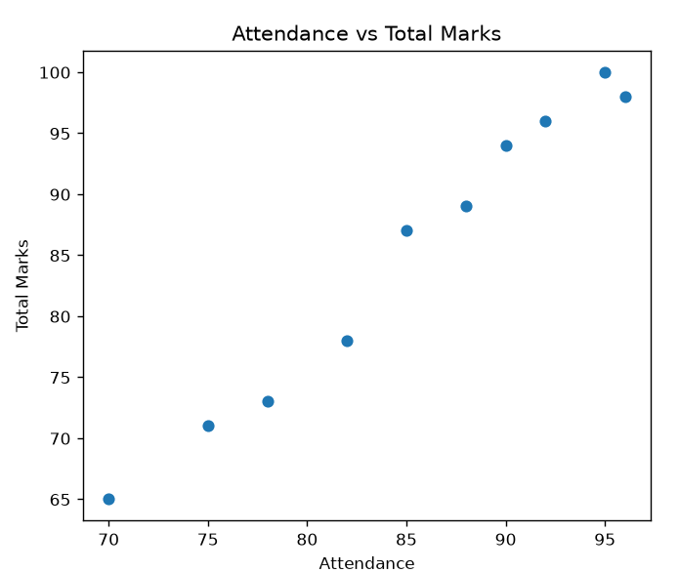

Task H: Observations
1. Female students scored a higher average total marks (95.4) than male students (74.8).
2. Anu secured the highest total marks (100), while Raj secured the lowest (65).
3. Students with attendance above 90% generally obtained higher total marks.
Higher attendance appears to be associated with better academic performance, as students with better attendance achieved higher total marks.

