**CREATE A CHATBOT IN PYTHON**

TEAM MEMBERS

1. **SUYAMBULAKSHMI V**
2. **SHARINITHA R**
3. **AYESHASITHIKA S**
4. **PIRITHIBA M**

**Phase 2 – Document submission**

**OBJECTIVE:**

* The Objective of this project is to create a high-quality support to users, ensuring a positive user experience and customer satisfaction chatbot in Python that provides exceptional customer service, answering user queries on a website or application.

**PROGRAM:**

* This is the sample program,

import json

import string

import random

import nltk

import numpy as num

from nltk.stem import WordNetLemmatizer # It has the ability to lemmatize.

import tensorflow as tensorF # A multidimensional array of elements is represented by this symbol.

from tensorflow.keras import Sequential # Sequential groups a linear stack of layers into a tf.keras.Model

from tensorflow.keras.layers import Dense, Dropout

nltk.download("punkt")# required package for tokenization

nltk.download("wordnet")# word database

import re

import long_responses as long

def message_probability(user_message, recognised_words, single_response=False, required_words=[]):

  message_certainty = 0

  has_required_words = True

  #counts how many words are present in each predefined message

  for word in user_message:

    if word in recognised_words:

      message_certainty +=1

  #calculates the percent of recognised words in a user message

  percentage = float (message_certainty) / float(len(recognised_words))

  #checks that the required words are in the string

  for word in required_words:

    if word not in user_message:

      has_required_words = False

      break

  if has_required_words or single_response:

    return int(percentage+100)

  else:

    return 0

def check_all_messages(message):

  highest_prob_list = {}

  def response(bot_response, list_of_words, single_response=False, required_words=[]):

    nonlocal highest_prob_list

    highest_prob_list[bot_response] = message_probability(message, list_of_words, single_response, required_words)

    #response----------------------------------------

    response("Hello!",["hello","hi","sup","hey","heyo","whatsup"], single_response=True)

    response('I\'m doing fine, and You?',["how","can","i","help","you"], required_words=['how'])

    response("Thank You!",['i','love','doing','online','courses'], required_words=['online','palace'])

    response(long.R_EATING, ['what','you','eat'], required_words=['you','eat'])

    best_match = max(highest_prob_list, key=highest_prob_list.get)

    #print(highest_prob_list)

    return long.unknown() if highest_prob_list[best_match] < 1 else best_match

def get_response(user_input):

  split_message = re.split(r'\s+|[,;?!.-]\s*', user_input.lower())

  response = check_all_messages(split_message)

  return response

while True:

  print('Bot: ' + get_response(input('You: ')))

* Here mentioned program is called in the above program.

import random

R_EATING = "I don't like eating anything because I'm a bot obviously!"

def unknown():

    response = ['Could you please re-phase that?',

                "...",

                "sounds about right",

                "what does that mean?"][random.randrange(4)]

    return response

**OUTPUT:**

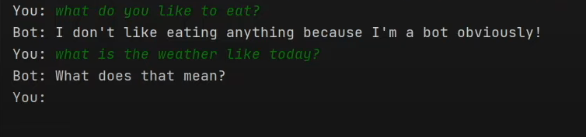

* **STEP 1:** We have developed a website in order to implement the chatbot. This is our website link - <https://technerdscentre.neocities.org/chatbot/> . This website is created by using the basic knowledge of HTML, CSS, JavaScript. and it is published with the help of [neocities](https://neocities.org/) website.
* **STEP 2:** By learning some important features of **Machine Learning,** For Example Data wrangling, neural networks, natural language processing,etc. And also some of the basic libraries we have installed the **Visual Studio Code** , They are, JSON,string, random, nltk, pytorch, flask app, request.
* **STEP 3:**  We are using Visual Studio code plateform to implement this code
* **STEP 4:** With the help of flask app and javascript , we are able to connect the python chatbot in our website.
* **STEP 5:** Here we will test our project