## Front End Engineering-II

Project Report

Semester-IV (Batch-2022)

Title: Movie Website

­

**Supervised By: Submitted By:**

Faculty Name: Raveesh Samkaria Suyash dubey

2210990880

G13

**Department of Computer Science and Engineering**

## Chitkara University Institute of Engineering & Technology,

## Chitkara University, Punjab

**Abstract:**

**In today's digital age, interactive platforms play a pivotal role in engaging users and facilitating learning experiences. This abstract presents a novel approach to designing a quiz application leveraging the power of Bootstrap, a front-end framework known for its responsiveness and user-friendly design elements.**

**The quiz application aims to provide an intuitive and seamless experience for users across various devices, including desktops, tablets, and smartphones. Bootstrap's grid system enables the creation of a responsive layout, ensuring optimal viewing and interaction regardless of screen size.**

**Key features of the quiz application include:**

**1. \*\*Responsive Design\*\*: Utilizing Bootstrap's responsive classes to adapt the layout and content dynamically based on the user's device, ensuring a consistent experience across different screen sizes.**

**2. \*\*User-friendly Interface\*\*: Leveraging Bootstrap components such as buttons, forms, and navigation bars to create an intuitive and visually appealing interface that enhances usability and navigation.**

**3. \*\*Customization Options\*\*: Integrating Bootstrap themes and customization utilities to personalize the visual appearance of the quiz application, aligning it with the branding and preferences of the target audience.**

**4. \*\*Accessibility\*\*: Implementing Bootstrap's accessibility features to ensure that the quiz application is inclusive and accessible to users with diverse needs, including those using assistive technologies.**

**5. \*\*Scalability and Maintenance\*\*: Leveraging Bootstrap's modular structure and documentation to streamline development, facilitate code maintenance, and enable scalability for future enhancements and updates.**

**By harnessing the flexibility and robustness of Bootstrap, the quiz application aims to enhance user engagement, foster interactive learning experiences, and cater to the evolving needs of modern digital consumers.**

**Table of Content:**

|  |  |  |
| --- | --- | --- |
| **S.NO** | **Topic** | **Page no** |
| 1. | Introduction/Landing Page | 4-5 |
| 2. | Folder Structure | 6 |
| 3. | Code | 7-17 |
| 4. | Result | 17-20 |
| 5. | References | 20-21 |

**Introduction:**

Title: Interactive Quiz Application: Engaging Users Through Bootstrap

Project Overview:

The project aims to develop an interactive quiz application leveraging Bootstrap, a front-end framework, to create a seamless and engaging user experience. The quiz application targets users seeking an enjoyable and educational platform to test their knowledge across various topics.

Key Objectives:

1. \*\*User Engagement\*\*: The primary goal is to captivate users by offering an intuitive and visually appealing interface that encourages participation and interaction.

2. \*\*Scalability\*\*: The application should be designed to accommodate a growing user base and expandable content categories, ensuring scalability for future updates and enhancements.

3. \*\*Responsive Design\*\*: Implementing a responsive layout using Bootstrap's grid system to optimize user experience across devices, including desktops, tablets, and smartphones.

4. \*\*Customization\*\*: Providing customization options to tailor the visual appearance and branding of the quiz application to align with user preferences and organizational branding.

5. \*\*Accessibility\*\*: Ensuring accessibility features are integrated to accommodate users with diverse needs, including those utilizing assistive technologies.

6. \*\*Performance\*\*: Optimizing the performance of the application to deliver swift loading times and seamless navigation, enhancing user satisfaction and retention.

Key Features:

1. \*\*User Authentication\*\*: Implementing user authentication mechanisms to secure user data and personalize the quiz experience.

2. \*\*Quiz Creation and Management\*\*: Providing tools for administrators to create and manage quiz content, including questions, answers, and categories.

3. \*\*Responsive Quiz Interface\*\*: Developing a responsive quiz interface that adapts to various screen sizes and orientations, optimizing usability and accessibility.

4. \*\*Real-time Feedback\*\*: Offering instant feedback to users upon completing quizzes, including scores, correct answers, and explanations.

5. \*\*Leaderboard\*\*: Incorporating a leaderboard feature to showcase top performers and encourage competition among users.

6. \*\*Social Sharing\*\*: Integrating social sharing functionality to allow users to share quiz results and challenge friends, enhancing engagement and virality.

Project Deliverables:

1. \*\*Technical Specifications\*\*: Detailed documentation outlining the project requirements, architecture, and technical implementation.

2. \*\*Prototype\*\*: A functional prototype showcasing the quiz application's core features and user interface design.

3. \*\*Implementation\*\*: Development of the quiz application according to the outlined specifications, leveraging Bootstrap for front-end design.

4. \*\*Testing\*\*: Rigorous testing to ensure the application meets quality standards, including functionality, usability, compatibility, and performance.

5. \*\*Deployment\*\*: Deployment of the quiz application to a production environment, ready for user access and interaction.

6. \*\*Maintenance and Support\*\*: Ongoing maintenance and support to address bugs, implement updates, and enhance functionality based on user feedback and evolving requirements.

Conclusion:

The interactive quiz application project aims to leverage Bootstrap's capabilities to create a compelling and user-friendly platform for knowledge assessment and engagement. By prioritizing responsiveness, customization, accessibility, and performance, the project endeavors to deliver an enriching experience for users across diverse demographics and devices.

**Folder Structure:**

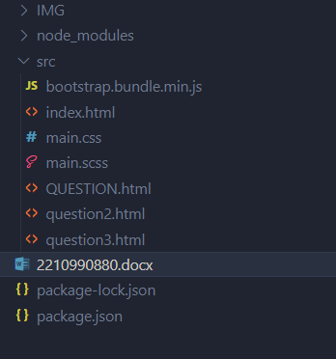

Figure: Folder Structure

**Files & Folders:**

* **index.html: index.html** provides the basic structure and content includes bootstarp.
* **Main.scss: has all the css part**
* **Question,question2,question3: has the qizz part**
* **Images**: All images are in the images folder

**Code:**

**index.html:**

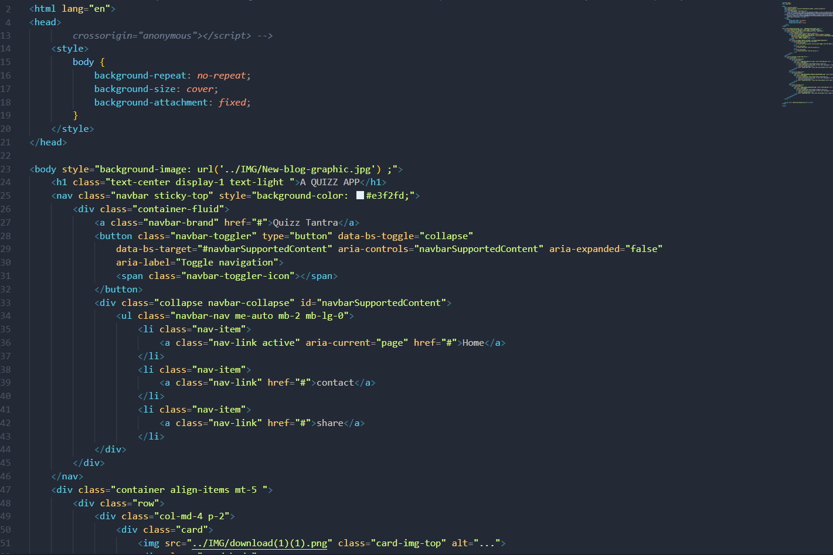

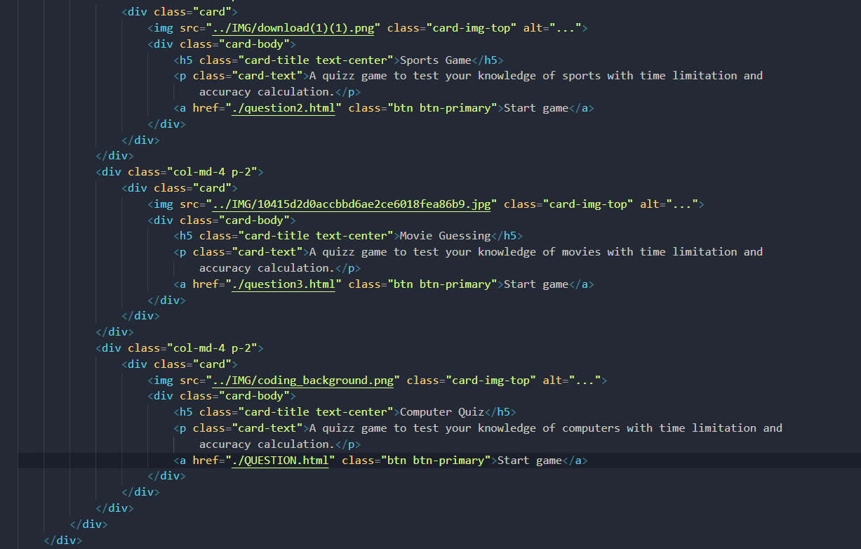

**qiuz:-**

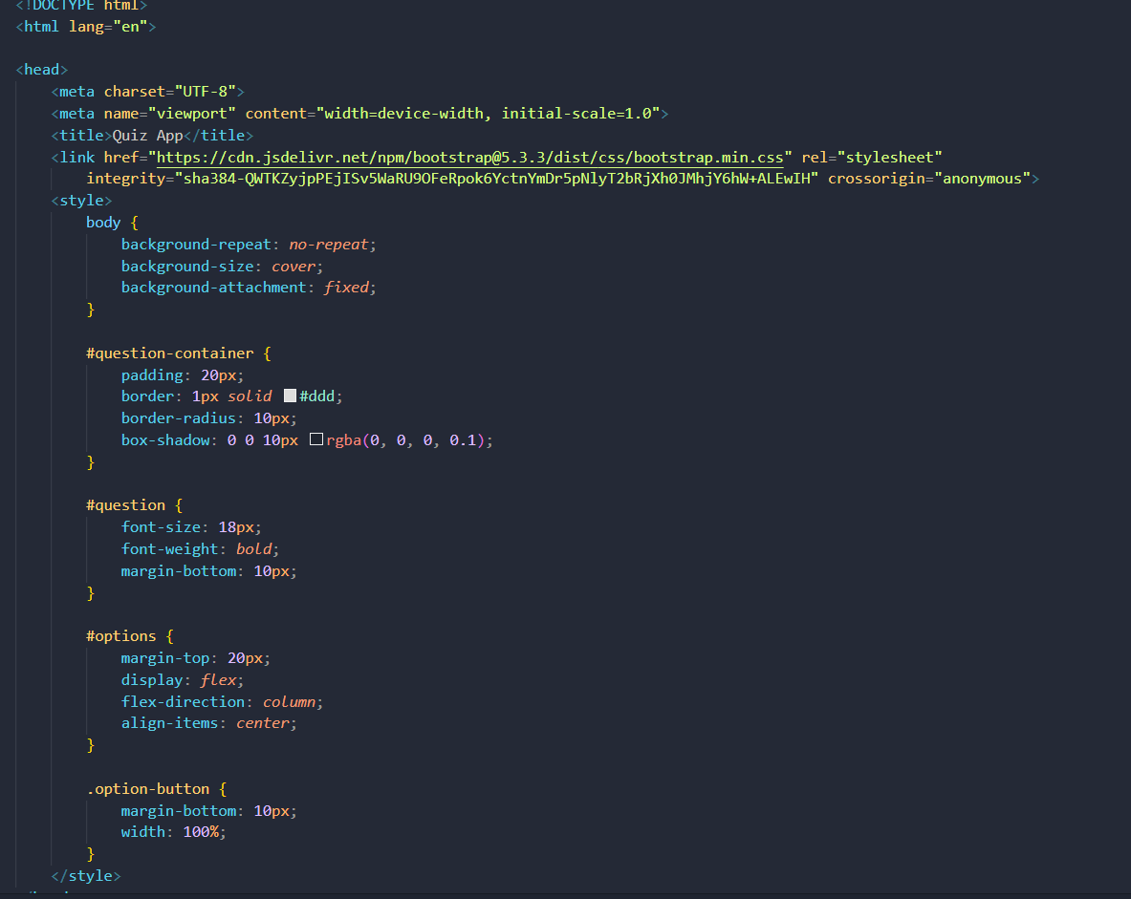

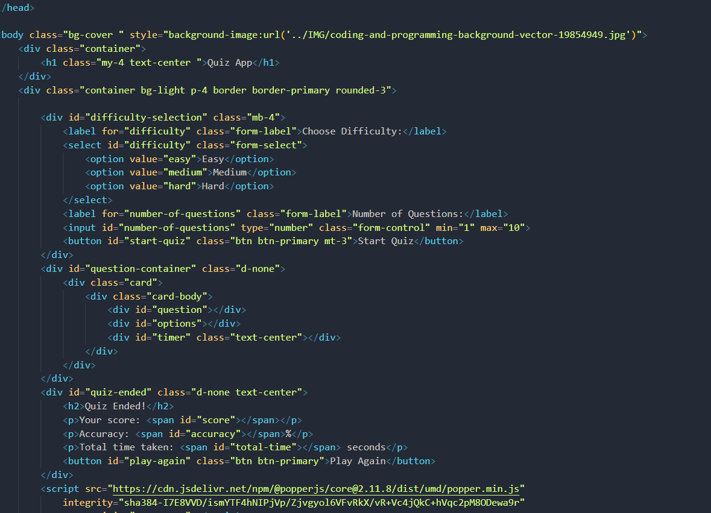

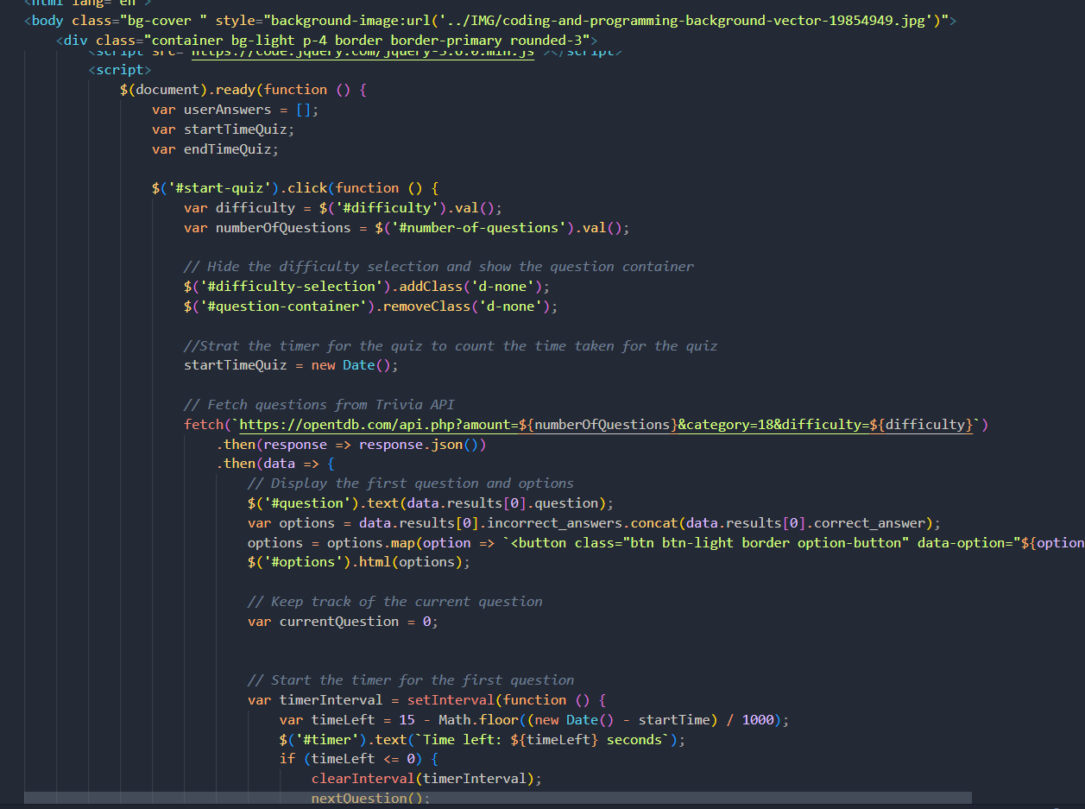

**Moviesdetail.html:-**

.

**Script.js**

**Results:**

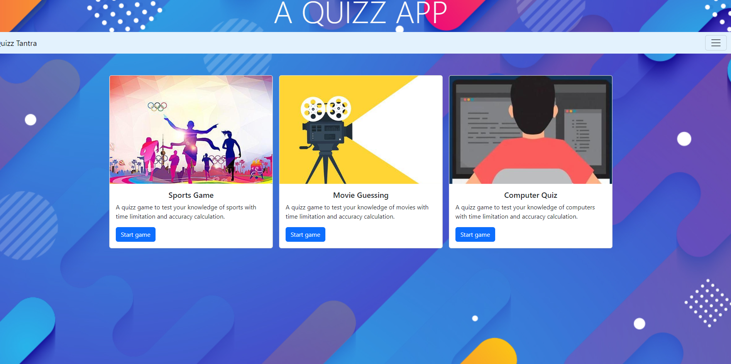

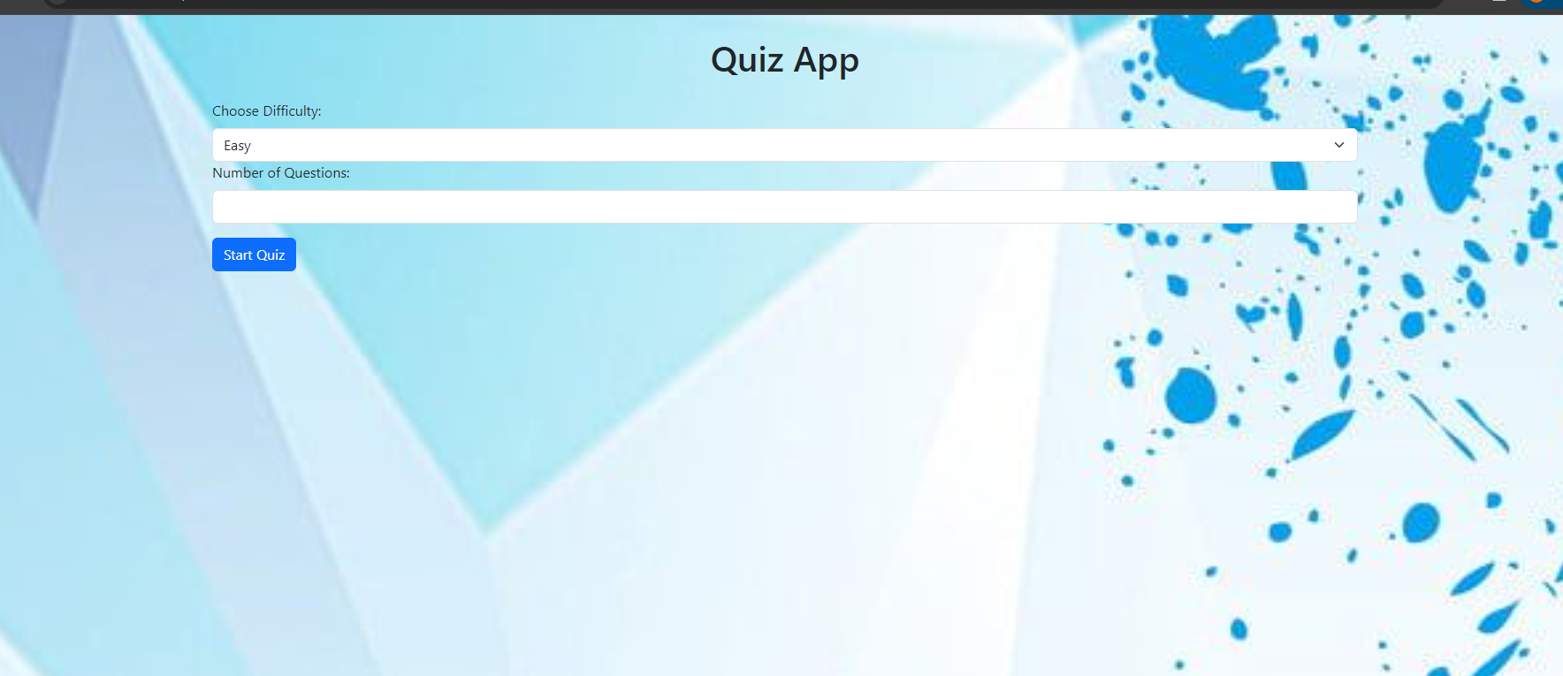

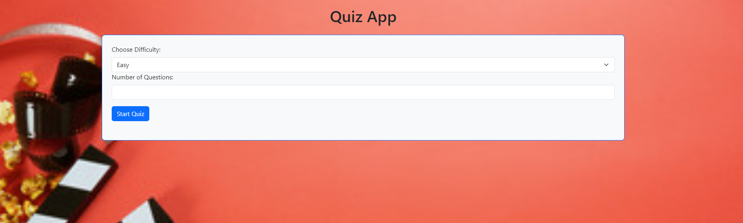

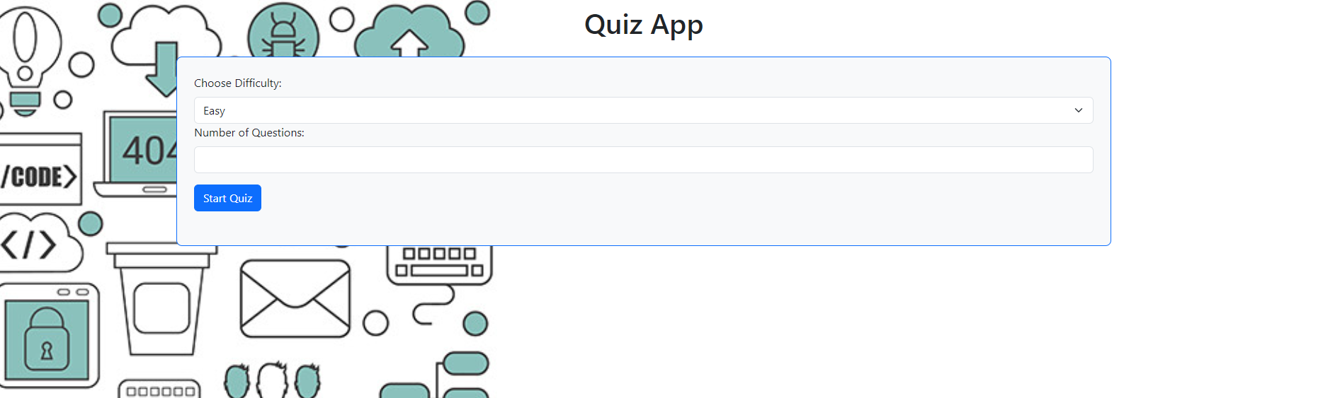

**References:**

**Bootsstrap: https://getbootstrap.com/docs/5.3/getting-started/download/**

**CSS:**  **[https://developer.mozilla.org/en-US/](https://developer.mozilla.org/en-US/" \t "_blank)**

**Website:** https://opentdb.com/api