

Sri Lanka Institute of Information Technology

B.Sc. Honors Degree in Information Technology

Specialized in Information Technology

IT4020 – Modern Topics in IT

Assignment 04

Group ID: MTIT-020

Group Details:

|  |  |
| --- | --- |
| Registration Number | Student Name |
| IT20029968 | Athukorala Y.J |
| IT19192024 | Jayawardhana E.H.K |
| IT20147846 | Thennakoon S.U |
| IT20051020 | Shaminda W.G.T |

**Contents**

**1** **Contribution** 3

**2** **Screenshots of Folder Structure and Final Applications** 4

i. Folder Structure 4

ii. Final output of the Application 4

**3** **Link of the Application** 6

# **Contribution**

|  |  |  |
| --- | --- | --- |
| **IT Number** | **Name** | **Contribution** |
| IT20029968 | Athukorala Y.J | * Build a simple augmented reality application. * Make your own marker. * Download the source code and texture files for the individual artifact. * Applying the augmented reality idea, display 3D artifacts. * Build your own application and report. |
| IT19192024 | Jayawardhana E.H.K | * Build a simple augmented reality application. * Make your own marker. * Download the source code and texture files for the individual artifact. * Applying the augmented reality idea, display 3D artifacts. * Build your own application and report. |
| IT20147846 | Thennakoon S.U | * Build a simple augmented reality application. * Make your own marker. * Download the source code and texture files for the individual artifact. * Applying the augmented reality idea, display 3D artifacts. * Build your own application and report. |
| IT20051020 | Shaminda W.G.T | * Build a simple augmented reality application. * Make your own marker. * Download the source code and texture files for the individual artifact. * Applying the augmented reality idea, display 3D artifacts. * Build your own application and report. |

# **Screenshots of Folder Structure and Final Applications**

## **Folder Structure**

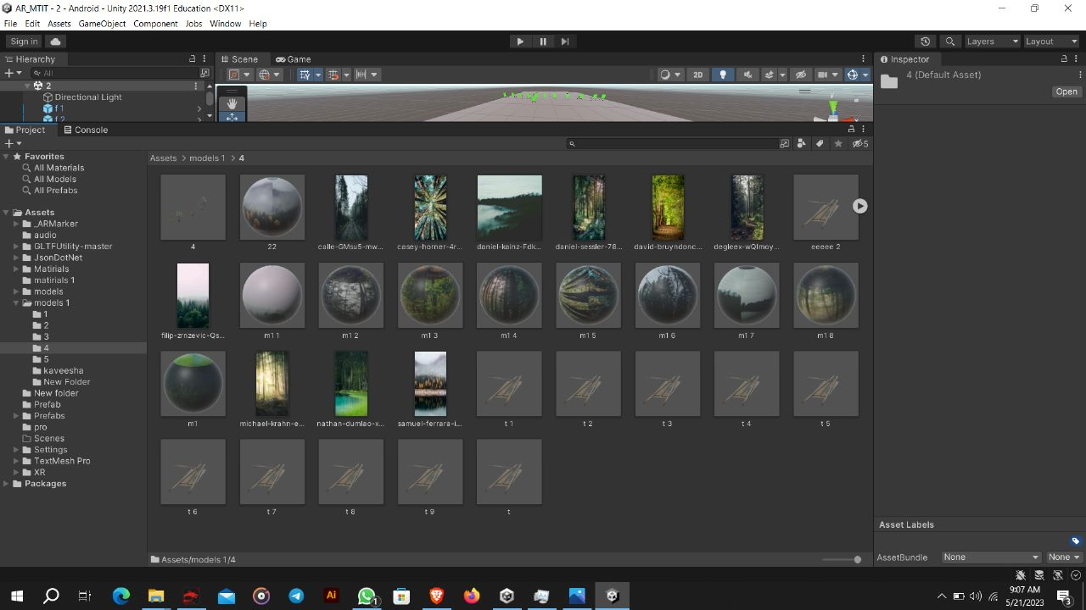

## **Final output of the Application**

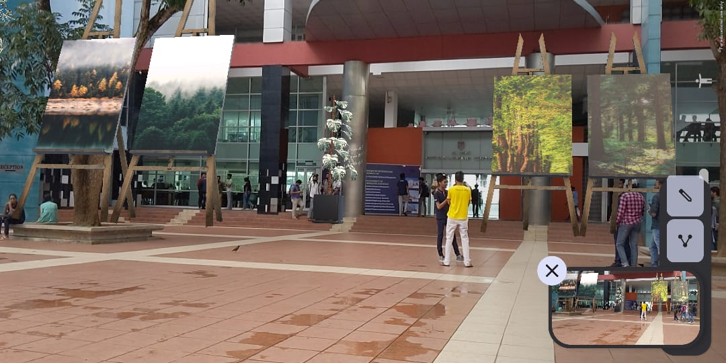

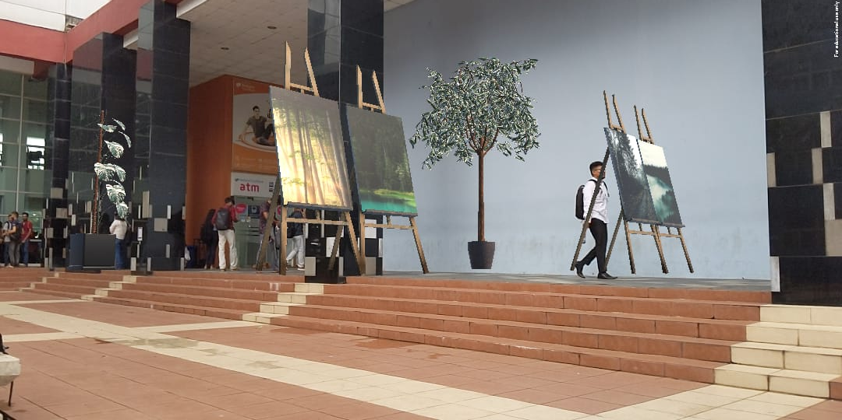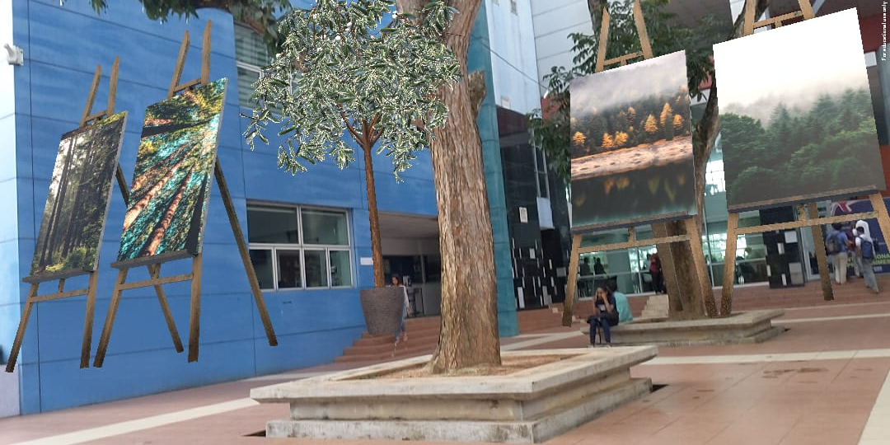

## 

# **Link of the Application**

<https://drive.google.com/drive/folders/13Fryjv0TrkMIrl57EfEQu_eNj9CPhr9h?usp=share_link>