A Faithful Hybrid Pipeline for Natural Language Generation from Universal Semantic Representation
Rule-Based Chunking with Large Language Model Surface Realization for Hindi to English
Author 1 Name
Designation, Department, Institution Name, City, Country
Email ID ORCID ID (Optional)

Author 2 Name Author 3 Name
Designation, Department, Institution Name, City, Country Email ID
ABSTRACT
Large language models write fluently, and that very fluency can mask a loss of meaning, because a reader seldom notices a fact that has quietly gone missing or changed. A natural assumption is that a more complete and unambiguous input will lead to more faithful output. We put that assumption to the test using the Universal Semantic Representation (USR), a Paninian and language independent formalism that records lexico conceptual, relational, and discourse information together with the speaker view, and that is meant to be complete, unambiguous, and computationally tractable. Three experiments were run on the same 250 tourism sentences with three models, namely Llama 4 Scout, Mistral Small, and Gemma 3. Translating the Hindi sentence directly reads well yet still invents names and shifts meaning, with faithfulness between 0.540 and 0.593. Handing the raw USR to the models is worse, since faithfulness falls to between 0.075 and 0.191, the models being unable to read the formalism. Our hybrid pipeline first turns each USR into intermediate English chunks through an eight step rule system that carries exactly the source content, and a model then orders and smooths those chunks into one sentence. The rule stage reaches 93.2 percent exact chunk accuracy, with an F1 of 97.82 percent, against expert validated gold chunks. Three linguists rated the hybrid outputs, with Mistral Small highest overall at 4.85 of 5, Llama 4 Scout at 4.77, and Gemma 3 at 4.76, at strong agreement, with a mean Cohen kappa of 0.905. To our knowledge this is the first generation pipeline built over USR, and the evidence shows that a structured intermediate representation curbs hallucination and keeps generation tied to the input.
Keywords: faithfulness and hallucination; hybrid rule based generation; large language models; natural language generation; Universal Semantic Representation.
1. INTRODUCTION
1.1 Background of the Study
Turning a meaning representation into text is the task of saying, in fluent and grammatical language, exactly what a structured input specifies, no more and no less. It sits under machine translation, dialogue, data to text reporting, and cross lingual content creation. Two demands pull against each other. One is fluency, how natural the writing sounds. The other is faithfulness, how completely and accurately the writing reflects the input. Older rule based generators leaned towards faithfulness, since each word came deterministically from the input and nothing unlicensed could slip in, but their output often sounded wooden. Large language models have shifted the balance the other way. They write smoothly, and that smoothness is exactly what makes a dropped fact or a distorted name hard to catch, because the sentence still reads well. In a domain such as tourism, where one sentence may carry several place names, distances, and dates, a single wrong name or missing qualifier can mislead a reader who is using the text to plan a journey.
A common reply is to give the generator a more explicit input, in the hope that a fully specified meaning leaves less room to wander. The Universal Semantic Representation offers such an input. It is a language independent formalism rooted in the Paninian tradition that records, for each unit of a sentence, its concept rather than its surface word, its relation to other units through karaka and other dependencies, its discourse role, and the speaker view. It is designed to be complete, so nothing essential stays implicit, unambiguous, so each element has one reading, and computationally tractable, so a program can process it step by step. If a representation truly holds all and only the intended meaning, generation ought to reduce to rendering it faithfully, and whether that holds in practice is the question we examine.
1.2 Research Problem
The question is simple to state. Given a complete and unambiguous semantic input, does a language model generate faithfully? The expected answer is yes, on the view that a better input yields a better output, and our results show that this expectation is mistaken in two separate ways. Translating the Hindi sentence directly produces fluent text that still invents named entities, garbles transliterations, drops discourse markers, and shifts sense. Passing the raw USR to the model fares worse, because the model has never been trained to read the formalism and returns text that has little to do with the source. The weakness, then, lies in the act of generation rather than in the input, since an unconstrained model treats even a precise specification as a prompt it is free to embellish.
1.3 Need and Significance of the Study
USR is being built up as a semantic backbone for Indian language technology, yet generation from it has not been studied, so whether one can generate faithfully from a USR at all is still an open question, and answering it decides whether the representation can carry downstream applications. This paper offers the first generation pipeline over USR, a measured account of where direct generation loses faithfulness, and a hybrid design that recovers it without giving up fluency. The reach is wider than USR itself. Indian languages remain comparatively under resourced, and USR is meant to be a shared layer that several languages map into, so a faithful generator over USR can be reused across those languages and makes each annotation count for more. More broadly, the lesson carries to any case where a structured meaning has to be put into words by a language model.
1.4 Scope of the Study
We work on Hindi to English generation over a hand built, expert validated set of 250 tourism sentences, 10.0 words long on average and ranging from 3 to 22. The restriction to one language pair and one domain is deliberate. Rather than gather a large but noisy collection, we put annotation quality first, so that every USR is written, concept labelled, relation annotated, and checked by an expert, which lets us study generation without the confound of inconsistent input. Extending the work to other source languages such as Telugu, and to other domains, is left for later.
2. RESEARCH GAP / PROBLEM STATEMENT
Three questions about turning a Hindi USR into English are still open, and together they mark out the gap this study fills. The first asks whether a semantic representation is needed at all, or whether a model can simply translate the Hindi sentence and be faithful. It cannot, since direct translation, fluent though it is, invents names, garbles transliterations, drops discourse markers, and shifts sense, which is the reason for fixing the meaning in an explicit input. The second asks whether, given that input, the model can generate straight from the USR. Again it cannot, because the models have no grounding in the formalism and return text unrelated to the source. The third asks how the representation can be used without relying on the model to interpret it, and this is the question that no earlier work has taken up, since to our knowledge no generation method for USR exists.
Underlying all three is a more general point. It is widely assumed that a complete and unambiguous structured input will, by itself, make a model faithful, but that assumption has gone untested, because the hallucination literature has mostly looked at open ended or loosely constrained inputs and has not asked whether a fully specified semantic input suppresses the behaviour. The gap is therefore twofold. No faithful generation method exists for USR, and there is no evidence that structured input alone makes a model faithful. We address both. We show that neither translating the Hindi nor feeding the raw USR yields faithful output, and we present a hybrid pipeline that closes the gap by letting a rule system carry the content as chunks while the model only orders and smooths them. As the task is new and has no external system to compare against, the first two experiments serve as internal baselines for the pipeline.
3. RESEARCH OBJECTIVES / RESEARCH QUESTIONS / HYPOTHESES
Research Objectives
- To examine whether direct generation, from the Hindi sentence or from the raw USR, produces faithful English.
- To design and build a hybrid USR to English pipeline that gives faithfulness to the rules and fluency to the model.
- To evaluate the chunking accuracy of the rule stage against expert validated gold chunks, and the quality of the full pipeline through automatic metrics and expert human judgement.
Research Questions
- RQ1. Does an explicit, unambiguous semantic input stop the models from hallucinating or distorting meaning?
- RQ2. Does a deterministic rule based chunking stage between the USR and the model improve faithfulness while keeping fluency?
- RQ3. How do the three models compare on fluency, adequacy, and comprehension in the hybrid setting?
Hypotheses
- H1. Direct generation shows measurable faithfulness failures despite a structured input.
- H2. The hybrid pipeline produces output that is both faithful, being tied to source derived chunks, and fluent, as the human ratings show.
4. LITERATURE REVIEW
4.1 Theoretical Review
Generation from a meaning representation rests on a simple premise, that the meaning of a sentence can be held in a structured form from which the surface text is produced. Abstract Meaning Representation is the most studied such form and draws a sentence as a rooted, directed graph of concepts and relations (Banarescu et al., 2013). USR continues this line within a Paninian frame, and beyond predicate and argument structure it records karaka relations, discourse connectives, and the speaker view, with the stated aim of being language independent, complete, and unambiguous. The appeal for generation is that a faithful generator over such a form should never need to invent content, since the form already fixes it. Whether that guarantee survives once a language model does the realizing is the matter we test.
A faithful generator has to meet two conditions at once. It must be adequate, carrying all and only the intended content, and it must be fluent, reading naturally. Rule based realizers secure adequacy by construction but read stiffly, while neural realizers read well yet offer no adequacy guarantee. Architectures that join symbolic planning with neural realization are motivated by the wish to have both, and our pipeline is one such design, specialised to USR.
4.2 Empirical Review
Work on AMR to text moved from grammar based methods to neural and pre trained transformer models, judged with metrics such as BLEU (Papineni et al., 2002) and chrF (Popovic, 2015). These studies report good fluency from neural models alongside content errors, which has prompted faithfulness aware decoding and evaluation. A separate literature documents hallucination, content not entailed by the input, across summarisation, translation, and data to text (Ji et al., 2023). A recurring finding is that fluency and faithfulness do not move together, and that more fluent systems are not necessarily more faithful, since their errors are harder to spot. Our work adds a further observation, that hallucination persists even when the input is a complete and unambiguous semantic representation, and grows worse when that representation is handed over in raw form.
A related strand concerns symbolic generation from meaning representations. Rule and grammar driven realizers map relations and concepts to surface forms through explicit lexical, morphological, and ordering rules, and because every output token is licensed by the input they cannot fabricate, though they read stiffly. Hybrid systems pair a symbolic part, which fixes content and structure, with a statistical or neural part, which improves fluency. Our design parts from earlier hybrids by handing the rule system the whole of the content, as faithful chunks, and confining the model to ordering and smoothing them. For agreement among raters we use Cohen kappa (Cohen, 1960) read against the bands of Landis and Koch (1977).
4.3 Conceptual Framework
We treat USR to English generation as a problem of preserving faithfulness during realization, and we split it into two duties. Content realization has to be deterministic and tied to the source, so that nothing is added or lost, and we give it to a rule system that emits chunks. Surface realization has to read naturally and order the words well, and we give it to a language model that works only on the chunks. The claim is that a small, fully specified space, in which the model reorders and smooths chunks it has been given, keeps the fluency while removing the freedom that breeds hallucination. We set out this framework in detail in Section 5.
4.4 Identified Research Gap
In short, no generation method exists for USR, the structured input assumption has not been tested, and the complementary strengths of rules and models have not been combined for this formalism. We take up all three with a working pipeline and a controlled comparison on identical inputs.
5. RESEARCH METHODOLOGY
5.1 Research Design
This is a design and evaluation study built around a controlled comparison on identical inputs. Three configurations run on the same 250 sentences, namely direct translation of the Hindi sentence, direct generation from the raw USR, and the full hybrid pipeline, so that any difference traces to the method and not to the data. Nothing is trained or fine tuned, so there is no train, development, and test split, and the 250 sentences form a fixed evaluation set used in full for every configuration.
The proposed system takes a validated Hindi USR as input and returns an English sentence, and it divides the work between two stages with separate duties. The first stage is a deterministic rule system that turns the USR into intermediate English chunks, and because every chunk is derived from the input, this stage carries exactly the source content and cannot introduce anything the USR does not hold, which is where the faithfulness of the pipeline comes from. The second stage hands those chunks to a language model under a role based, few shot prompt that asks it to compose one natural sentence without adding or removing information, so the model contributes only word order and fluency, the one task the rules perform poorly, while the rules retain the faithfulness the model cannot guarantee on its own. Figure 1 shows this architecture. The remainder of this section first introduces the representation that the pipeline reads, then describes the eight rule based steps, and finally traces a single sentence through the whole process.
Figure 1
The hybrid USR to English pipeline. Stage one is a deterministic rule system that turns the USR into source anchored chunks; stage two is a language model that reorders and smooths those chunks into a fluent sentence.
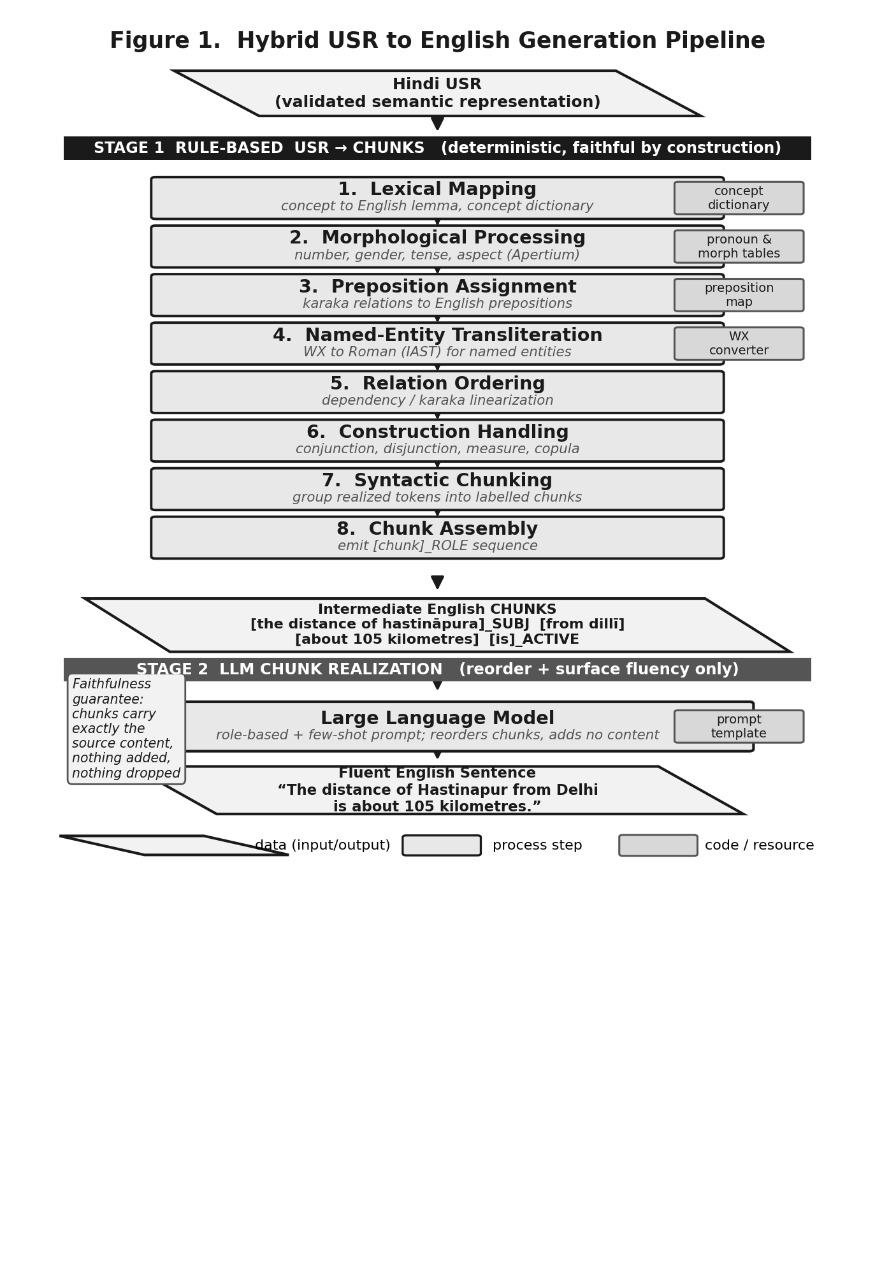
Source: Author(s)’ compilation.
5.2 The Universal Semantic Representation
The USR is a text based, multi layered encoding of meaning rooted in the Paninian grammatical tradition, and what sets it apart from comparable formalisms is that it preserves the speaker's intention rather than only the surface arrangement of words. It represents a sentence at three levels, the lexico conceptual, the relational, and the discourse level, and it is designed to be complete, so that nothing essential is left implicit, unambiguous, so that each element carries a single intended reading, and computationally tractable, so that a program can process it deterministically. A single USR is intended to support generation into more than one language, and the framework currently targets Hindi, Tamil, Bengali, and English.
At the lexico conceptual level the representation records the concept of each unit rather than its surface word, and concepts are sense numbered so that distinct readings of one word are kept apart, for example phala_1 in the sense fruit against phala_2 in the sense reward, or de_1, to give, against de_3, to confer. At the relational level the units are connected by the karaka and non karaka relations of Paninian grammar, which abstract away from word order to the underlying semantic roles, among them k1 for the agent (karta), k2 for the object (karma), k5 for the source, k7 for location and time, and r6 for the genitive. Because these roles are stated independently of any particular surface order, the same representation can drive generation into several languages. The framework also draws distinctions that surface form alone does not express, separating permanent possession, marked rsm, from temporary possession, marked rsma, and recording degrees of comparison on an adjective as superlative, comparative more, or comparative less. Layered above these are the morpho semantic features such as number, the speaker's view, which carries discourse particles, definiteness, and markers such as the approximative, and the discourse level, which links coreferring units across a sentence. In practice a USR is written as a table with one unit per row and one column per layer, a form we adopt for the worked example below.
5.3 The Eight Rule-Based Steps
With the representation in place, we now describe how the rule system converts it into chunks. Step 1, lexical mapping. Each concept is replaced by its English lemma through a multilingual concept dictionary of roughly 1,42,622 entries that maps a universal concept, with its Hindi and Sanskrit forms, to an English lemma and the corresponding MRS predicate. The sense numbering introduced above is what lets the dictionary resolve a concept to the right lemma, so that phala_1 maps to fruit while phala_2 maps to reward. Table 1 shows a sample.
Table 1
Sample entries from the multilingual concept dictionary (about 1,42,622 entries in total).
Universal concept | Hindi | Sanskrit | English | MRS predicate
phala_1 | phala_1 | phala_1 | fruit_1 | _fruit_n_1
phala_2 | phala_2 | phala_3 | reward_4 | _reward_n_1
phala_3 | phala_3 | phala_4 | return_15 | _return_n_of
phala_4 | phala_4 | phala_5 | effect_7 | _effect_n_1
de_1 | de_1 | sada_3 | give_1 | _give_v_1
de_3 | de_3 | upama_3 | confer_1 | _confer_v_1
Source: Author(s)’ computation.
Step 2, morphological processing. Number, gender, person, tense, and aspect are realized, and pronouns are produced from a dictionary that lists, for each English pronoun, its features and the relation it carries. The root wyax stands for every third person pronoun, and the relations are read in the Paninian sense, where k1 is karta (the agent), k2 is karma (the object), and r6 is sambandha (the genitive). A unit marked wyax, singular, masculine, animate, with a proximal or distal speaker view and the relation k1 is realized as he, the same unit under r6 as his, and under k2 as him. Table 2 shows a sample of the mapping.
Table 2
Sample of the pronoun mapping used in morphological processing. wyax is the root for third person pronouns; k1 is karta (agent), k2 is karma (object), r6 is sambandha (genitive).
Pronoun | Term | Num. | Gender | Person | Anim. | Speaker view | Relation
I | speaker | s | m/f/null | u | anim | 0 | k1
we | speaker | p | m/f/null | u | anim | 0 | k1
you | addressee | s/p | m/f | m | anim | informal/respect | k1
he | wyax | s | m | a | anim | proximal/distal | k1
she | wyax | s | f | a | anim | proximal/distal | k1
it | wyax | s | null | a | null | proximal/distal | k1
they | wyax | p | m/f | a | anim/inanim | proximal/distal | k1
him | wyax | s | m | a | anim | proximal/distal | k2
her | wyax | s | f | a | anim | proximal/distal | k2/r6
its | wyax | s | null | a | null | proximal/distal | r6
his | wyax | s | m | a | anim | proximal/distal | r6
Source: Author(s)’ computation.
Step 3, preposition assignment. The karaka and related relations to a unit's head are mapped to English prepositions, as listed in Table 3. For example, k7t marks time, so saradi (winter) under k7t is realized as in winter, and k3 marks the instrument, so cabi (key) under k3 is realized as with the key.
Table 3
Mapping from karaka and related relations to English prepositions.
Relation | Preposition | Relation | Preposition
k7t (time) | at | k2p | to
k3 (instrument) | with | rblak | after
k5, k5prk | from | rt | for
k7 | on | rblpk | before
k7p | in | rn | among
k7a | according to | rd | towards
 |  | rp | through
Source: Author(s)’ computation.
Step 4, named entity transliteration. USR writes concepts in the WX notation, so a WX converter renders named entities into Roman script, for example ceMgalapata steSana into cemgalapata stesana (the Chengalpattu station). Step 5, relation ordering. Each unit names its head and relation as an index pair, for example 8:k1 marks the agent of the verb at index 8, and the units are linearized around the main verb by these relations. Step 6, construction handling. Multi token units are assembled, covering conjunctions, disjunctions, and measure constructions, for example two place names joined by aura (and) become a single coordinated chunk. Step 7, syntactic chunking, groups the realized units into labelled chunks, and Step 8, chunk assembly, emits the chunk sequence with its role tags.
5.4 From USR to Chunks: A Worked Example
We trace one sentence, Tourism_017, whose Hindi is dilli se hastinapura ki duri takaribana 105 kilomitara hai (the distance from Delhi to Hastinapur is about 105 kilometres). This sentence is a useful illustration because, unlike a short route sentence, it exercises several layers at once: a genitive, a source, a distance measure built from a number and a unit, and a speaker view marker. Table 4 lays out its USR in the layered form, with the information layers down the left and one column per unit across the top, and Figure 2 then carries the same USR through the eight steps to the chunks and the final sentence.
In line with the layered description above, each unit is recorded by its concept rather than its surface word. The distance noun appears as xUrI_1, the two place names are held as the named entities ne_1 and ne_2, the number and the unit are grouped by the dist_meas construction at index 12, and the speaker's view marker wakarIbana, meaning approximately, rides on that construction and is what later yields the word about.
Table 4
The USR for Tourism_017 in layered form (Roman script with gloss). Columns are the units; rows are the information layers. k5 is source, r6 is genitive, k1 is agent, rmeas is the measure relation; the speaker view marker wakaribana means approximately.
Layer | xillI  (Delhi) | [ne_1] | hastinApura  (Hastinapur) | [ne_2] | xUrI_1  (distance) | 105 | kilomItara_1  (km) | [dist_meas_1] | hE_1  (be)
Concept | xillI | [ne_1] | hastinApura | [ne_2] | xUrI_1 | 105 | kilomItara_1 | [dist_meas_1] | hE_1
Semantic category | – | place | – | place | – | numex | – | – | –
Morpho-semantic | – | – | – | – | def | – | – | – | pres
Speaker view | – | – | – | – | – | – | – | wakaribana | –
Index | 1 | 3 | 4 | 5 | 7 | 10 | 11 | 12 | 8
Dependency | – | 8:k5 | – | 7:r6 | 8:k1 | – | – | 8:rmeas | 0:main
Construction | 3:begin | – | 5:begin | – | – | 12:count | 12:unit | – | –
Sentence type | affirmative
Source: Author(s)’ computation.
Reading the steps on this representation, lexical mapping gives distance, kilometre, and the copula; morphological processing realizes the present tense as is, the definite distance as the distance, and the number with its unit as 105 kilometres; preposition assignment turns k5 into from and the genitive r6 into of, while k1 becomes the subject; transliteration renders the two names as dilli and hastinapura; relation ordering places the subject, then the source, then the measure, then the verb; construction handling groups 105 with kilometre and realizes the speaker view marker as about. Chunking and assembly then emit [the distance of hastinapura]_SUBJ [from dilli] [about 105 kilometres] [is]_ACTIVE, which the model smooths into The distance of Hastinapur from Delhi is about 105 kilometres.
Figure 2
Tracing the USR for Tourism_017 through the eight rule based steps to the chunks, and then through the language model to the final sentence.
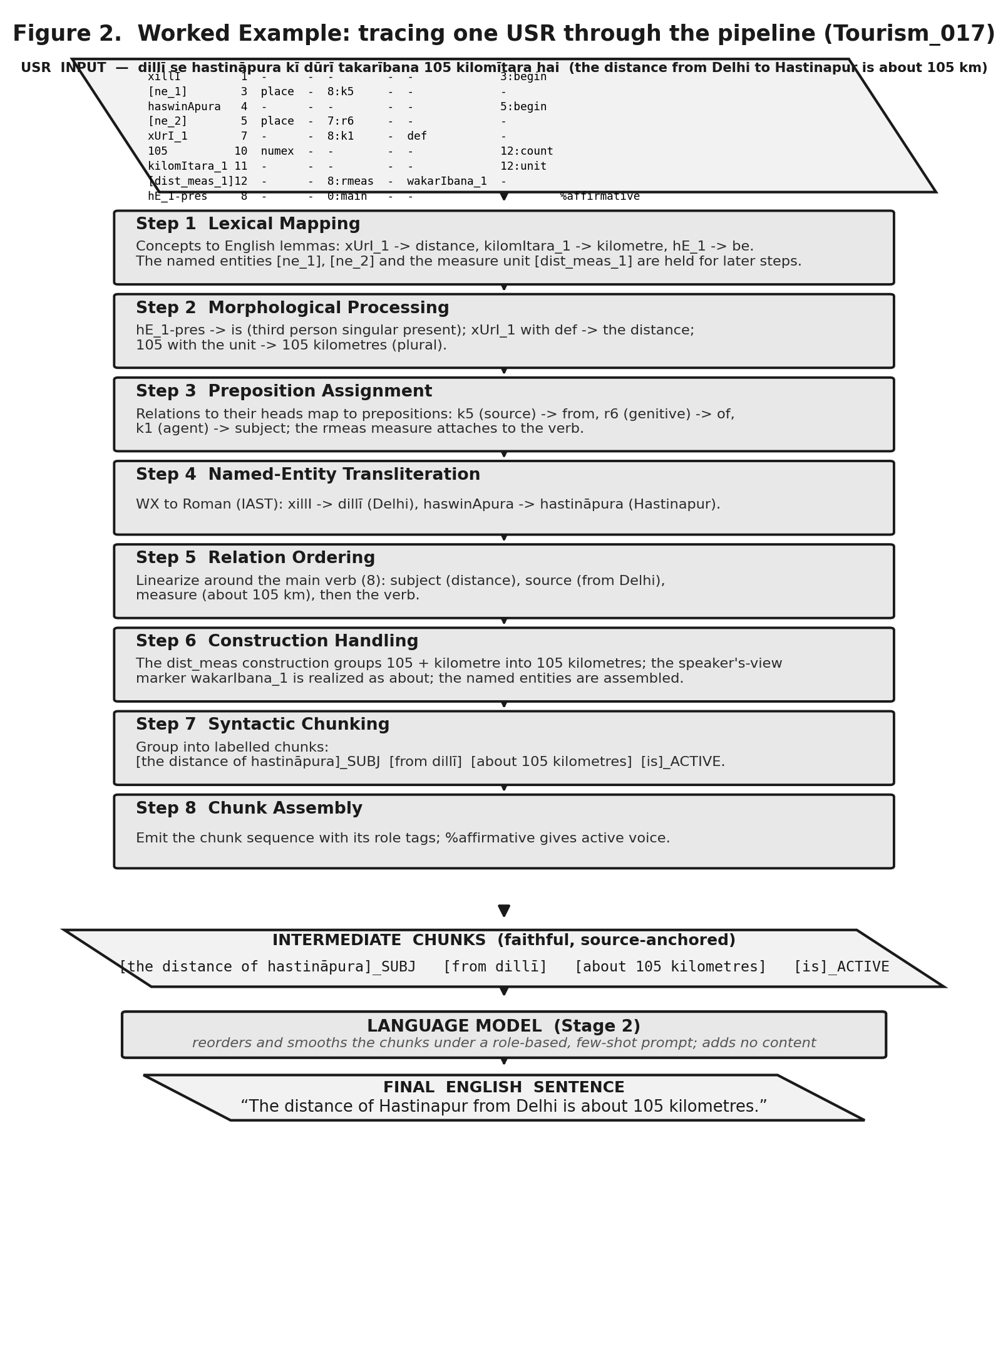
Source: Author(s)’ compilation.
5.5 Data Sources
The sentences come from a Hindi tourism corpus developed at IIIT Hyderabad. The set holds 250 sentences, 10.0 words long on average, from 3 to 22, describing places, routes, distances, festivals, and historical facts. Such content is dense with named entities and numbers, which makes any lapse in faithfulness easy to see.
5.6 Sampling Design
The population is the full tourism set, and we use all 250 expert validated USRs rather than a sample, so the evaluation is a census of the corpus. The order of work runs as follows. The USRs are created and validated first. The rule system then produces the chunks, and the three models generate the sentences from those chunks. For the human study we then draw a fifty sentence subset and have three expert annotators rate the hybrid output of all three models against the USR, which gives one hundred and fifty judgements per annotator.
5.7 Data Collection Methods
Each USR was created by two linguists with training in linguistics and experience in USR annotation, working independently on the same sentences. We recorded how often the two agreed, comparing their annotations field by field, and the result is summarised in Table 5. The two then differed mainly on which concept best fitted a word and on how a relation should be labelled, while they agreed most on whether a span was a named entity. A third expert, with four years of USR experience, reviewed and reconciled the two annotations and produced the final gold USR that the pipeline takes as input. The same expert separately wrote gold chunks for all 250 sentences, used later to score the rule stage.
Table 5
Where the two annotators agreed and differed when creating the USRs, by annotation decision.
Annotation decision | Agreement | Where they differed
Named entity identification | 92.4% | occasional missed or extra entity
Concept selection | 74.1% | choice of sense, for example which concept fits
Dependency relation | 69.1% | label of the relation to the head
Whole USR identical | 24.8% | one differing field separates two blocks
Source: Author(s)’ computation.
Three models were chosen, namely Llama 4 Scout, Mistral Small, and Gemma 3. The aim was to try more than one model rather than rest the findings on a single system, so we picked three that differ in family and in size and that are openly accessible, which lets others reproduce the work, and one of which, Gemma 3, runs locally. Generation used the same protocol across models. For the first experiment the model received only the Hindi sentence and was asked to translate it and to output only the translation. For the second it received the raw USR block and was asked for the English sentence. For the third it received the chunks under a role based, few shot prompt that cast it as a surface realizer and told it to compose one fluent sentence without adding or removing content, to keep proper nouns exactly as spelled, to add only function words such as articles and forms of the verb to be, and to respect the role tags. A low decoding temperature was used throughout to favour faithful and stable output.
For the human study the three annotators, a research scholar, a research associate, and an expert linguist, judged each output beside dropdown scales whose options stated the meaning of each score, so that a fluency of five meant perfect English and a one meant text that was not really English, adequacy ran from exact meaning to meaning lost, and comprehension from instantly clear to not understandable. They read each output and chose the option that fitted, judging against the meaning of the source. The recorded scores differed from an automatic reference suggestion on about 31 percent of ratings, which shows the judgements were made by hand rather than copied from the suggestion.
5.8 Tools and Techniques for Analysis
The rule system is written in Python, with morphological generation through Apertium and the concept dictionary for lexical mapping, and named entities transliterated from WX to Roman. Chunk accuracy is reported as exact match accuracy and as token level precision, recall, and F1 over chunks. Hybrid output is scored with corpus BLEU and chrF against the human reference and with the human ratings for fluency, adequacy, and comprehension. Agreement is the pairwise Cohen kappa averaged over the three annotator pairs, read against the Landis and Koch bands. For the two direct conditions we compute a transliteration tolerant faithfulness score, a token level F1 against the gold meaning that does not penalise spelling or script, and we support it with a hand checked list of semantic errors.
5.9 Ethical Considerations
The study uses tourism facts that carry no personal or sensitive data. The annotation and evaluation were carried out by linguists working within the same research group, under the project supervisor and as part of their normal research, so no separate clearance from a higher authority was required, and the work posed no risk to anyone involved.
6. RESULTS / DATA ANALYSIS / FINDINGS
6.1 Three Pipelines on the Same Sentences
Table 6 sets the three configurations side by side on the same evaluation set. Translating the Hindi sentence reads well but is unfaithful. Generating from the raw USR fails almost completely. The hybrid pipeline is faithful and fluent at once. This is the central result, and it answers two obvious objections together, why one should not simply translate the Hindi, since the first experiment shows that route hallucinates, and why one should not simply hand the USR to the model, since the second shows that route collapses.
Table 6
The three configurations on the same 250 sentences.
Configuration | Faithfulness | Output form | Hallucination
Exp. 1: Hindi sentence to English | low, F1 0.540 to 0.593 | fluent sentences | yes, invented names, drops
Exp. 2: raw USR to English | very low, F1 0.075 to 0.191 | largely incoherent | severe, format not read
Exp. 3: hybrid pipeline | high, 97.82% chunk F1 | fluent sentences, 4.85/5 | none seen in entities
Source: Author(s)’ computation.
6.2 Rule Stage Chunk Accuracy
Set against the expert validated gold chunks, the rule system reproduces the whole chunk sequence exactly for 93.2 percent of sentences, and at the level of single chunks it reaches precision 97.69 percent, recall 97.95 percent, and F1 97.82 percent, as Table 7 reports. Because each chunk is derived from the USR, the stage cannot add content the input does not hold, and what it gets wrong are omissions or mis formed chunks, never fabrications.
Table 7
Rule based USR to chunk accuracy against expert validated gold chunks on 250 sentences.
Metric | Value (%) | Reading
Exact sequence match | 93.2 | whole chunk string equals gold
Chunk precision | 97.69 | of produced chunks, share correct
Chunk recall | 97.95 | of gold chunks, share recovered
Chunk F1 | 97.82 | harmonic mean of the two
Source: Author(s)’ computation.
6.3 Where the Rule Stage Still Errs
The residual errors of the rule stage are few and systematic, and they are realization slips rather than failures of faithfulness. Table 8 lists the kinds with a real instance from the data, drawn from the gold against tool comparison. They concern articles, the placement of a genitive preposition, the choice between a demonstrative and a possessive, the realization of a tense and aspect cell, and a few hard coordinated measure constructions, and in each case the smoothing stage repairs many of them on the surface.
Table 8
Residual rule stage errors, each with a real example (gold versus tool output).
Error kind | Gold | Tool output | Sentence
Article over generation | the utmost importance of pilgrimage | a the utmost importance of pilgrimage | Tourism_097
Genitive order (r6) | of country and world | country and of world | Tourism_055
Demonstrative vs possessive | its name | this name | Tourism_098
Pronoun choice | they | that | Tourism_190
Morphology | beautiful lake | beauty lake | Tourism_170
Measure and conjunction | 32 kilometre kasola and 35 kilometre manikarna | 32, 35, kasola, kilometre kilometre and ... | Tourism_133
Extra chunk | ascension and descension then | descension then; ascension and descension | Tourism_151
Source: Author(s)’ computation.
6.4 Direct Generation Falsifies the Structured Input Assumption
The two direct conditions show that a structured input does not, on its own, give faithful output, and Figure 3 sets them against each other. Translating the Hindi sentence gives faithfulness of 0.588 for Llama, 0.593 for Mistral, and 0.540 for Gemma, with a hand checked audit finding 35 clear semantic errors across the three, as Table 9 records. Handing over the raw USR lowers faithfulness sharply, to 0.191, 0.174, and 0.075, since the models cannot parse it and often return unrelated or broken text. The score normalises script and spelling before comparing, so a model is not charged for writing Arakonam where the gold writes arakonama, and the error counts are checked against the Hindi so that fair translations are not miscounted. The instances in Table 10 are of a kind the rule pipeline cannot produce, since it emits only tokens derived from the source.
Figure 3
Direct generation faithfulness in the two direct conditions. Faithfulness collapses when the raw USR is supplied in place of the Hindi sentence.
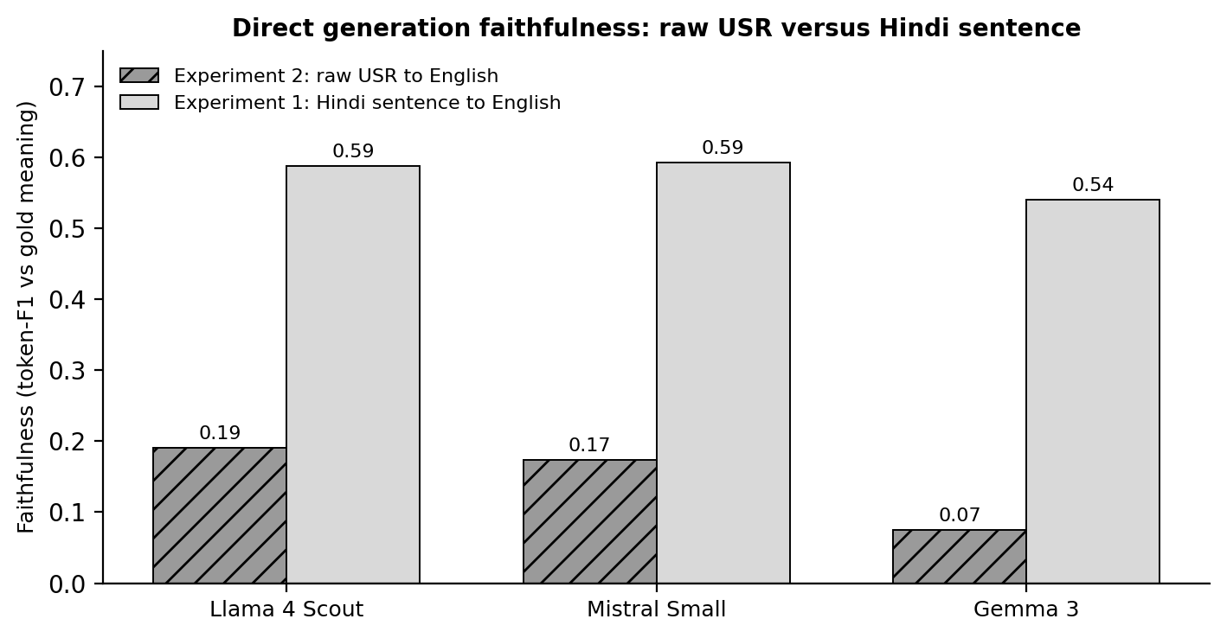
Source: Author(s)’ compilation.
Table 9
Direct generation faithfulness and hand checked semantic error counts on 250 sentences.
Model | F1, Hindi to English | F1, USR to English | Semantic errors | Severe
Llama 4 Scout | 0.588 | 0.191 | 7 | 2
Mistral Small | 0.593 | 0.174 | 9 | 6
Gemma 3 | 0.540 | 0.075 | 19 | 10
Source: Author(s)’ computation.
Table 10
Real semantic errors from direct translation of the Hindi sentence (Roman script with gloss).
Error kind | Source to model output | Model
Entity hallucination | podanapura to “kingdom of Mahishmati” | Mistral
Entity hallucination | laksara to “Luxor” (a city in Egypt) | Gemma
Entity hallucination | amcutemgu to “Andaman and Nicobar Islands” | Mistral
Name corruption | khajiyara to “the jackal” | Gemma
Lexical shift | lagatara (continuously) to “on a regular basis” | Llama
Lexical shift | dharmasalaem (rest houses) to “religions” | Llama
Word sense | casma (spring) to “glasses” or “a tear” | all three
Truncation | siva ballabhapura to “Shiv” | Llama
Source: Author(s)’ computation.
6.5 Hybrid Pipeline: Automatic Metrics and Human Evaluation
With the model now only reordering faithful chunks, quality is high across the three. Against the human reference, in Table 11, Mistral leads on BLEU at 64.0 and Llama on chrF at 88.0, with Gemma close. The human ratings in Table 12 agree with this. Mistral is highest overall at 4.85 of 5, Llama is close behind and at times preferred at 4.77, and Gemma follows at 4.76. The gaps are small, so we read Mistral as best overall while noting that Llama is sometimes better, and we make no claim of a decisive winner.
Table 11
Hybrid pipeline automatic metrics, corpus BLEU and chrF, against the human reference.
Model | BLEU | chrF | Note
Llama 4 Scout | 59.4 | 88.0 | highest chrF
Mistral Small | 64.0 | 87.4 | highest BLEU
Gemma 3 | 61.7 | 86.0 | competitive
Source: Author(s)’ computation.
Agreement among the raters is high, with an overall kappa of 0.905. This is expected rather than odd, since the sentences are short and, in the hybrid setting, mostly realized correctly, so three independent experts land on similar scores.
Table 12
Human evaluation by three expert annotators, scales of one to five. Mean Cohen kappa is 0.910 for fluency, 0.877 for adequacy, and 0.928 for comprehension, 0.905 overall.
Model | Fluency | Adequacy | Comprehension | Overall
Llama 4 Scout | 4.78 | 4.71 | 4.81 | 4.77
Mistral Small | 4.88 | 4.77 | 4.91 | 4.85
Gemma 3 | 4.76 | 4.74 | 4.79 | 4.76
Source: Author(s)’ computation.
7. DISCUSSION
The findings speak to the questions in turn. On RQ1, an explicit and unambiguous input does not stop the models from hallucinating. Translating the Hindi distorts entities and shifts sense, and the raw USR is worse, with faithfulness down to between 0.075 and 0.191, so H1 holds and the structured input assumption does not. The reason is telling. A model reads even a precise specification as a prompt it may dress up, and its prior knowledge overwrites unfamiliar source content, so a little known town turns into a famous one and a rare name into a common word. Given the raw USR, the model has no training to read the formalism and drifts away from the source.
On RQ2, the chunking stage removes that freedom. The chunks are tied to the source and the model only reorders and smooths them, so the hallucinations of direct generation disappear while the writing stays fluent, with human scores between 4.76 and 4.85 of five, which supports H2 and bears out the framework of giving faithfulness to the rules and fluency to the model. On RQ3, the three models behave alike in the hybrid setting, Mistral best overall, Llama close and at times ahead, Gemma close behind, which suggests the design does not hinge on any one model, since its faithfulness comes from the rules.
The direct condition also shows the models failing in different ways. Gemma fails most often and most visibly, turning Khajiar into the jackal or Laksar into Luxor, while Mistral fails less often but more dangerously, replacing Podanpur with the cinematic kingdom of Mahishmati, a substitution a reader is likely to accept. Confident and plausible invention is exactly the failure that fluency hides, which is why an anchoring stage is needed. The residual rule errors, by contrast, are small and local, the kind that map to a single rule and can be fixed, and neither stage is ever allowed to alter content.
8. THEORETICAL AND PRACTICAL IMPLICATIONS
Theoretical Implications
The study sharpens the link between input quality and faithfulness. Completeness and lack of ambiguity in the input are necessary but not sufficient, and a constraint on what the generator may do is needed as well. It also shows, for the first time, that USR can drive generation, which carries the formalism from analysis into generation and gives a basis for further work on generating from Paninian semantic representations.
Practical Implications
The pattern of deterministic, source tied content realization followed by model based smoothing is a usable recipe wherever faithfulness matters, in travel, government, or health information, where an invented name or a dropped condition has real consequences. It also gives a plain guideline for anyone building on a language model, namely to hand the model the smallest sufficient task, reordering faithful units, rather than an open one, expressing a meaning from scratch. For Indian languages in particular, a faithful generator over USR can be reused across the languages that map into the representation.
9. LIMITATIONS OF THE STUDY
The corpus is one domain, tourism, and one language pair, Hindi to English, a deliberate choice of depth over breadth, since each of the 250 USRs was written, concept labelled, relation annotated, and expert validated, which is demanding work, and a single controlled domain keeps generation behaviour clear of input noise. The human study covered fifty sentences with three experts, and agreement was high because the sentences are short and mostly realized well. The rule stage still has the small realization gaps listed in Table 8, which are being addressed. These bound the reach of the exact numbers, but they do not weaken the central qualitative finding, that a structured input alone does not make generation faithful and a rule anchored hybrid does.
10. FUTURE RESEARCH DIRECTIONS
Three directions follow. The first is multilingual generation, taking the pipeline to other source languages such as Telugu to English, which the language independent design of USR supports. The second is closing the residual rule gaps, in particular article generation, the genitive and locative prepositions, and the hard coordinated measures, so the rule output needs even less smoothing. The third is widening the corpus across domains while holding annotation quality, together with automatic checks that verify each generated sentence against its source chunks.
11. CONCLUSION
We set out to test the belief that a more complete and unambiguous input makes a language model faithful, and found that it does not. Over three experiments on 250 Hindi sentences with three models, translating the sentence read well but was unfaithful, and feeding the raw USR failed almost entirely, with faithfulness down to between 0.075 and 0.191. We then presented, for the first time as far as we know, a generation pipeline over the Universal Semantic Representation, in which an eight step rule system turns each USR into source anchored chunks that carry exactly the input content, and a model then orders and smooths them into fluent English. The rule stage reaches 93.2 percent exact chunk accuracy, with an F1 of 97.82 percent, and the full pipeline earns high expert ratings, 4.85 of five for the best model, at strong agreement with a kappa of 0.905. By giving faithfulness to the rules and fluency to the model, the pipeline keeps generation tied to the input while reading naturally, and the wider lesson is that faithful generation needs not only a good input but a generator held to it.
REFERENCES
Banarescu, L., Bonial, C., Cai, S., Georgescu, M., Griffitt, K., Hermjakob, U., Knight, K., Koehn, P., Palmer, M., & Schneider, N. (2013). Abstract meaning representation for sembanking. Proceedings of the 7th Linguistic Annotation Workshop and Interoperability with Discourse, 178–186.
Cohen, J. (1960). A coefficient of agreement for nominal scales. Educational and Psychological Measurement, 20(1), 37–46.
Ji, Z., Lee, N., Frieske, R., Yu, T., Su, D., Xu, Y., Ishii, E., Bang, Y. J., Madotto, A., & Fung, P. (2023). Survey of hallucination in natural language generation. ACM Computing Surveys, 55(12), 1–38.
Landis, J. R., & Koch, G. G. (1977). The measurement of observer agreement for categorical data. Biometrics, 33(1), 159–174.
Papineni, K., Roukos, S., Ward, T., & Zhu, W. J. (2002). BLEU: A method for automatic evaluation of machine translation. Proceedings of the 40th Annual Meeting of the Association for Computational Linguistics, 311–318.
Popovic, M. (2015). chrF: Character n-gram F-score for automatic MT evaluation. Proceedings of the Tenth Workshop on Statistical Machine Translation, 392–395.
[Author to supply] Reference for the Universal Semantic Representation framework and guideline (version 4.2.1).
[Author to supply] Reference for the Paninian grammatical framework underlying USR.
[Author to supply] Reference for the IIIT Hyderabad tourism corpus used as the source sentences.
[Author to supply] Reference for the Apertium morphological resources used in the rule system.
AUTHOR DECLARATION
I/We hereby declare that this manuscript is original, unpublished, and not under consideration elsewhere. All sources have been duly acknowledged and cited in accordance with academic conventions.
Corresponding Author Name: ____________________
Signature: ____________________
Date: ____________________

