Considering this overarching structure:

I will focus on the following parts of any given SURVEILLANCE ACTIVITY:

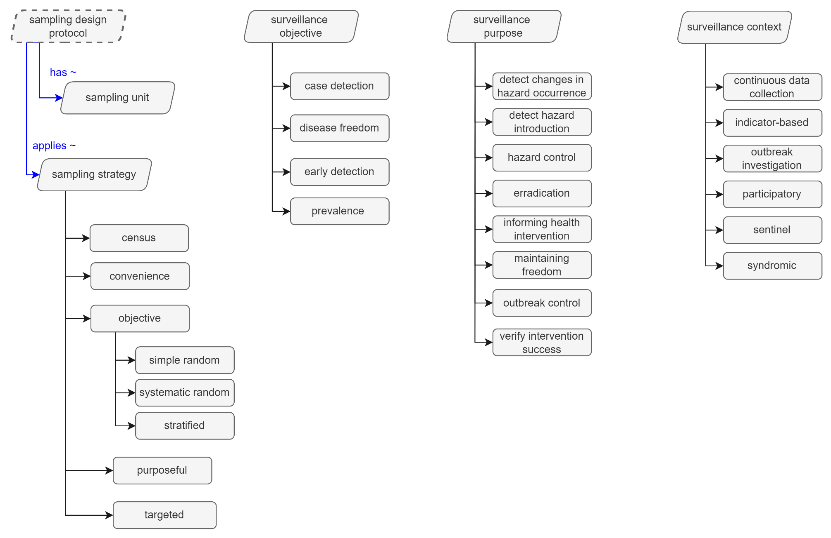

Additionally, HSO allows specific types of surveillance activities to be listed, and their definition to be constructed using properties/conditions related to these dimensions. For instance, “Outbreak investigation” is a type of surveillance activity which has the surveillance context “outbreak investigation”.

Considering the example above, and the definition of “Baseline surveillance” that Rhiannon provided: “A surveillance sampling strategy in which baseline is established at the beginning of a study or project by the selection of sample units via random sampling”, I suggest for instance that *Baseline surveillance* is a specific type of surveillance activity, which has the specific *surveillance purpose* of establishing a baseline prevalence, and *sampling strategy* “objective sampling” (simple, systematic or stratified, the latter which can be used for instance when establishing a baseline for different age groups). “Establishing a baseline prevalence” is not defined in HSO, and it made me realize just how not straightforward things are (and how badly defined they are withing HSO).

The surveillance context, as Rhiannon found, is not explicitly defined in HSO. They came from this figure:

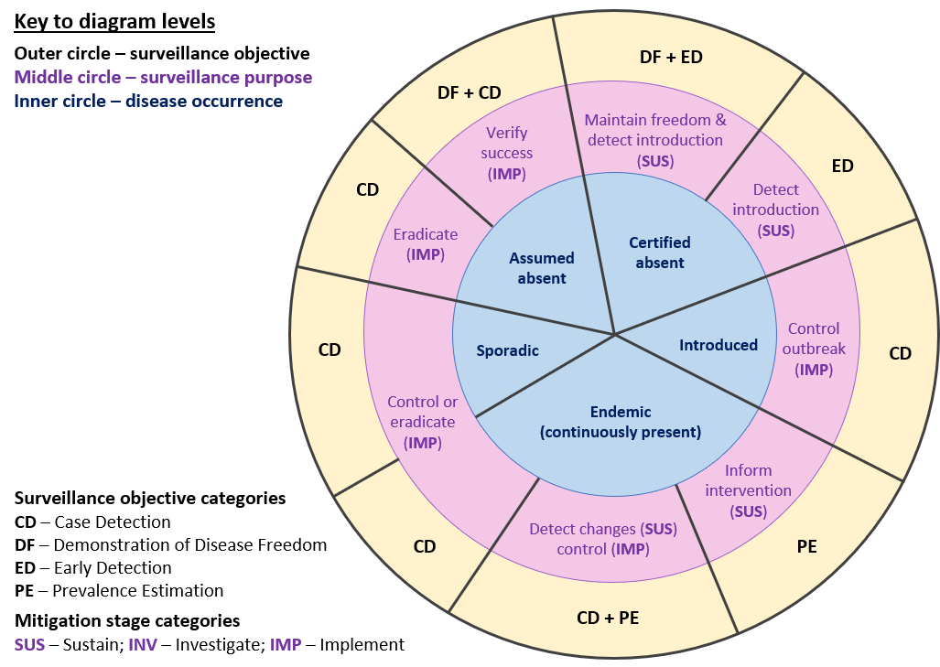

It takes a while to take this figure in, but if you read from inside first, these are the cycles of introducing a new disease, controlling, eventually eradicating, and being free again. Going outwards, you can then follow the lilac circle, which are the surveillance purposes. These are then summarized into four main surveillance objectives in the yellow circle, but you can ignore those for now, as they are meant to be used for surveillance systems (a collection of various surveillance activities).

“inform intervention” is the first step when a disease is introduced and we are past just considering it an outbreak. It is now established. Defining a baseline seems to fit well under this surveillance purpose.

That said…

If I look through this list of strategies in your spreadsheet (which I hope I got the hierarchy right):

* Baseline surveillance (random sampling)
* Targeted surveillance (non-random sampling)
  + Screening for Variants of Concern (VoC)
  + Longitudinal surveillance (repeat sampling of individuals)
  + Re-infection surveillance
  + Vaccine escape surveillance
  + Travel-associated surveillance
    - Domestic travel surveillance
      * Interstate/ interprovincial travel surveillance
      * Intra-state/ intra-provincial travel surveillance
    - International travel surveillance
      * Surveillance of international border crossing by air travel or ground transport
        + Surveillance of international border crossing by air travel
        + Surveillance of international border crossing by ground transport
      * Surveillance from international worker testing
* Cluster/Outbreak investigation
  + Multi-jurisdictional outbreak investigation
  + Intra-jurisdictional outbreak investigation

I thought it would be more productive to list all of them directly under “surveillance activity” for a few reasons:

1. Then you have an URI directly that you can use, and we can figure out the finer details later, by mapping specific sampling strategies, surveillance purpose and context to each one
2. It will make it straightforward to people who are doing the COVID work to find the surveillance activity types they are looking for, and the ontology takes care of all the philosophical questions of what is context, what is purpose, etc.
3. It buys us (read:me!) some time to figure out some of these philosophical details. It is straightforward the time of sampling used in each case, but I am still unsure whether I would like to add all these types of targeted surveillance to the context, the purpose, or both.

So, I added all of those to HSO under surveillance activity, with the definitions from the google sheet (thanks Rhiannon!!!). I added their URIs there.

Lastly, for these:

* Variant of Concern
* Variant of Interest
* Variant Under Monitoring

I do think that they should exist somewhere where we can link surveillance designed specifically around those. For instance if the purpose of surveillance is “Screening for Variants of Concern (VoC)”, then there should be some property between this surveillance activity and “the” VoC. When we talked, I suggested that they should probably be in GenEpiO, but I guess even then I would need to think out which property from HSO points to them.

Outbreak investigations have their own specific list of information in HSO (under directive information entity):

I don’t know if we could fit some under there, or maybe have a higher level that includes both the outbreak investigation and whatever other type of investigation this falls under. I did create URIs for them, and added to the spreadsheet. For them I created a “genetic epidemiology surveillance datum” class for them, and left them under “awaiting placement”. To be discussed.

P.S.:

For these:

* Research
  + Viral passage experiment
  + Protocol testing experiment

I hesitated to add them to the sampling strategy because I don’t think they are “surveillance”, and because the definition in the Excel file read to me more like the purpose, than the strategy. I wonder about having them added to GenEpiO as a specialization of some bigger class from OBI? But I also could add “research” or even “secondary use of research data” somewhere in HSO if it helps.